THE KOREA REVIEW

Volume 3, October 1903.

A Korean Poem. F. S. Miller 433

Korean Relations With Japan 438

The Fortress Of Puk-Han 444

Odds And Ends

The Secret Armor 451

Presence Of Mind 452

Editorial Comment 453

News Calendar 455

Korean History 465

[page 433]

A Korean Poem

Korean poetry having fallen into disrepute and become mainly one of the allurements of her whose “house inclineth unto death,” the better class Korean will not acknowledge his acquaintance with it. One might study with a teacher for several years and not discover that there is such a thing as a Korean poem. Yet when he delves into the somewhat difficult language of a book of songs he finds much that gratifies.

Some idea of one style of Korean poetry may be gained by studying a few extracts from a poem on woman’s devotion, the 우미인가 or “The Song of U, the Pretty One” (U being her surname and Pretty One her personal name). The setting is Chinese. Perhaps it is a translation, but its similarity to poems that seem to be purely Korean would indicate otherwise. A faint attempt at translation and some romanization is made for the benefit of those readers who are not acquainted with Korean.

After a brief description of the place and time the heroine is introduced and described

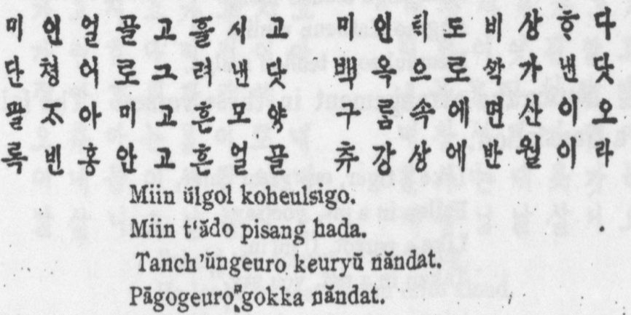

[page 434]

From this romanization of the first four lines an idea may be gotten of the occasional play upon the sounds of the words and the repetition of the same syllable in corresponding parts of the couplets. This takes the place of rhyming, which would be impossible in Korean.

It will be noticed that the stanza consists of couplets, each verse containing four trochaic feet. This is the usual form of Korean verse and the easiest to write. This is one of the greatest obstacles to the making of hymns in Korean, as our corresponding verse is all iambic,

“ Mi-in’s face, how sweet it is!

Mi-in’s carriage how refined;

Like a painting in red and blue

Like a carving from whitest jade.

The figure eight (八) of her butterfly brows,

A distant peak above the clouds.

Raven locks, pink cheeks, her pretty face

A half-moon lighting the autumn river.

Her age, at the time the story begin, is referred to as

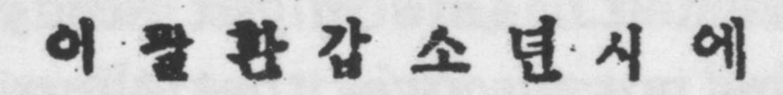

“In the flowery youth of twice eight years.”

Again, speaking of her beauty:

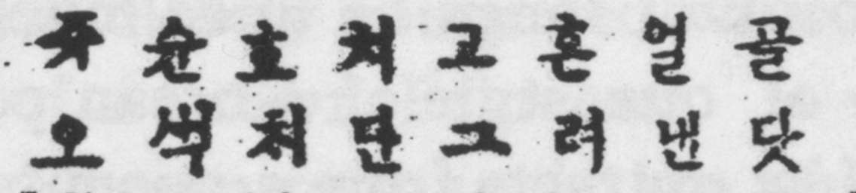

“Red lips, white teeth, her pretty face

A picture painted in many colors.”

Then follows a description of the mighty chief and his warlike hosts.

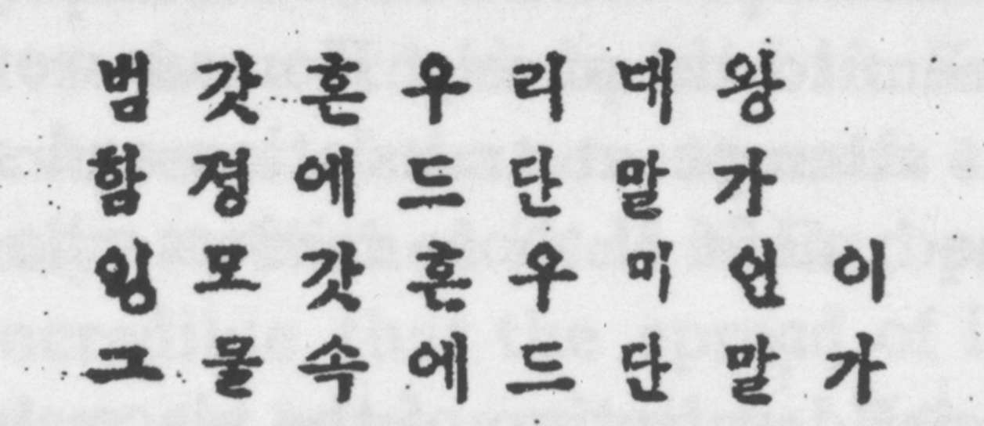

Pom katheun uri Tawang.

Hamjunge teudan malga

Angmo Katbeun umiini

Keumul soge tendan malga.

Notice the arrangement in these verses. The following is a translation.

“Like a tiger, our great chief,

Fallen in a pit, you say;

Like a parrot, U mi in,

Taken in a net, you say.” [page 435]

This is how it happened. The enemy above the camp played “The Thoughts of Home,” the national air of our hero and his forces, and they were scattered “like falling leaves in the Autumn wind.” Or in the words of the poem,

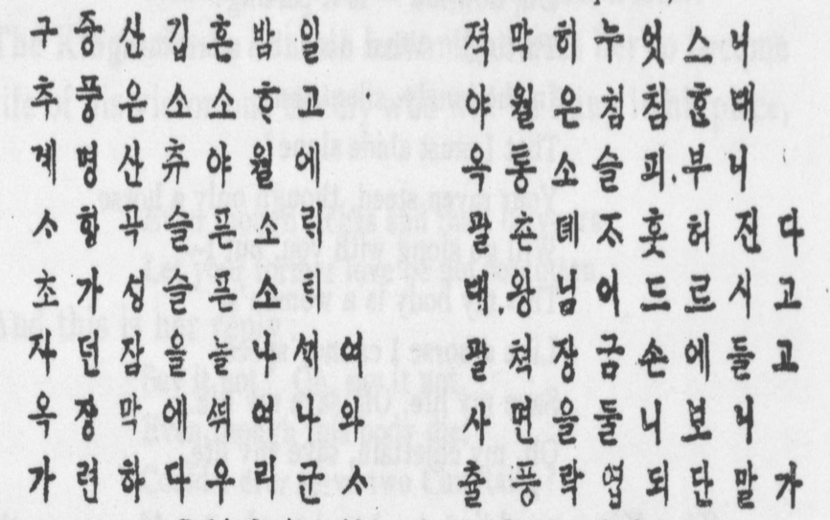

Behind nine ridges, in the depths of night

In a lonely place they laid them down.

The Autumn winds were blowing cool

The midnight moon was shining dimly

On the Koe-myung Mountain, in the Autumn moon.

They mournfully blew on their flutes of jade;

Sad notes of the tune of “Thoughts of Home.”

And the eight thousand followers are scattered abroad.

The mournful song of his native land

Fell on the ears of the chieftain great;

With a start he awakened from his sleep.

Took in his hand his eight-foot sword.

Leaping he left his tent or jade

And looked around on all four sides.

Sad to relate—the mighty hosts

Were fallen leaves in the Autumn wind.

Then, as defeat is inevitable, comes the sorrow at parting:

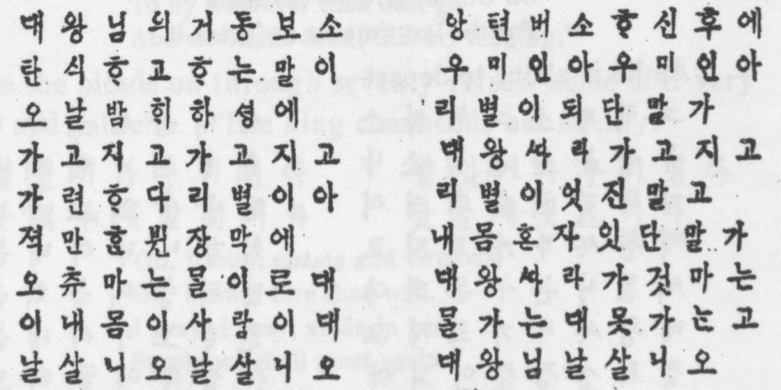

Behold the sorrow of our King.

He looks to heaven and cries aloud.

Amidst his sighs he thus exclaims;

Oh, Umiin! Oh, Umiin! [page 436]

Tonight at the lower walls of Hai

Does it mean that we must part?

To which she replies:

I want to go. I want to go.

With my king I want to go.

Oh, how sad! Is it parting?

Parting! What does this word mean?

In the lonely, silent tent,

That I must abide alone?

Your raven steed, though only a horse

Will go along with you, but I -

This my body is a woman’s.

Like a horse I cannot speed.

Save my life. Oh, save my life.

Oh, my chieftain, save my life.

The King explains to her how he could escape through the ranks of the enemy if he were alone, but with this frail one, what could he do? She hears his word and as she sits with the candle before her -

Like white jade was her face,

Crystal-like the tears that fell.

She offers him the consolation of the cup and he replies:

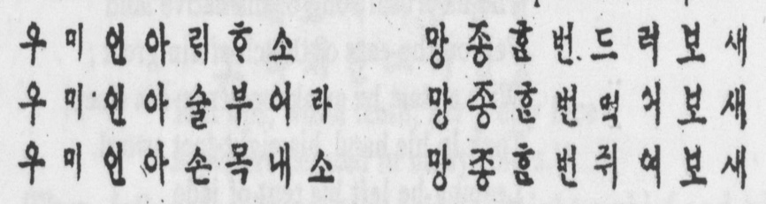

Oh, Umiin, sing a song

For the last time let me hear thee.

Oh, Umiin, pour me a cup.

For the last time let me taste it.

Oh Umiin, give me thy hand

For the last time let me; press it.

As he is about to depart—

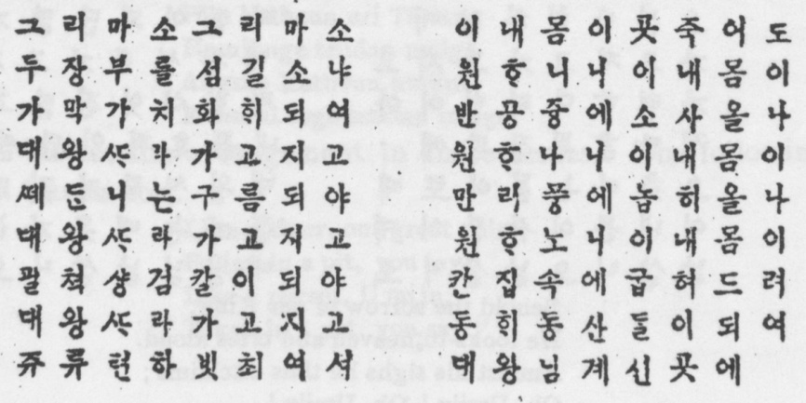

[page 437]

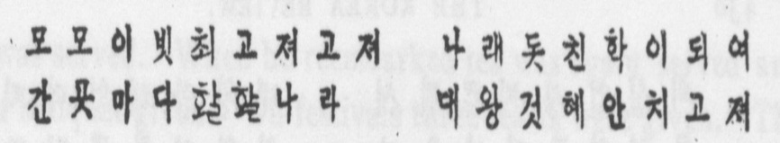

In a distant village a cock is crowing,

On the tent jade, the moon is shining.

The moon’s light is sad and chill.

Mournful the tune of The “Thoughts of Home.”

The King tries to console her and advises her to become the wife of his victorious enemy who will be King in his place, but

Even though riches and rank be yours

Let your former love be not forgotten.

And this is her reply:

Say it not. Oh, say it not.

Even though this body die,

Could I ever serve two Chieftains?

How I wish that this my body,

Changed into a crow or magpie.

In mid-air might fly away

And follow thee; Oh, this my longing.

How I wish that this my body

Might become a floating cloud,

On far-flying winds to drift away

And follow thee: Oh, this my longing.

How I wish that this my body

Might become an eight-foot sword

To crouch and hide within thy scabbard

And follow thee; Oh, this my longing.

To be the moon on Eastern sea or mountain

To roam the whole world o’er and o’er,

In whatever place my chief may be.

To shine in every crack and cranny,

To become a winged crane

To fly wherever thou dost go

And sit beside thee: this my longing,”

So she pleads on through seventy verses, some of it very pretty and pathetic. The king commends her fidelity:

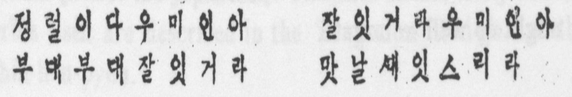

“Oh, Umiin, chaste and virtuous,

Oh, Umiin, fare thee well.

I pray, I pray, abide in peace

Surely we shall meet again.”

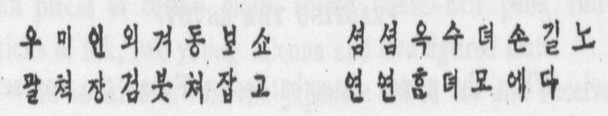

[page 438]

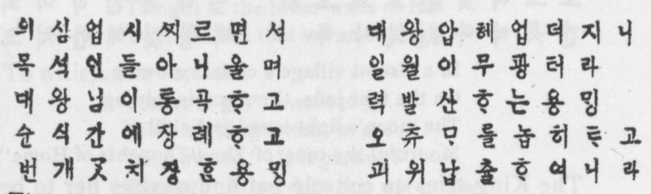

Then comes the tragical climax—

Behold the actions of Umiin.

With slender fingers, white as jade

She tightly grasps his eight-foot sword.

Into her delicate beautiful throat

Fearlessly she thrusts the blade

And falls before the mighty chief.

Men of wood and stone, who weep not!

Sun and moon both hide their light.

The mighty chieftain midst his weeping,

With strength enough to pluck a mountain,

In the space of a breath, gives her burial.

And bounding high on his raven steed

With the speed of a flash of lightning

Breaks through the ranks and southward flies.

If you should ask a Korean why the mighty chief makes no attempt to save her life he would reply with a dazed look “What! And spoil such a beautiful illustration of feminine devotion?” But this need not prevent our enjoying the beauty of the song. Notice the music in such passages as the following:

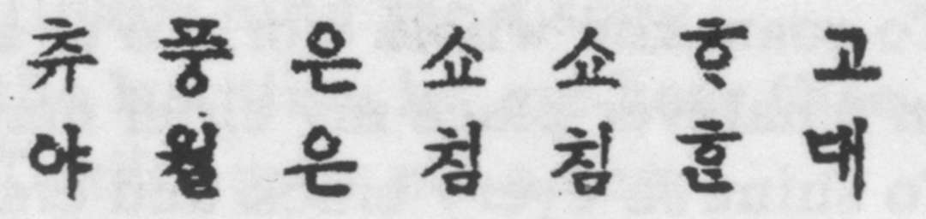

Ch’up’ungeun so-so bago

Ya wuleun ch’im-ch’im handa

While the autumn wind was sighing, sighing, sighing.

And the midnight moon shone dimly, dimly.

Through it all we find a wonderful freedom of motion, a casting off of the bonds of syntax which our hymn-writers might do well to imitate.

Korean Relations with Japan

FEASTING THE ENVOY.

When the envoy disembarked at Fusan tea was served and a feast was spread. On the road to the capital tea only [page 439] was served. When he reembarked tea was again served and a banquet given. On festivals three feasts were given. The food used at these banquets consisted of wine, bread, vinegar, gluten rice, black beans, lentils, wheat flour, bean flour, yeast, oil, honey, condiments, salt, mustard, ginger, jujubes, dried persimmons, pine nuts, walnuts, hazelnuts, pomgranates, dyestuff, mushrooms, fresh pork, dried beef, pheasants, hens, eggs, fish, beche-du-mer, clams, cuttlefish, sole, cod, herring and dried fish.

Besides these things there were used in connection with the feasts, for making awnings, etc., etc., forty straw mats, forty-two bamboos, twenty-six bundles of straw, ten straw grain mats, five sail mats, one coil hemp rope, one coil of small rope, one coil of vine rope, one plank, twenty iron nails and fifteen small nails. Besides this three bags of rice were given the visitors to eat on their voyage back to Japan.

THE LETTER TO THE KOREAN GOVERNMENT.

Each envoy brought a formal letter which he delivered to the ch’am-eui of the Board of Ceremonies. The wording of this letter and the form of address are described in the books called Tong-mun Whi-go 彙考) and Chin-hon-p’yun.

The list of goods formally mentioned in this letter consisted of 500 lbs. of black pepper, 700 lbs. of dyewood, 300 lbs. of alum, two pounds of cinnabar, 300 sheets of figured paper.

Besides this there was brought for the purpose of barter 2,800 lbs. 1,551 lbs. of lead, 325 lbs. of dyewood, 400 pairs of black goat borns.

THE REPLY OF THE GOVERNMENT.

The Board of Ceremonies gave a formal written answer to the letter of the Japanese. The form of that letter and the terms used are described in the Tong-mun Whi-go and the Chin-hon-pyun.

The government also reciprocated by sending three pounds of ginseng, two tiger skins, two leopard skins, four pieces of white silk, four pieces of linen cloth, five pieces of grass cloth, ten pieces of cotton cloth, thirty weasel-hair pens, thirty sticks of ink, two young falcons and two figured mats.

In addition to this the Japanese asked for and received [page 440] one pound and ten ounces of ginseng, twenty brush pens, twenty sticks of ink, six quires of paper, three laundering irons, three ink-stones, three ink-water cups, one knife, three brushes, ten fans, six fine-tooth combs, one peck and one measure of linseed oil, one peck and one measure of honey, one peck and one measure of lentil meal, one peck and one measure of “Job’s tears” meal, thirty pounds of tiger’s flesh, three tiger’s galls, three dogs, two quires and three sheets of umbrella paper, three paper canopies and three pecks each of pine nuts, hazelnuts, walnuts, shelled chestnuts, unshelled chestnuts and jujubes.

[In addition we are told that the Japanese brought sixteen bundles eleven bolts, twenty-nine yards and one inch of cotton cloth to sell, but whether that was in addition to the other goods or in lieu of part of them we are not told. Ed.]

In early days the annual boat brought one envoy and only one attendant or aide, but in the first year of Kwang-ha, 1609 A. D., the envoy brought two aides with him. For this piece of presumption he was taken to task by Cho Chon-sung the governor of Fusan. He ordered the envoy to send back all but the number of men definitely agreed upon by treaty, but the envoy evaded the issue and did not comply with the demand. This precedent was followed for some years. The envoy asked the governor as a favor to let the extra aide come in to have a view of the place. The governor assented. At this time the length of the envoy’s stay was fifty days but in the sixth year of King In-jo, 1629 A. D. it was lengthened by thirty-five days.

[At this point is inserted a statement that the Koreans sent annually fifty bags of rice and fifty bags of beans to the Daimyo Tsushima but it does not say on what account nor are any particulars given. Ed.]

THE ENVOY IN THE SECOND BOAT.

The second boat came at the same time as the first boat with one envoy, one aide and forty boatmen. The length of stay and the amount of rice, beans and flour were the same as in the case of the first boat except that they received one less dried fish than the first boat, also a little less of each of the other things; so that on the whole the second boat received [page 441] the equivalent of fifty bags, ten pecks, seven measures and five handfuls of rice, five bags and ten pecks of beans and forty-one bags, five pecks, six measures and seven and seven tenths haudfuls of rice as equivalent to all the other edibles.

When he reembarked for his return to Japan he was again feasted. The good things partaken of on this occasion were much the same as those used in the feast given to the first envoy but the quantities were a little smaller.

THE LETTER TO THE KOREAN GOVERNMENT.

Its terms were much the same as those contained in the letter brought by the first envoy.

The goods brought for barter were four hundred pounds of cooper and eighty pounds of lead.

THE REPLY OF THE GOVERNMENT.

The terms used in this letter were the same as those of the government answer to the letter brought by the first envoy. The complimentary goods sent back by the government were only two falcons. The goods bartered for the copper and lead were five weasel-hair brushes, five sticks of ink, three fans, one ured mat, one quire of white paper, ond laundering iron, one knife, one brush, one inkstone, one ink-water cup, three pecks each of honey, Job’s tears, lentil meal and linseed oil, ten pounds of tiger’s flesh, one tiger’s gall, one dog, ten sheets of umbrella paper, two fine-tooth combs, one peck each of walnuts, pine-nuts, hazelnuts, shelled chestnuts and jujubes.

THE ENVOY IN THE THIRD BOAT.

This envoy came in the same boat with the second envoy aud his own proper boat came along later. His entertainment differed in no considerable degree from that of the second envoy. The goods he brought and the goods he carried back all were practically the same in amount and quality as those of the second envoy.

THE ENVOY IN THE FOURTH BOAT.

He came with one aide and thirty boatmen. With him came also an envoy from Hyun-so (玄蘇). It is said that [page 442] there were seventeen boats in all but in fact this boat brought all the letters and goods of the boats from four to seventeen inclusive, and the fourth envoy received all the answers to the letters. The boats themselves came along later.

This fourth boat received in all thirty nine bags, five pecks, seven measures and five handfuls of rice and flour, five bags and ten pecks of beans and forty-one bags, five pecks six measures and seven and nine-tenths handfuls of rice as equivalent for wine and side dishes.

This boat brought three hundred and fifty pounds of copper and forty-five pounds of lead.

The goods she carried back were the same as those of the second boat.

THE BOATS FIVE TO SEVENTEEN.

Their envoys, as we have seen, all came in the fourth boat, and the complimentary goods went in that boat but the goods for barter came in the separate boats.

All the boats from the fifth to the tenth inclusive brought the same goods as the fourth and carried back as barter the same goods that the second boat carried excepting that the fans, knife, brush, laundering iron, ink-stone water-cup and combs were omitted. They each carried thirty men.

From the eleventh to the seventeenth boats inclusive, each boat carried only twenty men and instead of bringing three hundred and fifty pounds of copper and forty-five of lead, the brought two hundred and fifty of copper and twenty-five of lead.

ENVOY FROM HYUN-SO (玄蘇)

In the third year of Prince Kwang-ha (1610) Hyun-so (玄蘇) went to Ma-do (馬 島) or Tsushima and built a house on Hal-lyo San. He called it the Yi-jung-am. He was succeeded by Hyun-jong (顯宗) who pretended to be the shogun and sent to Korea more than the stipulated amount of goods for barter. For this reason he fell from the good graces of the Korean court. In the fourteenth year of King In-jo (1637) the seals were taken away from him and brought back to Korea but two years later they were restored at the humble [page 443] supplication of Hyun-bang who sent a very weak letter to an official of low grade in the ceremonial department at Seoul. When Hyun-so sent an envoy he was accompanied by three aides and forty boatmen and he was treated in a manner equivalent to that accorded to the envoy of the first of the seventeen boats, excepting that he got one less dried fish each day and a little less of each of the other kinds of food.

All together the envoy and his following received the equivalent of fifty-five bags, twelve pecks, two measures and five handfuls of rice; ten bags and three measures of beans, and sixty-two bags, ten pecks, eight measures and one and 85/100 handfuls of rice for side dishes.

The letter he brought was not to the cham-eui but to the chwa-rang who was inferior to the cham-eui.

The complimentary goods which he brought were 200 lbs. black pepper, 500 lbs. dyewood, colored painting seven inches long, one looking glass with cover.

For barter he brought 800 lbs, of copper, 385 lbs. of lead and 40 lbs. of dyewood.

The complimentary goods sent back by the Korean government were two pounds of ginseng, one tiger skin, one leopard skin, three pieces each of silk, grass-cloth and linen, five pieces of cotton, twenty weasel-hair brushes, twenty sticks of ink, three figured mats and two oil-paper canopies.

At the same time the envoy brought a letter to the prefect of Tongna (near Fusan) but this letter required no answer.

The goods asked for in this letter were brushes, ink, falcons, mats, paper, laundering irons, ink-stones, fans, combs, honey, linseed, lentils, oil, tiger’s flesh and gall, dogs, umbrella paper canopies.

Cotton to the extent of sixty-two pieces were given in barter and twenty-five bundles, thirteen bolts, eleven yards and six inches of cotton cloth were also given (doubtless in exchange for the copper, lead and dyewood brought by the envoy. Ed.) [page 444]

The Fortress of Puk-han.

The first mention of the site of this ancient fortress throws light on the southern limit of the kingdom which was founded by Keui-ja (箕子) in 1122 B. C. and which lasted until 193 B. C. We know that it extended far beyond the Yalu River on the north. In fact more than half of ancient Chosun was probably west of the Yalu; but there is little to indicate where the southern limit was. When ancient Chosun fell before Wi-man(衛滿) in 193 a dynasty came in that was doomed to swift destruction. China sent her armies and overthrew the government after eighty years of precarious existence. But in 36 B. C. Chumong (朱蒙) from the far northern land of Puyu (扶餘) founded the kingdom of without opposition from China. It is probable that he claimed all the territory that had formerly belonged to Chosun at least toward the south. We do not know just when the delimitation of the western portion of ancient Chosun began but that has nothing to do with the present subject. Chumong left one son in Puyu when he emigrated to the Korean peninsula. That son followed him, but not until Chumong had gotten two more sons by a queen whom he espoused after coming south. When, therefore, that first son Yu-ri (儒理) followed his father and appeared in Koguryu as heir to the throne the two other sons feared for their lives and, knowing that there was plenty of room to the south, set out to explore the regions beyond and carve out realms for themselves. At this point the mountain whorl known as Sam-gak-san (三角山) in the crest of which the fortress lies, first became known to history. These two adventurous young men climbed the mountian to obtain a good view of the surrounding country and decide where they would settle. Is it not evident from this that they had already passed beyond the danger line, namely the limits of their father’s kingdom of Koguryu? And if so then in all probability they were beyond the limits of ancient Chosun. This view is likewise upheld by certain Korean books of more or less credibility which state that the southern boundary of Chosun was the Ye-sung (禮成) River which for a part of its [page 445] course forms the boundary between Whang-ha and Kyung-geui Provinces. It was the first high mountain that the adventurers came to after crossing the border.

The first name by which this mountain was known was Pu-a-ak (負兒岳) or “Baby-on-the-back Mountain.” The reason for this queer name was that when approached from the northwest the different peaks of the mountain are so disposed that one seems bowed forward and another seems riding on its back. It is surmised that these two brothers On-jo (温秨) and Pul-lyu (沸流) gave the name, but it is not certain.

After the Chinese written language and literature were introduced into Korea, some time between 300 and 500 A. D. the similarity in shape between this mountain and the T’a-wha san (太華山) of China gave rise to the name Wha san (華山) or “Fire Mountain.” by which it is sometimes mentioned today. The common name, however, is Sam-gak San or “Three-peak Mountain.” Koreans say that there are five peaks, four being arranged about a central one, so that from whatever point of the compass they are viewed there are always three in sight. In the days of Silla this mountain was also called Nan-juk San or Wolf-track Mountain.

It is plain that Koguryu extended her dominion down to the vicinity of the Han River before 500 A. D. for when King Chin-heung (眞興) of Silla, in 541, went to war with Koguryu he added this mountain to his southern kingdom and set up a stone on it, on which was written the statement that it formed the northern border of Silla. That stone is standing today and is one of the very oldest relics in Korea.

It is at the mounastery of Seung-ga Sa just outside the wall of Puk-han on the South-west, and is clearly visible from several points in Seoul. At the same time the king of Silla set up another stone near the town of Wonsan on the eastern coast on which a similar inscription was carved, namely that it marked the northern border of Silla. Through the kindness of Mr. Yun Chi-ho we are able to give the readers of the Review a reproduction of that stone. It shows the effect of wear and tear but is a very valuable relic. It is almost impossible to read any of the inscription but we have made out this much, that the stone was erected in the twenty-eighth [page 446] year of the Silla king Chin-heung (眞興) which would correspond to 568 A. D., in the eighth month of the year, and that it marked the northern boundary of the kingdom. The stone on Sam-gak San was erected at the same time, at least by the same king. And so the date must have been approximately the same.

Sam-gak San is supposed to be the termination of a line of mountains starting from Ch’ul-yung or “Iron Pass” in the town of An-byun in South Ham-gyung Province, and proceeds by way of Pun-su ryung or “Water-shed Pass,” in P’yung-gang. Coming south some four hundred li it arrives at Yang- ju. There the range is quite low but it again rises speedily to the heights of To-bong or “Religion Peak.” Thence it passes south to the highest point, called Man-jang-bong “Ten Thousand Long Mountain,” which is the central peak of Sam-gak San. Just behind this is Pa-gun-da or “White Cloud Heights,” the most difficult peak to ascend of all the five peaks. From this point the range comes around to the south and forms Man-gyung-da or “Ten Thousand View Heights.” It is also called Mun-su-bong, Mun-su being the name of a Buddha. Then it drops to the lower and yet perhaps the most beautiful crest of Puk-ak or North Peak which rises so close behind the Kyung-bok Palace, It is at the foot of this long range that the builders of the new dynasty in 1392 placed the palace of their king.

Buddhist monasteries have existed on Sam-gak Mountain from the days of Silla. One of them, Seung-ga Monastery was immortalized by a poem from the pen of the great Silla scholar Ch’oe Ch’i-wun (崔致遠). This monastery was first called Nang-juk Monastery became the mountain was called Nang-juk Mountain at that time. In the miscellanlous works of this great scholar we find that this monastery was built by Su-ta (秀台) and that he learned Buddhism from a teacher from China. This monastery is the one which hangs on the ledge of rock just outside the highest gate of Puk-han. It has a cave behind it in which is a spring. On the rock beside it is carved a Buddha with a face like Su-t’a’s teacher. It was made by the latter in honor of his teacher. In later times its name was changed to Seung-ga Monastery.

Since that time the Seung-ga Monastery has been a [page 447] favorite place to offer sacrifice and prayers for rain in time of drought or to ward off any other national calamity.

It was in the days of King Suk-chong (肅宗; 1711 A.D.,) that the fortress of Puk-han was built. It was a stupendous piece of work and proves that Korea was possessed of wealth and ability. The wall is about six miles around and it climbs over at least seven high mountain peaks and from every side except one it is practically unapproachable by a hostile force. On the west the ascent to the wall is comparatively easy and yet even here the wall is capable of being defended by a mere fraction of the numbers of a storming force. We learn from the Cho-ya Whe-tong (朝野會通) that it was built under the direction of an official named Yi Yu (李濡). We are further told that it was begun in the Autumn. The particulars as to its construction are exceedingly meager but we know that it was done at a time of comparative posperity.

Inside the wall was built a palace which could be used by the court in case it became necessary to seek asylum in the fortress. There are also special granaries. Formerly a new stock of rice was stored here each season but this has lately fallen into disuse. The fortress was in charge of a Ch’ong-sup (摠攝) or monk-general. Now it is in the hands of a regular officer in the Korean army but under him there are monk-soldiers (僧兵).

It was my fortune to spend a portion of last summer in this mountain retreat and I will briefly describe what I saw there. I found the monasteries less brilliant in color and in poorer repair than they were before 1894 but the monuments and remains of ancient times were as interesting as ever. The largest monastery, among the six that now exist, is the Chung-heung Monastery (重興寺). It is near the center of the fortress. To the east of it and higher up the valley is the T’a-go Monastery (太古). They were both built during the latter years of the Koryu dynasty which fell in 1392. Behind the T’a-go Monastery high up among the rocks is the little Pong-seung-am (奉聖菴) built about a century and a half ago.

In the northwestern part of the fortress is the Sang-un Monastery (祥雲) or “Propitious Cloud Monastery.” This [page 448] has stood about 300 years. Near this is the Wun-yo-am (元繞菴) In the southern part is the Pu-hang Monastery Behind the T’a-go Monastery these stands a moument erected in memory of the celebrated monk Po-u (菩遇) who was once the teacher of the founder of the present dynasty, The latter was educated mostly in Ham-gyung Province but at one time he came down to T’a-go Monastery and studied under Po-u for one hundred days, a sort of post-graduate course. The inscription on the monument is from the pen of the great Koryu scholar Yi Sak (季穡). When this monk Po-u died and was cremated a jewel is said to have been found among the ashes. This the Koreans believe to be the concentrated mind or intellect of the dead man. It was buried near by and a stone pagoda was erected over it. This pagoda is still standing. It is about twelve feet high. As this jewel is called a Sa-ri (舍利) the pagoda is called Sa-ri Tap.

Behind the Pong-seung-am is a famous spring called Kam-no-su (甘露水) “Sweet Dew water.” The monks say that the water will cure any one suffering from asthma. Near this same place is the Kwi-am or ‘‘Tortoise Rock.” The rock is shaped like a a tortoise. At the time of the Japanese Invasion, it is said, a Japanese general came and broke the back of the tortoise, as it looked down upon the palace. He then set up a copper image of a horse before the rock (for good luck?) but it afterwards disappeared.

Behind Chung-heung Monastery is the highest part of the mountain. It is composed of five peaks. One is called Pak-un-da or “White Cloud Height.” the view from which is magnificent. Another is No-juk Peak or “Rice Heap Peak” at the time of the great invasion of 1592 there was a famous woman living near the mountain, who sold wine. She knew that the Japanese were coming and she invented a strategem to entrap them. There was a very deep and dangerous gorge and the woman knew that if the Japanese could be induced to enter this defile, rocks could be rolled down to cut off their exit and they would starve. To induce them to enter the defile, the woman scattered rice bags about the entrance and then threw lime into the stream above. The white water

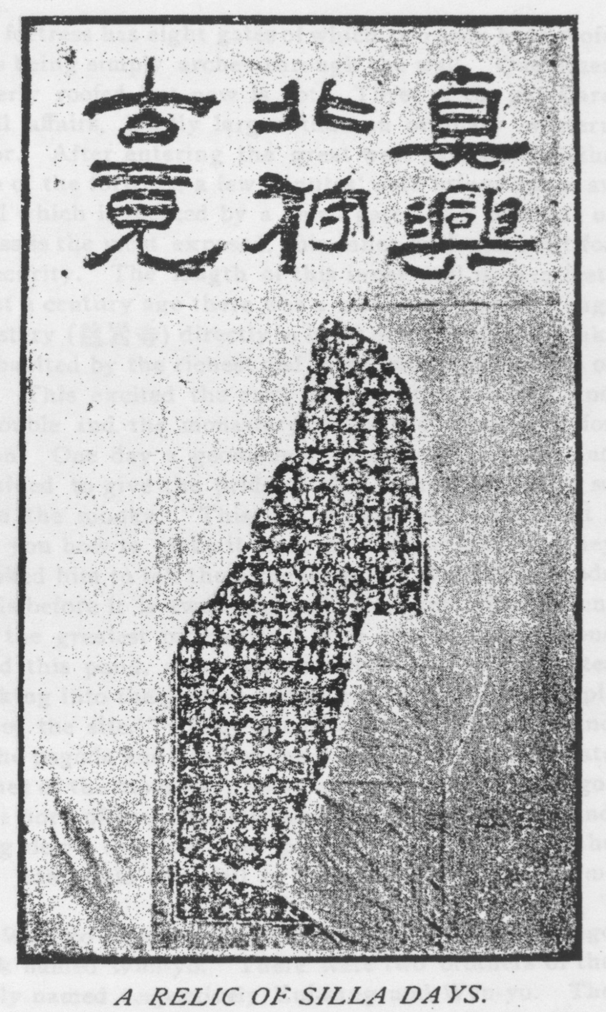

[page 449]

made the Japanese think someone must be washing a great deal of rice; so they entered the defile to find it. The concealed Koreans cut off their retreat and the invaders were destroyed.

This fortress has eight gates of which two only have roofs the others being simply arches through the wall. One other was formerly roofed but now is not. Three of the gates are very small affairs, hardly larger than an ordinary western house door. After entering the great west gate which is the main gate of the fortress, a few minutes’ walk brings one to an inner wall which is pierced by a small gate. As this side of the fortress is the most exposed, this inner wall was built for greater security. The length of this inner wall is 9417 feet.

About a century ago there was a monastery named Yong-am Monastery (龍岩告} directly in front of the Yong-am Peak. It was inhabited by the richest and most influential monks of Puk-han. This excited the envy of the other monks and caused trouble and the monastery got a bad reputation for this reason. One day a geomancer happened to pass by and he determinded to give the pride of this monastery a fall; so he said to the monks, “This is a wealthy monastery but I could tell you how to make it more prosperous stil.” They eagerly asked him to tell them the secret. “Well, this pagoda that stands before it is too high and interferes with the entrance of the greatest prosperity. You should lower it one story; and this pond, also, you should fill up, as the water keeps soaking into the ground and detracting from the propitionsness of the site.” They immediately went to work and lowered the pagoda and drained the pond; but from that date the fortunes of the monastery declined; for, in truth, the pagoda was the horn of the mountain and the pond was its eye and by cutting down the nose and putting out the eye of the mountain how could they fail to bring disaster upon themselves.

The Wun-yo Monastery was built about 250 years ago by a monk named Wun-yo. There were two brothers of the Yun family named respectively Eui-sang and Wun-yo. The former was a diligent student of Confucianism while the latter turned his attention to Buddhism. They both came to these mountains to study and took their places on two mountain [page 450] spurs on either side of the valley leading up into the present fortress. The legend goes on to say that when the mist was thick they would mount the clouds and ride from one peak to the other and visit with each other. So the two spurs are known today as the Eui-sang and Wun-yo peaks respectively. A flat stone is pointed out on the former as being the place where Eui-sang sat and studied.

There are in Puk-han what are called the “Eight sights of the Fortress. “

(1)The No-jak Nak-ha (露積落露) “The cloud Cataract of No-juk Mountain.” This mountain has a round head and smooth rocky sides that are nearly perpendicular. When the clouds are rolling about the head of this peak and tumbling over each other it is said to resemble a cloud cataract.

(2)The Pong-sung Mun-jong (奉聖閱鍾) “The sound of bells at Pong-sung Monastery.” Not the bells of this monastery, but the sound of the bells floating up in the evening air from the Chung-heung Monastery below. The sound is said to be very affecting.

(3)The Tong-jong Wul-sak (東亭月色) “The Moon-light from the East Pavilion.” This is the little pavilion perched high on the ridge on the eastern edge of the fortress. It is a maginficent place from which to view the moon rise.

(4)The Na-han Kwi-un (羅漢歸雲) “The Cloud-encircled Na-han.” The Na-han refers to the 500 Buddhas seated together. The peak called Na-ban-pong is so called because its top is split into many small points and the Korean imagination sees in them the likeness of many men seated together. The clouds circle about the peak but the “men” are above the clouds and seem to be riding upon them.

(5) The Sang-un P’o-p’o “The Waterfall of Sang-un Monastery.” Behind this monastery is a beautiful waterfall whose waters look, as the Koreans say, “like a curtain of hanging prisms,” referring to the rainbow colors which are seen whenever the sun shines. [page 451]

(6) Wun-yo Nak-cho (元繥落烏) “The sunset at Wun-yo Monastery.” It is literally the “Fall of the Bird” but this means sunset because the Koreans say the sun is a crow and the moon is a rabbit.

(7)The Ch’ung-ha Kwi-seung (淸露歸僧) “The Monk going around Ch’ung-ha Hill.” Just above the little pavilion beside which there are so many memorial tablets, there is a high point the rock on the top of which is said to resemble a monk beating his wooden gong and asking for alms. When the clouds roll down and envelop the hill the rock stands out above them and the monk seems to be seated on the cloud and bowing toward Pu-whang Monastery.

(8)The San-yung Kan-su (山映看水) “The Water at the San-yung Pavilion.” This is the pavilion near which are the memorial stones and when the stream is full it roars down its rocky bed in a manner that is well worth seeing.

In addition to these there is the celebrated tan-p’ung or “Maple leaves.” There is a kind of maple in Puk-han which in Autumn turns a brilliant red. There is a common saying among the Koreans Nam wha-ryn, Puk tan-p’ung or “south flower picnic and north maple leaves” by which they mean that there are two beautiful sights near Seoul, one the flowers at Nam-han in the Spring and the other the brilliant foliage of the maples of Puk-han in the Autumn.

O. SEUNG-GEUN.

Odds and Ends.

The Secret Armor**.**

King Hyo-jong, who reigned 1649-1659 A.D., was the son of the king who was forced to bow to the Manchu yoke. He never got over the disgrace which had come upon Korea during his father’s reign and it was his most cherished scheme to attack China and redeem the honor of Korea. Of course it was a mere chimera, but he adhered to it until the last. Once [page 452] at dead of night he sent in haste to Yi Wan his great general, and summoned him to the palace. The general made ready to go but as a precaution he put on a suit of armor under his outer garments. When he came into the presence of the King, who was in the prime of his strength and vigor, the latter asked him why he was so slow with the preparations for invading China. Yi Wan answered that Korea could not attack China. And why not, the king demanded. The general tried to put him off with the excuse that the preparations were not complete. The king had heard this excuse once too often and his anger boiled over. He raised his sword and struck Yi Wan a mighty blow on the breast. The general rolled over as if he had received his quietus but a moment later the king repeated of his hasty action. He called for his attendants but before they arrived Yi Wan rose from the floor and assumed the same attitude as before. The king in surprise asked him how he had survived such a blow and he answered that before he left home he had taken the precaution to don a suit of mail beneath his outer robe, as the king’s summons had been very sudden and at night. The king was glad no harm had been done but a moment later he frowned and said, “How is it you were so quick to arm youself when danger came and yet are so slow to prepare for the invasion that I have determined on?” Yi Wan had to think of some excuse on the instant or else he might get into deeper trouble. He was equal to the emergency. He smiled faintly and said, ‘‘I never would have been able to think of the armor myself but when I sprang up to obey your summons ray wife brought the armor and insisted upon my putting it on.” Whether this was true or whether it was only an excuse, it saved Yi Wan’s life.

Presence of Mind

In the spring, when the ice was rotten, people were still crossing the river on it. Suddenly the ice gave way and a boy with a broad brimmed straw hat fell through into the water, but the hat caught in the broken ice and prevented his sinking, for of course it was tied under his chin. People were running about screaming and some were trying to reach the hat to pull the boy out, when a man shouted, “If anyone touches that hat I will kill him!” He brandished a sharp knife and the crowd naturally fell back aghast. He then crept to the edge [page 453] of the broken ice, deftly cut off the crown of the hat, seized the boy by the top-knot and drew him out safe and sound. When questioned why he had threatened to kill anyone who touched the hat he replied that if anyone had seized the hat the hat-band would have broken and the boy would have sunk but as it was he was saved.

Editorial Comment.

As quoted by the Kobe Chronicle, Dr. Morrison, the brilliant correspondent of the London Times, says that in any case the continuance of Korea’s autonomy is out of the question. With all due regard to the keenness of his observation and the astuteness of his mind we beg to be allowed to hold our judgment in abeyance for a time. We were told in 1894 Korean autonomy was practically at an end, but today, nine years later, we find her exercising complete autonomy. This may not be because of intrinsic strength; but, whatever the reason, it is a fact. Some things are held together by internal cohesion and others by pressure from without. Korea may be one of the latter, but it is a prophetic eye indeed that can see signs of an immediate loss of that autonomy. The Far East has not reached that delicate adjustment which makes the “balance of power’’ such a fetich as it is in Europe but nevertheless the dismemberment of a people, even Orientals, that numbers once and a half as many souls as the kingdom of Spain will not, be accomplished without strenuous exertion. For the last thirty odd years Japan has declared herself the champion of Korean autonomy and she showed the honesty of that declaration when in 1894 she forebore to take advantage of her position and absorb the peninsula. No thoughtful person can believe that Japan would wish to tamper with the autonomy of Korea so long as her legitimate interests here are respected. Nor is this last clause a loop-hole of escape from the main proposition. Her interests are those of commerce and they are legitimized by the fact that they are as beneficial to Korea as to Japan. Except it be in order to safeguard these interests we do not believe Japan would be [page 454] any more ready to assume the administration of civil government in the peninsula that the United States would be. It would be a difficult, an almost hopeless task. Even a continuance of the present attitude of thinly veiled antagonism on the part of the government would be preferable, to Japan, to the necessity of grappling with the terrific problem of shouldering the administration of the government. It is logically absurd. Who then is to disturb the autonomy of Korea? There is only one other possibility, but if there is any one thing surer than another it is that Japan will not allow the autonomy of Korea to be tampered with. If it comes to war, war it will be. If Russia wins, the presentiment of Dr. Morrison may take on substance, but if Japan wins or if a compromise is effected the prime feature in it will be the continued autonomy of Korea, unless she herself should act in such a way as to make such autonomy impossible; and our past experience of Korea does not warrant the belief that she would be other than quiescent as she was after the Japan-China war, when she was wholly in the hands of Japan.

Nor must it be inferred that public sentiment is entirely against Japan here in Korea. Public expression of sentiment always follows the will of the party in power in such a country as this, but it would be a mistake to think that Korea has witnessed the rise of Japan in vain and that there are not multitudes who see in Japan’s achievements the promise of future progress for Korea.

Preponderance of influence does not necessarily impair sovereignty, and so long as Korea is in treaty relations with the rest of the world-powers and their representatives are accredited to her court so long shall we claim that Korea’s sovereignty is unimpaired and her autonomy complete.

And right here it is pertinent to say that we believe that the working out of Korea’s political, social and industrial salvation can be accomplished much better as well as much faster under a separate and autonomous government than under any protectorate that is at all likely to intervene. But she needs help to do it. Japan with all her vigor, engendered of feudalism, was not able to become what she is without enormous help from outside. How much less, then, can Korea do it without tutelage.

[page 455]

News Calendar.

We learn from Kunsan that on the 11th inst. a band of about forty robbers appeared at Sin-na-p’o opposite Kunsan after stealing some money then they crossed the river and pillaged Ham-yul magistracy, Na-p’o and Kon-ga and then encamped at Se-p’o. Some soldiers crossed the river and attacked them killing one and capturing one. The rest fled leaving many of their arms. They did their plundering in broad daylight. They levied on many of the towns and wealthy individuals. They are said to have taken a Japanese junk loaded with money. The soldiers recovered some of this.

Miss Corbett of Chefoo has been secured as teacher for the foreign children’s school in Seoul. This is a very happy solution of a very vexed question. We trust that Miss Corbett will learn to like Seoul.

Rev, J. S. Gale returned from Europe, via the Siberian Railway arriving in Seoul on the 19th inst.

We note that the enterprising Japanese newspaper in Seoul, the Han-sung Sin-bo has become a daily, since the beginning of October.

Mr. W. H. Emberley, at the time of the street railway disturbance last month, acted with great promptness and bravery, and single-handed drove back the crowd which was acting in a very threatening manner. For this service he was handsomely rewarded by the street railway authorities. - It is with deep regret that we have to record the death on the 9th inst of Pearl, the little daughter of Mr. and Mrs, Emberley. The funeral was held on the 10th inst. The parents have the deep sympathy of the whole foreign community and of very many Korean friends as well.

Near the Mo-gyo bridge there is a pawn-shop standing by itself and unconnected with any dwelling. A policeman’s box is right in front of it, so the owner does not watch the shop at night. A few nights ago along came a man with sacrificial cakes, wine and a boiled cow’s head. He said he was going to offer sacrifice to the house spirit of his pawnshop. The policeman supposed it was all right. The thief then opened the building, filled a big bag with the best he could find, and finally left after giving the policeman some of the cakes, meat and wine. The next, morning the owner came to open up and then it transpired that the policeman had been hoodwinked and that the place had been looted under his very nose.

The government is preparing to erect a large building in foreign style in the center of the city for use as the Central Bank of Korea. It will be a three story building and the stones for the foundations are already on the ground. It is intended to establish branches of this bank in all the thirteen provinces. It is not intended to put out a paper currency but it will facilitate the transfer of money to and from the provinces by a system of drafts. It will be a bad blow to the highwaymen [page 456] of the country. The benefit to be derived from the bank will he principally the saving in the transport of money which has always been a severe tax on the government. But besides this the bank will engage in general banking business.

During the illness of Yi To-ja, the Foreign Office is under the charge of Yi Ha-yung.

On the 26th ult., a market in the town of Chuk-san was raided by a band of about forty armed robbers. They looted the place and carried off all they could handle. Several men were killed. Ten muskets and ammunution were sent down to that place with orders to use them on the next gang that put in an appearance.

News has just arrived that during the rains of summer a flood occured in T’an-ch’un. Two hundred and sixty-one houses were swept away and fifty-two lives were lost. In the town of Yi-wun eight houses fell.

It is reported that Koreans on the Yalu are complaining that the Japanese lumber buyers are trying to force the sellers to part with their goods at merely nominal prices. It is quite possible that this statement is promulgated for a purpose and must be taken cum grano.

Yang Sung-whan has succeeded Yi Yu-in as Chief of Police in Seoul.

Ten thieves broke into a pawn-shop near Tuck Hing’s store and carried away several thousand dollars worth of goods. The heavy stock of this pawn-shop is a rather sad commentary on the times.

On the 27th ult. the Foreign Office sent a dispatch to the Russian Legation stating that the building of a lookout station on high ground at Tu-ryu harbor near Yong-am-p’o was not in accord with any agreement between Korea and Russia and demanding that orders he given for the pulling down of such structures.

In compensation for a foreign house situated behind the Mulberry Palace and taken over from a French subject by the Korean Government the Foreign Office has decided to give Yen 9,500.

Forest Superintendent Cho Song-hyup started for Young-am-p’o about the end of September to carry out the instructions of the Government relative to the retirement of the Russians settled there.

Certain representatives in Seoul are still pressing for the opening of Yong-am-p’o to foreign trade and seem determined to keep at it till this is accomplished.

The Korean theater reopened on the 28th ult. and is said to be reaping a harvest of nickels. From the program as reported it does not seem to be a very high class entertainment.

A great archery tournament was held about the beginning of October. Seventy-five men competed. There were five archery clubs engaged, each sending fifteen men, The club that won had nothing to pay for the feast which followed.

A sudden storm on the Nak-tong river last month capsized a boat containing forty people of whom only seven were rescued. This occurred near Mi-ryang.

[page 457] The rice given by the Emperor to famine sufferers in Ham-gyung Province last Spring amounted to 20,000 bags.

The contract of Mons. Clemencet, the efficient Inspector of the Postal Bureau, has been renewed for another term of years.

The Superintendent of Trade at Chemulpo requested the Japanese Consul at that port on the ninth inst. to see that the Japanese soldiers, landed at Chemulpo, should not cause excitement among the people by practice firing or by other means.

On the sixth inst. a fire started in a building in Chemulpo owned by a German subject. It spread rapidly and was not extinguished until seventeen houses were consumed.

On the sixth inst. fifty-three Koreans started from Chemulpo for the Hawaiian Islands.

About the 20th inst. a fire started in a lumber yard adjoining the premises occupied by the Italian Minister. It was so near that the windows of the latter building were broken and there seemed to be so much danger of the fire that preparations were made to move out, but fortunately the danger was averted.

Yi Heui-ik the prefect of Chang-heung, Chulla Province, gave $900 for famine relief in his district last spring and many of the people were saved from starvation. The native papers say that the people call him a “reincarnated Buddha.”

The prefect of Un-san informs the Government that at the American mines there are thirty-five Americans, seventeen Japanese and 133 Chinese.

On the fourteenth ult. a severe hail-storm struck Chin-ch’un in North Ch’ung-ch’ung Province, Some of the hail-stones were as large as a man’s fist, so the native papers say, and six houses were destroyed.

Chang Pyoung-suk, the Korean who acted as Russian agent in buying up houses at Yong-am-p’o has been condemned to the chain-gang for life. The Russian authorities have done nothing to help him, The land asked for by the Russians at the port, and marked out by thern, is 6,360 feet long and 4,260 feet wide.

Another pawn-shop was raided by robbers on the 13th inst. They were pursued by a policeman but turned on him and inflicted very serious wounds, and then made good their escape.

Whang U-yung the Superintendent of Trade at Kyong-heung on the Tuman River reported by telegram on the 15th inst, that a company of Russian soldiers crossed the Tuman into Korean territory and that a Japanese war-vessel had anchored in the harbor. This caused great excitement among the common people.

Im-ch’i the chief of the mounted Manchurian bandits who have lately been making trouble along the Yalu on the Korean side was caught by Chinese troops and sent to Chefoo where he was beheaded.

Thirty-five thousand bags of Annam rice arrived at Chemulpo on the 12th inst.

His Majesty has made Kwak Chong-suk a present of a fine house.

[page 458] Kil Yung-su has become Mayor of Seoul in place of Min Kyung-sik. Mr. Kil is a skilful geomancer and was the one selected to point out the site for the grave of Lady Om’s father.

Yi Keui-dong, the man who introduced some dynamite secretly into the palace last Spring, has been banished for life.

Five Japanese gendarmes who were sent to Eui-ju to protect Japanese subjects there, arrived at their destination on the 14th inst.

Ground has been selected near the Imperial Mint for the building of a gun factory. The machinery is being bought in Japan and will arrive shortly.

A Korean company has been formed with Min Yon-ch’ul at its head, to mine coal and oil in Ham-jong and Kang-dong.

The telegraph cable between Fusan and Tsushima has broken and it will take some time to repair. Meanwhile a Japanese torpedo-boat is taking the telegrams across the straits.

The Finance Department has ordered that no more revenue money be sent up to Seoul but to wait until the new Central Bank is done and then the money can he transmitted by draft. For this reason the treasury is empty and the Palace Finance Bureau has advanced money to pay salaries for the month.

Sim Sang-hun came to Seoul from Ch’ung-ju on the 20th inst. He is the new Minister of Finance.

The local Japanese paper states that the Russians have laid a telegraph cable under the Yalu from Euiju to Andong on the Manchuria side.

We are pleased to announce the arrival in Seoul of Mr. N. D. Chew who is to assist Mr. Beck in the Methodist Publishing House.

Another recent and welcome arrival is that of Mr. Holdcroft who has come to act as private secretary to Dr. Underwood.

The Russian authorities have been trying to purchase lighters in Chemulpo but up to the present time without success.

The custom of building a fire on the side of Nam San in order to attract the attention of the authorities, bring one’s self into notice and get an opportunity to prefer a request, is to be stopped. Police have been stationed on the mountain with strict orders to prevent any such wild work.

A sorceress named Yu, who lately obtained access to the palace on professional business, has fallen ill. She says she could get well if she prayed for recovery but she will not do so as by her continued illness she will be able to ward off a great misfortune which is impending over the country this Autumn.

A great sacrifice was held on Oct. 10th, the anniversary of the funeral of the late Queen.

The cattle plague has been so severe that it is reported that in the country the fields are being plowed by hand, men dragging the plows.

A Bureau of Emigration to look after the interests of Koreans going abroad was established last winter but has now been discontinued as the Foreign Office has been attending to all such business.

[page 459] Yi Keun-ho the secretary of the Prime Minister has formulated a scheme for reforms and embodied them in thirteen propositions, a perusal of which casts some light on the needs of the time.

(1)The education of the princes should be sedulously cared for.

(2)Attention should be paid to religion.

(3)Official duties should be attended to.

(4)The laws of the country should be unambiguous.

(5)Every official should be at his office promptly.

(6)Everybody who has a good suggestion to make in regard to better government should have an opportunity to broach it.

(7)There should be complete freedom of speech.

(8)Petitions which have been pigeon-holed should be opened and acted upon.

(9)Care should be exercised in the selection of prefects.

(10)Special penalties should be attached to official extortion.

(11)The Central Bank should be firmly established.

(12)Treaties with foreign powers should be scrupulously observed.

(13)The theater should be closed.

Korean report state that at Yong-am-p’o the Russians have prepared places for three batteries of guns, and that there are seventy Russian soldiers stationed there.

As the eighth of October approached Koreans were on the qui vive to learn what was to be the outcome of the negotiations between Japan and Russia. There was a general anticipation that hostilities were imminent and opinions differed widely as to what attitude Korea ought to take in view of possible contingencies. Some said that the East is for Easterners and that Europeans should leave things alone in these parts for this reason they argued that Japan should be the one to act as Korea’s patron until such time as such tutelage was unnecessary. Others said that Korea ought to lean toward Russia and accept the advice given from that quarter. Others still said that in the event of war Korea should summon all her powers into action and stand prepared to defend herself the best she could, assuming an entirely neutral position as between the two contestants.

The feeling of the Japanese merchants in the Japanese settlement in Seoul is shown by the fact that mortgages on Korean real estate cannot be negotiated, and all money outstanding has been called in as far as possible.

The Tobacco Company has secured its franchise from the government, agreeing to pay an annual tax of one hundred dollars.

In Pyeng Yang the people have subscribed the necesssary funds to found a private English Language School. It is aheady in successful operation.

It is stated that arrangements have been completed far uniting the Seoul-Chemulpo Railway with the Seoul-Fusan Railway.

Sim Sang hun has succeeded Kim Sung-geun as Minister of Finance. Yi Yong”ik has added to his other onerous duties the leadership of the Seoul gendarmes.

[page 460] Yi Chong-geun has been appointed Governor of North Pyeng Yang Province.

The people of Seoul are rejoicing in the visit of Mr. Kwak Chong-suk to this city. He is one of those men who have attained special sanctity in the eyes of the Korean people because of his literary attainments and his contempt of mere wealth. They say that after reading a volume he can take up his pen and write it all by heart. His fame became national and many people went and studied under him in his little mountian village whither he retired a few years ago after giving away most of his property to the poor. After repeated offers of government office had been made and refused by him he has at last consented to do Seoul the honor of a visit. He had an audience with His Majesty on the 18th inst but refused to go in court dress. By special consent he went in ordinary citizen’s clothes, and His Majesty received him graciously and asked him several interesting questions. He has been given a special rank and it is expected that he will soon become Prime Minister. What his attitude toward foreigners will be and how he looks upon the opening of Korea to foreign intercourse have not transpired as yet.

A Japanese with 340 dollars in counterfeit nickels was apprehended by the Customs officials at Chemulpo on attempting to enter the country a few days ago.

A Korean company has applied for a charter to sell a new remedy for the pleuropneumonia which is killing so many Korean cattle.

The foreign community had occular and auricular evidence on Tuesday the twentieth inst. that progress is being made on the Seoul-Fusan Railway. By the kind invitation of Mr. Kusaki, the genial director of the road, the diplomatic corps and the foreign employes of the government with their families boarded a train at the West Gate Station of the Seoul-Chemulpo Railway, at half past nine in the morning. At the South Gate Station a few others put in their appearance. Arriving at Yong-tong-po they met the Chemulpo contingent of a dozen or more, one of whom had no kodak with him. This is a habit only one step removed from actual postage-stamp collecting, but on the whole it is an innocent form of amusement and is said to be an antidote in severe cases of bridge whist. They were welcomed, kodaks and all, and the train pulled out of Yong-tong-po on the new line. An hour’s run through a delightful harvest country along the base of the rocky Kwan-ak Mountain brought them to the vicinity of the walled town of Su-won. The station is to the west of the town about a mile distant and is near a reservoir made many years ago for storing water for irrigation purposes. On the bank of this artificial lake the host had prepared three or four pavilions, decorated with the Japanese and other national colors. The arrival was marked by the explosion of fire-crackers and a general Fourth of July enthusiasm. A walk of fifteen minutes along the pretty embankment of the lake brought the party to the dam which confines its waters. This was crossed dry shod and after a half hour’s kugyung, during which the whole party was photographed on the rocks at the dam, they [page 461] sat down to a collation to which each guest did ample justice. Then a large majority voted to invade the town of Su-won although it was a stiff two mile walk by the main road. They must have found it nearly deserted for apparently every denizen of the town was out on the hills to witness this great event. About four o’clock the enterprising pedestrians returned to the train with every film exhausted. Some came on foot and some on jigi. The train pulled into the Seoul station just in time for dinner, and everyone voted the day a grand success. The thanks of the community are due to Mr. Kasaki and his colleagues of the Seoul-Fusan Railway Company, and its hearty congratulations also. We understand that about November 1st regular traffic will be opened between Seoul and Su-won, and in fact to the next station beyond Su-won, We all await eagerly the completion of the road, which besides being of such great advantage to the Koreans will also put us nearly twenty-four hours nearer Japan than we are at present. It is intimated that the railway is intending to erect a hotel at the lake at Su-won where the overworked foreigners of Seoul and the Kodakophils of Chemulpo can go at the week-end and recuperate.

On the 28th inst at eight o’colck p. m. a public meeting of gentlemen of Seoul was held in the rooms of the Seoul Union for the purpose of organizing a Young Men’s Christian Association of Seoul, This is the outcome of long months of effort and preparation and the results so far obtained have fully justified the venture and met the expectation of those who hope by this means to reach a large number of young men who otherwise would be very difficult to influence. Something over a year ago the International Committee of the Y. M. C. A. in America, in response to representations made by Christian gentlemen in Seoul, sent Mr. Philip Gillett to this city to act as Secretary in this field. Last March a mass meeting was held in Seoul and the subject was discussed publicly. Financial support was secured by contributions from foreigners in Korea and from the International Committee in America. The sum guaranteed up to the present time amounts to nearly yen 50,000.

As it is deemed advisable to secure a site for a building it was necessary to organize the Association and appoint trustees who should be legally able to hold and disburse the funds of the Association. The Advisory Committee, which had been helping the Foreign. Secretary, Mr. Gillett, worked out a draft of a constitution and the public meeting convened as above stated on the evening of the 26th. After prayer and the reading of the Scriptures the Chairman of the Advisory Committee, by order of which the meeting had been called, made a brief statement of the object of the meeting. Mr. Hulbert was then elected Chairman and Mr. Gillett Secretary for the meeting. The first business before the meeting was to decide whether those present should organize themselves into the Young Men’s Christian Association of Seoul. Upon motion by Dr. O. R. Avison it was unanimously voted that the meeting did thereby form itself into such Association. It then became necessary to adopt laws for the regulation and administration of the Association. For this purpose Rev. J. S. Gale read the draft of a constitution prepared by [page 462] the Advisory Committee; which upon motion by Mr. Gordon was unanimously adopted as the law of the Association. The Chairman then declared a recess of ten minutes in order that the members might sign the constitution and thus become full members and acquire the right to vote as the constitution itself requires. When the names had been signed it was found that there were twenty-eight active members and nine associate members.

The next business of the meeting was to elect twelve members of a Board of Directors, who together with the Foreign Secretary should, according to the constitution, form the Board of Directors. The following list of names was put in nomination by Mr. Gordon: J. McLeavy Brown, LL.D., M. Takaki, Ph.D., Dr. O. R. Avison, Rev. A. B. Turner, Rev. H. G. Underwood, D.D., Alex. Kenmure, Esq., Rev. J. S. Gale, Rev C. G. Hounshell, Rev. R. A. Sharp, Mr. P. S. Kim, Mr. P. H. Yer and H. B. Hulbert, Esq. Mr. Gordon moved that the Secretary be instructed to cast the ballot for this list of nominees. Mr. Welbon seconded the motion and the motion was passed unanimously. This closed the actual business of the meeting bat the Chairman called for remarks from the members, and a very interesting symposium followed in the course of which many pertinent and valuable points were brought up. By motion of Dr. Takaki the Secretary was ordered to send a cablegram to the International Committee in America announcing the fact of the organization of the Y. M. C. A. in Korea. Remarks were made by Messrs, Gillett, Turner, Avison, Gordon, Takaki, Woo, Welbon, Gale, Ken mure, Yer and Hulbert.

It was the unanimous sentiment of the meeting that the organization had been effected in a most encouraging manner and at a most auspicious time. The members present included Americans, Englishmen, Japanese, Chinese and Koreans.

It is with great pleasure that we announce the wedding, on the 19th inst. at the Church of the Advent in Seoul, of Mr. J. W. Hodge and Miss Laura Mills. The ceremony was performed by Rev. A. B. Turner and the sermon was delivered by Father Drake. The church was tastefully decorated with palms and flowers. The auditorium, which has lately been enlarged, was filled with the friends of the bride and groom. Mr. G. R. Frampton was best man and Miss Beckley was bridesmaid. The bride was given away by Dr. E H. Baldock. The ceremony was followed by a wedding breakfast at the home of Dr. and Mrs. Baldock, after which the happy couple departed for Ma-p’o, where Dr. J. McLeavy Brown had kindly put at their disposal his summer villa. They were followed by the congratulations and good wishes of a large number of friends.

Particulars of the crossing of the Tuman River have been received by the authorities in Seoul from the Superintendent of Trade at Kyong-heung who says that on the 23rd at night two Russian captains crossed the river in civilian clothes and soon after at another point 200 Russian soldiers crossed and joined them. In the course of the tactics which they went through the Koreans were greatly disturbed. [page 463]

The Japanese authorities have demanded the very modest sum of Yen 60 to cover doctors’ bills and other damages resulting from the attack on the Japanese mail carrier who was attacked by a mob, the day the accident occurred on the electric tramway.

Several children have been killed in the vicinity of Seoul by a species of animal called a neuk-ta by the Koreans, It resembles a wolf but is more dangerous. The War Department has offered a bounty of fifty dollars for each animal killed.

Yi Yong-ik has given orders that the next ginseng crop amount to 30,000 pounds.

One hundred muskets and 10,000 rounds of ammunition have been sent by the War Department to the border guard at Kapsan.

Exchange has dropped to 120 per cent discount on the Korean dollar In other words one yen will bring two dollars and twenty cents of Korean money. The Korean copper coins sustain a better ratio to the yen than this, and so there are exchange quotations between the two kinds of Korean money. On the 28th the nickels were at twelve per cent discount as compared with the copper cents. It is a very pretty muddle altogether.

A Japanese company is putting out a daily news bulletin in Seoul which circulates very widely at three yen a month. It has been decided to put this into English and print on a mimeograph for circulation among foreigners: It will be an interesting venture and will be of value to the foreign community, which has long needed such a news bulletin.

[page 464]

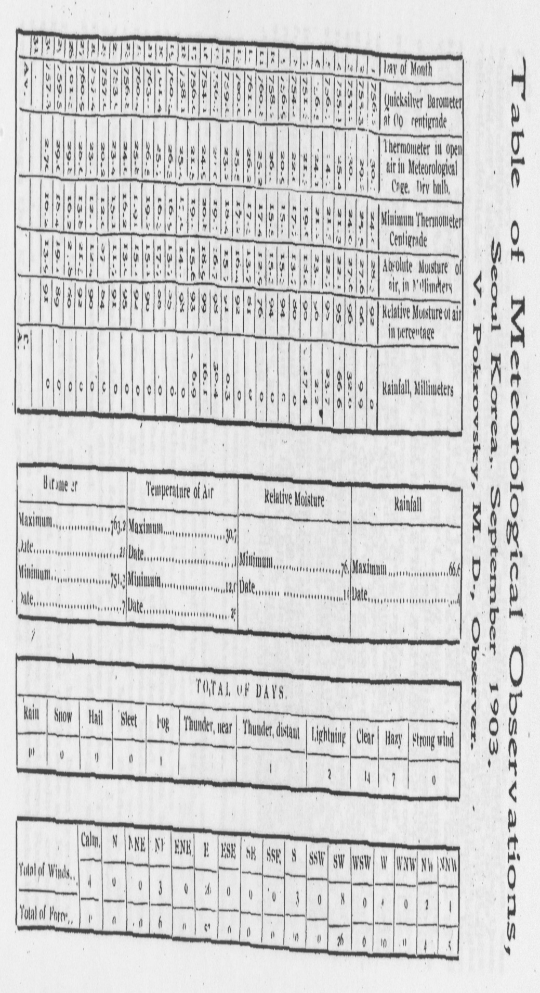

[page 465]

Korean History.

to intedict its use. It is needless to say that he failed. When first introduced, it cost ten thousand cash for half a pound but merchants obtained seed and it soon became common.

In accordance with the demands of the Manchus, the king sent 5,000 troops to accompany them in their invasion of China, but as they arrived a month later than the set time they were sent back home by the angry Manchus. Early in the following year, however, Generals Yi Wan and Im Kyong-up started with 5,000 troops and joined the Manchu army. The plan was to attack Teung-na on the Shantung promontory; whether by land or sea is not clear, but probably by land. This being known to the Koreans, three boats were secretly despatched to the threatened place, giving warning of the attack, and stating that the Koreans joined in the attack with the Manchus because forced to do so. It was suggested that whenever feasibly the Chinese and Korean forces should use only blank charges against each other. This was gladly agreed to and in a battle at Puk-sin-gu, which followed, not one man was killed among the Chinese forces that were brought in contact with the Korean contingent, and the latter suffered as little. The Chinese general managed to get a letter to the Koreans saying “The emperor reminds you of the vital aid he gave Korea at the time of the Japanese invasion and he now offers the half of his kingdom to anyone who will seize and deliver to him the Manchu general in command.” This reveals in a striking manner the desperate straits to which the Chinese had been brought by the Manchus. The Korean generals did not see their way to accede to this but they kept the Chinese informed of every movement of the Manchus; where they were weak and where they were strong, where they were likely to attack and where they might be successfully attacked. In this way the Manchus were continually thwarted and the Chinese encouraged.

It was proposed that there be a combined Manchu and [page 466] Korean attack upon Kon-ju-wi near the point of the Shantung promontory, the Manchus to attack by land and the Koreans by sea; but the latter said they had no provisions and their boats were in very bad order. The Manchus replied “Then you had better go home,” an injunction that they were by no means loath to obey.

Meanwhile the king had been doing what he could to mitigate the sufferings consequent upon the invasion. He ordered all the eight provinces to give rice to help the poor, the widows and the orphans, and to provide proper burial for those who had no near relatives who could afford the expense. He likewise gave strong encouragement to the Confucian School in the capital. He sent spies throughout the land to discover whether the prefects were attending to their duties well. Fearing that the guard along the Tuman River might be suffering, he made them a grant of 4,000 pieces of cotton. He likewise gave money to repair the ancient altar on the top of Ma-ri-san (Mountain) on the island of Kang-wha. This altar is said to have been used by the Tan-gun two thousand years before Christ, and may well be believed it to be the oldest monument in Korea.

This period of rest and recuperation was broken in upon by the appearance, on the northern border, of Manchu troops under Yonggolda and Omokdo. Rumors had again reached Manchuria that certain Korean officials had been advising against the Manchu povver. As a result of this, four prominent officials were sent captive to the north. Early the following year King Chilga, the emperor’s brother; came to try these man, and held a proper court at which the Korean Crown Prince was present. Each of the accused men was brought in turn and questioned and each had some plausible excuse to give. The result was sure from the beginning. They were all condemned and were thrown into a dungeou with a door in the top, a sort of Black Hole of Calcutta, where they all languished with cold, hunger and disease. They even excited the pity of their jailors, and when the Crown Prince plead for them before the emperor, they were ordered sent to Eui-ju, but heavily guarded.

In 1640 the Japanese who had settled at Fusan complained that the harbor was too small, for it did not include the [page 467] whole bay, but only that part directly in front of the settlement, which was about half way between the present Japanese town and the Korean town of Pu-san. The harbor was called Tu-mo Harbor. Consent to the enlargement of the harbor was refused.

In 1641 Prince Kwang-ha, the deposed and banished wretch, died on the island of Quelpart. So great is the respect for royalty in the abstract, in Korea, that the king fasted four days, had the body brought up to Yang-ju and buried it with royal honors. To the one surviving daughter the king gave a comfortable house and an annuity.

The next year a seditious movement was made by C’hoe Hyo-il of P’yung-an Province, and two accomplices. They took boat for China, being provided with funds by the prefect of Eui-ju. Arriving at Teung-na they joined the Chinese forces, received commissions in the Chinese army and despatched a letter to the prefect of Eui-ju asking him to gather a force and with them make a combined attack upon the Man-chus. As fate would have it the Manchu Yonggolda was at Eui-ju when this letter arrived, and it fell into his hands. He immediately sent to the king demanding the seizure and execution of all the men implicated in the plot. In spite of the expostulations of the Prime Minister, who wished to see only the prime movers punished, eleven men in Eui-ju and else-were were seized and met their fate before the palace gate in Seoul.

One more sacrifice was necessary before the last remnant of opposition to the Manchus should be extinguished. It was now six years since the surrender. Soon after that surrender the king had sent to China explaining that it was a hard fate and not his own inclination which had forced the surrender from him. Not knowing whether the letter had ever reached the Chinese capital he sent another letter two years later by a monk, Tok-po, who had come from China to ascertain whether Korea had really surrendered or not. Arriving at P’yung-yang he had been received by Gen. Im Kyung-up who sent him on to Choe Myung-gil the Prime Minister. He was handsomely treated and was provided with a new vessel and a complete outfit of clothes and provisions for the return journey. He carried a letter from the king stating his ex- [page 468] cuses as above narrated. Four years passed and at last in the year under review the emperor’s answer was forwarded by way of Chefoo. In it he exonerates Korea from all blame and mourns the fact that he cannot come to her aid as when the Japanese invaded the peninsula. The bearer of this missive was feasted and treated with the most flattering attentions by the governor of P’yung-an. This would have amounted to nothing had it not been known to Yi Kyn the prefect of Sao-ch’un who was carrying on trade with China by junk across the Yellow Sea. He was seized by the Manchus and carried north. Fearing the worst, he offered to tell his captors an important secret as the price of his life. He thereupon unfolded the whole transaction between Seoul and Nan-king. The Manchus were furious and sent a demand to the king for the persons of Choe Myung-gil, Im Kyong-up, Yi Kyong-yo and Yi Myung-han, all leading men. There was nothing to do but comply, and as these men went the king wept and gave Ch’oe Myung-gil 500 ounces of silver for traveling expenses. Arriving at Pong-whang Fortress beyond the Yalu they were taken in hand by Generals Yonggolda and Mabuda. Ch’oe asserted strongly that he alone was to blame for the whole transaction. When the emperor had looked over the evidence he sent word that fines should be accepted from the others, but that Ch’oe be sent in a cangue and handcuffs to Pok-kwan goal. And there be leaves the stage of history, on which he had played no mean part. The traitor Yi Kyn plumed himself on his newly acquired Manchu citizenship and presumed on his services to write the emperor a memorial under twelve heads; but the emperor in fine contempt exclaimed that a man who was not true to his own king must be a rascal at heart and ordered him bound and sent back to Korea where we may well believe the axe did its work without delay.

The next few years of the reign witnessed the return of many captives taken by the Japanese during the years of the invasion; they beheld the promulgation of the law that no one could marry during the three years of mourning for a parent; also a scourge of cholera so terrible as to cause the king to send and sacrifice upon the eight high mountains of Korea. A powerful conspiracy, led by the prime minister, Sim Keui- [page 469] wun, came near overthrowing the dynasty but the alarm was given in the very nick of time and he and his fellow conspirators were seized and executed.

The twenty-first year of the reign, 1643, beheld the fall of the Ming dynasty in China. The pretext given by the Manchus for marching on Nanking was the revolt of Yi Cha-sung who burned Nanking and drove the emperor to suicide. Then, terrified at his own deed, he fled and the Manchus stepped in. When Nanking fell, a letter was despatched to Korea saying “I am the greatest of rulers. You have long been my vassal and I will now show you a favor by returning your hostage, the Crown Prince.”

A word is necessary as to the fate of Im Kyong-up, one of the men who had been sent to Manchuria with Ch’oe Myung-gil. He succeeded in making his escape before the party reached the Yalu and in the disguise of a monk made his way in a merchant boat to Teung-na where he attached himself to Gen. Whang Chong-ye and made himself very useful. It is said that he made himself famous by capturing a notorious pirate. He sailed straight for the island on which the pirate had his headquarters and having gotten the pirate and his crew drunk with wine he bound and brought them safely to the Chinese camp. Later he fell into the hands of the Manchus through treachery but was so steadfast in his refusal to do obeisance to them that he excited their unbounded admiration, and they let him go back to Korea. This was an unfortunate move for him, for in the meantime Kim Cha-jum had been recalled from banishment and had become court favorite. As these men were deadly enemies the returning general was immediately seized and put to death. This same year saw the publication of the historical work named the Tong-sa Po-byun.

In the following year the Crown Prince and his brother returned from China but the Crown Prince soon after sickened and died. It had been customary heretofore for the king and queen to assume mourning for three years for a Crown Prince but now an innovation was made and thirteen months was the limit set. Of course the succession fell to the infant son of the dead prince, but the wife of prince Poug-im, the second sou of the king was [page 470] extremely ambitious to become queen, and so she went about to gain the desired end. By every means in her power she brought pressure to bear upon the king to induce him to set aside the infant prince and nominate her husband as heir to the throne. She was partially successful and the following year the king called his courtiers together and consulted as to the advisability of the plan. He urged that the real heir was but a babe in arms and that he himself was old and about to go the way of all the earth. It was evident that he desired to put Prince Pong-im on the throne, and a very animated discussion followed. Most of the leading ministers and officials argued against the plan saying that it was contrary to the best traditions of the land and that the people all looked to the young prince as their future ruler. To all these arguments the king opposed counter arguments which revealed plainly that he had already made up his mind as to his course, and that he was merely seeking for confirmation of his views. Kim Nyu then said, “If the king has already made up his mind let him speak out and put an end to this useless discussion,” The king then announced that Prince Pong-im was to be his successor.

About this time a dangerous rebellion broke out in Kong-ju the capital of Ch’ung-ch’ung Province, but by the prompt action of the troops from the South it was put down. This is worthy of mention only as it illustrates a curious custom in Korea. On account of this rebellion the name of Kong-ju was for many years changed to Kong-san and the province of Ch’ung-ch’ung to that of Hong-ch’ung.

The Prince Pong-im, though now by royal edict in full view of the throne, feared that by some turn of fortune’s wheel he might fall short of that goal and so he much desired to have the infant prince and his mother taken from his path. The aged king had entered upon a period of mental semi-decrepitude and was easily managed by the wife of Prince Pong-im. Six palace women were accused of poisoning the king’s food and were summarily put to death. The king then summoned the courtiers and accused the wife of the deceased Crown Prince of having assumed the garments of royalty while in Mauchuria, of having used disrespectful language to him on her return and of having instigated the [page 471] palace women to poison him. He said she must be killed. All agreed that some positive proof of guilt must be produced but the king insisted upon her immediate execution which was accomplished by the use of poison. Her two brothers were likewise beaten to death. Three of the leading men who had advised against the nomination of Prince Pong-im were also banished.

The next year passed quietly, but the official corruption had become so prevalent and the people were ground down by the prefects to such an extent that the king made the law that each prefect must have three bondsmen who would be liable to punishment in case of his malfeasance.

The next year saw the introduction on the field of politics of a noted man, Song Si-ryul, who was destined to be a leading spirit for many a year. He was a celebrated scholar and the king induced him to come to Seoul only after repeated invitation.

The very last year of his life this king cherished a bitter enmity toward the Manchu power and in the twenty-seventh year of his reign, selecting generals and planning to equip an army, he hoped to throw off the hated yoke; but it was not to be, for in the early summer of 1649 the aged monarch breathed his last and the heir assumed the reins of power. He is known in history as Hyo-jung Ta-wang.

The accession of a new king was the signal for the combined attack of all the officials upon Kim Cha-jum who had been so long the practical autocrat. He was deposed, but the king would not have him executed, because of his former services. Song Si-ryul also took offense at the king because of a supposed slight and departed to the country in anger, after publishing three accusations against him.

The reign began with a storm. Kim Cha-jum who had retired to the country in disgrace, took advantage of the fact that the Japanese had made a proposition to the prefect of Tong-na to come over and join the Koreans in an invasion of China, and sent a detailed account of it to China adding that the Korean government was preparing for war and had discarded the Manchu calendar. This news caused tremendous excitement in China and the veteran generals Yonggolda and Mabuda were sent forward to the Yalu with a powerful force. [page 472] Six envoys were sent to Seoul one following the other at intervals of only two days. These six arrived at Eui-ju, stopped there and sent forward letters demanding what it all meant. Of course this was like thunder from a clear sky to the court at Seoul, and Minister Yi Kyoug-suk rode in person to Eui-ju and met the envoys. He invited them to Seoul and after a long discussion and a present of a thousand ounces of silver and the promise of a princess to go to China to wed one of the Manchu princes and the banishment of a few of the officials, it was found that no blame was attached to the king. Thus began an eventful reign of ten years. The first years were signalized by severe famines in the north and the government had to bring large quantities of grain from the south to relieve the sufferings Corruption had crept even into the system of examinations and it was found necessary to preserve the incognito of the candidates by having each one write his name on the margin of his examination paper and than have this portion of the paper cut off through the middle of a stamp so that at last when the papers were examined and the successful ones selected, the writers’ names could not be known until they had been matched on, and found to fit.

An unsuccessful attempt at rebellion was made by the notorious Kim Cha-jum and Kim Sik, son-in-law to the late king. They persuaded the latter’s wife to place a fetich under the floor of the king’s sleeping apartment. This is supposed to bring about the speedy death of the person so cursed, but someone found it out and divulged the plan. The three leaders were beheaded, the woman poisoned and her brothers banished. Some wanted the king to move because the palace had been defiled by the fetich, which consisted of a dead rat with the king’s name written on its belly, but it was voted down because it would tend to confirm the people in their belief in this foolish superstition.

This king inherited much of his father’s hatred of the Manchu power and we find him building a palace at Kang-wha and storing provisions there in case of a break in the peaceful relations then existing. He instituted some useful reforms also, forbidding the cruel practice of beating criminals to death. He likewise legislated in the interests of the people [page 473] when he forbade the exacting of rent for water drawn from the government reservoirs for their rice fields.

Twenty-two years before this, Kim Hyuk, one of the envoys to China, had there met a Westerner who is known in Korean history as Tang-yak-mang. This was one of the Jesuit priests. He came first to Canton as a missionary but his great talents were recognized in Nanking and the emperor called him to the capital and questioned him about his religion, and employed him as court astronomer. There the Koreans saw the calendar called Si-hon-yuk. When the Ming dynasty fell the Manchus urged the Westerner to remain and they allowed him a regular salary. Kim Hyuk brought back a book from Peking which is probably a copy or abstract of the celebrated book above mentioned. For these twenty-two years a scholar, Kim Sang-bum, had been studying this book, and at last having mastered its secrets, he came out with a calendar of his own. It is stated that the Westerners Yi Ma-du and Sa Su-sin had already been many years in China when Kim Hyuk visited Nanking. (These are Ricci and Schaal).

It was discovered that the country people were evading the revenue laws by cultivating the hill sides above the margin of cultivation set by law. Commissioners were sent out to remeasure the taxable land and to set limits to hillside cultivation, for it was feared that the cultivation of the hillsides would diminish the fuel supply too much. It was in this same year that the ill-fated sailing vessel Sparwehr sailed from Holland with Hendrik Hamel as super-cargo. There seem to have been sixty-four men on board, and when she went to pieces on the island of Quelpart only thirty-six of them reached shore in safety. They were taken to Seoul by the authorities and for fourteen years lived, now on the royal bounty, now by the work of their own hands, and at times they were even compelled to beg for food. At last however the remnant of them made good their escape by night and finally reached Nagasaki. Hamel afterwards wrote an account of his capitvity in Korea.

In the year 1654 the hostility of the king toward his suzerain took more definite shape. He appointed Yi Wan, a brilliant young general, to have charge of all military matters, and lie sent military instructors all through the south where [page 474] the great mass of the population lived, to drill the people in the science of war. He likewise built fortresses at Sung-jin in Ham-gyong Province and at Yi-bam-keum-sung and at Kyuk-p’o in the south. He appointed four generals to be stationed about Seoul to guard its approaches, and he collected great quantities of grain, much of which he massed at Wha-ryang near Chemulpo to be in readiness to ship to Tientsin when he should invade China. He provisioned Kang-wha thoroughly and built a monster store-house at Chang-san in Whang-ha Province, because of the difficulty experienced by the boats in rounding the exposed point of that province; he founded a school for the training of military officers and twenty of the best men were detailed for study there. Any sign of indolence insured a prompt dismissal.

This sovereign was an ardent advocate of dress reform. At first he made the soldiers wear shorter sleeves and skirts and for the sake of lightness they were often made of silk. From that he made a more general application of his ideas. He found the hats too broad of brim and the flowing sleeves very inconvenient in the breeze. These points were ordered to be changed and the palace hat as seen today was introduced. It was first invented by the celebrated Chong Mong-ju whose blood still marks the stone bridge at Song-do. It was he too that introduced the hyung-p’a or embroidered storks to be worn on the breasts of civil officers, and the tigers to be worn by military officers.

Chapter XX.

The king dies . . . . seeds of discord sown . . . . the new king . . . . extensive reforms . . . . party changes . . . . strife . . . . a great reformer . . . . the ajuns checked . . . . abuses remedied . . . . a convent broken up . . . . various reforms . . . . revenue . . . . forestry . . . . memorialists rebuked . . . . honest examinations . . . . the people cared for . . . . the census . . . . numerous reforms . . . . qualities of a good prefect . . . . the king dies . . . . a noble record . . . . the new king . . . . bad outlook . . . . party strife . . . . census . . . . Japanese settlement at Fusan . . . . ceaseless quarrels . . . . a minister falls . . . . wholesale execution . . . . plot and counter-plot . . . . reforms in the navy . . . . calamities . . . . reign of terror . . . . Roman Catholics . . . . [page 475] trouble brewing . . . . change of party . . . . unutterable cruelty . . . . the queen deposed . . . . concubine made queen . . . . a great statesman dies of poison.

In the tenth year of his reign, 1559, having exposed himself to the sun and rain while sacrificing to heaven to secure the cessation of a great famine that was on the land, the king was taken ill, an abcess broke out on his temple and after a short illness he expired. In connection with his death arose a contention that was destined to cause the death of many men. The mother of the dead king was still living. She had worn mourning for three years after the death of her elder son, and now the question was whether she should assume it for an equal length of time for this her second son. Song Si-ryul and Song Chun-gil argued that one year only was sufficient. The other side was taken by Yun Hyu and the debate was fierce and long. The classics were ransacked for proof texts in support of either contention. The Prime Minister decided in favor of the shorter term and the Queen Mother wore mourning for but a year. Song Si-ryul also laid up wrath against himself by neglecting to have the king’s body wrapped tightly in bandages, until it had swollen so that it required two planks joined together to form the bottom of his coffin. This was considered a great misfortune ana ere a year had passed Song was obliged to retire precipitately to the country to avoid beiog mobbed for the offense.

The new king entered upon the duties of his exalted position as a mere lad, in 1660. His posthumous title is Hyon-jong Ta-wang. His first duty was to give his father burial. The geomancers said he ought to be buried on a site near the town of Su-wun, but the courtiers thought that was too near the main road, so a place was selected outside the East Gate. This first year was one of reform. The penalties for murder were too small. If a high class man committed murder he could get off with a hundred blows and ineligibility for office for a short time, but now the king, with the advice of the court, made all high class murderers permanently ineligible for office. It must be borne in mind that the demarcation between the upper and lower classes was much more distinct in those days than it is at present.

Looking carefully into the condition of things, the king [page 476] found many abuses that required correction. He ordered that the army be better clothed; he examined into the cases of many of the prisoners of state and liberated not a few; he remitted the tax on hemp and ginseng in Ham-gyung Province; he remitted the tax on the gold mines at Tan-ch’un which had amounted to a thousand ounces a year; he lowered the land tax in Ch’ung-ch’ung Province, These voluntary retrenchments called for economy at the capital and the king discontinued the royal stables, to meet the falling off in revenue. A word is necessary here as to the complexion of the political parties. The old Tong-in had gone to pieces and in its place we find the Nam-in, the So-ron and the Su-buk parties. We have in all then the

Nam-in with Hu Mok as leader

So-ron ‘‘ Yun Cheung ‘‘ ‘‘

No-ron ‘‘ Song Si-ryul ‘‘ ‘‘

Su-buk ‘‘ Yu Yong-gyung ‘‘ ‘‘

Among these the names of the Nam-in and No-ron were the most prominent and their leaders, Hu Mok and Song Si-ryul were deadly enemies of each other. There was no intermarriage between these different parties. Each had its separate color: The Nam-in was red, the So-ron blue, the No-ron white and the Su-buk black. It was not the men but the women who wore these distinctive colors and even to this day it is common to see tbe party colors in the collars of women’s coats. The men were distinguished by the shape of the coat collar. The No-rons and Narm-ins had a collar cut square at the bottom; the So-rons had a bulging curve at the bottom and the Su-buk had a plain curve. These things sound childish but in those days they meant life and death. The number of men who have been sacrificed upon the altar of party strife mounts up into the hundreds of thousands. The violent and unreasonable strife between them prevented anything like concerted action when the country was threatened from without. They made it impossible for any man to be judged according to his true merits. They effectually blocked the efforts put forth by honest men to secure a clean and honest government. There is nothing more despicable in political life than the continued excitement of fierce passions when there is no principle at stake and when personal aggrandisement is the only goal. [page 477]

But at the time of which we write the No-ron party, with Song Si-ryul at its head, was so overwhelmingly predominant that party strife was for a time almost held in abeyance. The remarkable character of this reign is largely due to his efforts. The reign from beginning to end was one grand march of progress, reform following reform with such rapidity that the reign fairly scintillates with them. To realise how great a part Song Si-ryul played in these movements it is necessary to know the enormous power wielded by a Prime Minister in Korea, especially when he enjoys the entire confidence of the king. His power to keep the king informed or misinformed makes him practically the ruler of the land. That Song Si-ryul was a real reformer is shown by the frequency with which, during many a decade after his death, statesmen would break out in panegyrics on his memory. It is shown also in the passionate hatred of political enemies who saw in him a successful rival. We have little evidence that this man ever lowered himself to the plane of common party polities. Let us then review the fifteen years of this reign and see the stamp of his great presonality upon it.

We have already mentioned some of the reforms inaugurated. First he gained a signal victory over his rival Ho Mok who tried to have him degraded because of his position in regard to the period of the queen’s mourning. Song Si-ryul went over the whole ground again, cited history in support of his views and silenced by a simple and conclusive argument the captious criticism of his detractors, but he showed his greatness in not using his power to have his enemies killed, an act of generosity which later cost him his life. The following are some of the reforms instituted, and we give them here in full, for they afford a deep insight into the condition of the people.

It had been very common for men to leave their families and go off to some monastery and become monks. Now, the Buddhist monasteries are the poor-houses of Korea. Beggary is uncommon, but often, when a man has no visible means of support, he will shave his head, don the garb of a monk and spend part of the year at some monastery and the remainder in receiving donations from the people in the shape of rice or money. To do this they necessarily desert their families. To [page 478] counteract this evil the king sent forth an edict that no more men with family ties should desert them in this way, and furthermore that all monks who had families living should doff their religious garb and come back to the world and support their families like honest men.

The ajun is a peculiar excrescence on the body politic of Korea. He is the prefect’s clerk, or factor, or agent, or pimp, or jack-of-all-trades. He is in a large sense the incarnation of all his master’s vices, to which he adds many of his own. A royal edict was promulgated which brought a host of these men to justice and compelled them to disgorge much of their illgotten gains, which were given back, so far as possible, to the people from whom they had been extorted. In this case the reform was notable because of the limit which was put to it. Ordinarily in Korea, when a man is caught and made a public example of in this way, the law extends the punishment to the near and remote relatives of the culprit, and many innocent men suffer with the guilty; but in this case only actual offenders were punished. It was strictly forbidden to call to account any man’s relative because of his fault.

For many years all the salt factories and fisheries had been groaning under a heavy tax which went to support an almost unlimited number of the king’s relatives: but now these taxes were entirely remitted. We are not told what the relatives did. Let us hope they went to work.

It had become customary for the tax collectors to demand a poll tax not only from grown men, who alone were taxable according to law, but from children as well. This abuse was likewise remedied.

The king gave up entirely the wild project of assaulting China, which had been a pet scheme of his father, and he likewise found no cause for supporting such a large military retinue about his person, and they were discharged.

There was a flourishing Buddhist convent just west of the Kyong-bok Palace, in Cha-kol. The king wished to do away with it, but some objected on the ground that it formed an asylum for aged palace women, and because there were many royal tablets stored there. We may well imagine the consternation of these objectors when the king said concerning the tablets, “Well, dig a hole and bury the whole lot.” [page 479]

The useless custom of having masked dancers accompany the royal procession when returning from the ancestral temple was done away. The king put an end to the custom of taking girls by force and compelling them to become palace women. It must be only with the free consent of the girl’s father. He consented to send men to various places where sulphur was mined to see that the people of the surrounding were not ill-used. At the same time he ordered that no more sulphur should be dug at Tal-sung-wi-gung inside the South Gate. He ordered that the tombs of the king of Koryu should be kept in good repair. He quelled a great popular excitement in the south, which arose from the rumor that various Buddhas in the monasteries were sweating, by showing that it was caused by the frost bringing out the moisture which had been absorbed during the rainy season. The rumor was probably false, but how politic it was to take it for granted and turn it off by giving some natural cause rather than merely to deny the rumor. He added however the command that as these Buddhas had caused such a disturbance they must be burned.

At that time the province of Chul-la contained about 190,855 kyul of land, a kyul being supposed to produce forty bags of rice. The revenue was set at thirteen pecks of rice from each kyul. The revenue from 24,084 kyul was set aside for the support of the king’s relatives, royal grave-keepers and for men whom the king particularly desired to honor because of distinguished services. The revenue from the remaining 169,771 kyul, amounted to 147,134 bags of rice, 69,280 of which came up to the capital and 85,916 were stored for use by officials in the country. A certain amount of forest land was customarily set aside for fuel supply for the different palaces, but through maladministration these palaces each had much more forest land that it was entitled to, and as a consequence the people had to suffer. So the king ordered a redistribution of the forest lands and a correction of the fuel bill. He sent twenty bags of cotton seed into Ham-gyung Province, for he desired to see this useful plant grown in every one of the eight provinces. The island of Quelpart being still very wild and the people uncultivated, the king, for the first time in the history of the peninsula, made an attempt to civi- [page 480] lize them, by offering them government offices and by establishing schools for them. He also did the same for the river towns along the Yalu. As the wild tribes of Sol-han and Pyul-ha frequently came across the border and looted the people’s houses at and near Chang-jin, a general was sent to take care of Korean interests. When 1403 scholars from the country came to the capital and memorialized the king against Song Si-ryul they were told that they were engaged in a mere party strife and had not the interests of the country at heart, and that if scholars meddled with the affairs of government they would be severely handled. Along the Tuman River the people were utterly ignorant, and scarcely knew whether there was a king at all; so men were sent to found schools among them and teach. Nepotism existed to such an extent, especially in connection with the government examinations, that the king decided that no relative of any of the examiners should be a candidate for honors. He established a criminal court in Seoul and took all criminal cases out of the hands of the prefects, as they often judged from prejudice rather than from the facts. He lessened by half the tax that had been levied for the making of arms. The government seized all common prostitutes and made them government slaves. Being a devout Confucianist the king commanded that the names of Confucius’ four disciples be never pronounced aloud. He diminished the garrison of Su-wun from 6000 to 4000 on the plea of economy. He gave presents of money to all unmarried women over thirty years of age, as some compensation for what, in Korea, is considered the hardest of hard lots. He was so affected by distress which he saw in the country during one of his frequent trips to the hot springs, that when he returned to the capital he laid aside many of the luxuries both of his wardrobe and his table. He made camps for the poor who flocked to Seoul because of utter want in the east country. One was outside the Water Mouth Gate, and the other at A-o-ga. He likewise furnished them food and medicine. When a boatload of Chinese belonging to the Ming dynasty, which had fled southward, was driven by a storm on Quelpart the king promptly forwarded them to Peking rather than lay himself open to any possible charge of bad faith toward the Manchu power.