[page 45]

COINAGE OF OLD KOREA.

BY M. ICHIHARA, PH.D.

To find and destroy the venerable old coins of Korea and replace them with new ones, which, whatever merits they may have in other respects, are destitute of those time-honoured oriental charms and of historic interest belonging to the old, has been my duty for many years. To perpetuate their memory, therefore, in some way or other, and so atone for my rather cruel treatment of them in the past is the task which I gladly undertake. To treat them, however, in a way such as an antiquary would is a work for which I am rather ill qualified. I have not much taste for it, nor does my time allow of it What I am about to undertake is to give a rapid survey of the history of Korean coinage and to pause here and there at appropriate moments to describe the coins themselves.

The coinage history of Korea is such as one may well doubt its being worth studying at all. It is for the most part the history of cash or yopchon, higher coin having been but very rarely in circulation, recklessly issued, abruptly prohibited, reissued and reprohibited, a repetition of the same thing over many centuries. The introduction of nickel coins in recent years, and the interference of the Japanese Government in the monetary affairs of the country, in still more recent years, gave, indeed, much variety to the monotonous record, but these have already been treated in the “Report on Currency Adjustment in Korea” prepared by the Bank of Chosen, and various reports published by the Government. I shall, therefore, no more than touch upon these recent changes. Necessarily my narration will be confined to that monotonous period in which issue and prohibition followed each other in almost endless succession, and I am afraid, with all desire to avoid tediousness, my paper will far from interesting reading. For conveni-[page 46] ence sake, I have divided the whole period into three, that is, The Period prior to the Koryu Dynasty 高麗朝 (Before A.D. 936), The Koryu Period 高麗 (A.D. 936-1391) and The Ri 李 Period (A.D. 1392-1910).

**PERIOD PRIOR TO KORYU 高 麗 DYNASTY. (BEFORE A.D. 936).**

Of the coins of this period little is known and that little is hardly supported by authentic records. The Moon Heun Pi Ko 文猷備考 says (Vol. 32, Chap. 159) : “The land of Ko Koo Ryu 高勾麗 produces copper but knows not how to cast coins. The coins given by the Middle Kingdom were kept in the Treasury and often taken out and admired from hand to hand. The book further states that it was not until after the Ts ‘ung-ning era 崇寧: (A.D. 1102-1106) that the country learned to cast coins. Evidently there was no minting of coin during the period. There were indeed some Chinese coins, for China, with which Korea bad intercourse from time immemorial, had coins of her own as early as the Chow 周 Dynasty (B.C. 1122) , but then they were not used in Korea as a circulating medium, but looked upon as we look upon a rare old coin, something to be “often taken out and admired. On the other hand, there seems to have been times in which blank pieces of iron were used as money in certain parts. The Som Kook sa 三國史 (See 海東繹史 Vol. pp. 524-535) records: “Jin Han Kook 辰韓國 (a state which occupied a part of the present Kyung Sang Do 慶尙道 about the beginning of the second century) produces iron, and in towns iron is used as we use coins in the Middle Kingdom.” Again it is recorded in the Chun Shi 泉志: In the state of Shinra 新羅 coins have no inscription. But it is certain that, if such blank pieces of iron were used as money, it was very limited both in place and period, and that the mediums which were most in use throughout the period and throughout the country were rice and [page 47] hemp. In the Song-sa 宋史 we read : “In Ko-ryu 高麗 people are engaged in trade ; in the middle of the day fairs are held and they trade with rice and cloth.” It says again : “Manners and customs of the country resemble those of the Middle Kingdom, but fairs arc held at noon in which they do not use money but trade with rice and cloth. Again in the Kei-rim-yu-sa 雞林類事 we read ： “In Ko-ryu, they keep fairs morning and evening, and women carry with them willow baskets and small measures. They fix the price of things by means of rice and millet. These and similar statements abounding in Korean and Chinese books all point to the conclusion that rice and cloth were not only the principal mediums of exchange, but also the standard of value of commodities from earliest times, and we shall see later that this state of affairs continued even after the introduction of coinage into the country and was a constant obstacle to the diffusion of coinage. Nor is there any question that barter was most extensively carried on in these early times. Some opine that barter was the chief means of trading, and rice and hemp simply served to fix the respective values of the commodities to be thus exchanged.

There is evidence that some early native numismatists attributed the coinage of the Chosen Tong Po 朝鮮通寶, specimens of which now exist, to the age of Ki Si Chosen 箕氏朝鮮 which is about one thousand years before the Christian era. The absurdity of this assertion is self-evident and has already been exposed by later numismatists. It was evidently minted at the beginning of the Ri 李 Dynasty when the country was again called Chosen after the lapse of some one thousand years.

In summing up, we may say that Korea had no coin of her own during this period and what was in the country was not her own, nor used as money. It may seem strange that Korea whose civilization was so much ahead of that of Japan should have been left so much behind the latter country in the matter of coinage alone, for Japan had a coin of her own as early as A.D. 708, but all evidence points to the fact and there is hardly any room to doubt it. [page 48]

Remarks:—The Moon Heun Pi Ko 文猷備考 is a treatise on laws and institutions enacted under successive Korean Kings and compiled by the Court Chroniclers. It is a very valuable work, perhaps one of the most valuable of all good things that Korean kings have left us, and undoubtedly the most trustworthy of all Korean books of its kind It is chiefly from this book that information was obtained for this paper.

**THE KO RYU 高 麗 PERIOD.(A. D. 936-1391.)**

The Moon Heun Pi Ko 文獻備考 (Chapter 159) says : “In the 15th year of King Sung Chong 成宗 of Ko-ryu Dynasty (A.D. 996) iron coins were first used and high officials were ordered to put them into circulation on a good day.” Though no word of minting appears in the statement, that they were minted and not introduced from China is shown by the fact that in the royal instructions issued by the next king, Mok Chong 穆宗, are found the words “coins minted in the preceding reign.” But if they were minted, they must have been minted by a method different from that followed in later periods, for the art of casting coins termed Ko Choo 皷鑄 was, according to the Moon Heun Pi Ko, first introduced into the country some one hundred years later. No further record is found of this first coin of Korea nor is there to be found any specimen of it. Evidently it was very similar to those coined in later periods as is indicated by the term kwan sak 貫 索 (string put through) or pang won 方圓 (square and round) appearing in the instructions issued by the next king. The coin was soon out of circulation.

In 1101, in the 6th year of King Sook Chong 肅 宗 , a silver coin by the name of Run Biung 銀 瓶 was manufactured, and in the year following the oldest Korean coin of which specimens now exist was minted according to the method then introduced from China. The coin then minted was the Hai-Dong-Tong-Po 海東通寶. [page 49]

Of the Eun Biung, nothing is known except that it was of silver, that it weighed one kin, was shaped after the form of the country and was commonly called wal koo 濶口. Eun 銀 means silver, biung 瓶 jar or vase, wal koo 濶口 large mouth. According to the idea conveyed by the name, therefore, it must have been something like a jar having a large mouth. Its des-cription as being shaped after the form of the country suggests to us nothing of its form, as we have no idea as to what they conceived to be the form of the country.

The Hai Dong Tong Po 海東通寶 is of copper, circular in form with a square hole in the centre. Four characters Hai-Dong-Tong-Po 海東通寶 are inscribed on the face around the square hole and the reverse side is left blank. According to the style of the character inscribed the coin may be classified into four kinds ; one in square style 楷 書, another in semi- square style 行書, a third in seal style 篆書, a fourth in happun style 八分. A further subdivision may be made according to the size of the characters and certain slight peculiarities in their style making altogether 7 different kinds.

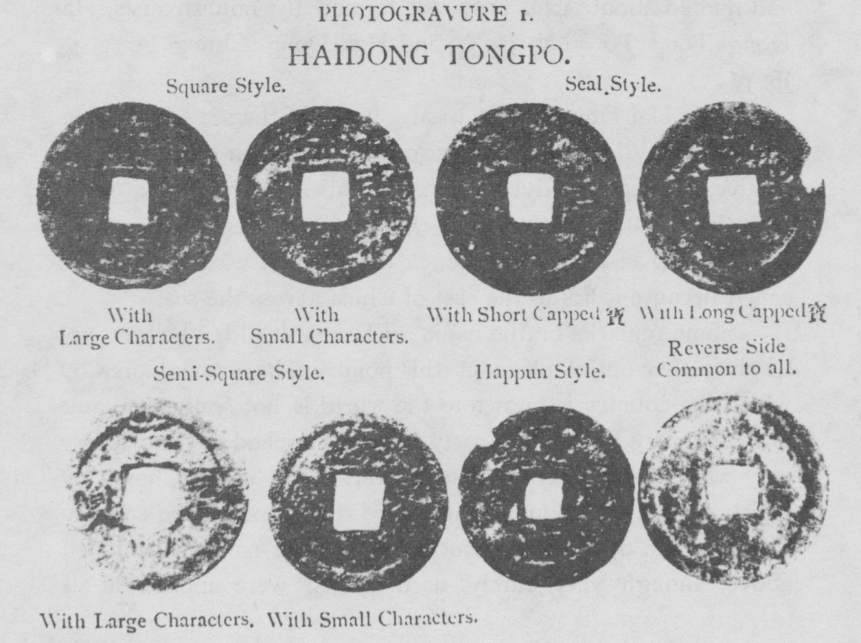[page 50]

There was another coin which, though history is silent concerning its minting, in all probability was minted simultaneously with the other, bearing the same characters but one, i.e. Hai Dong Chung Po 海東重寶, the character chung 重 replacing the character tong 通. Only one kind of this has been found, one in square style.

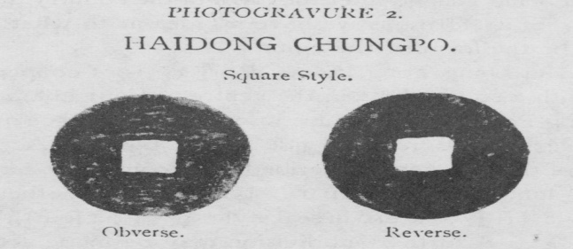

There were thus two different coins belonging to the Hai Dong coin, as the coins having the characters Hai Dong 海東 and minted about A.D. 1102, are termed by numismatists, Hai Dong Tong Po 海東通寶 and Hai Dong Chung Po 海東重寶.

Now Hai Dong 海東 means “east of the sea” and is the name used by learned Koreans to designate their country irrespective of reigning dynasties as are also Dong Kook 東國 (eastern country) Dai Dong 大東 (great east) and, rather poetically, Kei Rim 雞林 (cock forest). It was evidently so called because it lies to the east of China across the sea.

Some remarks on the name of Korea would, I believe, not be altogether out of place at this point The name Korea by which the country is known to the world is not really the name of the country but of a dynasty and was applied to the country only while the dynasty was in power. The name Chosen by which we call the country was indeed the name of the country under certain dynasties but not always. The names mentioned above, though very rarely used by us, were applied at all [page 51] times and to any part of the country, and it was these that were mostly used in the state documents to designate the country. It was sometimes called Dong To 東土 (eastern land). China was thought to be the middle of the world一Middle Country 中國, hence these names.

There is another group of coins in which the term Dong Kook is used to designate the country and which is thought to have been minted about the same time as the Hai Dong coins. The four characters Dong Kook Tong Po 東國通寶 or Dong Kook Chung Po 東國重寶 are inscribed on the face of the coins while the reverse side is left blank. The following are specimens of the Dong Kook Tong Po :―

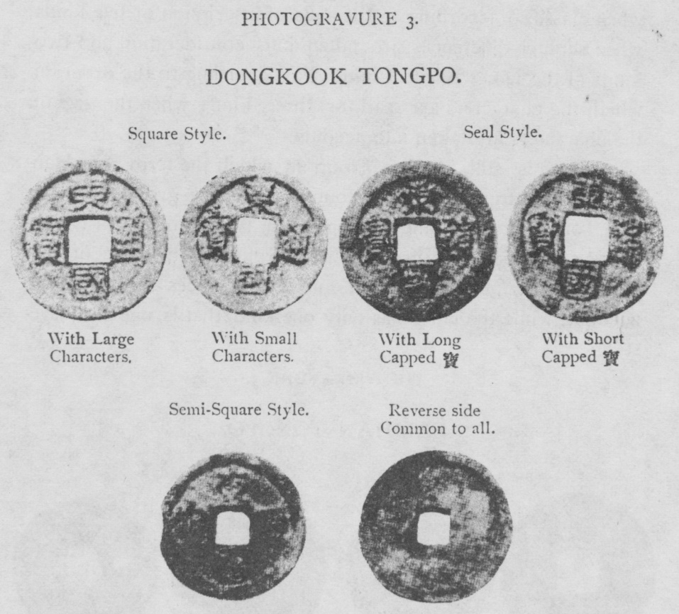

The specimens of the Dong Kook Cluing Po are as fol-lows :—  [page 52]

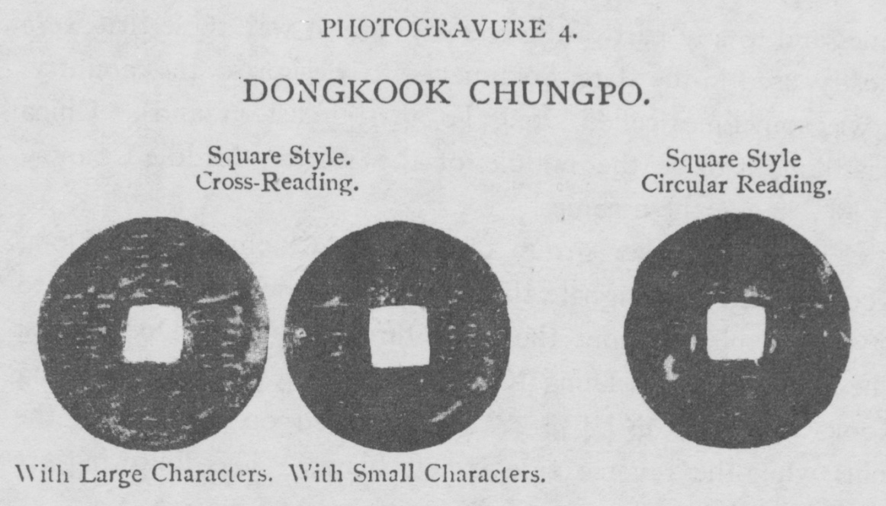

There are thus three kinds of the Dong Kook Tong Po when classified according to the style of inscription or five kinds when slighter differences are taken into consideration and two kinds of the Dong Kook Chung Po according to the order in which the characters are read or three kinds when the size of the characters are taken into account

There is still another group in which the term Sam Han 三韓 is used to designate the country. Of this group there are also Tong Po 通寶 and Chung Po 重寶 the former of which may be classified into three kinds according to the style of the characters or four kinds when minor differences are taken into account, while the latter has only one kind, that is, one in square style.

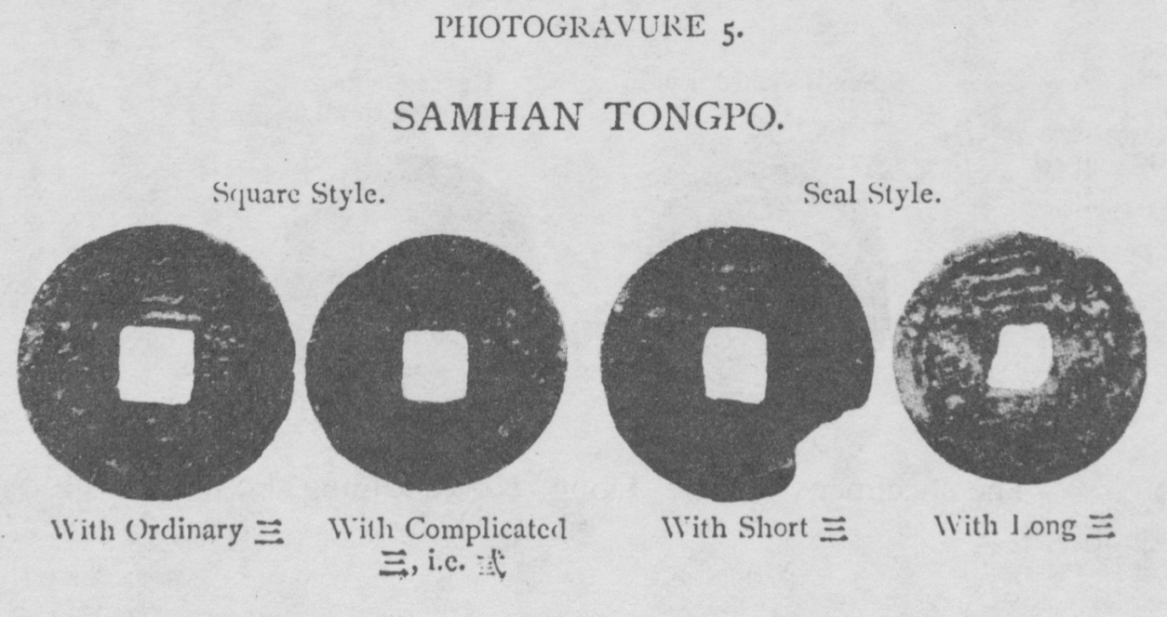[page 53]

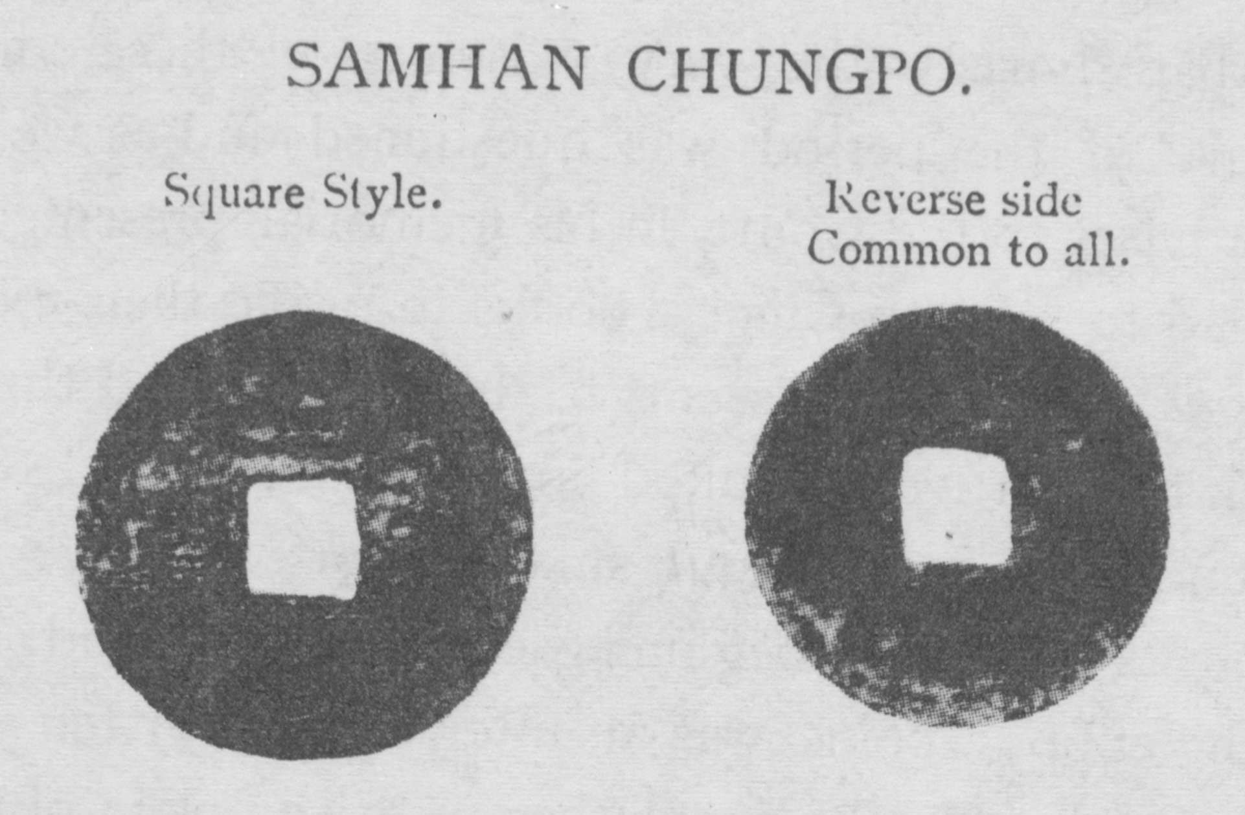

The term Sam Han 三韓 means “Three Han” and was another name for Korea derived from the three states, the name of which all end in Han, i.e. Ma Han, 馬韓, Jin Han 辰韓, Biun Han 辨韓, into which the country was once divided. The coins were minted under the Ko-ryu Dynasty but the exact date of minting is not known.”*

The remarks of the Chun chi 泉志 (history of coins) on these coins may not be without interest being the comment of Chinese on them many centuries ago. They speak of them in very high terms. “Excellent workmanship” 製作頗精 is the comment on the Hai Dong coins while they speak of the Dong Kook coins as having “Form dignified and characters clear and even” 輪郭渾重字畵明担. There is indeed some primitive rudeness in them ; but in the matter of taste, their superiority over later coins seems to be quite evident,—a sad proof of Korea’s degradation in art and taste.

It is to be regretted that no positive proof as to the date of minting of the last two groups of the Korean coins, r.e. Dong Kook 東國 and Sam Han 三韓 coins, has been found. In all probability, they were minted about the same time as the Hai Dong coin, the date of coinage of which is given in history as about 1100 A.D. because not only have we no authentic record of new minting of coin at any later period under the Ko Ryu Dynasty, but proofs are not wanting to show us that toward the

* For the study of these coins, I am greatly indebted to Mr. C. Miyake who has allowed me free use of his valuable collection.

[page 54] close of that dynasty the very existence of these coins in the earlier part of the period was questioned and as we shall see later, an adviser to the Court, in his memorial presented to the Throne, had to refer to Chinese books to prove their existence.

The Eun Biung 銀瓶 seems to have been used throughout the period, though very limited in circulation, and was often recoined and grew smaller and smaller, for we have an edict prohibiting its use at the beginning of the next period. But the issue of the copper coins was an utter failure, for ten years had hardly passed before the people began to complain of them and Yei Chong 睿宗, the next king, was obliged to issue a decree which, in substance, may be translated as follows :—

“Money was the means by which ancient kings and emperors used to enrich their country and accommodate their people, so it was not to serve his own interest that our Father adapted it to this country. A new law is always followed by public slanders, showing the wisdom of the saying of the ancients that the people should not be consulted at the beginning. Our subjects, in their opposition to money, refer to the testament left by our great ancestor, the rounder of the dynasty. It is true that he has forbidden us to imitate foreign customs but what he has forbidden is their luxurious customs. As to the laws and institutions, where shall we seek for a model, if not in the Middle Kingdom.” (M. H. P. K. Chap. 159 P. 3).

The pathetic tone of the decree fully testifies to the distressed situation to which the monetary condition of the country had then been brought. By these words the king commanded the people to use money but the people did not obey. Thus the attempt ended in utter failure and no new coins seem to have been minted during the period. Rice and cloth remained as ever the medium of exchange and standard of value and 110 doubt barter was the chief means by which people traded with each other.

With the system of fairs pretty well organized from the earliest times barter seems to have been by far a more preferable means than an imperfect circulating medium. With the people [page 55]

of all trades corning from every part of the country or of the town into an appointed place it was not very difficult for each one to find an equivalent for his products or wares in the articles he needed, their respective value being determined by means of rice and cloth. There was, however, one place, it would seem, in which money was used more conveniently than, in any other place and where it was preferred to other forms of exchange medium. Such place was a restaurant Perhaps this was because all visitors to the fair from distant places had to lunch there and it was not likely that all had something to offer acceptable to the proprietor in payment of their bill. Whatever reason may be given for this, it was the fact that, whenever there was a new issue of coin, it was always with restaurants that they were first placed, and the order was given to proprietors to use the coin even when other people were not so compelled. It is often recorded that the Government went so far as to establish restaurants just for the purpose of teaching the people the use of money. All these means, so often repeated at later times, were tried at this time but were of no avail.

Then came the first foreign interference in monetary matters of the country recorded in history. It is interesting to note that the monetary interference successively attempted by Japan and Russia in recent years was nothing but a copy of the policy pursued by China under the Yuan dynasty some six hundred years before. The Moon Heun Pi Ko 文猷備考 says (Chap. 159, P. 5) : “In the 13th year of King Chung Ryul 忠烈 (A.D. 1287) Yuan 元 sent an envoy and decreed that the Chi won po cho 至元寶鈔 and Jun tong po cho 中絲寶鈔 should be used and that one kwan of the former should be exchangeable for 5 kwan of the latter. These were Chinese paper money. This was the period in which the power of China took the most aggressive form. It was but seven years before that she made an unsuccessful attempt on Japan when the greatest fleet that has ever visited the coast of Japan was defeated and annihilated. Having so formidable a power to dictate to her, Korea could only submit and obey. Some Chinese coins also[page 56] must have made their way into the country about this time, for in 1385, it was found necessary by a decree to fix the relative value between Chinese money and Korean cloth by which one kwan of the former was made exchangeable for five pil 匹 of the latter. This statement shows at the same time that Korea had then no money of her own to compare with the Chinese, but that cloth formed the principal standard of value. The existence of Chinese coins in no small quantity in these times, is further proved by the fact that they are so often found in old Korean graves dating from those days.

Towards the close of the Ko Ryu 高麗 Dynasty, all sorts of metallic money had practically disappeared from circulation, and the need of a convenient circulating medium was felt so keenly that one of the advisers had to propose, in a memorial, the issue of a paper money, following Chinese precedents, to relieve the situation and most probably also to replenish the empty treasury of the then declining dynasty. The memorial, though of little value as such, is at once interesting and instructive as it reflects the existing monetary condition and refers to the old coins of the realm of which so much has already been said.

After lavish references to the past Golden Ages of China of Yu 禹, Tang 湯, and Chow 周, as is usual in this kind of writing it goes on to say : “Our East (Korea) has also had money and such as the Sam Han Chung Po, Dong Kook Chung Po, Dong Kook Tong Po, Hai Dong Chung Po and Hai Dong Tong Po are mentioned in the book of the Middle Kingdom and so can be referred to. Later on we had also Eun Biung and all these were used with cloth. But both copper coins and Eun Biung have long since disappeared and we have nothing but cloth left to us. But now the cloth is becoming coarser and coarser, and is not fit to use : when being transported oxen sweat under it: when it is stored rats gnaw it. Commerce is handicapped and the price of rice goes up by leaps and bounds. Should there be a flood or a drought lasting a year or two or a war costing millions of money where shall we find funds? The [page 57] country produces neither copper nor silver ; so it is impossible to revive silver or copper coins.” Then he comes to the point and proposes that a paper money should be issued (M. H. P. K. Chap. 159, P. 7).

From this memorial, we may gather the following important information: first, that, by the close of the Ko Ryu Period, not only had all the above mentioned Korean coins disappeared from circulation but even the fact of their existence had long been forgotten,—a circumstance strongly supporting our assertion that they were minted very early in the period ; secondly, that, there was then no money whatever in use, either metallic or paper and cloth formed the sole and only medium of exchange ; thirdly that, with all her mineral wealth, she was thought by her statesmen to be destitute of, not to say gold, but even silver or copper.

In 1392, the Ko Ryu Dynasty came to an end and that of Ri 李 rose into power.

**THE RI 李 PERIOD.(A. D. 1392-1910).**

The issuance of paper money which had been suggested toward the close of the preceding dynasty was put into practice under the new regime. The Moon Heun Pi Ko 文猷備考 says : “In the first year of Dai Chong 太宗 (A.D. 1392) the king ordered the premier Ha Rioon 河侖 to print a paper money and have it circulated among the people.”

In 1464, the 9th year of King Sei Jo 世祖, a very singular kind of coin was minted. It is no doubt one of the most eccentric coins which human ingenuity has ever conceived. It was so designed that in time of peace it was to be used as money and in time of war as an arrow-head and hence was called Jun Pei 箭 幣 i.e. arrow coin. The royal instruction on this occasion appear in the Moon Heun Pi Ko which may be translated : “Different moneys were used in different reigns but each one[page 58] suits its time. The arrow coin, though never used by the an- cients, will surely prove useful to a warlike country and we see no reason why it should not be used.”

Unfortunately the coin failed to answer either as money or as an arrow-head. The fact that it has never been mentioned since will be sufficient proof of the failure of this novel attempt.

So far no specimen of this interesting coin has been found and one might doubt the fact of its minting, were it not for the description given in the Moon Heun Pi Ko, the most trustworthy of ail Korean books. The description is as follows : “An arrow coin resembles in form a willow leaf, the blade or head having a length of 1 sun 8 bu and the steam or tang a length of 1 sun 7 bu. On the two sides of the tang near the end are inscribed four characters pal-pang-tong-wha 八方通貨. One piece of arrow coin was made exchangeable for 4 pieces of paper money.”

The drawing given below is that of an arrow-head called in Japan “willow leaf” and it is most likely that the coin had a similar form with the above mentioned four characters inscribed somewhere along A.

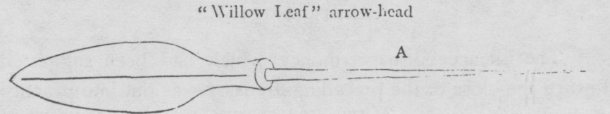

(Copied from the Shakwai Jii)

One may well doubt if man could ever have been so eccentric as to conceive such a design for money. None the less it is a fact and our common sense, I think, has largely contributed to the failure to find specimens of it. Collectors of coin may have picked them up by chance but thrown them away never dreaming that they were once coins. Lovers of old coins are advised, therefore, whenever they chance to come across an old arrow head, not to throw it away but to examine its tang and see if it bears the characters pal-pang-tang-wha 八方通貨 which, by the way, mean “Currency in eight directions,” i.e. [page 59] currency everywhere. History tells us no more of this coin. Its fate is evident, however. No one would like such a prickly coin which could not be pocketed with any safety nor be handled but with great caution. It must have gone out of circulation as fast as it was issued.

Paper money was also losing its credit and the whole credit system was entirely upset by the invasion of the Japanese Army in 1592.

In 1603, the thirty-ninth year of King Sun Jo 宣祖, that is, five years after the evacuation of the country by the Japanese army, the king desired to have money minted and so held council with high officials to discuss the matter. Fourteen of the officials summoned were in favor of it saying:— “Our country uses but rice and cloth, so agriculture wanes and the country is impoverished. It is advisable that money should be used and both Government and people be enriched.” Seventeen were of the opinion that it might well be tried. But one man was against it on the ground that the country produced neither copper nor iron and so it was impracticable. He seems to have been the only practical man of the thirty two officials summoned and of course, the king had to agree with him and abandon his coinage plan. Such was the poverty into which the country was then reduced.

In 1625, the 3rd year of King In Jo 仁祖, a new coin was minted. It is recorded that this time stores were established in the Capital in which wines and food were sold for money ; the people imitated this, and knew for the first time the advantages of money. The Chosen Tong Po 朝鮮通寶, specimens of which now exist, is in all probability, the coin minted at this time.

The name Chosen 朝鮮 is of very remote origin being once used some one thousand years before the Christian era. On the assumption of the sovereign power by the Ri 李 Dynasty, the name was again used to designate the country. As to the origin of the name Chosen, opinions vary among scholars, but the one which seems to us most reasonable is that[page 60] it was so named because the country is situated to the cast of China where the sun is seen freshly 鮮 in the morning 朝. Cho means morning and sen fresh.

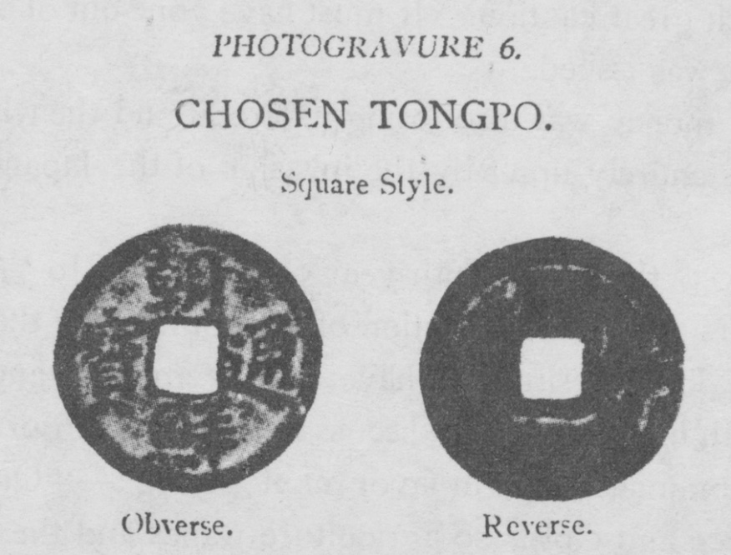

There is only one kind of this coin in my collection, made of copper and with the characters on it in square style. There may be more but attempts to find others have failed The Chinese List of Coins also gives only one kind, that which is here represented.

Eight years later, in 1633, a Government Office by the name of Sang Piung Chung 常平廳 was ordered to mint a coin on which were inscribed the four characters Sang Piung Tong Po 常平通寶. This event in itself is of no great consequence, being only another failure to add to the already long list of ailures. But the fact that the coin bore the four characters Sang-piung-tong-po gives much significance to this otherwise unimportant event, for, though many changes were afterwards made in the coinage of the realm, these four characters remained unchanged on each and every coin minted up to the very last clay on which Korea ceased forever to mint the so-called cash or yopchon. Evidently it was so inscribed as the coin was first minted by the Sang Piung Chung, which was a kind of famine relief office. Sang 常 means “always” piung 平 “even”; the two put together meaning “always even” making a fit name for a famine relief office by which the surplus of a good year is kept to make up the deficit of a bad one. [page 61]

In 1651, the second year of King Hio Chong 孝宗, adecree was issued ordering the people to use coin and at the same time prohibiting them from the use of cloth as money. Up to this time, money when it was in existence was used side by side with cloth, and though there were times in which the use of money was prohibited, that of cloth had never been prohibited. Now it was forbidden for the first time and this, drastic as it seems, was a very important step toward the diffusion of metallic coin. Deprived of the last means upon which the Korean people had always had a tendency to fall back whenever money failed to satisfy them, they had now to accept money willy nilly and realizing its benefits soon became accustomed to its use. Up to this time, there had always been a party opposed to the use of coin that took every opportunity to suppress its use and replace it with rice and cloth. Now this party was fast disappearing and though they once more succeeded, five years later, in causing the rescission of the order to use coin, the people by that time had become so accustomed to its use that they began to coin for themselves, and hardly ten years had passed when the coinage question was again taken up seriously.

In 1678, the 4th year of King Suk Chong 肅宗, it was decided that coins should be minted and orders to that effect were given not only to the Sang Piung Chung 常平廳 but to various other government offices such as the Hocho 戸曹 (Revenue Office), Jin Hiool Chung 賑恤廳 (Charity Office) Sa Bok Shi 司僕寺 (Bureau of Royal Mews), Urh Yung Chung 御營廳 (a military office) and Hoon Riun Do Kam 訓鍊都監 (a military division) and to some provincial military stations such as those in Piung An 平安 and Chon La 全羅 Provinces.

This constitutes a turning point in the coinage history of Korea. The economic position of money was at last established and rice and cloth were deprived forever of their monetary function. It took, as it were, a firm root in the soil of this country, and if it did not contribute much to the well-being of the people, it, at least, began to be regarded as indispensable to[page 62] the economic life of the nation. This new issue of coin was followed by many others. Indeed the two hundred years that followed was the period in which money thrived most in Korea. Coin after coin was issued under different pretexts, at different times and in different places. There were so many, indeed, that it is impossible to describe them separately in this limited space. I shall, therefore, pass them over and proceed at once to describe the coin itself, all the issues of which, though not without certain minor differences, may be brought under one generic term “Sang Piung Tong Po” from the principal characters they all bear in common.

All the cash minted then and afterwards invariably bear, as I have just said, the characters 常平通寶 (Sang Piung Tong Po) on the face but different numerals, character and marks on the reverse side indicating the offices by which they were made, number of issue and number of furnace. The office by which a coin was minted is indicated by the first character (sometimes second) of the name of the office being inscribed at the top of the coin. Thus the coin minted by the Ho cho 戶曹 has the character Ho 戸 inscribed on it, that minted by the Jin Hiool Chung 賑恤廳 the character Jin 賑, while that coined by the Urh Yung Chung 御 營 廳 has the character Yung 營, the second character instead of the first Urh 御.

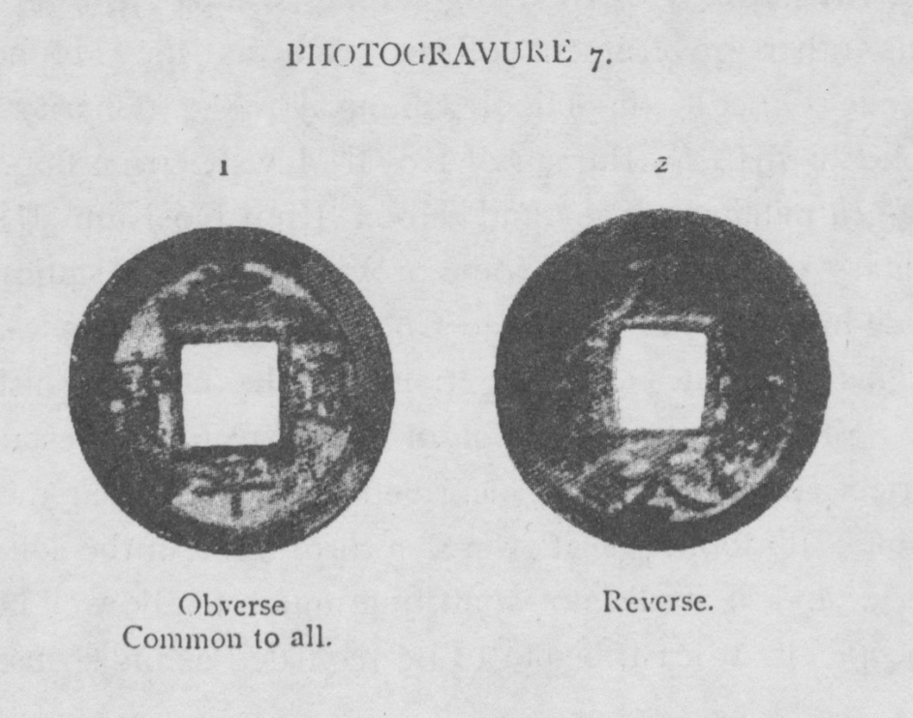[page 63]

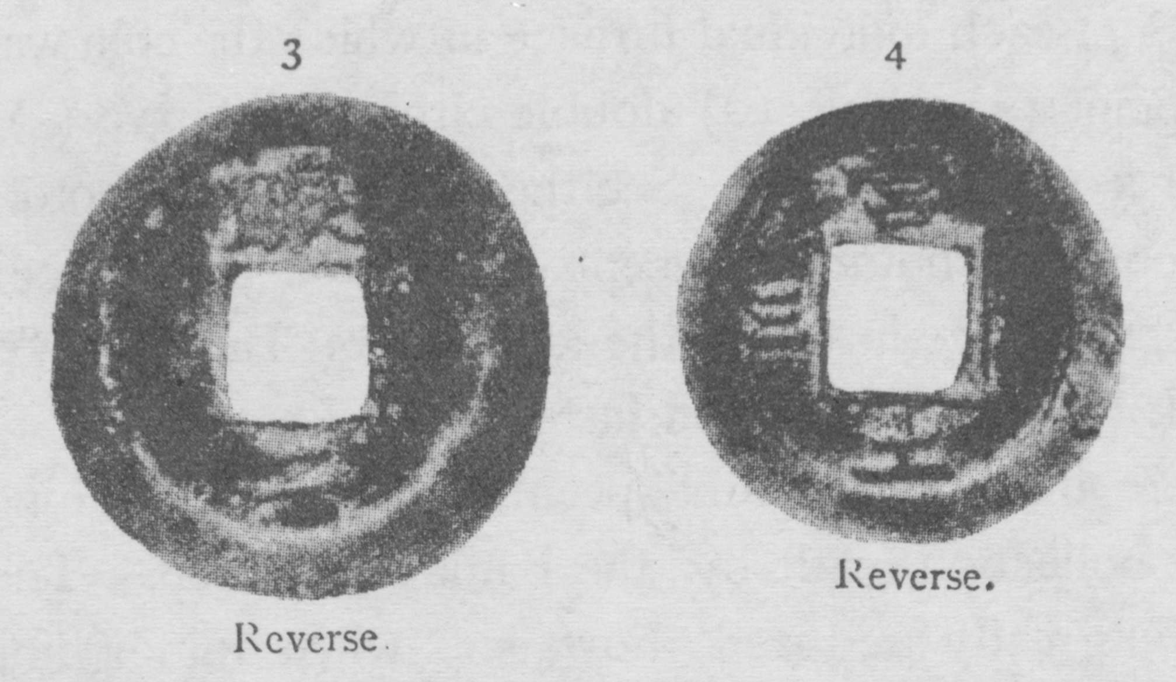

The numerals or characters inscribed at the bottom of the coins indicate, according to the information given by Korean scholars, though not substantiated by authentic records, the serial number of a group of furnaces called Il ro kan 一爐間. The characters such as 天 (Chun) or 土 (To) are used as numerals according to the order in which they stand in the Chun ja moon 千字文 or the Oh hang 五行. The Chun ja moon is a Chinese classical writing consisting of one thousand different characters which begins thus :—天 (Chun) 地 (Chi) 玄 (Hyun) 黃 (Hwang) 宇 (Oo) 宙 (Joo) 洪 (Hong). In using these characters as numerals, chun 天 stands for one, being the first character and cm 地 for two, being the second and hyun 玄 for 3, being the third and so on. The Oh hang 五行 means the five elements of nature in Chinese philosophy, that is, Mok 木 (wood) Hwa 火 (fire) To 土 (earth) Kum 金 (metal) Su 水 (water) and these are used as numerals in the same way as those of the Chun ja moon. Thus of the coins represented in Picture 7 No. 1 shows the obverse side of the Sang Piung Tong Po with the characters common to all the coins minted in 1678 and afterwards. No. 2 shows the coin minted by the Hocho 戸曹 and in the first group of furnaces, while No. 3 shows that minted by the Jin Hiool Chung 販 恤 廳 and in the second group of furnaces and No. 4 shows that coined by the Urh Yung Chung 御 營 廳 and in the third group of furnaces. On the reverse side of the coin and on cither or both sides of the square hole in the centre there are sometimes other numerals or various differ-[page 64] ent marks of each individual furnace in which the coin was made such as point (•) circle (○) double circle (◎) curve ()) or the character il (一) or yee (二) (See the last coin in Photo. 7 and the first coin in Photo. 8) except in the five cash piece or one hundred cash piece in which the characters Tang Oh 當五 or Tang Pak 當 百 are inscribed instead (see Photo. 9).

There are 3137 different specimens of the Sang Piung Tong Po in the collection made by the Bank of Chosen. This number will be greatly reduced, however, when minor differences are disregarded and only principal ones taken into consideration, for instance to 36 when the principal character indicating the minting office only is regarded and to 63 when size is taken into consideration. We are in the habit of naming a cash after the character indicating the place or office of minting, for instance, we call one bearing the character Yung 營 indicating that it was minted by the Urh Yung Chung 御 營 廳 by the name of Yung Ji Chun, i.e. Yung 營 coin, and as I have just said, there are 36 different specimens according to this classification. It is also to be noted that there are some coins which, though having different principal characters, are neverthless issued by the same office. They are such as the Sun 宣 and Hei 惠 coins. Both of them were issued by the Sun hei chung 宣 惠 廳 but have different characters, one having the first character, the other the second.

The next thing to be considered is their size. Some coins have three sizes, large, middle and small, some two sizes, large

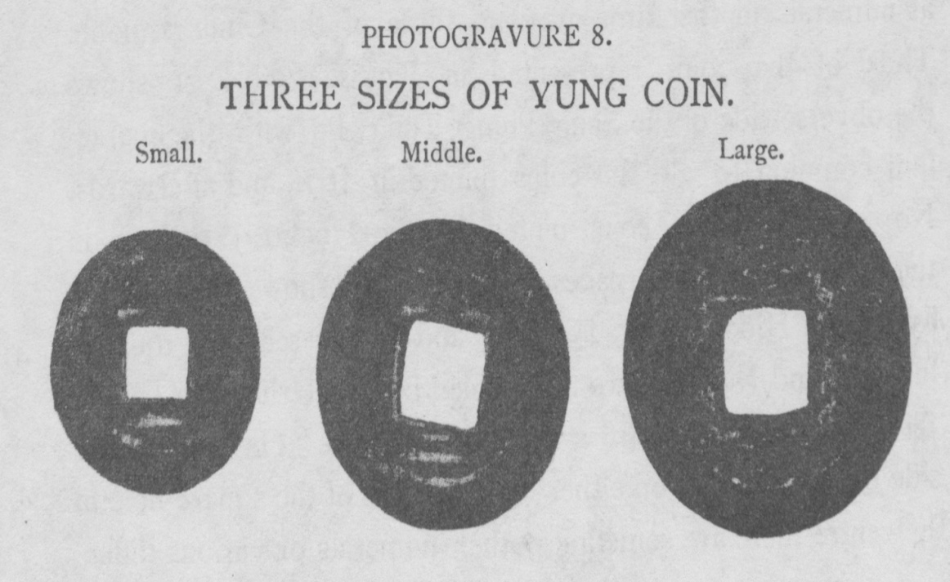

[page 65] and small, and some only one. For instance, the Yung 營 coin has three sizes, the Keum 禁 coin, only two, large and small, and the Hiang 向 coin only one, large.

In most cases, they all circulated at the same value, smaller ones being minted later to increase mintage profits. Below is a list of Sang Piung coins arranged according to the principal characters with the names of the offices by which they were minted and sizes into which they are classified.

KIND OF COIN. OFFICE COINED BY. SIZE.

I 營 Urh Yung Chung 御 營 廳 Large, Middle, Small

2 開 Kai Sung Kwan Ri Yung 開城管理營 Large and Small

3 禁 Keum Wi Yung 禁 衛 營 Large and Small

4 訓 Hoon Riun Do Kam 訓 鍊 都 監 Large, Middle, Small

5 戸 Ho Cho 戸 曹 Large and Small

6 尙 Kyung Sang Kam Yung 慶 尙 監 營 “

7 向 Ryang Hiang Chung 粮 餉 廳 Large

8 宣 Sun Hei Chung 宣 惠 廳 Large and Small

9 總 Chong Yiung Chung 總 戎 廳..... “

10 統 Tong Wi Yung 統 衛 營 Large, Middle, Small

11 平 Pyeng Yang Kam Yung 平 壤 監 營 Large and Small

12 折 Kiung Ki Kam Yung 京 幾 監 營... “

13 全 Chunra Do Kam Yung 全 羅 道 監 營 “

14 京 Probably an office in Seoul 京 城 “

15 咸 Ham Kyung Kam Yung 咸 鏡 監 營 “

16 沁 Kang Wha Do Sim Yung 江 華 島 沁 營 Small

17 均 Kiun Yuk Chung 均 役 廳 “

18 武 Moo Bi Sa 武 備 司 Large and Small

19 惠 Sun Hei Chung 宜 惠 廳 Small

20 昌 Chang Duk Koong 昌德宮 “

21 海 Hoang Hai Kam Yung 黃海道監營 Large and Small

22 同 Unknown ................................................. “

23 原 Unknown Large

24 守 Soo Wi Chung 守 禦 廳 “

25 賑 Jin Hiool Chung 賑 恤 廳 Large and Small

26 水 Unknown Large[page 66]

KIND OF COIN. OFFICE COINED BY. SIZE.

27 備 Bi Burn Sa 備 邊 司 Large and Small

28 黄 Hoang Hai Do Kam Yung 黃海道監營 “

29 兵 Biung Cho 兵 曹 Large, Middle, Small

30 江 Kang Won Do Kam Yung 江原道監營 Large

31 工 Kong Cho 工曹 ................ “

32 抄 Jung Cho Chung 精 抄 廳 Large, Middle, Small

33 忠 Unknown Large

34 經 Kiung Ri Chung 經理廳 Small

35 松 An office in Kai Sung “

36 利 Unknown “

I have so far described the ordinary yopchon or cash which, in spite of all their differences in inscription and size, circulated at the same value. There are two larger coins called Tang Oh Chun 當五錢 (five cash piece) and Tang Pak Chun 當百錢 (one hundred cash piece).

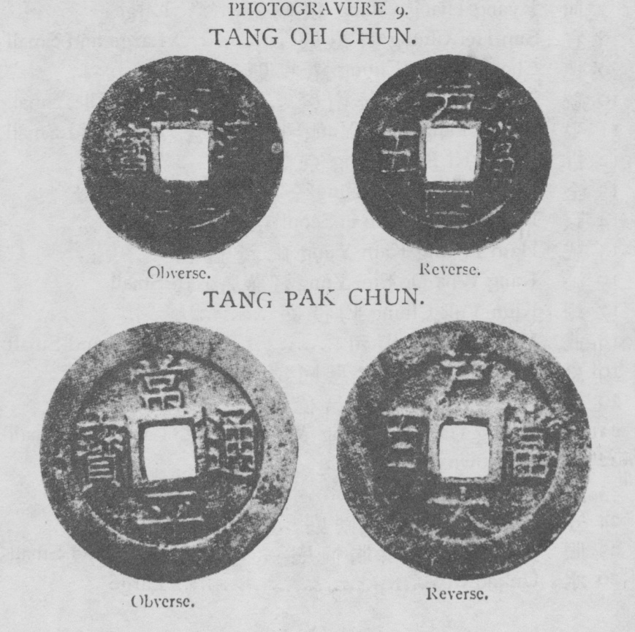

[page 67] Tang Oh 當 五 and Tang Pak 當 百 mean respectively “worth five” and “worth one hundred” signifying that they are worth so many times the ordinary cash. Of the Tang Oh Chun 當五錢, the Bank of Chosen has been able to collect the following specimens :―

KIND OF COIN. WHERE MINTED.

戶 Hocho 戸 曹

統 ............... Tong Wi Yung 統 衛 營

平 Pieng Yang Kam Yung 平 壤 監 營

京 ............... Seoul (?) 京 城

春 Choon Chun 春 川

沁 ............... Kang Wha Do Sim Yung 江 華 島 沁 營

均 Kiun Yuk Chung 均 役 廳

典 Jun Whan Kook 典 圜 局

昌 Chang Duk Koong 昌 德 宮

川 Choon Chun 春 川

Of the Tang Pak Chun only one kind was minted, that is, the Ho 戸 coin minted by the Ho Cho 戸 曹.

The Tang Pak Chun 當 百 錢 was minted in 1866, when Tai Won Kun was regent, to obtain thereby funds for the build- ing of Kiung Pole Palace 景福宮 and was issued at a value one hundred times that of an ordinary coin, while its size, though considerably larger than the ordinary one, by no means warranted such a value as represented. The people, of course, refused to take it at its face value and in a short time the Government had to stop minting it.

The Tang Oh Chun 當五錢, the face value of which was fixed at five times the ordinary coin, was minted in 1883 for the first time but, its size being nearly the same as that of the larger ones among ordinary coins, circulated except in Seoul and its vicinity at no greater value than that of an ordinary coin, and was the first to be exported when the price of copper abroad rose according to the law of Gresham.

A year previous to the minting of the Tang Oh Chun 當五錢, silver coins were minted. They were of three [page 68] denominations, i.e. Dai Dong Sam Chun 大東三錢, Dai Dong Yee Chun 大東二錢 and Dong Il Chun 大東一錢.

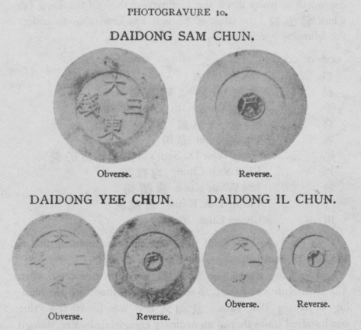

On the face of these coins appear the characters Dai Dong 大東 (Great East) which is another name for Korea as I have explained before and on the reverse side the character Ho 戸 inscribed in a circle of blue enamel located in the centre of the coin, indicating that it was coined by the Revenue Office, the Ho Ch0 戸曹. They have no hole in the centre and are slightly nulled around the edge. On the whole, they are a very clumsy imitation of Western coins, being of very poor workmanship and lacking uniformity. They have never been put into circulation.

A glance at the list of the Sang Piung coins given before will be sufficient to convince one of the disorganized state of the coinage of this country during the period. There was no[page 69] central mint, and the privilege of coinage was granted to many different civil and military offices in the Capital as well as in the provinces. It seems that whenever an office found itself in pecuniary embarrassment, it applied to the Government for the privilege of coinage to relieve thereby its pressing need. Naturally they cared only for mintage profits and nothing else, —no wonder that the coin was debased year by year until the original weight of 2 chun 5 fun was finally reduced to about half the weight, i.e. to 1 chun 2 fun and no further reduction in weight being possible lest the people should refuse to receive it, they tried to circulate certain coins at a face value many times that of an ordinary coin, while their real value was not increased in the same proportion. The outcome was the minting of the Tang Oh Chun and Tang Pak Chun which resulted in failure as I have just mentioned.

In 1883, Korea had for the first time a Government Mint which was named Jun Whan Kook 典 圜 局. The Mint was first engaged in minting Tang Oh Chun 當 五 錢. Later an adviser was invited from Japan in order to effect a reform in the country’s monetary system on a more modern method and new machinery was installed in the Mint for that purpose. In 1891, coins of the modern type were struck for the first time. They are shown in the picture below.

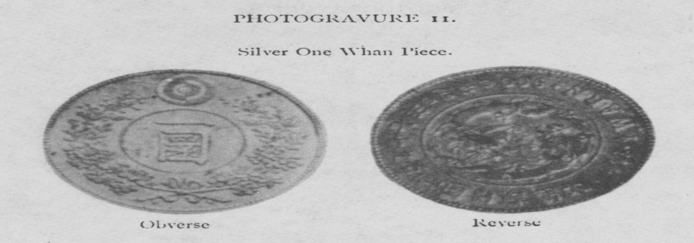[page 70]

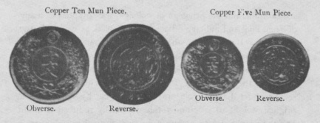

These coins had hardly been put into circulation in any large quantity when the China-Japan War broke out and prevented the Korean Government from pursuing its intended monetary reform.

In August 1894, new coinage regulations were promulgated at the instigation and under the guidance of the Japanese Government. The following were the coins according to the new regulations:—

1fun, brass, equal in value to 1 old coin.

5 fun, copper, “ “ “ “ 5 old coins.

2chun 5 fun, nickel, equal in value to 25 old coins.

1 Yang, silver, equal in value to 100 old coins.

5 Yang, “ “ “ “ “ 500 “ “

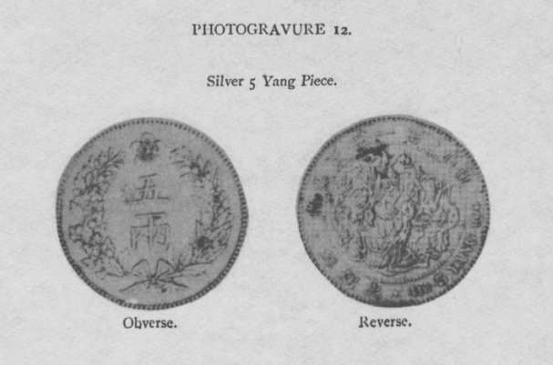[page 71]

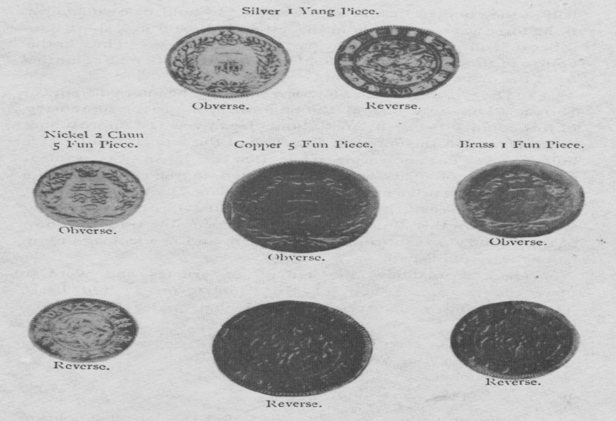

These were splendid regulations on a silver basis and a real reform should have been effected in the monetary system of the country if they had been adhered to. But the long corruption pervading every department of the Government was not to be removed by a single set of regulations. The mintage profit was the only thing that they cared for, and as the nickel coin afforded the largest profit, it was coined to an enormous amount, while the 5 yang silver, which was the standard money, was minted only to the insignificant amount of Yen 19,923. Soon the country was flooded with nickel, and though in one [page 72] half of the country the old coin was able to hold its own against it, its force was irresistible in the other half, and in a short time it became all powerful in that part of the country. Thus in the course of time, Korea was divided into two different countries from the monetary view point.

In 1897, came Russia’s interference with the internal affairs of Korea. This was just at the time the struggle for supremacy in this country between Russia and Japan was fast approaching its crisis, and at this moment Russia had the upper hand. Her influence was fast increasing while that of Japan was waning, and this state of affairs was soon reflected in the coinage of the realm. On the advice of M. Alexieff, financial adviser to Korea sent from Russia, the circulation of the Japanese currency which had by this time become an indispensable trade medium of the country was abruptly prohibited and new coinage regulations were published.

These regulations consisted of 11 articles and were to place the coinage system of the country on a gold basis. The following coins were to be issued under the regulations :

Gold 20 Whan 10 whan 5 whan

Silver 1/2 Whan 20 Chun

Nickel 5 chun

Copper 1 chun

These regulations were compiled after the Japanese coinage regulations and were the best one could conceive for this country. Some coins were minted according to the regulations and they bore Russian eagles on their face. But Russia was not in power long enough in this country to see them circulate. The coins were melted down but their excellent regulations survived Indeed, every letter of the regulations, with but some insignificant additions, such as the addition of copper 1/2 chun piece, was carried into practice by her antagonist. The following are coins minted under Japanese guidance according to the regulations enacted under Russian influence. [page 73]

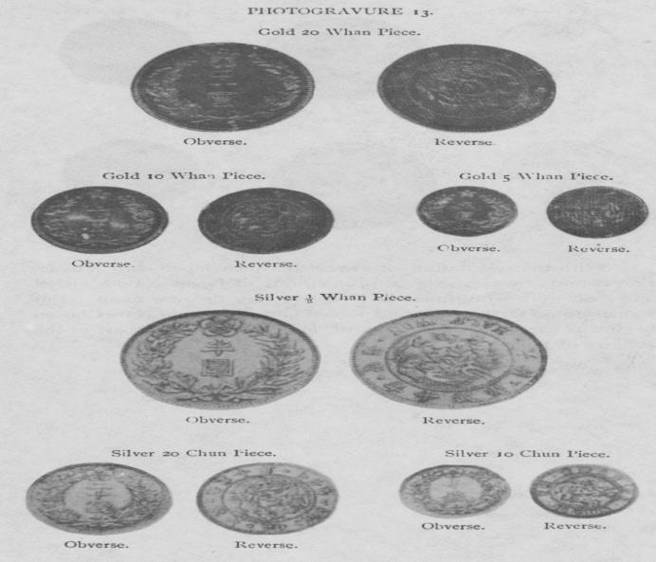

[page 74]

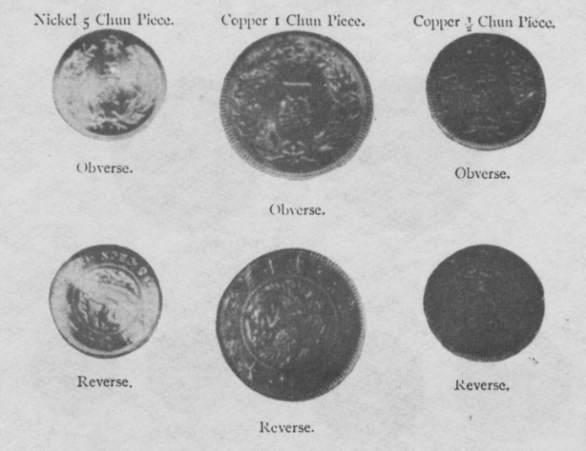

With the restoration of peace between Japan and Russia, the country was made a protectorate of Japan. Both nickel and cash were withdrawn and replaced by the new coins. But I shall go no farther, for Old Korea ends there and New Chosen begins its career with new vigor and strength as a part of the Empire of Japan.