[page 150]

**LIST OF MEMBERS, KOREA BRANCH, ROYAL ASIATIC SOCIETY**

HONORARY MEMBERS

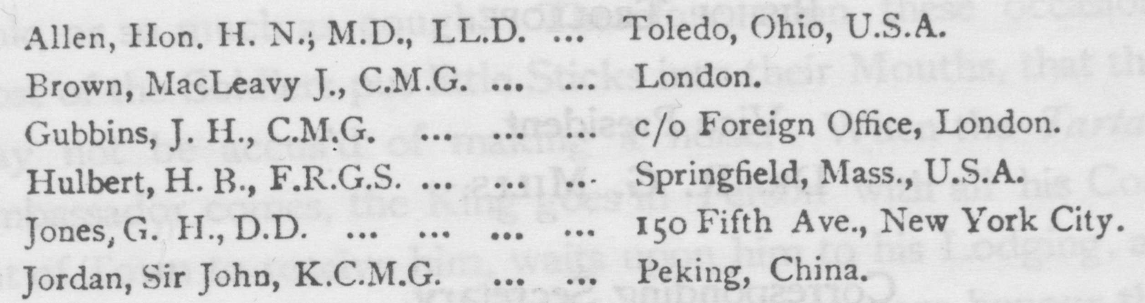

ORDINARY MEMBERS

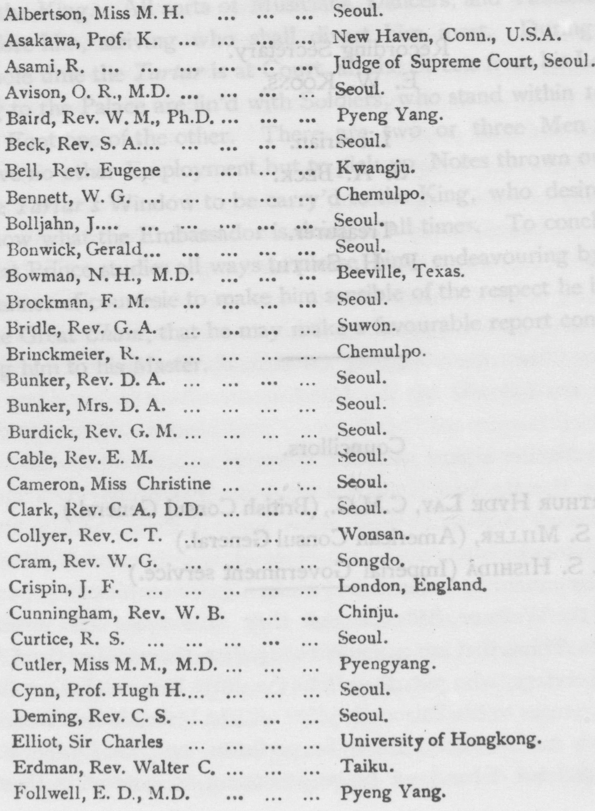

[page 151]

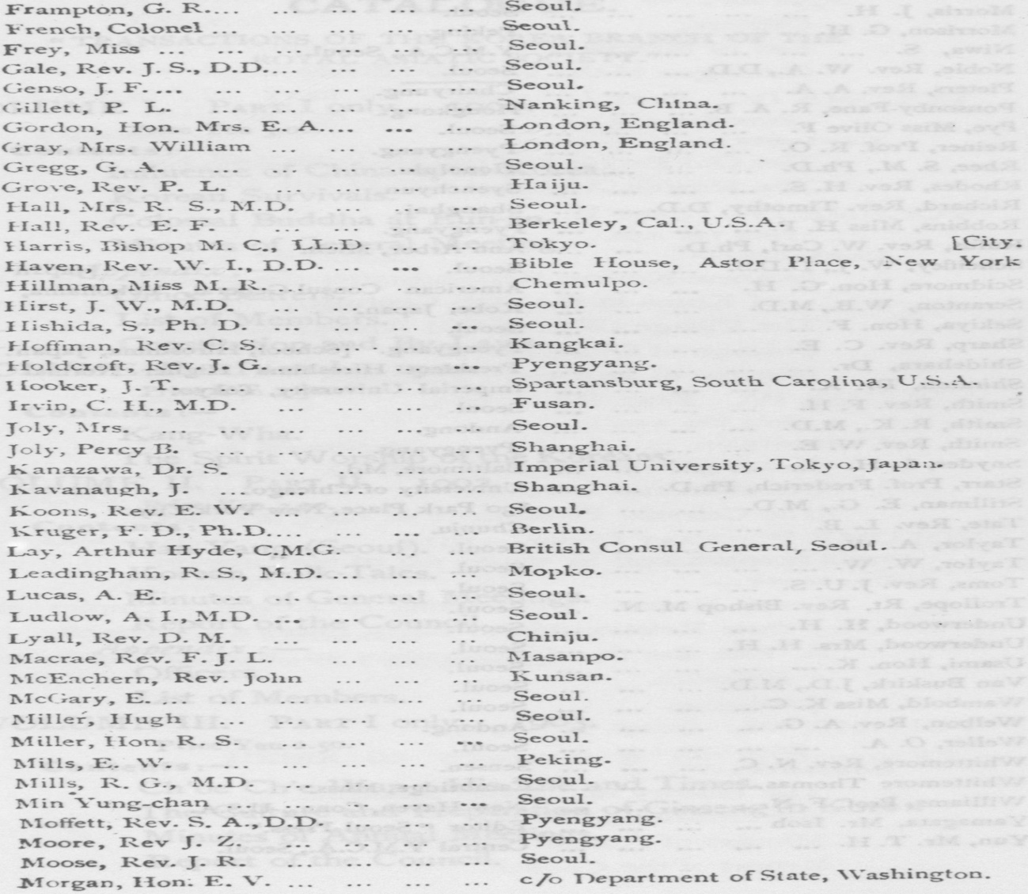

[page 152]

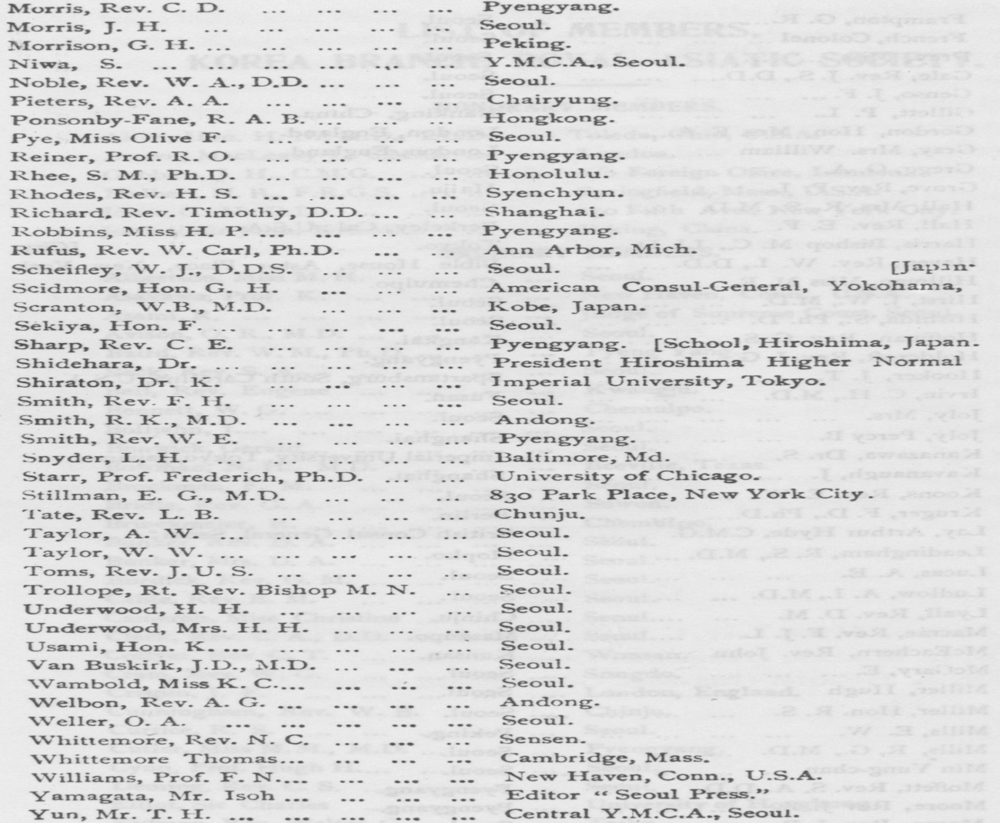

[page 153]

**CATALOGUE.**

“ TRANSACTIONS OF THE KOREA BRANCH OF THE

ROYAL ASIATIC SOCIETY.”

VOLUME I. PART I only. 1900.

Price Yen 3.00.

Contents :—

Influence of China upon Korea. Korean Survivals.

Colossal Buddha at Eun-jin.

Minutes of General Meeting. Appendix:—

Office Bearers.

List or Members.

Constitution and By-Laws.

VOLUME II. PART I. 1901.

Price Yen 2.50.

Contents :

Kang-Wha.

The Spirit Worship of the Koreans.

VOLUME II. PART II. 1902.

Price Yen 3.oo.

Contents ：一

Han-Yang (Seoul).

Korean Folk-Tales.

Minutes of General Meetings. Report of the Council.

Appendix:-

Officers.

List of Members.

VOLUME III. PART I only. 1903.

Price Yen 2.50.

Contents :-

Ch’oe Ch,e Wun : His Life and Times.

The Culture and Preparation of Ginseng in Korea. Minutes of Annual Meetings.

Report of the Council [page 154]

Appendix : —

Officers.

List of Members.

Catalogue of the Landes Library.

VOLUME IV. PART I. 1912.

Price Yen 1.50. Contents :一

The Old People and the New Government. The Korean Alphabet.

VOLUME IV. PART II. 1913.

Price Yen 2.50. Contents :一

Japanese-Korean Relations after the Japanese Invasion

of Korea in the 16thCentury.

The Village Gilds of Old Korea.

Coinage of Old Korea. Minutes of Important Meetings. VOLUME IV. PART III. 1913.

Price Yen 2.50. Contents :-

Marriage Customs of Korea.

Selection and Divorce.

The Celestial Planisphere of King Yi Tai-Jo. VOLUME V. PART I only. 1914.

Price Yen 2.50. Contents :一

Some Recent Discoveries in Korean Temples and

their Relationship to Early Eastern Christianity. A Plea for the Investigation of Korean Myths and

Folklore.

Catalogue. ，

VOLUME VI. PART I. 1915.

Price Yen 2.50. Contents :一

The History of Korean Medicine. Afforestation in Korea.

Minutes of Annual Meeting.

Report of the Council. [page 155]

Appendix :—

Officers.

List of Members.

Catalogue of Publications.

VOLUME VI. PART II. 1915.

Price Yen 2.50.

Contents :一

The Pagoda of Seoul.

Hunting and Hunter’s Lore in Korea.

Appendix :—

Officers.

List of Members.

Catalogue of Publications.

VOLUME VII. PART I. 1916.

Price Yen 2.50.

Contents :一

Gold Mining in Korea.

Appendix:一 Officers.

List of Members.

Catalogue of Publications.

VOLUME VIII.

Price Yen 2.50.

Contents:—

Introduction to the Study of Buddhism in Corea. Appendix:—

Officers.

List of Members.

Catalogue of Publications.

index to volume 9 in volume 17