POTTERY OF THE KORAI DYNASTY. (924-1392 A.D.)

A. I. I.UDLOW, M.D.

Severance Union Medical College, Seoul, Korea.

Ten years ago a little Korean boy brought to our home a basket containing a few dishes which had been secured from the tombs in the region of Songdo (Kaijo). This marked the beginning of my interest in this particular pottery, commonly known to the Koreans as, “ Koryo Chagi.” to the Chinese as “ Kao-li-yao.” to the Japanese as “ Korai-yaki “ (Korai pottery. literally, baking) and to the Western nations as Korean Tomb Ware, or Korean Mortuary Pottery.

I make no pretense of being an authority on this subject but simply wish to present information gained from a rather scant literature and from my own personal observation of a considerable number of pieces of this pottery.

Historical Introduction.

The Catalogue of the Le Blond Collection of Korean Pottery in the Victoria and Albert Museum gives a most excellent historical introduction as follows ;

“ The geographical position of the peninsula of Korea, stretching as an outpost from the Asiatic mainland towards the archipelago of Japan accounts in large measure for the impoitant part which the country has played during the past in the development of Far-Eastern culture. It was the highway along which civilization marched from China and Central Asia, and through Central Asia from the Mediter-ranean, to the island empire ; it was also through Korea that the Buddhist religion made its way to Japan. [page 34]

During the early centuries of the Christian era the country consisted of three independent States : Korio (Japanese, Korai or Koma ; Chinese Kaoli), Pekche (Japanese, Hiakusai or Kudara ; Chinese Pochi) and Silla (Japanese, ^hinra or Shiragi ; Chinese, ^in-lo)^ About the middle • of the seventh century the most important of the three, Silla, founded in 57 A.D., and occupying the south-eastern extremity of the peninsula, absorbed the other two, and a single kingdom was erected under Chinese suzerainty with its capital at Taiku (note, the capital was at Kyungju). During the ensuing period, roughly contemporary with the 1 ang dynasty in China (618-907), under the influence of Buddhism, which was introduced into Korea about 372 by the Chinese Monk Sun-do» the country reached a high stage of prosperity and civilization • The art of the period, showing GraecoBractrian influences which had travelled eastwards from Khotan in Central Asia, can be studied only from the frescoes and sculptures in temples such as the Horiu-ji at Nara and elsewhere in Japan, where they are revently treasured as memorials of the nation which the Japanese regard as the source in these early days of their own civilization.

In 918 the kingdom of Silla was conquered by the revolted province of Korio, the name of which, adopted as that of the entire kingdom, survives in the European name Korea. What is generally known as the Korai dynasty, sometimes also called the Wang dynasty, was established in 924 by Oang (Wang) the Founder, and the capital was transferred to Songdo (“ pine capital “), near the west coasts This dynasty came to an end in 1392 with the revolt of \ 1 1 aijo, founder of the Yi (in Japanese Ri) dynasty, which closed with the Japanese annexation of Korea in 1910- The name of the kingdom was changed to Chosen (Chinese Ch’ao-hsien, morning calm n), the capital was removed to Seoul, and Buddhism was finally suppressed• With the exception of the few relics preserved in Japan, scarcely an^hing remains to the Present day of the greater arts from the classical period of [page 35] Korean history, ending with the overthrow of the Korai dynasty in 1392.

Amongst the lesser arts, on the other hand, that of the potter can be studied from a large number of surviving specimens. For this we have to thank the Korean burial customs of the period. As in Europe in pre-Christian times and in ancient China, so in Korea, it was the practice to inter with the bodies of persons of distinction various articles for their use in another world, including vessels with offerings of food and wine. In Korea such objects were placed in stone chests, deposited in the tumulus on either side of the coffin of the deceased. After the change of dynasties, the burial customs were altered, so that the “ tomb wares” of later date are exceptional. The absence of all signs of wear in the pottery from the tombs, as distinct from occasional decomposition of the glaze due to the effects of burial, may be explained by the use for this honorable purpose of vessels new from the kiln. Such wares are known by the Japanese at the present day as Meiki, i.e. undergroand ware.”

The pottery of the Silla dynasty (57-918) is crude and of much less artistic interest than the Korai ware. It is found chiefly in the southern part of Korea in the regions of Kyungju, Taiku and Fusan. We submit a specimen to show the type, a rice bowl and cover, the bowl of which is decorated with five rows of hook-like devices above which are two deeply incised horizontal circles. The cover is also decorated with ten rows of marks similar to those on the bowl.

(No. 1).

Height 8.5 cm. Diam. 12 cm. Weight 330 gm. (Plate I).

The pottery of the Korai dynasty (924 A.D.-I392) most of which has come from the tombs in the region of Songdo is the best type of porcelain found in Korea. In the catalogue above mentioned Bemard Racham writes:

“ In general the Korean wares of this classical period show a dignity and simplicity of form, combined with an exquisite sense, alike of right proportion in spacing, and of the [page 36] beauty of subtle curves, which entitle them to a high rank amongst the achievements of the potters of the world. “

This pottery presents various colors, shapes and decorations. There is a fine white Korai covered with a translucent glaze of bluish tone. Other white pieces are coarser and non-translucent.

“ A more common color is the so-called “Celedon,” a sea-green glaze. The word “ Celedon is of French origin, being derived from the name of a character in a seventeenth century play (based upon L’Astree, the romance by Honore d’Urfe) who appeared on the stage in a costume of this color.” Black, green and persimmon-colored glazes are found. The inlays are of white, dark green to black, and rarely crimson colon The painted wares are in white, brown or dark green slip.

The shapes are in certain cases very characteristic, among which the cup and stand (No. 28-74-76), vegetable forms such as the sprouting bamboo (No. 21) and the melon (No. 22) may be noted.

Most writers claim that the vessels shaped like tea-pots, were used for wine. This is based on the repeated statements that tea drinking was unknown in ancient Korea. I believe we have evidence to prove that not only was tea drinking known in ancient Korea but that it was used during the very period of the making of the Korai pottery. I am indebted to Rev. J. S. Gale, D.D., for this information. In the Korean Magazine September, 1918 he wrote as follows :—

“We learn from the Sam-gook Sa (三國史) and other sources that Korea first became acquainted with tea in the reign of Queen Sun-tuk (632-647 A.D.), a wise woman. She built a high tower from which to watch the stars, which tower still stands, and she introduced tea as a refined substitute for the wildly intoxicating drinks that the old poets used to talk of. Korea thus learned to drink tea, but for two hundred years, apparently, never learned to grow it herself.”

The Sam-gook Sa or “ History of the Three Kingdoms” [page 37] also tells that the seeds of tea were first brought to Korea by Tai-ryum (大廉) the envoy of the Tangs in 828 A.D. These were the days of China’s greatest glory, when she beneficently over-shadowed the smaller states, like Korea, that looked up and worshipped hen Tea was then planted in the Chiri Hills (智異山) of Chulla Province where it flourished and grew.

Su Keung (徐兢) a Chinaman, envoy of the Song Kingdom (宋) who came in 1134 A.D. wrote a book called Ko-ryu Tokyung (高麗圖經) “ Korean PicturesHe says, “The Tea of Korea has a slightly bitter and astringent taste almost disagreeable to a Chinaman. Our ‘dragon’ and ‘ phoenix ‘ brands, which are given by the emperor as gifts, and are also sold by merchants in large quantities, Koreans specially like. Of late, Korea has become a great tea drinking country and makes many varieties of tea-pots.Tea-cups are decorated with gold and flowers. There are black tea-cups too, and small pots of blue coloured ware.

On occasions of special entertainment, Koreans provide tea, and as they bring it into the room, they walk very slowly and say, ‘Please have tea.’

When guests are seated they arrange the tea things on a central table and cover them with red silk gauze till it comes time to serve it It is their custom to offer tea three times a day. “

In view of this evidence it seems proper to apply the name tea-pot to the vessels of that shape.

The tea-pots show three different shapes: one, the sprouting bamboo (No. 21), the second, a plain rounded form (No. 6)，and the third, the form of a melon (No. 22).

A miniature melon-shaped tea-pot (No. 24) is an exceed ingly rare specimen. It may have been used as a toy. The little vase (No. 11) and the box (No. 90) may belong to the same class.

The wine jugs (Na 7, 23) have a rounded body and long neck flaring out at the mouth.

In addition to the cup and stand mentioned above there is [page 38] a cone shaoed cup (No. 77) which may have been so formed that all the wine or tea should be taken at one time.

Numerous specimens of small flat circular boxes (Nos.30-33; 88-93) were made to contain pigment for use on seals. It is also probable that they contained face pigment or incense.

The collection contains a number of bottles (Nos. 12-18 ; 78-87) of depressed globular form intended to contain oil.

Vases of many different forms (Nos. 20, 27, 63, 72, 100) were perhaps used for flowers.

Bowls, some shallow (No. 37, 40) and others deeper (No. 43) contained the food.

Among the more uncommon shapes are found : a fish bowl (No. 8), a cuspidor (No. 9) and a vessel (No. 105) like the ones used at the present day for the Korean pickle (Kimchi).

Decorations.

Some of the pieces are plain but for the most part the pottery exhibits many and varied decorations. Plant life is well represented by rows of overlapping lotus petals (No. 88), the lotus flower (No. 53), chrysanthemums, single blossom or in sprays or wreaths (Na 89), peonies (Na 25), pomegranate flower (Na 93), formal floral designs (No. 54), the sprouting bamboo (No. 21) and the weeping willow (No. 106), cranes flying among clouds (No. 78), birds with long flowing tails (No. 40-43) ; butterflies (No. 95), ducks and fishes are also found The human figure is rarely found, though there is a bowl with such design in the museum at Seoul.

The key border is commonly found, as is also the row of Chinese “ jui” “ wish-granting” scepter heads (No. 94).

Method of Decoration.

First, the incised ware in which the design was made in the paste with a pointed instrument, or cut out in countersunk relief before the application of the glaze. This is sometimes combined with the mold or the inlay. [page 39]

“ Mishimade” (Mishima pattern) is the term generally used of all inlaid Korean or Japanese wares. It was first applied to the early Korean ware with inlaid pattern showing a resemblance to the vertically set ideograph of the Japanese almanacs compiled at Mishima in Japan.

The inlay may be in white alone, or in white and dark- green or black. In the Museum at Seoul there is a specimen of a dull crimson pigment inlay (“Peach blow”), which is very beautiful and rare.

Vases (No. 101-102) show the so-called painted wares known in Japan as Yegorai (“painted Korean”). This is also called slip painting, the one in light brown and the other dark brown or dark green clay.

With this brief introduction let us proceed to the description of the pieces following the classification of the Le Blond Collection.

[page 40]

COLLECTION OF A. I. JLUDLOW.

POTTERY OF THE KORAI DYNASTY.

(Le Blond Collection Classification followed).

A.

WHITE PORCELAIN, highly translucent, with thin transparent glaze of more or less pronounced bluish tone over a suqary white paste, showing a brownish surface where not covered by glaze.

1. Undecorated.

No. 2.

Dish, shallow with flat base and rounded sides. H. 1.5 cm. D. 10 cm. W. 25 gm.

1. With incised or engraved decoration under the glaze.

No. 3.

Bowl with rounded sides. Inside plain, on the outside incised lines. (Specimen loaned by Mr. W. W. Taylor).

1. With relief decoration.

No. 4.

Pigment Box and cover, (Specimen loaned by Mr. W. W. Taylor). H. 2 cm. IX 4.5 cm, W. 30 gm. (Plate 1).

B.

MINIATURE PIECES, apparently intended for toys.

These are of white porcellanous ware, thick, relatively coarse, and non-translucent, with uneven bluish glaze similar to that of the preceding class. [page 41]

No.5

We were unable to secure a good specimen of this class though we have described later miniature pieces of the celadon group.

C.

(i) Porcellanous celadons with heavy hard ashqrey body, reddish on the surface where exposed, end quite opaque, even where the walls are thin, covered with a thick jade-like glaze varying in tone from the bluish-green of the majority to qreenish- brown or grey. In some cases the glaxe is much more translucent and fluid than in the others.

(a) UNDECORATED.

Non. 6-19.

No. 6.

Tea-pot with Cover, globular in shape with broad reeded handle, on top of which is a loop. Cover shows marks of base of loop broken off. Imperfection at base of rounded spouts No foot ring, base only partly glazed. Five sand marks on base. H. 15 cm. D. 23 cm. W. 1150 gm. (Plate 2).

No. 7.

Wine Jug with rounded base, narrow neck and spreading top, reeded handle. Portion of the mouth poorly restored. Foot ring and base glazed, few sand marks. H. 22 cm. D. 16 cm. W. 915 gm. (Plate 2).

No. 8.

Fish Bowl with broad base and low rounded sides curving in at the rim. No foot ring, base unglazed, firing scars on the outside. H 10.5cm. D. 21.5 cm. W. 1505 gm. (Plate 2).

No. 9.

Vessel in shape of a cuspidor. Broken in two places and mended. Faint incised horizontal line within the rim. Four [page 42]

spur marks within the loot ring. Both foot nng and base glazed. H. 10.5 cm. D. 21 cm. W. 700 gm. (Plate

No. 3).

No. 10

Stand on cup. Three spur marks within base ring.

No. 11.

Vase, in miniature, barrel shaped, short neck, small mouth partly restored with gilt lacquer. Four sand marks on foot ring. Base glazed. H.9 cm. D. 7 cm. W. 210 gm. (Plate 7).

No. 12.

Oil Bottle, of globular form with short narrow neck and cup-shaped mouth. Base glazed, three spur marks on the foot ring. H. 7 cm. D. 8 cm. W. 145 gm.

No. 13.

Oil Bdtlte, brown color, of moderately flattened globular form, sand marks on foot ring, base glazed H. 6 cm. D. 7 cm. W. 100 gm.

No. 14.

Oil Bottle, of flattened globular form, short neck and cup- shaped mouth, celadon color, three sand marks within foot ring, glaze of base of partly discolored. H. 5 cm. D. 7.5 cm. W. 122 gm.

No. 15.

Oil Bottle, same as No. 14 except more flattened. Three sand marks on foot ring, glaze missing on the base. H. 4 cm. D. 7.5 cm. W.95 gm.

No. 16.

Oil Bottle, aquamarine color, fine glaze flattened globular shape neck and mouth smaller than No. 12-14. Large sand mark within glazed bast. H. 4 cm. D. 7.5 cm. W. 145gm. [page 43]

No.17

Oil Bottle, flattened globular form, only portion of neck and mouth. Three sand marks on the foot ring. H. 4 cm. D. 7.8 cm. W. 130 gm.

No. 18.

Oil Bottle, globular shape, short neck and cup-shaped mouth. No foot ring, base partly glazed H. 4 cm： D. 6.8 cm. W. 72 gm.

No. 19.

Bowl, olive color, cone-shaped, with small foot ring on which are four sandy marks. H. 6 cm. D. 16 cm. W. 260 gm.

(b) WITH INCISED OR CARVED DECORATIONS UNDER THE GLAZE.

Nos. 20.53.

No.20.

Vase with fluted body, scalloped line incised round the shoulder, glaze greenish in color shading to brown on one side. Base unglazed with sand marks. H. 20 cm. D. 14.5 cm. W. 915 gm. (Plate 2).

No. 21.

Tea-pot (usually called wine-pot by most writers) in the form of a sprouting bamboo. Reeded handle, on top of which is a small branch of bamboo with a couple of leaves forming a loop for a cord. Spout broken, and mended with gilt lacquer. On the base just within the unglazed foot ring are six sandy spur marks. H. 18.5 cm. D. 21 cm. W. 1160 gm. (Plate 2).

No. 22.

Tea-pot, melon-shaped with reeded handle, on top of which is a small loop for cord. On the cover another loop formed by the stem of the melon. Body is divided into eight lobes by[page 44] deeply incised lines, Six sand marks on tne flat glazed base. H. 16 cm. IX 18cm. W. 930 gm. (Plate 3).

No. 23.

Wine Jug with reeded handle, spout restored at the top with gilt lacquer. Double incised vertical lines dividing the body into six equal parts. There is a deeply incised palmette on either side. Foot ring fairly high. H. 20cm. D. 13cm. W. 945 gm. (Plate 4).

No. 24.

Tea-Pot, in miniature, in form of a melon divided into eight lobes. Reeded handle and loop on top of handle. Spout and part of the cover restored with gilt lacquer. Glaze on the base partly decomposed. Four sand marks within foot ring. H. 9 cm. D. 9 cm. W. 163 gm. (Plate 3).

No. 25.

Tea-Poty in miniature, flat globular form beautifully in_ cised and glazed. Handle and portion of the spout restored with gilt lacquer. No coven On each side of the body a very plainly-incised tree peony and foliage. Inside half covered with glaze. Wide base covered with glaze except near foot ring. Two spur, or sand marks on foot ring. H. 4 cm. D. 8 cm. W. 131 gm. (Plate 2).

No. 26.

lea-Pot, cover missing, deeply incised vertical lines on the outside. Loop for cord on the top of the handle. Spout poorly restored H. 19 cm. D. 21 cm. W. 1675 gm. (Plate 2).

No. 27.

Vase, with scalloped line incised around the shoulder, and vertical lines dividing the body into seven equal parts. Another scalloped line and radiating lines close to the neck. Glaze, greenish-brown colon Base and foot ring unglazed. [page 45] Three spur marks within the foot ring. H. 27 cm. D. 14.4 cm. W. 123a gm, (Plate 2).

No.28.

Cup and Stand. Cup with rounded bowl divided by fine lines running down from notches in the rim, into six lobes. These lines also run down on the foot rim and divide it into six parts. The inside of the cup is plain, but around the outside are six floral sprays, one in each of the six sections. The foot ring is partly unglazed, but the base is covered with glaze. One sand mark on the foot ring. H. 5 cm, H. 8 cm. W. 60 gm.

The stand has a flat rim with six notches and six incised lines with a faintly incised floral spray in each section. A shallow channel separates the rim from the projection which receives the cup. Overlapping lotus petals are found carved around this pro]ection. A firing defect is found in the channel. The high foot ring is divided into six parts by notches and verticle incised lines. Six faint sand marks on the foot ring.

Foot ring glazed inside and outside. H. 5 cm. D. 14 cm. W. 180 gm.

No. 29.

Stand, no cup, flat rim on which are six delicately incised lotus flowers, enclosed in incised lines. A shallow channel separates the rim from the rounded projection for cup, delicate incised overlapping lotus petals on the side of this projection. High foot ring with six notches and incised lines, Five sand marks. Base glazed. H. 6 cm. D. 15.8 cm. W. 385 gm.

No. 30.

Stand, no cup, rim rounded, delicate incised border and four incised lotus flowers at equal intervals. A cup-like projection in the center. Low glazed foot ring. Three spur marks on the inside of foot ring. H. 5.5 cm. D. 16 cm. W. 363 gm. [page 46]

No. 31.

Pigment Box and Cover, circular, glazed inside and out- side. Central portion of the top of cover is undecorated and glaze is missing in places. From this central .portion incised lines like rays extend over the edge of the cover. These lines extend also around the edge of the box. Four spur marks, outside the depressed base, which is glazed. H. 3 c. D. 8 cm. W. 160 gm.

No. 32.

Pigment Box and Cover, circular, glazed inside and out side. On the cover incised lines which seem to represent a map with roads leadings to a central city. Throe other lines mark off areas evidently intended to represent the sea, as the lines are wavy. On the bevelled edge arc incised lines. Base glazed, three spur marks within the foot ring. H. 3 cm. D. 8 cm. W. 168 gm.

No. 33.

Pigment Box, with flat cover bevelled at the edge. A delicate floral design is incised on the cover. Three spur marks, one on the inside and two outside the foot ring. H. 4 cm D. 8.5 cm. W. 187 gm.

No. 34.

Oil Bottle, of flattened globular form, short neck and fairly wide cup-shaped mouth. Overlapping lotus petals about the neck, then a double circle enclosing a border of formal hook- shaped design. Sand marks within foot ring and a couple outside. Bottle is coarser than others. H. 4 cm. D. 7.5 cm. W. 127 gm.

No. 35.

Oil Bottle of fine aquamarine color, flattened globular shape, short neck and cup-shaped mouth slightly chipped. A floral design is visible about the neck. Three sand marks on[page 47] the foot ring. Base partly denuded of glaze. H. 4 cm. D. 7.5 cm. W. 110gm. (Plate 2).

No. 36.

Oil Bottle, globular in shape, pronounced cup-shaped mouth, fine glaze beneath which floral designs are visible. Sand marks oh base and foot ring. Glaze missing in part on the base. H. 6 cm. D. 8.2 cm. W. 220 gm.

No. 37.

Saucer, divided by deeply scored vertical lines into lobes, with horizontal line incised just below the rim on the outside. Wide depressed base, glazed, within which are three spur marks. H. 3 cm. D. 9.5 cm. W. 125 gm.

No. 38.

Bowl, shallow, plain on the inside except for a faintly-incised horizontal line. On the outside deeply incised overlapping lotus petals. Base and foot ring glazed. Three spur marks on the base. H. 4 cm. D. 16 cm. W. 300 gm.

No. 39.

Bowl small foot ring, high sides, engraved floral design inside and incised horizontal line just below the rim. Outside plain. Three spur marks within foot ring, which with the base is covered with glaze. H. 7 cm. D. 18 cm. W. 433 gm.

No. 40.

Bowl, shallow, decorated inside with a delicately engraved design of two birds with long flowing tails. Outside plain. Small depressed base, which with the foot ring is partly unglazed. H. 5.5 cm. D. 18.5 cm. W. 505 gm.

No. 41.

Bowl, slightly larger and coarser than the preceding, incised horizontal line just below the rim inside and two birds[page 48] with long tails. Outside plain, three spur marks within the foot ring, which with the base is glazed. H. 6 cm. D. 18 cm. 528 gm.

No. 42.

Bowl, same general design as the preceding, except lines of birds are more deeply cut. Foot ring and base small and glazed. Three spur marks on the base. H. 7 cm. D. 19 cm. W. 625 gm.

No. 43.

Bowl, large, similar to the two preceding except for finer incised lines of birds and a better glaze. H. 9 cm. D. 19. 5 cm. W. 658 gm.

No. 44.

Bowl, shallow, plain on the inside, and on the outside incised overlapping lotus petals. Three large sandy marks on the base. H. 5 cm. D. 16 cm. W. 256 gm.

No. 45.

Bawl, with high sides and small foot ring. Outside plain. Inside carved floral design and horizontal incised line near the rim. H. 7.5 cm. D. 19 cm. W. 364 gm.

No. 46.

Bowl, highly rounded sides, plain except for horizontal incised line inside, and heavy incised outside line near the rim. Five sand marks on the foot ring. Both foot ring and base glazed H. 7.5 cm. D. 19 cm. W. 482 gm.

No. 47.

Bowl, shallow, incised horizontal line inside. Outside glaze much decomposed, but faint incised overlapping lotus petals are visible. Foot ring and base partly unglazed. H. 4 cm. D. 16 cm. W. 235 gm. [page 49]

No. 48.

Bowl, with rounded sides and medium sized foot ring. Inside two faintly incised birds. Incised horizontal line just below the rim. Outside plain, except for two horizontal lines extending partly around the bowl. Four sand marks on foot ring which with the base is glazed. H. 8 cm. D. I6.5 cm. W. 412 grn.

No. 49.

Bowl, plain inside. Outside deeply-carved overlapping lotus petals. Three large sand marks within the foot ring, which with the base is partly glazed H. 4 cm. D. 16 cm. W. 362 gm.

No. 50.

Bowl, with small foot ring and high sides. Inside plain except for a few faint incised horizontal lines. Outside overlapping lotus petals, A little sand adherent to the foot ring which with the base is partly unglazed. H. 8 cm. D. 16 cm. W. 325 gm.

No. 51.

Bowl, inside plain, outside overlapping lotus petals. Sand adherent to the foot ring which with the base is partly glazed H. 8 cm. D. 17 cm. W. 330 gm.

No. 52.

Bowl, inside plain, outside overlapping lotus petals, high foot ring. Sand adherent to the base and foot ring both partly glazed. H. 8 cm. D. 16 cm. W. 370 gm.

No. 53.

Bowl, small foot ring, inside faintly-incised lotus in waves. Incised horizontal line near the rim. Three lotus flowers and oliage at equal intervals around the outside of the bowl. Four sand marks on the foot ring which with the base is[page 50] glazed. The color and incised work on the bowl is unusually

fine. H. 6 cm. I). 14 cm. W. 90gm (Plate 2).

1. WITH DECOKATION IN RELIEF PRODUCED. BY FORMING ON A MOULD.

The depressions caused on the reverse side of the vessels by pressing them into the hollows of the mould are distinctly perceptible.

Nos. 54-55.

No.54.

Bowl，inside four formal flowers and leaves in striking relief. Foot ring and base small and partly unglazed. Remnants of spur or sand marks on the foot ring. H. 6 cm. D. 17 cm. W. 230 gm. (Plate 2).

No. 55.

Bowl (or cup). The mould has produced a mottled white appearance on both inside and outside. Three sand marks on foot ring. Base glazed. H. 5 cm. D. 10 cm. W. 140 gm.

1. WITH DECORATION IN RELIEF, MOULDED AS IN THE LAST

SECTION (c) WITH THE ADDITION OF INCISED DETAILS.

Nos. 56-62.

No. 56.

Bowl, shallow with spreading sides, fine color and glaze. Inside three large and three small formal flowers and foliage. A faint incised horizontal line is visible just below the rim on the outside. Foot ring and base small. Foot ring glazed ; base unglazed. H 3.5 cm. D. 12 cm. W. 107 gm. (Plate 6).

No. 57.

Bowl, of fine color with small foot ring, and high sides a little distorted. Inside lotus and foliage in relief. Inciscd horizontal line near the rim which has six notches. Outsule[page 51] plain. Three sour manes within the foot ring which with the base in glazed. H. 65 cm. D. 17 cm. W. 304 gm. (Plate 6).

No. 58.

Bowl, shallow, with spreading side. Inside conventional lotus in relief supplemented by a horizontal incised line near the rim which shows six notches. The outside plain except for two horizontal lines near the base. Three spur marks on the base with a small foot ring. Both foot ring and base glazed. H. 4 cm. D. 16.4 cm. W. 283 gm.

No. 59.

Bowl, with spreading sides, faint floral mould on inside, horizontal incised line just below the rim Outside plain, foot ring ana base partly glazed and covered with sand marks. H. 7 cm. D. 18 cm. W. 465 gm.

No. 60.

Bowl, shallow with spreading sides, in the center a flower in relief in a double circle, outside of which is a floral design in relief beneath a horizontal incised line. Outside of bowl plain. Three sand marks within foot ring. Foot ring glazed ; base partly glazed. H. 4 cm. D. 16 cm. W. 304 gm.

No. 61.

Dish, on the inside faint mould with horizontal incised line below the rim. Outside plain, sand marks on base and foot ring. Both glazed. H. 4 cm. D. 17 cm. W. 283 gm.

No. 62.

Saucer, with small foot ring and low sides. Inside two formal flowers in relief and a horizontal inciscd line below the rim. Outside plain, glaze partly decomposed. H. 4 cm. D. 16 cm. W. 225 gm. [page 52]

(e) WITH MISHIMA DECORATION, INLAID UNDER THE GLAZE IN WHITE.

Nos. 63.70.

No. 63.

Vase, double horizontal white lines around the shoulder. Three double chrysanthemum sprays at equal intervals on the body. tiring defect on one spray. Interior of the vase and base only partly covered with glaze. Many sand marks on the base, H. 20 cm. D. 17 cm. w. 1450 gm. (Plate 7).

No. 64.

Bowl, with curving sides and small foot ring. Inside four horizontal lines. Three spur marks inside. Outside plain. About half of the glaze on the outside is decomposed. H.8 cm. D. 17 cm. W. 465 gm.

No. 65.

Bowl, with spreading sides and small foot ring. Inside three single chrysanthemum flowers at equal intervals on the sides below two horizontal lines. Foot ring and base covered with sand marks. H. 7 cm. D. 18.5 cm. W. 427 gm.

No. 66.

Bowl, with small foot ring and curving sides. Inside three single chrysanthemum sprays at equals intervals below a double circle. Glaze on the outside much decomposed. Foot ring and base partly glazed. H. 8 cm. D. 18 cm. W.472 gm.

No. 67.

Oil Bottle, globular in form, cup-shaped mouth. Double circles about neck and a third near the edge of the body. Between the double circles are four rows of little circles each containing a dot in the center. Sand marks on the foot ring and base. Glaze on the under side partly decomposed. H. 5.5 cm. D. 8.5 cm W.163 gm. [page 53]

No. 68.

Oil Bottle, of fine aquamarine color with short neck and wide cup-shaped mouth partly restored with gilt lacquer. There is a double circle about the neck and a second near the edge of the body. The space thus enclosed in intersected by five double arcs. Three spur marks just within the foot ring which with the base is covered with glaze. H. 5 cm. D. 8 cm. W. 117 gm. (Plate 5).

No. 69.

Oil Bottle, flattened globular shape, straight cup-shaped mouth. A double circle about the Jneck enclosing an area of small circles. Between this double circle and a third one near the edge is a formal chrysanthemum design. Sand marks on the foot ring and base which are partly glazed. H. 4cm. D. 7.4 cm. 122 gm.

No. 70.

Saucer, with flat base on which are three spur marks. Inside a chrysanthemum within a double circle, outside of which is a formal border. Six floral designs at equal intervals and a scroll border. On the outside four chrysanthemum at equal distance. The glaze is uneven. H. 4 cnu D. 14 cm.

(F) WITH MISHIMA DECORATION INLAID UNDER THE GLAZE

IN WHITE AND DARK GREENISH-BROWN OR BLACK.

Nos. 71-99.

No. 71.

Bottle (Top poorly restored) with small ring projecting from the neck, probably for a cord to fasten a cover or stopper, now missing. Round the neck a sceptre head ornament in Chinese ju-i, below four chrysanthemum sprays in black and white inlay. Glaze of foot ring and base partly denuded. A few sand marks on the foot ring. H. 31 cm. D. 16 cm. W. 1655 gm. (Plate 2). [page 54]

No. 72.

Vase, with glaze varving from greenish-brown to greyish- green. Overlapping lotus leaves enclosed in double circle about the shoulder. Normal floral designs on the side. Base unglazed with sand marks. H. 30 cm. D. 16.5 cm. W. 2270 gm. (Plate 8).

No. 73.

Cover, in the center single spray of chrysanthemum en- closed in a double circle outside of which are three chrysanthemum sprays at equal intervals in a second double circle, then a faintly incised line and key border. Inside plain, all glazed except rim. H. 4 cm. D. 14 cm. W. 274 gm.

No. 74.

Cup and Stand. Cup with rounded bowl divided by vertical lines running down from notches in the rim into nine lobes. These lines also divide the foot ring into nine parts. On the inside of the cup in the center a delicate incised floral spray, also a spray on each lobe. Near the rim and foot ring inside and outside arc double horizontal incised lines. On foot ring and base mostly unglazed. H. 6.5 cm. D. 8 cm. W. 130 gm.

The Stand, flat rim with 12 notches, on top of rim a single and double horizontal white line enclosing a row of white dots. On each lobe of the rim are two chrysanthemums in sprays separated by white lines marking off the lobes. A shallow channel separates the rim from the carved projection which receives the cup. The high foot ring is divided into 12 lobes on each of which is a chrysanthemum flower. Three spur marks high up on the inside of the foot ring. H. 6. 5 cm. D. 14 cm. W. 400 gm. (Plate 4).

No. 75.

Cup and Stand, The cup now broken was divided by deeply incised vertical lines into eight lobes. No decorations. [page 55]

The stand has a flat rim with eight notches which together with faint incised lines, mark off the lobes, each of which con- tains a floral spray. The rim is separated by a deep channel from the projection which receives the cup. There is an incised design about this projection and radiating incised lines in the center. The high foot ring shows eight notches. The foot ring and a part of the base are devoid of glaze. Five sand marks with the foot ring. H. 6 cm. D. 14 cm. W. 345 gm.

No. 76.

Cup and Stand, ten lobed. The cup is undecorated on the inside. Outside the cup are vertical chrysanthemum sprays 011 each lobe. Three spur marks within the foot ring. Both foot ring and base glazed H. 7 cm. D. 8 cm. W. 120 gm.

The stand also has ten lobes marked oft by notches in the rim and incised lines, each lobe containing a chrysanthemum spray. The central projection is carbed. Incised horizontal and vertical lines on the outside. Wide foot ring with eight notches. Several spur marks within foot ring. All stand glazed. H. 5 cm. D. 13.5 cm. W. 323 gm. (Plate 4.)

No. 77

Cup, conical in shape, inside undecorated, outside a faint incised bonier near rim and one horizontal incised line near apex. Five floral sprays on the body. Three spur marks on the outside of the cup near the apex. H. 9 cm. D. 8.5 cm. W. gm. (Plate 7).

No. 78.

otile, globular in shape, short neck and small mouth, decorated with cranes flying at equal intervals among clouds, within two double circles. Glaze on a portion of the side and base partly destroyed. Three faint spur marks on the foot ring. H. 5 cm. D. 9 cm. W. 185 gm. (Plate 5). [page 56]

No. 79.

Oil Bottle, of flattened globular form, short neck and wide mouth. Three sprays of peonies at equal distance on the body. Three spur marks within the foot ring which with the base is covered with glaze. H. 5 cm. D. 8.2 cm. W. 166 gm. (Plate 5).

No. 80.

Oil Bottle, of flattened globular form, short neck and small mouth, rim of which is partly restored by gilt lacquer. The body is divided by white lines in three rows of eight arcs ; within each of the two outer rows of arcs there is a formal flower with dark center. The inner zone has only a white spot in each arc. One spur mark within the foot ring. Glaze of base partly decomposed. H. 4cm. D. 7.5 cm. W. 126gm. (Plate 5).

No. 81.

Oil Bottle, globular in shape, short neck and fairly wide mouth. Three floral designs at equal intervals, separated by three dark figures. Remnants of sand marks on the foot ring and base both of which are unglazed for the most part. An incised circle just without the foot ring. H. 5 cm. D.7.5 cm. W. 102 gm.

No. 82.

Oil Bottle, flattened globular in shape, rim and body mended with gilt lacquer. Two double circles within which is a row of lotus petals. Two spur marks without and one within the foot ring. Foot ring and base covered with glaze. H. 5 cm. D. 7.4 cm. W. 107 gm. (Plate 2).

No. 83.

Oil Bottle, flattened globular shape, mouth broken, incised

lotus petals within a white circle about neck. Three black and white floral designs at equal intervals on the body. Three well marked spur marks within foot ring. Base covered with glaze. H. 3cm. D. 7 cm. W. 83 gm. (Plate 5). [page 57]

No. 84.

Oil Bottle, small, slightly uneven globular shape. Dark circle about edge of the body between this circle and the neck are overlapping lotus petals. Three spur marks, one on the foot ring and two outside. Both foot ring and base glazed. H. 4 cm. D. 6 cm. W. 90 gm. (Plate 5).

No. 85.

Oil Bottle, fine glaze, flattened globular shape with two cranes and two floral designs at equal intervals on the body of bottle. Three spur marks within foot ring, base glazed. H. 4.5 cm D. 8 cm. W. 130 gm. (Plate 5).

No. 86.

Oil Bottle, flattened globular in shape with narrow neck and cup-shaped mouth. Three chrysanthemum sprays at equal intervals on body. Three spur marks in foot ring. Base and foot ring glazed. H. 4 cm. D. 8 cm W. 150 gm. (Plate 5).

No. 87.

Oil Bottle, on the body a wreath of chrysanthemums within double circle of white inlay. Mouth and neck of bottle filed down. Three spur marks on foot ring. Foot ring and base glazed. H. 4 cm. D. 9 cm. W. 193 gm.

No. 88.

Pigment Box and Cover. On the cover a chrysanthemum spray within a double circle. Next to this is a wreath of chrysanthemums, another double circle, then a row of overlap ping lotus petals on the bevelled edge. Key pattern around the sides of both cover and box. An unusual feature is the row of lotus petals on the bevelled portion of the box. Two spur marks on the glazed base. H. 4 cm. D. 9 cm. W. 195 gm. (Plate 5). [page 58]

No. 89.

Pigment Box and Cover. On the center of the cover a spray of chrysanthemums within a double circle, then a wreath of chrysanthemums, a second double circle outside of which is a ring of small circles. On the edge of both cover and box is a key pattern. Three spur marks on shallow foot ring. Base unglazed. H. 3.4 cm. D. 8 cm. W. 150 gm. (Plate 5).

No. 90.

Pigment Box and Cover, miniature, floral spray in the center of cover enclosed in a double circle, without which is a circle of white dots, and still a third circle of a white horizontal line. Key border about cover and box. Foot ring and base covered with glaze. No spur marks visible. H. 2.4 cm. D. 4 cm. W. 38 gm. (Plote 5).

No. 91.

Pigment Box and Cover, in the center of the cover a lotus within a double white circle, then three chrysanthemum sprays alternating with formal lotus flowers, another double circle and then a row of black dots within small white circles. Key border on the cover and box. Depressed base. Two spur marks on the base and one outside the foot ring. Both entirely glazed.

H. 3.5 cm. D. 9 cm. W. 228 gm. (Plate 2).

No. 92.

Pigment Box and Cover. In the center of the cover a floral spray within a double circle, then a wreath of chrysanthemums with another double circle and overlapping lotus petals on the bevelled edge. Key pattern on the side of cover and box. Three spur marks witlnn the foot ring which with the base is glazed H. 2.5 cm. D. 8.5 cm. W. 157 gm. (Plate 5).

No. 93.

Pigment Box and Cover, with a spray of pomegranate foliage and fruit on the cover. On the side of the cover and [page 59] box a well marked key pattern in black inlay. Small depressed base in which are three small spur marks. Glazed partly de- composed on base. H. 2.5 cm. D. 8 cm. W. 140 gm. (Plate 5).

No. 94.

Bowl, shallow, inside in the center a chrysanthemum within a double circle enclosed by a row of ju-i sceptre head devices, then four chrysanthemums at equal distance, and near the rim a double and single circle enclosing a scroll border. All this inside in white inlay. On the outside, four chrysanthemums at equal intervals in double circles all in wickerwork. Near the rim four cranes flying among the clouds between a double circle and scroll border. Foot ring and base glazed. Three spur marks on the base. H. 5 cm. D. 15 cm. W. 325 gm.

No. 95.

Bowl, with curving sides and small foot ring. The rim shows six notches. Just below the rim are horizontal lines, two white enclosing a black. All three lines dip down and divides the inside in six portions, in three of which are two butterflies and a chrysanthemum spray alternating with floral sprays (This is the only dish in which a butterfly has been noted). In the center a single chrysanthemum enclosed within a double white and single black circle and border of ju-i sceptre heads. The outside of the bowl is divided similar to the inside, except the sprays are in black and white and there are no butterflies. Outside the foot ring a large row of overlapping lotus petals, enclosed in a white and black circle. Two spur marks within the foot ring. Two sand marks on the foot ring. Foot ring and base both glazed• H. 6 cm. IX 19^5 cm. 465 gm. (Plate 7).

No. 96.

Bowl, shallow, rounded sides. On the inside in white only chrysanthemum within a double circle in the center, and around the sides at equal intervals, five sprays of three spotted fruit[page 60] beneath a formal border. On the outside, at equal intervals with a double horizontal line above and below, four chrysanthemums in white and black foliage, each within a double circle. Around the foot ring are four smaller chrysanthemums not enclosed in circles. Three spur marks within the foot ring which with base is covered with glaze. H. 6 cm. D. 19 cm. W. 546 gm.

No. 97.

Bowl, with medium size foot ring. On the inside in the center is a chrysanthemum spray. On the sides four sprays of five spotted fruit at equal intervals beneath a formal border. All inside are in white inlay. Outside, four chrysanthemum sprays enclosed in double circles at equal intervals, above and below are double circles. Two spur marks within the foot ring which with the base is glazed. H. 9 cm. D. 20 cm. W 690 gm.

No. 98.

Bowl, similar to the preceding, except glaze decomposed. Three spur marks within the foot ring. H. 9 cm. D. 20 cm. W. 800 gm.

No. 99.

Bowl, similar to two preceding, except for sceptre head border about the central flower on the inside and scroll pattern outside between the chrysanthemums. H. 9 cm. D. 21 cm. W. 760 gm. [page 61]

1. WITH MISHIMA DECORATION IN WHITE, COMBINED

WIIH RELIEF DECORATION PRODUCED BY PRESSING IN A MOULD. (NO SPECIMEN).

1. WITH RELIEF DECORATION PRODUCED BY PAINTING

IN WHITE SLIP, COMBINED WITH INLAID DECORATION IN WHITE, ALL UNDER THE GLAZE.

Nos. lOO-1Ol.

No. 100

Bowl, small foot ring, high sides, fine celadon color. Inside three formal lotus flowers and foliage below an inlaid scroll border, a lotus flower in relief at the bottom. Three spur marks within the foot ring which is glazed. H. 8 cm. D. 18.5 cm. W 458 gm.

2. Same as (I) except inlay in black and white.

No. 101

Dish, shallow, inside in the center a floral design within a double circle. It is hard to determine whether this was made by a mould or slip painting. Surrounding this is a row of formal floral sprays. On the outside a key border just below the rim and four floral sprays at equal distance around the sides. Fine glaze covering the whole dish. Three well. defined spur marks within the foot ring. H. 6 cm. D. 14 cm. 345 gm.

(ii) Celadons with coarse red earthen ware body, covered with a thin crackled glaze generally opaque, ranging from greenish-grey to greenish-buff.

(A) WITH INLAID MISHIMA DECORATION IN WHITE CLAY.

No. 102.

Vase, two weeping willows on the flattened sides alternating with lotus. Two formal lotus flowers in wreaths about the shoulder. Rim broken. Inside glazed Wide base with many sand marks. H. 28 cm. D. 17 cm. W. 2825 gm. (Plate 2). [page 62]

(b) WITH DECORATION PAINTED UNDER THE GLAZE IN

THICK DARK GREENISH-BROWN SLIP.

Nos. 103-104.

No. 103.

Vase, with two conventional pomegranate sprays on the body. Rim restored with gilt lacquer. Glaze on the base and body partly missing. The vase is quite light for the size. H. 25 cm. D. 17 cm W. 170 gm. (Plate 6).

No. 104.

Vase, with three conventional flowers and foliage at equal distance on the body with a wavy petal-like design about the shoulder. Base unglazed. H. 24 cm. D. 17 cm. W. 1560 gm.

E.

Early stoneware with opaque body and pearl-grey glaze bordering on celadon, over inlaid mishima decoration in white clay.

No. 105.

Jar, rounded, inside glaze very thick and unevenly spread. Wide mouth. Overlapping lotus petals enclosed in double horizontal lines about the shoulder. On the body five lotus flowers, beneath which is another double circle. All the inlay is in white cxcept for a few black leaves in the flowers. Wide foot ring unglazed, base glazed. No spur marks. H. 18 cm. D. 21 cm. W. 1920 gm. (Plate 8).

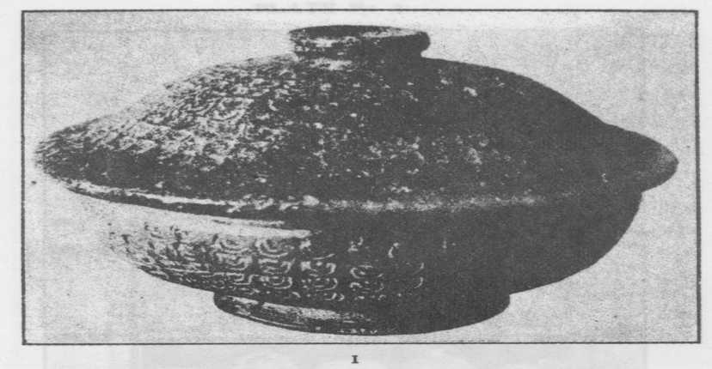

Rice Bowl of the Silla Dynasty.

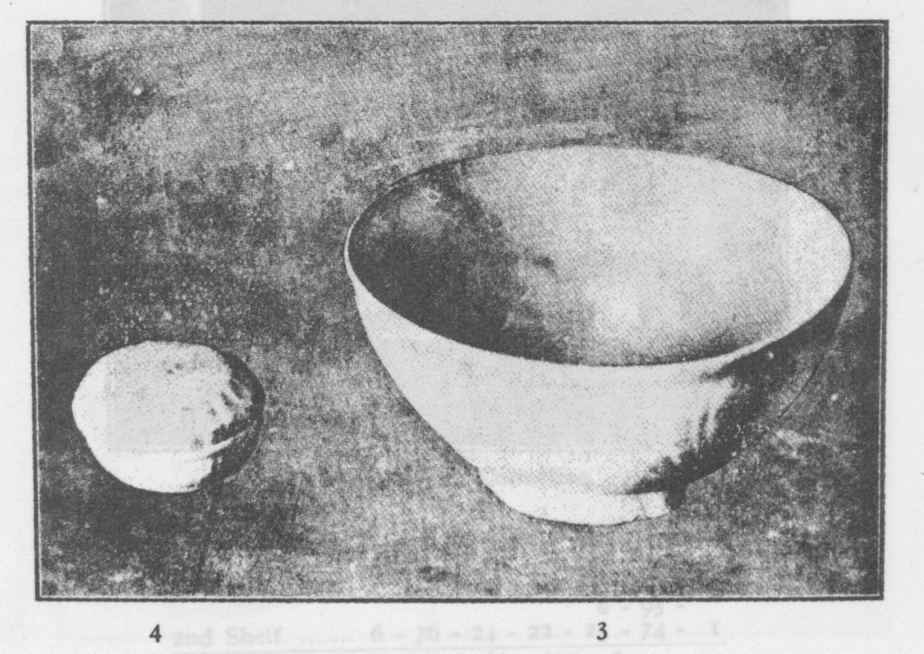

White Porcelain Box and Bowls

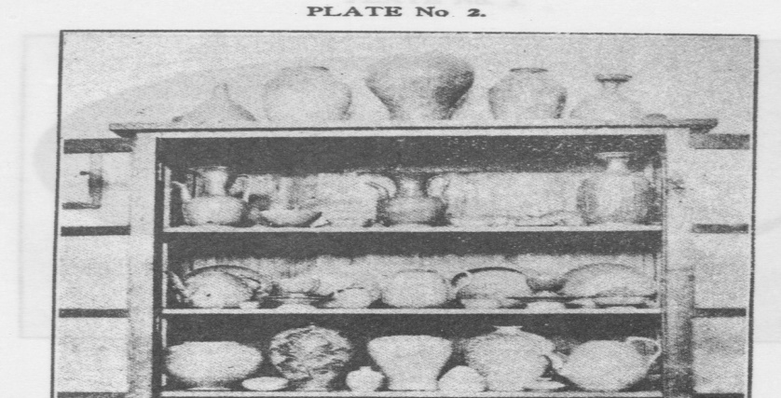

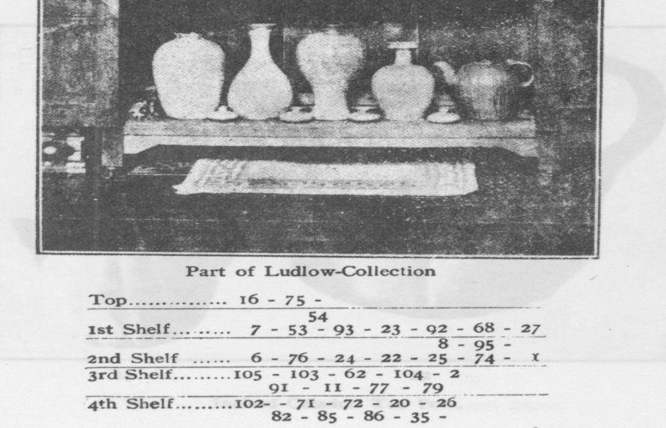

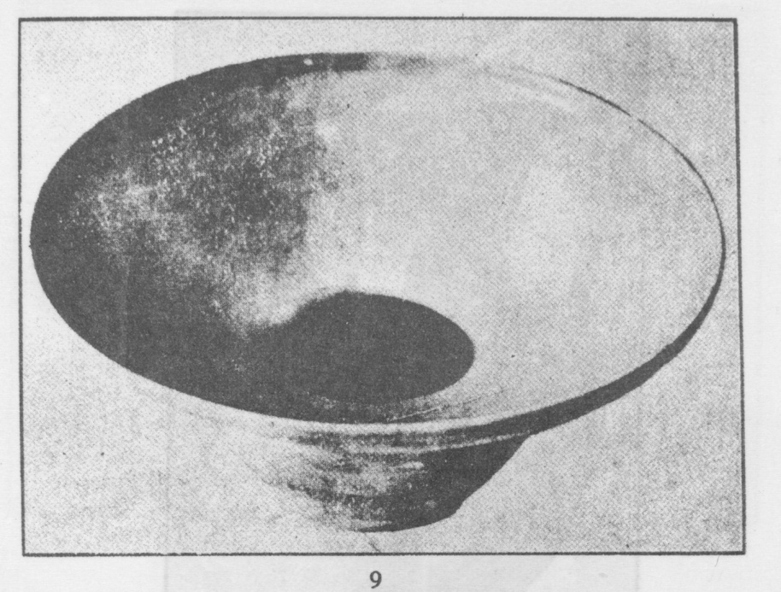

Undecorated Celadcn Cuspidor.

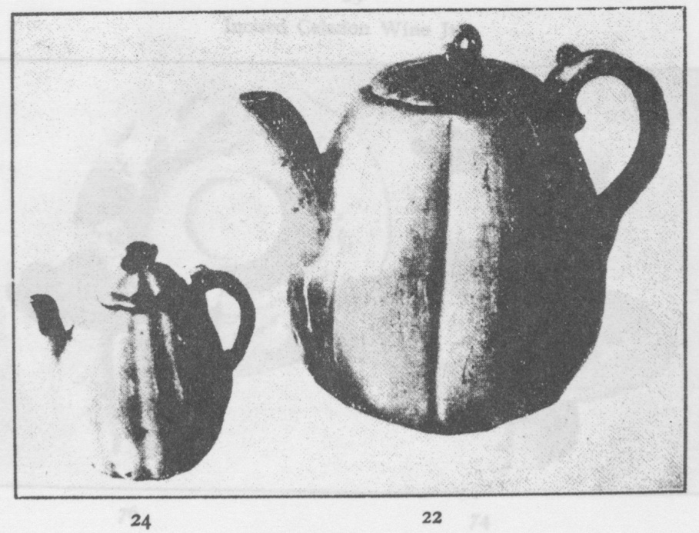

Incised Celadon Tea Pots.

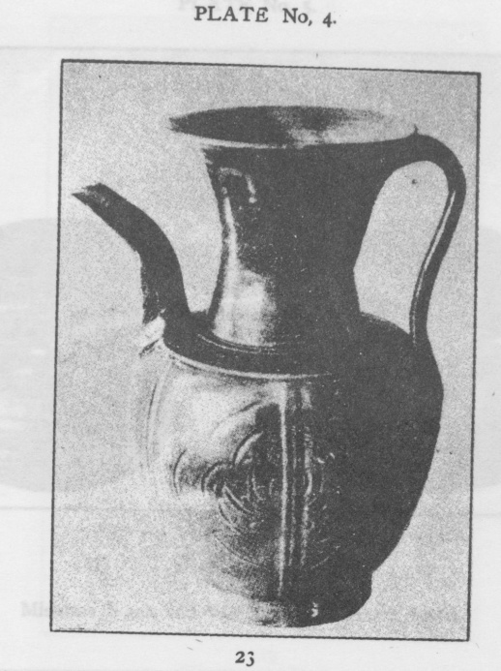

Incised Celadon Wine Jug

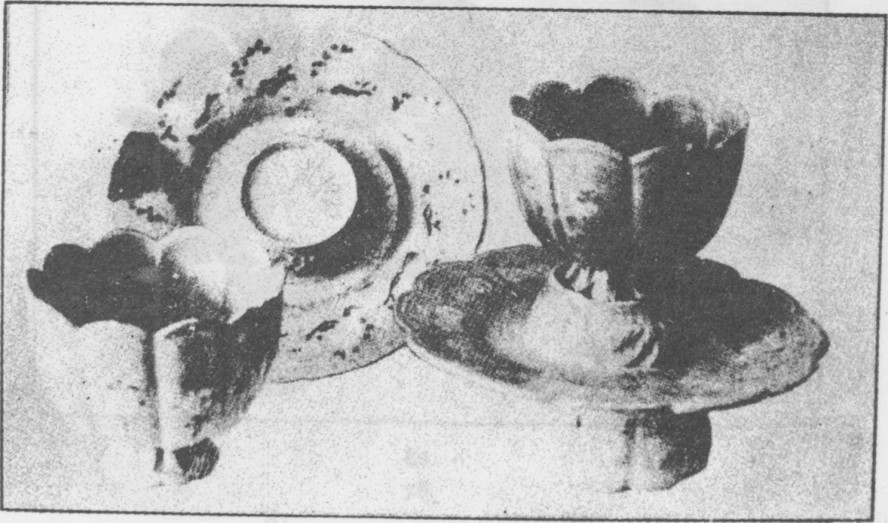

Mishima Black and White Inlay Cup and Stand

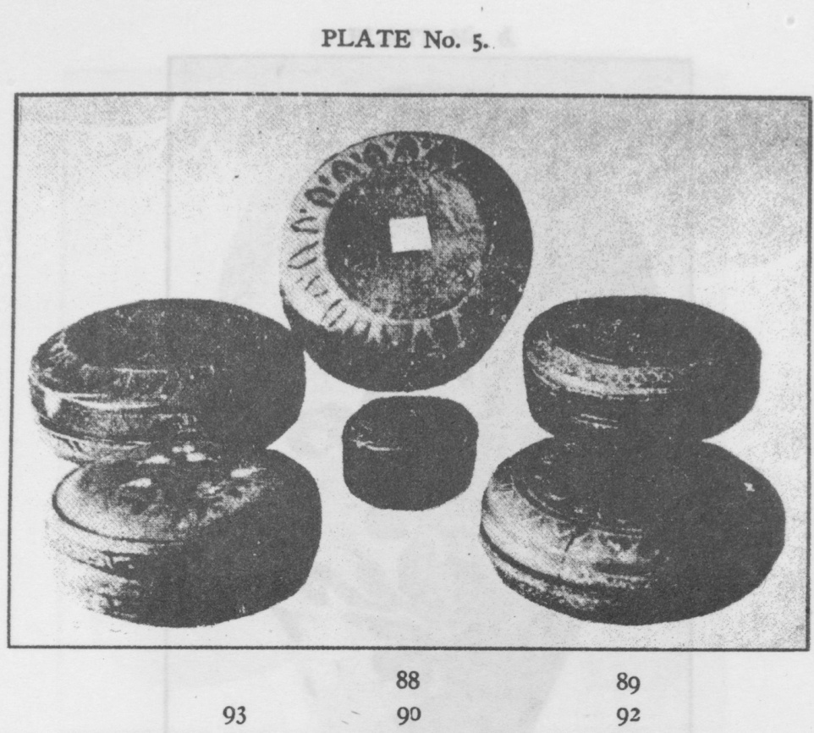

Mishima B ack and White Inlay Pigment Boxes.

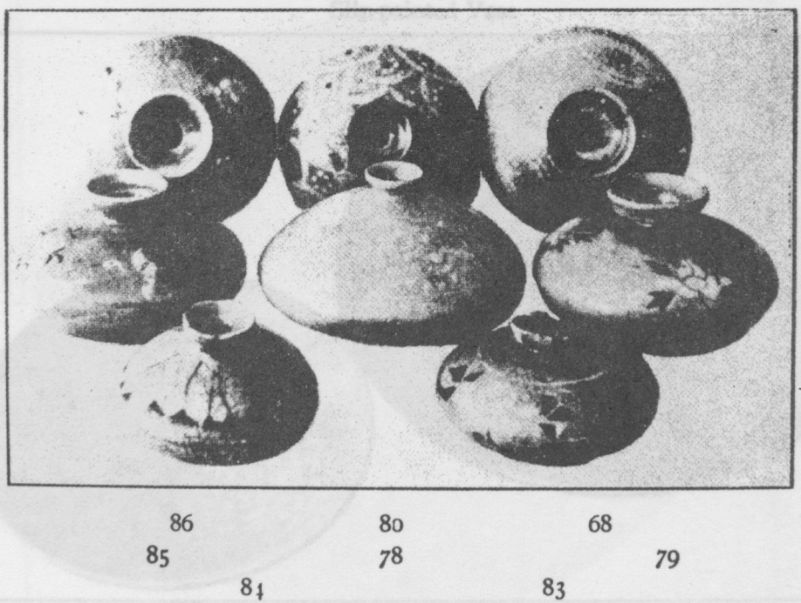

Mishima Oil Bottles

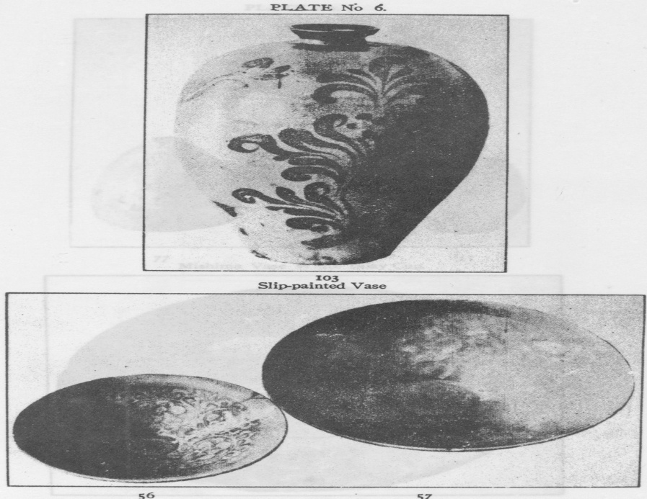

Celadon Bowls, Decoration in Relief.

