DIARY OF A TRIP TO SUL-AK SAN

(Via the Diamond Mountains.) June 4th-20th, 1923

A precedent has already been created for publishing such a diary in the Transactions of the Royal Asiatic Society in that Dr. Gale published his interesting diary of a trip to the Diamond Mountains in Vol. XIII, 1922.

The chief interest in this diary now presented is that to most foreigners in Corea the Sul-Ak Mountains are unknown. As far as I am aware, the late Bishop Trollope and I were the first foreigners to visit these mountains, and by the publication of this diary many will perhaps be moved to visit the places recorded.

The Sul-Ak Mountains (雪岳山 셜악산) (The Mountains of Snow) are in In-Jay District (麟蹄郡인제군) in the Pro-vince of Kang-Won. This range is said to be covered with snow later into the year than any other mountains in Kang- Won Province. The mountains are now listed by the Government as a National Reserve. They can be approached by road from Seoul via Su-Won, YoJu, Won-Ju and Hong- Chun or, as we approached them, down the East Coast from Wonsan,

The object of our journey was first to visit Kyen-Pong- Sa, a temple on the spur of the Diamond Mountains near Kan-Song; then to pass over Sul-Ak-San, eventually walking down the coast to Kang-Neung, and inland to O-Tai- San (五臺山오대산). We were, however, prevented from getting to O-Tai-San since after sixteen days’ walking and sight-seeing our purses were reduced and our shoe leather worn out, so that on reaching Chu-Mul-Li, a port on the East Coast, we took ship to Po-Haing and returned from there by train via Taikyu to Seoul (After Bishop Trollope’s death I visited O-Tai San with Bishop Cecil in 1930 and a diary of the journey was kept and may be published at a later date). [page 2]

This diary is really a combination of two accounts of the journey, one kept by Bishop Trollope and the other by myself. In the published account whenever the first person singular is mentioned it refers to the editor of these notes, but the larger part of the diary is taken from Bishop Trollope’s account, and my account only supplements the Bishop’s diary.

The chief points of interest in this diary are:—

(a) The Reliquary said to contain the teeth of the his-toric Buddha at Ken-Pong-Sa. As far as I know this is the only Reliquary in Corea which professes to have any relics of the real Buddha; this links us, at least in thought, to the “Temple of Buddha’s Tooth’’ at Kandy in Ceylon.

(b) The outstanding beauty of the scenery of Sul-Ak- San, especially that in the immediate neighbourhood of O-Sai-Am.

(c) The link which we have with Tibet and the Dalai Lama at Nak-San-Sa on the East Coast of Corea.

It was my privilege to lecture on this tour at an annual meeting of the Society held in Seoul 4th June, 1934.

CHARLES HUNT.

[page 3]

On Monday, 4th June, 1923, we left Seoul by the 8:15 a. m. train, taking with us our Corean servant, who went with our heavy luggage to Won-San and then by boat to Chang-Ch’un(長箭쟝젼) with orders to join us later at Ko-Song (固城고셩)，whilst we left the train at Pyeng-Kang (平康평강) We arrived at Pyeng-Kang at 12:30 p. m. (our barometer registered 1,000 feet) and we left immediately for Chang-An Sa (長安寺쟝안사), our motor bill being Yen 11.30. The road was rough in places, but all the bridges were in repair, except the one over the gorge river which the motor crossed a in boat

We noticed again that the few villages through which we passed looked clean and prosperous. A cold sea mist shrouded the pass between Sin-An and Wha Chon and again between Wha-Chon and Mal-Hoi-Ri. The village of Mal-Hoi-Ri had just been rebuilt after a fire of a year or two before when the village had been destroyed. Reached Chang - An - Sa, in the Diamond Mountains, (barometer, 1,700 feet) at 7:30 p. m., and stayed the night in the hotel which was still housed in the old monastery buildings. On Tuesday, June 5th, after breakfast, we purchased straw shoes and sticks from the little shop outside the temple and set off at 9:30 a. m. with two carriers (each costing Yen 2.00 a day for going and Yen 1.00 a day for returning empty) and made for Yu-Chom-Sa. We reached Mahya-Am at 11:30 a. m. where we found the monks were holding a three months’ retreat. They looked very picturesque in their robes and hoods as they stood or knelt in the temple.

At 1:00 p. m. we reached An-Moo-Choi (內務在嶺뇌무죄령) Pass (barometer registering 4,000 feet) and just over the crest we stopped for lunch. The season seemed dry and rather backward. However, we noticed plenty of purple and white lilac, weigelia and columbine, but the magnolias were only in bud. The pink azaleas (already faded lower down) were a wonderful sight for the last 1,500 feet, where the ground was almost carpeted with pink primulas and marsh marigolds. Bird cherry was in flower and very nume-[page 4] rous near the top of the pass. Some little way down the pass we plucked wild white peony. Stopped for a bathe just before we reached Yu-Chom-Sa (barometer, 2,100 feet) at 7:00 p. m. We stayed the night at an inn run by the monks.

Early the next morning, Wednesday, June 6th, I viewed the temple and saw the reredos in the main shrine—the rere- dos containing figures of the famous Buddhas—originally fifty-three in number but now only forty-two. I saw, also, the well which was supposed to have sprung up owing to a magpie pecking the rock for the historic fifty-three Buddhas to drink from. We left at 8:30 a. m. on Wednesday, June 6th, and set out for Ko-Song. We went over Kai-Chan-Yong (開殘嶺개잔령) “Deer Neck Pass” (barometer, 2,350 feet) and walked to Po-Hyen-Tong, where we stopped for lunch at about 1.00 p. m.

The vegetation was more advanced on the east slope of Kai-Chan-Yong, the magnolia and styrax being especially beautiful and in flower. Among the trees hornbeam was very plentiful. The country is thickly wooded. There were also masses of white and red dog-roses, “rugosa roses’’, purple lilacs and syringa.

We reached the village of Paik-Chun at 12:00 noon, but pressed on to the village of Po-Hyen-Tong. It was very hot in the plain at the foot of the mountain. We reached Ko-Song-Eup (固城邑고셩읍) and met our servant at about 6:00 p. m. We stayed for the night at Tong-Il Inn (“The First Hotel in the East).” Ko-Song-Eup is a picturesque little town with rocky hillocks and a pretty stream close by.

We spent the next day, June 7th, at Hai-Kum-Kang

A beautiful, clear sea—we bathed and spent a perfect day by the shore. At lunch-time we noticed a bird with a light-blue head, dark-blue wings and a crimson breast This bird was obviously a rock-thrush. Later we saw many more of the same kind.

In the evening I went to Sam-Il-Po (三日浦삼일포) (“Three Inland Lakes”), which in the evening looked cold, eerie and forbidding.

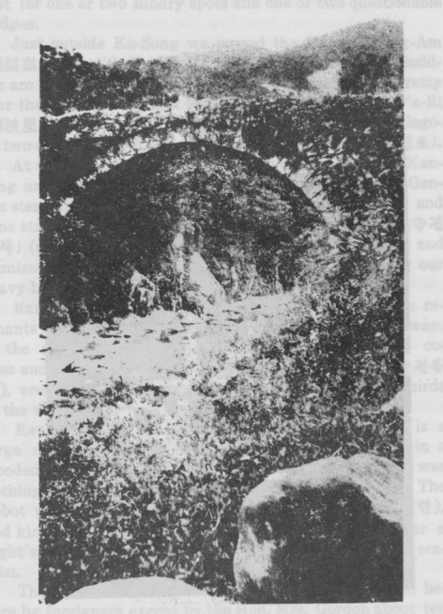

PLATE 1.

A Fourteenth Century Bridge

between Kan-Song (杆城) and Ken-Pong-Sa (乾鳳寺)

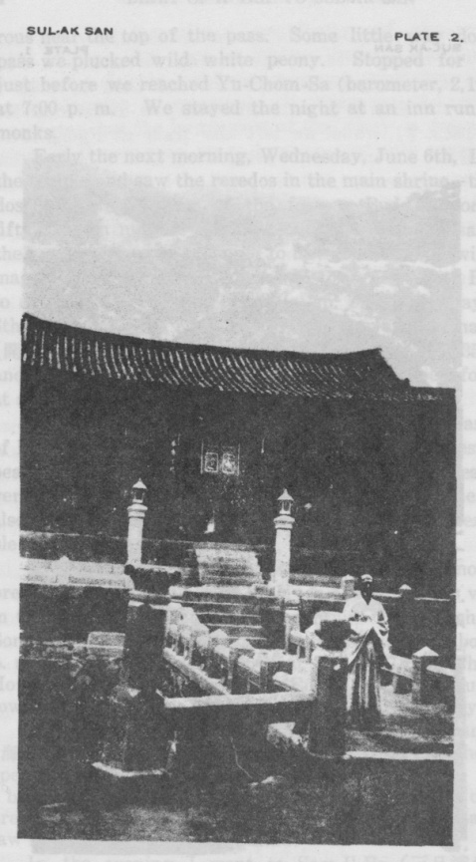

PLATE 2.

Entrance to Ken-Pong-Sa (乾鳳寺)

[page 5]

On Friday, June 8th, having arranged for a private motor (a very shaky vehicle) to take us over the 100 li down the coast to Kan-Song (杆城간셩), we left a little after 8.00 a. m. A picturesque road down the coast, and good except for one or two sundry spots and one or two questionable bridges.

Just outside Ko-Song we passed the Hyeng-Chong-Am (懸鍾器현종암) “bell rock” on which the fifty-three Budd- has are said to have hung their bell. The road keeps pretty near the coast for the first 60 li or so, passing Myeng-P’a-Ri (明波里명파리), and turns inland, around the beautiful lagoon two or three miles long at Wha-Chin-P’o (花津浦화진포).

At Cha-San-Ri (慈山里자산리) (about 20 li short of Kan- Song and close to the sea front of Kan-Chin-Ri where Gen- zan steamers stop) we might as well have left the car and gone straight up the valley direct to Ken-Pong-Sa (乾鳳寺건봉사) (about 20 li direct) ； but we went on to Kan-Song and dismissed the car there, stopping for lunch and leaving our heavy baggage in a Corean inn.

Kan-Song is a picturesque little town enclosed in the remnants of old earth-works measuring about 1/4 mile each way. In the afternoon (very clear) we walked with two coolies and our servant up the hill to Ken-Pong-Sa (乾鳳寺건봉사), crossing a good arched stone bridge about two-thirds of the way.

Ken-Pong-Sa, “The Heavenly Phoenix Temple”, is a large monastery about 800 kan, beautifully situated in a wooded valley about 1,000 feet above sea level. There was nothing remarkable in the mountains or vegetation. The abbot was a very polite and charming man (李太逮리태련), and kindly caused us to be housed in his sarang. After a night’s rest we awoke to find the place shrouded in a sea- mist

The abbot took us all over the temple (never visited before by foreigners except by the Hon. Mrs. Gordon about ten years earlier), which according to one account was founded in the reign of Pop-Hung-Wang (法典王법흥왕), A. D. 514-540, [page 6] by Pal-Jing-Pop-Sa (發徵法師발징법사). (The abbot said that one monk Man-Il-Whai having associated thirty other men in this place with himself for thirty years’ prayer, he disappeared in Kung-Nak-Say, and there has been a tradition of continuous prayer ever since).

Another account says that the monastery was founded about A. D. 520，and that a Chinese named A-Do-Wha-Saing (阿道和尙아도화샹) first came to this site; but tradition is stronger in favour of Pal-Jing Pop-Sa, who founded the temple with thirty monks. They meditated for thirty years in this spot, and at last Amida came and took them away；but Pal-Jing-Pop-Sa refused to go, saying he must first save others. Amida came several times for him and at last persuaded him to leave.

A third account says that the original name of the temple was Won-Kak Sa.

In a. D. 758 in the first year of Tang-Suk-Chong (唐肅宗당숙종), Pal-Jing-Pop-Sa founded his Mi-T’ha-Man-Il-Whai (彌陀萬日會미타만일회) “The Society for Meditating ten thousand days” and after twenty-one years his thirty companions were suddenly translated to paradise, and the name of his monastery changed to Soh-Pong-Sa, then to Ken- Pon-Sa.

In A. D. 1465 King Syei-Cho (世祖세조) paid a famous visit here, giving the monastery great privileges which were confirmed by later kings. The relics were stolen by the Japanese in A. D. 1592. In 1846 a great forest fire destroyed many of the buildings.

In 1878 a terrible fire practically wiped out the monastery, 3,183 kan of buildings being destroyed. After this only two-thirds of the buildings were repaired.

The monastery is a collection of at least four great monasteries, each complete in itself with a Great Chamber and also—which is uncommon—separate studies for each monk, from twenty to forty in each building. There is a large burying-ground full of Poo-Tau (cone-shaped tombstones) about 1/4 mile before reaching the main buildings.

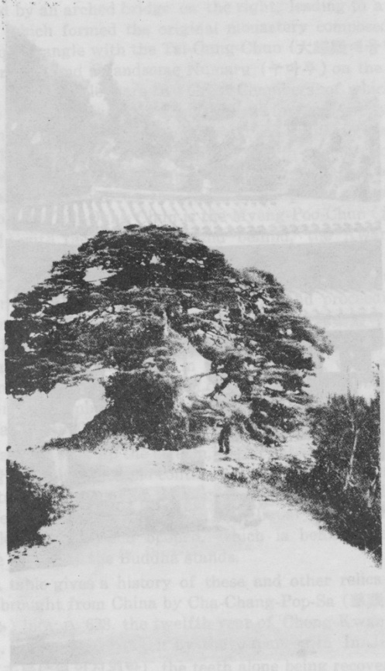

PLATE 3.

“Pinus densiflora”

on the East Coast Road between

Kan-Song (秆城) and Hang-To-Won (杏桃源)

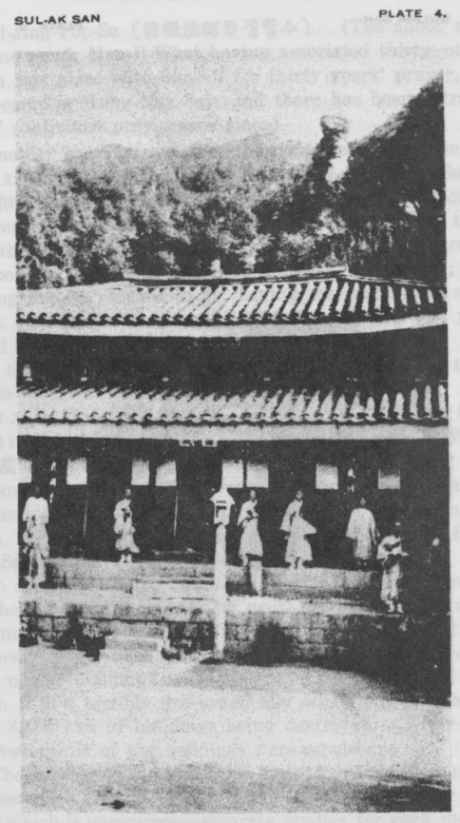

PLATE 4.

The Temple of O-Sei-Am (五法鬼) in the Mountains of Sul-Ak (雪岳山)

[page 7]

In approaching the buildings the deep gully is seen to be crossed by an arched bridge on the right, leading to a large group which formed the original monastery composed of a large quadrangle with the Tai-Oung-Chun (大雄殿대웅전) on the far side, and a handsome Numaru (누마루) on the other side. Right and left are two Great Chambers, of which that on the left is now used as a boys’ hostel for the seventy students in the temple school, and that on the right is called the Man-Il-Whoi-Chun (萬曰會殿만일회년) (in memory of the founder’s devotions). Opening out of this is a special Hall of Meditation, besides the special studies for the monks. East of the Tah-Oung Chun is the Myeng-Poo-Chun (溪府殿명부뎐) with the ten kings, and behind, the Kwan-Eun-Chun with pictures and images of Kwannon (觀昔관음). To the west is the Sa-Sung-Chun (四聖殿시^13) with the sixteen Nahan. Returning to the bridge and proceeding up the stream one finds the Keuk-Nak-Chun (極樂殿극탁13), with the Great Chamber and separate studies. Farther up the stream is the Nak-Soh-Am (樂西庵락셔암), with a similar complement of buildings, in one of which the abbot lives. The Great Chamber is fifteen kan with a kitchen almost as large and a quadrangle of separate studies.

Farther still, up the stream, is the Pal-Sang-Chun (八相殿팔상뎐), with a temple containing the Pal-Sang (八相팔상) and standing in front of the pagoda beneath which are buried twelve of Buddha’s teeth. This reliquary is seen through a little window when opened, which is behind the altar where generally the Buddha stands.

A table gives a history of these and other relics which were brought from China by Cha-Chang-Pop-Sa (慈藏法師자장법사) in A. D. 638, the twelfth year of Chong-Kwan (貞觀졍관). They were taken by the Japanese.in Im-Jin-Wah Ran (壬辰倭亂임진왜란), the teeth alone being recovered by Sa-Myeng-Tah Sa (四漠大師사명대사), who was sent to Japan as an envoy by the king. Adjoining this is a hall with forty-three portraits of famous abbots of this temple, the [page 8] most important being that of the founder, Pal-Jing-Pop-Sa, painted by Soh-San-Tah-Sa and Soh-Myeng-Tah-Sa.

On Saturday, June 9th, we climbed up to Po-Rim-Am (普林庵보림암) behind Ken-Pong-Sa--一most romantic climb up the valley to a monastery situated on a precipice. Here we were wrapped in a mist but we were able to see the beautiful waterfall below us. There were two monks in this small temple but generally only one resides there.

In the evening, after returning to Ken-Pong-Sa, the abbot brought out his books for us to see and gave us the history of the monastery. Sunday, June 10th: still very misty.

We left Ken-Pong-Sa at about 9.00 a. m. and reached Kan-Song-Eup at about 11:00 a. m. Left Kan-Song-Eup at about 11:30 a. m. and walked 20 li by the sea, paddling all the way, to a place called O-Ho-Ri (五湖里오호리), where we lunched, and left again at 3.00 p. m. and walked 20 li to a village called Hang-To-Won (杏桃源행도원) at the foot of the Sai-Ryeng (大間嶺대간령). Here we slept. Heavy mist and clouds all night

We left at 7:00 a. m. on Monday, June 11th; a steep climb up Sai-Ryeng (barometer, 2,600 feet) through dripping clouds; beautiful vegetation, flowering magnolias, styrax and syringa, and reached the top of the pass at about 10:00 a. m. The weather was quite clear on the other side of the pass.

A gradual descent by Ch’ang-Whai and Yong-Tay-Ri to Ka-P’yek on the Seoul road. We lunched at Ka-P’yek, then turned on the left, up the romantic Paik-Tam (百潭백담) Valley (“The Valley of one hundred pools”) for 200 yards the road pegged on the cliff, then up 25 li to Paik-Tam-Sa (‘‘The temple of one hundred pools”).

The evening clouded again, with thunder and lightning at night The monastery and surroundings (about 2,000 feet) uninteresting. Recently rebuilt

On Tuesday, June 12th, we left Paik-Tam-Sa at 9:30 a. m. A lovely day. Passed up a romantic gorge full of pools as far as Yong-Si Am “The Temple of the Long Arrow”

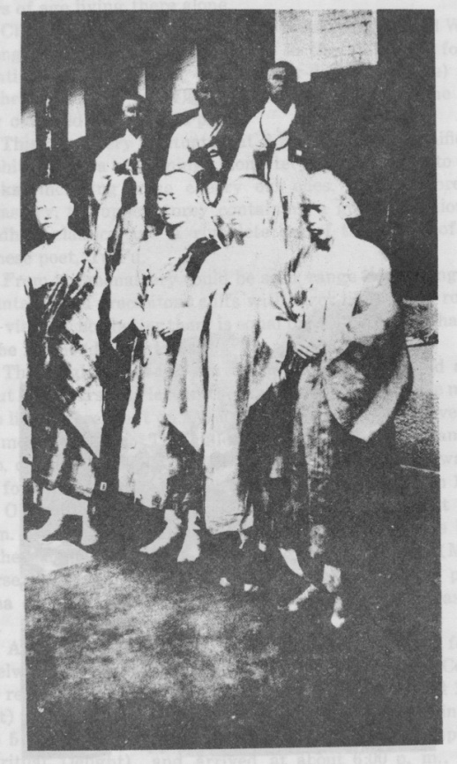

PLATE 5.

Buddhist Monks at the Temple of O-Sai-Am (五歲庵)

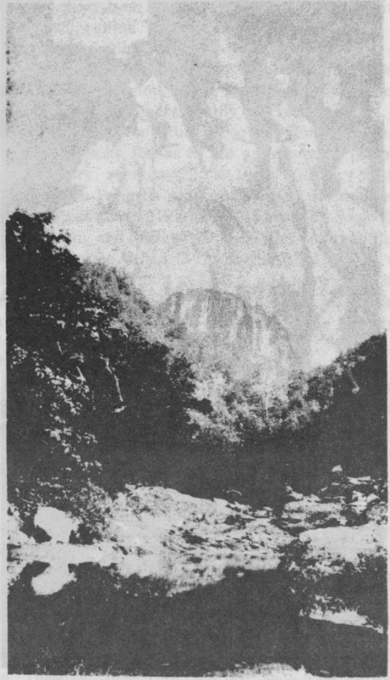

PLATE 6.

Mirror Rock in the precincts of Shin-Hung-Sa(神典寺)

[page 9] (永矢庵영시암), a fine building. One old monk over eighty years of age living there alone.

Climbed up the hillside, leaving the stream, passed Won- Myeng-Am (圓明庵원명암) (where in the valley we found quantities of the flower called Coeur-de-Notre-Dame) and reached O-Sai-Am (五歲庵오계암) “The Shrine of the five year old child，, about 1:00 p. m.

This monastery is situated at 3,200 feet in a magnificent amphitheatre—a charming monastery with eight to ten monks, including some cheery old ones. A two-storeyed monastery, the upper storey containing a good collection of Buddhist classics and a complete set of the works of the Chinese poet, Tu Fu.

From the monastery could be seen range after range of mountains and precipitous cliffs with razor-like edged rocks. The view, if not better than, is equal to that seen at Mahayam in the Diamond Mountains.

The origin of O-Sai-Am is that ages ago a child aged about five years was left in the small temple whilst the monk who lived there went on a jonrney. Heavy snow prevented the monk’s return. The child was nourished by Kwannon, who, on the return of the old monk, vanished—flying away in the form of a blue bird. The monastery was rebuilt in 1878.

On Wednesday, June 13th, we left O-Sai-Am at 8:30 a. m. We struggled 1,500 feet up the precipice at the back of the temple to the Mal-Tung-Ryong (馬等嶺마등령) (Many Horse Pass) which is 4,700 feet, where is a glorious panorama down through precipices and gorges to the eastern sea.

A very strenuous walk took us three hours, and I found eidelweiss on the rocks—the first time I have seen it in Corea. We reached the bottomof the valley at 1:00 p. m. (about 1,500 feet) where we lunched and rested by a pool before going on the 5 li to Shin-Hung-Sa (神興寺신흥사) (The Temple of Spiritual Delight), and arrived at about 6:00 p. m., very tired. We bathed in a glorious pool in which was reflected a great, mirror-like rock. [page 10] Shin-Hung-Sa, a fine monastery with ten or twelve monks, dates back to Silla days, but was rebuilt on its present-site 280 years ago. The site of the old temple is marked by a pagoda 5 li down the road ； a romantic situation with a view up the valley to Oul-San-Pong (蔚山峯울산봉) which should be visited for its Am-Ja.

At Shin-Hung Sa the Pop-Tang called Keuk-Nak-Po- Chun;極樂普殿극락보뎐) is a handsome old building with three fine Buddhas and some interesting frescos on the walls, old book-plates, and the usual furniture; also a marble candlestick and marble incense-burner. A fine, large Great Chamber with offices at the back facing a fine hall (very neglected) of portraits of former abbots; a very fine, handsome maru 60’ x 30’ completes the quad. There is also a Temple of the Kings and, a fine Ch’un-Wang-Mun(天王門천왕문) This temple and its neighbourhood would repay another visit and more study.

We left at about 1:30 p. m. on Friday, June 15th, and walked down the valley to the sea at Mul-Chi (about 30 li), passing a fine group of Poo-Tau, and then 10 li to Nak-San- Sa (洛山寺낙산사) which we reached at 6:00 p. m., and slept there. The temple stands on a wooded undulation known as O-Pong-San (五峯山오봉산) about 700 feet above the sea, on which it looks down. It was formerly enclosed in a fortified wall about 1/4 of a mile each way, with gates. The temple consists of an enclosure surrounded by a high tiled wall, all of flat red bricks, containing three chief houses —all rebuilt about A. D. 1890:—

1. The Won-T’ong-Po-Chun (圓通資殿원통보뎐) (Shrine of Kwannon). This contains two large figures of considerable dignity, well carved and coloured, seated side by side; Kwan-Syen-Posol, white with coloured clothes, and Yeng-Chun-Posol, all gilt with the usual embroidery; and there are the usual pictures on the walls.
2. TheYong-Sam-Chun (靈山殿령산뎐) (The Spi-ritual Hill Shrine) contains the usual Syek-Ka-Yau-Rai

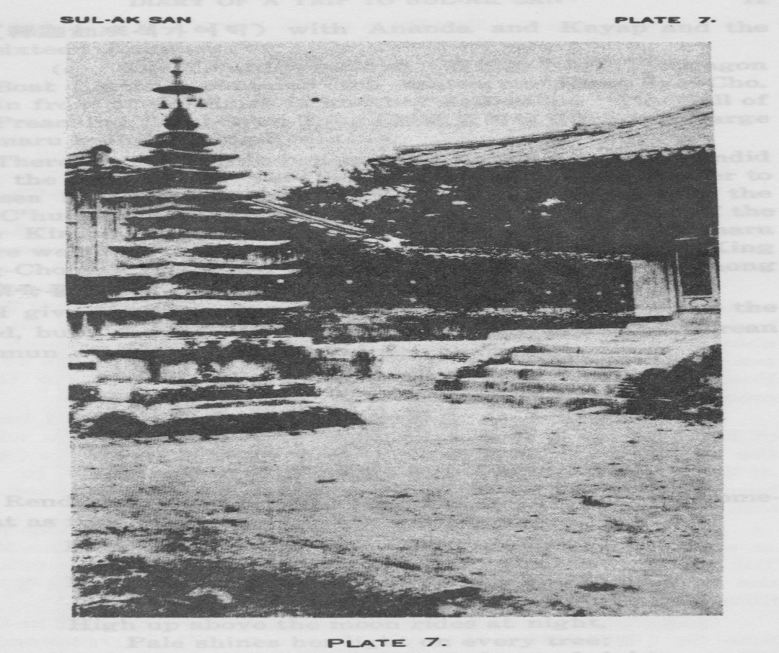

The Pagoda at Nak-San Sa (洛山寺) [page 11]

(釋迦如來석가여래) with Ananda and Kayap and the sixteen Aahans.

(c) The Yong-Syen-Chun (龍船殿용선전) (Dragon Boat Shrine) contains the tablets to King Syei-Cho. In front of the court is another hall called ‘‘The Hall of Preaching,” Sul-Syen-Tong (說禪堂설선당), with a large maru built by King Syei-Cho.

There is also a large bell-tower with a bell of a splendid tone, the gift of King Yei-Chong, A. D. 1469. Still nearer to the sea is the great gate (大門대문), and nearer still the Koo-C’hun-Wang-Mun (九天王門구천왕문) (The Gate of the Nine Kings), containing four large figures. On the maru where we slept there are two boards with writings by King Song-Chong (成宗성종) and a poem by King Seuk-Chong (肅宗숙종).

I give below the poem, the Chinese only being on the board, but I think that it may be useful to write the Corean eun-mun at the side of the Chinese characters.

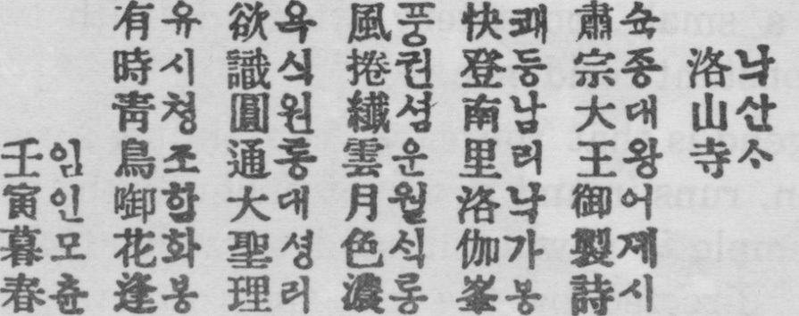

Rendered into Western verse, the poem would run somewhat as follows:-

Merry of heart the high hill I ascend,

Near the village, south, by the sea:

Long the walls stood, the temple to defend,

Ere now, they give shelter to me.

High up above the moon rides at night,

Pale shines her light on every tree;

Clouds by the soft winds rolled out of sight,

Heaven and earth are set free. [page 12]

Sive me the Buddha’s mind, pierce me with light,

Let me think on doctrine and decree:

Turn the wheel of time; purify my sight;

Shave my head, and mark my rosary.

Goddess of Mercy, why with this flower

Flies the Blue Bird from tree to tree?

Would’st thou I lay aside all kingly power,

And, is this thy call to follow thee ？

The other board records the gifts of King Song-Chong. The reason why the temple is called Nak-San-Sa is because of its resemblance to the place where the Dalai Lama dwells in Tibet, where also is the house of Kwannon, the Dalai Lama being a manifestation of Kwannon.

About 1/2 a mile to the north is a little promontory on which the founder, Oui-Sang-Pop-Sa (義相法師의상법사) had his vision of Kwannon, and perched on the rocks 50 feet above the sea, over the cave mouth in and out of which the sea washes, is a little shrine with a very sacred image of the Posol, and a small monastery attached, with two or three monks in constant residence.

The legend is that the cave, containing a sacred image of Kwannon, runs inland to a spot underneath that on which the main temple is now built, and to which Oui-Sang (義相 의상) was directed by the presence of Kwannon to two bamboos, which he was told to look for there. Bamboos are still cultivated in the temple grounds.

The temple history, a printed book, says Oui-Sang-Pop- sa was born in the eighth year of the Emperor Ko-Cho-Moo- Tok (高祖武德고조무덕) of the Tang dynasty, A. D. 625, in the forty-seventh year of King Chin-P’yeng (眞平진평) of Silla.

In A. D. 661 he went to China and studied under Chi-Om- Syen-Sa (智嚴禪師지엄선사)연In. A. D. 671 he returned to Silla in the eleventh year of Mun-Moo-Wang (文武王문무 왕), and in A. D. 702 he died, then in the seventy-eighth year

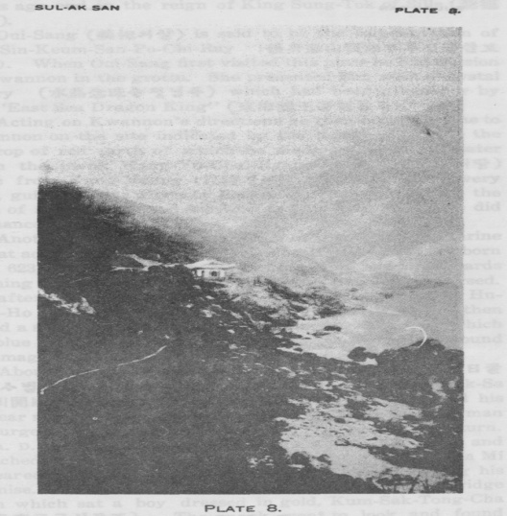

The Path to the Shrine of Kwannon (教普底)

near Nak-San-Sa (洛山寺)

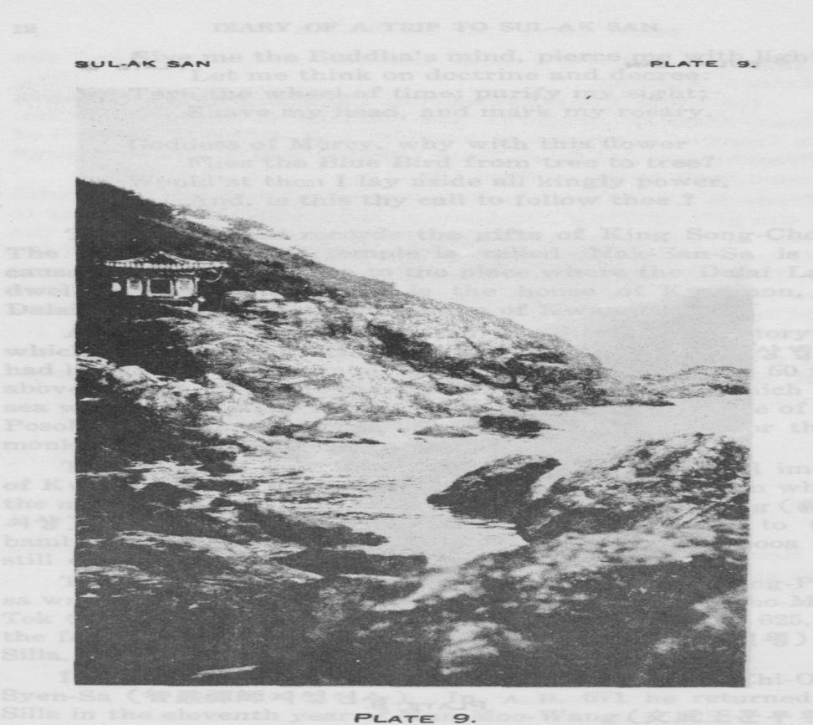

The Shrine of Kwannon (觀昔庵)

“on the rocks over the cave mouth in and out of which the sea washes”

[page 13] Oui-Sang (義相의상) is said to be the reincarnation of Hoo-Sin-Keum-San-Po-Chi-Ray (後身金山寶知來후신금산보지래). When Oui-Sang first visited this place he had a vision of Kwannon in the grotto. She presented him with a crystal rosary(水晶念珠수정념주) which had been given her by the “East Sea Dragon King” (東海龍王동해용왕).

Acting on Kwannon’s directions he then built a shrine to, Kwannon on the site indicated by the bamboos and by the outcrop of red earth of which he made an image. Later when the monk Kang-Yu-Chai-Ryang (公庾才良공유재량) came from Kang-Neung (江陵강능), prostrating at every pace, guidance was given by Kwannon who appeared in the form of a blue bird and led him to the cave where he did obeisance.

Another version of the founding of this Kwannon shrine is that according to the vision of Won-Hyo (元曉원효) born A. D. 623, a woman was seen plucking corn and afterwards washing a cloth in a stream, and with her he conversed. She afterwards changed into a blue bird; and said that Hu- Chai-Ho (休醍醐휴제호) was spiritually blind. He then found a single shoe on the ground under the tree from which the blue bird spoke, and when he got to the temple he found the image of Kwannon with only one shoe.

About A. D. 830 Kul-San-Cho-Sa-Pom-Il (堀山祖師梵日굴산조사범일) went to China and at Myeng-T’chun-Kai-Kuk-Sa (明川開國寺명천개국사) met Sa Mi (沙彌사미) who had his left ear missing, and who claimed to be a fellow-countryman and urged His Reverence to build him a temple on his return. In A. D. 847 he returned and first built Kul-San-Sa and preached there. In A. D. 858 he had a dream in which Sa Mi appeared and rebuked him for his tardiness in fulfilling his promise. Going to the village indicated he found a bridge upon which sat a boy dressed in gold, Kum-Sak-Tong-Cha (金色童子금색동자). The monk went to look and found under the bridge a stone Buddha with his left ear missing.[page 14]

He decided this was Chung-T’choi-Po-Sal (正趣菩薩정취보살) and built a temple to him.

In a great fire a hundred years later everything was destroyed ‘except these two temples. In the time of the Japanese invasion, 1613-1614, the two sacred images and the rosaries were removed to Yang-Yang (襄陽양양) and recovered many years after by a monk named Cho-Shin (調信조 신). The temple was visited by King Sai-Cho (世祖세조) on his eastern progress in A. D 1468.

On Friday, June 15th, we left Nak-San-Sa about 2:30 p. M. and went on to Yang-Yang, a quaint old town a little inland from the sea, and reached there at 4:00 p. m. We slept there and paid off the coolies for 250 li.

The next day we set out for a small port called Chu- Mul-Li (主文里주문리), having decided to give up our trip to O-Tai-San.

The first 10 to 20 li was through typical inland country and the walk was very trying and hot, but about noon we again reached the coast and walked for 60 li by the side of the sea, passing on our right some very pretty inland lakes or lagoons. We reached the port of Chul-Mul-li at 6:00 p. m. Here the sea is very clear and very blue, though we could find no decent spot for a bathe—Japanese houses were all along the sea front On Sunday we walked to another bay where was good bathing.

On Monday evening, June 18th, we left by steamer for Po-Haing and sailed at midnight. On Tuesday, June 19th, at daybreak the vessel stopped at Sam-C’hok (三涉삼척) then later at Pyeng-Hai (平海평해) and Yong-Hai, and at sunset we arrived at Yong-Tok (盈德영덕).

We sailed again at midnight and reached Po-Haing (浦項 포향) on Wednesday the 20th at 5:00 a. m., and boarding a light railway we reached Taikyu at 4:30 p. m., and changing there took the night train to Seoul.