LIST OF MEMBERS

THE ROYAL ASIATIC SOCIETY—KOREA BRANCH

LIFE MEMBERS

ORDINARY MEMBERS

HONORARY MEMBERS



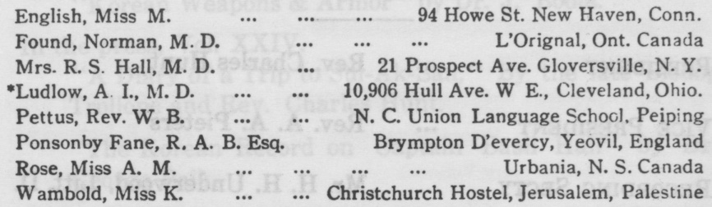

LIFE MEMBERS

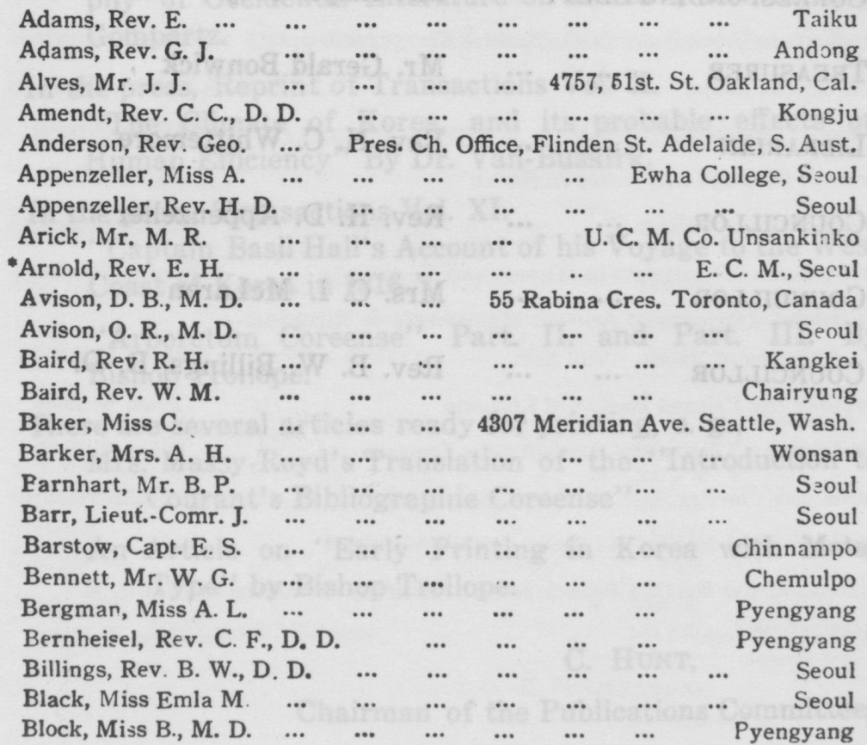

ORDINARY MEMBERS

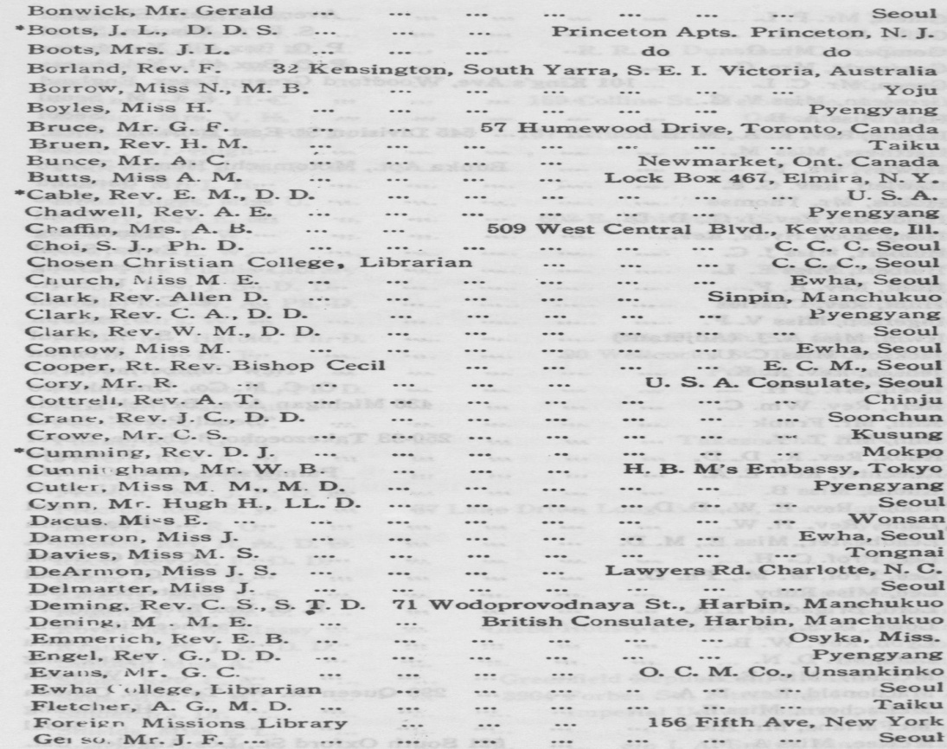

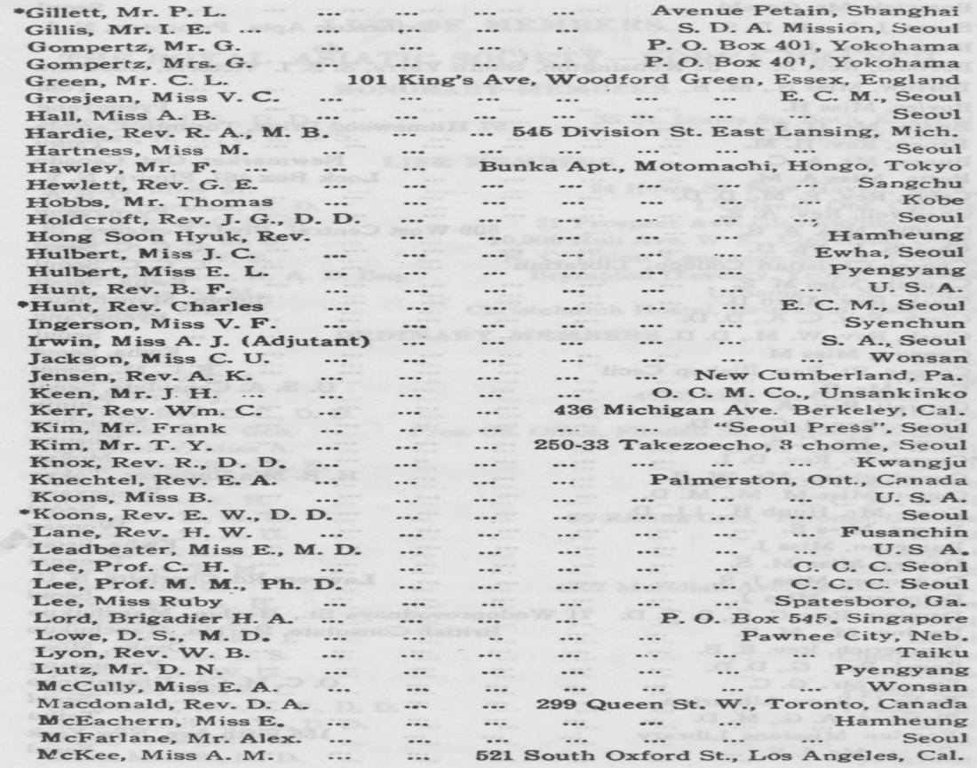

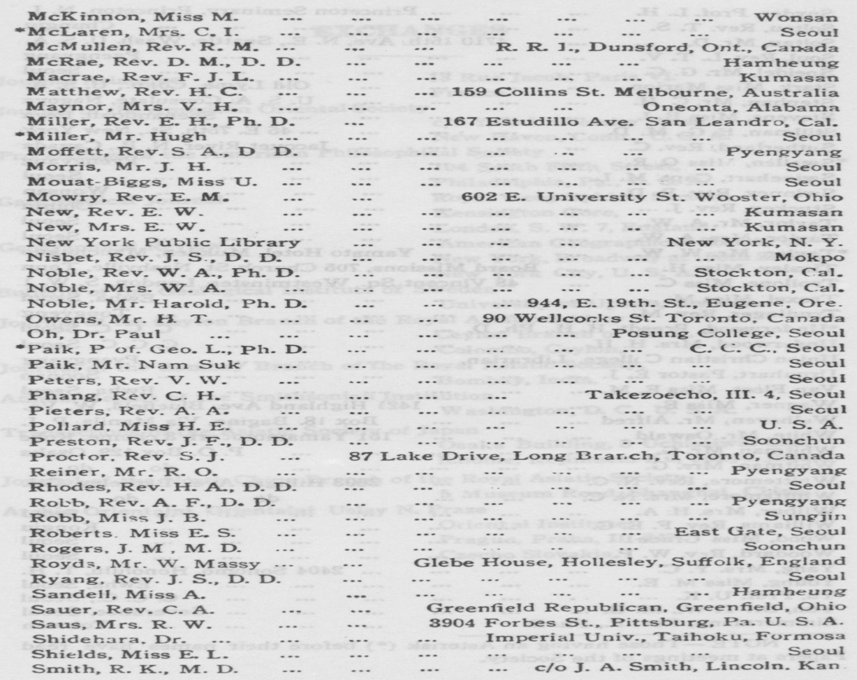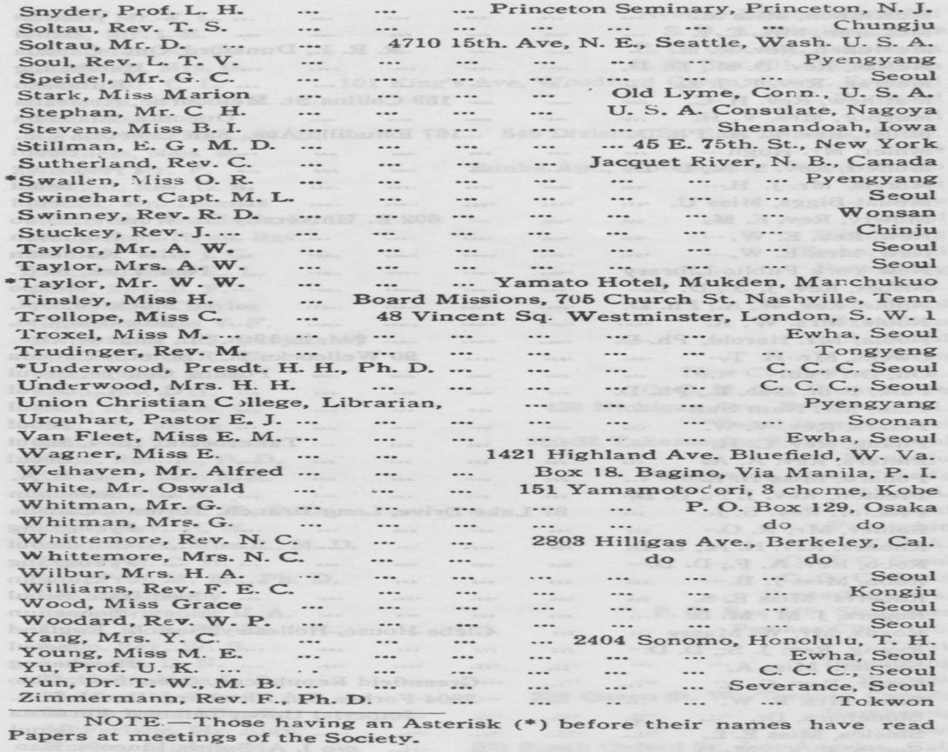

EXCHANGES

Journal Asiatique 13 Rue Jacob, Paris VI.

France

Journal of the American Oriental Society

c/o Yale University Press, New Haven, Conn., U. S. A.

Proceedings of the American Philosophical Society

104 South Fifth Street, Philadelphia, P., U. S. A.

Geographical Journal Royal Geographical Society,

Kensington Gore,

London, S. W. 7, England.

Geographical Review American Geographical Society of

New York, Broadway at 156th Street, New York City, U. S. A.

Bulletin of the Geol ogical Institute of Sweden

University of Upsala, Sweden.

Journal of the Ceylon Branch of the Royal Asiatic Society

Ceylon Branch of the R. A. S., Colombo, Ceylon.

Journal of the Bombay Branch of the Royal Asiatic Society,

Bombay, India.

Annual Report of the Smithsonian Institution

Washington, D. C., U. S. A.

Transactions of the Asiatic Society of Japan

Osaka Building, 3 Uchisaiwai Cho, Ichome, Kojimachi-Ku, Tokyo, Japan.

Jourzial of the North China Branch of the Royal Asiatic Society

5 Museum Road, Shanghai, China.

Archiu Orientalni, Orientalni Uslav N. Praze

Oriental Institute,

Prague, Praha, III-347

Czecho Slovakia.