[page 3**]**

**CERAMIC HISTORY OF THE YI PERIOD**

by G. St. G. M. Gompertz

Pottery and porcelain are the best-known and in some respects the most important artistic products of Korea. The reasons for this are, first, that the celadons and other wares of the Koryŏ period have become so famous and are considered equal to the finest products of Sung China and, second, that the much less known porcelains of the Yi period have exercised enormous influence on Japanese ceramics and hence on the work of leading artist-potters in Japan, England and America. It is with these later Yi period wares that I propose to deal tonight, because you will not be able to find any comprehensive survey in any Western language, whereas the Koryŏ wares have been the subject of many articles and a few books, which are available to those interested.

The study of Koryŏ pottery has been impeded by the lack of reliable information concerning most of the specimens which have survived. This has resulted mainly from the wholesale pillaging of ancient tombs by unauthorized excavations. However, a few examples were recovered from dated tombs under proper scientific supervision, while many others were found to bear inscriptions which provided some evidence of the time when they were made.

When we come to the Yi period, the situation is still more baffling. The burial of ceramic and other wares in tombs persisted for only a short period until the strict observance of Confucian precepts put an end to the practice. Just when this took place is difficult to determine. The founder of the dynasty, King T’aejo, was a devoted Buddhist, but his successors rejected Buddhism and favoured the Confucian ethic. This was declared to be the basis of national policy and, by royal edict of 1421, the Crown Prince himself was enjoined to worship at the Confucian Shrine. The imposition of severe restrictions on Buddhism followed three years later, and finally, in 1472, [page 4]all Buddhist monks were expelled from the capital1.

Thus, with very few exceptions, all extant specimens of Yi pottery and porcelain have been preserved above ground and handed down from one generation to another without any record or indication of their date and origin, while the destructive invasions by the Japanese in 1592-8 and the Manchus in 1637 resulted in serious losses over and above the constant attrition caused by fires and ordinary wear and tear, for most of the vessels were in daily use for serving and storing foodstuffs or as accessories to the scholar’s writing-desk.

Some other obstacles to the study of Yi pottery and porcelain have been described by Dr. Okudaira, who was the leading scholar in this field during the first half of the century, and the following passage from his contribution to the *Tōki Kōza* lecture series is worthy of quotation:

*“The Yi period in Korea covered some five centuries from 1392 to 1910. Consequently to say that a ceramic ware is a product of the Yi period indicates very little concerning its date. Furthermore there are as yet no scientifically determined periods for the ceramic history of the Yi dynasty and the obstacles in the way of drawing up a satisfactory system may be summed up as follows:*

***(1) Little progress in technique in the craft of ceramics****.*

*No epoch-making development took place during the Yi period as at the Ching-te-chen potteries in China. However, the news that blue-and-white ware was being made successfully in China soon reached Korea, stimulating activity in the manufacture of white porcelain and finally resulting in the same class of ware being made in Korea. It is known definitely that white porcelain was being made during the reign of King Sejong in the early part of the Yi period and I think it would be correct to regard the perfecting of white porcelain*

1 For an account of Confucianism in Korea see Youn Eul-sou *Le Confucianisme en Corée*. Paris, 1939, also Key P. Yang & Gregory Henderson, *An Outline History of Korean Confucianism*, The Journal of Asian Studies, Vol. XVIII, No. 1, November 1958, pp. 81-101, February 1959, pp. 259-76.

[page 5]

*as the starting point in the ceramic history of the Yi period. It is significant that some 136 porcelain and 185 stoneware factories were in existence in Korea at this time, as recorded in the Sejong Sillok or annals of King Sejong, s Reign (1419- 50).2 This, together with the later establishment of the Pun- won kilns, forms the basis for the ceramic history of the Yi period. Unfortunately there is no publication worthy of study at the present time excepting the report on the excavation of the kiln sites at Kyeryong-san by the Government-General of Korea.3 This investigation seems to have revealed one thing in particular, namely that the structure of the ancient kilns was the same as that of the ‘split bamboo’ ascending type kilns used to this day at Punwon and other places. Of course, to reach a final conclusion on this matter we must await further excavations with studies and projections of early kiln sites. But it seems clear that a method of manufacturing porcelain was developed early in the Yi period and continued in use for about five hundred years, viz. manufacture in an ascending type kiln on the slope of a hill utilizing richly endowed porcellaneous clay as the raw material. It is a well-known fact that, in other details besides the style of constructing kilns, Korean potters adhere closely to tradition and the old order.*

***(2) Names and products of potters not definitely known.***

*It has been said that Yi period pottery lacks any Kakiemon or Ninsei and it is true that Yi wares never bear the names of individual potters who became famous or whose works can be identified at the present time. While the names of potters are often inscribed on Yi wares, nothing further is known about them. It is clear that there were skilled craftsmen in the*

2 *Sejong Sillok*, geographical section. The complete list of pottery kilns is given in Choshoken-Shujin’s article: “Stray Notes on *Mishima* Ware (in Japanese).” Toji. Vol. VII, No. 2, June 1935, pp. 19-26, also in the chapter: “Extract from the Geographical Section in the Sejong Sillok (in Japanese),” Sekai Toji Zenshu(Catalogue of World’s Ceramics), Tokyo, 1956, pp. 225-30.

3 Ken Nomori & Sozo Kanda, *Shōwa Ninendo Koseki Chōsa Hokoku* (Report of Investigation of Ancient Remains for the Year 1927), Chosen Government-General, Seoul, 1929.

[page 6]

*Yi period comparable with those in Japan and it is difficult to account for the fact that their fame did not spread far and wide to be recorded in ceramic history: The reason for this anonymity must be sought in the social position of the potters and further in the social conditions which prevailed in the Yi period.4 The potters were divided into categories and held their positions hereditarily; they were brought up with the potter’s wheel and worked at it until they died. They could indulge in no ambition in life beyond the making of their wares. Besides the official potters who worked for the government there were many others who made a living by bartering their wares for rice and cloth. In this somewhat primitive society they could not gain the patronage of wealthy people by making outstanding wares. No such event took place as the emergence of a merchant class, supporting a colourful and many-sided popular culture, as in Tokugawa Japan, so that Yi period culture became the monopoly of the royal house and court. Since Yi wares were made by unknown potters, there is no potters’ lineage nor any anecdotes about potters.*

***(3) Few specimens having dates inscribed.***

*From the Ming period onward, Chinese wares made at the imperial factory bear inscriptions of dates or special names but this is not the case with Yi period pottery. Sometimes one sees high grade blue and white dishes bearing characters such as “made in the Wan-li era” on their base, but this is merely conventional decoration copied from Chinese wares and has no real significance. It was employed in the late Yi period when Chinese influence was at its height. We also frequently notice ceramic wares bearing cyclical marks but none of these goes back further than two hundred years and it is difficult to determine the cycle to which they refer. Thus, not only was there no custom of inscribing dates in the Yi period, but there are very few ceramic wares which show the date when they were made. Moreover, we can find few if any wares which*

4 This is discussed by Gregory Henderson in his article: “Pottery Pro- duction in the Earliest Years of the Yi Period,” *Transactions of the Korea Branch of the Royal Asiatic Society*, Vol. XXXIX, 1962, pp. 5-22.

[page 7]

*have been handed down with some definite tradition regarding their make. Finally, no investigations have been made at the Punwon and other kiln sites. People merely give a rough estimate of the date when Yi wares were made.*5”

The first attempt to divide Yi ceramic history into periods was made by Asakawa in 1922. He suggested four divisions, which he described as follows: ‘In the early Yi period, lasting about one hundred years, the tradition of Koryŏ celadon persisted, but *mishima*6 ware—i.e. ware having decoration in white slip—was made extensively. Also hard-paste white porcelain began to appear. In the middle Yi period, lasting about one hundred and fifty years, hard-paste white porcelain flourished and mishima ware declined, while blue-and-white began to gain favour. In the late Yi period, lasting some two hundred years, blue-and-white flourished and hard-paste white porcelain showed signs of declining. There was also a change in the type of finish as regards white porcelain. Moreover the increased use of brassware resulted in a falling-off in ceramic production. The last period of about fifty years saw an almost complete loss of the age-old tradition: the official Punwon kilns became a private industry which paid taxes to the government and employed Japanese craftsmen.7

It will be evident that this was merely a rough, provisional division and left a good deal to be desired. Dr. Okudaira did not consider it satisfactory and felt that it needed some revision. The basis for the system he proposed, which has gained general acceptance in Japan, was set forth as follows:

‘Since 1922 when Asakawa’s periods were first suggested, excavated wares of all dates have come to light; many inherited wares also have become known and kiln studies have been made. However, it is doubtful whether we have yet reached the stage where a scientific division into

5 Takehiko Okudaira, “Ri-cho(Yi Period),” *Tōki Kōza* (Lectures on Ceramics, No. 20,193, pp. 9-13.

6 *Mishima* is the Japanese name for the Korean *punch’ŏng*.

7 Hakukyo (Noritaka) Asakawa, *Chosen* November 1922.

[page 8]

periods can be made. This is because so many important questions remain to be solved, for example the dates when *mishima* ware was first introduced and finally came to an end. It is generally accepted by students of ceramics that **mishima** ware was no longer made after the Japanese invasion of 1592-8, the chief reason for this view being that there is no known *mishima* epitaph bearing a date later than 1592. Another problem is that so much is still obscure concerning the origin and development of Punwŏn, the institution which occupied such an important position in the history of Yi porcelain. Even the date when the name Punwŏn was first used is unknown. The records show that Yi blue-and-white was introduced during the reign of Sejo (1456-68), but no evidence has been found with regard to the types of wares involved. There are many other unsolved questions, and indeed we are confronted by numerous obstacles both in establishing a chronological system and in studying any part thereof. However, the desire to make a start on the study of Yi period ceramic history has led me to attempt subdivision into periods, though these will naturally require revision and modification as time passes by. Since the Korean civilization of the Yi period cannot be grasped without due consideration for the relationship with China, I should like to divide Yi ceramic history into two broad sections, the first being when there was close contact with Ming culture and the second being when the contact was with the culture of Ch’ing, calling these respectively the first half of the Yi period and the second half. It will be a matter for debate just where the dividing line between the two periods should be drawn. The invasion of Korea by the Manchus forms an important political landmark; however, it was only as a matter of form that Korea subsequently paid tribute to Ch’ing: in fact—albeit surreptitiously—the Koreans looked down on Ch’ing culture, considering the Manchus northern barbarians, and continued the use of Ming year-titles (*nien-hao*). It was not until the latter part of the K’ang-hsi era that the Koreans gradually came to recognize Ch’ing culture. In the year 1718 the Punwŏn kilns were moved to the upper reaches of the [page 9]Kyŏngan river in Kwangju district.8 To the best of my belief this is the first time that the name Punwon was used, so I would like to consider the period before this year as the first half of the Yi period and the time thereafter as the second half.’9

Dr. Okudaira went on to subdivide each half of the Yi period into three sections, the first three being:

1. 1392-1464

2. 1464-1598

3. 1598-1718

At first there was a succession of able rulers and the country was pervaded by an invigorating atmosphere. The staple product during both the first two sections was punch’ŏng, or *mishima*, ware. There were several different classes of the ware, known to the Japanese as *koyomi-de, hakeme, hori-hakeme, e-hakeme, kohiki*, etc.; but the subject of punch’ŏng ware is a study in itself and will not be considered in any detail here; the points to be stressed are that punch’ŏng is a stoneware, basically similar to Koryŏ celadon though coarser in texture, and that the volume of production throughout the first two centuries of the Yi period was enormous, the whole of southern and central Korea being studded with punch’ŏng kilns. However, it must not be imagined that this was the sole type of ware to be produced. Black glazed, or temmoku, ware and white porcelain also were widely manufactured, often in the same potteries whose main product was punch’ŏng;and it was at this time that white porcelain was perfected. The reign of King Sejong (1419-50) may be regarded as the high-water mark of the early Yi period. A later ruler, King Sŏnjo (1568-1608), is said to have remarked, in Johnsonian style, ‘Sir, look at the record of Sejong’s reign—at that time everything was precise: when it comes to books, they are very clear.’

According to a contemporary literary source, the Yongjae Ch’onghwa by Sŏng Hyŏn (1439-1504), white porcelain was used exclusively in the royal household of

*8 About 20 miles east of Seoul.*

*9 Takehiko Okudaira, op. cit., pp. 14-15.*

[page 10]

King Sejong. The *Sejong Sillok*, or official annals of the reign, contain several references to ceramic wares. The most important of these is the census of pottery factories mentioned earlier, which was carried out in 1424-5, and the lists of 136 porcelain and 185 stoneware kilns which resulted. In 1424, at the request of a Ming envoy, the Kwangju kilns were ordered to make large, medium-sized and small white porcelains for presentation to the Emperor Yung-lo, a testimony to the high quality of Korean white porcelain at this early date. In 1428 a gift of porcelains from the Emperor Hsuan-te included ‘five large dishes with blue decoration and five smaller dishes also decorated in blue.’ Ten years later a further gift from the Emperor comprised six table wares, three having blue decoration of dragons among clouds and three decorated with lions.

In the eighth month of 1464, according to the *Sejo Sillok* or annals of King Sejo’s reign(1456-68), an official in Chŏlla Province discovered cobalt ore at Sunch’ŏn, in the extreme south, and presented the King with a porcelain decorated in blue from this native source.10 This is the first official reference to blue-and-white made in Korea, though it is probable that cobalt was obtained from China some years earlier—Koyama cites references in the Yollyosil Kisul which indicate that blue-and-white was produced in 1457 and 1461.11 It was for this reason that Dr. Okudaira suggested the year 1464 as an appropriate terminal date for the first of his sections. In 1466 a petition was submitted to the King asking that the manufacture of white porcelain be restricted to wares made for the royal household. This request was sanctioned, and local authorities were enjoined to keep registers of places where white kaolin was mined and to take all necessary measures to prevent unauthorized use.12 It seems that the native sources of cobalt blue were unsatisfactory or inadequate, for the *Yongjae Ch’onghwa* states that cobalt was imported from China, the decoration used

10 Sejo Sillok, XXXIV

11 Fujio Koyama, *Chosen* (Korea), Vol. 6, of Series: *Toyo Kotoji* (Ancient Oriental Pottery), unpaged section on blue-and-white.

[page 11**]**

being similar to that seen on Chinese wares, but the material was scarce and costly, so that it was impossible to obtain an adequate supply. A report that it was in general use in China led to, inquiries whether there was any satisfactory substitute for the much-prized ‘Mohammedan Blue’ and the response was that a cheaper, locally-produced, cobalt was employed when Mohamme-dan Blue was not available; but even this local cobalt could not be procured by the Koreans.13 For this reason very little blue decoration could be used; some blue-and-white as well as plain white porcelain was to be found in the royal household of King Sejo, but for about one hundred years its use outside the palace was prohibited except for wine vessels required by the warrior class.

The Japanese invasion of 1592-8 was an unmitigated disaster for Korea and for its ceramic industry. Not only was the greater part of the country devastated and scores of potteries either destroyed or abandoned, but hundreds of the potters themselves were taken captive and carried off to Japan in the hopes that the industry could thus be transplanted and such coveted wares as the ‘Ido bowls’ and other Tea Ceremony requisites made on Japanese soil. In fact the invasion is sometimes known in Japan as the ‘Pottery Wars,’ and Dr. Okudaira had good grounds for ending his second section with the year 1598, which saw the final withdrawal of the Japanese armies and must mark the nadir of the ceramic industry of Yi period Korea. Indeed, the sufferings of the Korean people had not yet come to an end; the country was repeatedly swept by famine, and economic conditions were still so bad in 1628 that the official manufacture of pottery was suspended for one year.

It is not surpising that public morale was undermined in consequence, and an ordinance issued by the Ministry of Laws in the year 1616 admonished the people for relaxing rules and infringing regulations. The ordinance starts as follows: The order of the country has become

12 *Sejo Sillok*, XXXIX.

13 *Yongjae Ch’onghwa*, X.

[page 12**]**

loose and the distinction between the upper and lower classes has disappeared; there is no difference in the style of writing; the use of high-grade wares has become promiscuous; when it comes to clothing and table wares, rules are broken shamelessly....Such articles as ornamental wares, dinner wares, chairs and tables are made for the common use at public expense; yet they are stolen and used privately or are casually borrowed and lost. This is not the fault of this Office: it is due to the prevailing disregard for the distinction between public and private property.’ The ordinance proceeds to further improprieties and prescribes the correct usage for various types of ware. Thus white porcelain made at the official kilns was for the sole use of the royal household and blue-and-white should only be used by the Crown Prince’s household. Ordinary white wares were for the use of government officials, and so on. Hereafter those potters who manufactured copies of official wares secretly in violation of the law should be punished by death. Government officials found to be breaking the law should be punished under the ordinance concerned with the appropriation of royal possessions. Government employees clandestinely borrowing wares from the official warehouses should receive punishment under the same ordinance.14

From a brief note in the *Kwanghae-gun Sillok* or annals of the reign of Kwanghae-gun (1609-23), it is evident that blue-and-white porcelain could not be made in 1618 because no cobalt had been imported from China since the Japanese invasion, as the country lacked the means for continuing foreign trade.15 It is believed that decoration in iron-brown and copper-red was used extensively at this period as a substitute for cobalt blue, since the necessary materials were obtainable locally. But the greatest change in ceramic manufacture as a result of the Japanese invasion was the disappearance of punch’ŏng ware; it seems that famous potteries like those at Kyeryongsan were abandoned and never afterwards revived. Since there were probably as many as two hundred potteries making punch’ŏng ware, this was an epoch-making de-

14 *Kwanghaegun Sillok*, CII.

15 *Ibid*., XXVII.

[page13**]**

velopment. Henceforth the primary product of the Korean kilns was to be porcelain rather than stoneware, though various types of stoneware were still made at local kilns for common use, and it was not until the Punwon factory became a flourishing institution during the first half of the eighteenth century that the production of porcelain made rapid strides. Before this took place, however, Korea was destined to suffer another destructive invasion, this time from the north. Korean loyalty to the Ming dynasty resulted in a deterioration of relations with the Manchus, and in 1637 a large Manchu army invaded the country and besieged the King and his main forces in the fortress of Namhan-san near Seoul. Capitulation became inevitable, and Korea’s slow recovery from the Japanese spoliation of 1592-8 was further delayed. Indeed the economic state of the country was such that a return to normal conditions cannot be deemed to have taken place until the reign of King Sukchong(1675-1720).

We now come to the second half of the Yi period, which Dr. Okudaira subdivided as follows:

1. 1718-1752

2. 1752-1883

3. 1883-1910

It was in 1718, according to the *Sukchong Sillok*, that the Punwŏn kilns were moved to the upper reaches the of Kyŏngan river in Kwangju district, some twenty miles east of Seoul.16 Their exact location at this time is believed to have been in the vicinity of Kumsa-ri. It seems that the official factory had originally been established in Seoul, but shortage of fuel and other materials necessitated a move outside the city boundaries. At first the factory was set up in the foothills of Pukhan, the

16 *Sukchong Sillok*, LXII

17 The existence of high-grade porcelain kilns in the Kwangju district at an early date is proved by references in the Sejong Sillok: thus they are shown in the census list of 1424-5 and were required to make white porcelains for the Emperor Yung-lo in 1424(see page 10). They are also mentioned in the late fifteenth-century works Yongjae Ch’onghwa and Sinjung Tongguk Yoji Sungnam as kilns making wares for the royal household (see page 14).

[page14**]**

mountain which overlooks Seoul, but later it was moved further away and the date of transfer to Kwangju may actually have been much earlier than indicated by the official record.17 The Kyŏngan river is a tributary of the River Han, and in 1752 the kilns were again transferred, this time to Punwon-ni on the banks of the Han itself. No doubt the reason for this final move was that the broad and navigable River Han afforded facilities for the transport of clay and wood-fuel from other localities. The clay used at the Punwon kilns came from such places as Ch’unch’ ŏn, Hwach’*o*n, Ich’ŏn and Yanggu to the north and east of Seoul, and from Hyŏpch’ŏn and Chinju far to the south. In 1883 the maintenance of the Punwŏn kilns out of state revenue became too costly and it was decided to terminate government support; however, the kilns continued as a private undertaking.

The name Punwŏn indicates that the factory was a branch or subsidiary of the *Saong-wŏn*, the office in charge of the preparation and serving of food for the King and court, or Bureau of Royal Cuisine. Besides looking after the food for the palace, this office was entrusted with the arrangements for ceremonial banquets, excepting those held for envoys or other honoured guests, which were controlled by the *Yebin-si*. The manufacture of table and other wares for the palace and court formed part of its responsibilities, and for this reason 480 skilled potters came under its control, 380 of these being stationed at the official factory and 100 at local kilns where miscellaneous wares were made for court use. The *Yongjae Ch’onghwa* states: ‘In order to make porcelain wares white clay should be used and great care exercised over the firing. While there are many kilns in all provinces which make these wares, the best are produced at Koryŏng. They rank equal with the wares made at Kwangju. Every year, from Spring to Autumn, the Saong-won officials supervise production and arrange for deliveries to the government. The products are recorded and graded, and the makers of the best pieces are awarded prizes.’ The *Sinjung Tongguk Yŏji Sungnam* of 1481 also refers to the Kwangju kilns as follows: Every year the Saong-won officials take painters [page 15**]** with them and supervise the making of wares for the royal household.’

The *Saong-wŏn* owned various forest lands, and all these who obtained their supplies of wood from this source were required to pay taxes, which were allocated to Punw*o*n to defray the cost of fuel, potters’ wages, etc. By 1744 it seems that this source of revenue had proved insufficient; the best clay was henceforth requisitioned from Kwangju, Yanggu, Chinju and Konyang and loaded on vessels for delivery by sea and river to the official kilns. At the same time the right was conceded for Punwŏn officials to collect a ten per cent tax levied on vessels and rafts using the Han River. Within a few years Punwon was located at the confluence of the Han and Pukhan rivers and, as most of the wood-fuel and timber for Seoul came by this route, collection of the prescribed toll constituted a regular and substantial income. As recorded in a contemporary verse, ‘at 3 o’clock all the ships loaded with wood and timber congregated and Punwŏn officials collected the tax.’

An interesting record has been preserved of the workers employed at the Punwŏn factory at the time of King Chongjo(1777-1800) and King Sunjo (1801-34)when it was at the height of its prosperity. The details are as follows:

Supervisor 1

Clerical assistants 20

Handymen 6

Watchmen 2

Throwers 10

Finishers 10

Dryers 10

Clay crushers & Water mixers 10

Clay kneaders 10

Firing men 7

Head firing men 2

Assistant firing men 7

Fire adjusters 2

Painters 14

Glaze preparers 2

[page16**]**

Glaze appliers 2

Graders 2

Ash handlers 2

General hands(various categories) 433

The total comes to 552.18 It is clear from this that the operations were well organized, with an economic division of labour. The products were allocated to the royal household, the court and government departments or used in ceremonies held at the royal tombs and palaces. Some of them were set aside as royal gifts for use both inside the country and outside. The total annual production aggregated as much as 13,720 wares during the latter part of the eighteenth and early nineteenth century. After meeting official requirements, the kilns produced wares for general use; it is evident also that there were private kilns in the vicinity which made similar wares, though not of the same high quality.

An account of investigations at the Punwŏn kilns was published by Takumi Asakawa in 1927, but no systematic studies or excavations have been carried out by trained archaeologists. Asakawa believed that the earliest kilns were established by Buddhist monks and that they made porcelains with incised decoration and designs painted in iron-brown together with plain white wares. Some of the earliest blue-and-white porcelains seem to have been made at a group of kilns located near the village of Wusan-ni: ‘here were found thin white porcelain shards with designs of arabesques and scenery traced in clear “Mohammedan Blue” which it would be difficult to identify as Korean if found at any other place than a kiln site and having no obvious defect or firing damage, so close are they in style to Ming wares.’ Plain white porcelain shards, however, were more abundant than blue-and-white. The later kiln sites at Punwon-ni yielded an increased number of blue-and-white shards, but ordinary wares made for the royal household became commonplace and standardized; not only this, but the forms gradually deteriorated, while the contemporary porcelains showed a

18 Takumi Asakawa, *Chosen Toji Meiko* (Study of the Names of Korean Pottery Wares), Tokyo, 1931, pp. 139-42.

[page17**]**

complete loss of individuality.19

The scenic attractions of the place where the Punwŏn kilns were situated drew many visitors and sightseers, especially as they were beside the River Han, about half-way between Yŏju and Seoul, and could thus be easily reached by boat. There were villas on both banks of the river, and the kilns were frequented by men of literary and cultivated taste who became interested in the technique of pottery making. Some brought with them painters to draw designs to their liking, and scholars were particularly concerned with placing special orders for brush stands, water droppers and other articles for the writing-desk. Vessels and dishes decorated with Han River scenery became popular among the Punwon wares.

Dr. Okudaira states: ‘The types of wares produced included almost everything that could be made with potter’s clay. For wine there were flat pots, angular flasks, bottles and small heating-bottles; for dinner wares there were plates, dishes, bowls, covered vessels and boxes in tiers; and for the writing-desk there were water droppers, brush stands, brush racks, brush washers, painters’ dishes, dishes, ink-slabs and seals made with every sort of originality and ingenuity. For toilet wares there were pots and dishes for powder and bottles for oil and water on which every type of skill and artistry had been lavished. There were also such ceramic wares as head-rests, candle-stands, sun-dials, flower-pots, smoking utensils, toy horses for children and sets of chess for men. All this reflects the peaceful and stabilized period from the reign of King Yongjo (1725-76) to that of King Chŏlchong (1850-63), by which time a mature culture had been restored and was prospering.20

The first part of the second half of the Yi period, i.e. from 1718 to 1752, is often known as the Punwŏn, Kumsa-ri, period and the second part, from 1752 to 1883, as the Punwon, Punwon-ni, period. During the nineteenth century cobalt blue became more plentiful and was used

19 Takumi Asakawa, “Study on the Punwon Kiln Sites (in Japanese),” *Daichowa*, December 1927.

[page 18**]**

to excess for producing elaborate and often fussy decoration. The forms also lost their spontaneity and either followed conventional lines or became unduly complicated in a striving for effect. In 1883 the government withdrew its support, but the kilns continued in a private capacity. Japanese craftsmen were engaged from the Arita and Kutani potteries and such alien methods as transfer printing came into use. This naturally resulted in dereliction of the long-maintained tradition, and the industry grew increasingly commercialized until, during the second decade of the present century, the kilns were finally closed down.

* *

While the divisions suggested by Asakawa were too vague to be of much value, it cannot be said that the more precise dating proposed by Dr. Okudaira possesses the requisite validity, except where it marks the Japanese invasion and the end of the official factory at Punwŏn. Thus the discovery of cobalt ore in Korea in 1464 does not denote the beginning of blue-and-white porcelain, for there is evidence that blue decoration had been employed some years earlier; nor was it of any great moment, since chief reliance continued to be placed on China for the supply of cobalt blue and it must be assumed that the native source proved unsatisfactory. Again it is unlikely that the date 1718 selected as the dividing-line between the first and second halves of the Yi period had any special importance, for the records quoted above (see page 10 and footnote 17) indicate that official wares were being made in the Kwangju district at least as early as the fifteenth century, and this is supported by the discovery of blue-and-white shards of the earliest type at the kiln sites near Wusan-ni. It seems likely that the year 1718 merely marks the transfer of the official kilns from Wusan-ni to Kumsa-ri, a distance of but a few miles. The further move of some three miles to Punwŏn-ni in 1752 is likewise devoid of significance, for there is nothing

20 Takehiko Okudaira. *op. cit*., pp. 53-6.

[page19**]**

to show that the decline of blue-and-white began at this time.

Everything considered, there is much to be said for the system adopted by Tanaka and used by present-day Korean scholars of dividing the Yi period into two halves, with the Japanese invasion of 1592-8 as the line of demarcation.21 We have seen that the leading class of ware made up to this time was punch’ŏng of which there were many varieties, while the years subsequent saw the rise of porcelain and particularly of blue-and-white. There is accordingly good reason to regard this division as the best that can be made in the present state of knowledge and the simplification it involves seems all to the good when we consider the questions raised by Dr. Okudaira’s elaborate scheme with its somewhat artificial boundaries.

21 Toyotaro Tanaka, *Ri-cho Toji-fu* (Yi Period Pottery), Tokyo, 1942, pp. 266-7.

[page21**]**

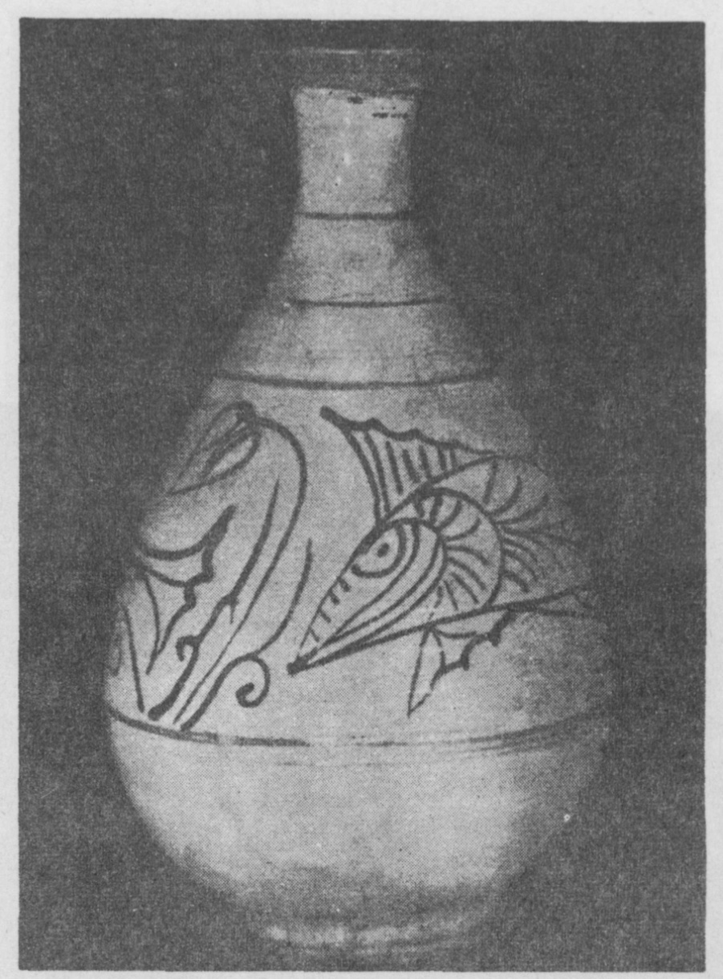

1. Punch’ŏng ware bottle with fish design painted in black on a background of brushed white slip; made at the Keryong-san potteries, 15th/16th century. Height 11 5/16 in. Owned by Mr.Yi Hong-kun.

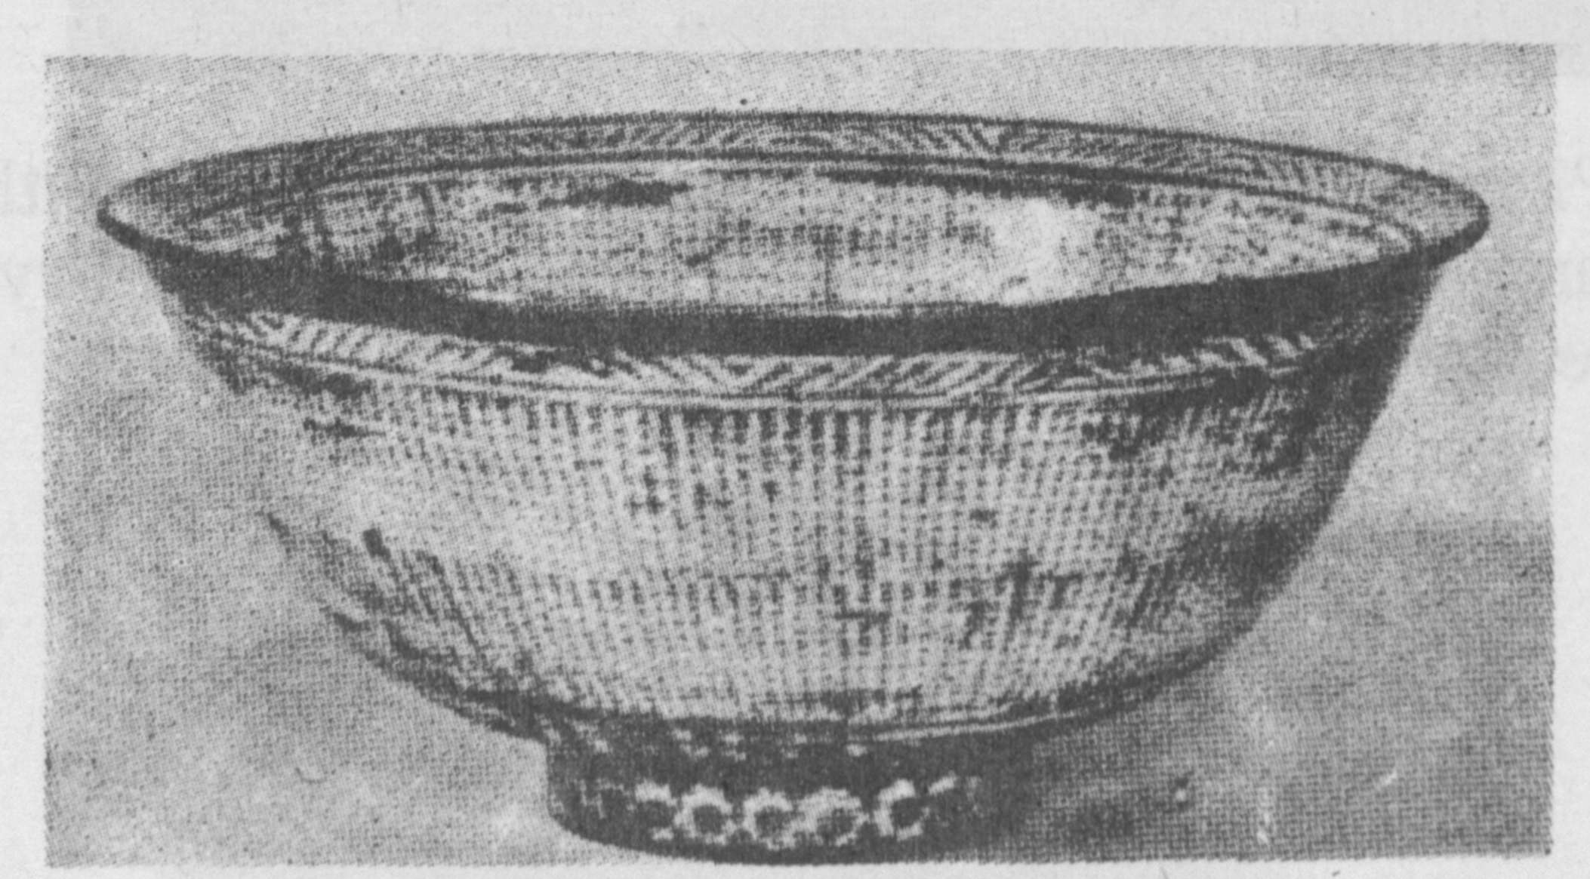

2. Punch’ŏng(mishima) ware bowl of standard type covered with stamped patterns over which white slip has been brushed. 15 th century. Diameter c. 7 in.

[page22**]**

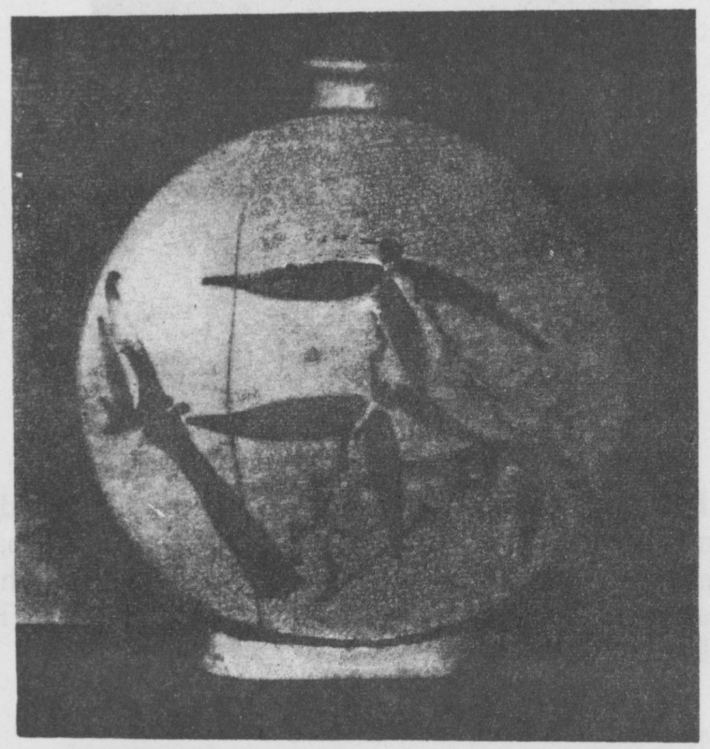

3. Pilgrim flask of white porcelain decorated with bamboo design in iron brown. 17th century. Height 7 3/4 in. Author’s collection.

[page23**]**

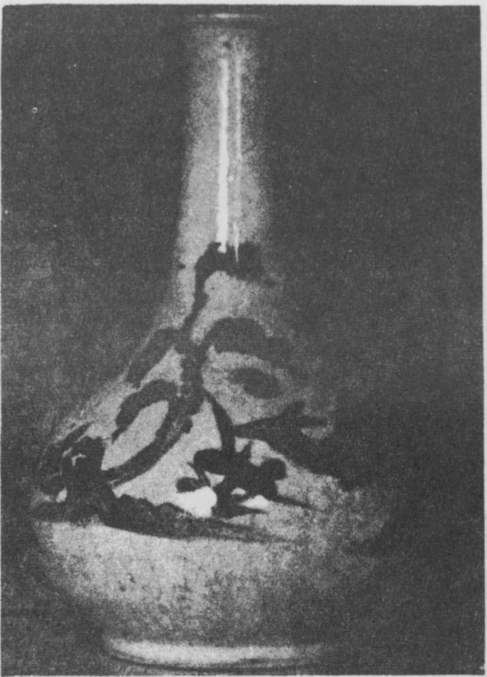

4. Wine-bottle decorated in cobalt-blue with deer, tortoise and crane. 18 th/19 th century. Height 10 3/8 in. Author’s collection.

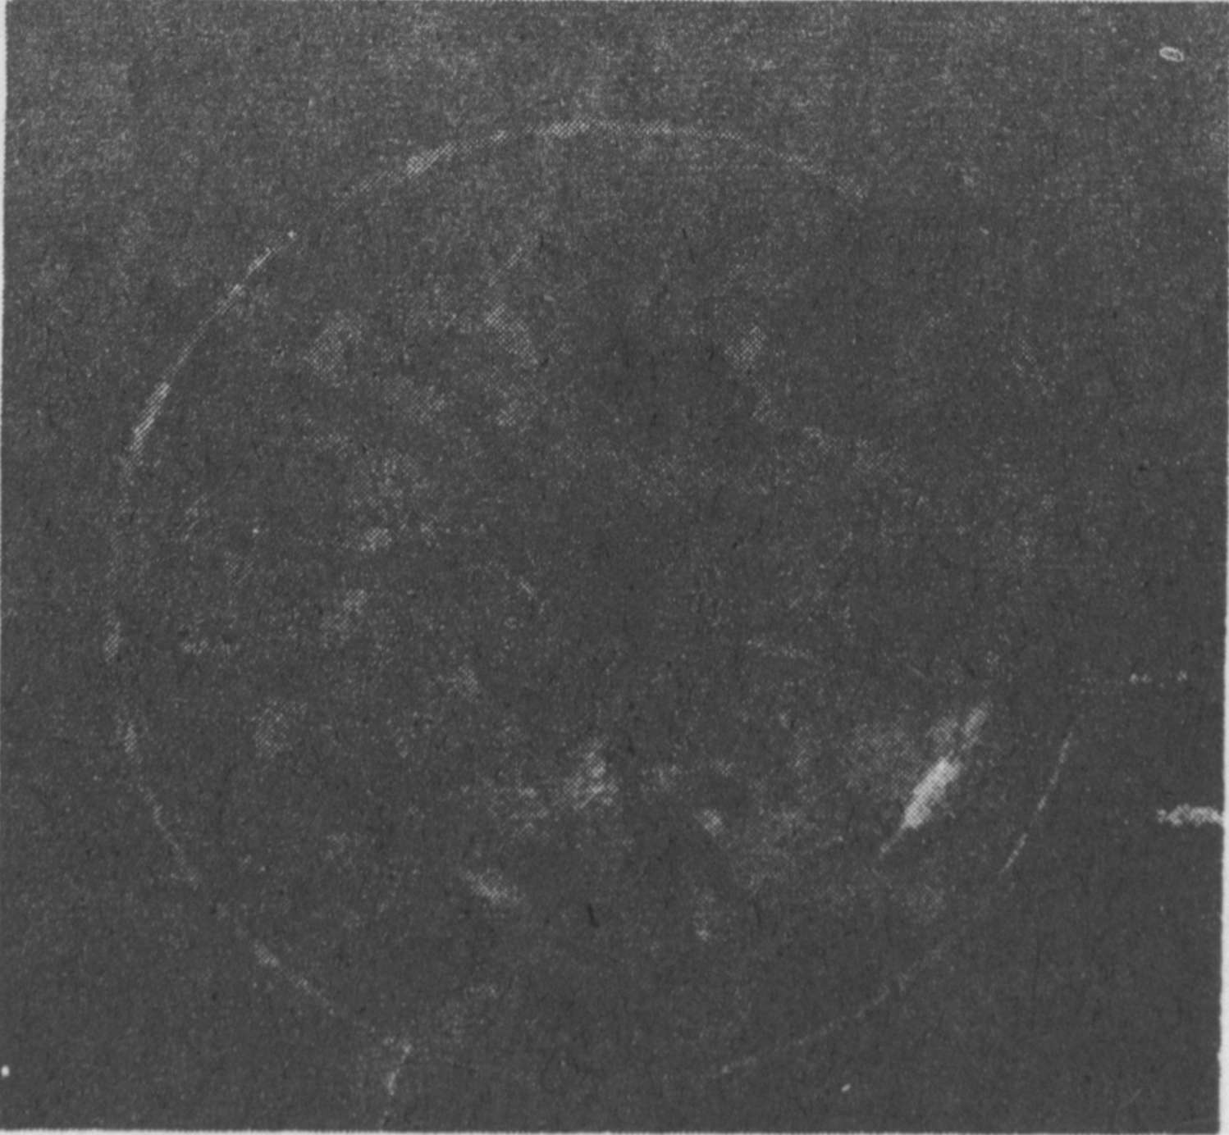

5. Dish decorated in cobalt-blue with crane flying amid clouds. 18 th/19 th century. Diameter 5 5/8 in. Author’s collection.

[page24**]**

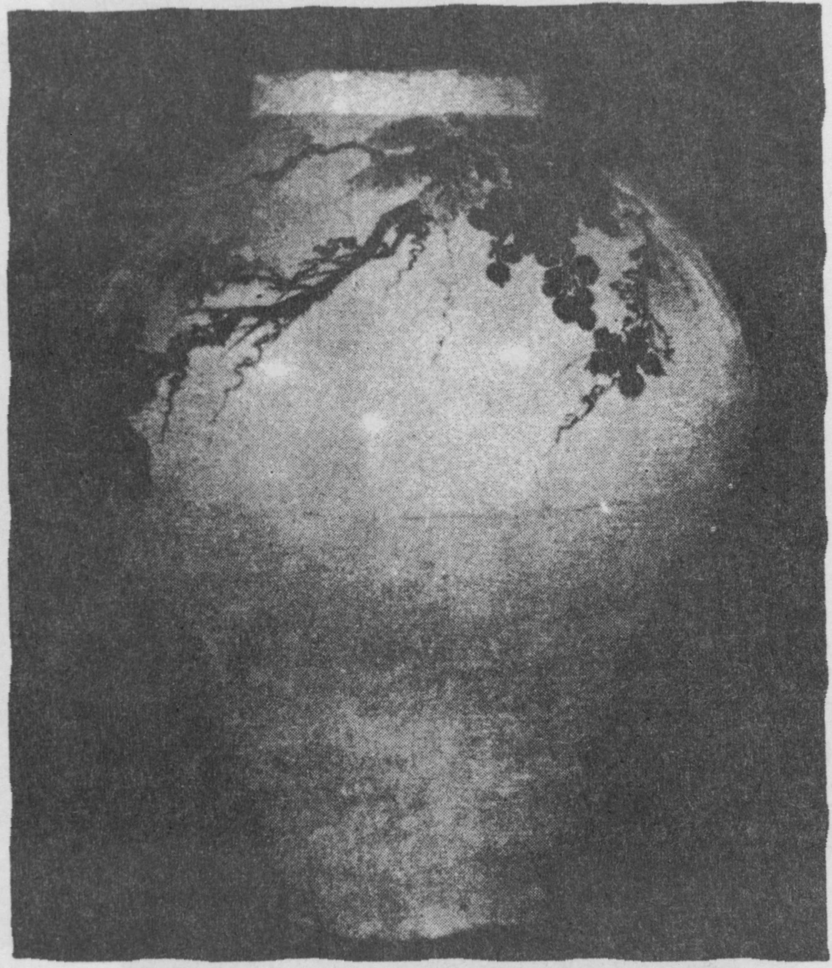

6. Jar of baluster shape, bulging at the shoulder, painted in iron-brown with clusters of grapes. 17 th/18 th century. Height 21 in. Ehwa Women’s University Museum.

[page25**]**

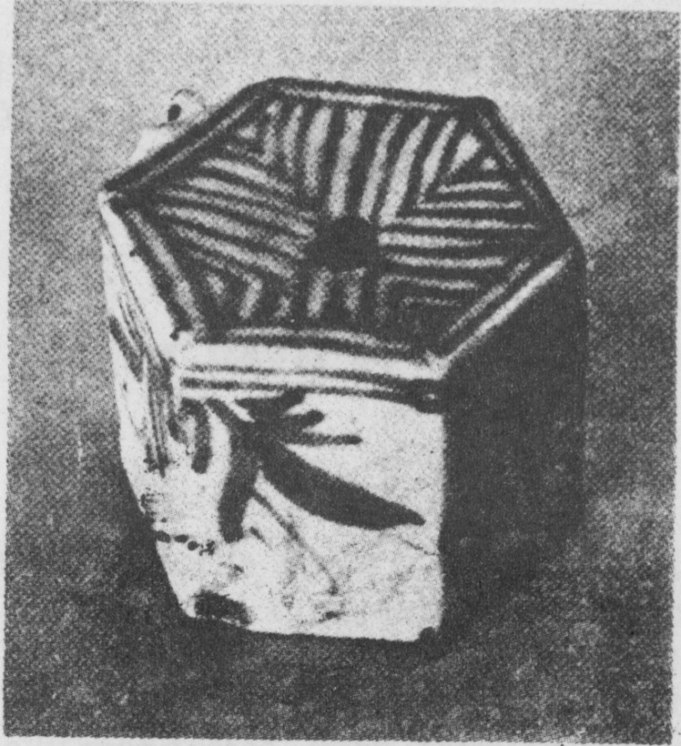

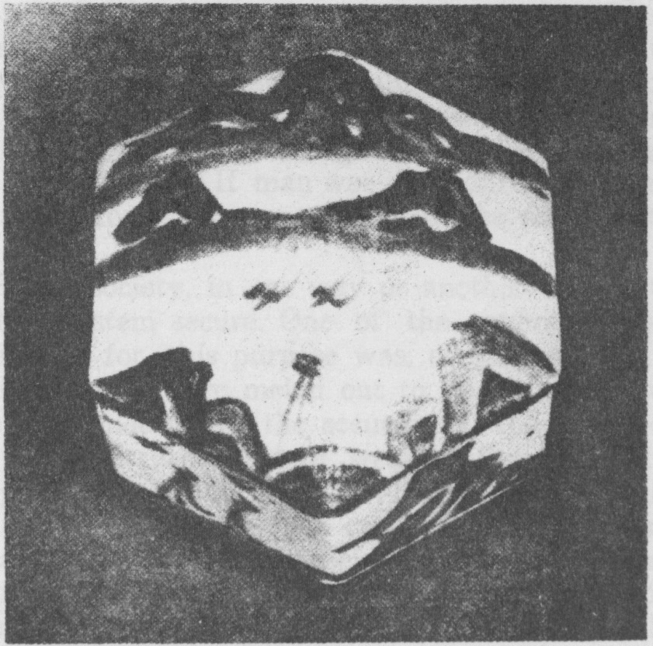

7/8. Water-droppers for the scholar’s desk. Decorated in cobalt-blue with designs of leaves and Han River scenery. Probably made at the Punwon potteries. 18 th/19 th century.