[page 70]

**Some Korean Maps**

Shannon McCune

Every eighteen days a satellite passes over the Korean peninsula taking remote sensing imagery of its landscapes. This imagery, sent back to earth by sophisticated communications systems, is used for the updating of the maps of Korea.1 Checked in the field and more commonly by using conventional aerial photographs, the modern Korean maps are indeed accurate and useful for all purposes. This new excellent cartography is in the Korean scholarly tradition.

There are many maps of Korea which merit study and comment. Only some of these maps are discussed in this paper which is part of a research project on the transmission of geographical information about Korea.2 In the recent resurgence of research in Korean cartography

1 Much information on the Earth Resources Technology Satellite (ERTS) imagery and its usefulness for research is available. An informational summary,including a map of the coverage of Korea by the 26 rectangles into which it is divided for imagery, was prepared in Korean for Korean geographers by Lee Chung- myon, “The Prospects of Remote Sensing Techniques,” Chiri Hak (Geography), Korean Geographical Society, No. 11, June, 1975, pp. 79-93.

2 I summarized information on the maps of Korea available after World War II in an article: “Maps of Korea,” The Far Eastern Quarterly, Vol. 5, No. 2,May, 1946, pp. 326-329. A short article, including bibliographical references’ was written on “Old Korean World Maps”, Korean Review, Vol. II,No. 1,September, 1949,pp. 14-17. An old map of the northern frontiers of Korea in the Haedong Yoksa by Han Ch’i-yun (b. 1765) was briefly described in an article: “The Northern Defence of Korea”,Korean Survey, Vol. 7,No. 10, December, 1958,pp. 3-5. Though I have done some research on the European cartography of Korea and have assembled an interesting collection of original and copied maps, I have not written on this subject until I had an opportunity of seeking knowledge of the old Korean cartography. Being a Fulbright Research Professor at Soong-jun University in Seoul gave me this opportunity in the fall of 1975; I am grateful for this appointment and for a research leave from the University of Florida.

[page 71] it is interesting to note that the only book-length study in the Korean language on the history of the cartography of Korea was published in P’yongyang in 1965.3 Some Seoul publisher should commission a well-illustrated study by an acknowledged authority such as Ch’an Lee of Seoul National University.4

Some notable collections of maps may be found in libraries and family archives in Korea; frequently it takes considerable tenacity to get to see these maps. Some libraries are burdened by heavy layers of bureaucracy which seem more designed to frustrate the scholar than to help him. Notable among the library collections in Korea are those at Seoul National University, Yonsei University, Korea University, Soong-jun University, the National Library, the Royal Palace Library in Seoul and at Yongnam University in Taegu. Some of these have catalogues of their maps.

Various centers of cartographic work within the Republic of of Korea and some private map companies, notably the Chungang Chido Munhwasa, publish sheet and wall maps of Korea. The major cartographic center is the Geographic Research Institute,since November 1, 1974

3A North Korean publication on the history of Korean cartography available in the Library of Congress and other libraries is by Mok Yong-man, *Chido Iyagi*, (The Story of Maps), P’yongyang, Kanjung Munhwasa Ch’ulp ansa, 1965, 352 page s. Though rather poorly printed,this book includes reproductions of some old Korean maps and a commentary on the history of Korean cartography.

4 Ch’an Lee of Seoul National University has written numerous research papers on the cartography of Korea and has a noteworthy collection of photographic reproductions of old maps of Korea. One article in English and a monograph with an English abstract illustrate his research work: Korea Old World Maps—Chonha-do and Hanilgangni-Yokdae-Kukdo-Chido, Graduate School of Education, Seoul National University,April 1971, 40 page s and “Old Maps of Korea: Historical Sketch”,Korea Journal, Vol. 12,No. 4, April,1972,pp. 4-14 and 32.

Woo Nak-ki of the Korean Geographical Research Institute, a personal research organization,has prepared a full length book in rough draft on Korean cartography which he kindly showed me. He served for some years as a research assistant to Yi Pyung-do, the eminent Korean historian, who has also written on Korean cartography.

I am much indebted to Chan Lee and Woo Nak-ki for information they have given me as I was engaged in this study in the fall of 1975.

[page 72] an independent institute under the Ministry of Construction. In 1972 the Institute prepared a booklet in Korean with a brief English abstract on The History of Mapping in Korea. This includes some reproductions of old and modern maps.5 The Institute has also published a composite reproduction of a famous Korean map, the *Taedong-Yojido* of Kim Chong-ho of 1861. In the booklet is promised a new and more thorough history of Korean mapping. This is certainly much needed and should be distributed widely, so that scholars throughout the world will be aware of the nature of Korean cartography.

Maps are used universally in Korea and are found in many forms. Though such an enterprise has been discussed, Korea does not yet have a National Atlas, similar to those of other countries. Because history and geography are very closely intertwined in Korean scholarship many historical works have maps within them. Maps are often seen at places of tourist interest and tourist maps are widely sold and given away. In some palace grounds ancient ponds are shaped in map form. When replying to an inquiry of location, a Korean will frequently sketch out a map on a dirt road or on a piece of paper. Maps are even used to illustrate effectively the themes of some Korean postage stamps. Today maps are used in Korea for all the myriad functions of government. Though it is obvious that maps are indispensible for military operations, the use of maps for peaceful purposes is also recognized. This is in line with the Korean tradition which was well expressed by the Korean cartographer, Kim Chong-ho, who wrote concerning a map he had produced in 1861:

“My map will be used to defeat the enemy and to suppress violent mobs, when the nation is troubled ; and to carry out policies, govern every social affair and enforce economic policies

5 *The History of Mapping in Korea*, National Construction Research Institute, Seoul, 24 pages plus 17 reproductions, 1972, has a brief English abstract, unpaged.

[page 73] in times of peace.”6

**MODERN MAPS**

A wide selection of modern maps is available for persons interested in research and general geographical information on Korea. The basic series of maps for all of Korea is at the scale of 1:50,000, or four-fifths of a mile to the inch. The mapping at this scale was a major effort made by the Japanese in their early days of control of Korea. The mapping project was started in 1914 and finished in 1918,when 722 sheets were completed.7 The 1:50,000 sheets were (and are) very handy maps, for they include topographic details through the use of contour lines, except for some mountainous areas in northern Korea where only spot elevations and shading are used. Land use and built- up areas are shown by symbols ; transportation routes are drawn in various categories. The original Japanese series are attractive maps

6 The quotation from Kim Chong-ho is taken from an article by Chong Hyung-u, “Kim Chong-ho’s Map of Korea”, Korea Journal, Vol. 13,No. 11,November, 1973,pp. 37—42. Another article on this famous Korean cartographer is that of Woo Nak-ki, “Geographer Kim Chong-ho’s Three Achievements”, Journal of Social Sciences and Humanities, The Korea Research Center,Number 38, June,1973, pp. 69-83.

7 The 1:50,000 maps of Korea published by the Japanese were produced in the following sequence according to The History of Mapping in Korea, op. cit.

Date Number Area

of maps (Sq. Km.)

1914 34 13,047

1915 147 47,022

1916 199 60,852

1917 281 79,813

1918 61 20,157

722 220,891

This mapping project with which was associated a cadastral (or land ownership) survey was financed in part by a loan which the Japanese government floated in Paris [page 74] and are of value for historical research purposes.

The 1:50,000 series of topographic maps was up-dated by the Japanese and used as the basic source material for their mapping of Korean urban areas at various scales. During World War II, the 1:50,000 series was reprinted in various ways by the United States Army Map Service and more recently the same grid has been used for maps produced by the United States Defense Mapping Agency. Some of these maps are published in bi-lingual form. The Chungang Map Company sells a modern Korean series at the scale of 1:50,000 which covers South Korea in 239 sheets; these have been up-dated through aerial photography and field survey. The 1:50,000 maps are easy to use for travel and field work. They are attractively printed in four colors to which green for forest control areas is sometimes added. Occasionally English names are included in the title of the sheet; however,these maps may be used without a knowledge of Korean, for their contours and symbols follow international usage.8

Each of the areas of South Korea coveread by the 1:50,000 sheets is in turn divided and covered by four maps at a scale of 1:25,000. These also are very useful sheets, though perhaps a little awkward to handle in the field (especially if one is travelling on a crowded bus!). The 1:25,000 maps have more detail than the 1:50,000 maps with the land use usually given in green symbols. Maps of some parts of South Korea, the area along the Demilitarized Zone and some of the coastal areas, for example, are not available to the general public. However, 762 sheets in the 1:25,000 series are available from the Chungang Map Company.9

8 An interesting book giving many examples from the topographic maps of Korea is that of Lee Ji-ho and Lee Yong-jak,Gukto wa Jido (Landscapes and Maps), Po- jinji,Seoul, 2nd Edition,1974,156 page s. This book also reproduces some historical and thematic maps of Korea. Though in Korean an index includes the English romanizations of the places from which the 258 maps are taken to illustrate the varied landscapes in Korea.

9 The Chungang Chido Munhwasa, or Chungang Map Company, has its main office on a side street southeast of the intersection of Ulchiro and Namdaemoonro in central Seoul very near the Chosun Hotel. The address is 199-34, Ulchiro-2, Chung-Ku, Seoul- The company has branches in the leading cities of the Repub-lic of Korea.

[page 75]

The 1:25,000 maps are in turn being utilized for a very worthwhile effort of land use mapping with the use of aerial photographs and field surveying to obtain up-to-date information on land utilization. Unfortunately, these land use maps are restricted to use by government agencies and in government-sponsored or approved research projects. Printed in many colors,the land use maps give interesting mosaic-like pictures of the varied land use of Korea. Not all of South Korea has yet been covered by the 1:25,000 land use maps, though progress on publishing them has been rapid.

In addition to these basic map series at scales of 1:25,000 and 1:50,000 many more series of maps of Korea are available at various scales. Some of these are published by the United States Defense Mapping Agency and by the Republic of Korea mapping agencies. At the Library of Congress in Washington maps published by the North Korean regime at various scales may be found. The set of 1:500,000 maps published by both the Republic of Korea and the United States Defense Mapping Agency which covers all of Korea in eight sheets is useful for general purposes ; a set at 1 :250,000 is in molded relief. The sets of 1:200,000 maps of the provinces of Korea are well suited for someone travelling in Korea or for wall use. Various city maps have been published at different scales,including 1:50,000, 1:25,000, 1:10,000 and 1:5,000. These are useful for urban studies, though they are usually only in Korean. English language equivalents of some have been published by the United States Defense Mapping Agency but it takes some cutting of red tape to obtain them.

In addition to the maps noted briefly above, there are many wall maps and thematic maps of Korea. Two very useful, cartographically attractive and inexpensive maps, one of North Korea and the other of [page 76] South Korea, each including thematic inset maps, have been published by the United States Central Intelligence Agency and may be purchased from the Government Printing Office outlets throughout the United States. Many thematic maps are produced in very limited numbers in Korea and consequently are difficult to obtain. The best known thematic maps, the geologic maps, bi-lingual and in many colors, at a scale of 1:250,000 cover all of South Korea. A number of excellent geologic folios with bi-lingual maps and comments cover in detail the geology of certain areas of geologic interest in Korea. Various thematic maps of soils,climates, forests, water supplies and so on are also available from Korean government agencies ; they may take some searching to find and when found require the cutting of considerable red tape to obtain. All in all,the number and character of the maps available on Korea is most remarkable. It illustrates the importance wnich the Korean people have placed on maps.

**OLD KOREAN MAPS**

Throughout Korean history maps have been valued,almost as much as they are today. Unfortunately many of these ancient maps, produced only in manuscript form before the days of printing, have been lost. Though it is known that maps were made before the start of the Yi Dynasty in 1392, copies of such early maps have not been found. The *Samguk-Sagi* and the *Koryo-sa*, histories of the early periods of Korea, contain interesting geographical information. In the Koryo period the histories note that Korean maps were sent to China in the early XI century and in the mid- XII century. Little is known,how- ever, of these early Korean maps,though some Korean scholars have been writing on the subject.10

10 Two general articles by Korean scholars on early Korean cartography are: Roh Do-yang,”History of Korean Geography”, Korea Journal, December, 1973, pp. 1930 ,and Hyung Kie-joo, “Materials of Old Maps in Korea”, Chiri Hak, (Geopraphy), No. 1, July,1963,pp. 97—109. Tne latter is in Korean with some re-productions. Sang-woon Jeon, Science and Technology in Korea: Traditional Instruments and Techniques, M.I.T. Press, Cambridge,Mass., 1974,has a discussion of Korean geography, page s 273-315.

[page 77]

The earliest map by a Korean scholar is now in a library in Japan. It is a map of the then-known world drawn in 1402. Kwon Kun,a Korean scholar who had been in China procured maps, some of which had been adapted by the Chinese from Arabic sources.11 On his return, combining the information on these maps and maps of Japan which had been obtained by other Korean scholars, he had drawn for him a map of the world. The Peninsula of Korea on this map was inordinantly large in scale and may have been copied from a map made by another Korean cartographer, Yi Hoe ; it is remarkably accurate in shape. Other maps of the world were obtained from China in later periods, but these did not show Korea with much accuracy. One such map,showing Korea as a peninsula with a long border on Manchuria,was included in the so-called Mongol atlas, originally drawn in 1320 but extensively revised in 1541 and 1555.12 Perhaps the best known old map of Korea and one that was used for centuries by Korean scholars is a map of the eight provinces of Korea which was published in the famous geographical encyclopedia, the Tongguk-Yoji-Sungnam. The first edition, completed by No Sa-jin and others in 1481, was revised in 1486,1491 and 1530. This last revision

11 Chan Lee in his *Korean Old World Maps*, op. cit., discusses the world map of Kwon Kun. This map is also noted in a brief note by Walter Fuchs,”Development of Chinese Maps”, Seminar Series, The Korea Research Center, No. 1,January, 1962, pp. 7-10. An article emphasizing the work of the other Korean cartographers who worked at the behest of Kwon Kun is by Chang Bo-Woong, “A Study of Some Maps which were made in the 15th Century in Korea, the Early Part of the Yi Dynasty”, Chiri Kwa Hak (Geographical Science Papers), Tongguk Univer- sity,Vol. 16,February 1972,9 page s.

12A reproduction of the map of Korea,Map 42,from the 1555 edition of the “Mongol Atlas” is given in Walter Fuchs, “The ‘Mongol Atlas” of China by Chu su-pen and the Kwang-Yu-T’u”, *Monumenta Serica*, journal of Oriental Studies of the Catholic University of Peking, Monograph VIII, Fu Jen University,Peking, 1946, 32 page s and 48 reproductions.

[page 78] is called the *Sinjung- Tongguk-Yoji-Sungnam* and had a map of all of Korea and of each of the eight provinces into which Korea was divided at that time. The map of Korea is fairly simple, showing the major rivers and mountains and placing the provincial names in boxes. Perhaps because of its simplicity it was much copied in atlases and books.

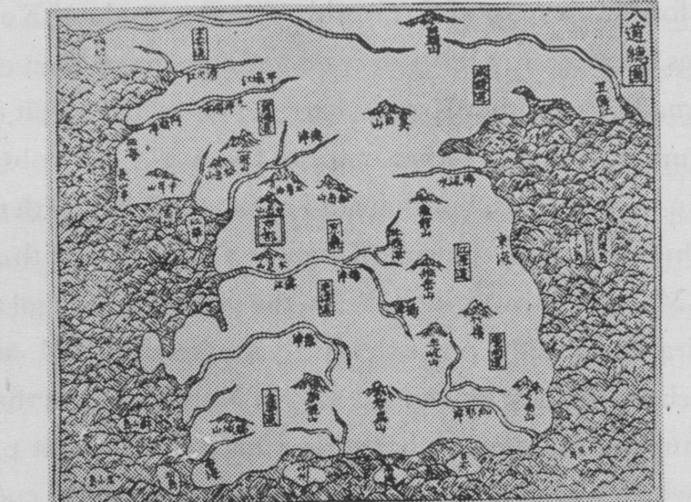

**Figure 1.** P’aldo-Chongdo, circa 1463,A map of the eight provinces of Korea reproduced in the Tongguk-Yoji-Sungnam.

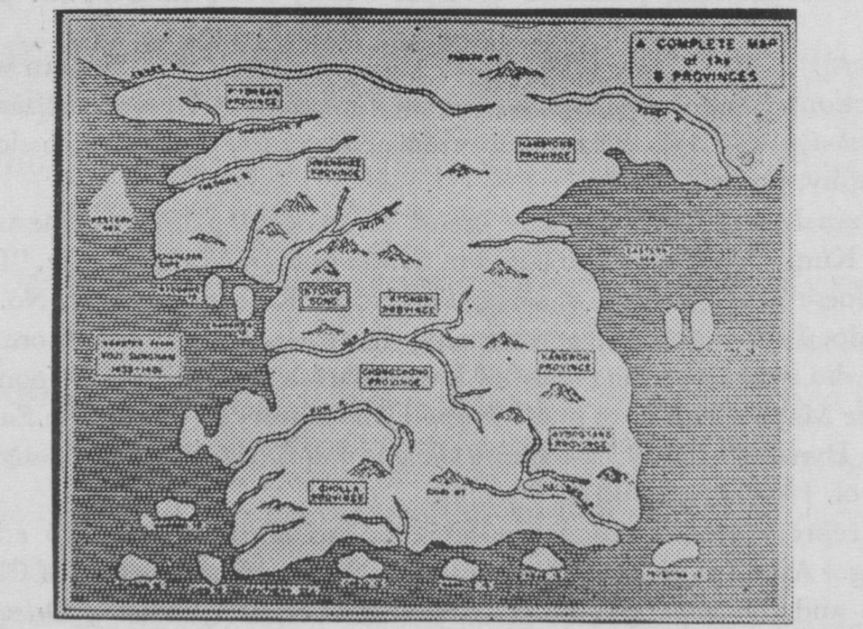

**Figure 2.** A Complete Map of the 8 Provinces, an English language translation of the *P’aldo-Chongdo*.

[page 79]

The map of Korea in the *Tongguk-Yoji-Sungnam* was fitted onto two sheets of paper with a binding area of varying size down the middle of the map. The proportions of the map were adjusted to the size of the paper sheets. In fact the size of the paper used was a major factor in the shapes of the areas shown on early Korean maps. The size of an area being mapped was lessened or exaggerated depending upon the dimensions of the paper sheets. Thus, these early Korean maps have no exact scale. Map making was an art form and aesthetics played an important part in the presentation.

Korean atlases, which came into use in the early part of the Yi Dynasty and continued to be produced throughout this period,are especially interesting. Korean scholars used maps on screens and on scrolls, as did the Chinese and Japanese. They also assembled the maps into atlases much more commonly than did their neighbors. It is difficult to ascertain the reasons for the popularity of atlases among Koreans ; perhaps it was because they could be stored or carried more easily in this form. I he maps in the early atlases are in single or double sheets, mounted often back to back, or mounted in such a way that they can be folded out quite simply.

The common Korean atlases which may be found in map collections and for sale in old book and antique stores are in manuscript form, variously colored, or in wood-block print form.13 The latter are

13 These atlases have been very easy to obtain and at relatively low prices, but in recent years the prices have been grossly inflated. Leo Bagrow, one of the great scholars of cartography, who visited Seoul in 1914 and in 1919, noted in the foreword of his *History of Cartography* (Edited by R.A. Skelton, Harvard University Press, 1964) that “in 1914 there were still many little book shops about the walls of the imperial palace in Seoul in Korea, where one could find ancient native maps. Five years later, these little shops had been demolished and heaven knows what became of their stock.”

In 1938 and 1939 I bought a number of Korean atlases at second-hand book stores in Seoul for the equivalent of a dollar to five dollars each. I gave some to libraries in the United States and still have four or five copies of various styles. The present day prices for inferior manuscript copies usually start at thirty to fifty thousand won, a highly inflated price.

A brief description of the atlases in an American collection is given in a note on “An Early Korean Atlas” in “Some Notes from the Tall Tree Library”, Imago Mundi, Vox, XIII,1956,pp. 163-164. The maps of Cihina and of P’yongan Province are reproduced.

An elaborate reproduction of many of the maps from a Korean manuscript atlas in the British Museum was published in France in 1896. The explanatory note was by Henri Cordier: “Description d’un Atlas sino-coreen manuscript du British Museum”, Recueil de voyages et de documents pour servir a l’historie de la geographie, depuis le XIIIe siecle jusqu’a la fin de XVI-Section cartographies Paris, 1896,pp. 6-12, 13 maps.

[page 80] more authentic and valuable, though not so decorative. The atlases have a rather standard arrangement of maps. A map of the world is followed by maps of China, of Korea, of each of the eight provinces of Korea, of Japan and of the Ryukyu Islands. The order of the maps, may vary and maps of Seoul, of P’yongyang and of Mukden may be added. In some atlases diagrams of the stars and constellations may be included as well as notes on the place names and tables of distances. The Japanese cartophile, Hiroshi Nakamura, published in 1948 a definitive article on the Korean world map included in these atlases. He categorized the wood-block atlases into twelve major type.14

The Korean atlases are of value for the maps within them. The map of China and the maps of Japan and of the Ryukyu Islands are of contrasting quality ; the accuracy of the map of China is far superior to the others,an indication of the relative paucity of geographic knowledge of Japan and the Ryukyu Islands in Korea. Most of the maps of Korea and of the Korean provinces are copies of the maps in the *Sinjung-Tongguk-Yoji-Sungnam* and are fitted to the size of the paper

14 Nakamura, Hiroshi, “Old Chinese World Maps Preserved by the Koreans,” *Imago Mundi*, Vol. 4, Stockholm, March, 1948, pp. 3-22. Dr. Nakamura collected many Korean maps during his stay in Korea as a Professor in the Medical College of Keijo Imperial University; he also collected maps on trips to Europe. This arti-cle was scheduled for publication in 1939 but was delayed in publication by World War II,somewhat to his dismay. Dr. Nakamura has published a number of books and articles, mainly in Japanese. His East Asia in Old Maps, East-West Center Press, Honolulu, 1963, 84 pages, is an English language abridgement of a Japanese work published in 1958; unfortunately, considering his interest in Korean maps, this book has only passing mention of Korean cartography.

[page 81] in the atlases.

The world map, or *Chonha-Do (*Under Heaven Map), has had more attention than perhaps it deserves.15 As Dr. Nakamura pointed out in his article in *Imago Mundi*, the world map was based on antecedents in Buddhist maps. The many exotic place names were derived from Chinese romantic and mythical accounts, particularly from the Chinese classic the *Chan-hai-king* written in the third century B. C. The world map has China in its center and shows cartographically the dominant position of the Middle Kingdom in the minds of Korean scholars. The Korean scholar, Ch’an Lee, who has written on this world map, notes that such a map is uniquely Korean.16 Though the world map and the other maps in the Korean atlases were based on

15 The world map in the Korean atlases has been reproduced in many publications. Two of the early articles in English were those of Yi Ik-seup,”A Map of the World”, The Korean Repository, Vol. 1,1892, pp. 336-341 and H. B. Hulbert, “An Ancient Map of the World”, *Bulletin of the American Geographical Society*, October, 1904, pp. 600-605.

An American visitor to Korea, Percival Lowell,in his *Chosen, the Land of the Morning Calm*, Boston, 1886, 412 pages, reproduced the map, as did Maurice Courant in his *Bibloigraphie Coreene*, Ernest Leroux, Paris, 1895, Volume II, No. 2187, page 480. An Italian, Carlo Rossetti, reproduced the map in his book *Corea e Coreani, impressioni e ricerche sull’ Empero de Gran Han,* Bergamo, 1905. Some years later Stewart Colin reproduced it in an article “A Korean Map of the World”, *The Brooklyn Museum Quarterly*, 1925, pp. 183—193.

The recent articles and monographs by Ch’an Lee, Shannon McCune,and Hiroshi Nakamura, already cited, give additional references to reproductions of this map and comments on it. The map has become a common illustration in books on the history of cartography, The American Geographical Society reproduced a copy they had received from H. B. Hulbert as a Christmas card a few years ago.

16 Ch’an Lee notes in his monograph on Korean Old World Maps, op. cit., that his “study suggests that the Chonha-do may well be originated by Koreans during or before the Yi Dynasty was founded in 1392.” A different view is expressed by Hiroshi Nakamura in his “Old Chinese World Maps Preserved by the Koreans” op. cit., who concludes that “. . this mappemunde is purely Chinese. It bears no trace of anything specially Korean, which is understandable when we consider that the sciences and the arts of Korea were almost always slavishly modelled upon those of China.” This rather sweeping over-generalization by a Japanese scholar does not explain why the Chonha-do persisted so long in Korea. A Korean perception of the outside world is well illustrated by this map.

[page 82] ancient sources, they had an amazing popularity and were copied and reproduced in wood-blocks for many centuries during the Yi Dynasty.

Change did come to Korean cartography, however. One of Korea’s most famous cartographers, famed in part because he broke away from the tyranny imposed by the size of the sheets of paper used for maps, was Chong Sang-gi, who lived from 1678 to 1752.17 He was a descendant of a famous scholar, Chong In-ji, one of the revisers of the *Koryo-sa*, who lived from 1396 to 1478. Chong Sang-gi’s descen-dants in turn became well known cartographers. His best known map is the *Tongguk-Chido* (Map of the Eastern Country) which is in fact an atlas comprising a map of all of Korea followed by maps of the individual provinces with small Kyonggi and Ch’ungch’ong provinces on one sheet and large Hamgyong province on two sheets. The provincial maps may be fitted together to make a total map of Korea at a scale of roughly 1:420,000.

Chong Sang-gi used a scale on his maps, a device he derived from Chinese practices which were in turn obtained through Arabic and European sources. In commenting on his map Chong Sang-gi said: “Maps of our country which exist today are numerous. Whether manuscript or wood-block maps, almost all of them are distorted in direction ana distance, because the drawings were restricted very much by the sizes of the paper.... If one travels around the country with this kind of a map as a guide, it may be said that he is travelling in the dark! Regretting such an event, I have drawn this map.”18

17 The well-known Korean historian,Yi Pyung-do,discussed the work of Chong Sang-gi in an article “Chong Sang-gi and Tongguk Chido”, *Bulletin of the Bibliograpnical Societies of Korea*, No. 1, 1960, pp. 5—16. A reproduction of the provincial maps and a study of the *Tongguk-Chido* are given in an article by Norman J. W. Thrower and Young-il Kim, “Dong-Kook-Yi-Ji-Do: a recently discovered manu script of a map of Korea”, *Imago Mundi*, Vo . XXI, 1967, pp. 30-49. This article is also valuable far the extensive bibliographical notes on Korean cartography which it gives.

[page 83] The *Tongguk-Chido* (copies of which are sometimes called *P’aldo-Chido*, or Eight Provinces Map) is generally dated around 1730. Originally in manuscript form, various copies were made. One fine example at the Royal Palace Library is dated 1790, long after Chong Sang-gi’s death in 1752. Another copy, probably drawn as late as 1889, is in the library of the University of California at Los Angeles ; this has been reproduced and analyzed by Norman J. W. Thrower and Young-il Kim.19

Another famous Korean cartographer is Kim Chong-ho, who lived from circa 1804 to 1864. Although much has been written about his life and work, actually not too much is know.20 Not coming from a well-known scholarly family, Kim Chonsg-ho is noted for two maps of Korea which he drew. He also wrote a geographic description of Korea, the *Taedong-Chiri* completed in 1864.

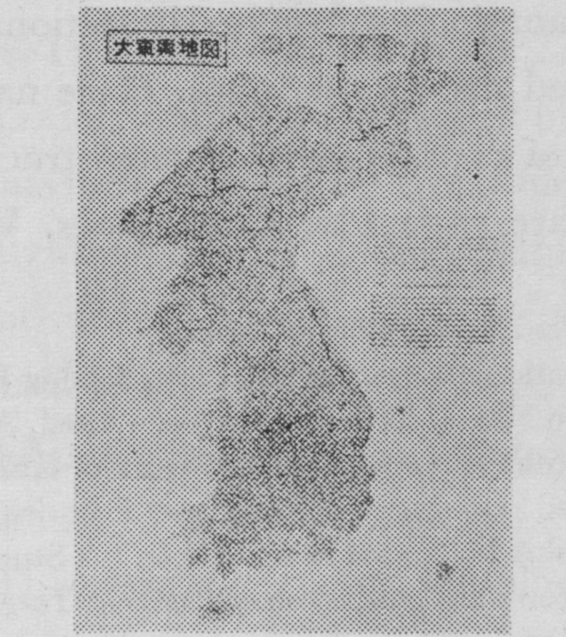

**Figure 3.** Taedong-Yojido, 1861,a photographic reduction by the Geographical Research Institute of the 23 fasciles of the map by Kim Chong-ho.

18 The quotation from Chong Sang-gi’s explanatory note on the North Ham- gyong sheet of the Tongguk-Chido was translated by Ch’an Lee in his article “Old Maps of Korea: Historical Sketch”, op. cit.

19 Norman J. W. Thrower and Young-il Kim in their article “Dong-Kook-Yu- Ji-Do”, op. cit., give the impression that the copy at the University of California at Los Angeles is rather unique ; actually there are many manuscript copies of Chong Sang-gi’s Tonnguk Chido in libraries and private collections. It would be beneficialif it could be reprinted in a satisfactory manner.

[page 84]

The first of his maps, dated 1834,the *Chonggu-do*, was in manuscript form and was usually bound into two or four volumes. The atlas was circulated initially with a preface by a Korean scholar, Ch’oe Han-gi (1803-1879), who was also interested in maps. The *Chonggu-do* includes explanatory notes and historical maps of Korea of past periods. There are various manuscript copies available in libraries; one of the best and most beautifully copied is in the Royal Palace Library.A reprint of the *Chonggudo* has been made, though unfortunately the copy used for reproduction was not of high quality or clarity.21

The map of Korea in the *Chonggu-do* is in two sections or volumes, north and south Korea, divided almost along the 38th parallel, oddly. The maps were drawn on a grid system and the place names indexed, making it relatively easy to find the desired sectional map. The scale for the sectional maps is roughly 1:160,000, or three miles to the inch. Cheju island, for example, is shown on six sectional maps. Rivers are drawn in exaggerated size on the maps. Place names and roads are shown ; the names of county seats or magistracies are enclosed in boxes ; boundaries are shown by dotted lines. Walls around some

20 The somewhat sensationally-worded article by Chong Hyung-u and the more scholarly article by Woo Nak-ki have already been cited. Almost every article on Korean cartography comments on the life and work of Kim Chong-ho, though as Woo Nak-ki has pointed out there are only two historically reliable statements about him. Ro Jeoung-shik has noted in an article, “A Study on the Jigu-Jeonhu- Do Engraved by Kim Jeong-ho”, Collection of Papers of Taegu Teachers College, Vol. 8,1972, pp. 257-266, that Kim Chong-ho engraved on wood blocks a world map in two hemispheres so that he was knowledgeable on latitude and longitude and map projects,even though his maps of Korea did not have latitude and longitude, only a grid system for locational purposes.

There are many Korean geographers who are interested in Kim Chong-ho in addition to those whose work has been cited. Almost every Korean geography teacher considers himself an authority on the subject and welcomes an opportunity to discuss his life and work. An American Peace Corps volunteer, Curtis Evans, is also doing a study of Kim Chong-ho.

21 The reprint of the Chonggu-do was published in two volumes as No. 47 and No. 48 in the series, Kochun Gukyak Chongsu, published in Seoul in 1971.

[page 85] cities and defensive posts in northern Korea are shown. The mountains are drawn as individual peaks or groups of peaks rather than as ranges. On those on which the signal beacons were located,a symbol of a triangle-shaped fire is drawn. The shape of Korea in the Chonggu-do is remarkably accurate. As Kim Chong-ho explained in a foreword he used a series of concentric circles to depict distances and then fitted places together in their correct locations. He reduced the scale of the map by a grid system which he also explains in the foreword.

Kim Chong-ho continued to gather geographical information and in 1861 made another map of Korea,an improvement upon his map of 1834. Instead of an atlas form he used sheets which were pasted together and could be unfolded. The result was a folio of 23 map fasciles, including one of the whole country for the title page , one for Seoul, and one for Cheju. The remainder of the country was presented in 20 sectional maps. This map was entitled the *Taedong-Yojido* (Map of the Great Eastern Country) and was engraved on wood-blocks. He is reported to have done the carving of the wood-blocks with the devoted assistance of his daughter. A second edition of this map,based on new wood-blocks,was printed in 1864, because requests for the map had exceeded the original printing and the wood-blocks had become worn. The *Taedong-Yojido* could be fitted together, though it was usually kept in the 23 fasciles, since no normal space could contain it if it were spread out. This, however,was done photographically by the Geographical Research Institute so that a single sheet map for decorative purposes could be printed.22 The original map has a scale of roughly 1:162,000 and is more accurately shaped than the *Chonggu-do*,

22 The Geographical Research Institute’s reproduction at a reduced scale of the *Taedong- Yojido* is very attractive. There is a brief English explanatory note which notes: “In 1861 ... Sir Kim Jong Ho finished compiling a Korea map . . . This accomplishment was due to the faithful efforts of his daughter. They made their own reconnaissance and field checks on foot, using only a compass and cloth measuring tapes. They roamed every mountain, path, valley and town in Korea to accomplish their goal.”

[page 86] though very similar to it. One major change is that the mountains are shown in ranges rather than in peaks, so that the drainage systems stand out more clearly. Ch’an Lee calls this “a projected-mountain- shadow method”,23 a uniquely Korean topographic relief symbol- Some scholars have written that when the Taewon-kun, the Regent of Korea and its virtual ruler in 1864,saw Kim Chong-ho’s Taedong yojido with its great detail of geographical information accurately presented, he flew into a rage and imprisoned Kim Chong-ho as a spy for a foreign power,Japan.24 Whether Kim Chong-ho was killed in prison or whether he went into quiet retirement is not known ; he is reported to have died shortly after the completion of the second printing of the Taedong-Yojido and the accompanying geographical description of Korea, the Taedong-Chiri.

Many Korean geographers and cartographers revere Kim Chong-ho as a hero for his desire to preserve the freedom of geographical inquiry and for his insistence that,as quoted earlier, maps are equally important “in times of peace” as “when the nation is troubled”. Kim Chong-ho’s Taedong-Yojido was much used by Japanese and Western visitors in the decades after it was published. In 1936 a reprint and an index of the place names on it prepared by the Japanese scholar,Y. Suematsu,was published.25 Recently Korean reprints of the Japanese reprint have been published.

23 Ch’an Lee gives this epitomization in his article “Old Map of Korea: Histo-rical Sketch”, op. cit. Dr. Lee notes that through this method of drawing mountains “it is like a shadow of mountains projected onto the plain from a 45-degree angle above.” When well drawn as they are on the Taedong-Yojido they are very effective in showing the relief.

24 This account of the fate of Kim Chong-ho is given in Chong Hyung-u,”Kim Chong-ho’s Map of Korea”, op. cit.

25 Suematsu, Yasukazu, *Shinzo Tokoku Yochi Shoran Sakuin*, (Index to the Revised Survey of Korean Geography), Government General of Chosen, Keijo, 1937—1940,2 volumes. One volume is composed of the reproductions of the 23 fascicles and the other volume is the index to the place names on the Tongguk Yojido. There have been reprints of Suematsu’s work published in Korea in recent years.

[page 87]

The works of only two eminent Korean cartographers have been stressed but there were many more Korean scholars interested in maps and in the drawing of maps in the late Yi Dynasty.26 Almost every Korean scholar had in his library an atlas, a screen map or a set of scroll maps. Students copied these as a part of their studies. Detailed maps of the counties were kept in the magistrates’ offices and were often corrected and up-dated by zealous clerks. Copyists often improved on the appearance of the maps and turned them into things of beauty as well as of instruction. They added commentaries and even drew sketches of notable places to supplement the maps. Place names were written in Chinese characters, not in Korean syllabary, and this added the artistry of calligraphy to the maps. It is truly a joy to sit with a Korean scholar and study the maps he may spread out on the floor of his study.27

**European Maps of Korea**

While these developments in cartography were taking place within Korea during the Yi Dynasty, European cartographers were becoming interested in Korea and other areas of the Far East. Though the Western cartography of Japan has been studied in detail and many beautifully illustrated books have been published on the sub-ject, relatively little research has been done on the equally interesting Western cartography of Korea.28

26The articles already cited include references to some of the other Korean cartographers. It is of interest to note the continuing cartographic activities of such scholarly families as the Chong family. Woo Nak-ki in his unpublished manuscript on Korean cartography mentions a large number of Korean cartographers.

27One of the most enjoyable evenings which I spent in Seoul in the fall of 1975 was sitting on the heated floor of the study of Dr. L.-J. George Paik while he spread out some of the maps in his collection. This collection of books and maps is being given to Yonsei University where Dr. Paik served as Dean and President for many years .

28 One of the few articles on the history of European cartography of Korea is Auguste Pawloski,”Historique de la connaissance de la Coree,d’apres la cartographie”, *Bulletin de la Societe de Geographie de Rochefort*, Vol. 26, 1904,pp. 216—225. Since this was so obscurely published I translated it and published it as “Pawlow- ski’s History of the Geography of Korea”,Research Monographs on Korea, Series G, No. 2, August, 1948, 13 pages. The article was based on research in European libraries and map collections and includes a bibliography of materials about Korea published in Europe. Though he calls “the French missionary Regis, the first European historian of Korea”, he seems to be confused as to Regis’ contibution to the development of the European cartography of Korea.

A German article on the development of the cartography of Korea notes the early European maps briefly but discusses at greater length the European and Japanese maps of Korea made in the 1800’s, such as Andre Kim’s map of 1846 and the various European expeditions along the coasts of Korea. This article was published as a note without a designated author: “Die Entwickelung der Kartographie von Korea”, *Petermanns Mitteilungen*, Vol. 29, 1883, pp. 341—344. The article was reproduced in *Acta Cartographia*, Vol. 13, 1972, pp. 1-4.

Many of the articles,monographs and books on the European cartography of China and Japan incidentally include material on Korea and reproduce maps which include Korea. The writings on China and Japan include those of Walter Fuchs,Henri Bernard,Henri Cordier, Albert Kammerer,Paul Teliki, George Kish, M. Ramming, Boleslaw Szczesniak, William Hung, Sen-dou Chang and many others. Specific references to their publications which have been of value to me are too lengthy to be included here; they may be found in standard bibliographies. There is truly a vast literature on the subject of European cartography of the Far East and Japan in Japanese language publications.

[page 88]

The earliest Western knowledge of Korea was obtained from Arab scholars who spoke of Sila; this name was derived from the Silla Dynasty which controlled much of the Korean peninsula from 57 B. C. to 935 A. D. One of the early Arabic writers,Ibn Khardazb- eh, noted in 848 : “At the extremity of China is a country named Sila,very rich in gold. The Moslems are so seduced by the beauty of the country that when they reach there they settle themselves and do not wish to leave.”29 Another Arabic writer, Masudi, in 943

29 The quotations from Arabic sources given here are from “Arab Accounts of the Geography of Korea”, Research Monographs on Korea, Series G, No. 1,August,1948, 7 pages. This monograph comprises translations I made of references to Korea in “Relation de Voyages et Texts Geographiques Arabes, Persans et Turks Relatifs a l’Extreme-Orient du VIIe au XVIIIe Siecles” by Gabriel Ferrand who translated the original Arabic sources into French in Documents Historiques et Geographiphiques Relatifs a l’lndochine, Paris, 1913-1914.

A brief article noting some of the same sources is by Chung Kei-won and George F. Hourani, “Arab Geographers on Korea”, *Journal of the American Oriental Society*, Vol. 58, no. 4,1938, pp. 658-661.

One of the Arab visitors stayed in Korea in 1274 and founded a Korean clan, what is called the Deogsu Jang clan. This is described along with the subsequent lineage of 12 branches of the clan in a bi-lingual book by Choe Sang-un: Relations between Korea and Arabia, Korea Saudi Arabia Association, Seoul, 1971,90 and 115 page s. Unfortunately Professor Choe did not quote from Arab geographical writings, though he quoted comments about the Arab visitors from Korean writings such as the Koryo-sa.

[page 89] amplified the idea that the Moslem visitors who had come to Korea did not want to leave “since the air there is healthy, the water pure, the soil fertile and all comforts abound.” This theme of the Moslems enchantment with Sila continues through the Arab descriptions even to 1332 when an Egyptian writer, Nurayi, noted: “It is recounted that strangers who establish themselves in this country never can decide to leave it, even though they may resign themselves to living in a state neighboring on poverty,since the air is pure and the water clear.” These Arab views of Korea are similar to those held by many of the present foreign residents in Korea ; few who come wish to leave, though the air is less pure and the water less clear than it was in the past!

The first European cartographers,using information derived from Arabic and Chinese sources, located Korea on the eastern edge of China. The name used on the early maps was Corai, derived from the Chinese pronunciation of the Koryo Dynasty that controlled Korea from 935-1392. The name was variously spelled,some Euro-pean cartographers inserted an N into the word and used the place name Conray. The problems of romanization of Korean place names on the maps of Korea for Western use began early !

The first European maps to show Korea, therefore, depicted it only as a place name on the coasts of China. A good illustration of this is the map of Japan of Fernao vaz Dourado of 1568 which shows the Costa de Conrai in a rather picturesque style on the continent west of Japan. As Western knowledge of the Far East expanded,

[page 90]

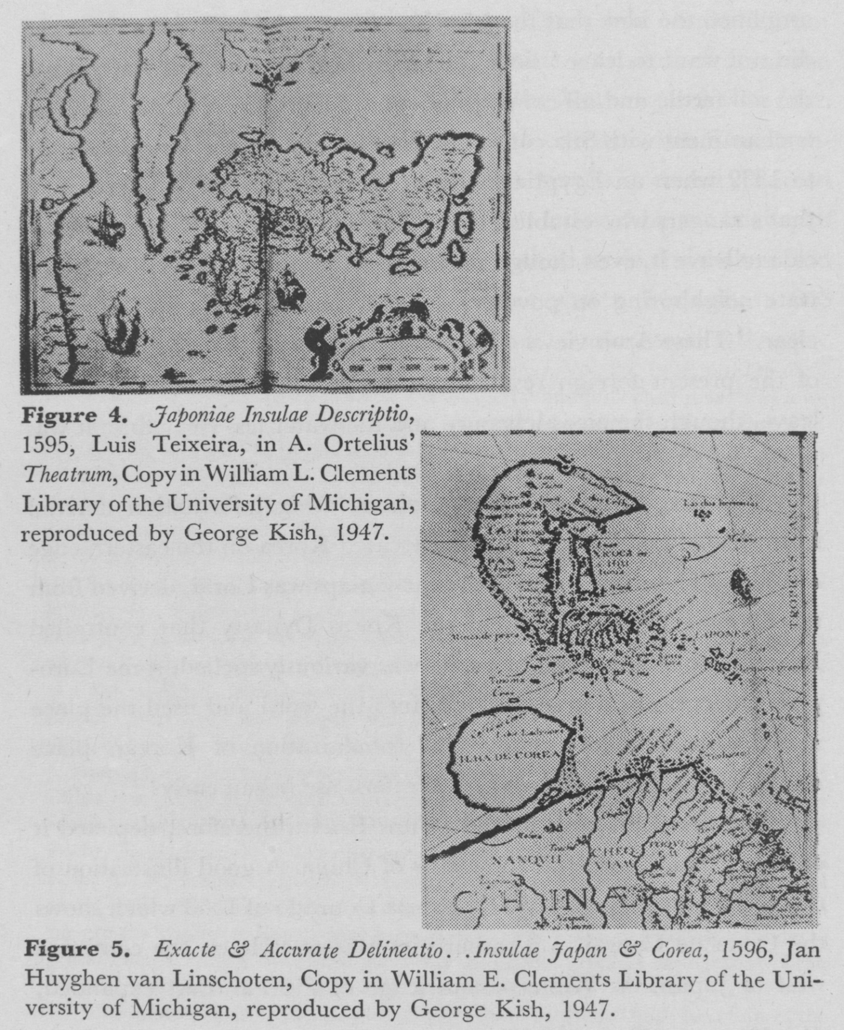

particularly through the contacts with the Japanese by missionaries and traders, better information on Korea began to appear on European maps. A famous map of the Far East by the Dutch cartographer, Linschoten, dated 1596, shows Korea in the shape of a circular island. It was called Ilha de Corea, but a note was added : “One can- [page 91] not certainly affirm whether this land is an island or a part of the continent.”30

Another way that Korea was shown in these early maps was as an elongated island. This shape appeared on many of the maps in the atlases that were published in Europe from 1550 to 1650. For example, Gerhard Mercator’s atlas of 1569 had Korea as an elongated island. This same shape was on a map published by Ortelius in 1595 which was drawn by the Portugese cartographer, Luiz Teixeira, who used largely Japanese source materials.

New accounts of Korea began to come to Europe through letters and maps sent by Jesuit missionaries in China. These contained much more accurate information on Korea than that which had been derived from Japanese sources. One famous Jesuit priest-cartographer was Matteo Ricci who drew world maps for the Chinese from 1584 to 1608. European cartographers began to accept the fact that Korea was a peninsula rather than an island, though on their maps they accentuated the Yalu and Tuman rivers which separated the peninsula from Manchuria. The shape of Korea, though shown as a peninsula, was still elongated, on some maps exceptionally so.

Many of the Jesuit missionaries in Peking at this time were skilled cartographers. The Korean envoys to the Imperial Court in Peking met with these learned Jesuit scholars in East-West contacts that fostered the rise and development of Silhak, or modern learning in Korea. One facet of this intellectual exchange was the furnisning of geographical information about Korea to the Jesuits and in turn

30 Linschotten’s note was given in the commentary accompanying his map in Latin: “...quae an sit insula an pars contends nondum constat.” This is noted in “Pawlowski’s History of the Geography of Korea”, op. cit., There has been some research on Linschotten and his various comments on Korea, on Quelpart (or Cheju) Island and on Gausien, which he notes is the same as Chausien “which is the Chinese name of Korea”. These remarks are noted in Albert Kammerer, “La Decouverte de la Chine par les Portugais au XVIeme Siecle et la Cartographie des Portulans”, T’oung Pao, Leiden, Supplement to Vol. XXXIX, 1944.

[page 92] providing to the Korean scholars information about the outside world. Among the materials which the Koreans received was a map of the world which Matteo Ricci had had printed in 1603. On this map Ricci had corrected the mis-information on the Far East, including Korea, which was currently on European maps.

This 1603 map of Matteo Ricci is a significant one in the history of cartography. The map was printed in eight panels which could be mounted on sections of a screen. Matteo Ricci had prepared numerous editions of a world map and there is a lengthy literature on the subject.31 The 1603 edition, one of the best of his world maps, was brought to Korea by a Korean envoy, a member of the Huang family, who kept the map in his home. Perhaps at a subsequent time of religious persecution, or when the Silhak was considered subversive, the map was sealed in a package, marked ‘Something Never to be Opened” and placed in the family vaults of the Huang family. In 1936 a young member of the family who had been in a university in Japan, disobeying the injunction, opened the package and found the map. Japanese scholars, greatly interested, photographed the map since it was the only copy of the 1603 edition known to be in existence.32 The subsequent preservation of this map during World War II and through the Korean War is difficult to trace. However, this world map of Matteo Ricci is now one of the prized possessions in the collection of old Korean maps held in the Christian Museum on the campus of Soong-jun University in Seoul. The whole collection

31 The bibliography on Matteo Ricci is so extensive it is not feasible to give references here; they can be found in standard biliographies. A brief summary in Korean is by Rojung-shik, “Eastward Movement of European Geography-Chiefly on World Maps Introduced to Korea”, Collection of Papers of Taegu Teachers College, Vol. 5, 1970, pp. 225-255. Other articles in Korean are by Chang Bo-woong and Kim Yang-son.

32 The story of the discovery of the Huang family map is given by Ayuzawa, Shintoro, “Matteo Ricci’s World Map Published in 1603”, *Chirigakushi-Kenkyu*, (Research in the History of Geography) , Kyoto, Japan, 1957, pp. 1-19,in Japanese with an English abstract and a reproduction of the Ricci map of 1603.

[page 93] is of interest and the writings of the founder of the Museum, the late Professor Kim Yang-son, on the Matteo Ricci map and other maps are of great value.33

Decades after the time of Matteo Ricci, in 1674, another world map on two hemispheric projections was made in Peking by Father Ferdinand Verbiest. This map was brought to Korea where woodblocks were carved so that the map could be reproduced. Some of the Korean copies of the Verbiest map were sent to Japan where they were much prized. In later years after the first Korean wood-blocks were lost or became worn, a new set of wood blocks was made. Unfortunately, two of the eight sets of wood-blocks have been lost ; the remaining six panels are now housed at Seoul National University. The six panels comprising the map portion of the Verbiest world map were used for a reprinting on modern paper under the supervision of the Japanese scholar, Taro Takahashi, in 1933.34

Both the Verbiest map and the Matteo Ricci map, as well as some others made by other Jesuit missionaries,while showing Korea as a peninsula, portrayea it in a rather simplified and distorted shape. These world maps obtained from China were used by Korean scholars in various ways. In some cases the latitude and longitude from them were copied onto their existing world maps such as the Chonha- do, which thus resulted in a map of largely mythological places with parallels and meridians superimposed on them ! New world maps of small size to fit the dimensions of Korean paper or to insert in Korean atlases were also made. Kim Chong-ho in circa 1834 cut the wood blocks for one such map which showed the world in two hemispheres. A good example of this type of atlas is

33Kim Yang-son’s major writings were reprinted in a memorial volume in Korean published by Soong-jun University after his death.

34Professor Takahashi very kindly gave me a set of the modern reprints of the Verbiest map in 1953. I had them mounted on six scrolls and they hang in my office at the University of Florida.

[page 94] in the Yi Clan Museum in Chonju

**Father Regis’ map of Korea**

An important event in the history of the cartography of Korea was the publication in Paris in 1737 of the *Nouvel Atlas de la Chine* . . . This atlas was called new because an earlier atlas, *Novus Atlas Sinensis*, prepared by Martin Martini had been published in Amsterdam in 1655. The Martini atlas had been copied in large part from a Chinese version of the “Mongol Atlas” of 1541. The *Nouvel Atlas de la Chine* of 1737 had a long title and contained maps which were drawn by a French cartographer, Jean Baptiste Bourguignon d’Anville. Some of the maps in this atlas had also been used in Father Du Halde’s Description . . de la Chine . . which had been published in Paris in 1735. The atlas was designed to accompany Du Halde’s book. Among the maps in the atlas and the book was a map of Korea which was attributed to the work of Father Jean Baptiste Regis, a Jesuit missionary in Peking.

As they had been since the days of Matteo Ricci, Jesuit missionaries were employed in the early 1700’s at the court of the Manchu Emperor of China, Kang Hsi. They had shown their cartographic skills on a number of projects and were asked (or ordered) by the Emperor to make a map of each of the provinces of China and of the bordering lands. Thus a party of the Jesuit missionaries, headed by Father Regis, went into Manchuria in 1709 to map this area which they called Eastern Tartary. After completing their surveying work in Manchuria they sought permission to enter Korea in order to obtain data for a map of the peninsula. However, they were forbidden entry by both the Korean and the Chinese officials. Thus, Father Regis had to be content with going along the lower Yalu riven Through astronomical observations he and his colleagues made in this [page 95] area and elsewhere in Manchuria, they were able to ascertain the correct latitude and longitude of the border areas of Korea.

Upon his return to Peking,Father Regis made contact with an official of the Manchu court,a person whom he called a “Tartar Lord”. This official had been an envoy to the Court of the King of of Korea in 1710. It is not clear if this Tartar Lord had been expres-sly designated to obtain a map of Korea on his visit to Seoul, but at any rate Father Regis received a map of Korea from him. It was said to have been “copy’d from one in the King of Korea’s Palace.”

Accompanying the Tartar Lord had been an official of the Mathematical Tribunal of China who had measured the distance from a city near the entryway to Korea to Seoul and had through observation of the stars recalculated the latitude of Seoul.35

With his own geodetic measurements and with those of the Chinese official. Father Regis redrew the copy of the Korean map given to him by the Tartar Lord, The new map was completed with place names written in Chinese some time before 1714. The map was engraved and included in the so-called Jesuit Atlas of China which was presented to the Emperor Kang Hsi in 1718.36

The map of Korea in the Jesuit Atlas shows the Korean penin- sula rather too broad at its southern extremity. The island of Cheju is crowded close to the southwestern shore and the island of Ullung is located close to the eastern shore of southern Korea. The rivers are shown by two parallel lines for most of their distances, so that they are exaggerated in size. The mountains are shown in simple symbols of two or three overlapping, inverted V’s; islands, mountains

35 The latitude of Seoul measured by the Chinese officials was 37o38’20” North Latitude according to Father Regis’ account. The official latitude is given as 37o34’, though the present day city has such a sprawl it encompasses the latitude as estimated by the Chinese mathematician.

36 A study of the Jesuit Atlas and a reproduction of it was prepared by Walter Fuchs,”Der Jesuiten-Atlas der Kang-hsi Zeit”, *Monumenta Serica*, Monograph Series IV,Catholic University Press, Peking, China, 1943,iii, 414 page s.

[page 96] and rivers are all named. Towns and cities are designated by small circle. A square denotes the capital ; this is called Choson, rather than Seoul, and is located midway between the coasts in the center of the peninsula. Paek-tu-san, the mountain area between the headwaters of the Yalu and the Tuman rivers, is quite prominent. South from it along the interior slopes of the mountains there are symbols which may be interpreted to stand for large trees or forests. The map is on a grid of latitude and longitude. The longitude is given in degrees east from Peking ; the meridians are slightly slanted to the northwest. Though a few areas such as peninsulas and plains are named, the provincial boundaries and names are not given on the map. This seems rather extraordinary, for Korean maps almost always include the provinces. There are many outposts named along the northern frontier. The seas on each side of the peninsula are not named, only the character for “sea” is given.

A copy of the Jesuit Atlas was sent to Paris from Peking around 1725. In Paris, the Secretary of the Confessor of the King of France, Father Du Halde, undertook the task of editing the various “lettres edifantes” and other materials sent by the Jesuit missionaries in Peking and assembling them into a four volume work on China: *Description . . de la Chine*. This was published in Paris in 1735. An English translation was published in London a year later with the title: *The General History of China* ... 37 The editions of Du Halde’s China included maps of Korea similar to the map in d’Anville’s Nouvel Atlas de la Chine. A 1741 London edition of Du Halde’s China had a full page map of Korea which was copied from d’Anville’s map.38

37 The full title of the English edition of du Halde’s book takes up a page in the style of the time: “The General History of China, Containing a Geographical, Historical, Chronological, Political and Physical Description of the EMPIRE of CHINA, Chinese-Tartary, Corea and Thibet. Including an Exact and Particular Account of their Customs, Manners, Ceremonies,Religion, Arts and Sciences. The Whole adorn’d with Curious Maps,and a Variety of Copper-Plates.” Done from the French of P. Du Halde, 4 volumes, London, John Watts, 1736.

[page 97]

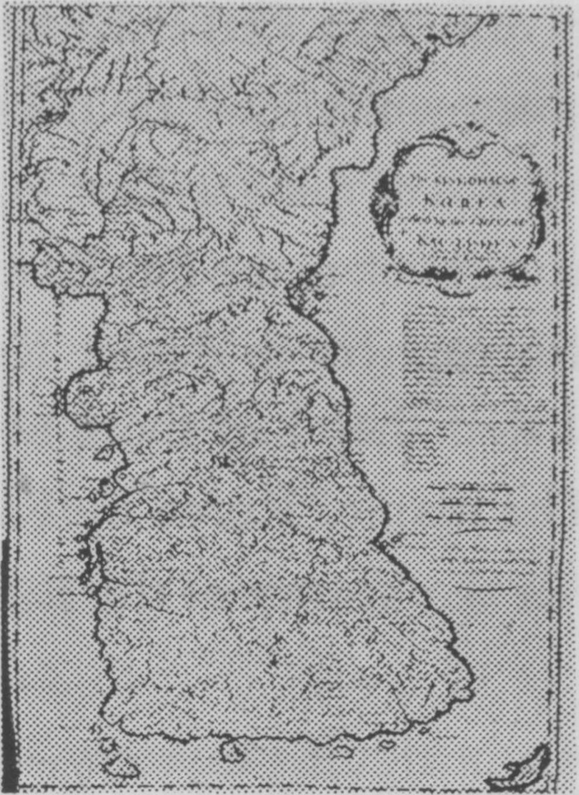

**Figure 6.** The Kingdom of Korea. 1741,Edward Cave, London, Derived from the Nouvel Atlas de la Chine by d’Anville,Paris, 1737,Copy in the Li-brary of the Toyo Bunka, Tokyo.

Though the d’Anville map and its copies were adapted from the map of Korea in the Jesuit Atlas, there were some slight changes. The shape is very faithfully copied and the grid of latitude and longitude kept. However, the symbol for the mountains is changed to a more hachured one and the rivers are drawn in single lines. The coastline is accentuated by drawing closely spaced lines out from the coast parallel to the parallels for short distances. The town symbols are small castle-like drawings. The capital is called King-Ki-Tau,which is the Chinese pronunciation of Kyonggi-do, or Kyonggi Province. The symbols for forests are omitted. However, added to the map are dotted lines for provincial boundaries and the names of the provinces. The boundaries are not too accurate ; they may have been derived from an interpretation of the “Geographical Observa-tions of the Kingdom of Corea, taken from the Memoirs of Pere Regis” which was included in Du Halde’s China.

38 The 1741 Edition which was in quarto size in two volumes was entitled in part: “A Description of the Empire of China and Chinese-Tartary, Together with the Kingdoms of Korea and Tibet. . .”, London, Edward Cave. 2 Volumes, 1741.

[page 98]

The map of Korea drawn by Father Regis and used by d’Anville and Du Halde was subsequently used by many European cartographeres to correct their maps of the Far East in the following decades. Eventually this map came back to the Far East in some form and was used by Japanese cartographers to depict Korea on some of their maps, despite the fact that they had more accurate maps of Korea available to them.39 The map of Korea by Father Regis did indeed mark a turning point in the history of the European cartography of Korea.

But—and this is an intriguing mystery—but what was the map which was in the King of Korea’s palace which was copied by the Tartar Lord and in turn adapted by Father Regis? There has been some speculation as to this map by Korean and Western scholars but no definitive answers have been published. Some persons have been confused by the dates, thinking that the map in the palace would be one of Chong Sang-gi’s maps, since d’Anville’s Atlas was published in 1736. But this is a wrong assumption,for the map used in the Jesuit Atlas given to the Emperor Kang Hsi was drawn before 1714. The Korean map would have had to pre-date 1710 in order for it to have been obtained or copied by the Tartar Lord. A person who likes the exotic might say that it was copied from the Pando-ji, the pond in the shape of a map of Korea near which a pavilion was built in 1642 in the Secret Gardens in Seoul. This explanation, though romantic,scarcely seems feasible! The Tartar Lord told Father Regis that “he had likewise been kept under great restraint; that there were Persons in his House who constantly watched him and that everything he said was carried to the Palace by young Per-sons placed at convenient distances along the street.” Being under

39 An eminent Korean geographer, Pak No-sik, Vice-President of Kyunghee University, kindly gave me a copy of a reprint of a Meiji 3rd Year (1871) map of Japan and adjoining areas which has the Korean peninsula in the identical shape as that of the map of Father Regis.

[page 99] such surveillance it was hardly possible for the Tartar Lord to copy any map of Korea without the blessing of Korean officials. It is, of course, possible that the Korean officials furnished to the Tartar Lord an old map of Korea, such as an elaborated copy of the map in the Tongguk-1 Yoji-Sungnam which has a somewhat similar shape to the map of Father Regis. It is hoped that they did not give him a map to copy that was purposely misleading. It is also possible that the Tartar Lord was not a very accurate copyist. All of these speculations are intriguing but not very helpful.

The late Kim Yang-son, a Korean scholar who founded the Christian Museum at Soong-jun University, conjectured that the map might have been similar to one drawn by Kim Suh-hong and published in a wood-block edition about 1700.40 This is a possibility, for the shape of southern Korea is fairly close to that on the map of Father Regis. The islands of Cheju and Ullung are drawn in similar positions close to the peninsula. The capital, though accentuated in size in Kim Suh-hong’s map, is located in the center of the penin-sula. However, the area of northern Korea as shown on Kim’s map is quite different than that of the map of Father Regis. Another possibility is the map of Korea in Hong Manjong’s book Tongguk-Yoktae-Ch’ongmok, a history of Korea written around 1700.41 However, this map, obviously drawn to fit the paper, is essentially a copy of the map in the *Tongguk-Yoji-Sungnam* and does not have the detail of the map of Father Regis. Neither Kim Suh-hong’s nor Hong

40 I have studied the wood-block map of Kim Suh-hong in the collection of the Christian Museum at Soong-jun University and was very kindly given photographs of it. Kim Yang-son only conjectured that this map was a possibility of a prototype of the Regis map in a conversation with me in 1970 and in one of his articles in Korean.

41 Copies of the *Tongguk-Ch’ongmok* may be found in a number of libraries. In making copies of the map from different editions and copies of the book I have been impressed by how widely the copyists varied in their skill and exactness of reproduction.

[page 100] Man-jong’s maps were likely to have been readily available in the Royal Palace.

In the years after the abolition of the Yi Dynasty, the books and maps in the Royal Palace were widely dispersed. Maurice Courant in his Bibliographie of Korean scholarly works lists under #2204 a. map without a title which he says was the map of Korea which was. in the palace in Seoul and of which a copy was used by the Jesuits, at the start of the XVIII century.42 But Courant gives no details on. the Korean map or even where he had seen it, so this reference is only tantalizing rather than helpful. Courant may have been referring to some well-known but undated maps of Korea, the Choson- Chido or the Haedong-Chido, both wood-block printed maps. sometimes copied and colored in manuscript form and which may be seen in a number of collections. However, these maps do not have the shape of the map of Father Regis.

The search for this elusive map despite the frustrations has been a very enjoyable experience. It has resulted in contacts with all sorts of persons. Some operator-types have been disappointed that some fabulous sum of money was not forthcoming for a map or atlas. They thought of an American research scholar as a Tartar Lord, not recognizing that the present rules and regulations forbid the export

42 The reference to this map is #2204 in Maurice Courant’s *Bibliographie Coreene*, op. cit. The Introduction to Courant’s bibliography was translated by Mrs. W. M. Royds and published in the Transactions, Korea Branch, Royal Asiatic Society, Vol.. XXV, 1936, pp. 1-99. Courant noted that the Koreans “have made a great number of maps of Korea” and particularly lauds Kim Ghong-ho’s map of 1861 as “a work of remarkable accuracy,and in addition is admirable as it was made only by indi genous processes”.

The standard references to Korean bibliography have mention of only the major geographical works and atlases. The catalogues of the collections at the various government and university libraries usually have a section on maps which lists their holdings by title. Catalogues of map exhibitions held at Seoul National University in 1971 and at Yongnam University in 1970 list and have brief comments on the maps displayed. However, there is no overall master catalogue of Korean maps; such a catalog, well annotated, would be very helpful.

[page 101] of Korean maps of venerable age. However, many enjoyable and valuable discussions have been held with scholars and with knowledgeable librarians and book dealers about old maps of Korea. There is a joy to the feel and appearance of an old map; there is always the hope that, when leafing through a set of maps, a map similar to that of Father Regis would appear.

It is possible to conjecture that the map copied by the Tartar Lord and used by Father Regis was a Korean map drawn to fit the dimensions of the sheets of paper used. It was probably in manuscript form rather than in wood-block reproduction. It was not drawn to scale as was Chong Sang-gi’s map of a few years later. It would have been of a fairly large size in order to include all of the place names used, and the map probably accentuated the rivers and mountains of Korea. It may well have been that this map quickly went out-of-date and was superseded by Chong Sang-gi’s excellent *Tongguk-Chido* which appeared some time after 1730. Thus the map copied by the Tartar Lord and furnished to Father Regis may well have gone into oblivion and not been copied or reproduced, explaining why no copies are to be found. The search has not ended. Newspaper articles and a magazine article that have been published in the fall of 1975 may help in the search. Who knows? Somewhere there may be another map like that of the Matteo Ricci map of 1603 lying rolled up and dust covered in a family vault, the discovery of which will solve the mystery.

The search for the Korean map used by Father Regis has been rewarding. Through it much has been learned about Korean cartography and of man’s eagerness to chart his way; centuries ago it was to the next contintent, now it is to use satellites to gain remote sensing imagery of the earth’s resources. The Korean map which has been sought is an interesting example of the ways in which knowledge has moved between the East and the West. It is evidence of the [page 102] kind of cooperation which took place almost three centuries ago between some Korean court officials, a Tartar Lord, a Chinese math- ematician, a Jesuit missionary-cartographer, a French cartogra-pher, a British cartographer and probably a lot of other persons. The Koreans did share their geographical knowledge and their maps and helped the outside world gain a more correct understanding of the geography of Korea. It is hoped that such will always be the case with Korea, and that the maps of Korea will always be available to the outside world.