[page 39]

A Note on Yi Dynasty Furniture Making

by Edward Reynolds Wright

The finished product of the Yi dynasty (1392-1910) wood craftsmen was usually determined by the size and characteristics of his raw materials. Woods with durable qualities and ornate grains were particularly prized by upper-class families. These included zelkova, paulownia, pear, persimmon, ginkgo, pine, pine nut, bamboo, walnut, Chinese date or jujube, juniper, chestnut, maple, elm, willow, cherry, red oak, and lime—also known as basswood.

Craftsmen often used two or more woods for constructing one piece of furniture. A hardwood might be used for the front frame (pear wood or zelkova wood); a wood with a natural ornate grain for front panels or top (persimmon or zelkova wood); and a more ordinary wood for the sides and back (pine wood or paulownia wood).

CONSTRUCTION TECHNIQUES IN TRADITIONAL KOREAN FURNITURE-MAKING

The dried wood was cut with a saw or with an adz-like instrument (*kkokkwi*), which was used for hewing and rough-shaping some wood pieces. Planing was done with an instrument called a *taep’ae*, and the wood was further smoothed with rough leaves. Other carpenter’s tools included an ink-box with string (*moktong*) for plotting straight lines, and a ruler measured in 15 units called *chi*. In construction, hardwood nails were used, usually made of bamboo, birch, or jujube. Another method of joining wood panels was by dovetail joints (in Korean referred to as finger joints) held together by glue.

Various techniques were used by Yi carpenters in finishing wood surfaces. Following are brief descriptions of some of the principal ones:

1. Lacquer. The lacquer tree (in Korean, ot namu,) is indigenous to East Asia. The lacquer process was used especially to provide a durable finish on furniture which received frequent and heavy use, such as individual small serving tables. Lacquer was usually applied in its natural, uncolored state, but sometimes was mixed with black or red coloring. The resin of the lacquer [page 40] tree was applied in several layers with a cloth or brush. A popular but less desirable alternative for uncolored lacquering was to rub the furniture with leaves of the lacquer tree. A third and least desirable method was to extract resin by burning branches of the lacquer tree and then to rub it on the wood.

The process for making colored, inlaid lacquerware was, and is, complex. The first step is to apply pure lacquer to the wood and then dry it for seven to ten hours. Next the wood is painted with a combination of 55 percent lacquer and 45 percent rice glue. A thin piece of hemp or linen is placed over that coating, and then a new coat is applied, this time combining 50 percent lacquer, 45 percent fine burned clay powder, and five percent rice glue. After drying, the surface is smoothed by watering it and then whetting with a grindstone. At this point, decorative objects may be inlaid, made from ab-alone, oyster or conch shells; tortoise shell; fish skin; ox bone; brass or silver. These materials were traditionally stuck in place with fish glue. Next a combination of 40 percent fine burned clay powder, 50 percent lacquer, and ten percent rice glue is applied twice, and the surface is again smoothed on a grindstone to allow the inlaid material to show at its best. Another thin layer of lacquer is applied and allowed to dry for ten hours. Then the surface is well rubbed with ginkgo tree ashes. Finally, the best quality lacquer is applied, rubbed with ginkgo ashes and polished with fine powder (preferably made from deer’s horn) and soybean oil. Women’s furniture especially was often treated in this way, including jewelry and cosmetics boxes, wardrobe chests, and food serving plates.

2. Sesame oil (tul kirum). Several coats of sesame oil were rubbed into the surface of the finished object.

3. Animal blood. Cow’s or pig’s blood was rubbed into the natural wood finish. This method was used more by the lower classes.

4. Smoking process. A cruder method for finishing small wood objects was to place them over the smoke from burning rice straw, resulting in resin from the wood coming to the surface, which was then rubbed with leaves or cloth.

5. Fine red or yellow clay mixed with water or lacquer. This finish was of a red (ppalgan huk) or yellow (noran huk) color derived from a fine natural gravel or clay substance. This finish was especially applied to wood with a grainy surface, effectively filling in surface irregularities. Wooden kitchen implements, such as rice cake and other mixing bowls, often were finished in this fashion.

6. Chinese medicinal herb-based finish. Some royal and upper-class furniture used a red stain made from a medicinal Chinese herb, in Korean called naesa ch ‘il or chusa ch’il. Wedding chests and upper-class traveling [page 41] chests, among others, often were finished in this manner.

Finished products were usually waxed with beeswax (mil ch’o), gingko nuts, pine nuts, walnuts, soybeans, or green persimmons.

Most furniture was furbished with sturdy, hand-crafted metalwork which was made to order by blacksmiths. The three most popular metals for this purpose were black iron; yellow brass (an alloy of copper and zinc, called in Korean nossoe or hwangdong); and white brass (paektong), derived from copper and zinc, with a larger proportion of zinc than in yellow brass. Another popular decorative material was ox or cow horn (called hwagak), used for panels of delicate women’s furniture such as wardrobe chests, and cosmetic and jewelry boxes, among others. The horn, through an intricate procedure, was sliced into thin layers and painted with rural scenes, birds, flowers, and long-life symbols.

In summary, the Korean Yi dynasty produced wood craftsmen who achieved a highly developed level of skill and artistry in their trade. It is no wonder, then, that their products have been admired and copied by westerners and orientals alike.

[page 42]

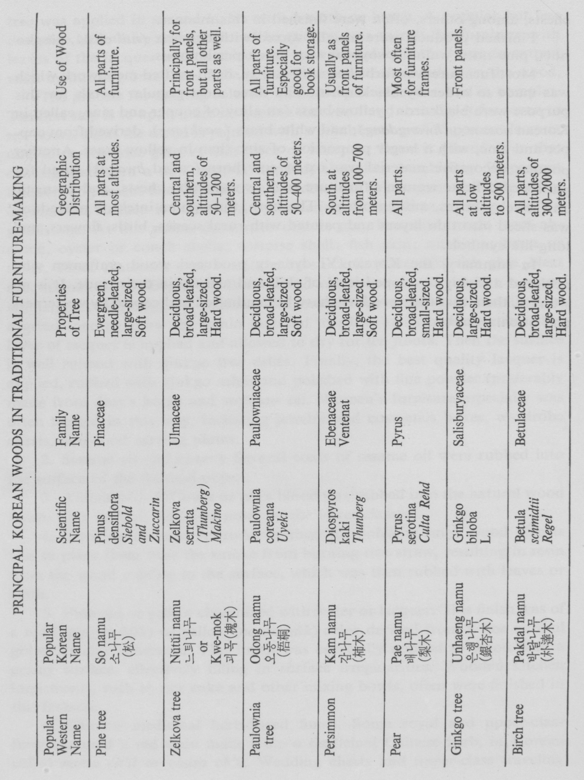

[page 43]

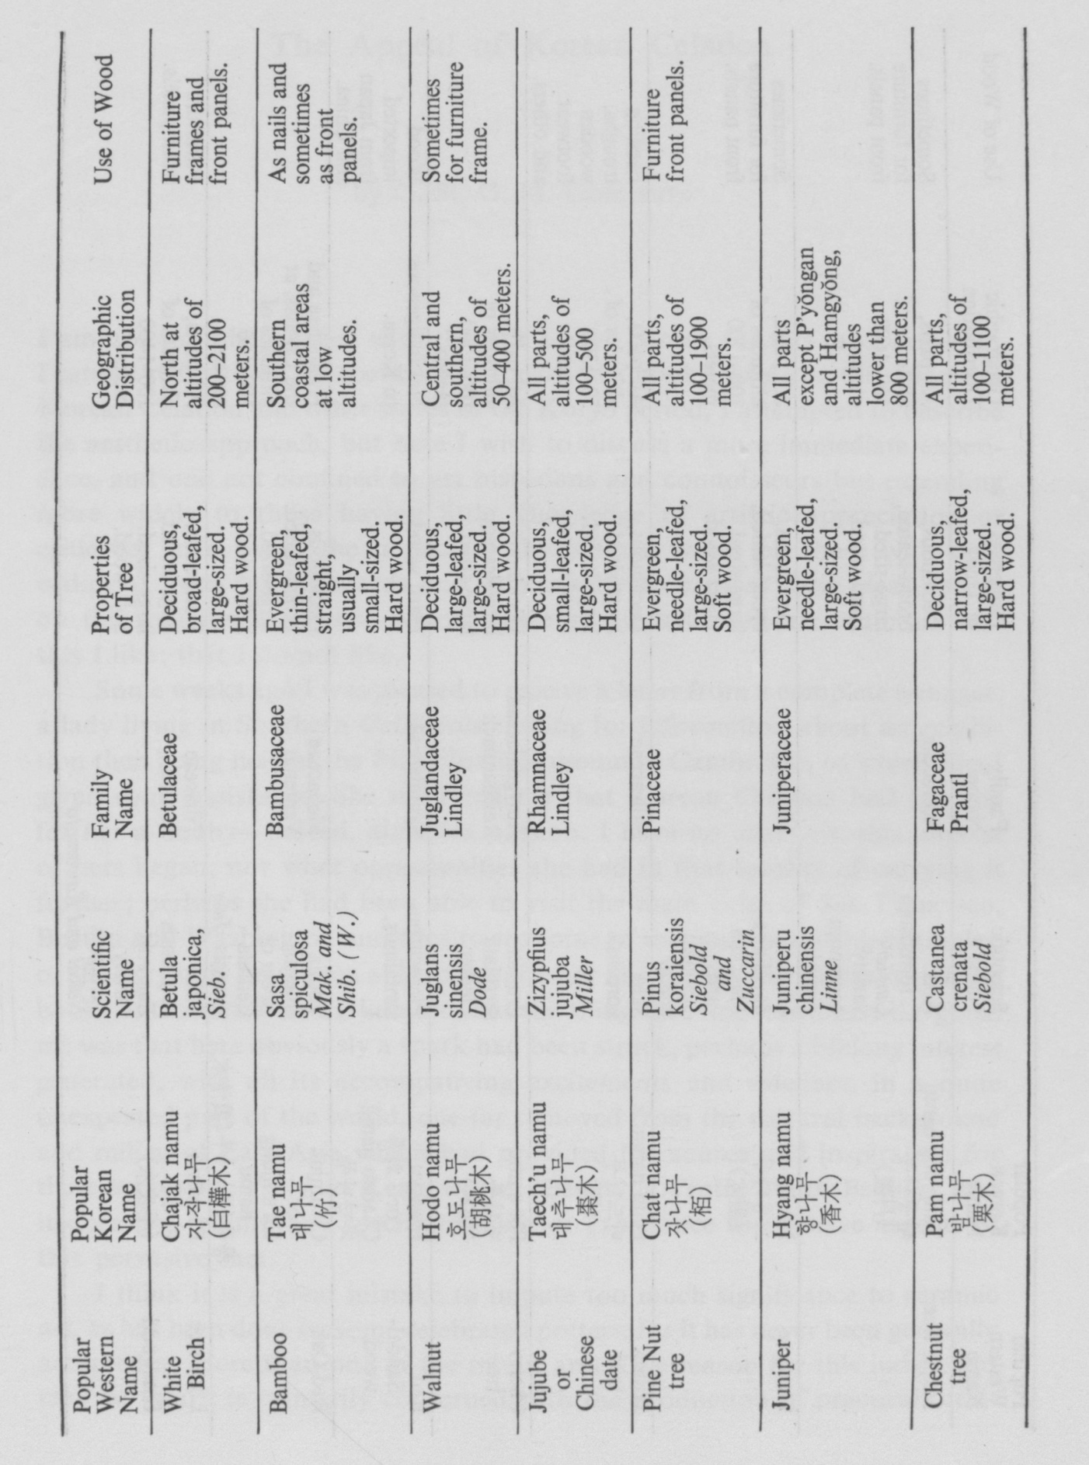

[page 44]

