[page 23]

**Geographical Divisions of Korean Plants**

Kong, Woo-seok

PREVIOUS FLORISTIC AND VEGETATIONAL ZONES OF KOREA

In the past, authorities have employed a range of different terms to describe the floristic and vegetational zones of the world. The earliest attempt to classify world floristic provinces was that of Schouw in 1823, which produced 25 floristic kingdoms. In 1872 Grisebach delimited 24 regions, while 21 floral regions were presented by Engler in 1912 (McLean & Ivimey-Cook, 1973). Later, world vegetation was classified into 6 floristic units (Good, 1947), 8 biogeographic realms (Udvardy, 1975), 10 floral divisions (Frodin, 1984), 5 biorealms (Muller, 1986) and 35 floristic regions (Takhtajan, 1986). In general, most of these research workers placed the Korean peninsula into the East Asiatic, or the Sino-Japanese region of the Holarctic Kingdom.

The Eastern Asiatic Floristic Region is one of the major world centres of higher-plant evolution, and it is also one in which many ancient floras are preserved in live form. The presence of a great number of Tertiary relics in the present-day flora of East Asia (Kryshtofovich,1929; Good, 1947; Li, 1953; Wang, 1962) is emphasised further by its geographical and environmental diversities, the presence of easy migration pathways for floral movement within the region, the absence of extensive glaciation during the Pleistocene (Good, 1947; Li, 1953; Giterman & Golubeva, 1965) and the consequential lack of any catastrophic changes of environment, other than the development of extreme cold during the Pleistocene cold phases, for a long- term period of time (Kryshtofovich, 1929; Li, 1948; Derevianko, 1978).

In view of this floristic richness, most of the early subsidiary divisions of vegetation in East Asia dealt solely with major forest tree species.

In Korea, the flora and vegetation remained little known to the West until Miquel published a report in 1865 (Chung, 1986). Past floristic and vegeta- [page 24] tional works since that time can be categorised into three main branches, viz. first, the demarcation of forest vegetation zones; secondly, the delimitation of evergreen broadleaved plant ranges; and, thirdly, subdivisions into floristic divisions. Thus, in 1872 Grisebach listed two vegetation zones, north and south, divided by the 40°N parallel; and Schimper adopted a similar approach in 1898, with the 38°N line as a divide. Following on from these two, Brock- mann-Jorosch used the 37°N parallel as a divide in 1919; and Miyoshi in 1911 recognized three zones, north, midland and south, separated by the 34°N and 38°N lines of latitude. Also in 1911, Uyeki produced probably the first true regional zonation of Korean forest vegetation, based on his own observations (Chung, 1986). The zonations of Korean forest vegetation, normally comprising three zones, and representative plants from each division, from 1919, are summarized in Taole 1.

A study of the northern distribution limit of evergreen broadleaved trees is also of ecological value, and provides useful information for the production of a vegetation map. Uyeki (1941) has described the northern limit of Korean evergreen broadleaved trees as connecting the mid-western islands, the southernmost coast and Ulreung Island. Recently this has been shifted northwards into the inland area of southwestern Korea (Kong & Chung, 1984). At present, the northernmost limit of evergreen broadleaved plants and their typical communities have been assigned as protected areas by the Natural Monuments Commission for conservation and research purposes (Lee, 1969; Cultural Property Preservation Bureau, Korea, 1970; Korean Ministry of Culture and Information, 1970; Korean Ministry of Home Affairs, 1972).

In comparison with the past elaboration of vegetation zonations, that relating to floristic division is poor Six previous floristic divisions have been compilea by research workers, and these are presented in Table 2. In general, five floristic regimes are recognized by most authorities, viz. the Northern, Central, Southern, Cheju and Ulreung regions.

Despite the richness and the floristic diversity of East Asia as a whole, very little is known about the biogeographical relationships therein, or the categorisation of the component plant species into more detailed biogeo- graphic regions. Most categorizations so far have been of a general nature, or limited to the examination of one particular, or a few common groups of plants. [page 25]

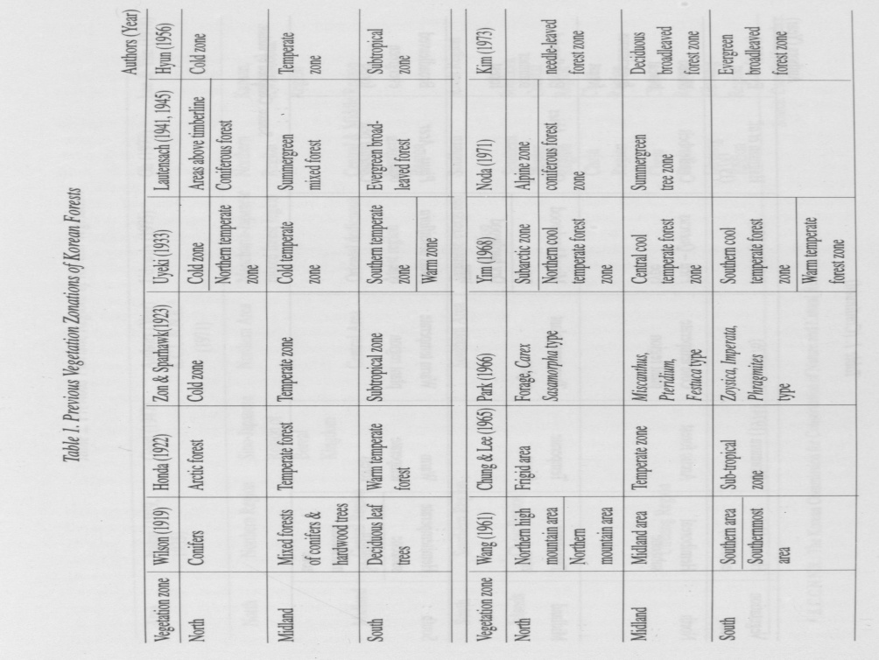

[page 26]

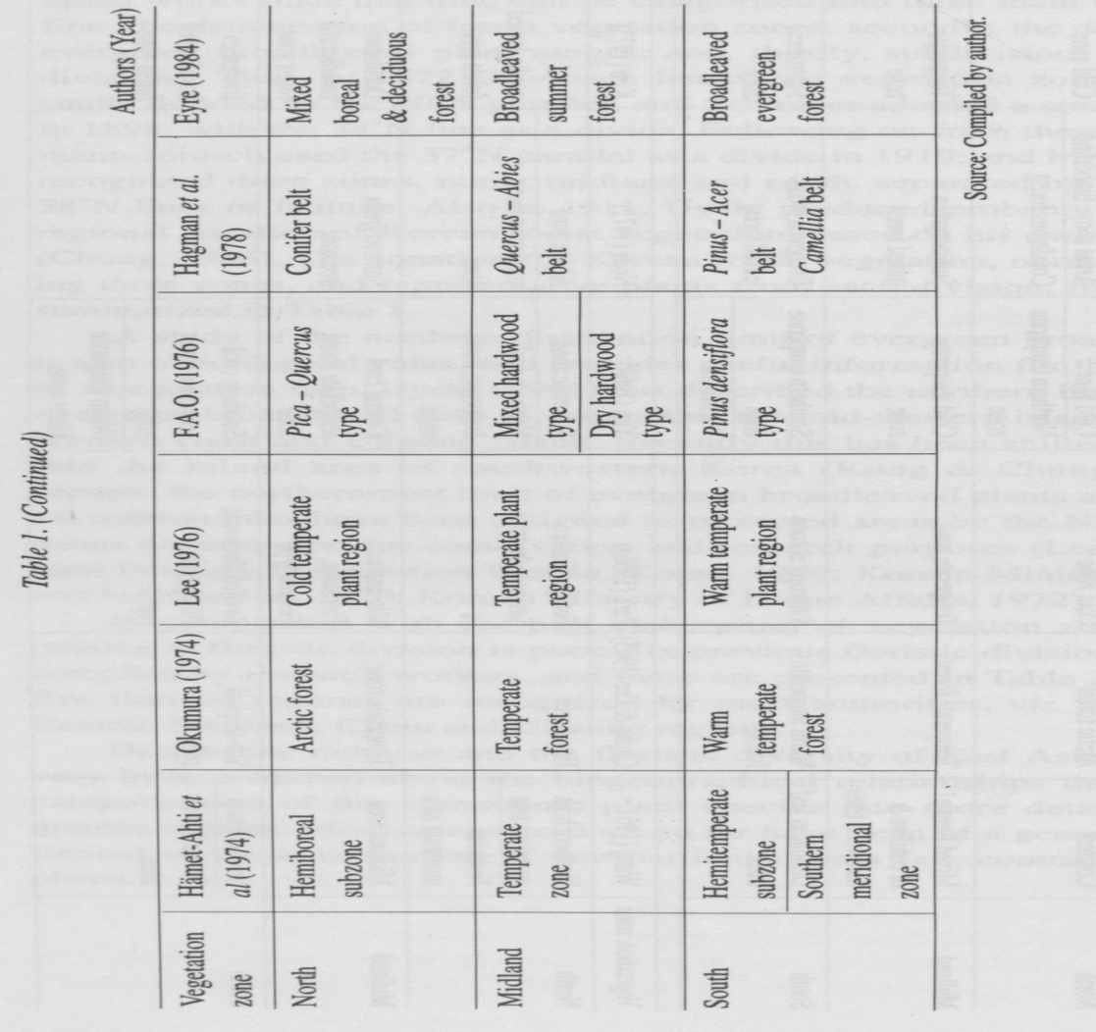

[page 27]

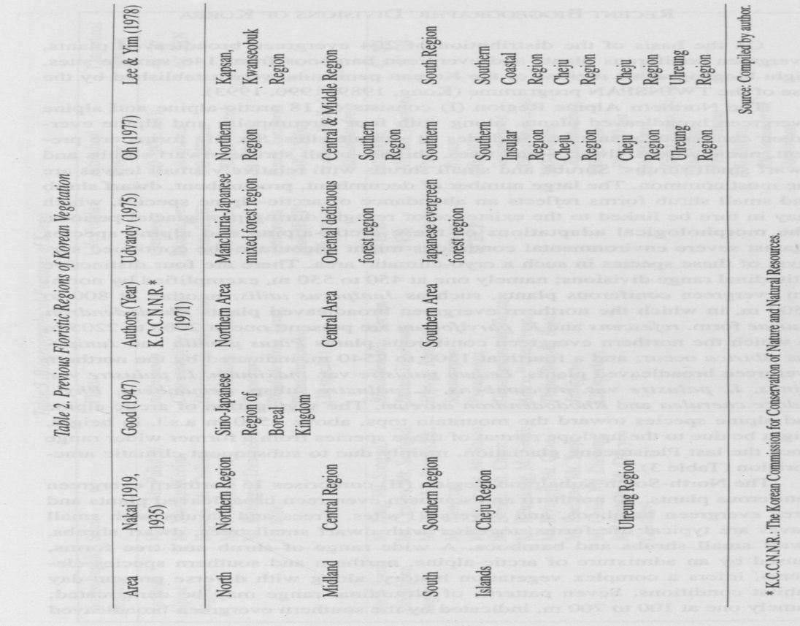

[page 28]

RECENT BIOGEOGRAPHIC DIVISIONS OF KOREA

On the basis of the distribution of 204 evergreen broadleaved plants, evergreen coniferous plants and evergreen bamboos from 146 sample sites, eight biogeographic regions of the Korean peninsula were established by the use of the TWINSPAN programme (Kong, 1989, 1990, 1993).

The Northern Alpine Region (I) consists of 18 arctic-alpine and alpine evergreen broadleaved plants, along with four circumpolar and alpine evergreen coniferous plants and includes 11 sample sites. Six life forms are present, namely trees, dwarf small trees, shrubs, small shrubs, dwarf shrubs and dwarf small shrubs. Shrubs and small shrubs with relatively small leaves are the most common. The large number of decumbent, procumbent, dwarf shrub and small shrub forms reflects an abundance of arctic-alpine species, which may in turn be linked to the existence of refugia during past glacial periods. The morphological adaptations of these arctic-alpine and alpine species against severe environmental conditions might encourage the continued survival of these species in such a cryo-climatic area. There are four distinctive altitudinal range divisions; namely one at 450 to 550 m, exemplified by northern evergreen coniferous plants, such as Juniperus utilis; another at 800 to 1500 m, in which the northern evergreen broadleaved plants Rhododendron fauriae form, refescens and R. parvifolium are present; one at 2000 to 2205 m in which the northern evergreen coniferous plants Pinus pumila and Juniperus sibirica occur; and a fourth at 1500 to 2540 m, indicated by the northern evergreen broadleaved plants, Ledum palustre var. maximum, L. palustre var. minus, L. palustre var. procumbens, L. palustre subsp. decumbens, Phyl- lodoce caerulea and Rhododendron aureum. The segregation of arctic-alpine and alpine species toward the mountain tops, above 1500 m a.s.l. in height, might be due to the upslope retreat of these species from a former wider range since the last Pleistocene glaciations, mainly due to subsequent climatic amelioration (Table 3).

The North-South Subalpine Region (II) comprises 15 northern evergreen coniferous plants, 10 northern and southern evergreen broadleaved plants and three evergreen bamboos, and covers 21 sites. Trees and shrubs with small leaves are typical life forms, together with dwarf small trees, dwarf shrubs, dwarf small shrubs and bamboos. A wide range of shrub and tree forms, caused by an admixture of arctic-alpine, northern and southern species elements, infers a complex vegetation history, along with diverse present-day habitat conditions. Seven patterns of altitudinal range may be demarcated; namely one at 100 to 700 m, indicated by the southern evergreen broadleaved [page 29]

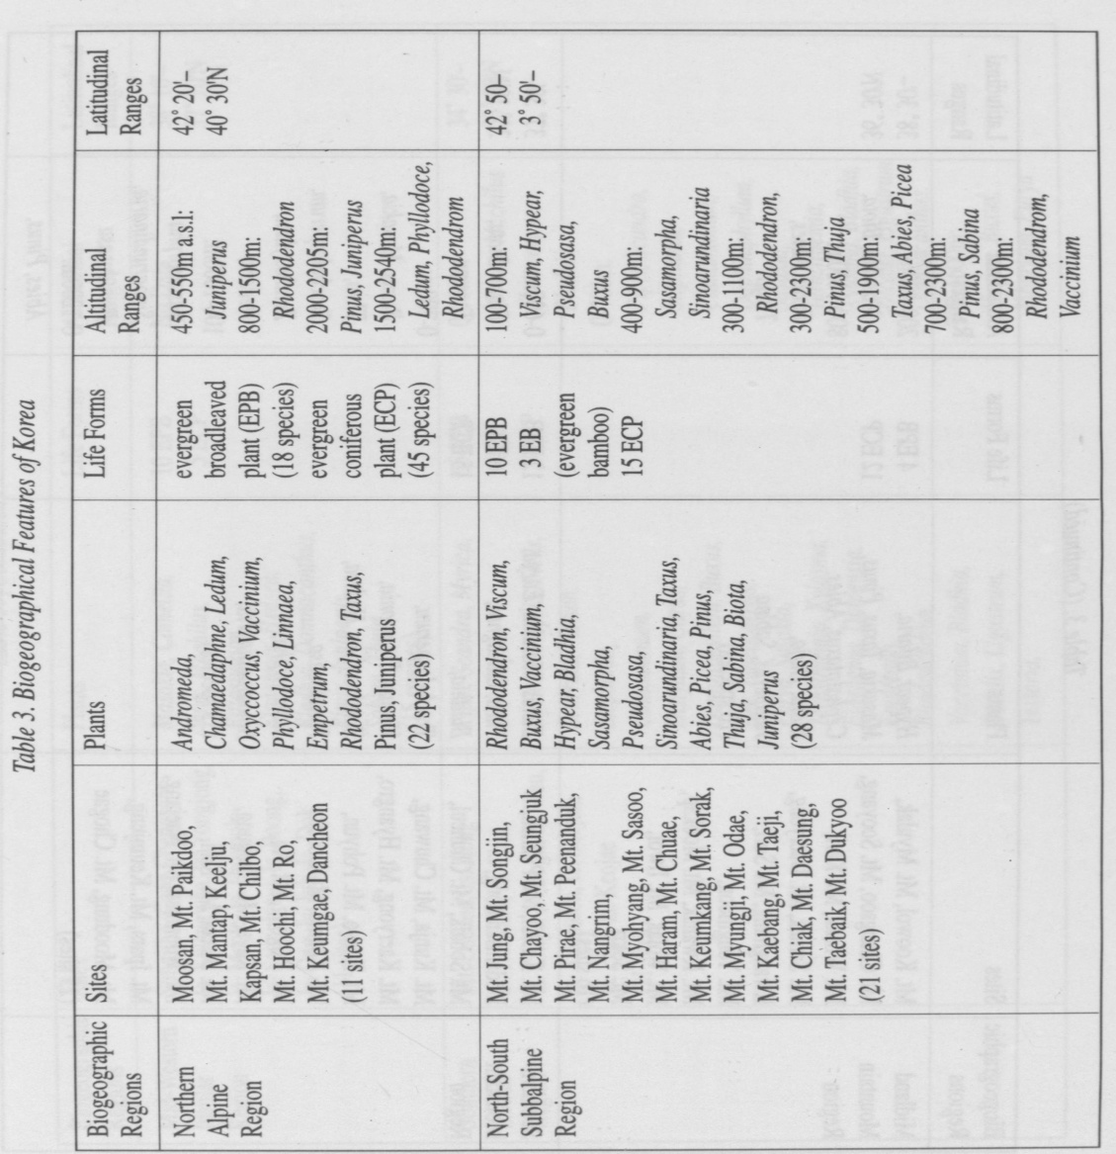

[page 30]

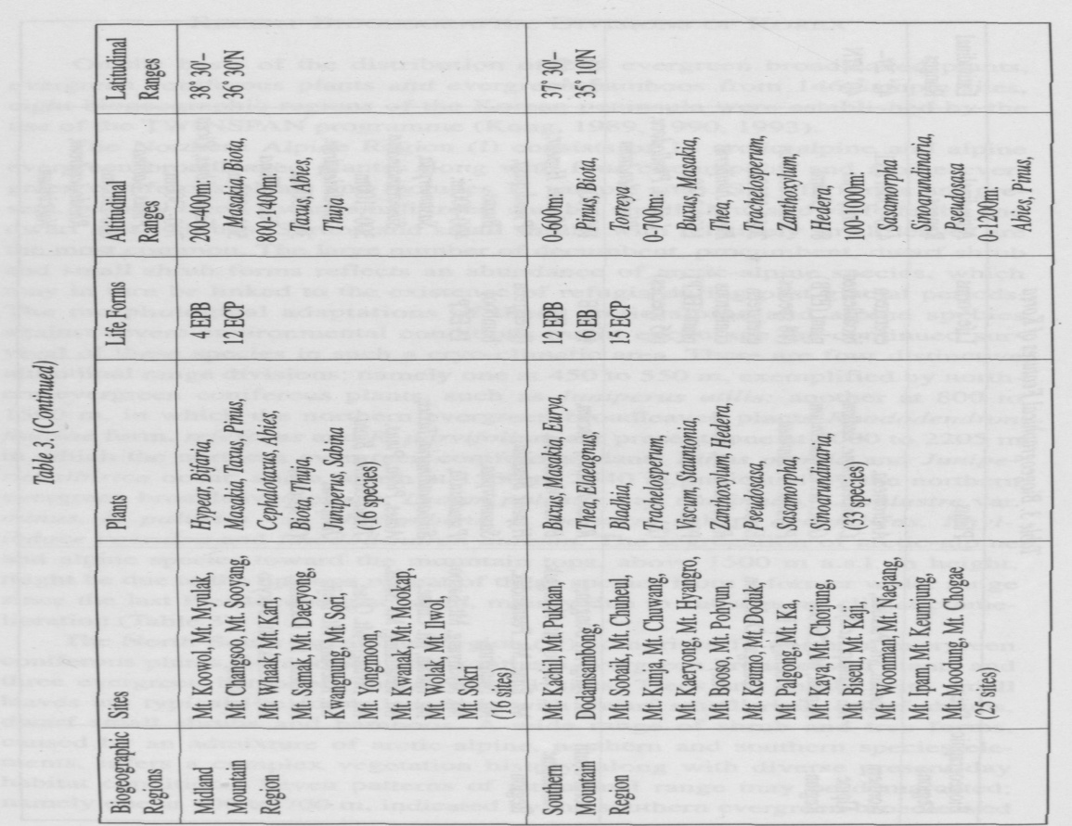

[page 31]

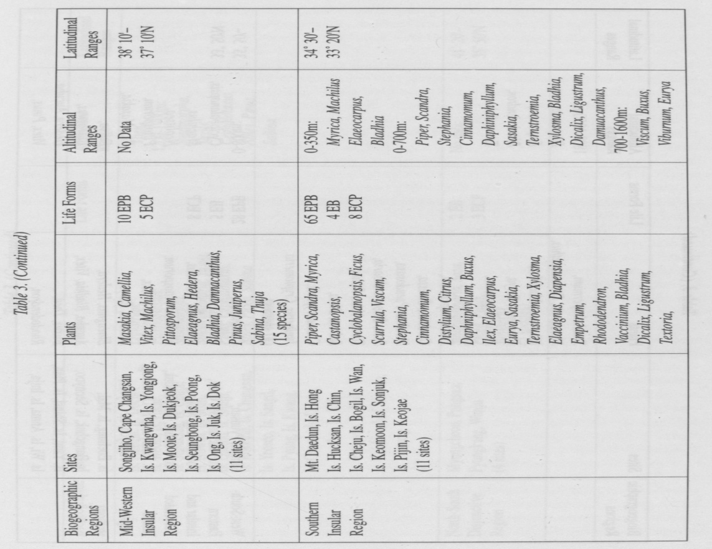

[page 32]

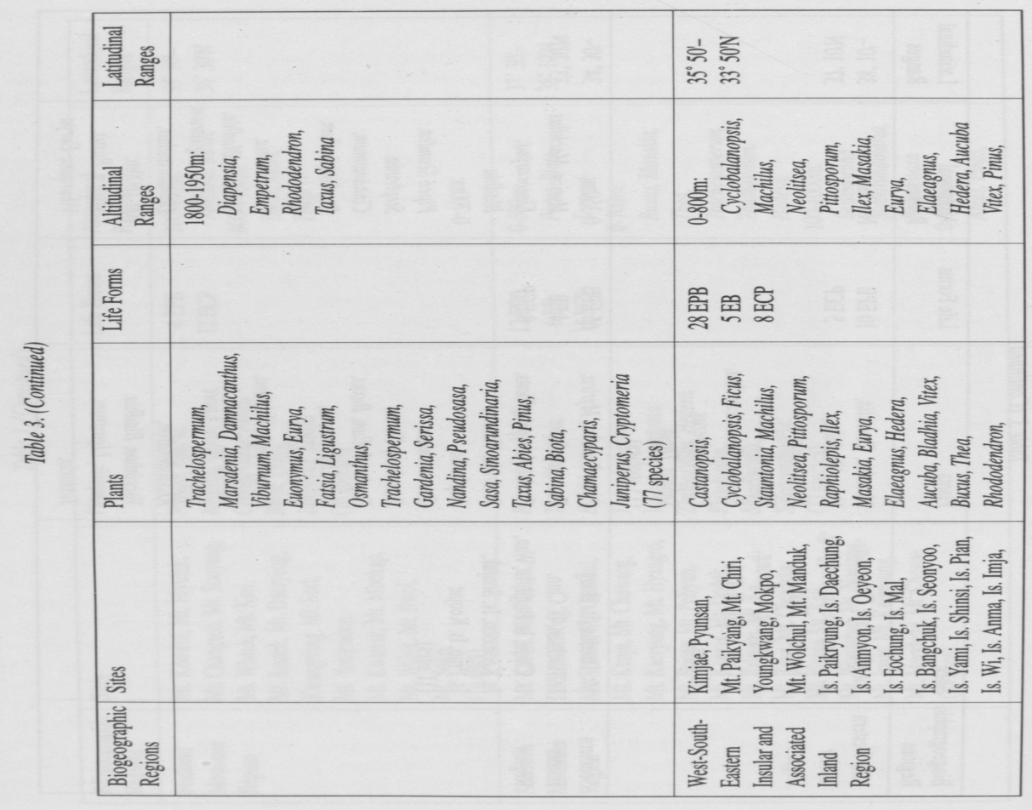

[page 33]

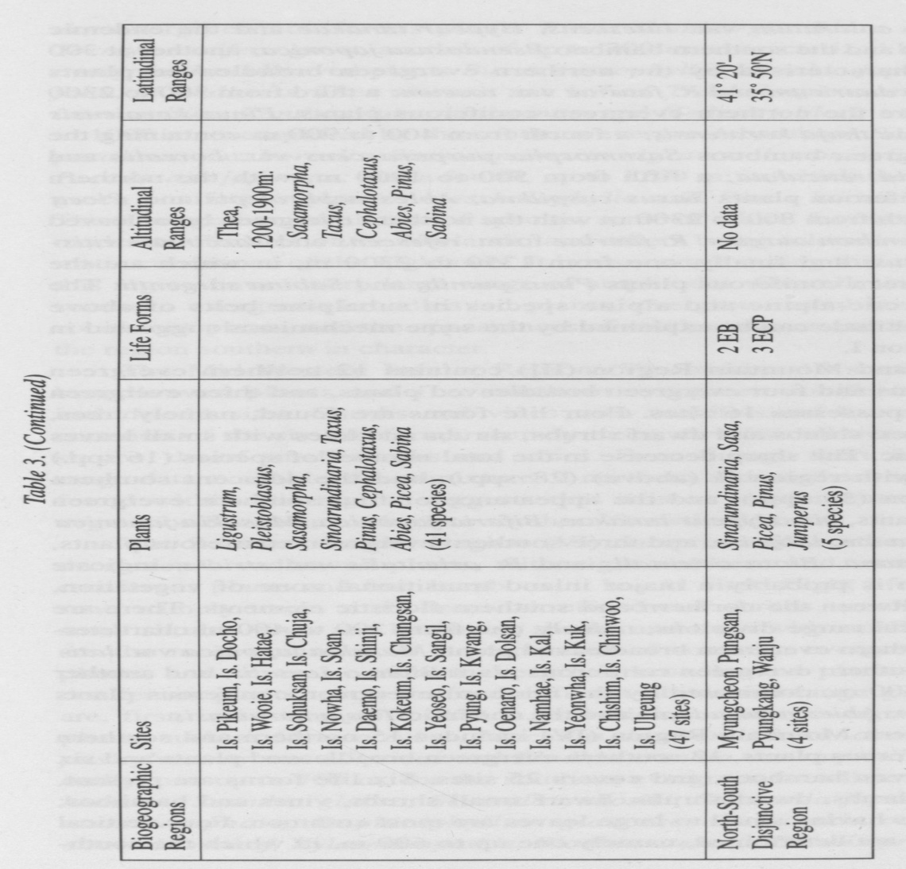

[page 34] plants Viscum coloratum var. lutescens, Hypear tanakae and the endemic Buxus koreana and the southern bamboo Pseudosasa japonica; another at 300 to 1100 m, characterised by the northern evergreen broadleaved plants Rhododendron dauricum and R. fauriae var. roseum; a third from 300 to 2300 m, in which are the northern evergreen coniferous plants, Pinus koraiensis and the endemic thuja koraiensis; a fourth from 400 to 900 m containing the southern evergreen bamboos Sasamorpha purpurascens var. borealis and Sinoarundinaria reticulata; a fifth from 500 to 1900 m, with the northern evergreen coniferous plants Taxus cuspidata, Abies nephrolepis and Picea jezoensis; a sixth from 800 to 2300 m with the northern evergreen broadleaved plants Rhododendron aureum, R. fauriae form, refescens and Vaccinium vitis- idaea var. minus; and finally, one from 1350 to 2300 m, in which are the northern evergreen coniferous plants Pinus pumila and Sabina sargentii. The isolation of arctic-alpine and alpine species in subalpine belts of above C.. 1500 m in altitude can be explained by the same mechanisms suggested in the case of region I.

The Midland Mountain Region (III) contains 12 northern evergreen coniferous plants and four evergreen broadleaved plants, and three evergreen bamboos, and possesses 16 sites. Four life forms are found, namely trees, dwarf small trees, shrubs and dwarf shrubs; shrubs and trees with small leaves are characteristic. The sharp decrease in the total number of species (16 spp.) as compared with region II (above) (28 spp), and the adjacent southern mountain region (33 spp), and the appearance of four southern evergreen broadleaved plants, viz. Hypear tanakae, Bifaria japonica, Masakia japonica and M. japonica var. latifolia, and three southern evergreen coniferous plants, Cephalotaxus nana, Biota orientalis and B. orientalis var. stricta, indicate that this region is probably a major inland transitional zone of vegetation, intermediate between the northern and southern floristic elements. There are two clear vertical range divisions, namely one from 200 to 400 m characterized by the southern evergreen broadleaved plant, Masakia japonica var. lati- folia and the southern evergreen coniferous plant Biota orientalis, and another from 800 to 1400 m, dominated by the northern evergreen coniferous plants Taxus cuspidata, Abies nephrolepis and the endemic Thuja koraiensis.

The Southern Mountain Region (IV) includes 15 northern and southern evergreen coniferous plants, 12 southern evergreen broadleaved plants and six southern evergreen bamboos, and covers 25 sites. Six life forms are present, namely trees, shrubs, dwarf shrubs, dwarf small shrubs, vines and bamboos; shrubs and trees having small to large leaves are most common. Four vertical range divisions are determined, namely one up to 600 m, in which the south- [page 35] ern evergreen coniferous plants Pinus thunbergii, Biota orientalis and Torreya nucifera grow; another of up to 700 m, characterized by the southern evergreen broadleaved plants Buxus microphylla, Masakia japonica var. lati- folia, M. radicans, Thea sinensis var. bohea, Trachelospermum asiaticum var. intermedium, Zanthoxylum planispinum and Hedera tobleri; a third, from 100 to 1000 m, exemplified by the southern evergreen bamboos Sasamorpha pur- purascens var. borealis, Sinoarundinaria nigra var. henonis, S. reticulata and Pseudosasa japonica; and a fourth, up to 1200 m, in which the northern evergreen coniferous plants Abies holophylla and Pinus koraiensis are found. These suggest an admixture of species, some of which favour the presently— moderate climates of the lowlands, and others being tolerant of the harsh climatic conditions of the highlands. It is also worth noting that many species in this region have a very large range of amplitudes. Overall, the dominance of southern evergreen broadleaved plants, evergreen bamboo and evergreen coniferous plants, and the appearances of southern vines and bamboos, makes the region southern in character.

The Mid-Western Insular Region (V) contains 10 southern evergreen broadleaved plants and five northern evergreen coniferous plants, and includes 11 sites. Shrubs and vines with middle-sized leaves are the most common of the six life forms, namely trees, dwarf small trees, shrubs, dwarf shrubs, dwarf small shrubs and vines. Even though there is no altitudinal range data available, the admixture of northern and southern species elements found within this region suggests that it is an insular transitional zone of vegetation between northern to southern floristic elements.

The Southern Insular Region (VI) comprises 65 northern and southern evergreen broadleaved plants, with eight northern and southern evergreen coniferous plants and four bamboos; it has 11 sites. Eight life forms are present, namely trees, small trees, shrubs, dwarf shrubs, small shrubs, dwarf small shrubs, vines and bamboos; shrubs and trees with small to large leaves are the most common. A large number of southern evergreen broadleaved plants, and several northern evergreen broadleaved plants and evergreen coniferous plants, occur in four different altitudinal-range groupings. These are, first, one found up to 350 m, in which southern evergreen broadleaved plants, such as Myrica rubra, Machilus thunbergii rorm. obovata, Elaeocar- pus sylvestrus var. ellipticus and Bladhia crenata var. taquetii are found; secondly, one up to 700 m, for the southern evergreen broadleaved plants Piper kadzura, Scandra glabra, Scurrula yadoriki, Stephania japonica, Cinnamo- mum camphora, Daphiniphyllum glaucescens, Sasakia ochnacea, Tern- stroemia mokof, Xylosma apathis, Bladhia crenata, Dicalix prunifolia, Ligus- [page 36] trum lucidum, Damnacanthus indicus, D. major; thirdly, one from 700 to 1600 m, exemplified by the southern evergreen broadleaved plants Viscum coloratum var. lutescens, Buxus microphylla, Eurya emarginata, Bladhia villosa var. typica and Viburnum awabuki; and finally, one from 1800 to 1950 m, characterized by the northern evergreen broadleaved plants Diapensia lap- ponica subsp. obovata, Empetrum nigrum var. japonicum and Rhododendron dauricum, and the northern evergreen coniferous plants Taxus cuspidata, the endemic Abies koreana and Sabina sargentii. It should be noted that the region has the largest number of southern evergreen broadleaved plants of all the eight biogeographic regions,which reflects the relatively warm and humid climatic conditions of the present-day. However, a disjunctive distribution of several arctic-alpine and alpine species, present near the peak of Mt. Halla (above c. 1800 m to the summit at 1950 m, relevant to other regions of Korea, seems to point to a much wider distribution for these species during the Peistocene glaciations. In short,the highly complicated range of life forms, and the high floristic diversity are due to the survival of arctic-alpine, alpine, temperate, and subtropical plants together, which reflect the diverse present-day environment, habitat conditions and vegetation history.

The West-South-Eastern Insular and Associated Inland Region (VII), which includes 28 southern evergreen broadleaved plants, eight northern and southern evergreen coniferous plants and five evergreen bamboos, has 47 sites. Large-leaved shrubs, trees, bamboos and vines are the most frequent of the seven life forms found; the others are small trees, dwarf shrubs and dwarf small shrubs. Southern evergreen broadleaved plants and evergreen bamboos are common in the insular and coastal areas, but northern evergreen coniferous plants occur more frequently in the inland area. There are two clear altitudinal range divisions: first, one up to 800 m, characterized by southern evergreen broadleaved plants like Cyclobalanopsis acuta, Machilus thunbergii, Neolitsea sericea, Pittosporum tobira, Ilex Integra van typica, Masakia japonica, M. radicans, Eurya japonica, var. montana, Elaeagnus glabra van euglabra, E. macrophylla, Hedera tobleri, Aucuba japonica van typica, Vitex rotundifolia and Thea sinensis var. bohea, and one southern evergreen coniferous plant, Pinus thunbergii; and second, one from 1200 to 1900 m, in which northern evergreen coniferous plants,including Taxus cuspidata, Pinus koraiensis and Sabina sargentii grow. The second largest number of southern evergreen broadleaved plant species present here, as compared to all other regions, reflects the existence of relatively mild climatic conditions today. The proportion of shrubs and trees is nearly equal, and so too in the case of vines and bamboos. Overall, this region is biogeographically closely related [page 37] to the southern insular region (VI).

The North-South Disjunctive Region (VIII),containing three northern evergreen coniferous plants and two southern evergreen bamboos, comprises four sites. There are three life forms, namely trees, shrubs and bamboos. The region is characterized by a high proportion of endemics (60.0%) for the total number of species in the region, and a high degree of physiognomic diversity for the small number of species present, which is so far unexplained.

SUMMARY

My work has delineated eight biogeographic regions in the Korean peninsula, mainly by the use of the TWINSPAN programme. It is based on the distribution of 204 evergreen coniferous, broadleaved and bamboo species from 146 sample sites (88 inland and 58 island sites). The eight biogeographic regions are: a Northern Alpine Region (I),a North-South Subalpine Region (II),a Midland Mountain Region (III), a Southern Mountain Region (IV),a Mid-Western Insular Region (V), a Southern Insular Region (VI), a West- South-Eastern Insular and Associated Inland Region (VII) and a North-South Disjunctive Region (VIII). A comparative analysis of each biogeographic division, and its component plant groups, its species composition, its physiognomy and the three-dimensional distributional patterns of species found therein has provided invaluable information as to the nature and history of the bio- geography of Korea.

The dominance of arctic-alpine and alpine evergreen broadleaved plants at the altitude of 1,500 m a.s.l. to 1,800 m a.s.l. of the Northern Alpine Region (I) (e.g. Ledium palustre var. procumbens, L. palustre subsp. decumbens, Phyllodoce caerulea and Rhododendron aureum), with their diverse life forms, has been demonstrated to indicate that first, the northern parts of Korea have maintained frequent floristic exchanges with neighbouring northern circumpolar, areas, notably during the Pleistocene period; secondly,both lowland and montane zones of this region have served as glacial refugia for arctic-alpine and alpine plants during the Pleistocene glacial phases; thirdly, the upslope retreat of these plants to alpine zones since the last glaciations, due mainly to climatic amelioration during the Holocene but also to the associated biological competition from more warmth-loving plants, has now confined many of these species to the alpine zones of northern Korea; and fourthly, the morphological adaptations of these plants to severe environmental conditions are the result of long-term gradual developments which have safeguarded the [page 38] survival of these species in such a harsh cryo-climatic area.

The admixture of arctic-alpine and alpine evergreen broadleaved plants from the alpine and subalpine zones, northern evergreen coniferous plants from the subalpine and montane zones, and southern bamboos and southern evergreen broadleaved plants from the montane and lowland zones in the North-South Subalpine Region of Korea (II) contains a wide range of life forms. Within this region, it is suggested that this diversity is the result of former active and frequent floristic movements between the Korean peninsula and neighbouring East Asian countries, and also within the Korean peninsula, especially along the north-south Hamkyung Mountain Range in the north, and the Taebaik Mountain Range in the south; and secondly, today, the segregation to some extent of these floras, in different altitudinal zones. From this, a complex vegetation history is postulated for this region, reflecting also its diverse environmental conditions.

The sharp decrease in the total number of species (16 spp.), and in the range of their life forms, within the Midland Mountain Region (III), as compared to those found in the North-South Subalpine Region (II) (28 spp.) and in the adjacent Southern Mountain Region (IV) (33 spp.), and also the clear vertical divisions of range within it (viz. northern evergreen coniferous plants are confined to the mountain zone, and southern evergreen coniferous and broadleaved plants to the lowland zone) suggest that this region is probably a major inland transitional zone of vegetation, intermediate between predominantly northern and southern floristic elements.

The coexistence of northern evergreen coniferous plants, southern evergreen coniferous plants, southern evergreen bamboos and southern evergreen broadleaved plants, all of which have a wide range of life forms, in the Southern Mountain Region (IV) indicates, first, that the high mountains present in the south have enabled some formerly much more widespread northern subalpine species to survive the present period of climatic amelioration by moving upslope; secondly, that the congregation of southern floristic elements both in the lowlands and montane zones of this region represents the influence of the presently-moderate climates; and thirdly, that the dominance of southern evergreen coniferous plants, southern evergreen broadleaved plants and southern evergreen bamboo species and the appearance of southern vines, allocates this region as being ‘southern’ in character, and moreover probably implies previous strong floristic connections with tropical and subtropical areas of East Asia as well. Many of these southern species still have a large distributional range, which extends to the southern parts of Japan and China.

The occurrence of northern evergreen coniferous plants and southern [page 39] evergreen broadleaved plants, and the even proportions of different life forms within the Mid-Western Insular Region (V) infer that this region is an insular transitional zone of vegetation, intermediate between northern and southern floristic elements.

The presence of the greatest number of evergreen plants in the Korean peninsula (77 spp.) in the Southern Insular Region (VI), including still some arctic-alpine evergreen broadleaved plants (e.g. Diapensia lapponica subsp. obovata, Empetrum nigrum var. japonicum and Rhododendron dauricum), northern evergreen coniferous plants, southern evergreen coniferous plants, southern evergreen broadleaved plants, and the southern bamboo species on Mt. Halla (1,950 m a.s.l.) in Cheju Island, with a highly complicated range of life forms, reflects more than any other single factor the diverse environmental conditions available. These include a vertical range pattern extending from cold alpine to warm coastal zones on Mt. Halla alone. Further to this, the isolated distributions of arctic-alpine and alpine evergreen broad-leaved plants and evergreen coniferous plants on the higher mountains of this region again suggest that these plants occurred on a much broader scale within the whole Korean peninsula during the Pleistocene glacial phases, and have retreated upslope to the present-day alpine zone because of the general Holocene climatic amelioration. On another level, the appearance of the evergreen endemic coniferous plant Abies koreana on the southernmost fringes of the peninsula mainland may provide an indicator of a previous land connection having been established between the mainland and Cheju at a time of former low sea- level, possibly during the penultimate glacial phase.

The existence of a large number of species (41 spp.), including northern evergreen coniferous plants at 1,200 m to 1,900 m a.s.l. on Mt. Chiri, and southern coniferous and broadleaved plants, and southern evergreen bamboo species in both its montane and lowland areas, characterise the West-South- Eastern Insular and Associated Inland Region (VII) These features reflect first the existence of relatively mild climatic conditions and, secondly the unexpected abundance (in terms of the limitations of the environment) of southern evergreen broadleaved plants and evergreen bamboos in the inland parts of this region.

A high proportion of endemism (60.0%), along with a high degree of physiognomic diversity for the small number of species present (5 spp.), is particularly noteworthy in the North-South Disjunctive Region (VIII).

Overall, however, there are several major differences within the analysis presented in Kong’s biogeographic divisions and those of previous workers. This is due to the following reasons: first, although there are a large number of plant species (c. 4, 164 species (Lee, 1982)) present in Korea the author has mainly concentrated on an understanding of the distribution of 204 evergreen broadleaved plants, evergreen coniferous plants and evergreen bamboos at the species level，which are together widely distributed within the peninsula. Therefore, the author has a broad and manageable floristic base relevant for the whole peninsula, which not only provides the delineation or biogeograph-ic regions, but also emphasises habitat differences. Secondly, this work has employed a quantitative, non-subjective method of data analysis, notably by the use of the TWINSPAN programme. Thirdly, the author has also incorporated analyses of floristic, physiognomic and bioclimatic characteristics of species, which are especially useful in interpreting vegetation pattern and structure. Fourthly, the three-dimensional presentation of vegetation data includes the analyses of horizontal and vertical distribution patterns of plant species, which makes a major contribution not only to the understanding of present vegetation but also to past vegetation history and present-day ecological amplitudes. Finally, the present work produces a more sophisticated biogeographic division of present-day vegetation in the Korean peninsula than any presented heretofore, paying considerable attention to floristics, physiognomy and range, spatial patterning. The eight biogeographic regions delineated have relevance not only to present-day but also to past habitat situations.

[page 41]

REFERENCES

Chung, T. H. & Lee, W. C. 1965, Horizontal and Vertical Distribution of the Korean Woody Plants, Theses Coll. Sungkyunkwan Univ., 10, 367-435 (in Korean).

Chung, Y. H. 1986,The History of Korean Plant Taxonomy, Academic Book Co., Seoul (in Korean).

Cultural Property Preservation Bureau 1970,Cultural Properties of Korea, Ministry of Culture and Information, Seoul (in Korean).

Derevianko, A.P. 1978. The Problem of the Lower Paleolithic in the South of the Soviet Far East. In: Ikawa-Smith, F. (ed.), Early Paleolithic in South and East Asia, 303-315, Mouton Publishers, The Hague.

Eyre, S. R. 1984, Vegetation and Soils, Edward Arnold, London.

FAO, UN, 1976, Forest Resources in the Asia and Far East Region, FAO, UN, Rome. Prodin, D. G. 1984, Guide to Standard Floras of the World, Cambridge Univ. Press, Cambridge.

Giterman, R. E. & Golubeva, L. V. 1965, The History of Development of the Vegetation of Eastern Siberia in the Anthropogene. In: Osnovaye Proble- my Izucheniya Chetvertichnogo Perioda, 365-375, Nauka, Moscow (in Russian).

Good, R. 1947, The Geography of the Flowering Plants, Longman, London.

Hagman, M.,Feilberg, L., Lagerstrom, T. & Sanda, J. E. 1978, The Nordic Arboretum Expedition to South Korea 1976, Helsinki.

Hamet-Ahti, L., Ahti, T. & Koponen, T. 1974, A Scheme of Vegetation Zones for Japan and Adjacent Regions, Ann. Bot. Fenn., 11, 59-88.

Honda, S. 1922, Forest Zones of Japan, Tokyo (in Japanese).

Hyun, M. S. 1956, Korea. In: Haden-Guest, S., Wright, J. K. & Teclaff, E. M. (eds.), A World Geography of Forest Resources, 561-572, The Ronald Press Ca., New York.

Kim, J. M. 1973, The Ecology of Korean Plants, Chonpakwahaksa, Seoul (in Korean).

Kong, W. S. & Chung, S. R. 1984, A Climatological Study on the Distribution of Tea Plant in Korea, Chirihakyonku, 9, 583-594 (in Korean).

Kong, W. S. 1989, The Biogeographic Divisions of Korea and Their Species Composition, Chirihak, 40, 43-54.

Kong, W. S. 1990, The Biogeographic Divisions of Korea, Their Physiognomy and Distributional Range, The Kyung Hee Geographical Review, 18, 1-8. [page 42]

Kong, W. S. & Watts, D1993, The Plant Geography of Korea, Kluwer Academic Publishers, The Netherlands. Korean Commission for Conservation of Nature and Natural Resources 1971.

,Nature in Korea, Ministry of Culture and Information, Seoul (in Korean).

Korean Ministry of Culture and Information, 1970, Cultural Properties of Korea, Seoul (in Korean).

Korean Ministry of Home Affairs, 1972, Protected Trees of Korea, Seoul (in Korean).

Kryshtofovich, A. N. 1929, Evolution of the Tertiary Flora in Asia, New Phy- tol., 28, 303-312.

Lautensach, H. 1941, Die Naturlichen Vegetationstufen in Korea, Petermanns Geographisch, 87, plate 5 (in German).

Lautensach, H. 1945, Korea, Koehler Verlag, Leipzig (in German).

Lee, T. B. 1982, Illustrated Flora of Korea, Hyangmunsa (in Korean).

Lee, W C. 1969, On the Natural Monument of Korea, J. Kor. Plant Tax. 1, 27-35 (in Korean).

Lee, W. C. & Yim, Y. J. 1978, Studies on the Distribution of Vascular Plants in the Korean Peninsula, Kor. J. P. Tax., 8, Appendix 1-32 (in Korean).

Lee, Y. N. 1976, Illustrated Flora and Fauna of Korea, Vol. 18 (Flowering Plants), Korean Ministry of Education (in Korean).

Li, H. L. 1948, Floristic Significance and Problems of Eastern Asia, Taiwania, 1, 1-6.

Li, H. L. 1953, Endemism in the Ligeneous Flora of Eastern Asia, Proc. 7th Pacific Sci. Congr., Vol. 5, 21-216.

McLean, R. C- & Ivimey-Cook, W. R. 1967, Textbook of the Theoretical Botany III，Longman, London.

Muller, P. 1986, Biogeography，Harper & Row Publ., New York.

Nakai, T. 1919, Flora of Ulreung Island, The Government of Chosen (Korea) (in Japanese).

Nakai, T. 1935, East Asian Flora, Tokyo (in Japanese).

Noda, M. 1971, Flora of the N. E. Province (Manchuria) of China, Kazama Bookshop Co.,Tokyo.

Oh, i. 1977, A Floristic Study of Vascular Plants in Korea, Nature and Life (Kyungpook Univ.), 7, 13-39 (in Korean).

Okumura, S. 1974, Forest of Korean Peninsula, Doi Ringaku Shinkokai, Tokyo (in Japanese).

Park, B. K. 1966, The Grassland Types of Korea, Kor. J. Bot., 9, 39-45 (in Korean). [page 43]

Takhtajan, A. 1986, Floristic Regions of the World, Univ. California Press, Berkeley.

Udvardy, M.D.F. 1975, A Classification of the Biogeographical Provinces of the World, IUCN Occasional Paper No. 18, Morges, Switzerland.

Uyeki, H. 1933, On the Forest Zones of Korea, Acta Phytotax. Geobot., 2, 73- 85 (in Japanese).

Uyeki, H. 1941, Northern Distribution Limit of Korean Evergreen Broadleaved Trees, Acta Phytotax. Geobot., 10, 89-93.

Wang, C. W. 1961, The Forests of China with a Survey of Grassland and Desert Vegetation, Maria Moors Cabot Foundation Publ. Ser. No. 5, Harvard Univ., Cambridge, Mass.

Wang, C. W. 1962, The Development of Forest Communities in Eastern Asia, Proc. 9th Pacific Congr, Vol. 4 (Bot.), 103-113.

Wilson, E. H. 1919, A Phytogeographical Sketch of the Ligneous Flora of Korea, J. Arnold Arb., 1, 32-43.

Yim, K. B. 1968, Principle of Silviculture, Hyangmunsa, Seoul (in Korean).

Zon, R. & Sparhawk, W. N. 1923, Forest Resources of the World, McGraw- Hill, New York.