**TRANSACTIONS** of the Royal Asiatic Society, Korea Branch

Vol. 69

1994

The RAS dedicates this issue of its TRANSACTIONS to Seoul, to honor the city upon the occasion of the six hundredth anniversary of its designation as the capital of Korea. Each of the articles is concerned with some phase of Seoul’s history. Happy Birthday Seoul!

The RAS Council

**Contents**

Korean Shamanism and Cultural Nationalism

by Hyun-kye Kim Hogarth page 1

Geographical Divisions of Korean Plants

by Kong, Woo-seok page 23

Introduction to Ancient Egyptian Temples and Tombs

by Ms. Maissa Cholkamy page 45

City Planning and Neighborhood Preservation in Seoul

by Josh Moreinis page 53

Women in Korean Politics

by Chunghee Sarah Soh  page 71

**Contributors**

HYUN-KEY KIM HOGARTH gradiated from Ewha Women’s University with a BA in English language and literature. After twenty years of travelling and living in many different countries and cultures, she reentered academia to enquire into the mysteries of human cultures. She received her MA in social anthropology from the University of Kent at Canterbury, England, in 1992, and is a doctoral candidate there. She has had numerous articles on English literature, Korean society, and Korean culture published in magazines and journals in both Korean and English.

DR. KONG is a senior lecturer in geography at Kyunghee University in Seoul. He received his B.Sc. and M.Sc. from Kyunghee University, and his Ph.D. in geography from the University of Hull in the U.K. in 1989. His previous publications include The Plant Geography of Korea (1993). He has also written several other papers on phytogeographing the Korean peninsula, especially arctic- alpine and alpine flora.

MRS. MAISSA CHOLKAMY is the wife of the Consul General of Egypt, and has been in Korea since 1991. She received a BA in English Literature from Cairo University and a diploma of Egyptology from the Egyptian Institute of Tourism. She has accompanied her husband during his postings in Brussels, Bonne, Kuwait, and Rome, and speaks Arabic, French, English, Italian, and German. She has worked as a tourist guide since 1977.

JOSH MOREINIS is a City Planner with the New York City Department of City Planning and did an eight month study of city planning and zoning in Seoul through the U.S. Fulbright Program. He has a Masters Degree in urban planning from Columbia University and is a member of the Executive Committee of the American Planning Association’s International Division.

CHUNGHEE SARAH SOH is Assistant Professor of Anthropology at Southwest Texas State University. She received her Ph.D. from the University of Hawaii. She has taught at universities in Korea and Hawaii, and was a visiting Assistant Professor of Anthropology at the University of Arizona, 1990-1991. She is the author of The Chosen Women in Korean Politics: An Anthropological Study (New York: Praeger, 1991), Women in Korean Politics (Boulder, CO: Westview, 1993; 2nd edition of Soh 1991).

[page 1]

**Korean Shamanism and Cultural Nationalism**

Hyun-key Kim Hogarth

INTRODUCTION

My fascination with shamanism began in 1987, when I came into direct contact with its practices, on returning to my native Korea after an absence of nearly twenty years. I only vaguely remembered the shamanistic ritual, called kut, which used to be held by women, mainly in the countryside, as noisy, colourful, and strangely eerie events. I was surprised, however, to find that kut was often performed by university students, and was sometimes presented in a well attended theatre by a famous shaman, called mudang, who has been declared a “human cultural treasure’ by the government. I was also intrigued to notice that shamanism was an object of serious academic research by various scholars, as well as being protected by the government as a cultural heritage to be cherished. Why, then is shamanism, which has suffered centuries of official persecution for being the undesirable ‘primitive’ element in Korean society, enjoying a revival among some educated elites whose religious affiliations are Christianity, Buddhism, etc, as well as managing to survive so persistently among people in rapidly industrializing modern Korea? To find the answer, it is necessary to study Korean shamanism in detail, and its influence on the lives of the Korean people in the past as well as the present.

DEFINITIONS OF THE SHAMAN AND SHAMANISM

The various aspects and manifestations of shamanism itself are still shrouded in considerable ambiguity and controversy, despite comprehensive studies spanning over two centuries and a large number of publications on it. At one extreme, the concept of shamanism itself is septically viewed; Geertz [page 2] mentions shamanism among the “desiccated” and “insipid” categories “by means of which ethnographers of religion devitalize their data,” and Spencer (1968) questions even the existence of such a phenomenon as shamanism. At the other extreme, La Barre (1970) claims that shamanism is the “basis of all religion,” since the construct god is based on the shamanistic man-god.

Shamanism is notoriously difficult to define, since the term tends to be used in a wide variety of senses. Shamanism is best defined in terms of who and what the shaman is. Some scholars, for example, most British anthropologists, are extremely reluctant to use the term, while some others tend to abuse it without inhibition to refer to any practitioner of non-western religious phenomenon which is beyond their comprehension. It is, therefore, important to present working definitions of the shaman.

Shamans have been known as ‘medicine men,’ ‘witch doctors,’ ‘exor-cists,’ ‘magicians,’ ‘visionaries,’ ‘mediums,’ ‘sorcerers,’ ‘rainmakers,’ ‘necromancers,’ ‘oracles,’ to name but a few, and at times all these ‘religious specialists’ have indiscriminately been called ‘shamans,’ Since the term ‘shaman’ is generally thought to have come from the Tungustic saman (Shi-rokogoroff, 1935), North Asia seems to be a logical place to look for a definition of it. According to the Evenki,shamans are capable of having direct contact with the spirit world through ecstasy, controlling spirits and using their power for helping other people who suffer illnesses or misfortune, attributed to the influence of malignant spirits. Shamans have the recognized abilities to achieve ecstasy, summon their guardian spirits, and with their help, ascend to heaven or descend to hell, to bring back the lost soul, or fight with and win over evil spirits, which cause illnesses or misfortune, and thus obtain the cure. They have ritual codes and paraphernalia, which are socially sanctioned and enjoy a privileged social status.

One of the most important features of shamans is, their will and control, being able “to transcend the human conditions and pass freely back and forth through different cosmological planes”(Furst, 1972). Most of all, they can will themselves into ecstasy and in the midst of such a radical transformation, are simultaneously aware of the ordinary reality (Harner, 1980). Hence a somewhat comic situation described by Kendall (1985), in which a possessed Korean shamaness asks for her rubber shoes before going outside during a kut, becomes perfectly understandable. This is what differentiates shamans from spirit mediums; the former are fully aware of what transpires in the altered state of consciousness, whereas the latter have no recollection of their visionary episodes afterwards, having merely acted as passive channels for the received revelations. [page 3]

Shamans are especially healers, but they also engage in divination, mak-ing use of their abilities to see into the present, past, and future. Hence shamans are clairvoyants, but not all seers are shamans, since divination is only one of the many aspects of shamanism.

Shamans are empiricists, in the sense that they “act on observation or experiment, not on theory,” and “regard sense-data as valid information”, “(Oxford English Dictionary) They depend primarily on firsthand experience of the senses to acquire knowledge.

Shamans are people of action as well as knowledge. They serve the community by moving into and out of the hidden reality when asked for help. Thus they are highly sensitive to social needs and can improvise ritual procedures as the need arises. Harvey (1979), who studied the socialization of six Korean shamanesses, also remarks on their “above average capacity for creative improvisation.”

Shamans are highly social people, being the central figures in rituals, which are an integral part of shamanism. Thus their priestly function is important, and for that reason shamanistic vocation is often followed by years of training and initiation. Thus some people cannot become shamans, despite possession sickness, through a lack of funds for training, and remain as mostly individual spiritual specialists, such as fortune-tellers, exorcists or spirit mediums (Akiba,1957 ;Yu,1975)

Last but not least, shamans are largely altruistic people who guard the welfare of their clients close at heart, although in some tribes, e.g. the Buryat, there exist ‘black’ shamans, practitioners of sorcery. Shamanistic vocation is often received with extreme reluctance even by shamans who enjoy a special social position. It is attributed to mankind’s ambivalent attitude towards the sacred (Park, 1938; Eliade, 1951). In Korean society, where the shamans’ sta-tus is traditionally very low, becoming a shaman involves a great self-sacri- fice for the initiate，particularly if she/lie is of good social class. Their self- sacrifice calls forth a commensurate emotional commitment from their patients, a sense of obligation to struggle. Most shamans I have met are warm, caring people. As Harner (1980) aptly puts it, “caring and curing go hand in hand.”

Thus Lebra’s definition (cited in Harvey, 1979) has a more universal value: shamans wield recognized supernatural powers for socially approved ends and have the capacity to enter culturally acknowledged trance states at will.

[page 4]

POSSESSION SICKNESS AND PSYCHOPATHOLOGY

There are two methods of recruiting shamans: hereditary transmission and spontaneous vocation (‘call, or ‘election,) (Eliade, 1951). Lowie (1963) argues that a shaman acquires his status only by divine inspiration, not by heredity or learned skills. Heredity, however, is not absolute; even in the case of hereditary shamans, divine intervention plays a part. Among the Buryat, for example, although both methods of recruitment are in force, in either case, the shaman’s vocation is manifested by dreams and convulsions, both provoked by ancestral spirits, who choose a young man in the family. Among the Altaians, where the shamanic gift is generally hereditary, a child who is to become a shaman proves to be sickly, withdrawn, and contemplative. Akiba (1957), in discussing shamanism in Korea, also remarks that the shamanistic predisposition seems to be hereditary. In Korea, this predisposition is called puri or ‘root,’ which is supposed to exist both patrilaterally and matrilaterally and in the case of a female, also in her husband’s family. Thus the distinction between spontaneous vocation and hereditary transmission gets somewhat blurred, although there are broadly two different types of shamans in Korea, i. e., god-descended shamans and hereditary ones.

According to a shaman, Mr. Park In-o, Vice-president of the Korean Spirit Worshippers’ Association for Victory Over Communism and the director of the Musok-pojon-hwe, a shaman training institute, there are three different ways in which spirits descend on people. The first and the most common is through sickness, the second through financial ruin, and the third and the most feared, through deaths of loved ones, called indari, meaning the “human bridge,” Sometimes all three can happen in turn. In the midst of these extreme sufferings, the first sign of a ‘choice’ from above manifests itself in what is commonly called ‘possession sickness,’ which has been likened to acute schizophrenia (Silverman, 1967), and other forms of mental illnesses, because of a remarkable similarity between people suffering from it and psychopaths. They get meditative and dreamy, seek solitude, seem absent-minded, and have prophetic visions and sometimes seizures that make them unconscious. They lose appetite and sleep, and often wander off alone to the mountain or forest. They occasionally find shamanic objects buried by shamans who died without leaving successors (Eliade, 1951; Akiba, 1957).

Many of my numerous shaman-informants have told me their life experiences of possession sickness before becoming shamans. Let us consider a couple of cases:

Mr. Pang Ch’ange-hwan (b.1943), one of the most successful male [page 5] shamans today, first experienced possession sickness at the age of nineteen. He was locked away in a mental asylum three times, and attempted suicide innumerable times. As a result of the shock, his father died. On the third night after his father’s death, at around 1 a.m. he had a vision in which his father’s tomb split open, and his father, carrying an octagonal table in his left hand and a staff in his right hand came out of it. He came down the mountain and said, “Get up quickly and take this table.” He took it, and taking off all his clothes, he dashed out into the snow-covered garden. He poured a bowl of icy water all over his naked body, murmuring. “Filthy, dirty, and disgusting!” He got a job at a trading company at 29, but was unable to continue with his career, since the spirits started building indari around him, i.e. his close relatives started dying. The following year, he had an initiation rite, by Pama Manshin (Perm Shaman), becoming her spirit son.

Another successful male shaman, Mr. Cho Cha-ryong (b.1946), as a child often had visions of his grandfather who had covertly practised the shamanistic profession. He tried to commit suicide at the age of thirteen, but survived. A year after his marriage at the age of 26, he was given a death sentence by his doctor, after his condition was diagnosed as blood cancer. As a last resort, he asked a shaman, who said that it was caused by the spirit descent. After various experiences with the spirits, he had a series of naerim kut (initiation rite), after which he was cured. He has had no serious health problems since then.

A first-class performer of the Seoul area kut, Pang Ch’un-ja (b.1939), experienced the spirit descent at the age of 14, as a result of which her father threw her out with only a tram ticket. She was trained under extremely difficult circumstances by her spirit mother until the age of 21, when, disguising her vocation, she was married off to a Christian. She immediately got sick, and nearly died. The spirits told her to resume her shamanistic career, or she would die, which obliged her to start “serving the spirits again.” Her husband’s violent objections broke up her marriage. She tried to be independent, trying her hand at various businesses, none of which was successful. After suffering a succession of misfortunes, which included losing all her money and an attempted suicide, she decided to accept the spirits. Since then, she has prospered, becoming a most successful shaman.

These, and over 100 other cases I have collected all fit Eliade’s traditional schema of the future shaman’s vocation: suffering, death, and resurrection. The Siberian shamans’ first ecstatic visionary experience almost always include one or more of the following themes: the dismemberment of their own bodies, their blood sucked by ‘devils,’, followed by a renewal of the [page 6] internal organs, ascent to the sky and dialogue with the spirits, and descent to the underworld and conversations with spirits and the souls of dead shamans about various secrets of the shamanic profession (Eliade, 1951). The Korean shamans I have talked to all have undergone similar experience: suffering and death, or near death, visions of the spirits, followed by the cure.

A shamanic vocation, be it hereditary or by divine election, is obligatory: one cannot refuse it. A person who receives the call suffers a mysterious illness or the above-mentioned misfortune until she/he obeys it and becomes a shaman. However, she/he cannot become a shaman without several years of training and being initiated at an initiation rite, called naerim-kut. The naerim-kut is a rite of passage for the shaman, in which the ‘psychopath’ dies and is reborn as a consecrated shaman by demonstrating her/his mystical capacities. From then on, the teacher shaman is called the spirit father or spirit mother. On becoming a fully-fledged shaman, the person recovers completely from the illness or other misfortunes, which recur if she/he stops shamanizing. Here lies the main difference between a shaman and a psychopath, i.e. a shaman is a sick person who has cured her/himself and is prepared to cure others suffering from similar or other ailments.

CHARACTERISTICS OF KOREAN MUSOK

The equivalent of the shaman in Korean is 무mu9 which is based on the visually explanatory Chinese character, 巫 It represents the linking of heaven (ㅡ) and earth (ᅳ) through two humans (ㅆ) dancing in the air. The existence of a great number of words referring to the mu bears witness to the extent to which shamanism has pervaded Korean society throughout its long history. The most generally used word for ‘shaman’ is mudang, although it usually refers to shamanesses, who predominate in number. The male shaman is called, most commonly, paksu, or paksu mudang. The female and male are collectively called, mugyok mu meaning the former and gyok the latter. The regional and other variations are:

Female: mudang, posal, manshim, munyo, tanggol, songwan, myongdo, etc.

Male: paksu, popsa, tosa, poksa, chaein, hwarang, shinjang, snimbang, etc.

The terms reveal the extensive syncretism of Korean musok with foreign religions; for example, posal and popsa came from Buddhism, while tosa and songwan are Taoist terms.

Mudang is generally believed to have the same origin as the Mongolian [page 7] udagan, the Buryat udayan, the Yakut udoyan, which all mean ‘shamaness.’ The influence of the Chinese character ‘mu’ may have given the initial sound ‘m,’ making it mudang (Akiba, 1957; Yu, 1975; Kim, 1987). The most commonly used term for a male mu, paksu, likewise can be linked with the Tun-gustic baksi, the Mongolian baksi or balsi, the Goldi paksi, the Manchu faksi, the Orochon paktjine (Akiba, 1957) and also the Kazak Kirgiz baqca (Eliade, 1951), which all refer to a male shaman.

Shamanism in Korea is usually referred to as musok, which literally means “popular mu practice,” or even mugyo (mu religion) by some scholars (Yu, 1975; Cho, 1984, 1990) who argue that Korean musok is a religion. Although it fits in with Tylor’ s broadest definition of religion, “belief in spiritual beings,” it cannot be called a religion for various reasons. First of all, although there exist the priest (mudang) and the ritual (kut), there is no written scripture (scanty records of the ritual procedures for instruction of shamans do exist, but they can hardly be called a scripture), thus the ritual and even ideologies are somewhat fluid, since they are passed on mostly verbally. Secondly, it is only concerned with the profane and this worldliness, the spirits being merely used to achieve the aims of the living. The gods do not enter people’s consciousness until a disaster strikes them, and as soon as the crisis is over, they are equally quickly forgotten; thus a shaman shrine is not believed to be inhabited by a particular spirit to which it is dedicated, but a place to which it descends, only when invoked. Thirdly, there is no focal figure, such as the founder, as in the great religions of the world. The spirits themselves are numerous and highly fluid in character. The polite term of address for a shamaness, manshin (literally ten thousand spirits) implies that she controls all the spirits, which number “ten thousand.” Many culture heroes in Korean history appear as gods; gods are invented as a need arises, and stop existing when they have served their useful purposes. A feared disease is believed to be the responsibility of a specific god, as in the case of mama-shin (Smallpox God). When an epidemic of smallpox, which was introduced in the fifteenth century from abroad, ravaged the Korean population, mama-kut was one of the most important and frequently performed kuts. Today the eradication of the once-dreaded disease means the disappearance of mama-kut, which only remains in sketchy records, and according to Mr. Shim Wu-song, a folklorist and folk dramatist, in a few regional community kuts. Finally, but perhaps most significantly, shamanism can and is practised alongside another religions, in the way no two other religions can.

In musok, gods are not worshipped metaphysically, but used as a means to obtain this wordly goals. Thus a kut is less a sacred exercise, and more a [page 8] very profane “strategic party,” in which spirits participate as honoured guests, enjoying food, drink, lively conversation, drama and other entertainment provided by man. Humans hope that spirits will reciprocate by granting them their wishes. In other words, gods and humans communicate freely with one another on equal terms at a kut, where the latter obligate the former to reciprocate, by means of various gifts.

Thus the most fundamental difference between Siberian and Korean shamanisms lies in the fact that in a Siberian shamanistic seance, the shaman makes a journey into heaven or descends into hell aided by his helping spirits, whereas in a kut the shaman, entering into ecstasy through frenzied dancing, invites the spirits to descend and join the human gatherings. Yu (1975) attributes the difference to the different lifestyles of the Siberian and Korean peoples. Thus the Siberians, pastoral nomads, actively travel to seek spirits, while the latter, settled agrarians, stay put, passively inviting and receiving spirits as guests.

The above hypothesis, however, does not fit in many other similar situations. For example, Potter (in Wolf, ed, 1974) describes how a Cantonese shamaness makes an upward journey into the Heavenly Flower Garden, possessed and helped by her ‘familiar’ spirits, meeting the souls of the assembled crowd’s deceased relatives and neighbours, who speak through her. Cantonese society is also a settled agrarian one, so if the above hypothesis worked, the Cantonese shamaness would also invite the spirits down, instead of making a journey herself. Therefore Yu’s explanation is purely one scholar’s conjectural interpretation, which lacks universality.

A more probable explanation may be the influence of the ancient Korean belief, according to which, singing, dancing, eating and drinking make spirits appear (Hyon, 1986). The Korean word for “to get excited,elated or ecstatic”is shinnada, which literally means “spirits have appeared.” Thus the rhythmic drumbeat and frenzied dancing that send the shaman into ecstasy cause the spirits to descend on the scene, possessing the shaman in her state of trance and speaking through her.

Another way of making gods descend is singing long biographical epic songs about them, based on the principle, “Talk of the devil, and he will appear” (Hyon, 1986). What is interesting is that taryong (mostly frequently rendered in Chinese characters, 打令, meaning ‘‘striking an order”), which refers to all ballads, can literally mean, “compromising with spirits”(妥靈).

The shamanic costumes and paraphernalia are also vital, since it is believed that spirits recognize their own clothes and objects, and descend on them. Thus a great manshin possesses a huge collection of various costumes, [page 9] which are often donated by her clients, called tanggol/shindo (regulars/believers). Only a few of these costumes are used at an ordinary kut, the whole collection only being displayed and worn at her own kut, called chinjok-kut.

In appreciation for their appearance, and by way of supplication, the spirits are then regally entertained with food, drink, song, dance, and drama. Sometimes clothes and money are given to them to curry their favour. Thus ‘entertainment’ is one of the most important aspects of Korean shamanism, which distinguishes it from other shamanisms of the world. When a kut is in progress in the neighbourhood, the noise can be heard miles away, and food and drink are given to anyone who happens to be nearby or passing by. That even applies to chapgwi (sundry ghosts), which are always fed at the end, as part of the ritual procedure, called twitjon.

Another distinguishing feature of Korean musok is the existence of hereditary ‘priests’ called sesupmu, alongside god-descended shamans called kangshinmu, who are all called by the same name, mudang. Although they share basically the same functions, the most important of which is performing kuts, there is an essential difference between them. Kangshinmu, the god- descended type, get possessed by spirits and practise kongsu (spirits speaking through the shaman) during a kut, whereas spirit possession, thus kongsu, is absent in susupmu. The god-descended ones are the accepted norm north of the Han River, while the hereditary ones predominate to the south of the Han River and along the east coast of Korea, and at one time nationally outnumbered the real shamans (Akiba, 1957)

The hereditary mudangs also have regional variations. Those in the southern counties of Honam and Yongnam are mostly female; in the former areas they are called tanggol (regulars), and in the latter mudang or mudang gakssi (mudang bride). Although the lineage is patrilineal, the profession is often passed down from mother-in-law to daughter-in-law; a mudang’s daughter marries another mudang’s son,thus learning her trade from her mother-in-law. The husband, who is called kongin in the Honam area and yangjung or hwraengi in the Yongdong area, and hwaraengi or sani in the Kyonggi area, south of the Han River, works as her assistant, usually playing the hourglass-shaped drums called changgu. On the east coast of Korea male and female mudangs co-exist; the females are called mudang or mudang gakssi, and the male yangjung, hwaraengi or paraji. Unlike those in the Honam area, who have a territory of regular customers, they form a group, usually by blood or marriage, get together only when there is a kut to perform, and normally live in different areas. Unlike tanggol mudang in the south, who are settled in one place, those on the east coast are highly mobile; [page 10] thus even their hourglass drums are smaller in size than those in other areas, and are collapsible for ease of transportation. The ritual song, dance and paraphernalia are supposed to keep to the ancient form which is rare elsewhere. In Chejudo, the island county off the southwest coast, the two types of mudangs co-exist.

In view of the existence of these hereditary mudangs and other differences, opinions are divided among the Korean scholars who have studied musok as to whether it can be termed shamanism or not. First Yim Sok-jae (1971) argues that it is an indigenous religious phenomenon, totally different from Siberian shamanism in terms of rituals, shamanic costumes, paraphernalia, dance and music, and thus should not be called shamanism. Secondly, Choi Kil-song (1969) maintains that only the central and northern variety is shamanism, the southern variety being a residue of the indigenous primitive beliefs. Thirdly, Kim Tae-gon (1969) suggests that all forms of Korean musok are essentially a kind of shamanism, though it has undergone a certain metamorphosis in the south owing to the cultural differences between the north and the south. He applies Weber’s theory of ‘routinization of charisma’ to explain the differences between the two types of mudangs.

To begin with, to say that musok is a totally different religious phenomenon from Siberian shamanism, there are too many parallels between the two, for example, the similar terms, symbols used and ritual gestures, as well as the basic principles. Even the paraphernalia used in the rituals, such as the important drum, rattles/bells, are remarkably similar. The superficial differences, such as the costumes, can be accounted for by the extremely fluid nature of shamanism itself, which is highly adaptable to the society in which it occurs.

Some anthropologists, such as Laurel Kendall (1985) refer to sesupmu as “priests,” totally avoiding the term ‘shaman,’ Many scholars of shamanism (Weiss in Harner ed, 1973; Lowie, 1954) make a clear distinction between the shaman and the priest. The shaman obtains his powers primarily from direct contact with spirits, operates independently, often on a part-time basis, deals mainly with individuals, particularly for purposes of curing, and is associated with activities characterized by possession, trance/ecstasy, and frenzy. On the other hand, the priest achieves his status through special training, is a member of an organization consisting of full-time specialists, leads group activities of a ceremonial nature, and conducts routine propitiatory acts of adoration, prayer, and offering. (Shirokogoroff, 1923; Lowie, 1940; Norbeck, 1961; citeu in Weiss in Harner, ed., 1973) Viewed from this perspective, sesupmu cannot be called ‘priests’ either, being closer to shamans. They are mostly [page 11] part-time practitioners with special abilities to control spirits, which are often used for the benefit of individuals, particularly for purposes of healing, both therapeutic and prophylactic, and their activities are also characterized by frenzy. The only important element missing is possession. If we endorse Eli-ade’s argument that spirit possession is not essential in shamanism, we could argue that sesupmus can also be considered ‘quasi-shamans.’ Then, it becomes perfectly understandable why the general Korean public call them both by the same name, mudang.

I, therefore, support the third view that Korean musok is a type of shamanism. Whilst agreeing that any spiritual specialist should not indiscriminately be called a ‘shaman.’ I consider the extreme reluctance to use the term, even when one should do so, a “constipated attitude,” as Lewis (1984) rightly points out. Shamanism is a term adoptea by English to refer to a certain socio-religious phenomenon, which happened to be first spotted among the Tungus in the late seventeenth/eighteenth century, although it had existed for a long time prior to that. A similar phenomenon, mutatis mutandis, can be found not only in Siberia, but also in such culturally diverse areas as North America, Mexico, South America, Australia, Indonesia and Malaysia, and east and north Asia (Drury, 1989). Thus the term ‘shamanism’ no longer refers only to the religious phenomenon of the Tungus and other Siberian tribes. The fact that the functions and the contents of the kuts, performed by both types, are identical, and sesupmus “act out” the voices of the spirits or the sentiments of the dead souls, and sometimes simulate kangshinmu’s magical acts, suoports the view that even the southern variety is a form of shamanism, although it may be said to be a relatively later development. What seems to confirm this view further is the fact that with the abolishment of the rigid social stratification, sesupmus have been fast disappearing, particularly in the southern counties. Today the god-descended shamans overwhelmingly outnumber hereditary ones (Hwang, 1988), whose number once exceeded that of the former nationwide (Akiba, 1950), signifying that without the artificial social constraint, Korean musok is reverting to its original form.

THE VARIETY AND THE STRUCTURE OF THE KUT

The kut is a comprehensive shamanistic ritual in which mudangs invite the spirits by entering into ecstasy, (in the case of sesupmus, by means of frenzied dance and music or borrowing the body and mouth of a member of the audience with psychic powers), and through entertaining them propitiate [page 12] spirits with unresolved grudges, or han, which are believed to be the cause of misfortune and illnesses, send off the dead to the other world, or merely seek the health, happiness and prosperity of a village or of an individual family.

Unlike many Korean words, kut does not have an equivalent Chinese character. Yi (1927) interprets kut as based on a pure Korean word, kutta, which means “nasty, foul or unfortunate,” as in kujun-nal (a rainy day), or kujun-nal (a nasty affair, i.e. a bereavement). Thus a kut is concerned with resolving the problems of misfortune, particularly illness and death. That is why kut is also sometimes called puri (solving or ‘dispelling’). Ramstedt (1949) traces the origin of kut to the Tungustic kutu, the Mongolian qutug, and the Turkish qut, which all mean “happiness” or “good fortune.” Thus the purpose of a kut is to bring about happiness and good fortune. Combining Yi’s and Ramstedt’s interpretations, a kut is a ritual which aims to dispel unexpected disasters and bring about good fortune.

The kut is inseparable from the mudang, since depending on the officiat- ing mudang, the form of the kut can also change. In the central and northern variety, the mudang (i.e. the shaman) not only evokes the spirits, but also gets possessed by them. Therefore, their costumes and paraphernalia tend to be more elaborate, since the shamans incarnate the descending spirits with them. They also perform magical acts, such as standing barefoot on sharp blades, and carrying a huge bucket filled with water with their lower lips, which get stuck to the rim of the bucket, standing a whole carcass of a pig on a trident, etc. These are supposed to be the signs of the powers of the possessing spirits.

The hereditary mudangs perform the same function, i.e. masterminding rituals and getting in touch with the spirits. They have highly developed dancing and singing skills, by which means they evoke the spirits and entertain them. Although possession never occurs, they act out the speech and the actions of the dead spirits. Apart from the absence of kongsu, or speaking in tongues, the contents, structure, and function of the kuts performed by both types of mudangs are fundamentally identical.

A kut basically consists of twelve koris, each kori being a small independent kut dedicated to a specific spirit. Twelve does not always represent the exact number of parts inside a kut, but a number symbolizing “a whole” or “completeness,” as twelve months complete a year (Yu, 1975). The contents and the number or Koris can vary slightly according to the officiating mudang, but the basic structure of the kut, i.e. 1) the evocation 2) entertainment, and 3) finally, the sending off of the spirits, remain unchanged.

The kuts can be broadly classified into four kinds; 1) the kut, performed for the dead, called chinogi-kut (Seoul and Kyonggido), ssikkim-kut (Cholla [page 13] and Ch’ungch’ong provinces), ogu-kut (the East Coast), Shiwangmaji (Cheju- do), etc. 2) the healing kut, called pyong-kut, uhwan-kut, michin-kut, etc. 3) the kut performed for the mudangs, i.e. the initiation kut, called naerim-kut or shin-kut, and the offerings to the shaman’s tutelary spirits, called chinjok-kut or haraboji-kut or haraboji-kut (Grandfather kut) 4) and the kut to pray for good fortune, which can be sub-divided into a) the private kut, and b) the community kut. The most commonly performed private kuts are called chae- su-kut (good luck kut), but also include toshin-kut, cholgi-kut (season kut), sonjumaji-kut (for the housesite spirit at the construction of a new house), honin-yetam-kut (pre-wedding kut), etc. The community kuts are performed every two to nine years to offer sacrifices to the village tutelary spirits, who are believed to bring good fortune, health, and prosperity to all the inhabitants. The names vary regionally, from taedong-kut, pydlshin-kut, pugunje, todang-kut, sonang-kut, tangsan-kut, ydngdong-lcut, to name but a few. These kuts are performed on a grand scale, involving and sponsored by everybody in the village, and sometimes neithbouring villages, creating an atmosphere of great festivity, as well as consolidating unity and solidarity among the villagers. They reflect the quintessence of Korean ‘culture’ and national identity, being a residue of the national scale shamanistic festivals of earlier ages. This is the very reason why the colonial Japanese government tried to eradicate all forms of kuts, under the pretext of superstition, particularly those performed en masse (Cho, 1990, etc.).

THE KOREAN SHAMANISTIC PANTHEON

Innumerable gods and spirits occupy the Korean shamanistic pantheon, which is reflected in a polite term of address for a shamaness, manshin, meaning literally “ten thousand spirits.” It implies that a competent shaman is capable of controlling all the spirits, which number “ten thousand,” a number often used in the sense of “countless” in Korean. It is, therefore, impossible to discuss them in such a short space of time, so I shall present the ten most popular spirits. In Korean, the distinction between singular and plural is sometimes blurred, so a group of more than one spirit is considered as one, for example, Chilsongshin (Seven Stars Spirit), although there are seven figures, is treated as one.

1. Heavenly God/Lord (Chonshin): is depicted as a white haired man, often wearing a crown, and controls life. [page 14]

2. Mountain Spirit (Sanshin): is shown as an old man always accompanied by a tiger He is responsible for procuring descendants, national security, and rain.

3. Seven Stars Spirit (Chilsong-shin): has been derived from the Big Dipper, or Ursa Major, and gives long life and general good fortune, including easier childbirth, healthier babyhood, wealth, prosperity, and virility.

4. The Dragon King (Yongwang): is depicted as an old man is royal robes and a crown, seen with a dragon, and is in control of the storms at sea and the rain.

5. Five-directional General (Obang-shinjang): is responsible for the changes in one’s life,usually for the better. When the shaman is possessed by this spirit, she carries five differently-coloured flags, which represent: 1) white-heaven 2) red-Mountain Spirit 3) blue-generals 4) yellow-ancestors 5) green-originally black, but since traditionally Koreans do not like black, has been replaced with green-sundry ghosts. She asks the sponsor to pick a flag, after rolling all five up together. White and red ones are supposed to be lucky, whereas a green flag signals trouble, and the sponsor is often asked to pick again. Blue and yellow ones seem to be indifferent.

6. Three Buddhas (Sambul, or Sambul-chesok): are shown as triplets wearing Buddhist monk’s costumes of peaked white hats and grey robes. They are deities of birth and fertility, as well as good luck.

7. Abandoned Princess (Pari-kongju): The Ballad of Princess Pari, the abandoned seventh daughter of a king, who eventually revives her already- dead parents, is recited at a mortuary kut. A personification of filial piety, one of the most important virtues in traditional Korean society, she is an ideal deity to guide the dead parent to the other world.

8. High Government Official (Taegam): is a bringer of luck, in exchange for wine, food, and money which he especially likes. The shaman demands a lot of money while playing this spirit, wearing ten thousand won notes stuck on her/his brow, and around the hat strings. Taegam-nori (“playing” Taegam) is often a part very entertaining for the shaman and the other participants of the kut, since it includes cheerful banter, catchy songs and dance.

9. A group of deified tragic kings (Pyolsang): are ironically responsible for welfare and good luck.

10. A group of deified war heroes (Kunung): which include foreign (mainly Chinese), and Korean generals, are believed to help drive away the evil spirits, which cause disease and misfortune. [page 15]

**BRIEF HISTORY OF KOREAN SHAMANISM**

Many Korean scholars who study shamanism trace its beginning to the famous and ancient myth of origin, known as the Tangun Myth. According to it, Hwanung, an illegitimate son of Hwanin, the Heavenly Lord, came down to Taebaek Mountain through a sacred tree, bearing the Three Heavenly Seals. At that time, there lived a bear and a tiger, who prayed to him to transform them into humans, They were ordered to eat only some sacred mug wort and garlic, and not to see light for 100 days. Both tried, but the tiger could not endure the ordeal, while the bear succeeded in becoming a woman after 21 days. The bear woman eventually became Hwanung’,s ‘wife’ and gave birth to a son, named Tangun, who founded the first Korean nation in 2333 B.C. He eventually became the Mountain Spirit at 1,908 years of age.

This myth, which is known to all Koreans, contains many elements which are also found in Siberian shamanism. First of all, the name Tangun is reminiscent of tengri of the Mongols, tengeri of the Buryat, tangere of the Volga Tartars, tingir of the Beltirs, tangara of the Yakut, etc., which all mean “sky” or “heaven.” The tree, as the cosmic axis which links heaven and earth, is a common concept in many Siberian tribes.

The transformation of the bear into a woman is effected only after a prescribed term of eating ritual food, and avoiding light which symbolizes life. In other words, the bear’s ordeal is similar to a Siberian shaman’s initiation experience of symbolic death and resurrection. It is interesting to note that mugwort is also considered sacred by other tribes of the world, for example, the Chumash call it the “dream herb” and use it as a hallucinogen (Drury, 1989). In Korea, even today, mugwort rice cake forms an indispensable part of the food offered to the spirits.

The union of gods and earthly women and the zoomorphic character of the shaman’s guardian spirits originating from totemism, are also common themes in Siberian shamanism. The Evenki shaman’s cult of the bear, which, according to Anisimov (1958, cited in Basilov, in Hoppal, ed, 1984) originates from a totemic source, is an interesting co-incidence. Also among the Yakut, an animal mother is considered the most important (Hultkrantz in Hoppal, ed., 1978). A remarkable parallel can be found in the existence of a zoomorphic guardian spirit in the form of a bear-mother in the Tangun myth. Hultkrantz (1978, ibid) claims that “shamanism cannot be spoken of without the belief in helping spirits and the ecstatic who attains the other world without the help of his guardian spirits is certainly no shaman.” Tangun with his powerful bear- mother as his guardian spirit can be said to be an archetypal shaman. [page 16]

The Tangun Myth first appeared in Samgukyusa (The Anecdotal History of the Three Kingdoms), compiled by the Monk Iryon in the late thirteenth century, when the then Koryo Kingdom was under Mongolian rule. It was a period of national submission and humiliation; the kings were forced to marry Mongolian princesses, and their culture, with its distinctive costumes and hairstyles, was avidly adopted by the fashionable elites. The Tangun Myth was a sort of invention of tradition by Iryon, based on the orally transmitted ancient myth, to boost the national morale and instill a sense of national identity and nationalism in times of national crisis. Since then the Koreans have prided themselves as the chosen people who have a divine origin, and their country a holy place specially chosen by God for his own son. Thus Koreans often proudly refer to themselves as “we,the descendants.” For centuries the Tangun Myth, in which the central figure may well have been a shaman king, has provided the Korean people with the rationale for national identity ana its sustainment.

There has been a theory among some Korean Historians that Tangun was a historical figure; the North Koreans have recently claimed that they have actually found Tangun’s bones. Tangun, whether he existed historically or not, plays a significant role in Korean shamanism, as one of the most popular tutelary spirits of the shamans. His picture invariably decorates the shaman’s private shrine, together with a Korean flag and often with a vase of pink artificial hibiscus, the Korean national flower. In the tenth month of the lunar calendar, when he is supposed to have come down to earth, a sacrificial offering is made by shamans on mountains everywhere, one of the main sites being Mai-san in Kanghwado.

Apart from the Tangun myth, various historical documents contain evidence that shamans were mostly men, who had political and jural, as well as ritual, power. For example, the second king of the Shilla Kingdom was called Namhae Ch’ach’aung (4-23 A.D), and according to Dr. Ross King of the SOAS, ch’ach’ aung are the Chinese characters used to transcribe a pure Korean word, susung, meaning “teacher,” but in the Hamgyongdo area a male shaman was also called susung (Akamatsu & Akiba, 1938).

Another piece of evidence that the early Korean kings may have fulfilled the shamanistic role is the royal regalia, excavated inside the royal tomb in Kyongju, the capital of Shilla (Yu, 1975; Grayson, 1989, etc.). The regalia, which consists of a gold crown, a gold belt, and shoes, bear a remarkable resemblance to the modern Siberian shaman’s costume. The crowns have wings, made of beaten gold in the shape of feathers, which also decorate the Siberian shaman’s headgear; the claw-shaped jade pieces, which hang from [page 17] the crown and the belt, are reminiscent of the bear or tiger claws, with which they decorate their clothing in the belief that they may obtain the power of those animals. The royal tomb, in which a set of these regalia was found, called Chonmach’ong (the Tomb of the Heavenly Horse; 4th-5th century A.D.) also contains a mural of a flying horse painted on birchbark. It is another piece of evidence to suggest that the early Shilla kings, before the adoption of Buddhism as the national religion, may have been shamanistic rulers, since the cosmic tree in the form of a white birch, and magical flights to heaven are classic concepts in Siberian shamanism.

The degeneration of shamanism from the central cult to a marginal cult is generally believed to have begun with the introduction of Buddhism from China in the fourth century A.D (Yu, 1975; Kim, 1987). However, although Buddhism was adopted officially as the central morality religion, extensive syncretism of Buddhism with shamanism meant that shamanism survived alongside it.

A full-scale persecution of shamanism began with the adoption of Confucianism by the Yi Dynasty (1392-1910) as the national guiding ideology. The mudangs of all descriptions were cast into the lowest of the low social class, from which there was no escape. Moreover, special taxes were levied heavily on all mudangs to discourage their practices (Yi, 1927). However, shamanism continued to thrive among the down-trodden mass belonging to the lower strata of society and women of all classes, providing cathartic release from oppressive patriarchy and social hierarchy.

Under Japanese colonial rule, shamanism was practised in defiance of the government ban, as a way of expressing cultural nationalism (Robinson, 1988). After liberation, successive governments’ movements for Korea’s modernization, particularly during President Park Chong-hi’s Third (1961- 1972) and Fourth (1972-1979) Republics, meant a further setback for shamanism. By 1968, the year I left Korea, kut was rarely performed in the centre of Seoul, at least not in public places, which accounts for my then scanty knowledge of it.

During my long absence, towards the end of President Park’s Third Republic, a revival of the traditional cultural movement was effected; The Spirit Worshippers’ Association for Victory Over Communism was officially formed in 1971 by Mr. Choi Nam-ok. However, ironically kut performances were banned at private homes because of the noise, and confined only to designated places. As part of The New Village Movement which included the abolition of superstitions, many shamanistic village shrines were destroyed While many religious leaders, mostly Buddhists and Christians enjoyed [page 18] powerful political connections, shamans continued to survive on the periphery of Korean society.

During the Fifth Republic (1980-1987, 8), the government’s main concern was with security and stability, and was particularly obsessed with globalism, which culminated in the 1988 Seoul Olympic Games, hence its motto, “Korea in the World.”

KOREAN SHAMANISM AND CULTURAL NATIONALISM

I returned to Korea in May, 1987. With rapid modernization and industrialization, traditional Korean culture was fast disappearing, particularly in large cities, where American culture, symbolized by hamburgers and Coca- Cola, dominated. In Seoul in particular,with wide roads and ubiquitous Mac- Donald’s, Wendy’s, and Kentucky Fried Chicken restaurants, it was sometimes difficult to know where one was exactly. Against this background, Korean shamanism, which had been deprecated and persecuted as tangible evidence of Korea’s backwardness, was enjoying a revival as ‘‘something uniquely Korean .”

Anthropologists studying rapidly modernizing, or more specifically westernizing societies, have often remarked on the revival of ancient or traditional rituals or customs by the people, including sometimes the sophisticated elites of the society, as a way of asserting their national identity and expressing their nationalistic feelings (Bloch, 1984; Smith, 1981; Lan, 1985).

Ecstatic cults, in various forms, have suffered gravely by the introduction of Christianity, which deprecates them as “demonic,” as testified by numerous missionaries’ accounts (Bishop, 1898). During the colonial periods, they remained largely in the ‘primitive’ backwaters of the society, kept alive by the ‘ignorant’ rural community. However, in the 1960s and 1970s, among the Xezuru in Southern Rhodesia, the ZANLA were legitimized as the returning ancestors by traditional spirit mediums, by observing the ritual rules set out by them (Lan, 1985) In a less deliberate and self-conscious way, among the Kaffa of south-western Ethiopia, the ego (spirit) cult serves as a vehicle for Kaffa cultural nationalism (Lewis, 1971).

Likewise in Korea, shamanism, which has never ceased to play an important part in the peoples’lives despite a long history of severe persecution, is being reappraised as a uniquely Korean religion-cultural heritage. Prof. Kim Tae-gon (1972) goes as far as to maintain that shamanism is “the source of the Korean people’s spiritual energy.” I would argue that this [page 19] renewed interest in hitherto disgraced shamanism is directly linked to the revival of the national identity, which has always been strongly present throughout Korea’s long turbulent history, and cultural nationalism. There is a sense in which Korean shamanism is revived as a protest and protection against cultural ‘colonialism’ by the West, particularly America, and a reaction against pan-global cultural homogenization.

BIBLIOGRAPHY

Akamatsu, Jijo & Akiba Takashi, 1937, (Book I); 1938, (Book II); 1991 (Korean translation), hanguk musok-ui yongu (A Study of Korean Shamanism) I & II, Trans. by Shim Wu-song, Tongmunson.

Akiba, Takashi, 1950: 1987, A Field Research on Korean Shamanism, Trans. by Choi, Kil-song, Seoul.

Beattie, John, & Middleton, John, (Eds),1969, Spirit Mediumship and Society in Arnca, London.

Bishop, Isabella Bird, 1898; 1970, Korea and Her Neighbours, Seoul.

Bloch, M, 1986, From Blessing to Violence, Current Anthropologist, 27:4.

Cho, Hung-voun, 1990, Mu wa minjok-munhwa (Mu and Folk Culture), Seoul.

Ch’oe,Kil-song, 1978,Hanguk musok-ui yongu (Research on Korean Musok), Seoul.

Covell, Alan Carter, 1986, Folk Art and Magic: Shamanism in Korea, New Jersey & Seoul.

Crapanzano, Vincent, & Garrison, Vivian (Eds), 1977, Case Studies in Spirit Possession, New York.

Derrett, J. D. M., 1979, Spirit Possession and the Gerasene Demoniac, Man 13, 2.

Dioszegi, Vilmos, & Hoppal, Mihaly, (Eds), 1978, Shamanism in Siberia, Budapest.

Dix, Griffin M, 1980, The Place of the Almanac in Korean Folk Religion, Journal of Korean Studies 2.

Douglas, Mary, 1966, Purity and Danger, London.

Drury, Nevill, 1989, The Elements of Shamanism, Worcester.

Durkheim, Emile, 1915; 1966, The Elementary Forms of the Religious Life, New York.

Eliade, Mircea, 1951; 1964, Shamanism: Archaic Techniques of Ecstasy, Trans, by Trask, Willard R, Princeton. [page 20]

Evans-Pritchard, Edward Evan, 1976, Witchcraft, Oracles and Magic Among the Azande, Oxford.

Firth, Raymond, 1967, Individual Fantasy and Social Norms: Seances with Spirit Mediums, in Tikopia Ritual and Belief, Boston.

Fortes, Meyer, 1957, The Web of Kinship Among the Tallensi, Oxford.

Freedman, Maurice, 1979, Ancestor Worship: Two Facets of the Chinese Case, in Skinner, G.W., (Ed), The Study of Chinese Society: Essays by Maurice Freedman, Stanford.

Furst, R T., (Ed), 1972, Flesh of the Gods: The Ritual Use of Hallucinogens, New York.

Geertz, Clifford, 1966, Religion as a Cultural System, in Banton, M. (Ed), Anthropological Approaches for the Study of Religion, London.

Gellner, Ernest, 1983, Nations and Nationalism, Oxford.

Gilbert, R., 1984, How to Recognize a Shaman Among Other Religious Spe-cialists?, in Shamanism in Eurasia, Hoppal, M. (Ed), Gottengen, Postfach.

Gomm, R., 1975, Bargaining from Weakness: Spirit Possession on the South Kenyan Coast, Man (NS) 19 Dec.

Grayson, James Huntley, 1989, Korea: A Religious History, Oxford.

Han, Woo-keun, 1970, The History of Korea, Trans, by Lee, Kyung-shik, Seoul.

Harner, Michael J., 1973, Hallucinogens and Shamanism, New York.

, 1980, The Ways of the Shaman, New York.

Harvey, Yongsook Kim, 1979, Six Korean Women: The Socialization of Shamans, Minnesota.

Hoppal, Mihaly, (Ed), 1984, Shamanism in Eurasia, Part I: Part II, Gottingen, Postfach.

Hon, Ichiro, 1968, Folk Religion in Japan: Continuity and Change, Trans, by Kitagawa, J.,and Miller, A, Chicago.

Hwang, Lucy, 1988, Hangukin-ui kutgwa mudang, (The Koreans’ Shamanis- tic Rituals and Shamans), Seoul.

Hyon, Yong-jun, 1986, Chejudo musok yongu, (A Study of Shamanism in Chejudo, Seoul).

Iryon, 13th Century, Samgukyusa (The Anecdotal History of the Three Kingdoms), modern Korean version, 1987: Trans, by Park, Song-bong, & Ko, Kyong-shik, Seoul.

Janelli, Roger L & Janelli, Dawnhee Yim, 1982, Ancestor Worship and Korean Society, Stanford.

Kendall, Laurel, 1985, Shamans, Housewives and Other Restless Spirits, Honolulu. [page 21]

Kim, In-hoe, 1987, Hanguk musok sasang yongu, (A Study of Korean Mu Ideology), Seoul.

Kim, Tae-gon, 1972, The Influence of Shamanism on the Living Pattern of People in Contemporary Korea, in The Modern Meaning of Shamanism, Kim, T, Ed, Seoul. 1981, Hanguk musok yongu (A Study of Korean Shamanism), Seoul: Chimmundang. 1991, Hanguk-ui musok (Korean Shamanism), Seoul.

Kim, Pu-shik, 1145, Samguksagi (The History of The Three Kingdoms), Modern Korean version, 1984: trans, by Kim, Chong-gwon, Seoul.

Lan, David, 1985, Guns and Rain, London.

Lee, Kwang Kyu, 1984, Family and Religion in Traditional and Contemporary Korea, SENRI Ethnological Studies 11, 1984.

Lewis, I.M.,1971; 1989, Ecstatic Religion, London.

, 1984, What is a Shaman?, in Shamanism in Eurasia, Hoppal, M.,Ed,

Gottingen, Postfach.

Loeb, E. M.,1924, The Shaman of Niue, American Anthropologist 26.

Lowie, Robert H.,1963, Indians on the Plains, American Museum Science Books 4, New York.

Mattielli, Sandra, (Ed), 1977, Virtues in Conflict, Seoul.

Messing, S., 1958, Group Therapy and Social Status in the Zar Cult of Ethiopia, American Anthropologist 60.

Mischel, W. & F., 1958, Psychological Aspects of Spirit Possession, American Anthropologist 60.

Radin, Paul, 1937, Primitive Religion, New York.

Ramstedt, G. J., 1949, Studies in Korean Etymology, Helsinki.

Rasmussen, K., 1929, The Intellectual Culture of the Iglulik Eskimos, Copen--hagen. Shirokorogoff, S. M., 1935, Psychomental Complex of the Tungus, London.

Silverman, Julian, 1967, Shamans and Acute Schizophrenia, American Anthropologist 69.

Smith, Anthony IX, 1981, The Ethnic Revival, Cambridge.

Spiro, Melford E., 1967, Burmese Supernaturalism, New Jersey.

Turner, Victor, 1969,The Ritual Process, London.

Van Gennep, Arnold, 1960,The Rites of Passage,London.

Voigt, V, 1984, Shaman- Person or Word? in Shamanism in Eurasia, Hoppal, M. (Ed), Gottingen Postfach.

Wilson, Peter J., 1967, Status Ambiguity and Spirit Possession, Man 2.

Wolf, Arthur P., 1974, Religion Ritual in Chinese Society, Stanford. [page 22]

Yang, C. K., 1961; 1967, Religion in Chinese Society, Berkeley.

Yi, Nung-hwa, 1927, Choson musok ko, (Reflections on Korean Musok), Modern Korean version, 1991: trans, by Yi Chae-gon, Seoul.

Yim, Suk-jay, 1970, Hanguk musok yongu sosol, (Introduction to Korean musok), Journal of Asian Women 9:73-90, l6l-217, Seoul.

Yu, Chai-shin & Guisso, R. (Eds.), 1988, Shamanism: the Spirit World of Korea, Berkeley.

Yu, Tong-shik, 1975, Han ‘guk musok-ui yoksawa kujo (The History and Structure of Korean Shamanism), Seoul.

[page 23]

**Geographical Divisions of Korean Plants**

Kong, Woo-seok

PREVIOUS FLORISTIC AND VEGETATIONAL ZONES OF KOREA

In the past, authorities have employed a range of different terms to describe the floristic and vegetational zones of the world. The earliest attempt to classify world floristic provinces was that of Schouw in 1823, which produced 25 floristic kingdoms. In 1872 Grisebach delimited 24 regions, while 21 floral regions were presented by Engler in 1912 (McLean & Ivimey-Cook, 1973). Later, world vegetation was classified into 6 floristic units (Good, 1947), 8 biogeographic realms (Udvardy, 1975), 10 floral divisions (Frodin, 1984), 5 biorealms (Muller, 1986) and 35 floristic regions (Takhtajan, 1986). In general, most of these research workers placed the Korean peninsula into the East Asiatic, or the Sino-Japanese region of the Holarctic Kingdom.

The Eastern Asiatic Floristic Region is one of the major world centres of higher-plant evolution, and it is also one in which many ancient floras are preserved in live form. The presence of a great number of Tertiary relics in the present-day flora of East Asia (Kryshtofovich,1929; Good, 1947; Li, 1953; Wang, 1962) is emphasised further by its geographical and environmental diversities, the presence of easy migration pathways for floral movement within the region, the absence of extensive glaciation during the Pleistocene (Good, 1947; Li, 1953; Giterman & Golubeva, 1965) and the consequential lack of any catastrophic changes of environment, other than the development of extreme cold during the Pleistocene cold phases, for a long- term period of time (Kryshtofovich, 1929; Li, 1948; Derevianko, 1978).

In view of this floristic richness, most of the early subsidiary divisions of vegetation in East Asia dealt solely with major forest tree species.

In Korea, the flora and vegetation remained little known to the West until Miquel published a report in 1865 (Chung, 1986). Past floristic and vegeta- [page 24] tional works since that time can be categorised into three main branches, viz. first, the demarcation of forest vegetation zones; secondly, the delimitation of evergreen broadleaved plant ranges; and, thirdly, subdivisions into floristic divisions. Thus, in 1872 Grisebach listed two vegetation zones, north and south, divided by the 40°N parallel; and Schimper adopted a similar approach in 1898, with the 38°N line as a divide. Following on from these two, Brock- mann-Jorosch used the 37°N parallel as a divide in 1919; and Miyoshi in 1911 recognized three zones, north, midland and south, separated by the 34°N and 38°N lines of latitude. Also in 1911, Uyeki produced probably the first true regional zonation of Korean forest vegetation, based on his own observations (Chung, 1986). The zonations of Korean forest vegetation, normally comprising three zones, and representative plants from each division, from 1919, are summarized in Taole 1.

A study of the northern distribution limit of evergreen broadleaved trees is also of ecological value, and provides useful information for the production of a vegetation map. Uyeki (1941) has described the northern limit of Korean evergreen broadleaved trees as connecting the mid-western islands, the southernmost coast and Ulreung Island. Recently this has been shifted northwards into the inland area of southwestern Korea (Kong & Chung, 1984). At present, the northernmost limit of evergreen broadleaved plants and their typical communities have been assigned as protected areas by the Natural Monuments Commission for conservation and research purposes (Lee, 1969; Cultural Property Preservation Bureau, Korea, 1970; Korean Ministry of Culture and Information, 1970; Korean Ministry of Home Affairs, 1972).

In comparison with the past elaboration of vegetation zonations, that relating to floristic division is poor Six previous floristic divisions have been compilea by research workers, and these are presented in Table 2. In general, five floristic regimes are recognized by most authorities, viz. the Northern, Central, Southern, Cheju and Ulreung regions.

Despite the richness and the floristic diversity of East Asia as a whole, very little is known about the biogeographical relationships therein, or the categorisation of the component plant species into more detailed biogeo- graphic regions. Most categorizations so far have been of a general nature, or limited to the examination of one particular, or a few common groups of plants. [page 25]

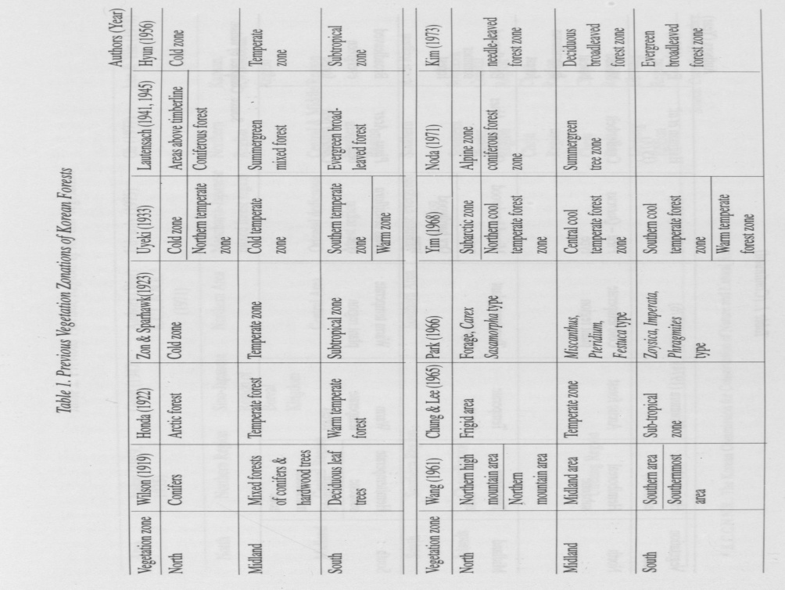

[page 26]

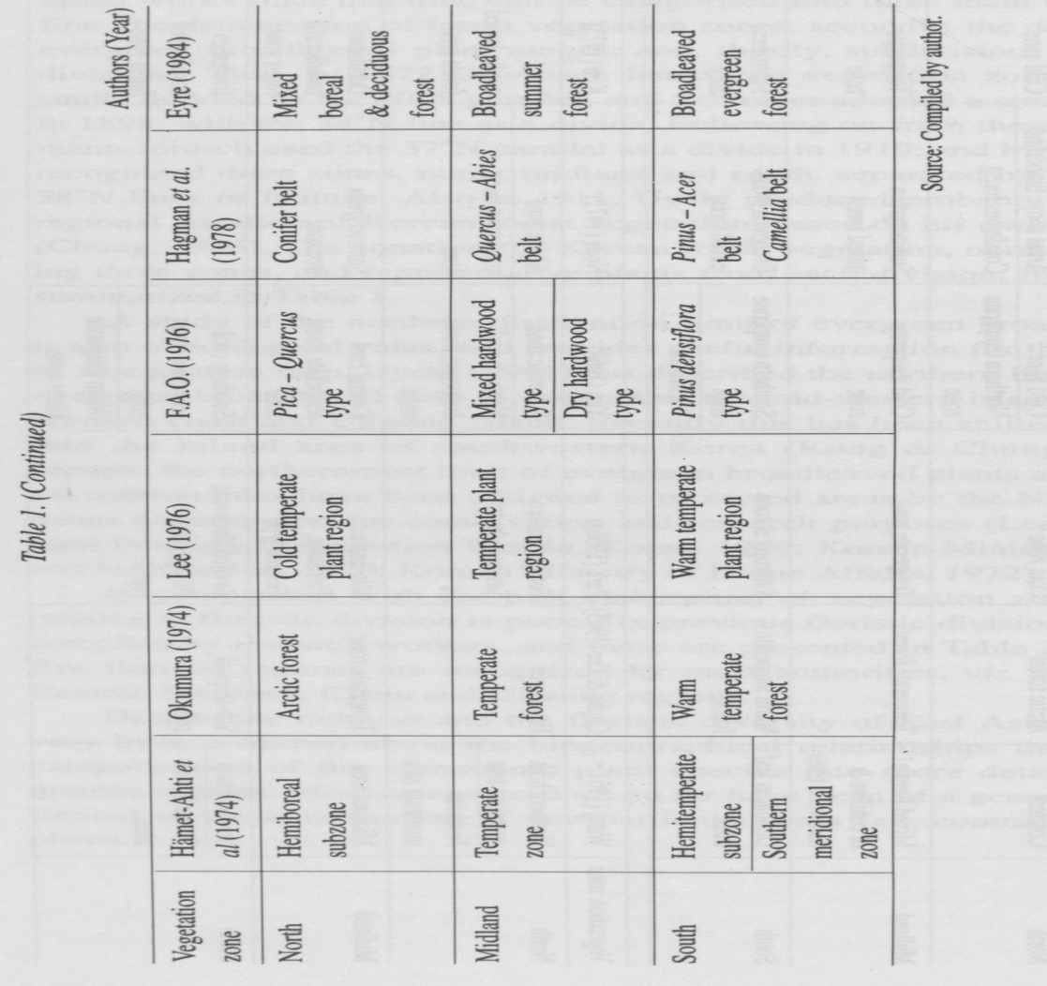

[page 27]

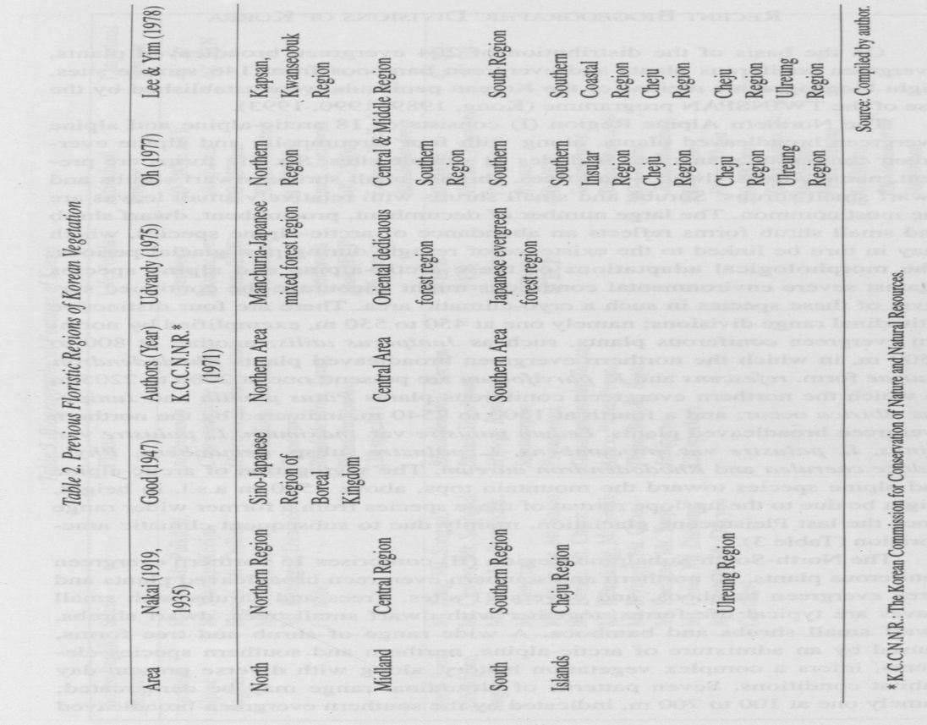

[page 28]

RECENT BIOGEOGRAPHIC DIVISIONS OF KOREA

On the basis of the distribution of 204 evergreen broadleaved plants, evergreen coniferous plants and evergreen bamboos from 146 sample sites, eight biogeographic regions of the Korean peninsula were established by the use of the TWINSPAN programme (Kong, 1989, 1990, 1993).

The Northern Alpine Region (I) consists of 18 arctic-alpine and alpine evergreen broadleaved plants, along with four circumpolar and alpine evergreen coniferous plants and includes 11 sample sites. Six life forms are present, namely trees, dwarf small trees, shrubs, small shrubs, dwarf shrubs and dwarf small shrubs. Shrubs and small shrubs with relatively small leaves are the most common. The large number of decumbent, procumbent, dwarf shrub and small shrub forms reflects an abundance of arctic-alpine species, which may in turn be linked to the existence of refugia during past glacial periods. The morphological adaptations of these arctic-alpine and alpine species against severe environmental conditions might encourage the continued survival of these species in such a cryo-climatic area. There are four distinctive altitudinal range divisions; namely one at 450 to 550 m, exemplified by northern evergreen coniferous plants, such as Juniperus utilis; another at 800 to 1500 m, in which the northern evergreen broadleaved plants Rhododendron fauriae form, refescens and R. parvifolium are present; one at 2000 to 2205 m in which the northern evergreen coniferous plants Pinus pumila and Juniperus sibirica occur; and a fourth at 1500 to 2540 m, indicated by the northern evergreen broadleaved plants, Ledum palustre var. maximum, L. palustre var. minus, L. palustre var. procumbens, L. palustre subsp. decumbens, Phyl- lodoce caerulea and Rhododendron aureum. The segregation of arctic-alpine and alpine species toward the mountain tops, above 1500 m a.s.l. in height, might be due to the upslope retreat of these species from a former wider range since the last Pleistocene glaciations, mainly due to subsequent climatic amelioration (Table 3).

The North-South Subalpine Region (II) comprises 15 northern evergreen coniferous plants, 10 northern and southern evergreen broadleaved plants and three evergreen bamboos, and covers 21 sites. Trees and shrubs with small leaves are typical life forms, together with dwarf small trees, dwarf shrubs, dwarf small shrubs and bamboos. A wide range of shrub and tree forms, caused by an admixture of arctic-alpine, northern and southern species elements, infers a complex vegetation history, along with diverse present-day habitat conditions. Seven patterns of altitudinal range may be demarcated; namely one at 100 to 700 m, indicated by the southern evergreen broadleaved [page 29]

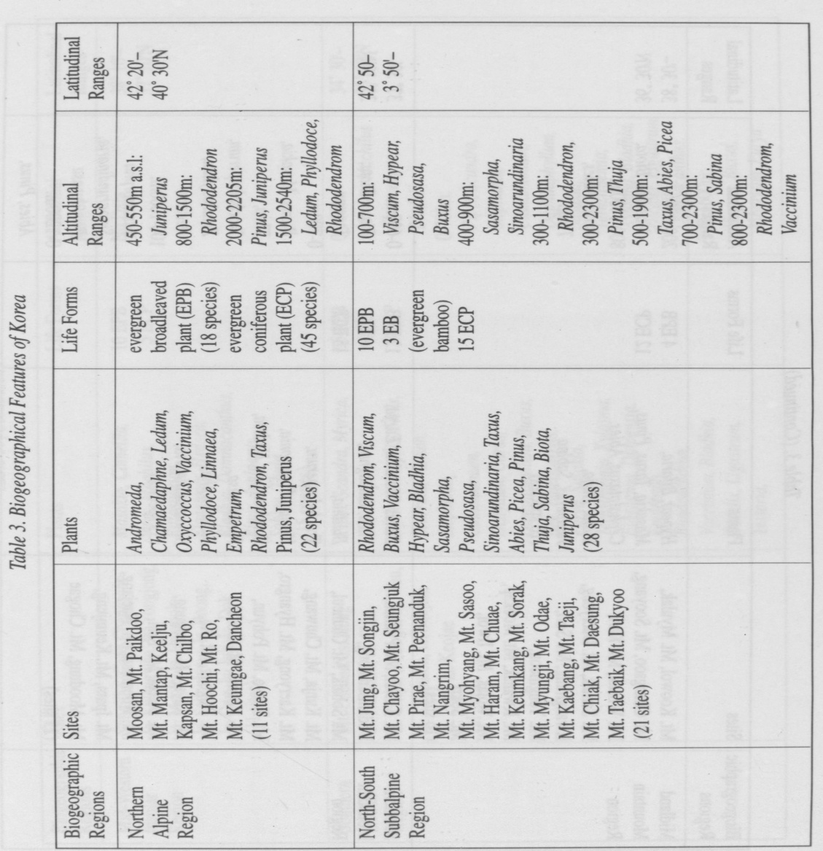

[page 30]

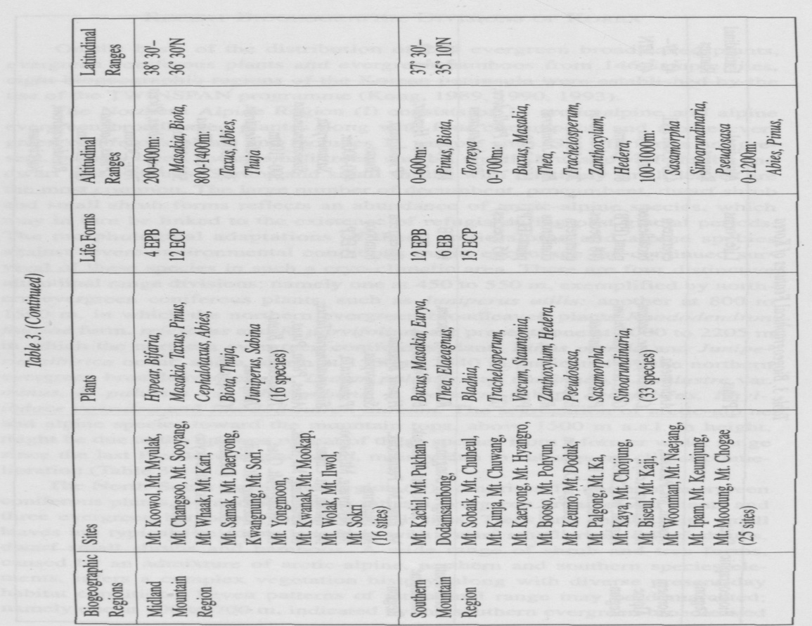

[page 31]

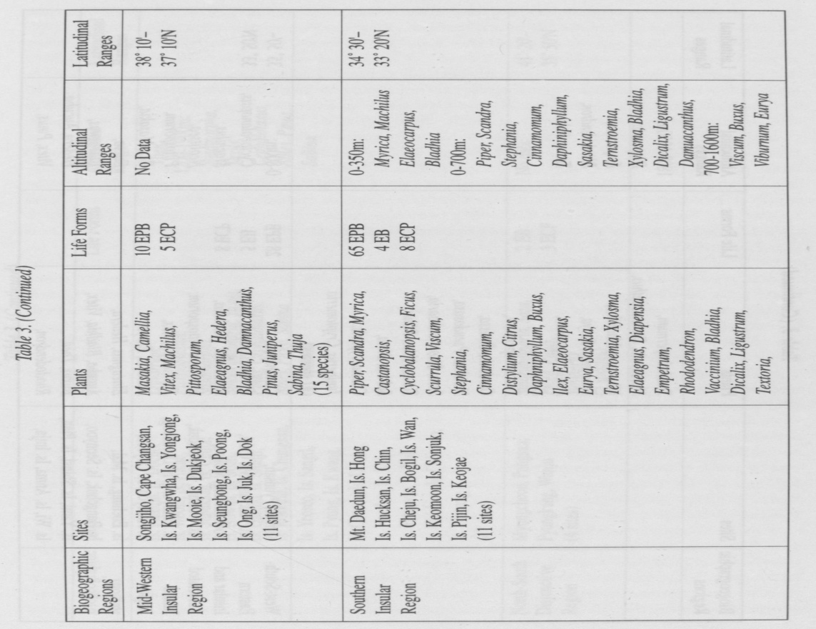

[page 32]

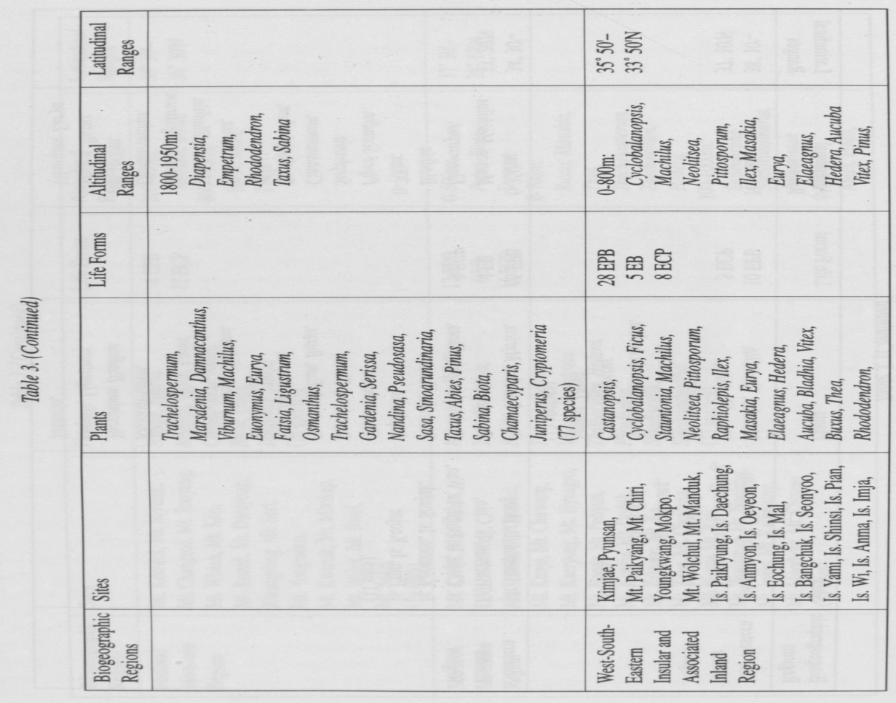

[page 33]

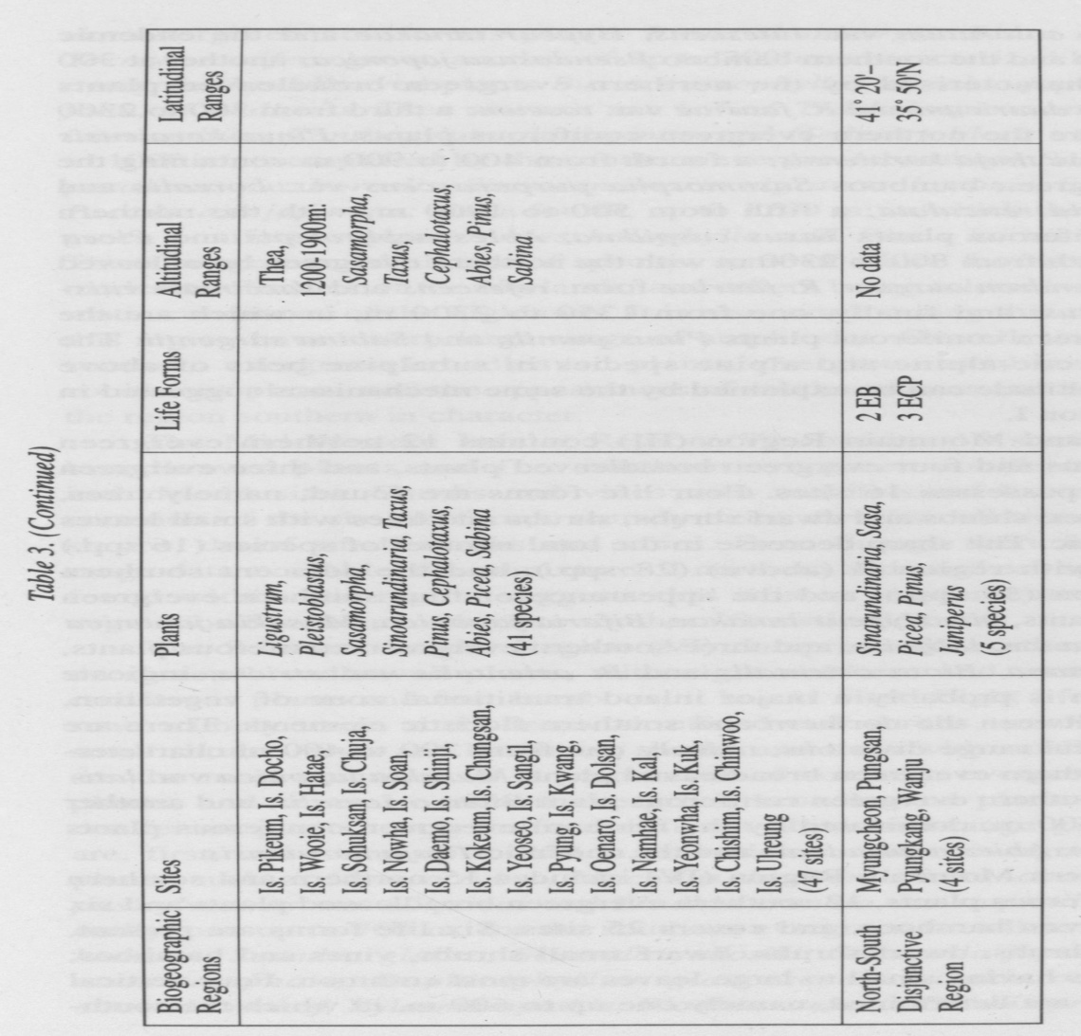

[page 34] plants Viscum coloratum var. lutescens, Hypear tanakae and the endemic Buxus koreana and the southern bamboo Pseudosasa japonica; another at 300 to 1100 m, characterised by the northern evergreen broadleaved plants Rhododendron dauricum and R. fauriae var. roseum; a third from 300 to 2300 m, in which are the northern evergreen coniferous plants, Pinus koraiensis and the endemic thuja koraiensis; a fourth from 400 to 900 m containing the southern evergreen bamboos Sasamorpha purpurascens var. borealis and Sinoarundinaria reticulata; a fifth from 500 to 1900 m, with the northern evergreen coniferous plants Taxus cuspidata, Abies nephrolepis and Picea jezoensis; a sixth from 800 to 2300 m with the northern evergreen broadleaved plants Rhododendron aureum, R. fauriae form, refescens and Vaccinium vitis- idaea var. minus; and finally, one from 1350 to 2300 m, in which are the northern evergreen coniferous plants Pinus pumila and Sabina sargentii. The isolation of arctic-alpine and alpine species in subalpine belts of above C.. 1500 m in altitude can be explained by the same mechanisms suggested in the case of region I.

The Midland Mountain Region (III) contains 12 northern evergreen coniferous plants and four evergreen broadleaved plants, and three evergreen bamboos, and possesses 16 sites. Four life forms are found, namely trees, dwarf small trees, shrubs and dwarf shrubs; shrubs and trees with small leaves are characteristic. The sharp decrease in the total number of species (16 spp.) as compared with region II (above) (28 spp), and the adjacent southern mountain region (33 spp), and the appearance of four southern evergreen broadleaved plants, viz. Hypear tanakae, Bifaria japonica, Masakia japonica and M. japonica var. latifolia, and three southern evergreen coniferous plants, Cephalotaxus nana, Biota orientalis and B. orientalis var. stricta, indicate that this region is probably a major inland transitional zone of vegetation, intermediate between the northern and southern floristic elements. There are two clear vertical range divisions, namely one from 200 to 400 m characterized by the southern evergreen broadleaved plant, Masakia japonica var. lati- folia and the southern evergreen coniferous plant Biota orientalis, and another from 800 to 1400 m, dominated by the northern evergreen coniferous plants Taxus cuspidata, Abies nephrolepis and the endemic Thuja koraiensis.

The Southern Mountain Region (IV) includes 15 northern and southern evergreen coniferous plants, 12 southern evergreen broadleaved plants and six southern evergreen bamboos, and covers 25 sites. Six life forms are present, namely trees, shrubs, dwarf shrubs, dwarf small shrubs, vines and bamboos; shrubs and trees having small to large leaves are most common. Four vertical range divisions are determined, namely one up to 600 m, in which the south- [page 35] ern evergreen coniferous plants Pinus thunbergii, Biota orientalis and Torreya nucifera grow; another of up to 700 m, characterized by the southern evergreen broadleaved plants Buxus microphylla, Masakia japonica var. lati- folia, M. radicans, Thea sinensis var. bohea, Trachelospermum asiaticum var. intermedium, Zanthoxylum planispinum and Hedera tobleri; a third, from 100 to 1000 m, exemplified by the southern evergreen bamboos Sasamorpha pur- purascens var. borealis, Sinoarundinaria nigra var. henonis, S. reticulata and Pseudosasa japonica; and a fourth, up to 1200 m, in which the northern evergreen coniferous plants Abies holophylla and Pinus koraiensis are found. These suggest an admixture of species, some of which favour the presently— moderate climates of the lowlands, and others being tolerant of the harsh climatic conditions of the highlands. It is also worth noting that many species in this region have a very large range of amplitudes. Overall, the dominance of southern evergreen broadleaved plants, evergreen bamboo and evergreen coniferous plants, and the appearances of southern vines and bamboos, makes the region southern in character.

The Mid-Western Insular Region (V) contains 10 southern evergreen broadleaved plants and five northern evergreen coniferous plants, and includes 11 sites. Shrubs and vines with middle-sized leaves are the most common of the six life forms, namely trees, dwarf small trees, shrubs, dwarf shrubs, dwarf small shrubs and vines. Even though there is no altitudinal range data available, the admixture of northern and southern species elements found within this region suggests that it is an insular transitional zone of vegetation between northern to southern floristic elements.

The Southern Insular Region (VI) comprises 65 northern and southern evergreen broadleaved plants, with eight northern and southern evergreen coniferous plants and four bamboos; it has 11 sites. Eight life forms are present, namely trees, small trees, shrubs, dwarf shrubs, small shrubs, dwarf small shrubs, vines and bamboos; shrubs and trees with small to large leaves are the most common. A large number of southern evergreen broadleaved plants, and several northern evergreen broadleaved plants and evergreen coniferous plants, occur in four different altitudinal-range groupings. These are, first, one found up to 350 m, in which southern evergreen broadleaved plants, such as Myrica rubra, Machilus thunbergii rorm. obovata, Elaeocar- pus sylvestrus var. ellipticus and Bladhia crenata var. taquetii are found; secondly, one up to 700 m, for the southern evergreen broadleaved plants Piper kadzura, Scandra glabra, Scurrula yadoriki, Stephania japonica, Cinnamo- mum camphora, Daphiniphyllum glaucescens, Sasakia ochnacea, Tern- stroemia mokof, Xylosma apathis, Bladhia crenata, Dicalix prunifolia, Ligus- [page 36] trum lucidum, Damnacanthus indicus, D. major; thirdly, one from 700 to 1600 m, exemplified by the southern evergreen broadleaved plants Viscum coloratum var. lutescens, Buxus microphylla, Eurya emarginata, Bladhia villosa var. typica and Viburnum awabuki; and finally, one from 1800 to 1950 m, characterized by the northern evergreen broadleaved plants Diapensia lap- ponica subsp. obovata, Empetrum nigrum var. japonicum and Rhododendron dauricum, and the northern evergreen coniferous plants Taxus cuspidata, the endemic Abies koreana and Sabina sargentii. It should be noted that the region has the largest number of southern evergreen broadleaved plants of all the eight biogeographic regions,which reflects the relatively warm and humid climatic conditions of the present-day. However, a disjunctive distribution of several arctic-alpine and alpine species, present near the peak of Mt. Halla (above c. 1800 m to the summit at 1950 m, relevant to other regions of Korea, seems to point to a much wider distribution for these species during the Peistocene glaciations. In short,the highly complicated range of life forms, and the high floristic diversity are due to the survival of arctic-alpine, alpine, temperate, and subtropical plants together, which reflect the diverse present-day environment, habitat conditions and vegetation history.

The West-South-Eastern Insular and Associated Inland Region (VII), which includes 28 southern evergreen broadleaved plants, eight northern and southern evergreen coniferous plants and five evergreen bamboos, has 47 sites. Large-leaved shrubs, trees, bamboos and vines are the most frequent of the seven life forms found; the others are small trees, dwarf shrubs and dwarf small shrubs. Southern evergreen broadleaved plants and evergreen bamboos are common in the insular and coastal areas, but northern evergreen coniferous plants occur more frequently in the inland area. There are two clear altitudinal range divisions: first, one up to 800 m, characterized by southern evergreen broadleaved plants like Cyclobalanopsis acuta, Machilus thunbergii, Neolitsea sericea, Pittosporum tobira, Ilex Integra van typica, Masakia japonica, M. radicans, Eurya japonica, var. montana, Elaeagnus glabra van euglabra, E. macrophylla, Hedera tobleri, Aucuba japonica van typica, Vitex rotundifolia and Thea sinensis var. bohea, and one southern evergreen coniferous plant, Pinus thunbergii; and second, one from 1200 to 1900 m, in which northern evergreen coniferous plants,including Taxus cuspidata, Pinus koraiensis and Sabina sargentii grow. The second largest number of southern evergreen broadleaved plant species present here, as compared to all other regions, reflects the existence of relatively mild climatic conditions today. The proportion of shrubs and trees is nearly equal, and so too in the case of vines and bamboos. Overall, this region is biogeographically closely related [page 37] to the southern insular region (VI).

The North-South Disjunctive Region (VIII),containing three northern evergreen coniferous plants and two southern evergreen bamboos, comprises four sites. There are three life forms, namely trees, shrubs and bamboos. The region is characterized by a high proportion of endemics (60.0%) for the total number of species in the region, and a high degree of physiognomic diversity for the small number of species present, which is so far unexplained.

SUMMARY

My work has delineated eight biogeographic regions in the Korean peninsula, mainly by the use of the TWINSPAN programme. It is based on the distribution of 204 evergreen coniferous, broadleaved and bamboo species from 146 sample sites (88 inland and 58 island sites). The eight biogeographic regions are: a Northern Alpine Region (I),a North-South Subalpine Region (II),a Midland Mountain Region (III), a Southern Mountain Region (IV),a Mid-Western Insular Region (V), a Southern Insular Region (VI), a West- South-Eastern Insular and Associated Inland Region (VII) and a North-South Disjunctive Region (VIII). A comparative analysis of each biogeographic division, and its component plant groups, its species composition, its physiognomy and the three-dimensional distributional patterns of species found therein has provided invaluable information as to the nature and history of the bio- geography of Korea.

The dominance of arctic-alpine and alpine evergreen broadleaved plants at the altitude of 1,500 m a.s.l. to 1,800 m a.s.l. of the Northern Alpine Region (I) (e.g. Ledium palustre var. procumbens, L. palustre subsp. decumbens, Phyllodoce caerulea and Rhododendron aureum), with their diverse life forms, has been demonstrated to indicate that first, the northern parts of Korea have maintained frequent floristic exchanges with neighbouring northern circumpolar, areas, notably during the Pleistocene period; secondly,both lowland and montane zones of this region have served as glacial refugia for arctic-alpine and alpine plants during the Pleistocene glacial phases; thirdly, the upslope retreat of these plants to alpine zones since the last glaciations, due mainly to climatic amelioration during the Holocene but also to the associated biological competition from more warmth-loving plants, has now confined many of these species to the alpine zones of northern Korea; and fourthly, the morphological adaptations of these plants to severe environmental conditions are the result of long-term gradual developments which have safeguarded the [page 38] survival of these species in such a harsh cryo-climatic area.

The admixture of arctic-alpine and alpine evergreen broadleaved plants from the alpine and subalpine zones, northern evergreen coniferous plants from the subalpine and montane zones, and southern bamboos and southern evergreen broadleaved plants from the montane and lowland zones in the North-South Subalpine Region of Korea (II) contains a wide range of life forms. Within this region, it is suggested that this diversity is the result of former active and frequent floristic movements between the Korean peninsula and neighbouring East Asian countries, and also within the Korean peninsula, especially along the north-south Hamkyung Mountain Range in the north, and the Taebaik Mountain Range in the south; and secondly, today, the segregation to some extent of these floras, in different altitudinal zones. From this, a complex vegetation history is postulated for this region, reflecting also its diverse environmental conditions.

The sharp decrease in the total number of species (16 spp.), and in the range of their life forms, within the Midland Mountain Region (III), as compared to those found in the North-South Subalpine Region (II) (28 spp.) and in the adjacent Southern Mountain Region (IV) (33 spp.), and also the clear vertical divisions of range within it (viz. northern evergreen coniferous plants are confined to the mountain zone, and southern evergreen coniferous and broadleaved plants to the lowland zone) suggest that this region is probably a major inland transitional zone of vegetation, intermediate between predominantly northern and southern floristic elements.

The coexistence of northern evergreen coniferous plants, southern evergreen coniferous plants, southern evergreen bamboos and southern evergreen broadleaved plants, all of which have a wide range of life forms, in the Southern Mountain Region (IV) indicates, first, that the high mountains present in the south have enabled some formerly much more widespread northern subalpine species to survive the present period of climatic amelioration by moving upslope; secondly, that the congregation of southern floristic elements both in the lowlands and montane zones of this region represents the influence of the presently-moderate climates; and thirdly, that the dominance of southern evergreen coniferous plants, southern evergreen broadleaved plants and southern evergreen bamboo species and the appearance of southern vines, allocates this region as being ‘southern’ in character, and moreover probably implies previous strong floristic connections with tropical and subtropical areas of East Asia as well. Many of these southern species still have a large distributional range, which extends to the southern parts of Japan and China.

The occurrence of northern evergreen coniferous plants and southern [page 39] evergreen broadleaved plants, and the even proportions of different life forms within the Mid-Western Insular Region (V) infer that this region is an insular transitional zone of vegetation, intermediate between northern and southern floristic elements.

The presence of the greatest number of evergreen plants in the Korean peninsula (77 spp.) in the Southern Insular Region (VI), including still some arctic-alpine evergreen broadleaved plants (e.g. Diapensia lapponica subsp. obovata, Empetrum nigrum var. japonicum and Rhododendron dauricum), northern evergreen coniferous plants, southern evergreen coniferous plants, southern evergreen broadleaved plants, and the southern bamboo species on Mt. Halla (1,950 m a.s.l.) in Cheju Island, with a highly complicated range of life forms, reflects more than any other single factor the diverse environmental conditions available. These include a vertical range pattern extending from cold alpine to warm coastal zones on Mt. Halla alone. Further to this, the isolated distributions of arctic-alpine and alpine evergreen broad-leaved plants and evergreen coniferous plants on the higher mountains of this region again suggest that these plants occurred on a much broader scale within the whole Korean peninsula during the Pleistocene glacial phases, and have retreated upslope to the present-day alpine zone because of the general Holocene climatic amelioration. On another level, the appearance of the evergreen endemic coniferous plant Abies koreana on the southernmost fringes of the peninsula mainland may provide an indicator of a previous land connection having been established between the mainland and Cheju at a time of former low sea- level, possibly during the penultimate glacial phase.

The existence of a large number of species (41 spp.), including northern evergreen coniferous plants at 1,200 m to 1,900 m a.s.l. on Mt. Chiri, and southern coniferous and broadleaved plants, and southern evergreen bamboo species in both its montane and lowland areas, characterise the West-South- Eastern Insular and Associated Inland Region (VII) These features reflect first the existence of relatively mild climatic conditions and, secondly the unexpected abundance (in terms of the limitations of the environment) of southern evergreen broadleaved plants and evergreen bamboos in the inland parts of this region.

A high proportion of endemism (60.0%), along with a high degree of physiognomic diversity for the small number of species present (5 spp.), is particularly noteworthy in the North-South Disjunctive Region (VIII).

Overall, however, there are several major differences within the analysis presented in Kong’s biogeographic divisions and those of previous workers. This is due to the following reasons: first, although there are a large number of plant species (c. 4, 164 species (Lee, 1982)) present in Korea the author has mainly concentrated on an understanding of the distribution of 204 evergreen broadleaved plants, evergreen coniferous plants and evergreen bamboos at the species level，which are together widely distributed within the peninsula. Therefore, the author has a broad and manageable floristic base relevant for the whole peninsula, which not only provides the delineation or biogeograph-ic regions, but also emphasises habitat differences. Secondly, this work has employed a quantitative, non-subjective method of data analysis, notably by the use of the TWINSPAN programme. Thirdly, the author has also incorporated analyses of floristic, physiognomic and bioclimatic characteristics of species, which are especially useful in interpreting vegetation pattern and structure. Fourthly, the three-dimensional presentation of vegetation data includes the analyses of horizontal and vertical distribution patterns of plant species, which makes a major contribution not only to the understanding of present vegetation but also to past vegetation history and present-day ecological amplitudes. Finally, the present work produces a more sophisticated biogeographic division of present-day vegetation in the Korean peninsula than any presented heretofore, paying considerable attention to floristics, physiognomy and range, spatial patterning. The eight biogeographic regions delineated have relevance not only to present-day but also to past habitat situations.

[page 41]

REFERENCES

Chung, T. H. & Lee, W. C. 1965, Horizontal and Vertical Distribution of the Korean Woody Plants, Theses Coll. Sungkyunkwan Univ., 10, 367-435 (in Korean).

Chung, Y. H. 1986,The History of Korean Plant Taxonomy, Academic Book Co., Seoul (in Korean).

Cultural Property Preservation Bureau 1970,Cultural Properties of Korea, Ministry of Culture and Information, Seoul (in Korean).

Derevianko, A.P. 1978. The Problem of the Lower Paleolithic in the South of the Soviet Far East. In: Ikawa-Smith, F. (ed.), Early Paleolithic in South and East Asia, 303-315, Mouton Publishers, The Hague.

Eyre, S. R. 1984, Vegetation and Soils, Edward Arnold, London.

FAO, UN, 1976, Forest Resources in the Asia and Far East Region, FAO, UN, Rome. Prodin, D. G. 1984, Guide to Standard Floras of the World, Cambridge Univ. Press, Cambridge.

Giterman, R. E. & Golubeva, L. V. 1965, The History of Development of the Vegetation of Eastern Siberia in the Anthropogene. In: Osnovaye Proble- my Izucheniya Chetvertichnogo Perioda, 365-375, Nauka, Moscow (in Russian).

Good, R. 1947, The Geography of the Flowering Plants, Longman, London.

Hagman, M.,Feilberg, L., Lagerstrom, T. & Sanda, J. E. 1978, The Nordic Arboretum Expedition to South Korea 1976, Helsinki.

Hamet-Ahti, L., Ahti, T. & Koponen, T. 1974, A Scheme of Vegetation Zones for Japan and Adjacent Regions, Ann. Bot. Fenn., 11, 59-88.

Honda, S. 1922, Forest Zones of Japan, Tokyo (in Japanese).

Hyun, M. S. 1956, Korea. In: Haden-Guest, S., Wright, J. K. & Teclaff, E. M. (eds.), A World Geography of Forest Resources, 561-572, The Ronald Press Ca., New York.

Kim, J. M. 1973, The Ecology of Korean Plants, Chonpakwahaksa, Seoul (in Korean).

Kong, W. S. & Chung, S. R. 1984, A Climatological Study on the Distribution of Tea Plant in Korea, Chirihakyonku, 9, 583-594 (in Korean).

Kong, W. S. 1989, The Biogeographic Divisions of Korea and Their Species Composition, Chirihak, 40, 43-54.

Kong, W. S. 1990, The Biogeographic Divisions of Korea, Their Physiognomy and Distributional Range, The Kyung Hee Geographical Review, 18, 1-8. [page 42]

Kong, W. S. & Watts, D1993, The Plant Geography of Korea, Kluwer Academic Publishers, The Netherlands. Korean Commission for Conservation of Nature and Natural Resources 1971.

,Nature in Korea, Ministry of Culture and Information, Seoul (in Korean).

Korean Ministry of Culture and Information, 1970, Cultural Properties of Korea, Seoul (in Korean).

Korean Ministry of Home Affairs, 1972, Protected Trees of Korea, Seoul (in Korean).

Kryshtofovich, A. N. 1929, Evolution of the Tertiary Flora in Asia, New Phy- tol., 28, 303-312.

Lautensach, H. 1941, Die Naturlichen Vegetationstufen in Korea, Petermanns Geographisch, 87, plate 5 (in German).

Lautensach, H. 1945, Korea, Koehler Verlag, Leipzig (in German).

Lee, T. B. 1982, Illustrated Flora of Korea, Hyangmunsa (in Korean).

Lee, W C. 1969, On the Natural Monument of Korea, J. Kor. Plant Tax. 1, 27-35 (in Korean).

Lee, W. C. & Yim, Y. J. 1978, Studies on the Distribution of Vascular Plants in the Korean Peninsula, Kor. J. P. Tax., 8, Appendix 1-32 (in Korean).

Lee, Y. N. 1976, Illustrated Flora and Fauna of Korea, Vol. 18 (Flowering Plants), Korean Ministry of Education (in Korean).

Li, H. L. 1948, Floristic Significance and Problems of Eastern Asia, Taiwania, 1, 1-6.

Li, H. L. 1953, Endemism in the Ligeneous Flora of Eastern Asia, Proc. 7th Pacific Sci. Congr., Vol. 5, 21-216.

McLean, R. C- & Ivimey-Cook, W. R. 1967, Textbook of the Theoretical Botany III，Longman, London.

Muller, P. 1986, Biogeography，Harper & Row Publ., New York.

Nakai, T. 1919, Flora of Ulreung Island, The Government of Chosen (Korea) (in Japanese).

Nakai, T. 1935, East Asian Flora, Tokyo (in Japanese).

Noda, M. 1971, Flora of the N. E. Province (Manchuria) of China, Kazama Bookshop Co.,Tokyo.

Oh, i. 1977, A Floristic Study of Vascular Plants in Korea, Nature and Life (Kyungpook Univ.), 7, 13-39 (in Korean).

Okumura, S. 1974, Forest of Korean Peninsula, Doi Ringaku Shinkokai, Tokyo (in Japanese).

Park, B. K. 1966, The Grassland Types of Korea, Kor. J. Bot., 9, 39-45 (in Korean). [page 43]

Takhtajan, A. 1986, Floristic Regions of the World, Univ. California Press, Berkeley.

Udvardy, M.D.F. 1975, A Classification of the Biogeographical Provinces of the World, IUCN Occasional Paper No. 18, Morges, Switzerland.

Uyeki, H. 1933, On the Forest Zones of Korea, Acta Phytotax. Geobot., 2, 73- 85 (in Japanese).

Uyeki, H. 1941, Northern Distribution Limit of Korean Evergreen Broadleaved Trees, Acta Phytotax. Geobot., 10, 89-93.

Wang, C. W. 1961, The Forests of China with a Survey of Grassland and Desert Vegetation, Maria Moors Cabot Foundation Publ. Ser. No. 5, Harvard Univ., Cambridge, Mass.

Wang, C. W. 1962, The Development of Forest Communities in Eastern Asia, Proc. 9th Pacific Congr, Vol. 4 (Bot.), 103-113.

Wilson, E. H. 1919, A Phytogeographical Sketch of the Ligneous Flora of Korea, J. Arnold Arb., 1, 32-43.

Yim, K. B. 1968, Principle of Silviculture, Hyangmunsa, Seoul (in Korean).

Zon, R. & Sparhawk, W. N. 1923, Forest Resources of the World, McGraw- Hill, New York.

[page 45]

**Introduction to Ancient Egyptian Temples and Tombs**

Maissa Cholkamy

We all have studied Egypt’s ancient civilization at school, therefore, I am not going to introduce my country to you. Here in Korea, when I tell people that I come from Egypt, they spontaneously say: Pyramids and Sphinx !

One has to admit that these are the most famous monuments in the world since the pyramids are considered one of the seven wonders of the ancient world .

When, why ,how and for whom were they built? This is what I am going to explain without bothering you with too many details as this topic is really wide.

I will also talk about the other types of tombs and the various kinds of temples and my lecture will be accompanied by some explanatory slides to help you imagine, if you have not been to Egypt, how beautiful these monuments are and maybe you will be encouraged to go and see them yourself.

First let tell you very briefly something about Egypt’s ancient history.

Our History begins around the year 3200 B.C. with the unification of Egypt during the reign of a king called Mina who unified the north and the south under one crown, the double crown.

It has been divided by modern historians into three main Kingdoms:

1. The Old Kingdom which started in the year 2700 B.C.

2. The Middle Kingdom which started in 2000 B.C.

3. The New Kingdom which started in 1500 B.C.

Between these three kingdoms there were two intermediate periods also called the Dark Periods, during which trouble and revolutions prevailed in the country.

Note: The following paper appears in the Transactions, because the RAS had the opportunity to hear a lecture on Egypt in which members were interested and which was given by a highly competent and interesting speaker. We wish to share that lecture with our members who were not at the lecture.

[page 46]

The New Kingdom was followed by what we call the Late Epoch during which Egypt was occupied by many foreign peoples like the Assyrians, the Nubians, and the Persians.

In 332 B.C. came Alexander the Great who founded the city of Alexandria and then left Egypt to the Ptolemes, the ancestors of Cleopatra. In 30 B.C. came the Romans who ruled Egypt until the arrival of the Arabs in 640 A.D.

All the kings or pharaohs of ancient Egypt have been grouped by a historian called Manetho, who lived during the Greek Period, into thirty dynasties. The Old Kingdom lasted from the 3rd to the 6th century the Middle Kingdom the 11th and the 12th, and the New Kingdom from the 18th to the 20th dynas- ties. All the other dynasties were during the Intermediate or Dark Periods.

The word pharaoh I have used, is derived from an ancient Egyptian word FER meaning the great house. It was used to designate the King.

These Pharaohs left us tremendous quantities of antiquitities which are still admired by the modern world. I will concentrate only on their tombs and the magnificent temples they left us.

As a general rule all the tombs were built on the western bank of the Nile because when the ancient Egyptians saw the sun setting behind the western mountains, they thought that the other world was there and when someone died they used to say, “He went to the west.”

During the Predynastic Period, the deceased was wrapped in a reed mat and buried with some of his personal belongings in a rectangular pit dug in the sand, and he was laid on his side in a contracted position like an embryo.

Because the wind blew the sand which covered the pit, the body was of course exposed and destroyed. As a solution, the Mastaba was introduced at the beginning of the Old Kingdom.

Mastaba is an Arabic word which means “bench.” It was called so by the modern Egyptians who noticed that these tombs resembled the benches located in front of the houses of Egyptian peasants. The first mastabas were made of mud bricks and covered the funerary chamber which was usually located at the bottom of a very deep pit.

As time passed, the brick construction developed into an imitation of the deceased’s house with various rooms and corridors, all decorated with reliefs representing scenes from the deceased’s daily life.

All that the deceased loved to do during his life was represented on the walls of his mastaba. The mastaba could contain as much as 32 rooms like the one built for Mereruka, the son-in-law and Vizir of King Teti of the 6th Dynasty. You can see him in his bedroom with his wife playing the harp or among his goldsmiths watching them make his jewelry or supervising the [page 47] peasants while they cultivated his land.

In the year 2700 B.C. King Zozer the first king of the Old Kingdom, ordered his architect, Imhotep, to build him a very impressive tomb which would impress his people and the generations to come. Imhotep started by building a huge mastaba which he surrounded with a 10 meter high wall. Noticing that the wall was higher than the tomb, he decided to elevate it by covering it with a limestone casing. At the last moment, the King asked him to include a few galleries where the members of his family would be buried after their deaths.

Finding the tomb too small, Imhotep decided to enlarge it and added another casing. It was only then that was born in his imagination the idea of building a huge staircase which would facilitate the ascension of his King’s soul to its father the sun god RA. He therefore enlarged it another time and added five steps to the original mastaba.

The importance of this pyramid does not come only from the fact that it is the first pyramid in the history of Egypt, but also from the fact that it is the first stone construction in our history. Before Imhotep, the Egyptians used either bricks or wood but never stones.

Next came the Pyramid of Medium, the steps of which were, for an unknown reason, filled with stones to create a true pyramid with a smooth facing. It became a fashion, which was followed by all the Kings of the Old and Middle Kingdoms, and until now we have discovered ninety six pyramids, and we are sure some are still undiscovered.

The pyramid built by King Cheops of the 4th Dynasty around 2600 B.C. is by far the most famous one. It is even considered one of the Seven Wonders of the Ancient World. It was built in twenty years by 100,000 workers who worked only. during summer when the Nile flooded and covered the valley with its waters. The peasants were then recruited to build the King’s tomb.

It was built with two and half million blocks of limestone cut on the spot and weighing between 2.5 and 15 tons each. The pyramid was then covered with a smooth facing cut in the quarries of Turah on the eastern bank of the Nile. Two pits were discovered near this pyramid. They contained two dismantled wooden boats which the King would ride during his eternal trip with the Sun god

How were the Pyramids built? This is still an enigma! As the Egyptians never revealed this secret, every now and then someone comes up with a new theory.

Logically two different methods could have been used: [page 48]

1. A long ramp, slightly sloped, made of rubble held together with Nile mud, might have been built from the ground to the desired level to allow the workers to pull the blocks to the specified height. This method might have been used for small pyramids.

2. The second method used four ramps starting at each corner of the pyramid and rising gradually along the side of the unfinished steps. At the end of each level the ramps were extended by workers whose only job was to build and maintain them.

When they reached the desired height, the ramps were removed and the steps were finished with the smooth casing.

It was King Tuthmosis I of the 18th Dynasty New Kingdom around 1500 B.C., who decided to change the tradition of being buried in a pyramid. When he noticed that the tombs of his predecessors were all plundered, he chose a natural pyramid in the Western Mountains of Thebes where he and his successors would be buried. The royal tomb and its burial chamber system of the New Kingdom was dramatically changed from those of the pyramids of the earlier kingdoms. New theological concepts had complicated the fate of the king. New religious texts were composed and drawn upon the walls of the tombs. The simple rows of blue hieroglyphs which decorated the pyramids were replaced by elaborately detailed wall-texts and scenes of great beauty.

These tombs of the valley are covered with scenes representing the journey of the bark and the daily revival of the king each morning without ending, the eternal rhythm of the sun! These scenes were all extracted from the Book of the Dead which is considered a guide book which told the deceased king about the dangers he would encounter during his trip to the other world and showed him how he could avoid them.

The ancient Egyptians used for their paintings vegetable and mineral colors. Carbon made of burnt bone was used for black, ochre for red, very pure chalk for white. The colors were finely ground and mixed with either water, beeswax, eggwhite, or animal glue.

All the tombs of the Valley of the Kings had been visited by tomb robbers except the tomb of Tut Ankh Amon, discovered in 1922 by the British archeologist Howard Carter

This is what he wrote of that day, “It was the day of days, the most wonderful that I have ever lived through.”Then he says after having made a hole in the corner of the door, “At first I could see nothing, but presently as my eyes grew accustomed to the light, details of the room within emerged slowly from the mist, strange animals, statues and gold! Everywhere the glint of gold! For the moment, I was struck dumb with amazement and when Lord [page 49] Carnarvon inquired anxiously “Can you see anything?” It was all I could do, to get out the words, “Yes wonderful things!”

If the kings were buried in such magnificent tombs, what about the common people? These were buried in a pit with some of their belongings or, if they were very poor, in a common grave.

As for the workers who were employed in the construction of the royal tombs, they lived in a settlement close to the tombs and during their day off, they decorated their own tombs. At Deir El Medina in Luxor we have beautiful examples of such tombs.

The nobles also had their valley close to the king’s but their tombs were decorated like the mastabas of the Old Kingdom, which means with scenes of everyday life and some religious themes.

During the New Kingdom, the Queens and Princes were buried in a separated valley called Set Neferu which means ‘the beautiful place.’

When Imhotep built the Step Pyramid for his King, he enclosed within its walls the funerary temple in which the King was mummified. Later on, his successors built the same kind of temple very close to the Nile and called it the Valley Temple. Then they added a second temple where prayers were said for the King’s soul before and after the burial in the pyramid.

This kind of funerary temple did not suit the taste of the kings of the New Kingdom who ordered the construction of gigantic temples on the West Bank of the Nile, very close to their tombs in the Valley, where the priests could live and perform the funerary rites for the king’s soul. As an example of this we have the Ramesseum built by Ramses II, medinet Habu by Ramses III and the Valley Temple of Queen Hatchepsut.

If we leave the King and his soul and turn to the gods, we find that the ancient Egyptians built a temple for each of their deities.

In the City of On, the actual Heliopolis, and in Abu Sir near Giza we find temples dedicated to the sun god RA. In Denderah and Edfu we find the beautiful, almost identical, temples of the couple Horus and Hathor; in Philae, the temple of the goddess Isis, the wife of Osiris; in Kom Ombo, the temple of Sobek the crocodile; in Abydos the temple of Osiris, god of the dead. The most magnificent temples were, however, those built for the god Amon. the god of gods. The best examples are Karnak, Luxor and Abu Simbel.

None of the temples was used as a place of worshiping. In fact worshippers were not allowed in the temple, which was considered the earthly or terrestrial residence of the god where he lived and where his servants, the [page 50] priests, served him.

Only the Great or First Prophet had access to the Sanctuary, but who was

he and how was he nominated? According to the ancient Egyptians, the king was the son of the god and his representative on earth, so he had to be present during the performance of the daily rituals. As he could not be present in all the temples at the same time, he nominated someone to replace him and this person was called the First Prophet. Every morning he opened the habits, the sanctuary which contained the statue of the god, washed, perfumed, incensed and dressed it then fed it, symbolically of course.

The high priests of Amon attained a very high position due to the fact that the temple they governed was by far the largest and richest in Egypt.

All the priests were called Wab which means pure. There were three types of clergy:

1. the Upper Clergy which took care of the god, his clothes, the offerings,

2. the Inferior Clergy who took care of the Temple as a whole,

3. and the specialists who were the scribes, the physicians, the musicians, and the astrologists.

It is said that during the reign of King Ramses III, the Temple of Karnak had 82,000 people at its service. These included of course the peasants who cultivated the land donated to the temple by the king.

As an example of the royal gifts donated by this same king during the thirty one years of his reign to Amon:

1. 86,000 slaves.

2. 420,000 heads of cattle.

3. 900,000 plots of land.

4. 433 vineyards.

5. 9 foreign knows.

For a lively and joyful people like the Egyptians, any occasion was good to celebrate, and where could it be better than at the temple? In the case of Karnak and Luxor, once a year, during the 2nd and 3rd months of the inundation season, a long religious festival was held, during which the statue of Amon, escorted by a long procession of priests, musicians, dancers, drum and flag bearers, was taken by boat to Luxor Temple where it stayed two weeks. Then it was returned to Karnak with another procession, but this time through the Sphinx Alley which linked the two temples (3 Km).

During the Feast of the Nice Encounter, goddess Hathor left her sanctu- [page 51] ary at Denderah and came to visit her husband Horus at Edfu. At Abydos, the resurrection of the god Osiris was celebrated annually. Beside these feasts, the birthday of the ruling king was celebrated in all the temples of Egypt. For such occasions, the nobles were allowed in the temple but only as far as the Hypostile Hall. The common people could watch from outside and were given a lot of food and drink.

If, however, they were not allowed to enter the temple, where did the common people worship? They worshiped at home and sometimes made the furthermost room of their house into a little chapel where they placed a little image of the god.

As for the architecture of the temple, a typical Egyptian temple is composed of a Sphinxes Alley which led to the Pylon or monumental gate to an open courtyard, a hypostile hall, a gigantic hall supported by pillars, and of course a shrine inside which was a richly adorned bark containing the figure of the god which was perhaps two feet high. It was this bark which was carried round in procession on great festivals, but why a bark? Because the Egyptian idea of travelling was always by Nile boat; the god would, therefore, according to them, require a Nile boat to go from place to place.

The pylons were painted and there were two obelisks and high flag- staves intended to impress the visitor with the sanctity of the place he was about to enter. The decoration of the temple was purely religious. The walls and pillars were covered from top to bottom with representations of the gods.

[page 53]

**City Planning and Neighborhood Preservation in Seoul**

by Josh Moreinis

Seoul is again experiencing a transformation of built form only thirty years after the city’s initial post war reconstruction. Hillside neighborhoods with no structures above five stories several years ago are witnessing the increasing appearance of construction sites spilling out onto narrow streets and the continual disappearance of views of the surrounding mountains. Rethinking traditional urban patterns while preserving natural features is the challenge to Korean planners in the 1990s as the construction sector replaces export goods production as the driving force of the national economy.

Though planners and residents complain of a lack of guidance, Seoul actually has an extensive history of planning policy implementation. From the mystical principles of geomancy applied to the layout of Seoul in the 14th century to numerous comprehensive plans since the 1960s, the Korean government has been far reaching in its efforts to shape the city. Possibly due to the hierarchical nature of Korean society and governance,it has exercised a relatively free hand. Milestones include the capital region’s five new satellite cities (four year old Bundang has a population of 400,000), the nation’s 5,397 square kilometers of greenbelt, and the “Concept of Public Land,” or Gongaenium: 1991 anti-speculation legislation imposing limits on the amount of urban land that can be owned by an individual, a progressive land holdings tax and a high unearned capital gains tax.

Until recently, however, national urban policies have been growth-based, relying on the development of the Seoul-Busan corridor to fuel the economy. Result: overconcentration of population and resources in Seoul at the expense of rural areas like Cholla and Kangwon provinces. In Seoul, systematic land use plans have often been superseded by urban renewal or industrial development legislation. Environmental quality, urban amenities, and neighborhood [page 54] character were sacrificed on the altar of economic development as Korea’s economy has grown to be one of the world’s top 152 and contains one of the greatest concentrations of large corporations in the region.

Located on the southern edge of Seoul, the neighborhood of Shillim 9 Dong illustrates the impact of recent housing development on lifestyles. Many of the tightly clustered homes which banket the slopes of Kwanak Mountain in this relatively low income community developed rapidly following the Revised Seoul City General Plan of 1970 which sought to redistribute population from overcrowded Kangbuk north of the Han River to Kangnam south of the Han River. The nearby relocation of Seoul National University in 1973 and an influx of families displaced by urban renewal projects in other parts of the city also spurred the development of this area. Until recently, housing forms in Shillim 9 Dong have included a smattering of traditional tile-roofed hanok residence-no among two to four story brick apartment buildings which step up the hillside as a natural extension of the landscape. Many of the mid-rise apartment houses contain functional rooftops used commonly for the storage of large kimchi pots or even for small gardens.

The human scale of Shillim 9 Dong, the social role of its streets, and the proliferation of ground floor neighborhood stores among its residences represent some of the characteristic traits of established neighborhoods in Seoul. Immediate access to Kwanak Mountain with a 2,000 foot peak provides much needed recreational opportunities as well as maintaining ties to past agrarian life styles with small garden plots maintained at its base. Although the high mix of uses and many irregularly layed out lots suggest ad- hoc, unplanned growth and permissive development regulations, the community seems to function in an orderly fashion. Both old and young can be found on the busy streets of Shillim 9 Dong which lead up the slopes of the adjacent pine and acacia covered Kwanak Mountain.

Forming a western boundary for Shillim 9 Dong is the Shillim Market. This low scale stretch of tightly spaced stores reflects some of the essential qualities of the Korean shopping district with its onslaught of colorful signs, displayed goods, and admix of people. The compressed spacing of storefronts, diversity of shops and tight pedestrian spaces are reminiscent of more famous markets in Korea such as Seoul’s Namdaemun Market or Pusan’s Chalgakchi Market. The face to face interaction and local access to fresh foodstuffs which the market allows are important components of the daily routines of local households, with informal communication among neighbors and spontaneous interaction also contributing to the village-like quality of Shillim-Dong. [page 55]

Housing types in Shillim 9 Dong are representative of development trends in Seoul over the last several decades. Mid-rise six story public projects blend into the surrounding terrain adjacent to the Shillim Elementary School while walls of high rise towers have recently begun to line the southern edge of Kwanak Mountain. In the words of a seven year resident, “These awesome developments immediately catch your eye when you enter the community and have destroyed the once harmonious feeling of living next to Kwanak Mountain.”

Another form of new construction that proliferates is five-story rental apartment buildings rapidly constructed by small developers. Recently built, low scale housing in the area includes numerous two-story “villa” residences, which are more upscale than previously existing housing, and the more common Dan Dok Chu Taek, translated literally as “stand-alone-housing,” with a single family owner and possibly one or two rental units. While single-owner occupied housing has been the norm until recently in Shillim 9 Dong, rising heating and maintenance costs have led people to seek more modern arrangements such as high rise cooperatives or condominiums. Low scale owner occupied homes are increasingly being demolished and redeveloped with mid-rise construction.

High rise housing, first introduced by the Korean National Housing Corporation in the 1960s and transformed into a common lifestyle preference with the development of Kangnam, has been promoted with recent government subsidized housing developments. With the Korean Housing Corporation having virtual monopolistic control in the process of large scale residential development in Korea, the government’s vision of housing has led to a marked change in the way Koreans live.

As the explosive development of Kangnam has proceeded, representing to Seoulites” ...a movement toward the new world associated with opportunity, affluence, mobility and anonymity,”3 so has the community of Shillim 9 Dong experienced rapid change. A number of urban renewal projects over the past five years have introduced twenty story high rise apartment buildings bearing the names of their Chaebol development corporations such as Hyundai and Gun Young. Their configurations have generally obscured visual access to the surrounding terrain and, with the disruption of local street patterns, a separation from the adjacent community has been ensured. Reflecting intense housing pressures in this once affordable community as well as in the rest of Seoul, prices for an apartment in the Hyundai Apartments complex are geared towards professionals. While many residents of Seoul profess a preference for such high rise lifetyles, there are certainly less disruptive locations [page 56] for such development. Community opposition held up the construction of the Shin Dong-A project in 1991. On-site protests continue in the spring of 1994 in response to the planned replacement of a vacant three-story apartment complex adjacent to the Hyundai development with an extension of the high rises.

Public policy has encouraged such developments. Height and bulk regulations are relaxed at times to facilitate the reclamation and stabilization of land often previously occupied by squatters.

While the production of housing is certainly much needed—Seoul currently has a housing shortfall of 46%—the form of new development could be more sensitive to neighborhood scale, topography, and lifestyle issues without unduly increasing costs or restricting the number of units produced. A consideration of sense of place and preservation of natural features in the regulation of development is particularly warranted in areas which possess a consistent context or distinct natural features such as Shillim 9 Dong.

TRAOT URBAN PATTERNS IN SEOUL

Pusan, Korea’s second largest city, is nestled between and built around mountains and a harbor. Famous as a port city, with a small section next to the central railway actually containing as many Russian signs as Korean, Pusan’ s population has grown to almost four million despite the severe obstacles of the terrain. Downtown streets still accent rather than obscure the stunning surrounding natural features. Similarly, one of the characteristics which distinguishes Seoul is its topography of nine mountains and sixty two hills. Some mountains have become regional recreational and tourist attractions, such as Namsan and Kwanak Mountains, while others are accessed daily mostly by residents of nearby neighborhoods compensating for the comparatively low amount of recreational open space such as playgrounds or neighborhood parks .

Strong cultural meaning is also attached to the mountains of Seoul with the four main encompassing peaks represented as animal guardian spirits. Originally the city was oriented southwards at the base of Pugak Mountain with Namsan Mountain, now an inner city landmark containing the famous Namsan Tower, defining its southern border. As the growth of Seoul has spilled outward beyond these two, the larger peaks of Pukhansan and Kwanaksan have come to define the northern and southern reaches of Seoul.

The Korean landscape is an important part of the religious beliefs of the [page 57] country. Images of the mountain spirit, Samshingak, with his companion white lion can be seen in art works dating back to the 1500s and represent an important element of Korean shamanism. Buddhist and shaman temples and burial mounds can also be found among the hillsides of many of Seoul’s mountains. Shillim 9 Dong has several examples of mountainside, religious sites including Kwanung Temple on Kwanak Mountain and a well known shaman temple located in an impromptu complex of one-story buildings adjacent to the Gun Young apartment towers.

While hillside temples and images of Samshingak indicate the reverence for mountains in folklore and religion, the principles that formed the underlying pattern of the city of Seoul are also largely based on location in relation to natural features such as water and mountains. The Chinese art of Feng Shui, known in Korea as P’ungsoo, seeks to channel forces commonly known as Gi in the placement of homes, roads, walls, tombs, wells, and other facilities with cardinal points providing orientation. Although writings on the subject often speak of its mystical aspects, P’ungsoo’s application is quite practical. Along with assuring good fortune through the channeling of cosmic energies, the rules of P’ungsoo are effective in orienting views, arranging paths of movement and drainage, and in strategic military considerations. Chinese Feng Shui dates back over 3,000 years and began to affect Korean design practices by the late 600s when it was absorbed from Tang Dynasty China (618-906) during Korea’s Unified Shilla Period (668-935).

Architecture and urbanism in Choson Dynasty Korea (1392-1910) were guided by P’ungsoo. Seoul, established as Hanyang in 1394, is a unique site for situating a capital according to P’ungsoo theory. Propitious features include its mountain-sheltered basin containing a winding waterway. King Tajo, the Yi Dynasty Founder who moved his capital to Seoul 600 years ago, used a geomancer, or P’ungsoo expert, to design the city. Ulchiro and Chong-no are still the central business district’s main east-west running streets and Sejongno, the broad north-south running corridor, still connects their eastern ends and is the focal point of the city’s main cultural and administrative landmarks, such as the National Museum, the Sejong Cultural Center and City Hall. Extending southward from the Royal Palace, or Kyongbok Gung, Sejongno originally contained civilian government offices to the right and military offices to the left, illustrating the city founders emphasis on order and the importance of location. Other key features of the original layout of the city are still reflected in the underlying organization of downtown Seoul with its 17 kilometer long royal palace complex being the second largest in Asia after Beijing’s Forbidden City.4 In many cases, street patterns of subsidiary [page 58] roads also follow established thoroughfares from Choson Period Seoul.5

The practice of Feng Shui recently became publicized in the west with reports of the 1985 redesign of the Hong Kong Bank. The building’s elevator and entrance were moved at great expense after it became apparent that the original layout was considered unlucky according to Feng Shui principles. The adaptation of the practice of P’ungsoo in modern Korea has largely been restricted to the countryside, but one recent case in Seoul makes the redesign of the Bank of Hong Kong seem like a minor adjustment.

The National Museum of Korea, a romanesque, white limestone building designed by a German architect in 1926, occupies a central site at the base of the city’s original focus, Mount Pugak. The building is slated for demolition in several years both due to the negative symbolism associated with the Japanese Occupation (1910-1945) during which it was built, and also because it is aligned with prevailing natural or geomantic energies in such a way as to bring bad luck according to P’ungsoo Theory. Despite its architectural grandeur, the building overshadows and separates the customary symbol of authority, the royal palace, from Kwanghwamun Gate, traditionally representing the connection of the throne to the people. The huge sums of money and time that will be expended on the building’s demolition and reconstruction illustrate the persistence of symbolism and traditional views toward the land-scape in shaping modern Seoul.

Other examples of Japanese colonial period architecture can be still be seen in Seoul such as the Seoul Railway Station and City Hall, although their continued use has not been questioned. Aside from these prominent landmarks, the origins of modern city planning methods in Korea can be found in Japanese techniques originally imposed during the occupation period but continued voluntarily after liberation. The first modern Korean planning laws from the early 1960s were based on Japanese colonial style laws. The Korean use of zoning, street widening, and a hierarchy of often grid-patterned streets all reflect the methods of the 1934 Japanese Keiji-Fu plan for Seoul, which was the first modern city plan for Seoul. The 1934 plant set a target population of 700,000 by 1959 and designated land use categories and a hierarchy of road widths over the city’s then 108 square kilometers.5

Prior to the late 19th century opening of Seoul to the outside world, the capital city’s population had remained stable. The construction of railways and modern infrastructure during the occupation allowed the rapid growth of Seoul starting from early in the century. Land readjustment techniques, whereby modern urban land use patterns were established and applied to either farmland or through urban renewal, was a method used by the Japanese [page 59] and dated back to 19th century Prussian city planning.6 This technique was continued by the Korean government in the modernization and expansion of Seoul. The standardized form of land readjustment projects results from the government’s taking private lands through eminent domain, improving them with regular streets, and returning rectangular parcels after subtracting the portion used for widened streets and public lands.

The built legacy of Japanese planning in Korea can also be seen in two cities which were designed as new towns by the Japanese early in the century. These include Najin in North Korea and the southern coastal city of Chinhae. Just west of Pusan, Chinhae continues its function as a naval home port, but is also quite a pleasant city with its tree-lined streets and famous springtime cherry blossom festival. Forty thousand of the butgot, or cherry blossom (trees), were replanted after liberation. Aside from glimpses of early-in-the century wood-sided Japanese buildings with their horizontal line emphasis, this city of 130,000 has a street layout and urban design reminiscent of 20th century Japanese city planning.7 The grandiose street network focuses around three central rotaries with broad, sidewalked boulevards intersecting the grid pattern streets that stretch out toward the mountains to the north.

The “five essential elements”is another concept borrowed from the Chinese which can be seen in the indigenous architecture and form of Seoul. With its natural construction materials of wood, straw, stone, and earth, the traditional Korean style house, or hanok, emphazes integration with nature and can still be seen scattered among modern brick and metal buildings. Traditional residential architecture of Korea has much in common with neighboring Chinese and Japanese styles. Several distinctly Korean features include the heated and raised ondol floors and the solid, low scale of the hanok. In many cases, these distinct qualities represent responses to the country’s severe climate and topography. The heavy tiled roof of the hanok follows the contours of the land rather than emphasizing the verticality of the structure as does upward-tilted Chinese roof design. While the layout of Korean palaces and residential complexes have their roots in Chinese styles, traditional Korean urban design principles are more reliant on aesthetics and integration with natural features than the rigid symmetry exemplified by the layout of Beijing’s Forbidden City.

Historically a respect for context is a key feature of Korean urbanism. Residential streetscapes of Choson period Seoul had consistent rows of lined- up eaves and a careful match between adjacent homes. Predating the modern concept of bulk and height zoning regulations, Choson Period sumptuary laws were based on the Neo-Confucian disdain for ostentatiousness and a rever- [page 60] ence for order and hierarchy. These laws, as in Edo Period Japan, limited both the size of ordinary peoples’ homes and exterior ornamentation. Homes for other than royalty had a size limit of 99 kan. Kan refer to the size of the space between two pillars. Preserved areas in Seoul such as Insa-Dong and Ka-Hoe still have streetscapes which approximate views of this earlier period although their backdrop is one of high rise offices.

The layout and flexibility of rooms in old style homes, as with Japanese residences, promotes interaction among family members with rooms often being accessed through other rooms rather than being located off of a central hallway. The impact of architecture in the social realm takes on critical importance as housing patterns shift in Korea during the 1990s. As modern apartment lifestyles become more widespread, family structure and the communal nature of Korean society may also shift to a convergence with western norms.

Buddhist architecture and temple construction has also influenced the built form of Korean cities. One of the most notable features of Korean Buddhist architecture is the use of brightly colored wooden structural members. A radiant mixture of colors sets Korean Buddhist architecture apart from the rest of Asian temple construction. Another distinct feature is the use of intricate wood carvings such as triple-tiered bracket structures below temple roof lines and the elaborate geometric patterns of window and door woodwork. The Chinese Sung and Yuan Dynasty styles which influenced Korean Buddhist architecture were also transferred to Japan via the Korean Peninsula. The Paekche Korean character of Japan’s oldest temple, Horyuji, which was built in the 8th century in the ancient capital of Nara, illustrates Korean influence at a very early stage in the development of Japanese architecture.

While some of the features of traditional architecture obviously cannot be duplicated with contemporary construction, there are many examples of modern architecture in Seoul which refer to these earlier forms. The Sejong Cultural Center is one of the most famous examples which uses the proportions of traditional architecture such as its pronounced roof design. More common is the use of rows of clay tiles around the perimeter of low scale apartment roofs or other references to traditions in contemporary vernacular architecture like intricately molded tile ends or hanging a pujok, amulette, outside of a door.

[page 61]

NATIONAL PHYSICAL DEVELOPMENT PLANNING IN KOREA

A review of planning policies in Seoul would have to include an overview of national physical planning in Korea as the two are closely linked and the capital region’s planning has been dictated by the central government. Korea’s greenbelt, open space system, entailing over five thousand square kilometers of land, is one of the nation’s most outstanding accomplishments in the area of urban planning. Established in 1971, this extensive network of preservation zones focuses on the major urban centers around Seoul and Pusan with development restricted to recreation related development and the existing agricultural and residential uses scattered among the mostly mountainous open spaces. Of the world’s major cities, few can claim to have maintained a greenbelt system comparable to that ringing Seoul, with Japan having abandoned its greenbelt in 1969.

When the greenbelt was established in 1971, the government’s primary consideration was strategic. Secondly it was intended to prevent the spread of real estate speculation by protecting enclaves of established housing around Seoul and lastly for recreational open space use. While it failed to contain the city’s growth or prevent two decades of subsequent land price escalations, its accomplishments in the last area are noteworthy, as it allowed a continuation of the Korean attachment to nature in the midst of what has become one of the world’s ten largest cities. With the increasing vocalism of residents which has accompanied the shift to local autonomy, however, land owners have led a movement to relax greenbelt regulations to allow a greater profit from the use of their properties. Over the past several years changes in the greenbelt regulations have been considered, first by allowing recreation related uses, later with minor additions to existing residences permitted and further changes to be announced.

The Presidential Decree which established the greenbelt system was accompanied in 1971 by the country’s First Comprehensive National Physical Development Plan. The theme of this major strategy and the two subsequent ten year plans has been decentralization, in an attempt to alleviate concentrated population growth which has resulted in the Seoul region’s 40% share of the national population. Their effectiveness has been limited against the strong pull to the capital region of businesses and migrants. Seoul maintains a stable yet high rate of primacy over other Korean cities, having almost triple the population of the next largest city. As opposed to the middle and upper class exodus common in American patterns of suburbanization, suburbaniza-tion around Seoul has proceeded largely due to residents escaping the rising [page 62] costs of inner city living as new rapid rail transit opportunities are introduced Development has leap frogged over the greenbelt to form a remarkably large urban sprawl. Cities with the highest growth rates in Korea are also located in the capital region.

The transition of Korean urban policy from a growth-based paradigm to current concerns with quality of life issues can best be traced in the past three decade’s Ten Year National Physical Development Plans. These documents have set the far-reaching targets and bold goals for infrastructure which, once achieved, seem remarkable to western observers used to political gridlock and fiscal restraint regarding public works.

The First National Physical Development Plan, covering the period between 1972 and 1980, succeeded in promoting impressive levels of national growth although territorial imbalances ensued as a result of the plan’s approach. Its goals included the improved efficiency of national land use and the expansion of transportation, power and utility systems. Investment was concentrated in areas where scales of economy were already in place, namely, Seoul. Seoul’s growth, originally targeted at 6.3 million in 1980, had actually reached 8.5 million by that time, while population and investment in the Seonam and Taebeak areas and Joongbu Province continued to decline. Large scale export oriented industrial complexes were developed along the Seoul- Pusan cornaor and along the southern coast at Pohang, Gumi Yeochon, and Changweon with major expansions of transportation and communications networks and water and energy supplies necessary for industrial development such as the Honam and Namhae expressways and the construction of multipurpose dams on the Soyang River at Andong.10

The First National Comprehensive Physical Development Plan represented a break from the previous five year plans of Park Chun Hee’s Administration with its integration of spatial and economic approaches.11 Yet while its deliberate focus on imbalanced development in the interest of the nation’s overall progress activated economic growth, the loss of population and investment in Seonam, Taebeak and Joongbu provinces which it facilitated became the focus of the two subsequent national physical development plans. Environmental degradation resulting from overconcentration has proven to be the most critical issue perceived by Korea twenty years later.

While the Second Comprehensive National Physical Development. Plan was also based on a growth paradigm, the imbalances brought on as a result of the first plan were recognized and measures were established to promote regional balance. The 1982 document opens with a description of the shortfalls of the previous ten year plan, including the bi-polarization of the country. [page 63]

At the heart of the second plan’s strategy was the relocating of central management functions and industrial development to what were called the “Induced Growth Centers”of Kwangju, Taejon, and Taegu and twenty eight integrated regional settlement areas around the country, each with its own central city.

The other side of the balanced development strategy of the Second Com-prehensive National Physical Development Plan was growth control in Seoul and Pusan. These measures included the relocation of administrative func-tions, including the ongoing relocation of government offices to the adjacent city of Kwachon, a graded tax system for enterprises, curbs on new industry, and the promotion of land use efficiency. Industrial policies represented a shift away from large-scale industrial estates to small-to-medium sized industrial estates and particular industrial uses designated, such as textile and electronics around Taegu and Gumi cities and machinery around Kwangju and Mogpo cities.

While many of the decentralization measures of the second plan were ineffective due to a lack of specific implementation measures, housing was one area which saw concrete results, both literally and figuratively. Three and a quarter million units were projected for the time period, with 42% slated for high-rise multi-family structures to economize on land use.12 While the plan discouraged slum clearance, the legacy of housing development in Seoul during this period was one of unrestrained and insensitive urban renewal often resulting in violent protests. Preparations for the 1988 Olympics included measures to improve the image of the city such as ridding it of the illegal squatter settlements, or “moon villages,” which most commonly occupied hillside land in the center of the city.

In the 1960s, squatters accounted for one third of the city’s population. They currently account for approximately one tenth of the city’s total population.13 With their narrow alleyways substituting for automobile accessible streets and poor plumbing and electric systems falling short of safety and convenience standards, the “moon village”squatter settlements of Seoul do provide a sense of community and security lacking in much of the recently built housing in Seoul. While the strong-armed approach to clearing squatter areas has passed, an upcoming deadline at the end of the decade for the designation of squatter areas for redevelopment has led to a sudden increase in new high rise developments, particularly on hillsides where squatters have tended to locate. The rapid progression of these projects, which are generally beyond the control of the underlying zoning’s size limits, raises concerns over environmental impacts to topographically sensitive sights,disruptions of social [page 64] networks and existing lifestyles, and the loss of housing for low income residents.

The Third Comprehensive National Developments Plan, covering the period between 1992 and 2001, continued the theme of balanced development, increased the emphasis on improved living environments and added a theme of “unity” through the establishment of foundations for reunification with North Korea. This last goal included transportation links, improvements to the border region and planning for joint projects for the post-reunification period. Many sweeping changes have been ushered in with the plan including a shift to a system of local autonomy rule. Other goals such as balanced development have been more illusive and the implementation of “unity” has slowed as issues over nuclear weaponry have surfaced and lessons from the recent German transition slow the speed at which South Koreans are willing to accept unification.

As with the second ten year plan, one of the most tangible accomplish-ments during the period of the third plan has been in the area of housing. This can be seen in the recent and ongoing construction of five shindoshi, or new towns, around Seoul. Astounding in the magnitude and speed of their construction, these include Pundang, a sprawling complex of high rises one hour by car outside of Seoul. While Pundang’s central park and mixed use exhibition area attest to the details of this new town’s design features, residents complain of a lack of attractions such as a preferred shopping area and report a dissatisfaction with the overly standardized nature of these living environments, Recent newspaper polls have also reported a shift in preference away from the lifestyles of high rise apartments.

The rapid growth of the new towns and other capital region cities has helped to alleviate overconcentration although projected functional roles, such as a high tech industry town, have not been achieved with these largely bedroom communities. Seoul’s population is stabilizing despite massive construction projects and ambitious government-set goals for housing production. A half percentage decrease in Seoul’s population occurred in 1993, now estimated at just under eleven million people.

Five and a half million housing units have been targeted for construction during the period of the third ten year plan in an attempt to achieve a housing supply rate of 86% by the end of the century. The Seoul region is slated to absorb over 40% of these units.15 While planning for the increasing trend of he nuclear family and decreasing housing overcrowding are certainly necessary, the lofty projections for construction in the Seoul region run counter to the theme of regional decentralization set forth as one of the plan’s main goals. [page 65]

Environmental conservation was also proposed as one of the plan’s main themes but, as with the second plan, a lack of specific measures has limited its effectiveness. Broadly stated goals of environmental preservation seem to contradict land use measures proposed in the plan such as the reclamation of 1,180 square kilometers of coastal tidelands. This level of coastal development will undoubtedly put a severe strain on the ecosystem with one example being the proposed New Seoul Metropolitan Airport on Yongjong Island off Inchon. Double the size of Chicago’s O’Hare Airport, the proposal has raised protests from environmentalists over impacts on bird migration patterns and ocean life. While there currently seems to be a burgeoning vocalism concorn- ing the environment, there are also continuing pressures to loosen environment policies for the sake of future growth. Hopefully, Korea’s signing of the Rio Summit Pact signals a commitment to wildlife and environmental protection which will spill over into the realm of land use.

The National Comprehensive Physical Development Plans fall under the purview of the Ministry of Construction with the Korea Research Institute for Human Settlement, a planning think tank, providing policy guidance, yet implementing the plans has been hindered by the fragmented nature of governmental jurisdiction over land use matters. Sixteen separate ministries and bureaus have partial control over land use decision making such as the Ministries of Construction, Environment, Defense, Transportation, and Finance. This has led to conflicting goals in some instances and has prevented the establishment of one single land information system to guide policy decisions.

COMPREHENSIVE PLANNING IN SEOUL

Apart from the national level physical development plans, Seoul has been the subject of a series of comprehensive master plans. The most far reaching impact of the earliest of these plans, including the Revised Seoul City General Plan of 1970, was shifting development south of the Han River into Kangnam. Increased bulk or size limits were used as well as land read-justment policies in an attempt to alleviate congestion in the established Kangbuk area. Laying down the one kilometer-spaced grid pattern streets of Kangnam also brought on waves of real estate speculation as witnessed in fashionable districts such as Apkujong and Shinsa. Some observers, however, felt that the rigid imposition of grid pattern superblocks, without consideration of natural features or the resulting streetscape, has created a built form in [page 66] Kangnam which lacks coherence and has little connection to the history, con-text, or landscape of the city.

Prior to the late 1960s, efforts to guide the growth of Seoul were directed at developing the infrastructure to lay the foundation for the city’s economic expansion. Four bridges were built over the Han River in the 1960s, there were 10 by 1977, 16 by 1988, and construction of new bridges is ongoing. The concept of selectively restricting facilities and development in the capital was introduced in the 1971 Revision of the City Planning Law.

Using a concentric ring theory of growth, plans for Seoul from the’60s and’ 70s targeted zones ringing the city for types of uses and levels of development. Resembling the Greater Plan for London and the Metropolitan Regional Development Plan in Japan, early plans also designated more land for development than could be planned for. Loop roads and rail lines through-out the capital region extended development and the population soon exceed-ed projected targets.

Later plans for Seoul sought to redistribute uses by emphasizing a sub- core strategy. The Olympic Stadium’s Chamshil Core and the Yeong Dung Po District are several of the thirteen sub-cores designated in the 1984 General Plan for Seoul. Each had approximately 1 to 2 million residents and major facilities for government and enterprise centers. The 1984 plan also stressed a grid versus a radial transportation network.

Following two decades of comprehensive plans the 1990 Master Plan for Seoul represented the first legal master plan for the city. Youido Island is an important aspect of the functional division of Seoul and is one of the main focuses of recent planning efforts. Designated as the legislative ana international finance center of Seoul, the skyscrapers and office buildings of this football-shaped land mass on the southern banks of the Han River give its skyline a Manhattan-like appearance. Youido is a showcase of corporate power and a symbol of modern governance including the 63-story Daehan Life Insurance Building and relocated government offices.

Behind the impressive series of master plans and national physical development plans in Korea are several hindrances to growth control. One is the overly centralized control over land use matters. Zoning throughout the country is based on a centrally dictated system with 10 land use zones applied to 70% of the country’s non-urban lands while the remainder are under the jurisdiction of the Urban Planning Law, also with centrally dictated zoning districts. Municipalities can only adjust bulk or size limits within the upper and lower limits specified by the central government. This system has resulted in cities throughout the country having a homogenous appearance. Major land [page 67] use decisions from all provinces are ultimately reviewed by the central City Planning Commission although there are individual city planning commissions at both the municipal level and, in the case of Seoul, at the Gu, or ward level. The underlying zoning of Seoul is generally not oriented toward guiding growth. As in Japanese and American systems, zoning in Seoul can be accused of being a post facto mapping of existing uses and has a central mandate of protecting property rights rather than the compelling guidelines for urban growth found in European zoning models such as in Holland or Great Britain.

IMPACTS OF PLANNING POLICIES AT THE LOCAL LEVEL IN SEOUL

Shillim 9 Dong is an example of an area where the underlying height and bulk limits for development permit new construction which is drastically changing the neighborhood’s character. Most of this community falls under the zoning ordinance’s General Residential Zone designation which encompasses over three quarters of the Seoul area. Representing an overly broad categorization of the city, there are only three basic residential zones as compared to ten in New York City’s zoning code. In May of 1991, as decisions over local land use matters began to be transferred to munipalities, three subdivisions of the General Residential Zone were written into Seoul’s building code/zoning ordinance although these distinctions specifying single-family detached, low to mid rise or high rise building configurations at particular locations have yet to be applied. On the average, Seoul’s zoned density can be considered quite high compared to permitted densities in similarly sized cities in Japan and the West. The amount of floor area permitted into General Residential Zone is equal to four times the amount of lot area, or a “Floor Area Ratio” of 4.0 with height and setback regulations allowing tower style construction on large lots regardless of the existing context.

The permissive nature of use regulations in Seoul’s zoning ordinance is illustrated by recent commercial development in Shillim 9 Dong. Having easy access to stores and the round-the-clock activity, which the corner “Kagae” provides, give typical neighborhoods in Seoul a vibrancy that is often lacking in rigidly zoned cities in America where land uses are more strictly separated. Yet commercial intrusions in residential areas also illustrate the Korean tradeoff of living standards for economic development. Foreigners living in Seoul often point out the nuisances involved in unwanted commercial uses in their neighborhoods. The general residential district permits neighborhood retail [page 68] and service establishments at any location in the community rather than restricting them to major streets as with western-style zoning regulations.

Aside from the common juxtaposition of residences and commercial uses which would be relegated to commercial or industrial zones in western cities, one portion of Shillim 9 Dong has been an influx of entertainment related uses including bars and coffee houses. These have promoted complaints from some residents over negative impacts on neighborhood character, and they raise the question of the compatibility of permitted non-residential uses. In addition, a recent government plan to create a regional business and cultural node within the larger Shillim-Dong community suggests that additional nonresidential uses are likely.

Zoning regulations are also often superseded in Seoul as in the case of urban renewal projects. An example is the innovative Cooperative Redevelopment Program begun in 1986 and accounting for a portion of the recently built, publicly subsidized, high rise housing in the city. This program joins unions of squatter residents with real estate development companies to produce both market rate units and replacement housing for these previously squatter residents. To allow an adequate return for the developers, bulk and density regulations are relaxed, permitting larger buildings.

Aside from being frequently superseded, Seoul’s zoning regulations lack measures to tailor future development to the needs of individual communities. Insensitivity to local conditions can partly be attributed to the lack of local control over decision making in the process of community development. While protests against one of the new high rise developments in Shillim 9 Dong by a group of women from the community actually held off the project several years ago, there here was no institutionalized framework for their input and construction was eventually resumed.

While zoning regulations and planning approaches to community devel-opment have recently been reassessed, significant changes in the planning process will most likely come about as a result of the implementation of Local Autonomy Rule in 1991 and the eventual implementation of direct elections at the municipal level in 1995. Following 1988 demands for Local Autonomy Rule by the Seoul City Council, the preliminary 1991 elections of ward level leaders were the first of their kind in thirty years. Gu level planning decisions have, until recently, been relegated to minor actions such as street widening for collector roads below approximately 30 meters wide. Greater powers will now be given to the Gu level City Planning Commissions including the ability to propose local comprehensive plans for approval by the city and central governments. Providing local level decision makers with a [page 69] greater level of control over land use matters and hopefully allowing citizens to be included in the process will eventually shape a more-rational approach to neighborhood change.

While other municipalities in Korea have been reluctant to take on responsibilities relating to local land use planning resulting from the implementation of Local Autonomy Rule, the rise of municipal control over planning policy in Seoul is epitomized by the 1992 creation of the Seoul Metropolitan Government’s city planning research institute, the Seoul Development Institute (SDI). While SDI is often caught up in immediate issues and in fact often absorbs responsibility for politically sensitive policy decisions, its mandate is one of long range planning with the city’s Department of City Planning having a strictly legalistic role in bringing plans and projects through the review process. SDI’s recently created Center for Urban Design is now grappling with a fine tuning of the city’s zoning. A lack of coordination or communication with the central government, however, limits these efforts with SDI’s recommendations having to fit within the framework of changes to the national zoning anticipated from the Ministry of Construction.

If development proceeds at its current pace and form in areas such as Shillim 9 Dong, the distinct lifestyles of Seoul’s neighborhoods, with their balance between nature and urbanism and close knit social structures, may be jeopardized in addition to more obvious impacts on light and air. While using P ‘ungsoo to guide the growth of Seoul today might seem impractical, some of its most basic concepts could be helpful to planners. Specifically, the underlying notion that we should not alter the topography or contours of the terrain should be taken up in the form of hillside preservation legislation and mandating new development which respects Seoul’s mountainous character. As Seoul celebrates the 600th Anniversary of its founding, preservation of its history and culture should be recognized not merely as preserving landmarks and national treasures, but also as protecting the scale and distinct features of its neighborhoods which nurture the character of its people and provide a refuge from the standardization of its modernized downtown.

[page 70]

NOTES:

1. Kim, Sung-Bae, “Recent Trends on Korean Land Policy,” In Technical Training Program on Human Settlements, Korea Research Institute for Human Settlements, Seoul, Korea, 1993, pp. 157-160.

2. Laney, Dr. James, United States Ambassador to the Republic of Korea, “Perspectives on Korea” presented at the Korean-American Educational Commission’s March 17, 1994 Fulbright Forum, Seoul, Korea.

3. Kim, Jinai, Seoul, With All Her Beauties, Seoul Forum, Organized by the National Museum of Contemporary Art, Seoul，Korea，1991, Part II, p. 23.

4. Bartholomew, Peter, “Walking Tour of Choson Seoul,” Sponsored by The Royal Asiatic Society, Seoul, Korea, March 20, 1994.

5. Nilson, Robert, South Korea Handbook, Moon Publications, Chico, CA, 1988,

p. 117.

6. Seoul Metropolitan Government and Seoul National University Institute of Environmental Studies, Seoul City Planning 1394, 1991, Seoul, Korea 1991.

7. Li Taek-Il, Lecture at Yonsei University, Seoul, Korea, November 18, 1993.

8. Ibid., Nilsen, p. 393.

9. Ibid., Bartholomew.

10. Park, Woo-Suh, “The Nature of Suburbanization in Seoul Metropolitan Region and its Impact on Land Price,” Social Science Review, Social Science Research Institute, Yonsei University, Vol. 17, 1986, p. 153.

11. Korean Ministry of Construction, First National Comprehensive Physical Development Plan, Seoul, Korea, 1971.

12. Park Woo-Suh, Lecture at Yonsei University, Seoul，Korea November 1993.

13. Korean Ministry of Construction, Second National Comprehensive Physical Development Plan, Seoul, Korea, 1981.

15. Korea Herald, November 1993.

16. Korean Ministry of Construction, Third National Physical Development Plan, Seoul, 1991.

[page 71]

**Women in Korean Politics**

Chunghee Sarah Soh, Ph.D.

First, I would like to explain my professional interests and personal background briefly to give you some idea as to the disciplinary approach and the research questions I deal with.1 Then, I will mention some specific facts about the women members in the national legislature of the Republic of Korea.

As an anthropologist, I have a wide range of interests, which might be classified into three categories: 1) social and cultural change, 2) social stratification and inequality, and 3) various dimensions of human growth and development.

Korea has undergone a tremendous degree of social and cultural change since the turn of the century, and I think that Korean society lends itself well to the study of the dynamics and processes of change and continuity in various dimensions of social life. The representation of women in national politics at the elite level, I believe, is an important indicator of women’s changing roles and status in society.

My work on women in Korean politics may be regarded as an attempt to understand the processes of change in the gender roles and relations in the political arena. It is not a study of Korean politics per se. Rather, it uses gender as an analytical tool, to throw light on various aspects of modern Korean society: the characteristics of the political elite and of the Korean political culture; the inner workings of the national legislature; the dynamics of changing male-female relations.

I should mention here that in the women’s studies literature, it is important to distinguish the term gender from the term sex. Gender may be defined as cultural constructions of sex-appropriate temperament, social roles, and relations for males and females. Although gender differences derive from biological differences between the sexes, they vary cross-culturally and across time. [page 72]

For example, weaving can be women’s work in one culture while it can be men’s work in another. Historically, premodern Korea had three female heads of state during the Silla dynasty (57 B.C.-935 A.D.). The appearance of these reigning queens was due to the “bone-rank” (kolp ‘um) institution,a unique status system that regulated a variety of special privileges according to hereditary bloodline. Since the social status distinction came before the gender or sex differences in the kolp’ um system, Silla royal women were able to succeed to the throne in the absence of qualified male heirs.

The bone-rank system disappeared with the demise of the Silla dynasty. Several queens of the Koryo and the Yi dynasties, however, were able to enter the political arena as mothers of minor kings. As for the women of the commoner class, the first opportunity to participate actively in national politics came during the Japanese colonial rule as fighters for national independence. I will talk more about this a little later during my slide presentation.

What I should mention here is that a major assumption of my study is that socio-historical forces are ultimately responsible for the patterns of female participation in politics.

Many of you must have noticed by now that Korea is a very status-con-scious, male-dominated society. Traditional Korean society was characterized by the contrastive traditions of the yangban (the upper class) and the sangmin (the commoner class) cultures. Contemporary Korea, in my opinion, is also characterized by a dualistic social structure, but the content of the duality has shifted, of course. The dual contradictory sets of values and norms derive from the traditional Confucian principles of hierarchical social relations on the one hand, and from the Western democratic ideology of egalitarianism on the other. The tension between the democratic idealism of equality and traditional authoritarianism, I believe, generates a host of social issues and conflict.

As far as gender roles and relations are concerned, South Korea may be referred to as a “patriarchal democracy,” where the ideology of male superiority coexists with the liberal-democratic principle of sexual equality.

Let me just indicate here that men and women tend to follow what I have called a compartmentalized gender schema. That is, in order to handle the contradictions of the dual gender-role ideologies, they compartmentalize the social arena into public versus private spheres and formal and informal situa-tions within each sphere, and alternate the guiding principle of gender relations in accordance with the situational variations and their good nunch ‘i (savoir faire or tact).

When a women legislator joins her male colleagues for an informal din- [page 73] ner, for example, she is expected to exercise her good nunch’i and leave the gathering sometime after the meal so that men can entertain themselves freely without the inhibiting presence of their female colleague.

If she does not do so, what would happen? She is likely to be criticized for being a woman without nunch’ i (nunch’ i omnun yoja). One informant told me during our interview that some men would half-jokingly suggest the departure time for their married female colleague by reminding her of her duty to look after her husband, the “kun aegi” (big baby), at home.

Nunch’ i, which literally means the eye measurement, I think, is one of the most important concepts to understand the patterns of Korean behaviors. Having good nunch’ i means one is quick to adapt to the changes in situational factors. The term nunch’i is used in a wide range of social situations such as the application procedure for a college entrance examination, parent-child and other hierarchical social relations, and in economic transactions as well.

Let me now mention a few specific things about the nature and scope of women’s participation in Korean politics. Since politics has been traditionally a male occupation, under-representation of females in politics seems a universal fact. The low participation of women and their underrepresentation in political life may be demonstrated by the minuscule percentage of women in national legislatures, executive cabinets, and chief executive offices across nations,2 and Korea is no exception.

The membership of the first National Assembly (1948-50) consisted of 199 men and, guess how many women: one woman, Yim Yong-sin who was known as Louise Yim among her foreign friends. The fourteenth National Assembly, which convened in 1992, has 295 men and 4 women. This represents an increase from 0.5% to 1.3% in the percentage of women’s representation in the national legislature from 1948 to 1992.

I should point out here that there have been two types of legislators since 1963, when the proportional representation (PR) system was adopted in the recruitment system of the legislators. In the current fourteenth National Assembly, for example, four-fifths of the members were elected by popular vote, whereas the remaining one-fifth of the legislative seats were distributed proportionately among political parties that had won five seats or more in the direct election.

In my study, for purposes of comparison, members of the former group are referred to as “elected legislators”and those of the latter group as “appointed legislators.” Appointed legislators are often perceivea in a negative light by the public, owing to the indirect method of their election by the party leadership.3 [page 74]

It is important to underline here the implications of the two categories of women legislators for the basic differences in their attitudes toward and skills for political careers. The majority of the appointed women legislators may be regarded as passive political appointees. In contrast, all elected women legislators and several appointed women legislators (mostly partisans) belong to the category of political women 一 women who possess the desire and necessary skills to seek positions of jural authority, wield significant influence in the decision-making processes of public life, and actively seek continued participation in power processes.4

In addition to the mode of recruitment, differences in historical circum-stances and motivational factors among women legislators further separate them into the pioneer- and second-generation legislators: those who became legislators before the “May Sixteenth Military Revolution” of 1961,5 and those who became legislators after it.

Women legislators of the pioneer generation began their political involvement under Japanese rule, with the March First Independence Movement of 1919,6 and continued their political participation in post-liberation Korea.

Women legislators of the second generation—except for three—are appointed members of the National Assembly, and the majority of them did not voluntarily seek active political participation. In most cases political socialization followed their appointments to the legislature. For the three elected women legislators of the second generation, intense personal experiences of major political events after liberation (particularly, the internecine civil war, known as the Korean War) motivated their lifelong commitment to political careers.

My research on women in Korean politics began in 1985—following the election of the Twelfth National Assembly (1985-8). Fortunately, there were two elected women as well as six appointed women in the 12th National Assembly. In contrast, there has been no elected woman member in the 13th nor in the current 14th National Assembly.

A total of 46 women found their way into the National Assembly between 1948, when the National Assembly was first inaugurated, and 1992, when the last general election took place. Fourteen of them have served for more than one term. Of these multi-term legislators, seven were elected and another seven were appointed to the National Assembly. Among the 46 women legislators, five have also served as cabinet ministers. Under the cir-cumstances, the question I raise in my research is not, “Why do women not participate in politics?” but rather, “How and why did these few women [page 75] become involved in the male bastion of politics at all?”

To answer the question concerning the motivations for and processes of the participation of women in national politics, I conducted in-depth inter-views with both former and incumbent women legislators and analyzed their life histories. In my book, I described their personal backgrounds such as their family, gender-role socialization, education, religion, and marriage, and also situate the individual variables in the particular cultural background and the historical circumstances of Korea and of the world at the same time. Let me briefly mention some major findings about the pattern of their career development.

The pioneer generation of women politicians came from the ranks of Christian women who were educated during the Japanese colonial period (1910-1945). They found their first opportunities to be directly involved in political activities during the March First Movement in 1919. They were pulled into the resistance movement against the Japanese. The process of the emergence of political women in modern Korea, therefore, is best understood in the context of the larger process of the resistance against Japanese rule, especially the March First Movement (Samil Undong) of 1919, which proved to be the turning point in the lives of the women legislators of the pioneer generation. These women experienced imprisonment due to their participation in the independence movement, but continued their participation in the resistance, risking their lives to help bring liberation of the country from Japanese rule. After liberation, they were appointed to high office in the Rhee administration and were elected to the National Assembly.

While various episodes in the career development of elected women leg-islators intimate extraordinary difficulties for women candidates to win leg-islative seats, an overwhelming majority of second-generation women became appointed legislators owing to their accomplishments as successful professional women in such fields as college teaching, journalism, medicine, performing arts, and women’s organizations.

There are many interesting elements in the life histories of women legis-lators, which reveal, for example, the importance of the father s influence on the daughter’s psychosocial development, and the role of Christianity in the modernization processes in Korean society.

[page 76]

NOTES:

1. Women in Korean Politics is a second edition in paperback published by Westview Press in 1993. The original hardcover edition was published under the title of The Chosen Women in Korean Politics: An Anthropological Study by Praeger Publishers in 1991.

2. Randall (1987); Sivard (1985).

3. Darcy and Song (1986: 683) state that the attitudes developed during the Park regime toward the members of the Yujonghoe carried over to the subsequent National Assembly, despite “a very different basis” of the election under President Chun. However, it should be pointed out that since both Presidents Park and Chun, as the top decision makers, fully exercised their authority in recruiting the legislative members at large, the ‘‘different basis” of their recruitment under President Chun was more formal than substantive. For further discussions of the negative perceptions of the PR system by the general public, see Chapters 6 and 7 of Soh (1991; 1993).

4. For an extended definition of “political women,” see Kirkpatrick (1974: 217-18).

5. Koreans often use dates in naming sociohistorical and political events, such as Samil (Three-One, i.e., the March First) movement, Yuk’ io (Six-Two, i.e., the June Twenty-Fifth) war, and Oilyuk (Five-One-Six, i.e., the May Sixteenth) military revolution.

6. For details, see Chapter [page 77]

REFERENCES:

Darcy, R.,and Sunhee Song. 1986. Men and Women in the South Korean National Assembly: Social Barriers to Representational Roles. Asian Survey 26 (6): 670-87.

Kirkpatrick, Jeane J. 1974. Political Woman. New York: Basic Books. Randall, Vicky. 1987. Women and Politics: An International Perspective.

Second ed. Chicago: University of Chicago Press.

Sivard, Ruth L. 1985. Women: A World Survey. Washington, D.C.: World Priorities.

Soh, ChungHee S. 1991. The Chosen Women in Korean Politics: An Anthro-pological Study. New York: Praeger.

. 1993. Women in Korean Politics. Second edition of Soh (1991).

Boulder, Colo.: Westview.

[page 79]

**ANNUAL REPORT of the ROYAL ASIATIC SOCIETY - KOREA BRANCH 1994**

The Korea Branch of the Royal Asiatic Society was established in 1900 by a group of foreign residents in Korea, who sought to encourage investigation of all aspects of Korean life, culture, customs, geography and literature to deepen their understanding of the country and its people and to make Korea better known to the rest of the world. This group was soon joined by many others, including a number of Korean scholars. Some members had great scholarly gifts and their names will forever be associated with Korean studies. Many others contributed unique papers on many aspects of Korea, leaving a legacy in the Transactions that is still a primary source of information on Korea in many fields. At this annual meeting we remember the great contribution of our forbears, and reassert that the primary objective of the Branch is still the encouragement of studies on Korea.

The Korea Branch is organized with a Council of twenty-six members, including the officers. To carry out its functions the Council is organized into five committees: Membership, Publications, Programs, Tours, and Finance.

Membership: At present the RAS-Korea Branch has a total of 1,469 members. This includes sixty-seven life members, 562 overseas members, and 840 regular members residing in Korea.

Programs: Lectures, slide presentations and performances were held on the second and fourth Wednesdays of each month, except during the summer, at the Daewoo Foundation Building near Seoul Station. We are most grateful to the Foundation for allowing us the use of this centrally located space. The annual Garden Party, graciously hosted by Ambassador and Mrs. James T. Laney at the American Embassy Residence, was most successful, with an enjoyable program of Korean music and dance, special book sales, and an opportunity for members to become better acquainted with each other. [page 80]

Tours: A full schedule of tours through the year took members throughout the country. A total of about 1,950 members and non-members participated in these tours, and tours remain one of the most popular activities of the Society. The worsening traffic in and out of Seoul is a continuing concern, but alternatives to bussing do not seem to be practical at this time.

Publications: The Publications Committee had another successful year supervising book sales, reviewing manuscripts, and editing Volume 69 of the Transactions for publication. A revised book list was prepared and distributed to all members and to various libraries and institutions interested in Korean studies. The R.A.S Korea Branch is proud to have published two new books in 1994: The Catholic Church in Korea by Juan Ruiz De Medina S.J. and Hamel’s Journal and a Description of the Kingdom of Korea by Br. Jean-Paul Buys of Taize.

Finances: I am pleased to report that the finances of the RAS-Korea Branch remained on an even keel during 1994. Although operating expenses are modest, the Society depends totally upon the support you provide as members in paying annual dues, participating in tours and purchasing publications. Remember, your support continues to be critical to the financial well-being of the Society. Lastly, I want to take this opportunity to acknowledge once again the generosity of the Daewoo Foundation in making the auditorium for our lecture meetings available free of charge.

Respectfully submitted, Sam Kidder President

[page 81]

1994 R.A.S. LECTURES

Seoul Branch

January 12 Taoist Hagiography in Mid-Choson Korea

Dr. John Goulde

January 26 The Cultural Dimension of International Business/Industrial Operations

Mr. Kim, Choong-soon

February 23 An Evening of Music Performed on the Okryugum Miss Park, Mee-hwa

March 9 Urban Planning and Neighborhood Preservation in Seoul Mr. Josh Moreinis

March 23 Korean Shamanism and Cultural Nationalism

Ms. Hyun-key Kim Hogarth

April 13 Alpine Flowers of Paiktu Mountain and Koguryo Remains of the Region

Dr. Kim, Young-duk and Prof. Kil, B.S.

April 27 Han as Aesthetic Principle in the Poetry of Kim Sowol

Ms. Ann Choi

May 11 Video Presentation of Koguryo Remains in Northeastern China Prof. Shin, Hyong-sik

May 25 Historical Material on Seoul Located Overseas

Prof. Ahn, Too-soon

June 8 Tonghak: Its Origins, Development, Denouement and Its Affects on Korean and Asian History Dr. Paul Berne

June 22 Social Development Trends in Asia,1970-1994, with Special Reference to South Korea and Other East Asian Tigers’

Dr. Richard J. Estes

August 24 Korean Landscapes and Country Scenes

Mr. Cha,Jung-whan

September 14 Slides of Old Seoul

Mr. Sam Kidder [page 82]

September 28 The Social Meaning of Residence and Housing in Present-Day Seoul

Prof. Park,Mun-su

October 12 Tradition and Economic Development in Asia Dr. Cho Soon

October 26 The Traditional Korean Garden in Yokohama, Japan Prof. Min, Kyung-hyun and Dr. Kim, Young-duk

November 9 Hamel’s Journal

Br. Jean-Paul Buys

November 23 The British Museum’s Korean Collection

Ms. Jane Portal

December 14 Remembering the Forgotten War: Research in America on the Korean War

Dr. Allan Millett

[page 83]

1994 R.A.S. TOURS

Date Destination Attendance

January 15 In-wang San Hike 31

January 16 Buddhism Tour 23

January 23 Pukhansan Fortress Hike 19

January 30 Winter Break Tour (to Kwangnung) 20

February 5 Market Tour 26

February 11-13 Sorak San National Park 42

February 20 Sujong-sa,East Nine Tombs and Kumgok-nung Tour 10

February 27 Yoju Tour 14

March 1 Independence Movement Day Tour 19

March 5 Kiln and Parka Crystal Factory Tour 34

March 6 Kumsan-sa Tour 18

March 12 Kyonghee University Museum Tour 14

March 12 Sokchonjae Confucian Ceremony 18

March 13 Exotic Shrine Tour 21

March 18 Hanyak (Traditional Medicine) Tour 18

March 19 Embroidery Tour 24

March 20 WalKing Tour of Choson Seoul 29

March 26 Paekche Tour — Puyo,Kongju 20

March 27 Kanghwa Island Tour 17

April 2 Chongju Tour 24

April 3 Realm of the Immortals (Soyosan, KosoKjong, Kosokjong,Sambuyon Falls) 32

April 8 -10 Chinhae Cherry Blossom Tour 69

April 16-17 Kyongju Tour and Yangdong Village 25

April 16 Inchon - Suwon Railroad Tour 41

April 22 - 24 Cheju-do Tour 14

April 24 Cherry Blossom Tour in Kyonggido 32

April 29 Ceremony of Ming Emperor 16

April 30 -May 1 Chollipo Tour 35

May 1 Chongmyo Ancestral Rites Ceremony 52

May 7-8 Sorak Rhapsody (Inner and South Sorak) 23

May 8 Palaces of Seoul Tour 28

[page 84]

May 18 Buddha’s Birthday Tour 126

May 21- 22 Andong, Hahoe Village Tour 30

May 26 - 29 Songni-san, Namhae-do, Chiri-san Tour 31

May 28 Sudok-sa Tour 24

June 2 HLM: “Our Twisted Hero” 32

June 4-6 Chungmu, Koje Island Tour 28

June 11 R.A.S. Garden Party 250

June 18 Music and Dance Tour with Mr. Cho Won-kyung 49

June 19 Kosu Cave and Ch’ungju Lake Tour 40

June 26 Triple Treat Tour (Olympic Park, Han River Cruise, DLI 63 Building) 18

July 3 Songmo-do, Pomun-sa Tour 22

July 9 Inchon Discovery Tour 12

July 16 Island Hopping Tour 28

July 17 Triple Treat Tour 14

August 13 Tour of Fortune 17

August 14 Hyonch’ung-sa Tour 14

August 15 Kosokjong and Sanjong Lake Tour 21

August 20 Kiln and Parka Crystal Factory Tour 12

August 27-28 Chollipo Tour 24

September 3 Silk Tour 42

September 4 Ch’ongp’yong Boat Tour 45

September 16-18 Hongdo and Huksan-do Tour 39

September 20-22 Sorak-san National Park Tour 17

September 24-25 Cholla-do Tour 40

September 25 Kangwha Island Tour 28

October 1-3 Wando Tour 17

October 8 Embroidery Tour 15

October 8-9 Kyongju Tour 19

October 9 Songni-san Tour 35

October 14-16 Chiri-san Tour 19

October 21-23 Cheju-do Tour 16

October 23 Odaesan Tour 30

October 29-30 Maisan and Muju Tour 25

November 5 Yongmun-san Tour 17

November 19 Paekche Tour: Kongju and Puyo 34

November 20 Sudok-sa Tour 23

November 26 Kimchi/Kiln Tour 32

[page 85]

Members

(as of December 30, 1994)

LIFE MEMBERS Palmer, Dr. & Mrs. Spencer J.

Peterson, Dr. Mark

Adams, Mr. Edward B. Quizon, Mr. Ronald P.

Bae, Mr. Kyoung-Yul Rasmussen, Mr. Glen C

Bartz, Mr. Carl F., Jr. Remmert, Mr. Brent G.

Bertuccioli, Mr. Guiliano Rucker, Mr. Robert D.

Bridges, Mr. Ronald C. Rutt, Mr. Richard

Bunger, Mr; Karl Sleph, Mr. Gerald

Cook, Dr. & Mrs. Harold F. Smith, Mr. Warren W., Jr.

Crane, Dr. Paul S. Snyder, Ms. Alice L.

Curll, Mr. Daniel B. Steinberg, Dr. David I

Davidson, Mr. Duane C. Strauss, Mr. William

de Vries, Ms. Helena Tieszen, Ms. Helen R.

Dines, Mr. Frank E. Tumacder, Mr. Modesto

Dodds, Mr. & Mrs. Jack A. Underwood, Dr. & Mrs. Horace G.

Folkedal, Mr. Tor D. Underwood, Dr. Horace H.

Goodwin, Mr. Charles Underwood, Mr. Peter A.

Goodwin, Mr. James J. Van Den Berg, Mr. & Mrs. Roland

Gordon, Mr. Douglas H. Williams, Mr. Von C.

Han, Dr. Sung-Joo Wholer, Mr. Jurgen

Hogarth, Mr. & Mrs. Robert Yi, Dr. Songmi

Hoyt, Dr. James Yoon, Prof. & Mrs. Chong-Hiok

Irwin, Rev. & Mrs. M. Macdonald Yoon, Mr. & Mrs. Young-Il

Kidder, Mr. & Mrs. Samuel H.

Kim, Dr. Dal-Choong OVERSEAS MEMBERS

Kim, Dr. Yong-Duk

Leavitt, Mr. Richard P. Aebi, Mrs. Doris

Ledyard, Mr. Gari Anderasen, Mr. Bryon C.

Lee, Mrs. Elizabeth Armour, Mrs. Shin

Lim, Ms. Sandra A. Asbury, Theo Seminary

Long, Mr. George W., Aude, Dr. & Mrs. Harold H.

MacDougall, Mr. Alan M, Austin, Mr. & Mrs. Stephen

Matthews, Mr. & Mrs. George E. B.L. Fisher, Library

Mattielli, Ms. Sandra Baker, Prof. Donald

Mill, Mr. Charles S. Jr. Bang, Mr. & Mrs. Hyo-Jin

Miller, Mr. C. Ferris Barinka, Mr. Jaroslav

Moffett, Dr. and Mrs. Samuel H. Bark, Mr. Theo J.

Overmoe, Mr. William J. Beaumont, Mr. Arthur F.

Pai, Ms. Inez Kong Belbutowski, Mr. & Mrs. Paul M.

[page 86]

Bertaux-Strenna, Ms. Nicole Durham University Library

Black. Mrs. Kay E. Eberstadt, Mr. Nicholas N

Blackwell, Mr. & Mrs. John Eckert, Mr. Carter J.

Blomkvist, Mrs. Margareta Edward ,Mr. & Mrs. John T.

Blondheim, Mrs. Carrie C. Eikemeier, Dr. & Mrs. Dieter

Bowie, Mr. & Mrs. Nigel G. Eisele, Mr. & Mrs

Bridges, Mr. Ronald Claude Elliot, Mr. Tim L

Bromley, Ms. Audrey Erismann, Amb. & Mrs. Hans-Peter

Brown, Prof. Donald N. Eshelman, Mr. & Mrs. Terry L

Brayant, Prof. Darrol Ferrier, Ms. Carolyn J.

Bundy, Prof. David Fowler, Dr. Seymour H

Burghardt, Mr. and Mrs. Ray Franiak, Mr. Edwin L

Buzo, Mr. & Mrs. Adrian F. Frary, Rev. Joseph P.

Byington, Mr. Mark E. Frederickson, Mr. George H.

Cambridge University Library Freshley, Ms. Mary Jo

Campbell, Mr. & Mrs. Robert E. Freund, Ms. Katherine

Canard, Mr. J.P. Garratt, Mr. & Mrs. Dale A

Carriere, Mr. Frederick Gault, Dr. Neal L.

Cha, Mr. Victor Ging, Dr. Rosalie

Chayapan, Ms. Monthida Graf, Mr. Horst E.

Cheung, Mr. Kisuk Grayson, Dr. & Mrs. James H.

Clark, Dr. & Mrs. Donald Greening, Mr & Mrs. Alvin R

Clark, Mr. Fred G. Griffith, Mr. & Mrs. Raymond

Cleveland Museum of Art Library Griffiths, Mr. Nigel

Cogan Mr. Thomas J. Grosjean, Mr. Glen M.

Coleman ,Dr. Craig Shearer Guillemoz, Dr. & Mrs. A

Cotton, Dr. James Hall, Dr. Newman A

Courtney, Mr. & Mrs. James R. Halvorson, Mr. Curtis H.

Dalton, Ms. Bronwen Hamilton, Prof. John

Dalton, Ms. Deborah Harbert, Mr. Henry

Davidson, Mr. Duane C. Harvard Yenching Library

Davies, Dr. & Mrs. Daniel Hawley, Rev. & Mrs. Morley M.

De Peaux, Professor Richard Hazard, Dr. Benjamin H

Dege, Dr. & Mrs. Eckart Higgins, Mr. & Mrs. Chris B.

de Guchteneere, Mr. & Mrs. Bernard Hlawatsch, Dr. George O

Dekens, Mrs. Elaine H Hoare, Dr. & Mrs. James E.

Deuchler, Dr. Martina Hobbie, Mrs. Charles A.

Diltz, Mr. & Mrs. Donald O. Hobbs, Mr. & Mrs. Michael D.

Doi, Mr. & Mrs. Kenichi Hostetler, Mr. James C.

Douglas, Dr. & Mrs. William A. Huberts, Mr. Herman

Driscoll, Mr. & Mrs. David J. Human, Mrs. Rachel R.

Dubeau, Mr. James G. Huster, Mr. & Mrs. r. Thomas

Dubois, Mr. & Mrs. Ron P. Ilmar, Mr. Taimre

Duke University Institut Fur Japanologie

[page 87]

Irrang, Mr. George D. Magure, Dr. & Dr. Douglas

Irwin, Rev. & Mrs. M. Macdonald Malmstrom, Mr. Pehr-Erik

Johnson, Mr. John Malouf, Mr. Mrs. Fawzi

Johnson, Prof. Thomas Wayne Margo, Mr. Joshua M.

Jones, Rev. & Mrs. Don C. Marllot, Mrs. Julret

Jones, Mr. Kenneth Martin, Ms. Joanne M.

Jordan, Dr. David K. Martin , Mr. & Mrs. Robert A.

Jordan, Mr. Gerald M. Mason, Mr. & Mrs. Carl J.

Jorgensen, Mrs. Ingrid Mathus, Mr. Roger C.

Josset, Dr. Patrice Mattson, Dr. Marlin R.

Judy, Dr. & Mrs. Carl W. Mauney, Mr. James P.

Kammler, Mr, & Mrs. Wilhelm McKenna, Ms. Geraldine L.

Kang, Mrs. Hildi McKenney, Mr. & Mrs. William R.

Kannenberg, Dr. Catherine McKillop, Ms. Beth

Kardoff, Dr. Alan D. Meier, Dr. & Mrs. Walter

Kass. Prof & Mrs. Thomas B. Meyer, Mr. & Mrs. Donald R.

Kay, Mr. John S. Middleton, Ms. Katrina

Keenan, Dr. Michael J. Millet, Dr. and Mrs. Allan R

Keim, Dr. Willard J. Mitchell, Mr. Richard H

Kelley, Cpt. & Mrs. Lawrence W. Moe, Ltc. & Mrs. Gary S

Kendall, Dr. Lavrel Moore, Mr. & Mrs. Geoffrey H..

Kilburn, Mr. and Mrs. David Morlan, Mrs. Dorothy

Killin, Mr. & Mrs. Robert D. Moskowitz, Prof. Karl

Kim, Mrs. Claire K. Mulholland, Mr. & Mrs. Michael P

Kim, Mr. Douglas S. Mulliken, Dr. John B

Kim, Dr. Yong J. Murdoch, Ms. Carol M..

Klein, Mr. Elliot Musee Guimet, France.

Knez, Dr. & Mrs. Eugene I. Neil, Mr. & Mrs. John M

Knutson, Prof. Thomas J. Nelson, Dr. Sarah M

Laursen, Dr. K.M. Bendedicte Nemeth, Dr. David J.

Lawrence, Mr. Stuart Nervik, Ms. Rut

Lee, Ms. Rose E. Nguyen, Mr. Ho

Lehman, Mr. ana Mrs. Roger Nilsen, Mr. Robert A

Leland, Dr. John L. Oberle, Mr. Philippe.

Lempitsky, Mr. John H. Ohlson, Mr. & Mrs. Kevin D

Leuteritz, Dr. & Mrs. Karl Orange, Dr. Marc

Lewerk, Mr. Joseph Orczcck, Ms. Laura W.

Liljeqvist, Ms. Ulrika Orlof, Mr. Walter

Limbird, Dr. & Mrs. Marin Ostasiatisches Seminar Germany

Lloyd, Mrs. Shirley M. Park, Mr. Sam Young

Lohmann, Dr. & Mrs. Frank Park, Prof. Si-Young

Loken-Kim, Ms. Christine J. Perkins, Prof. Dwight H.

Macmillan, Mr. Michael E. Pickett, Dr. William B.

Madden, Cpt. & Mrs. Kevin Pore, Mr. William F.

[page 88]

Porter, Mr. Jack W. Spaventa, Dr. & Mrs. Louis J.

Princeton University Library Spence, Mrs. Marilyn

Prorok,Dr. Carolyn Stankiewicz, Ltc. Paul R

Provine, Mr. & Mrs. Robert C. Stanoff, Mr. Jerrold G.

Rabe, Mrs. Cornelia Stewart, Mr. & Mrs. Warren A

Randies, Mr. Charles Stickler, Mr. John C.

Rasking, Mr. & Mrs. Peter J. Strauss, Dr. William

Ravaglioli, Mr. Franco Strickland, Mr. and Mrs. Curtis

Reedman, Mr. C. Warren Strickland, Prof. & Mrs. Daniel

Reynolds, Ms. Shirley S Suleski, Dr. Ronald

Rice, Dr. Roberta G. Swift, Mrs. Lois

Richmond, Mr. & Mrs. Peter C. Takahashi, Mr. Hirosumi

Rijksuniversiteits Bibliotheek Thorpe, Mr. & Mrs. Norman K.

Ritter, Ms. Judith Todd, Mr. Philip

Ritze, Dr. Fred H. Toiviainen, Dr. Hillevi H.

Roberts, Ms. Daphne Tomasko, Mrs. Frances W.

Robinson, Prof. Michael E. Tracy Jr., Mr. Wesley S.

Robinson, Dr. & Mrs. Thomas W. Trover, Ms. Stephanie

Roesch-Rhomberg, Ms. Inge Trzyzewski, Mr. & mrs

Rom, Ms. Sandra J. Tutsch, Mr Martin

Romero-Castilla, Prof. Alfredo Underwood, Mr. Frederick

Rossi, Prof. Phillip Sj. Urguhart, Ms. Betty

Rudiger, Mr Gerhard de Voorde, Mr. Joris Van

Ruscansky, Ms. Pat B. Van-Leest, Mrs. Hyung-A

Russell, Mr. & Mrs. James Van-Hoeve, Mr. J.P.

Sunim, Rev. Samu Van-Weddingen, Mr. Paul G.

Sasse, Dr. Werner Van-Zile, Prof. Judy

Sayners, Dr. Robert H. Vermeersch, Mr. S.

Schaedeli, Mr. Kurt P. Von-Falkenhausen, Dr. Lothar A.

Scherbacher, Dr. Marcus W. Voran, Mr. Dallas

Schnack. Mr. Kristian J. Vos, Dr. Frits

School of East Asian Studies Wagner, Prof. & Mrs. Edward W.

Scoggins, Mr. & Mrs. J. Glen Walraven, Mr. & Mrs. B.C.A

Shafi, Mr. Muhammad Warner, Mr. & Mrs. Denis A

Sheffield University Library University of Washington Libraries

Sheilds, Mr. Steven L. Wildman, Mr. & Mrs. Robert L.

Shin, Mr. and Mrs. Fred S. Williams, Mr. Edith W.

Shoemaker, Mr. David J. Williams, Mr. Homer F.

Shorten. Dr. Ann Williams, Ms. Edith W

Shultz, Dr. Edward J. Wissinger, Dr. Uwe

Slowman, Mr. Geoffrey Wollam, Ms. Elyn J.

Smart, Rev. & Mrs. Clifford E. Wydeveld, Mr. Peter

Smith, Mr. David R. Yale University Library

Soh, Dr. Chung-Hee chott, Mr. & Mrs. Chuck R

[page 89]

Yu, Dr. & Mrs. Eui-Young Bosma, Mr. & Mrs. Jan

Zielinski, Mr. L. Stanley Bothe, Mr. & Mrs. Frank

REGULAR MEMBERS Broeren, Mr. & Mrs. Joop

Bronkhost, Mr. & Mrs. Willem L

Brown, Mr. and Mrs. Michael S

Brown, Mr. and Mrs. Michael S

Adams, Mr. & Mrs. Daniel J. Brunk, Mr. & Mrs. Royce J.

Ahn, Miss Soo-Nam Bruns, Mn and Mrs. Dieter

Aichang, Mr. and Mrs. Bertrand Buckeridge, Mr. Julian C. M..

Anderson, Mr. and Mrs. Timothy Bugs, Mr. and Mrs. Heiko

Ann, Ms. Eun-Kyung Burford, Ms. Clare

Asada, Mr. and Mrs. Michael Burke, Christopher

Ashton, Ms. Diane Burleigh, Ms. Wendy J.

Atwood, Ms. Joanne Burton, Mr. John

Audibert, Mr. and Mrs. Jean Buys, Br. Jean-Paul

Avard, Ms. Dionne Byrd, Mr. John

Krugler, Gary Bader/Charles Calson, Ms. Beth

Bae, Mr. and Mrs. Jong-Tae Gamenzind, Mrs. Cornelia

Baer, Ms. Mary Cares, Lt. Commander Jeffrey

Bahl, Mr. and Mrs. Herms Cederin, Mr. and Mrs. Henrick B

Baird, Ms. Sara Cha, Ms. Hee-Young

Balson, Mr. & Mrs. John R. Chan, Mr. Sebastian

Bang, Ms. Jung-Ja Chang, Ms. Katie

Barry, Mr. Brian Childs, Mr. & Mrs. Royden A

Beal, Mr. & Mrs. Philip Cho, Ms. Maria

Beckman, Claudia & U. Stock Cho, Mr. Min-Ha

Behringer, Mr. & Mrs. Norbert Cho, Ms. Erin

Beijers. Mr. and Mrs. Andre Choe, Mr. Chong-Dae

Beirne, Mr. Paul Choe, Mr. Kyoo-Hyung

Belding, Mr. & Mrs. Richard Choe, Mr. Shiwon

Ben-Ner, Mr. & Mrs. Zohar Choi, Ms. Mi Hwa

Benbow, Ms. Lynne L. Choi, Dr. Bo Moon

Bennet, Ms. Anita Choi, Prof. Jin-Young

Best, Ms. Giana Choi, Dr. Seung-Kew

Best, Mr. & Mrs. Owen Choi, Prof. Uhn-Kyun

Bez, Mr. & Mrs. Ulrich Choi, Ms. Jong-Un

Bischof, Mr. & Mrs. Paul Daniel Choi, Mr. and Mrs. William C

Bishop, Mr. & Mrs. Jay S. Chong ,Ms. Kwang-Sook

Bizi, Mr. & Mrs. Serge Christie, Mr. and Mrs. William.

Blanchard, Mr. Robert Chu, Mr. Edi

Blincoe, Mr. and Mrs. Richard Chung, Ms. Hyo-Son

Boatwright, Mr. & Mrs. Wayne Chung, Mr Young-Sam

Bohnke, Mr. & Mrs. Gunter A. Cloutier, Mr. & Mrs. Marcel

Boonchoo, Mr. and Mrs. Kreang Colby, Mr. & Mrs. Heinz

Boshoff, Ms. Kathy Coley, Mr. & Mrs. Thomas

[page 90]

Collier, Mr. & Mrs. John Engstrom, Mr. & Mrs. Mark

Conard, Mr. & Mrs. Jean Pierre Enters, Mr. Jaap

Connan, Mr. & Mrs. Robert Eriksson, Ms. Helene

Cook, Mr. & Mrs. Jerry Everett, Ms. Terri A.

Copeland, Ms. Lynne Fagetti, Ms. Simona

Copeland, Mr. & Mrs. E.W. Fairlight, Ms. Barbara

Coquillat, Mr. Pierre Fearn, Mr. and Mrs. Dan

Corsi, Mr. James Fennessy, Mr. & Mrs. John

Countryman, Ms. Kay Ferrar, Ms. Gertrude

Cowie, Mr. Nigel R.J. Fennessy, Ms. Kate

Crawford, Mr. and Mrs. Flemming Ferre, Mr & Mrs. Jean-Eric

Crisostomo, Mrs. Cecilia V. Fish, Mr. & Mrs. Ian T.

Crowder, Mr. Philip Flaherty-Cruz, Ms. Margaret

Crowder-Han, Ms. Suzanne Flury, Mr. & Mrs. Paolo

Cullen, Ms. Marie A. Forsyth, Mr. Andrew

Danaher, Mr. and Mrs. Fouke, Ms. Jeanne K

Dano, Mr. Sven Fraser, Mr. and Mrs. Barry

Debekker, Ms. Suzanne Freeman, Mr. & Mrs. Andy

Demarco, Mr. Brendan Frembgen, Ms. Lucy

Demarco, Mr. John Frobenius, Mr. and Mrs. Peter

den Ouden, Mrs. Lidvina Frula, Mr. & Mrs. Peter

Denniston, Mr. & Mrs. Perry Fuxen, Mr. Oliver

Dickman, Ms. Kimberly Galvin, Ms. Beulah

Dietz, Ms. Ingeborg Ganse, Mr. Alexander

Dill, Dr. and Mrs. Peter Gardner, Ms. Lucy

Ditimann, Mr. and Mrs. Joery Gautschi, Mr. Marcel

Domenech, Mr. Antonio J. Geisthardt, Dr. & Mrs. Achim

Dong, Prof. Deok-Mo Gelinas, Mr. and Mrs. Don

Dormann, Mr. & Mrs. Dieter Gilmore, Mr. and Mrs. David

Dorow, Rev. & Mrs. Maynard Gobel, Mr. & Mrs. Lgon

Dorval, Mr. and Mrs. Pierre Goelz, Mr. and Mrs. Klaus H.

Douin, Mr. and Mrs. Thierry Gold, Mr. & Mrs. Brian R

Drake, Dr. and Mrs. William Goodwin, Dr. Charles

Dreisger, Mr. & Mrs. Johann Gortz, Ms. Judith

Drummond, Mr. & Mrs. Hugh F. Goulde, Mr. John

Duff, Mr. & Mrs. James Grace, Mr. Charles O.

Dufresne, Mr. Gilles Graf. Ms. Godrun

Dustin, Prof. Frederic H. Graham, Mr. Jim

Eckhardt, Mr. and Mrs. Werner Grant, Ms. Anita

Eckhardt, Ms. Gabriele Grant, Mr. and Mrs. Daniel

Edwards, Mr. and Mrs. Donald Gary, Mr. & Mrs. Tim

Edwards, Amb. & Mrs. Leonard J. Greenlee, Mr. and Mrs. B.

Ellebrok, Ms. Waltraut Grimmet, Mr. John

Endacott, Mr. Nicholas Grisham, Ms. Francelle

[page 91]

Gronwall, Amb. & Mrs. Hans F. Hong, Mr. Newton

Grunener, Mr. & Mrs. Franz Hopwood, Mr. & Mrs. Jerry

Guidella, Mr. and Mrs. Detlef Huber, Mr. & Mrs. Christoph

Gudella, Ms. Simone Huber-Siegl, Mr. & Mrs. Helmut

Ha, Mr. Tae-Woong Hughes, Fr. Greg

Hahm, Ms. Heidi Huh, Ms. Ji-Eun

Hahn, Mr. Dong-Ho Hur, Ms. In Ae

Hahn, Mrs. Myoung-Jin Huyge, Mr. and Mrs. Richad

Halbert, Mr. and Mrs. Doug Hwang, Ms. Yoon-Ok

Halbur, Ms. Carol Hyvonen, Ms. Teija

Halley, Mr. & Mrs. Malcolm Janelli, Dr. & Mrs. Roger L.

Halpen, Mr. Philip Jang, Mr. Kae-Sung

Han, Ms. Myung-Soo Jang, Mr. & Mrs. Song-Hyon

Han, Prof. Pyo-Wook Jannetta, Mr. and Mrs. S.J.

Hannah, Mr. and Mrs. James Janssen, Mr. and Mrs. Peter J.H.

Hansen, Mr. & Mrs. Uwe C. Jarvis, Mr. Mark Eric

Hardy-Birt, Mr. & Mrs. F. Jeon, Ms. Do-Sook

Harris, Amb. and Mrs. T.G. JenKins, Mr. Charles M.

Harrison, Ms. Laura Jeon, Mrs. Myung-Jin

Hassell, Mr. and Mrs. John Jerome, Mr. & Mrs. Donald J.

Haugh, Mr. and Mrs. Richard J. Jinnohara, Mr. and Mrs. Dennis

Heggie, Mr. Alan R. Johns, Mr. Richard

Heichinger, Ms. Anne Johnson, Mr. David

Haijnen, Mrs. Carmen Johnson, Mr. & Mrs. John K.

Heimbigner, Ms. Anne Johnston ,Mrs. Helen

Heldring, Mr. & Mrs. Ernst M. Jones, Ms. Cynthia

Hellbeck, Michael Jorgensen, Mr. Carsten

Hempton, Mr. Kenneth Jublou, Mr. Bryant

Hemstedt, Mr. Mark Judo, Mr. and Mrs. Ronald L.

Hendrix, Ms. Regina Jugant, Ms. Lucie

Hermanns, Ms. Heike Julin, Amb. & Mrs. Jorma

Herreros, Ms. Marian Jung, Mr. and Mrs. Seung-Kuk

Herrick, Mr. & Mrs. Andy Kaiseringrid, Ms, Ingrid

Hess, Ms. Heidi Kauschel, Mr. and Mrs. Volker

Hewitt, Ms. Lisa Kelly, Mr. and Mrs. Patrick

Heyman, Mr Alan C. Kemp, Mr. & Mrs. Philip S.

Heyning, Mr. and Mrs. T.C. Kendall, Mr. & Mrs. William N.

Hines, Ms. Nancy G. Kennedy, Amb. & Mrs. Peter

Hinne, Mr. & Mrs. Joachim Khan, Mr. and Mrs. Siskander

Hoban, Dr. Chnstine Kim, Ms. Bong-Yong

Hoey, Ms. Chantal Kim, Mr and Mrs. Chong-Kwan

Hoick, Mrs. Anne-Marie Kim, Dr. Byung-Kuk

Holstein, Mr. John Kim, Mr Chang-Soon

Hong, Ms. Sun-Hee Kim, Mr. & Mrs. Chong-Kwan

[page 92]

Kim, Ms. Dohee Lee, Mr. & Mrs. Douglas

Kim, Mr. Dong-Won Lee, Mr. & Mrs. Elizabeth

Kim, Mr. & Mrs. Gwang Jae Lee, Mr. Eugene

Kim, Mr & Mrs. Jin-Wang Lee, Ms. Heather

Kim, Mr. Jong-Yol Lee, Mr. Hee-Jin

Kim, Ms. Jee-Yoon Lee, Ms. Hee-Song

Kim, Ms. Kwie-Hyun Lee, Ms. In-Sook

Kim, Ms. Kate Lee, Ms. Joanne

Kim, Mr. & Mrs, Kyoung-Nae Lee, Ms. Jeong-Hee

Kim, Mr. Min-Soo Lee, Ms. Jeong-Yeon

Kim, Mr. Min-Ho Lee, Ms. Julia

Kim, Ms. Nancy Lee, Mr. Jong-Moon

Kim, Ree-Na Lee, Dr. & Mrs Kook

Kim, Ms. Song-Ja Lee, Mr. Kyo-Hyun

Kim, Ms. Soo-Kyung Lee, Ms. Kyung-Ai

Kim, Mr. and Mrs. Stephen Lee, Ms. Kyung-Sook

Kim, Miss Susan Lee, Mr. & Mrs. Kyung-Won

Kim, Prof. Sung-Hoon Lee, Ms. Namkyoung

Kim, Ms. Soo-Jin Lee, Ms. Ok-Young

Kim, Dr. Tae-Gon Lee, Ms. Pong-Soon

Kim, Dr. Tae-Jin Lee, Ms. Soon-Ja

Kim, Ms. Yeun-Sook Lee, Ms. Young-Mi

King, Ms. Amy S. Legrain, Mr. Jerome

Kingberg, Mr. and Mrs. Bryan Lehr, Mr. John R.

Knapp, Ms. Janet Leitich, Mr. Keith A.

Knudson, Anne E. Lettinga, Mr. Darrin W.

Koh, Mrs. Grace Lewis, Ms. Linda

Koo, Prof.. Jayoon Lewonowski, Col. Mark

Krahmer, Mr. and Mrs. Heiko Liapis, Ms. Noeleen

Kumpe, Ms. Priscilla Ewha Womens University Library

Kunkel, Dr. Peter Lieberherr, Mr. & Mrs. Beat

Kwak, Mr. Chan Lim, Mr. Timothy C.

Kwon, Mr. Gene Linthorst, Mr. & Mrs. Paul E.

Kwon, Prof. Yon-Ung Liskow, Mr. & Mrs. Uwe

Lagendijk Amb. & Mrs. Paul Lohoff, Mr. & Mrs. Gustav

Lake, Mr. Henry F. Longeway, Mrs. Mary

Lammers-Lewis, Mrs. Regina Lueth, Ms. Joan

Laney, Amb. & Mrs. James Luther, Mr. & Mrs. Gunter

Langley, Mn and Mrs. Lyso, Dr. & Mrs. Harlan E.

Larsen, Ms. Birte Macpherson, Mr. Robert W.

Laurion, Ms. Claire Madrid, Ms. Francoise

Lee, Mr. Albert Maher, James C. Mr. and Mrs.

Lee, Dr. Byoung-Ki Mahoney, Mr. Joseph

Lee, Mrs. Brigette H. Mancuso, Ms. Charlene

[page 93]

Marcotte,Mn and Mrs. (J.) Nagamiya, Mr. and Mrs. Hiroyuki

Marshall, Mr. and Mrs. Richard T. Nahm, Ms. Hye-Sun

Martell, Ms. Mary Naim, Amb. & Mrs. Asher

Martin, Mr. Eugene Nattera, Ms. K.

Mason, Mr. & Mrs. David A. Naylor, Mr. Rupert John

Mathar, Mr. & Mrs. Rudolf Neal, Mr. & Mrs. William C.

Mather, Mr. Aarian Neely, Ms. Cheryl

Mathews, Mr. Robert Nelson, Ms. Beverly

Mayer, Dr. & Mrs. Gert Nelson, Mr. Charles Norman

Maynard, Mr. Bourque Nelson, Ms. Karen

McAller, Mr. and Mrs. William P. Neuhoefer, Mr. & Mrs. Peter

McGill, Mr. David W. Neumann, Mr. Hartmut

McGinty, Maj. Michael B. New, Ms. Il-Ling

McKeon, Mr. & Mrs. Joe Newton, Mr. and Mrs. Keith G.

McKean, Mr. and Mrs. K. Niblock, Ms. Cnris

McKinney, Mr. Kevin Nicholas, Mr. & Mrs. Richard

Meakawichai, Ms. Pornsiri Nolden, Mr. Detlef

Mel, Mr. Joseph Norberg, Mr. & Mrs. George J.

Mellinger, Ms. Elise O’Connor, Mr. Thomas P.

Merforth, Mr. & Mrs. Bernd O’Connor, Ms. Sally

Merrit, Mr. & Mrs. Thomas W. Oberlin, Mr. William C.

Meschke, Mr. and Mrs. Gerhard Obermayer, Mr. & Mrs. Dennis H.

Mezei, Amb. & Mrs. Horst O’Brien, Mr & Mrs. Michael

Milburn, Mr. and Mrs. Tom Ogden, Mr. & Mrs. John

Miller, Mr. David B. Ohnesorge, Mr. & Mrs. John

Mills, Ms. Carol J. Ollivier Mr. Gerald

Ming, Mr. and Mrs. Martin Olson Ms. Arlis A.

Mintz, Ms. Barbara Ott, Dr. and Mrs. Manfred

Misserlian, Mr. and Mrs. Zareh M. Overby, Ms. Mary E

Miyamoto, Mr. & Mrs. Ray Owens, Mr. and Mrs. Ove

Mizgala, Mr. & Mrs. Steven Ki-Boum, Mr. Paik

Mohr, Dr. Andreas Pak, Mrs. Barbara R

Moon, Mr. BoMoore, Palmer, Mr. Jeremy

Mr. & Mrs. Simon F.W. Pampus, Mr. & Mrs. Karl

Moran, Amb, & Mrs. Brendan Pang, Ms. Kyong-I

Mourlevat, Mr. & Mrs. Pierre Paris, Mr. and Mrs. William

Mueller, Dr. Urs Alfred Park, Ms. Amy

Muenzel, Mr. & Mrs. Wolf-Dietrich Park, Mr. Chris

Mullie, Mr. & Mrs. Marc Park, Mr. Dae-Young

Murphy, Mr. & Mrs. Robert Park, Ms. Hee Sook

Murray-Mila, Ms. Bridget Park, Ms. Ji-Hyun

Musladin, Mr. James P. Park, Mr. & Mrs. Ki-Nam

Muther, Mr. & Mrs. Paul S. Park, Ms. Kwi-Ran

Myers, Mr. Thomas H. Park, Mr. Myung-Shin

[page 94]

Park,Prof. Mun-Su Schaack, Mr. Klaus

Park, Ms. Young-Ai Scharnweber, Prof. Dieter

Park, Ms. Young-Hye Schlenker, Mr. & Mrs. Norbert

Park, Ms. Young-Suh Schneider, Mr. Norbert

Parker, Mr. Ken Schoenenberger, Dr. and Mrs. Christian

Parsons, Ms. Mary Schuett, Mr. & Mrs. Petra

Parys, Mr. & Mrs. Michel Schuffner, Mr. Florian

Parziale, Mr. and Mrs. Vincent Schulte, Jojean Schulte

Pasturaud, Mr & Mrs. Guy Schumacher, Ms. Debra

Payson, Mr. Steven Seat Ms. Mr. & Mrs. Sam

Pearson, Mr. & Mrs. Scott Shaikh, Mr. Razeeuddin

Peens, Ms. Catharina Shepard, Ms. Helen

Peterson, Ms. Tina Shin, Mr. & Mrs. Jung-Jay

Piplits, Mr. and Mrs. Martin Sidney, Mr. & Mrs. George

Paltzer, Rev. Josef Sievers, Mr. and Mrs. Kevin

Popescu Mr. & Mrs. Victor Simmons, Ms. Margaret

Portal, Mrs. Jane Virginia Skinner, Ms. Louann

Prack, Mr. & Mrs. Heinz-Dieter Smigay, Mrs. Audrey

Praet, Mr. Phillip Smiley, Dr. Pamela M.

Prinz, Anna Gyorgy/Karl Smith, Mr. & Mrs. Stanley

Rector, Mr. Gary C. Smith, Ms. Joan E.

Reddies, Mn and Mrs. Bernd Sohn, Dr. Chull

Regan, Mr. & Mrs. Hilbert W. Song, Ms. Sang-Geum

Reis, Mr. Stefan Sorenson, Ms. Annette

Rhodes, Mr. & Mrs. Martin Sormark, Ms. Jeanette

Richardson, Mr. Christopher A. Sparhawk, Ms. Carol

Riddle, Mr. & Mrs. James H. Stanojevic, Mr. Ljiljana

Roanguez, Mr. Manuel Stegbaier, Mr. Christoph W.

Roh, Mr. In-Koo Stellmacher, Ms. Karin

Rojanapaibulya, Mr. & Mrs. Atipat Stewart, Dr. Ruth G.

Roney, Mr. Stephen Strand, Prof. Wilson

Rosenthal, Mr & Mrs. Manfred Strehle, Mr. and Mrs. Rolf

Rothman, Ms. Eve Suh, Mrs. Bong-Sun

Rounds, Mr. & Mrs. Stephen Suh, Ms. Eun-Hee

Rowlands, Ms. Jane Suh, Dr. Ji-Moon

Roy, Mr. and Mrs. Ken Suh, Mr. & Mrs. Man-Kyu

Roy, Sister Marya Sullivan, Mr. & Mrs. John

Rudolph, Mr. & Mrs. Martin Supachanaya, Mr. and Mrs. Sorrasak

Ryan, Mr. Thomas M. Surridge, Mr. and Mrs. John

Samstag, Ms. Suzanna Swartout, Mr. & Mrs. Robert R., Tr.

Samuels, Ms. Linda Swiss Delegation to NNSC

Satterfield, Ms. Margaret J. Szanto, Mr. and Mrs. Terry

Saxer, Mr. Carl J. Takahashi, Mr. & Mrs. Masakazu

Schaffer, Mr. Paul Tanaka, Mrs. Barbara

[page 95]

Taylor, Ms. Dell Walsh, Mr. & Mrs. M.G.

Teague, Br. Anthony Walz, Dr. & Mrs. M.E.

Tedesco, Mr. & Mrs. Frank Ward, Ms. Suzanne

Tepr, Mr. & Mrs. Herbert Watson, Mr. and Mrs. Thomas

Thompson, Mr. Phillip Wauford, Mr. & Mrs. Raymond J.

Thompson, Ms. Trudie Wayne, Mr. Benjamin E.

Thompson, Dr. & Mrs. Terry Weisenborn, Dr. Ray E.

Timko, Mr. and Mrs. Ivan Wendeler. Mr. & Mrs. Rolf J.

Tobias, Mr. Roy West, Dr. & Mrs. James

Toomey, Mr. John J. Widell, Mr. Don

Troadec, Mr. and Mrs. Yves Wilkerson, Mr. & Mrs. Patrick S.

Tudor, Col. Tom Williams, Mr. & Mrs. Christopher T.

Turner, Mr. David Williams, Mrs. Carla

Turunc, Mr. and Mrs. Gokhan Wilson, Prof. & Mrs. Brian A.

Uhm, Mr. James Wilson, Ms. Sarah

Van Hagen, Mr. Michael Wolosky, Ms. Sharon

Venzo, Fr. Mariano Won, Ms. Hyun Sook

Vermeulen, Amb, ana Mrs. J. Wong, Mr. Simon

Versavel, Mr. & Mrs. Eril Woo, Ms. Hyung-Sun

Videau, Mr. Jean Wood, Mr. Mark

Viratelle, Mrs. Frederique Worssam, Mr. Nicholas A.

Vlrotte-Ducharme, Mr. M. Wright, Mr. Franklin

Vogt, Mr. and Mrs. Harold W. Yamana, Mr. Ryo

Von Mengersen, Mr. and Mrs. A. Yang, Mr. Minwoon

Von Oeyen, Mr. and Mrs. Robert Yea, Ms. Sally

Voukidis, Ms. Genevieve Yongsan Library, US Army

Vuorinen, Mr. Anneli Zaat, Mr. & Mrs. W.L.

Wadle, Mr. John Zaldivar, Amb. and Mrs. Carlos

Wagner, Dr. & Mrs. Tilman S. Zanto, Mr. and Mrs. Sam

Waldherr, Mr. Thomas Zent, Mr. & Dr. Stan

Walker, Mr. Phil