[page 37]

**The Origins of the British Museum’s Korean Collection**

Jane Portal

The British Museum is one of the world’s great museums. Its collections are huge, with perhaps 7 million objects, from all over the world, of which about 50,000 are on display. It was founded in 1753 by Act of Parliament to house the collections bequeathed to the nation by Sir Hans Sloane, a physician, naturalist and antiquarian whose collection was vast and wide-ranging. A Board of Trustees was set up and Montagu House in Great Russell Street, London, was bought. In 1759 the Museum opened to the public. Three important principles were established at that time which have stood ever since: first, the collections should be held in perpetuity in their entirety; second, the collections should be freely available to the curious; third, the museum should be curated by full-time specialists.1

The museum started to attract gifts very quickly and has done so ever since. In fact it can be seen as a reflection of collecting history in Britain. It also benefited from the intrepid British archaeologists of the 19th century, whose efforts resulted in large increases in the collections from areas such as Assyria and Egypt. Sir Hans Sloane’s collection did include some oriental art, such as woodblock prints and bronzes and stone carvings from China. However the large majority of the oriental collections were acquired in the second half of the 19th century and later.

Inevitably, attributions which were given in the 19th century or the early years of the 20th century have sometimes been revised as a result of developments in scholarship. Thus paintings which were catalogued on acquisition as Song dynasty Chinese, for example, may now be thought to be Ming dynasty. In the same way, objects which were collected as Chinese have turned out to be Korean. An example of this is a painting acquired by the museum’s purchase in 1881 of the collection of Japanese and Chinese paintings belonging to [page 38] William Anderson (1842-1900), a professor of anatomy and surgery at the Imperial Naval Medical College in Tokyo. It was originally catalogued as Chinese 17th-18th century and is now catalogued as Korean 18th-19th century.

It is fortunate that, unlike some other large museums, the British Museum has stuck to the principle of refusing to allow de-acquisition. As scholarship and archaeological work develops in the field of oriental art, new attributions can continue to be made. This is particularly the case with Korean art because study and archaeological work in this field lags behind that of China and Japan. This is partly due to Korea’s modern history and partly due to the relatively modest amount of interest Korea has aroused amongst 20th century oriental art collectors. This has resulted in the Korean collections in major western museums being much smaller than those of China or Japan. hisattva Kwanum. Most such purchases have been made in Japan.

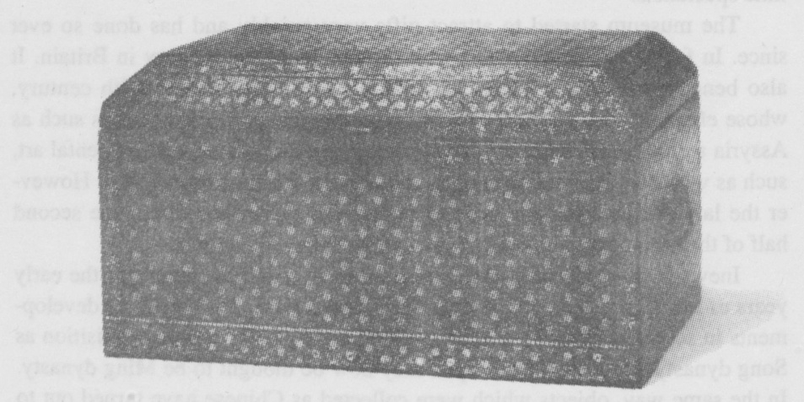

Fig. 1 Lacquer sutra box, decorated with inlaid mother-of-pearl and silver wire. Koryo dynasty, 13th century. Purchased in Japan. B.M.O.A. 1966. 12-21. 1. [page 39]

Collectors of Korean art can be divided into two groups: the first group are those who were Oriental art collectors and who collected Korean art in conjunction with Chinese and Japanese. The second group are those people who had some close connection with or interest in Korea, perhaps as diplomats or businessmen or missionaries. Then there are a few people who seem to have collected the odd Korean piece out of an interest in the particular material it was made from. Examples of the first group are relatively well-known collectors such as George Eumorfopoulos, Sir Harry Garner, Sir John Addis, Mrs Seligman, Oscar Raphael and A.W. Franks. The second group comprise diplomats such as W.G. Aston, missionaries such as Homer B. Hulbert and Stanley Smith and members of the consular service such as Thomas Watters. Perhaps the most famous British collector of Korean art, the late Godfrey Gompertz (d. 1992), was an employee of Shell, who lived partly in Korea and mostly in Japan. He married the daughter of an American missionary in Seoul and honeymooned in the Diamond Mountains in 1930. His books on Korean celadons and porcelain, published in the sixties, are still regarded as the standard works on the subject in English. He, however, has been written about in other places and since, unfortunately, he did not give any of his collection to the British Museum, he will not be included in this survey.2

By far the largest group of objects from one individual’s collection comes from that of George Eumorfopoulos (1863-1939), the British-born son of a Greek merchant from the island of Chios.3 These include the underglaze copper red celadon bowl exhibited in the Great Koryo Exhibition of summer 1995 in the Hoam Gallery (Fig. 2). Other Korean pieces of very high quality from his collection are a Koryo bronze censer inlaid with silver, a group of Choson dynasty Buddhist paintings, a group of Koryo celadons including a fine inlaid kundika and a considerable number of small metalwork pieces. Some of these things can be seen as they were displayed in his house at Chelsea Embankment in London during the 1930s (Fig. 3). He built a museum extension to his house where his Sunday receptions became a feature of London life at that time. He was always ready to show his huge collection to interested members of the public. The majority of the pieces were Chinese and many of the most famous Chinese objects in the British Museum came from him. He had always intended to bequeathe his collection to the nation but financial considerations led him to offer it to the British Museum for the price of 0100,000, well below the market price. The British Museum, although keen to acquire the collection, found it difficult to meet the cost and therefore had to invite the help of the Victoria and Albert Museum, Sir Percival David, The National Art  [page 40]

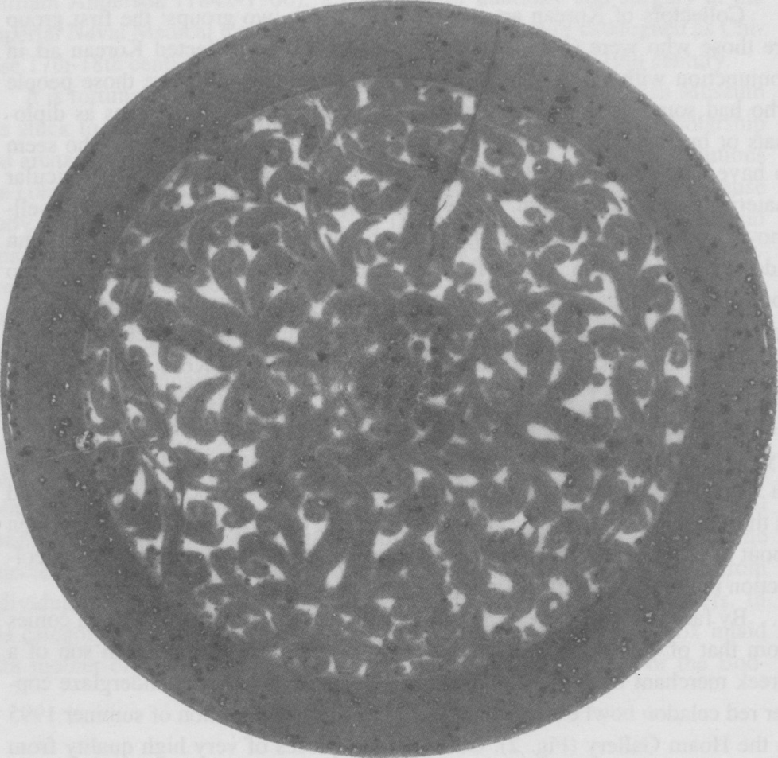

Fig. 2. Front view of a very rare celadon bowl decorated in underglaze copper red.

Koryo Dynasty, 12th century. Ex Eumorfopoulos collection. B.M.O.A. 1938.

5-24. 763.

Collections Fund and the Universities China Committee as well as members of the public. However, it was eventually purchased and divided between the British Museum and Victoria and Albert Museum on the basis of three to two.

Other collectors of Oriental art who collected Korean pieces include Sir Harry Garner (1891-1977), from whom the British Museum acquired a magnificent Koryo dynasty illuminated sutra, dating to 1341, a Koryo bronze kundika and several pieces of Choson dynasty lacquer.4 Sir Harry was a distinguished government scientist who, after his retirement, collected Chinese porcelain, cloisonne and Far Eastern lacquer. He wrote several well-known [page 41]

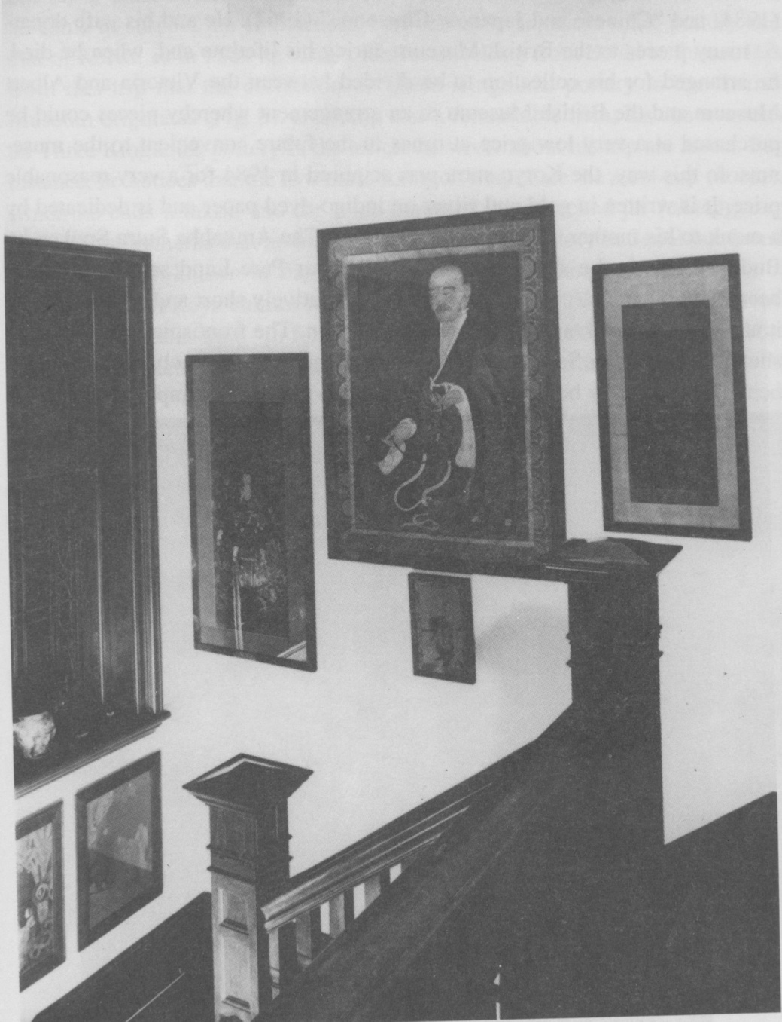

Fig. 3 Korean painting in the home of George Eumorfopoulos before it was acquired by the British Museum. London, 1934. [page 42]

books, including “Oriental Blue and White” (1954), “Oriental Lacquer Art” (1984) and “Chinese and Japanese Cloisonne” (1962). He and his wife donated many pieces to the British Museum during his lifetime and, when he died, he arranged for his collection to be divided between the Victoria and Albert Museum and the British Museum in an arrangement whereby pieces could be purchased at a very low price at times in the future convenient to the museums. In this way, the Koryo sutra was acquired in 1984 for a very reasonable price. It is written in gold and silver on indigo-dyed paper and is dedicated by a monk to his mother. The title of the work is The Amitabha Sutra Spoken by Buddha. This is the shortest of the three major Pure Land scriptures which became very popular, partly because it was relatively short and partly because it advocated a quick and easy route to salvation. The frontispiece of this sutra shows the Buddha Sakyamuni in paradise scene with newly re-born souls being welcomed by bodhissatvas. This sutra is the only example of its kind in a European collection5 (Fig. 4).

Another scientist who collected Korean art was William Gowland, A.R.S.M., F.C.S., a metallurgist who worked for the Japanese mint in Osaka from 1872-88.6 He was also a distinguished amateur archaeologist who carried

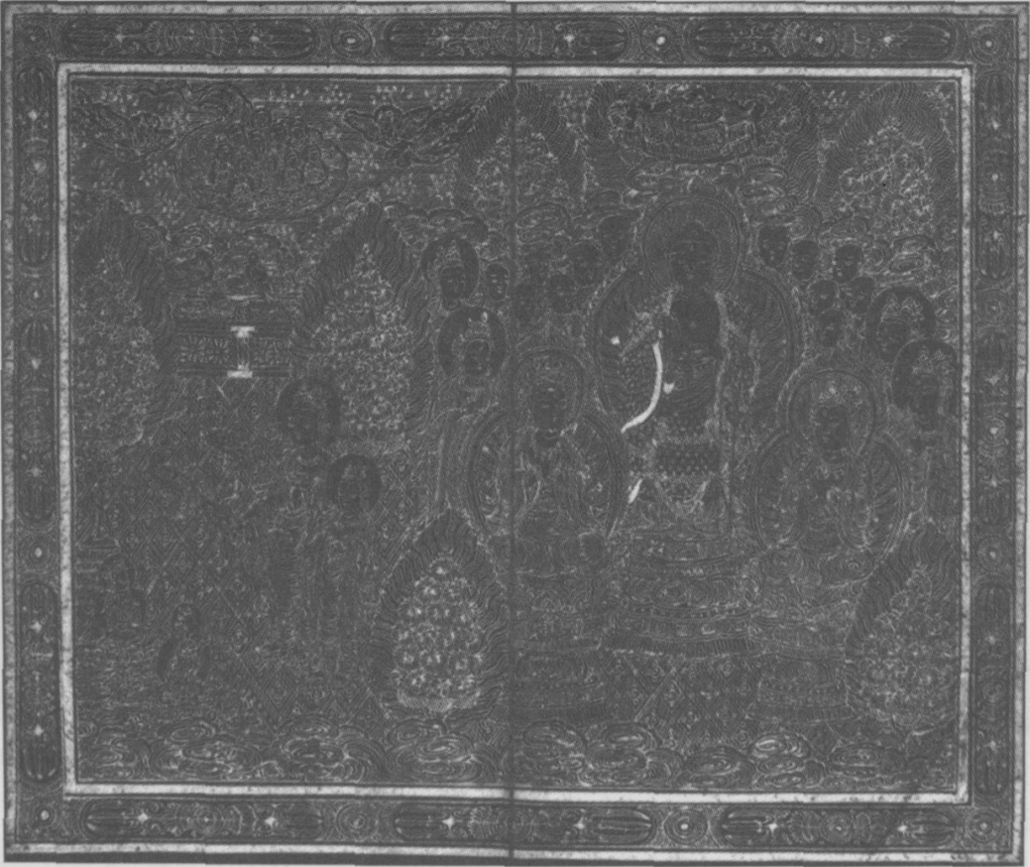

Fig. 4 Frontispiece to the sutra written in gold and silver on indigo-dyed paper. Koryo dynasty, dated 1341 A.D. Purchased from the Garner Collection. B.M.O.A. 1983. 10-8. 01. [page 43]

out many excavations of Japanese imperial tombs. Through his excavations, he came to suspect the connections between early Japanese tomb pottery and that of Korea, so in 1884 he visited Korea, travelling from Seoul to Pusan. It is from this trip that the collection of Three Kingdoms pottery in the British Museum originates (Fig. 5). Gowland was a remarkable man; his observations on Three Kingdoms pottery in the article he wrote about his trip are astute. For instance, he notices that the two most common shapes are the stem-cup (kobae), which he calls a tazza, and the wide-mouthed, long-necked jar (changgyong ho). He also remarks that he found few examples of pottery in Seoul but found that it was well-known in Pusan. This is hardly surprising, since Pusan is in the area of Silla/Kaya culture which produced these vessels in the largest numbers. He concludes that: “In form, inscribed designs, marks of matting, and the material of which they are made, many are allied to the sepulchral vessels of

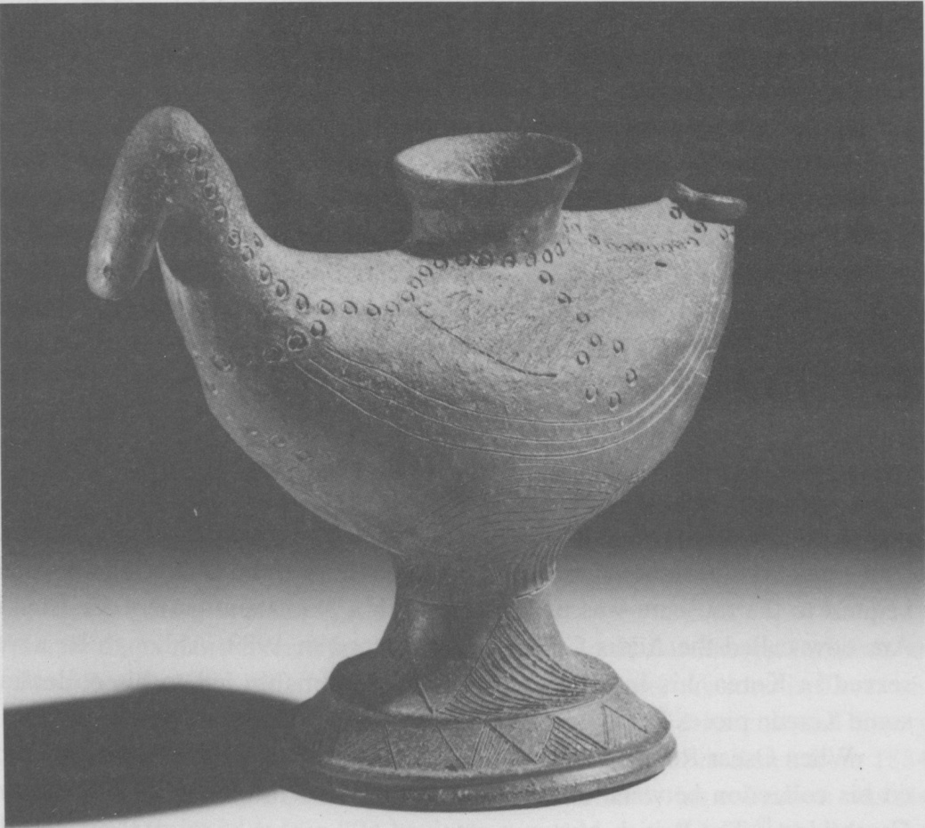

Fig. 5 Stoneware funerary vase in the shape of a duck. Kaya Kingdom, 5th century

A.D.Donated by Sir A.W. Franks who purchased it from William Gowland.

B.M.O.A.+583. [page 44]

the dolmens of Japan, but they are not identical.”7 He also provisionally dates the pottery to between the 2nd and 7th century A.D., by comparison with the Japanese excavated examples. This is rather remarkably accurate.

Gowland’s collection actually came to the British Museum after it was purchased by Sir A.W. Franks (1826-1897), Keeper of the Department of Antiquities and Ethnography from 1866 to 1896. He could be said to have been the greatest single benefactor in the history of the British Museum. He collected in a wide variety of fields, notably that of oriental ceramics. He was clearly interested in collecting Korean ceramics as he wrote the following to the American missionary, Homer B. Hulbert, in July 1887: “Our funds are also limited especially this year, when the annual grant has been reduced to nearly one half. There is one matter, however, in which you might assist the Museum as well as myself. I have given to the museum my extensive collection of oriental pottery, in which are a few pieces which I believe to be Corean. I should like to make the collection more complete, and I should be willing to expend a sum not exceeding £40 for this purpose out of my own pocket. I should wish of course to obtain very good and old specimens, the Corean origin of which is undoubted.... England has been deluged with some dreadful modern Japanese pottery which is sold as Corean but seems to have been imported there to supply the demand. My friend Mr Colbourne Baker has shewn me two pieces which he believes to be Corean, but one of which seems to me to be of Chinese work and the other Japanese.”8 Unfortunately, Franks was not able to acquire much more Korean pottery, apart from the Gowland Collection, although his Chinese and Japanese ceramics collections were huge.

Another well-known Oriental art collector, Sir John Addis (1914-83), donated two pieces of Korean art to the British Museum. These are two Choson dynasty blue and white porcelain bowls, decorated with auspicious symbols. Sir John is better known as a collector of early Chinese blue and white porcelain. He was a distinguished diplomat who served as Ambassador to China and who became a Trustee of the British Museum. After his death, his bequest to the museum was used to establish a permanent gallery for Islamic Art, now called the Addis Gallery. This opened in 1989. Although he never served in Korea, his interest in porcelain presumably led to his collecting some Korean pieces.9

When Oscar Raphael died in 1941, this great Oriental art collector divid- ed his collection between the British Museum and the Fitzwilliam Museum, Cambridge. The British Museum received 698 pieces of oriental art, mostly Chinese and Japanese. There were, however, some pieces of Korean metal- work, including Koryo dynasty hairpins, chopsticks and two bronze, horse- . [page 45] shaped, belt hooks dating from the 2nd or 1st century B.C.. He was particularly interested in ancient Chinese bronzes, collecting some important examples. He also collected a group of animal-shaped Chinese belt hooks of the Han dynasty and it may be that the two Korean ones were originally part of this group. Animal-shaped belt hooks were a feature of the Ordos style bronzes of Northwest China and there may have been some confusion as to the origin of the horse-shaped ones. There was, in any case, undoubted cross-cultural influence in North China, Manchuria and Korea at this time.

Charles Seligman was Professor of Ethnology at the University of London. When he died in 1940, his wife donated a Korean celadon vase from his collection in his memory. Then, after her death in 1965, the remainder of their collection was bequeathed to the museum. This included quite a large group of Koryo bronze mirrors as well as celadons such as a fine 12th century cup and stand. Professor Seligman was particularly well-known for his research on early Chinese glass beads. He built up a large collection and these are all now in the British Museum.11

All the above are people who collected and researched oriental art and, as a result, happened to include some Korean pieces in their collections, the number of Korean objects being more-or-less in proportion to the size of their collections. Then there are people like Lord Invernairn (William Beardmore, 1856-1936), a ship-builder who was president of the Iron and Steel Institute in 1917 and who collected a magnificent Koryo dynasty bronze incense-burner stand inlaid with silver and dated to 1358 A.D.. This was donated to the museum by his widow in 1945. He presumably collected it because of his interest in metalwork, but there is no record of how he came to acquire it, and it seems that he was not an art collector.

Similarly, Sir William Bateson (1861-1926), an eminent biologist and Cambridge Professor, collected Koryo bronze bowls, swords, chopsticks and spoons which were donated by his wife after his death. In his case, he also collected Old Master drawings and Japanese prints and was elected as a Trustee of the British Museum in 1922.

Perhaps more interesting for those with a particular interest in Korea are those Britons who, because of some professional reason, resided in Korea and started to collect out of an interest in the country and its cultural history. William Aston (1841-1911), Britain’s first consul-general in Korea from 1884- 1886, was an example of this category.12 Unfortunately his collection was dispersed and the British Museum has only one Korean pot donated by him, dating to the late Unified Silla/early Koryo period.

Thomas Watters, a British consul in Seoul around 1885, managed to. [page 46] acquire quite a few Korean pots, despite his complaint of poverty to his superiors in 1867, while a second assistant in his fourth year of service in China.13 He reported that, after meeting outgoings for mess, servants, teacher and mis-cellaneous domestic expenses, he had only $2 a month left over for medicine, clothing and any other essential needs. He could afford no sort of amusement, had had to sell his watch, bed and nearly all his furniture and was a few score dollars in debt. This suggests either that his situation had improved by the time of his appointment to Seoul or that he acquired the pots very cheaply. There are some Koryo celadons and some later porcelain pieces, none of first class quality, although there is one interesting white porcelain water dropper with openwork decoration of dragons (Fig. 6). He donated his collection to the British Museum in 1888.

A British missionary who worked in Korea from 1910-1914, Stanley Smith, built up a sizeable collection of Koryo celadons and a few pieces of Choson porcelain as well as some pieces of textile and furniture and a few

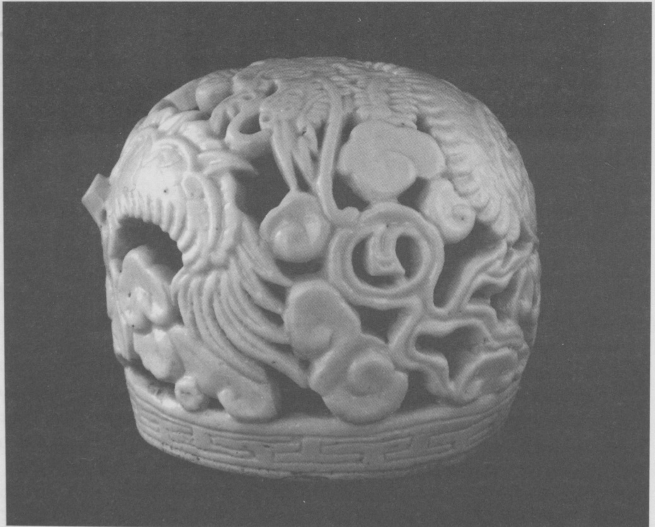

Fig. 6 Porcelain water-dropper with open work decoration of a dragon and clouds.

Choson Dynasty, 19th century. Donated by Thomas Watters. B.M.O.A. 1888. 9-13. 10. [page 47]

paintings. The British Museum purchased four pieces from his collection in 1951, including one fine porcelain teapot with underglaze blue decoration of a crane and bamboos. At present most of the rest of his collection is still in the possession of his widow.

Homer B. Hulbert, the well-known American missionary and friend of Korea, donated a few things to the museum in 1900, including a steel halberd. He also donated a map, which is now in the British Library.14 The question of why he donated to the British Museum rather than an American one, despite his famous desire to be buried in Korea rather than in Westminster Abbey, is an interesting one. On the whole, perhaps not surprisingly, missionaries did not prove a very prolific source of Korean antiquities.

A donation of 45 pieces was made in November 1910 by E. Ogita, who is described in the British Museum’s register as “Secretary of the Imperial Chosen Government, Office of the Japanese Commission.” These pieces were made especially to be exhibited in a Japanese Exhibition which was held at the White City in Shepherd’s Bush, London, in 1910. They were presumably donated to the British Museum after the close of the exhibition. There are also other pieces of porcelain which were donated by Ogita around the same date which were probably also exhibited at the exhibition. The Anglo-Japanese Exhibition of 1910 was designed to increase cultural and commercial ties between the two countries and the shared ethos of Imperialism was an important part of the exhibition in the year of the annexation of Korea by Japan.15 Work by the peoples of Taiwan (Formosa), Manchuria and the Ainu people were also exhibited, displayed in a Palace of The Orient, which had a Korean Pavilion, described thus: “The roofs of fantastic shapes covering the gateway and the walls which enclosed the exhibit from Korea showed the marked peculiarities of Korean work” (Fig. 7). The Korean pieces acquired by the British Museum as a result of this exhibition are of fine quality. They include a beautiful sedge mat decorated with the ten symbols of longevity (rig. 8), some oiled paper fans with paper-cut decorations, marble tobacco boxes, a group or inlaid lacquer pieces and a model of a traditional Korean house, cut away to show the roof tiling work and the underfloor ondol heating system. It is interesting that all of the Korean items were in the category of what would nowadays be called “Folk Crafts,” while the Japanese exhibits included “Fine Art” paintings, sculpture and porcelain, both ancient and modern. This was presumably to fit in with the imperialistic ethos of the exhibition. In fact the official report of the exhibition patronisingly states: “The development of Korea also, since that peninsular empire came under the guiding influence of Japan, was similarly shown by exhibits represented by and under the auspices [page 48]

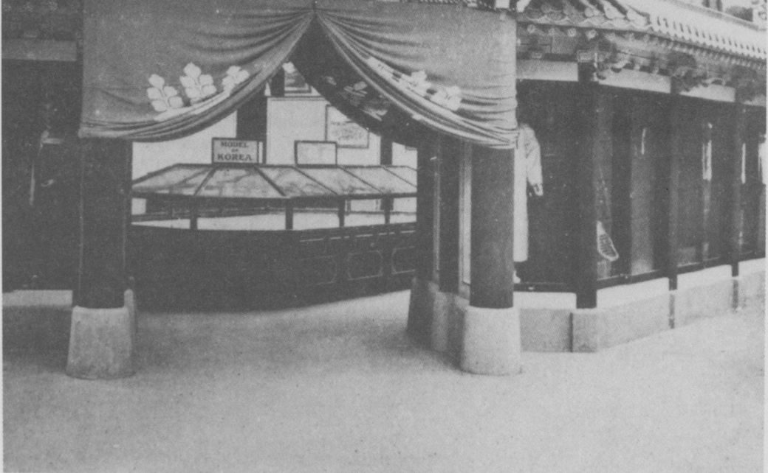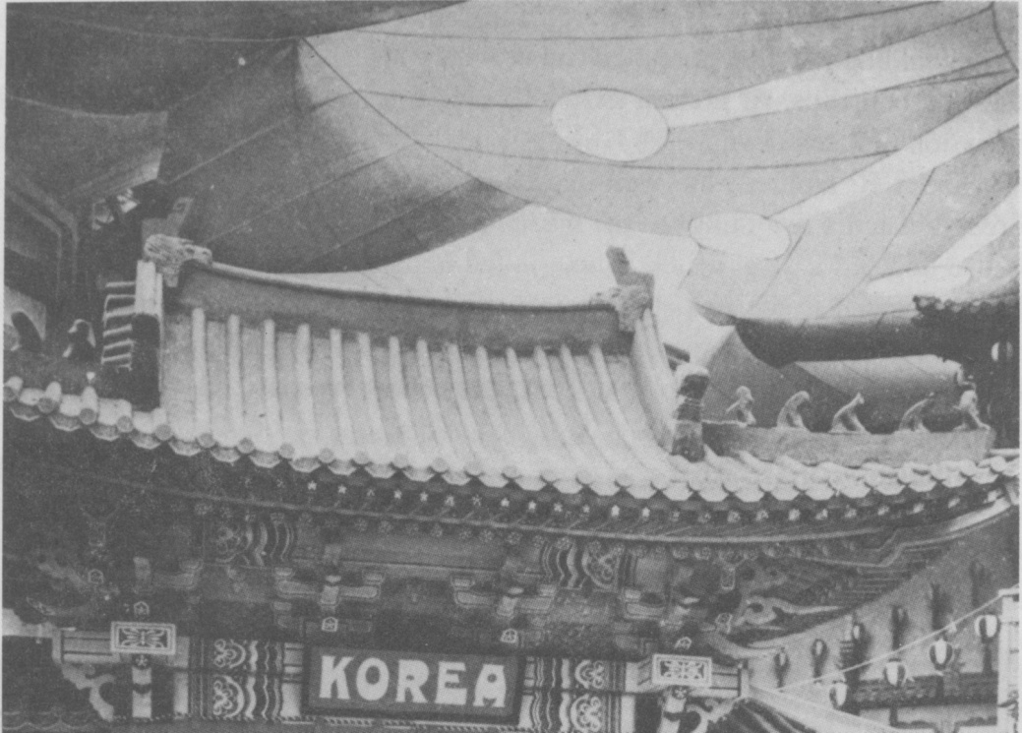

Fig.7 Photograph of the Korean Pavilion in the Palace of The Orient at the Japan- British Exhibition at White City, London in 1910. [page 48]

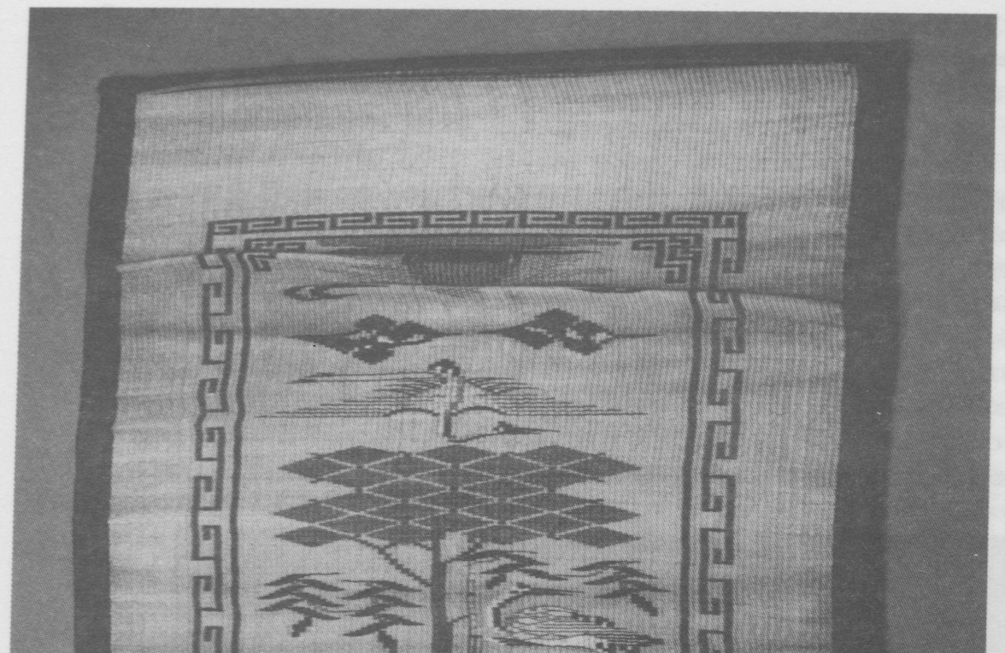

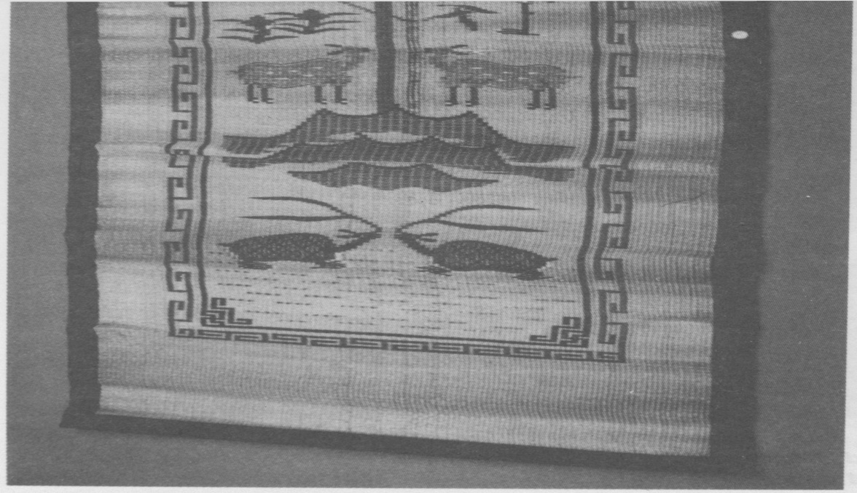

Fig. 8 Sedge mat decorated with longevity symbols. Made for and displayed at the Japan-British Exhibition in 1910.

[page 50]

of the Japanese Residency General in Korea.

The most recent donor to the British Museum’s Korean collection is Dr. A.G. Poulsen-Hansen, a Danish doctor who now resides in London. Dr. Poulsen-Hansen worked in public health programmes in Korea in the 1950s, after the Korean War. He lived in several towns, including Taejon and Seoul, and he managed to build up a considerable collection of ceramics at that time. Until recently he would delight in showing them to visitors to his house in Islington. In 1992，he decided to donate them to the British Museum. They include such fine pieces as a gourd-shaped Koryo celadon ewer, a monster mask roof tile from the United Silla period, and a small hexagonal bottle decorated with butterflies in underglaze blue, dating to the late 18th century17 (Fig. 9).

The museum continues to collect both antiquities and contemporary art. With the huge rise in prices of Korean art in recent years, however, it is increasingly difficult to acquire major pieces. The museum has a policy of

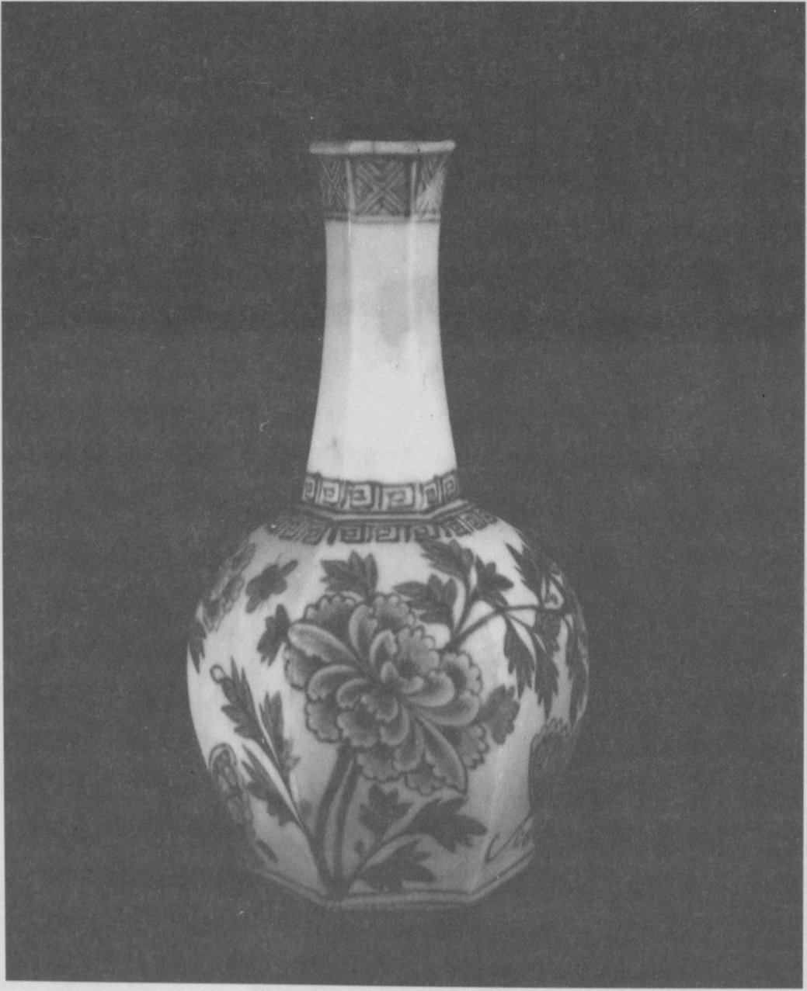

Fig. 9 Hexagonal porcelain vase with underglaze blue decoration of peonies and butterflies. Choson dynasty, late 18th-19th century. Donated by Dr. A.G. Poulsen-Hansen. B.M.O.A. 1992. 6-15. 33.

[page 51]

actively collecting 20th century works from Asia, conscious of the fact that this is a relatively unknown area in the West and that, as a major national museum, it is important to collect for the nation and the future. In this area, objects have been acquired in the last five years both through donation and purchase. The museum is trying to collect works which have some definite Korean quality, as opposed to more international style modern art works. It is sometimes difficult to explain the criteria for collecting in this area and, of course, the choice of works is, to some extent, ultimately a subjective one. A fine example of the type of work the museum has collected in recent years by donation is the painting in ink on paper of “People Dancing,” by Suh Se-ok. This work combines traditional Korean technique and material with a completely contemporary interpretation. The modern punch’ong style ceramic works of Shin Sang-ho have also been collected for this reason.

The British Museum’s Korean Collection has grown up during the last hundred years in a largely unplanned and unpredictable fashion. Much of it has not been seen by the public on a permanent basis, due to lack of display space. Now, as a result of a generous donation by the Korea Foundation, a permanent gallery for the arts of Korea can be established on the removal of the British Library. Visitors in the future will be able to see the works donated by and purchased from the collectors presented here.

N.B. I would like to acknowledge with thanks the help of J.E. Hoare of the Research Department, Foreign and Commonwealth Office, London and Miss Marjorie Cay gill of the Director’s Office, British Museum, London in providing references and information used in this article.

NOTES

1. See Wilson, Sir David, “The British Museum, Purpose and Politics.” British Museum Publications 1989, p. 14.

2. For Gompertz’s work, see “Korean Celadon and other wares of the Koryo Period,” Faber 1963 and “Korean Pottery and Porcelain of the Yi Period,” Faber, 1968.

3. See British Museum Quarterly IX，1934-5 and The Antique Collector, Sept. 1991 for information about George Eumorfopoulos’s collection. Information about the purchase of his collection comes from the British Museum archives.

4. See Garner, Harry, ‘‘Chinese and Associated Lacquer from the Garner Collec-tion,” London, British Museum 1973. Korean pieces from his collection are included. [page 52]

5. Pak Youngsook, “Object of the Month” in Orientations, Dec. 1982, pp. 44-48.

6. Jones H.J., Live Machines: Hired Foreigners in Meiji Japan, (Tenterden, Kent; Paul Norbury Publications: 1988), p. 93 and p. 177.

7. Gowland W., “The Dolmens and Other Antiquities of Korea” in Journal of the Anthropological Institute XXIV, 1895, p. 323.

8. Outletter Books Vol. 1, “A.W. Franks to H.B. Hulbert, Seoul, Korea 31. 7. 1887” ref: f.95. British Museum Department of Medieval and Later Antiquities.

9. See Times Obituary 2nd August 1983.

10. British Museum Quarterly XV, 1941-50, pp. 82-94.

11. Op. cit., pp. 95-102.

12. For information about Aston, see Kornicki’s chapter about him in Britain and Japan 1859-1991: Themes and Personalities, edited by Sir Hugh Cortazzi and Gordon Daniels (London, Routledge: 1991).

13. Coates, P.D., The China Consuls (Hong Kong, O.U.P.: 1988), p. 340.

14. For biographical information about Hulbert see preface to H.B. Hulbert, The Passing of Korea (Yonsei University Press: 1969) reprint of 1906 original, pp. 3-9. See also his tombstone in Seoul Foreigners’ Cemetry.

15. Tomoko Sato and Toshio Watanabe, ed., Japan and Britain, an Aesthetic Dialogue 1850-1930 (London, Lund Humphries: 1991), p. 159.

16. See “The Official Report of the Japan-British Exhibition 1910 at the Great White City, Shepherd’s Bush, London,” p. 135 and p. 284.

17. See Jane Portal, “The Korean Collection of Dr. A.G. Poulsen Hansen” in Orientations, December 1992.