[page 65]

**HISTORICAL DOCUMENTS**

In commemoration of the centennial of the Korea Branch of the Royal Asiatic Society, the Council takes great pleasure in providing for our members copies of documents relating to the founding the RASKB in 1900.

In the page s that follow are a letter from the Royal Asiatic Society in London, conveying copies of the original minutes of that Society to the Korea Branch. There is a certificate of authenticity signed by the President of the RAS London. And there are copies of two entries from the original minutes book of that Society, one for 9 January 1900 and the other for 13 November 1900.

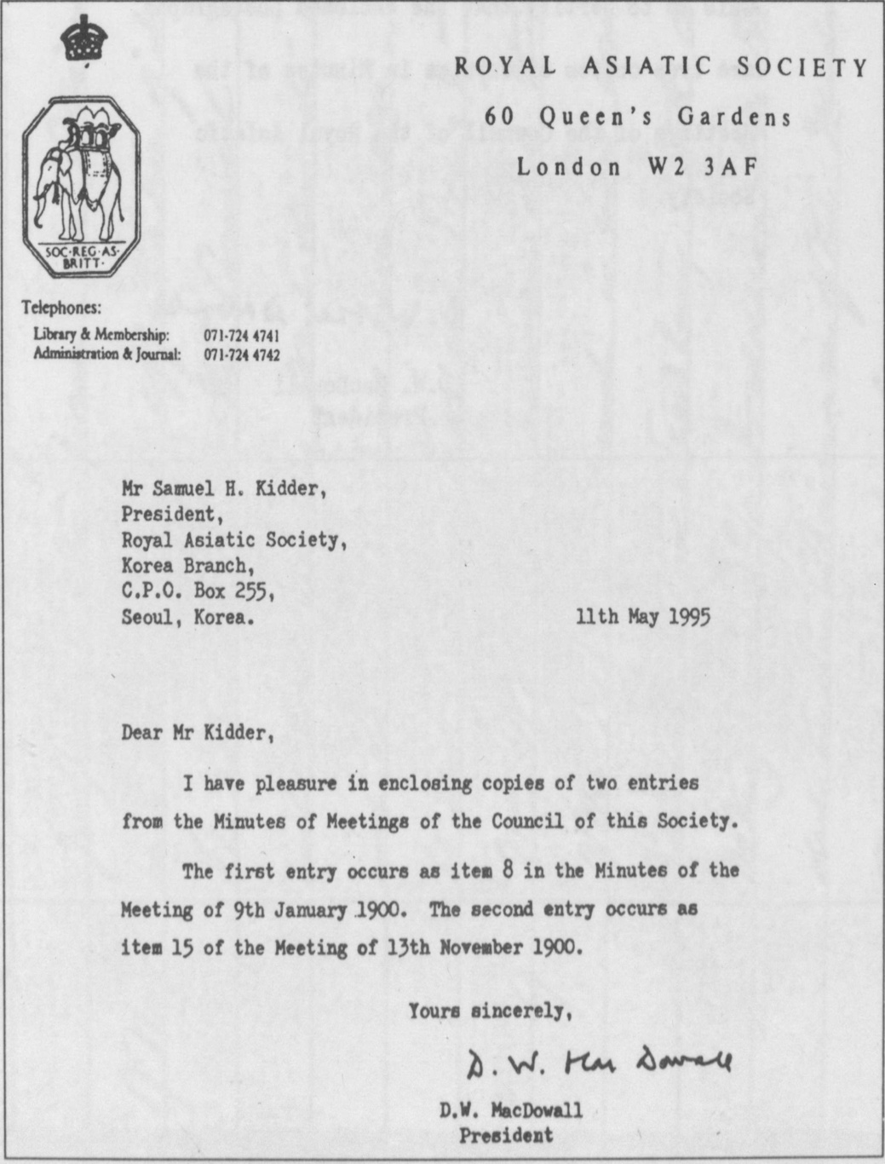

[page 66]

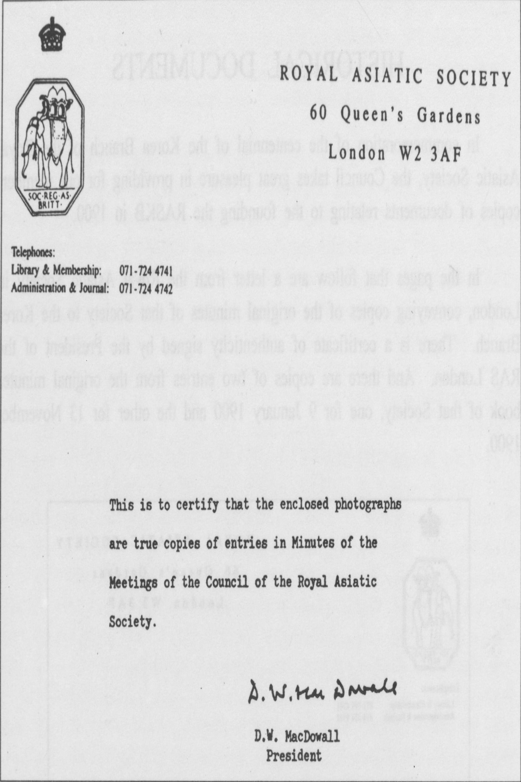

[page 67]

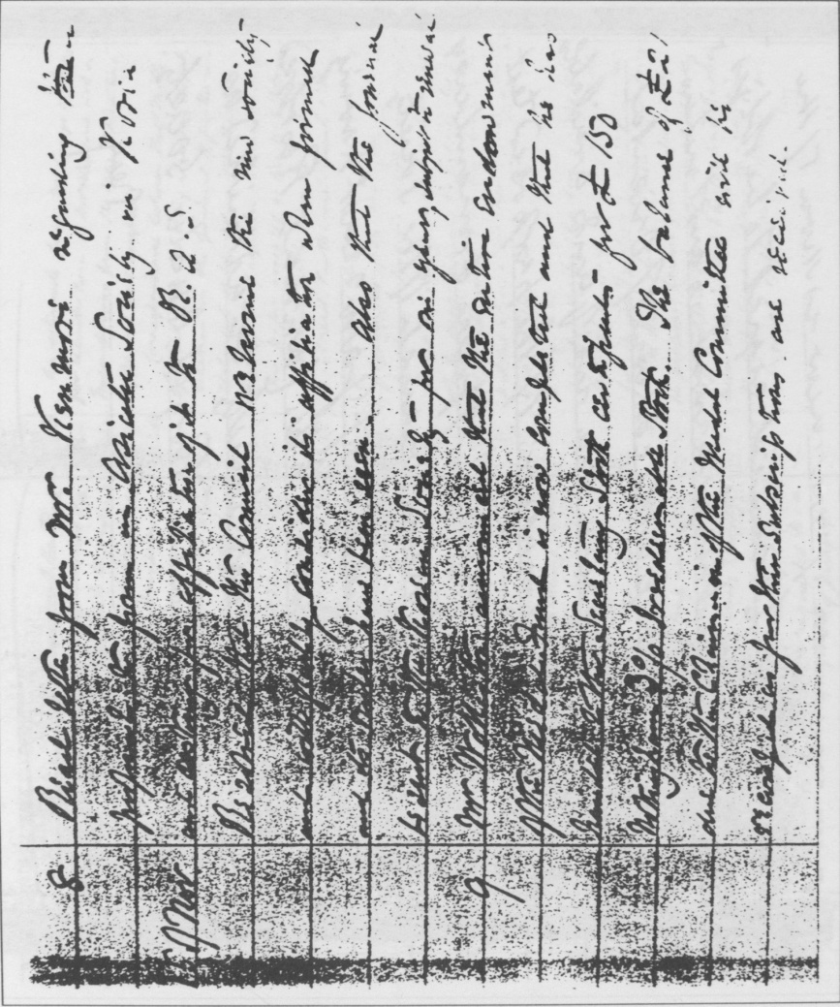

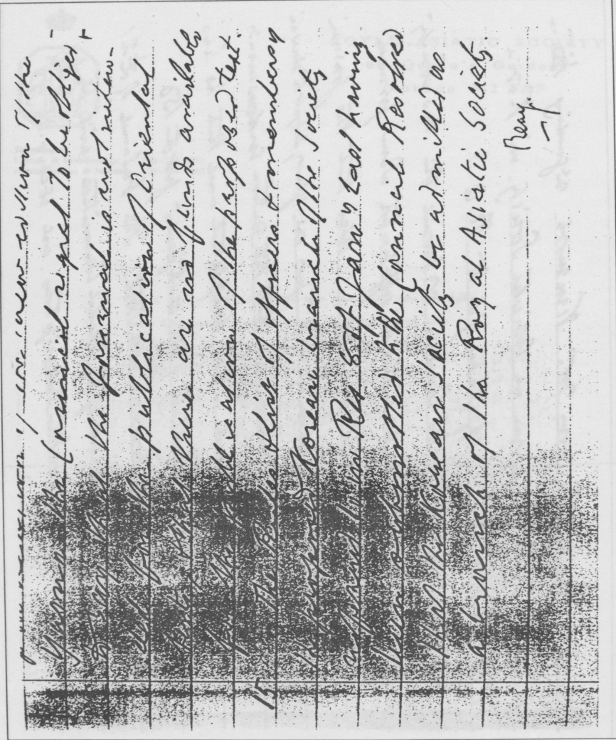

[page 68]

