The Early History of Korean Electric Light

and Power Development

Moon-Hyon Nam

**I. INTRODUCTION**

A plaque inscribed with the phrase “The Birthplace of Electricity in Korea” has recently been laid at the site of Korea’s first electric light plant (*jendeungso*) on the grounds of Gyeongbokgung palace in Seoul, to mark the 100th anniversary of powerhouse construction and electric lighting installation inside Geoncheonggung, the main residence of Gojong (r.1864-1897 as king, 1897-1907 as emperor).[1] The first modern lighting came to Joseon, “The Land of Morning Calm”,[2] just seven years after the invention of incandescent light by Thomas A. Edison. Thus, conventional royal palace lighting by candles and oil lamps was partially replaced by modern incandescent electric lights two years and four months after the Korean government ordered an electric light plant from the Edison Electric Light Company[3] on September 4, 1884. The powerhouse was completed in January 1887 and the test operation of triple-bulb electric lamps was carried out. The exact date of the first actual use of electric lighting is not known, although January 26, 1887 is the most probable date.[4] It was only four and half years after the opening of the Pearl Street Central Station in New York.[5]

In 1892, the government planned to relocate and upgrade the plant because of the noise and the need to electrify Changdeokgung, about one mile east of Gyeongbokgung.[6] American electric light engineer Thomas Power was in charge of the construction of the new plant, located about midway between both palace compounds. The old plant was closed after the completion of its successor on May 30, 1894.[7] This is recognized as a historic milestone that kicked off a national modernization effort in the late 19th century. In the 20th century, the plants were demolished without a trace remaining. Some documentation on the plants exists, for example Korean-U.S. and Korean-U.K. diplomatic dispatches during the construction project and subsequent operation. In 1893, Allen reported the electrical matters in Korea to Washington: “…a fine incandescent electric light plant of 750 lights from Edison Company…”[8] In 1936, the Japanese reported that two 3kW dynamos were operated by a steam engine and two 100-candlepower lamps were lighted up at the palace in 1887. The site of the powerhouse was in front of the king’s residence.[9]

In addition to its first lighting service within the palace, the nation’s first electricity provider, the Seoul Electric Company, was launched in 1898.[10] This accelerated the modernization process, which included the renovation in the capital, construction of a tramway and waterworks, and extension of electric light and power services to the public. The Seoul Electric Company managed to provide an integrated service that included street lights, telephones, and a new electric tram system.[11]

The first electric light plant on the palace grounds is forgotten as the very start of electrical engineering in Korea. This paper attempts to revive the early history of Korea’s electric lights and power by providing a chronological review of electrical developments before the turn of the 20th century. The main focus is on the initial stages of the process: the establishment of the first electric light plant at the main palace in 1887 and the erection of a second plant for lighting the detached palace compound, Changdeokgung, in 1894.

**II. Introductory contacts with electricity**

* 1. *General Knowledge of Electricity*

From the early 1860s several kinds of scientific literature published in China were introduced to Korea. Stories about electricity, electric trams and telegraphy were very popular in newspapers.[12] Koreans knew about the basic theory of electricity and its application to the telegraph and weaponry, while natural electric phenomena helped them to understand electricity better. Joseon opened her ports to Japan in 1876, and Gojong began to see electricity as a symbol of national “enlightenment” and “self-strengthening.”[13]

* 1. *Observations of Electricity*

Korea came in contact with electricity through Japan and China. The Joseon government sent special envoys to Japan during the 1870s and 1880s to inspect modernized schools, institutions, and industrial facilities. The members of several delegations witnessed the electric arc-lighting in the street of Yokosuka and Tokyo. Technology trainees sent to China learned about electricity and the telegraph at the Electricity Test Station in Tianjin.[14]

* 1. *Interactions between Korea and the USA*

*The Korean Special Mission to America*

Gojong realized the tremendous power of electricity through reports from his delegations and recognized that it was the only means to promote national wealth and military power. In conjunction with signing the Treaty of Friendship with Japan in 1876, the Joseon government signed the Treaty of Amity and Commerce with the USA in 1882. It was a result of an effort to actively join international society. Lucius H. Foote was appointed the first American Minister to Joseon and opened the American legation at Jeongdong in Seoul in May 1883.

The Korean government dispatched the *Joseon bobingsa*, or Joseon Special Mission to America, in accordance with the terms of the treaty with the US. The delegation consisted of eight men and was lead by Chief Minister Yong-Ik Min.[15] The general aim of the mission was not only to cement the friendship between the two countries but also to obtain American advisers, teachers, and loans.

*Devil’s Light*

The mission arrived in New York on September 18, 1883 via San Francisco and Chicago, and they met President Chester A. Arthur (1881-85) in New York to submit King Gojong’s letter and diplomatic credentials. They embarked on an inspection tour of modern facilities in Boston and Lowell, Massachusetts. This was the beginning of science and technology exchanges between Korea and America.[16] In Boston, they stayed in the Hotel Vendome and visited two industrial fairs (the Foreign Exhibition and the American Exposition). Joseon had porcelain ware, and this was the first Korean participation in an international fair.[17] While touring the Equitable Building in New York, the delegation was awed by the electric lights and wrote the following: “…In Japan we saw electrical apparatus, but could not be told what (it) was, though we were left to understand that nobody knew, and that it was a force controlled by devils and not surely under human control….”[18] They expressed their desire to introduce electrical equipment and facilities to Korea.[19] The envoys also saw the incandescent lighting and power generation facilities at the Hotel Vendome, which were installed in 1882.

*Ordering an Electric Light Plant from Edison*

During their stay in New York, many entrepreneurs and merchants interested in trading with Korea visited the envoys. Among them was Everett Frazer, who was already trading with Japan and China at that time. He introduced several manufacturers and textile factories. One of these companies was the Edison Electric Company, and the delegation had a meeting to discuss an order for an electric light plant.[20] Impressed by Frazer’s hospitality, Chief Minister Min asked him to be the Honorary Joseon General Consul in New York. Since there was no formal diplomatic consulate in Washington, the Joseon government officially assigned him as the Honorary Joseon General Consul in New York on January 17, 1884.[21] The mission’s activity in the US provided a chance to introduce electric lighting to Korea.

**Iii. Establishment and Removal of the Powerhouse**

1. *Planning the Electrification of the Palace*

After returning to Seoul, the envoys recommended to the king that advanced science and technology from America and Europe be introduced for the sake of national reform and enlightenment.[22] Meanwhile, Frazer and Edison discussed the establishment and operation of electric lighting, telephone equipment and facilities in Joseon. Frazer sent a message to Minister Foote on April 16, 1884 and asked him to apply to the government for the exclusive rights regarding the electric lighting and telegraph project.[23] Upon receiving Foote’s memorial on the electrification of the palace, the Joseon government ordered an electric light plant from the Edison Electric Light Company on September 4, 1884 via Foote. Foote reported it to the Secretary of State, F. T. Frelinghuysen, and asked him to cooperate in the installation of electric light in the palace.[24] In response to Foote, Frelinghuysen confirmed the report.[25] This led to a $15,500 contract between Frazer, the authorized representative of the Joseon government, and the Edison Lamp Company in October. Edison named Frazer as a general agent for his business in Joseon. Edison also assigned James R. Morse of the American Trading Company in Tokyo and Walter D. Townsend (Townsend & Co.) in Chemulpo (now Incheon) as trading agents in Korea.[26]

The attempted coup d’état in Joseon on December 4, 1884 delayed the electric lighting project until June 1885. In August 1886, Frazer reported that Edison was ready to send an electric light plant to Korea,[27] and he was waiting for the decision of the Joseon government on the invitation of an electric light instructor.[28] The government decided to invite an electric light engineer and Edison recommended William McKay. McKay was granted a passport on September 18, 1886 and left for Joseon with his family and a mechanic in October.[29]

1. *Construction of the Electric Light Plant*

*Building*

McKay arrived in Seoul on November and signed a contract with the Joseon government. He started to search for a site for the powerhouse on the palace grounds and decided to locate the building between the king’s residence and the side of the lotus pond, which would supply water for the boiler, and to install power lines for the electric lights. From December 1886 through January 1887, McKay erected a one-story frame building on a hill overlooking the lotus pond.[30] The building had an approximate area of 30ft × 80ft and was divided into an engine and dynamo room, and a room for the boiler.[31]

An electric light plant arrived in Japan from the US in early November. The Joseon government paid $12,179.87, the balance owed to the Townsend & Co., and took possession of it.[32] The plant was then carried by sea from Nagasaki to Incheon and up the Han River to Seoul.

*Boiler*

Steam was supplied by a coal-fired 80-hp boiler. Edison adopted the Babcock & Wilcox model to his systems from early on. observing that, “It is the best boiler that God has permitted man yet to make.” Thus it may be assumed that McKay installed a Babcock & Wilcox boiler at his powerhouse.

*Steam Engine*

There are several reports about the steam plant: one electric light plant for lighting 750-incandescent lamps,[33] two 3kW dynamos (and a steam-engine).[34] It is inferable that the steam plant consisted of a high-speed (Armington & Sims) engine having two flywheels, each of which was belted with a 3kW class Edison dynamo. In the Pearl Street station, Edison adopted 125-hp Armington & Sims engines capable of running at 350 rpm and linked his dynamos because of the ease of speed regulation. At Sunbury, he also belted his “L” dynamo with a high-speed Armington & Sims engine having two flywheels.[35] The engine was well matched with various Edison dynamos and thereafter became his favorite. The Armington & Sims Company produced small engines: two flywheels, a 9.5" bore and 10" stroke, producing produces 50-hp at 350 rpm with 175 psi of steam.[36] Edison probably sent an Armington & Sims engine for use at the Joseon powerhouse.

*Dynamo and Three-Wire System*

As mentioned above, two 3kW Edison dynamos were belted to a steam engine. In the early stage of the Edison Isolated Lighting System, the dynamos were long-legged Mary types. These were replaced by shortened bipolar generators, i.e. the Edison dynamo of 1886, and these were installed in the Edison system of central station lighting. The first operating manual of the Edison dynamos in the central station was published in 1886. Edison arranged two generators in series to provide 220V in outside wires and a neutral wire between the generators acted as a compensating conductor. This was a three-wire system which was first installed at Sunbury and elsewhere afterward.[37] It is inferable that two dynamos were connected in series, and that three wires led to simple bus bars at the powerhouse.

*Lighting Installations*

News reports on the lighting installations mentioned that 750 incandescent lamps,[38] two 100-candlepower arc-lamps, one for the search light and the other for the fore-garden,[39] and 5-bulb electric lamps had arrived.[40] Based on the capacity of the dynamos, 120, 16-candlepower and 100-candlepower arc-lamps were deployed on the palace grounds. The dynamo might have had a capacity of 60, 16-candlepower bamboo filament lamps each, thus giving a capacity of 120 lamps to the station. A three-wire distribution panel stood in front of the dynamos, and three wires from the dynamo were for the lamps in the king’s and queen’s residential area and around the palace.

1. *First Class in East Asia*

*The Death of McKay*

According to a letter to Edison from Francis Upton, superintendent of the Edison Lamp Company, the Korean plant was one of the first-class plants in East Asia, along with the one in the Japanese emperor’s palace, and it would be a model plant for future business in China.[41] The plant was fully functional and performed satisfactorily.[42]

On March 9, 1887, McKay died after being shot with a revolver by Korean assistant Ki-Su (Kim). The assistant was arrested and tried. This aroused diplomatic problems between the two countries because McKay was an invited government electrician. The US legation concluded that the assistant was not guilty and did not want him to be punished. At American minister Rockhill’s request, the Joseon government decided to free the assistant.[43]

William McKay was born in Scotland in 1863 and resided in Warwick, Rhode Island. Before coming to Joseon he worked at a textile printing factory.[44] He was a benefactor who brought modern lighting to Korea. Upon receiving the sad news, Gojong expressed his deep sorrow, paid the funeral expenses, and consoled the family by providing money for housing and education.

*Operations after McKay*

The powerhouse was halted until the government invited new electric light “teachers,” Pyirre and Forsyth, in August from England through the mediation of the USA.[45] Their duty was to re-start the powerhouse, operate the plant and manage the electric light facilities. The government asked them to train Korean students to run the powerhouse in the future. For operating the powerhouse, Pyirre and an assistant were enough, so the government discharged Forsyth on February 12, 1889. Pyirre served until August 1889 with a Korean assistant,[46] and American electrical engineer Payne was then invited, serving two years as his successor.[47] Another American, Thomas W. Power, succeeded Payne from 1891. Power had worked at the Shareham Hotel in Washington before coming to Seoul and was an excellent electrical engineer.[48]

The public attitude toward electric lights was not very welcoming, and many protested the high cost of using them.[49] On the other hand, electric lights were a source of curiosity, and some called then “marvelous fire” or “moolbul - water fire” because the electricity came from the water of the lotus pond and people believed the light was made from the water.

1. *New Plant Construction and Old Plant Closure*

*New Building*

In 1892, the Joseon government wanted to upgrade the obsolete powerhouse and electrify the detached palace, Changdeokgung, which was about a mile away. The Workshop Office of the Department of Interior signed a contract with the American Trading Company to purchase a new installation. Thomas W. Power was dispatched to America to select the new equipment from various places. It was shipped to Kobe, Japan, where it was met by Power and carried by Korean steamer to Chemulpo on June 1, 1893. After payment was completed, it was brought 60 miles upriver to Seoul on small river junks. After unloading at the landing, the equipment had to be carried by bull cart four miles into the city. The cost of the plant was some $31,000 in gold, including freight and shipping charges.[50] The original plan was to extend the present powerhouse by adding new equipment only. Considering the noise problem and design issues related to the extension plan, the new plant was installed in an empty building originally built as an arsenal and equipped with machinery for manufacturing weapons in 1883. The building stood about midway between the two palace complexes, necessitating the building of transmission lines and making the plant really a control station.

*New Plant Facilities*

According to Allen’s report, the new plant consisted of steam and electrical generating facilities with 240-hp output, capable of lighting two thousand 16-candlepower incandescent lamps. It was almost twenty times larger in capacity than the old one.[51]

*Boiler Plant*

The boiler plant consisted of three 80-hp boilers, which were made of steel and of the horizontal pin, tubular type. They were connected to be run independently and/or together as required. The wrought iron smokestack was 90ft high and 4ft in diameter; fabricated in sections to facilitate shipment by Thos. C. Bassnor Co. of Baltimore. The boilers were fed by a Warthington steam pump made in Brooklyn. The feed water heater was an upright cylinder enclosing two brass coils, thereby improving fuel efficiency. This was made by the National Pipe Bending Co. in New Haven.

*Engine Plant*

The engine plant consisted of two horizontal high-speed engines of the straight line type. Each could produce 100 horsepower, had two driving pulleys, and were connected directly to two dynamos by belts. They were built by the Syracuse Engine Works of Syracuse.

*Dynamo Plant*

The dynamo plant consisted of four generators that could generate enough current to power 2,000 16-candlepower incandescent lamps, each dynamo having capacity for 500 lamps or 250A. These 125V, DC compound-wound generators were arranged to run either independently or together, as required. They were built by the United States Electric Lighting Co. in New York City.

*Switchboard*

All the instruments, controllers and main switches were attached to a 10ft x 8ft main switchboard made in sections of well-seasoned cherry. This was the control center for the entire plant at all times, each dynamo having an independent voltmeter-ammeter, circuit breaker, rheostat and main switch. All instruments and switches were set on marble bases. The switchboard and instruments were made by the Westinghouse Manufacturing and Electric Co. of Pittsburgh.

*Lighting Fixtures and Wire*

The electroliers and fixtures were made by the Philadelphia Fixture Co. The wire was supplied by the American Wire Co. of New York City, while the tools and other articles were purchased at various places in New York City.

*Plant Operation*

The new plant was completed under Power’s supervision on May 30, 1894. It was a modern, economic system designed for simplicity and durability. The government had Power train Korean students to operate the plant once he was gone.[52] Power resigned on July 20, 1894 after the successful opening and returned to America in January 1895.[53] Subsequently, the powerhouse was operated by Korean engineers. The old plant had in operation for seven years, since 1887, with good results. With the opening of a new plant, the main buildings in the detached palace were lighted.

Lighting the royal palaces was the basic approach by which modern electric light was first introduced to Korea, Japan and China. The demand for electric light and electricity increased with modernization, and having electric lights and electricity available was expected to promote modernization and provide economic benefits to people in cities as well as in the palace compounds. Experience gained from the electric lighting in the palaces led Emperor Gojong to establish the Seoul Electric Company in 1898.[54]

Illustrations

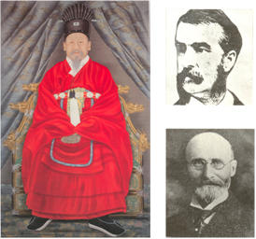

Fig. 1. Three major figures involved in electrification of Joseon: Gojong (left), American Minister Foote (upper right) and Dr. Allen (lower right).

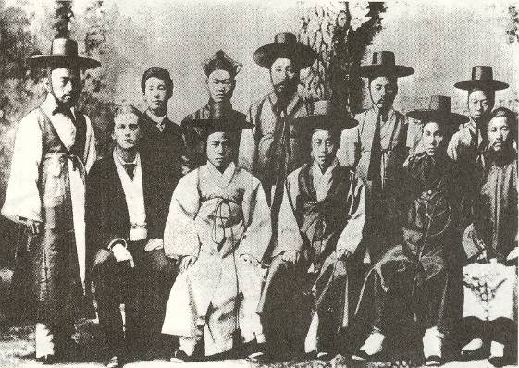

Fig. 2. Joseon Special Mission at New York on September 26, 1883.[55]

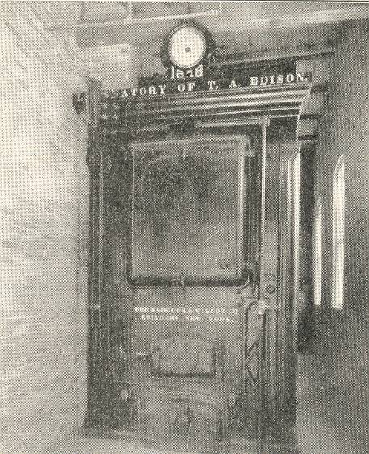

Fig. 3. Babcock and Wilcox boiler (restored boiler room, Dearborn, MI.

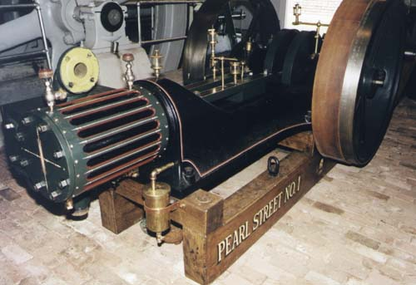

Fig. 4. Two-flywheel Armington & Sims engine. (By permission from NEWSM)

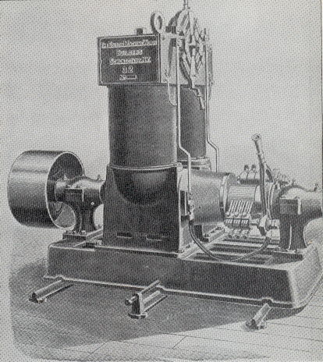

Fig. 5. Edison dynamo of 1886.

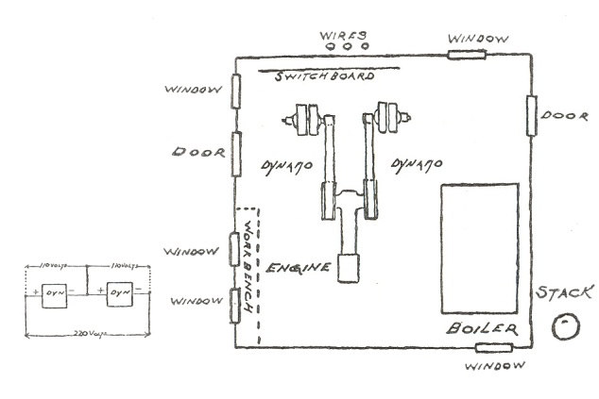

Fig. 6. Electric light plant installation arrangement and three-wire connection diagram– plan view (Redrawn based on Jehl.[56]

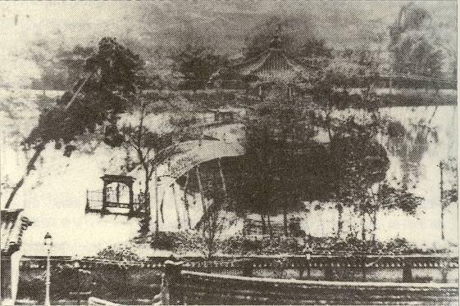

Fig. 7. A view from top of the Geoncheonggung toward lotus pond (O. N. Denny, 1887). The powerhouse was located next to the lower right pole.

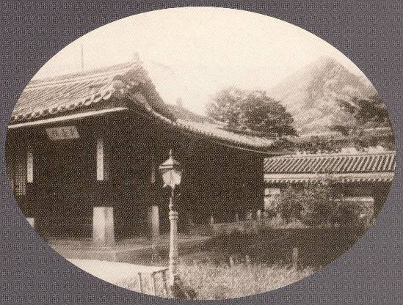

Fig. 8. Street-light in front of Queen’s residence. (Reprinted from Holms.)

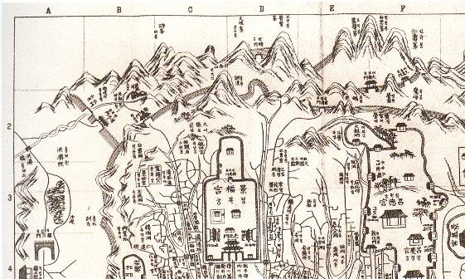

Fig. 9. Map of northern area of Seoul. The new plant (2-3-D-E) was erected in 1894 about halfway between Gyeongbokgung (3-C-D), where the first electric light plant was erected in 1887, and Changdeokgung (3-F).

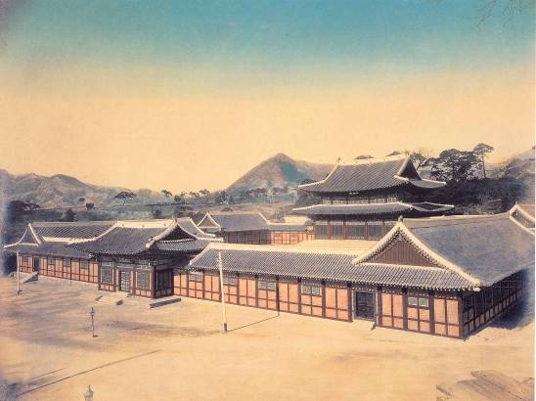

Fig. 10. Main Audience Hall, Changdeokgung after electrification.

**ACKNOWLEDGEMENTS**

The author wishes thanks to the Electricity Museum of Korea Electric Power Corporation (KEPCO); Jagyeongnoo Research Institute, Inc.; R. Merriam of the New England Wireless and Steam Museum (NEWSM) and Dr. P. Israel of Edison Papers for providing research materials.

**Moon-Hyon Nam** received a Ph.D. degree in Electrical Engineering from Yonsei University, Seoul, in 1975. He has been a professor in the Department of Electrical Engineering at Konkuk University, Seoul, since 1976. He is the founding director of the Research Center for the History of Technology at Konkuk University (1993), and founding President of the Korean Society for History of Technology and Industry (1999), and he served as an International Scholar for the Society for the History of Technology (SHOT). He is the author of several books. He is currently a member of the Cultural Heritage Committee at the Cultural Heritage Administration.

1. Geoncheonggung is a building completed in 1873 inside the Gyeongbokgung palace complex.
2. P. Lowell, *Choson: The Land of the Morning Calm* (Boston, MA: Ticknor and Company, 1886).
3. US Department of State, *Despatches from the United States Ministers to Korea* (hereinafter cited as *Korea Despatches*): No. 106: Legation of the United States, Seoul, Corea, Lucius H. Foote to F. T. Frelinghuysen, Secretary of States, Washington DC, September 4, 1884.
4. C-H. Youn, *Youn Chi-ho Ilgi* (A Diary of Youn Chi-ho), vol. 1, pp.244-245, Jan. 26, 1887; W-M. Kim, “Geoncheonggung McKay jeondeungsowa hankuk choechoui jeonkijeomdeung (1887) (in Korean) (“McKay Electric Light Plant in Geoncheonggung and first electric lighting in Korea, 1887),” in *Gaehwagi hanmi gyoseop gwangesa* (Negotiation relation history between Korea and U.S. in the Period of Enlightenment) (Seoul, Korea: Dankook Univ. Press, 1985), pp. 568-613.
5. R. Friedel and P. Israel, B. Finn, *Edison's Electric Light - Biography of an Invention* (New Brunswick, NJ: Rutgers Univ. Press, 1987), pp. 205-212; M-H. Nam, “Early History of Electrical Engineering in Korea: Edison and First Electric Lighting in the Kingdom of Corea,” presented at *IEEE Power Eng. Winter Meeting*, Singapore, Jan 23-26, 2000.
6. Gyeongbokgung palace was initially built in 1395 as the main palace of the Joseon dynasty.
7. H. N. Allen, *Korea: Fact and Fancy*, p. 9.
8. H. N. Allen, “Report on Electrical Matters in Korea,” October 26, 1893, *Despatches from United States Consuls in Seoul 1886-1906*, vol. 1, Washington, D.C.,: National Archives, Diplomatic Records, M167, (hereinafter cited as *U.S. Consul Despatches*).
9. *Collections of Joseon Korean Electric Business Matters Major Documents* (in Japanese) (Tokyo, Japan: Friendship Association, 1959) (hereinafter cited as *Collections of Major Documents*), vol. 1, pp. 48-49; *Hankukjeonki baeknyeonsa* (in Korean) (*One Hundred Years of Electricity in Korea* (hereinafter cited as *One Hundred Years*), 2 vols. and 1 vol. with plates (Seoul, Korea: KEPCO, 1989), vol. 1, pp. 83-84.
10. The Emperor Gojong invested capital in the company.
11. T-J. Yi, *Gojongsidaeui jaijomyeong* (in Korean) (*Rediscovering the King Gojong Period*)(Taehaksa, Seoul: 2000), pp. 307-85.
12. For example, “Theory of Electricity” *in New Encyclopedia* (Shanghai, 1854) by Benjamin Hobson (1810-1873); *Introduction to Science and Technology* by William Martin (1827-1916); *Hanesong Soonbo* (Ten-day Report Seoul), Nov. 30, 1883.
13. *One Hundred Years*, pp. 55-63.
14. Ibid. pp. 63-71.
15. *Despatches from United States Ministers to Korea, 1883-1895* (hereinafter cited as *Korea Despatches*), National Archives, Washington, DC: Diplomatic Records, M134, vol. 1, No. 14, “Foote to Frelinghuysen,” July 13, 1883.
16. *Korea Despatches*, vol. 1, Nos. 17, 21, 27, “Foote to Frelinghuysen.”, In G. M. McCune and J. A. Harrison, ed., *Korean-American Relations: Documents Pertaining To the Far Eastern Diplomacy of the United States,* vol. 1, The Initial Period, 1883-1886 (hereinafter cited as *Korean-American Relations*, I), Berkeley, Calif.: Univ. of Calif. Press, 1959, pp. 31-4.
17. C-W. Pyun, “1883 nyonui hankuksajeoldanui boston bangmungwa hanmi gwahakkisul gyoryuui baldan (in Korean)” (“The Visit of the Korean Mission to Boston in 1883 and the Beginning of Scientific and Technological Interactions between Korea and the United States (Korean with English Abstract and Summaries)” *Han’kuk Kwhaks-sa Hakhoe-Ji* (The Korean History of Science Society ), Vol.4, No. 1, pp. 3-25, Jan. 1982.
18. *New York Herald*, October 15, 1883.
19. Ibid.
20. *Korea Despatches*, vol. 1, no. 106, loc. cit.
21. Ibid., vol. 1, No.47, Mr. Lucius H. Foote to the Secretary of State, translation, January 14, 1884; Allen, *Korea: Fact and Fancy*, 165; Frazer served during 1884-1891, reappointed 1897.
22. *Korean-American Relations,* vol. I, pp. 32-35, no. 27, Frelinghuysen to Foote, October 16, 1883.
23. New York April 16, 1884. Foote, American Minister Corea, Edison requests exclusive concession of electric light (and) telephone in Corea, Frazer, In Everett Frazer Papers, Box 3, 1. Collected by The Public Library of New York City.
24. *Korea Despatches*, No. 106, loc. cit.: “Sir: On behalf of Mr. Thomas A. Edison I some time since applied for the exclusive right to place and operate electric lights and telephones in Corea; as the results of this together with the observations made by the Corean envoys while in the United States, an order has been to Mr. Edison to place his system of electric light within the palace. I have the honor to be, Sir, very respectfully, your obedient servant, Lucius H. Foote.”
25. *Diplomatic Instructions of the Department of State, 1801-1906: Korea,* vol. 1, Washington, D.C.,: National Archives, Diplomatic Records, M77, (hereafter cited as *Korea Instructions*), F. T. Frelinghuysen to L. H. Foote, November 5, 1884: “Sir: I have received your No. 106 of the 4th of September last, saying that an order had been given Mr. Thomas A. Edison to place his electric lights within the palace grounds and buildings at Seoul. I am Sir, your obedient servant. Fredk. T. Frelinghuysen.”
26. *One Hundred Years*, pp. 75-76, passim.
27. *Guhanguk Oegyomunseo (Diplomatic Documents of Late Joseon dynasty)* (Hereinafter cited as *Joseon Diplomatic Documents*): vol. 1, (U.S. document 1), p. 196, No. 273: “Invitation to purchase of electric light devices,” November 30, 1885.
28. Koreans called the electric light engineer the “electric light teacher” and the Americans referred to the position as “government electrician.”
29. *Joseon Diplomatic Documents*, vol. 1, p. 237, No. 340: “Reports and business communication,” August 3, 1886; *Korea Despatches*, vol. 4, W. W. Rockhill to Thomas F. Bayard, March 31, 1887.
30. *Collections of Major Documents,* pp. 48-49: Depending on the interview with former court lady Ahn, “…Western-style building erected by the western was located somewhere between the well for the King and Chuihyangkyo the bridge of lotus pond…”
31. It may be similar to Sunbury central station opened on July 4, 1883 by Edison himself, see F. Jehl, *Menlo Park Reminiscences*, vol. 3 (Dearborn, Mich.: Edison Institute, 1941), pp. 1089-1119.
32. *Despatches from the United States Minister to Korea*, vol. 1, 1883-1890, “Morse, Townsend Co. to Foulk,” November 4, 1886, pp. 550-555.
33. Allen, “Report on Electrical Matters in Korea.” loc. cit.
34. *Collections of Major Documents*, loc. cit.
35. R. Friedel, *et. al.* op. cit. p. 212; F. Jehl, op. cit., p. 1098.
36. The New England Wireless and Steam Museum (NEWSM), Inc. at 1300 Frenchtown Road, East Greenwich, RI, Robert W. Merriam, Director.
37. *Brief Instructions for Operating Edison Dynamos in Central Station* (New York City: Edison Electric Light Co., 1886).
38. Allen, op. cit.
39. *Collections of Major Documents*, loc. cit., passim.
40. *Asahi Shinbun*, Jan. 16. 1887.
41. Harrison, NJ, April 18, 1887. “Dear Mr. Edison ….We shall not loose in the end I think as we shall have a first-class plant and this with the one in the Mikado Palace in Japan will be only first-class plants in the East. … Francis R. Upton.”
42. *Joseon Diplomatic Documents*, vol. 1, no. 402, p. 278 ; Allen, “Report on Electrical Matters in Korea.” loc. cit.
43. Allen, *Korea: Fact and Fancy,* p. 176 ; *Joseon Diplomatic Documents*, vol. 1, no. 394, pp. 271-272, March 17, 1887 and ibid*.* pp. 272-273, no. 396; *Korea Despatches,* vol. 4, no. 72, W.W. Rockhill to Thomas F. Bayard, March 31, 1887.
44. 1880 Census Information enumerated on the 12th day of June, 1880.
45. *Joseon Diplomatic Documents,* vol. 13 (U.K. document 1), p. 243, no. 444, translation, “United invitation of electrical teachers,” September 1, 1887; Workshop Office of the Department of Interior was in charge of the powerhouse management and light teacher invitation.
46. *Joseon Diplomatic Documents*, vol. 1, p. 292, no. 535, September 26, 1888; p. 294, no. 538, October 1, 1888; p. 295, no. 539, October 1, 1888.
47. By the appointment letter to Payne on August 3, 1889, salary was 250 Mexican dollars and in addition to the salary 500 dollars will be paid to Frazer Company in Yokohama via Bank of Japan after expiration of the contract.
48. *U.S. Consul Dispatches*, vol. 1, no. 36: Acting Minister and Consul General to Korea Augustine Heard to Assistant Secretary of State, December 31, 1892.
49. *Gojong sillok* (Veritable Records King Gojong): vol. 24, March 29, 1887; vol. 26, October 7, 1887, passim.
50. *Joseon Diplomatic Documents,* vol. 10 (U.S. document 1), p. 754-759, no. 1123. English with translation, “Request of payment of electric light equipment by Townsend,” July 5, 1893; no. 1124, “Reply to the request,” July 6, 1893; no. 1125, “A collection letter on the Townsend’s request to the electric light equipment payment,” July 10, 1893; no. 1127, “Announcement whether report to the U.S. government on the claims of Townsend,” July 12, 1893; “Reply to the announcement,” July 13, 1893.
51. Allen, “Report on Electrical Matters in Korea,” loc. cit.
52. Ibid.; *Korean-American Relations*, vol. 1, Legation of the United States, Seoul Korea April 5, 1894, no. 549, Secretary of State, Sir: Replying to your No. 202 of Nov. 20, I regret to say that it is impossible to make clear to the Koreans, the matter of electrical measurements. A considerable course in electrical education will be necessary before the matter can be apprehended. H. N. Allen.
53. *Joseon Diplomatic Documents,* vol. 11 (US document 2), pp. 23-26, no. 1239, English with translation, “Return of electric light teacher Power to America and his salary payment,” May 4, 1894; No. 1240, “Request to persuade Power to remain his plant,” May 9, 1894; no. 1241, “Reply to the former request,” May 9, 1894; pp. 39-40, no. 1260, “Re-contract of Power,” July 13, 1894; p. 42, “Request of Power’s salary and return expenses,” July 20, 1894; pp. 75-76, “Payment of Power’s salary and return expenses,” January 1895.
54. T-J. Yi, op. cit; Y-H. Kim, “Establishment of the Seoul Electric Company, 1897-1905 (Korean with English abstract).” *Han’guk Kwahak-sa Hakhoe-ji* (Journal of Korean History of Science Society), vol. 19 (1997), no. 2, pp. 87-121.
55. *Notes from the Korean Legation in the United States to the Department of State, 1883-1906*, Diplomatic Records, National Archives, Washington, D.C.: M166, Percival Lowell to the Secretary of State, September 30, 1883, “Chosunese Special Mission.”
56. F. Jehl, op. cit., p. 1099.