The Birth of Korea’s Advertising Industry
and My Role in It

John Stickler

Chiang Kai Shek smiled at me across the conference room and said something to his interpreter seated next to him. The interpreter grinned and translated for me. “Funny,” he said. “You don’t look Korean.” The other delegates to the Fifth Asian Advertising Congress, seated around the square room, chuckled and waited for my response.
It was November 1966 and we were gathered on the top floor of the imposing governmental building in downtown Taipei, in a modern equivalent of a Chinese royal audience hall. I was a delegate to this bi-annual advertising conference but, as the only one from Korea, I’d become by default the chief delegate representing the entire country. Considering that I’d only launched my fledgling advertising agency in Seoul a few months before, this was a great leap forward. The fourteen personages seated around the room with me, each one representing a different nation, were leaders in the advertising and publishing industries worldwide.
They appeared to listen attentively as I told President Chiang that advertising was a new field in Korea and that I was one of the pioneers in Seoul. I said that Koreans were impressed by the export progress demonstrated by Taiwan and Hong Kong and with modern marketing methods we would strive to follow their example. (South Korea’s exports in 1965 were under US$200 million—about half of Taiwan’s and one-sixth of Hong Kong’s.)
As the meeting ended, a photographer was brought in and we each had our picture taken shaking hands with the Generalissimo [reproduced at the end of the article]. If I’d known then what a tyrant he was, both in Taiwan and on the mainland, I wouldn’t have been so obsequious. We then assembled for a formal group portrait.

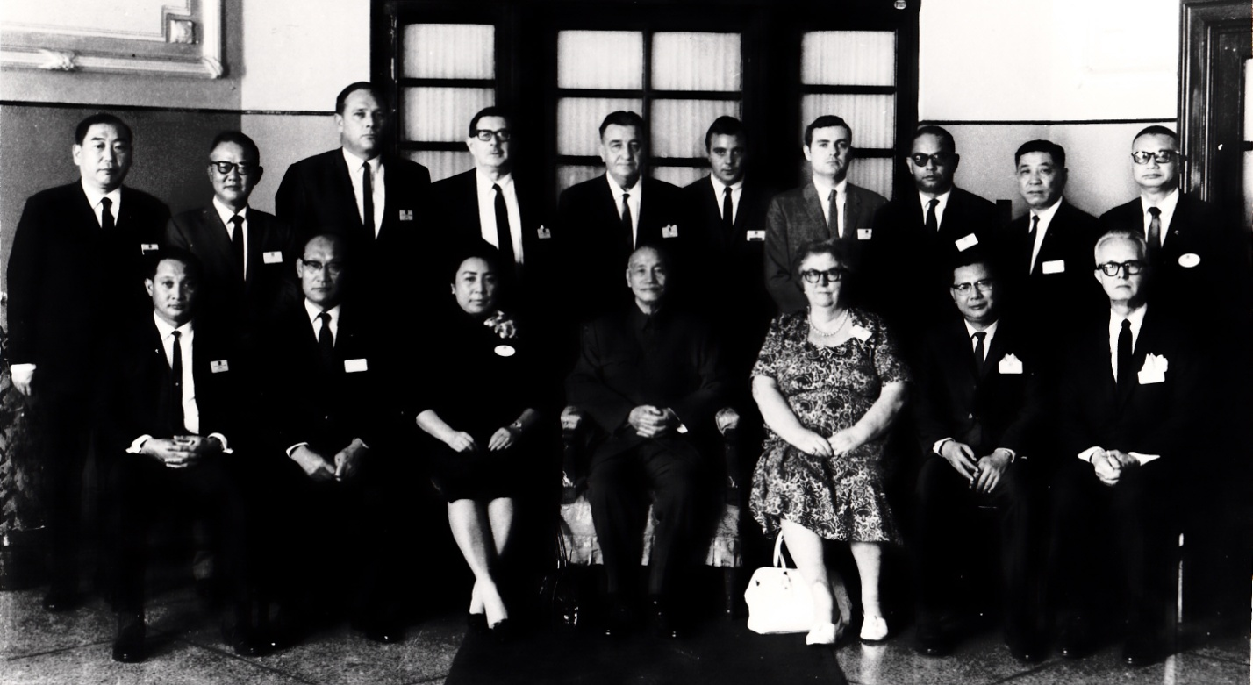

As reported by the local China Post, this conference was a significant event with total attendance exceeding five hundred. Heavyweights in the media world foresaw the significant role Asia, particularly East Asia, would play in the growth of the advertising industry and consequently international trade. Keynote speakers included James A. Linen, president of Time Inc., and L. Lew Callaway, Jr., publisher of Newsweek. Both were hosting luncheons for the entire assembly.
It wasn’t until after checking into my hotel that I’d been advised I was the sole delegate from Korea and that involved playing a part in the opening ceremonies the following morning. The chief delegates were to line up in alphabetical order and march into the auditorium, each of us led by a Taiwanese Boy Scout carrying the flag of our nation and a Girl Scout with a placard naming the country. Then, instead of joining the audience, we were seated in a row facing the audience, just beneath the stage, behind the placard of our nation. I was relieved that we weren’t expected to address the assembly.
The next morning, wearing a suit that I’d luckily brought with me, I joined the line and followed the prestigious march into the auditorium behind the South Korean flag. A band struck up some martial music and the attendees all stood as we entered the hall. The flag-bearers lined up in back of us and I took my seat behind the South Korea place card, trying to look as official as a baby-faced, 29-year-old American could. Seated next to me behind the Japan sign was Tsueji Hibino, president of Dentsu Advertising, at the time the largest advertising agency in the world. I was representing the smallest.
The key sponsor of the conference was the International Advertising Association, a worldwide organization based in New York City. I met their delegates attending the event and discussed the possibility of establishing an IAA chapter in South Korea.
On my way back to Seoul I realized that I’d been handed an unexpected opportunity to publicize my new business, S/K Associates Advertising, as well as to promote international advertising as an important component of export marketing. After doffing his ROK Army uniform, Park Chung Hee had been elected president just three years before and was hard at work on his first Five-Year Plan, to include full government support of international trade.
Armed with the press packet provided to each chief delegate, mostly 8x10 glossies of me playing my role, I introduced myself to some Seoul business reporters. Several publications picked up the story. I was never contacted by the Park administration, but I suspect that my little PR splash was noticed because of two things which subsequently did not happen. The photo of me marching down the auditorium aisle behind the Korean flag was never returned to me after it was published in the Seoul Kyungje Shinmun. And two years later, in 1968, when I attended the Sixth Asian Advertising Congress convened in Singapore, I was not alone. Korea fielded a full delegation and, moreover, in a brief ceremony we received the charter of the International Advertising Association Korea Chapter.
(In 1982, on a plane flying back to Korea from the US, I noticed a small news item in the Asian Wall Street Journal. It reported that Hong Kong had just received its charter for an IAA chapter. “Ha!” I thought, “We beat you by fourteen years!”)

The Early Years
In February 1964 I had taken my discharge from the US Army Korea Military Advisory Group, 8th Army Headquarters on the Yongsan compound in Seoul. I walked out of those gates jubilant at my new-found freedom but with no job, no prospects and no Korean language skills. Knocking on doors, I met Karl Bruce, another US Army alumnus living “on the economy.” Karl was tall and lean with dark hair and a black beard. He ran a translation service upstairs in a building near the US Embassy and the USIS. He looked very much like the oft-published photo of D. H. Lawrence. But I didn’t speak Korean and he wasn’t hiring.
Shortly after my call on him, he had been visited by another American, Mike O’Sammon, who was pulling out of Korea and selling his ad agency. Karl still had my resume on his desk, mentioning my advertising experience prior to being drafted, and thought maybe I could be of use. The Impact Advertising Agency, offered for sale at $100, had two assets: an Olivetti portable typewriter and the Northwest Orient Airlines account. Karl bought it, hired me on a part-time basis, and together we set out to develop Korea’s first ad agency from scratch.
We built Impact Advertising until the end of 1965, when we amicably split the company. Karl took the incoming dollar business and I took the outgoing won business, representing two specialized trade publications: The Importer (later Asian Sources) and Pacific Travel News. Soon we became friendly rivals for new accounts as foreign businesses ventured into Seoul. I got the first foreign bank to open, Chase Manhattan, then SAS and Thai International Airlines, and the American Airlines’ Chosun Hotel. Karl picked up Caltex and Japan Air Lines.
It never occurred to us at the time, but we were starting at “square one” of what is now known as Korea’s “economic miracle.” In the early 1960s South Korea’s exports were primitive: iron ore, fish and seaweed, dry grasses for grasscloth wallpaper, and “Korean field mink” furs which were actually mouse skins stitched together. Manufacturing gradually gained traction: hand-knitted sweaters were upgraded to machine-knit sweaters and exported by ship for $10 per dozen.
Both the magazines I represented were low circulation, and thus low cost, targeted to the particular industry. Korea was not yet ready for consumer advertising. Pacific Travel News went only to people active in the travel industry around the Pacific Rim: airline personnel, travel agents, hotel chain administrators, etc., all active members of the Pacific Area Travel Association. Many of them were in a position to send business to Korea. Once a year I contributed an editorial feature on the developments in Korea’s infant tourism industry.
The Importer, headquartered in Tokyo, had been founded by Ray Woodside, an early graduate of the Thunderbird School of International Management in Phoenix, Arizona. With in-depth news reports on consumer products being manufactured in East Asia, combined with advertisements from those producers, it circulated only to actual importers, their names and addresses having been laboriously culled from export cargo manifests in Japanese and other Asian ports.
The Importer was unusual in that its circulation was both paid and controlled, i.e., you could not purchase a subscription unless you were an actual buyer. A US library, for example, could not subscribe. This was done to protect naive Asian advertisers who might end up sending out free samples of their products to self-described “importers.”
When Ray died in 1970, his three American managers, also Thunderbird grads, could not reach an agreement with his Japanese heirs to continue the publication. They relocated to Hong Kong and launched a competing magazine with the same business model. They called it Asian Sources. I stayed with the Americans, who had become close friends, and continued selling, designing and writing advertisements for up-and-coming Korean entrepreneurs.

Advertising in Korea
Advertising in Korea at that time was not a noble profession. In fact, the term kwango-jengi was a pejorative, down there with butchers and mudangs. I learned not to hire sales people who had any prior experience selling ads because traditionally it was done with kickbacks. “Advertise in my magazine and I’ll buy you a new suit.” I had to turn the custom on its head. “Listen,” I’d explain to the new salesman. “They are not helping you by buying an ad. You are helping them by bringing buyers through the door.” It took a while for this to sink in, but as the mail brought serious inquiries, followed by hard-currency sales, the message got through. Soon we had convincing testimonials as to the real benefits of international export advertising.
Fortunately, the timing was perfect. In the 1960s and ‘70s Western importers realized that Japanese products were gradually becoming more expensive and they knew that Hong Kong and Taiwan could offer lower prices. The level of curiosity about Korea’s prospective role in the export world was such that when a Korean advertisement appeared next to those from other Asian countries, it would generate a number of serious requests for samples and pricing.
Generally, we didn’t keep in touch with our advertisers after their initial ad placement. They hooked up with buyers and didn’t need us anymore. We were a matchmaking service. One early Importer advertiser was an exception. A young man showed up who had inherited an old-fashioned brass-casting factory from his father. Using some Koryo dynasty technique, they sand-cast small items like ashtrays, bamboo pipe bowls and knickknacks. As I put together a one-third page ad cluttered with little color photos I wondered, “Who on earth would be interested in this stuff?”
But he was one of our first clients and we needed the business. Plus, he had the vision to realize that the world was his market and felt the urge to reach out. He ran his minimum of three monthly ads and we didn’t see him again. Several years went by. In 1970 we moved from our low-rent Myongdong office into the new Chosun Hotel. One day the young man returned, just to thank us for making his dream come true. This time he was wearing a nice tailored suit and I noticed he now had a car and driver.
His ad with the brass pipe bowls had caught the attention of a manufacturer in Illinois. The American buyer had no interest in knickknacks, but did need someone who could produce small metal objects, specifically cake icing decorator tips. The company was named Wilton Industries. The young man proved that he could produce what they needed and a major investment followed. He was now running a profitable business and doing very well, thank you.
(Not long ago I had occasion to buy a cake decorator tip and recognized the name Wilton. I checked the package—remember, this is 40 years later—and sure enough, it read “Made in Korea.”)
Maybe not all the stories are as dramatic as that, but I know we helped many start-ups on the road to international trade.
It wasn’t so easy for everyone. I made my presentation to one manufacturer. He looked at the magazine, studied the ads, and told me frankly, “Most of my output goes to one buyer in Japan. He retail packs my goods, exports them to the West, and makes a nice profit on my work. Would I like to bypass him and reach those buyers directly? You know I would. But if my Japanese buyer ever saw my ad in your magazine”—here he drew his fingers across his throat—“I’d be finished.”

Marketing Missionary
I called myself a marketing missionary, spreading the word about the efficacy of targeted media marketing. Traditionally, a Korean manufacturer would get permission from the government to make a trip to Europe or the US and receive some hard currency to cover the expense. (All dollars in the country at that time, by law, belonged to the government and were required to be exchanged for won. Even as an American, the rule applied to me.)
An overseas trip cost thousands of dollars and a CEO or salesman could visit maybe ten or twenty prospects. This put the cost-per-prospect in the hundreds of dollars. I met a maker of men’s dress shirts, “wy-shirsa” they were called. Each month he would send out ten sample shirts to companies he identified from directories available in the US Embassy commercial library. He said each shirt cost him $6 to mail. My pitch was that with an advertisement in Asian Sources he could display his product to hundreds if not thousands of prospects for pennies apiece. Plus, when an inquiry came in he was dealing with someone already interested in his product, not a “cold call.”
The Korean government never advertised itself, except through its commercial enterprises. Korean Air Lines was originally owned by the government and naturally it had to advertise. Before Walker Hill was privatized, it was government-owned and must have run some ads somewhere. (I was the first guest the night it opened to the swinging music of Louis Armstrong and wrote the first of many travel articles about Korea.) I’m not sure either of them placed ads overseas, however.
There was one exception of which I am aware. One year in the 1960s the New York Times published a four-page section paid for by North Korea. Somehow I obtained a copy and was appalled by the wretched design. If ever a self-promotion piece backfired, this had to be a prime example. The front page had one B&W photo, a shot of Kim Il Sung right in the center above the fold. The caption read, “Our Glorious Leader Kim Il Sung.” The rest of the page was dull grey type, too small to read comfortably. The whole package fairly shouted, “Totalitarian state!”
Let the Communist regime embarrass itself. What was totally disconcerting was when the South Korean government responded with an exact duplicate—a B&W shot of Park Chung Hee right in the center above the fold. The caption didn’t read “Our Glorious Leader,” but it might as well have. In 1973 I was involved in South Korea’s first full-color, tabloid section in the New York Times. It featured a lovely model wearing a blue satin hanbok on the cover and my full-page ad for the Korean Traders Association on the back.
Of course I didn’t launch Korea’s advertising industry. A thriving domestic advertising business existed before I strode out of the Yongsan compound in 1964. The Seoul newspapers were filled with display ads, primarily for pharmaceuticals and movie theaters as I recall, many of them quite artistically designed. At the same time, some companies in Seoul did not make the connection between advertising and the consumer, or business-to-business, sales. In December one would see “tombstone” ads in the papers containing Christmas greetings from major local corporations. I realized that these corporate types viewed print ads only as a way of thanking their loyal customers rather than stimulating more business; an oblique method of marketing at best.
My role was to assist in the introduction of overseas media into the marketing mix for export and tourism development. The Park government facilitated this by making the allocation of hard currency available, with a simple application to the central bank, for payment of ads placed in appropriate international publications. Never was one of our applications turned down, although on several occasions devaluation of the won resulted in the publisher receiving less than the dollar amount originally billed.

Competence Level
Around 1973 I realized that I had reached the ceiling of my competence. Although Karl Bruce and I were more knowledgeable about this market than anyone outside of Seoul, it was clear that if I were to advance to the next level I needed professional support. We had been using the written works of David Ogilvy, the British advertising guru, for guidance and to educate our Korean prospects. My mentor, Shin In Sup, even translated a key chapter of Ogilvy’s best-selling book, Confessions of an Advertising Man, into Korean for an S/K handout. So I corresponded with Ogilvy & Mather in New York and was pleased to receive a positive response.
They paid the way for a young American entrepreneur in Kuala Lumpur to visit me in Seoul. He had accomplished with Ogilvy & Mather exactly what I was trying to do, entice them into his market and to merge with his business. He brought with him O&M’s primary marketing tool, a set of video-and-slide presentations called “Magic Lanterns.” They were divided into industries. I recall the ones on tourism and banking, presenting the most successful television commercials and print ads in O&M’s impressive experience. The caveat was that unless I could land a major account making it worthwhile for O&M to join forces with me in Korea, they would not be interested in this market.
The following year was spent setting up meetings with industry groups in Seoul for presentations of the relevant Magic Lantern. I must credit our energetic creative director Kim Byong Sob for doing all the legwork. The bankers enjoyed the show but clearly felt that no Brit from New York was going to tell them how to sell credit cards or savings accounts to Koreans.
The tourism sector was much more receptive. The problem was that those travel enterprises which could benefit from an international campaign were much too small to afford the services of Ogilvy & Mather, with two exceptions: the Korean government and Korean Air Lines. The Korean government, in the form of the Korea National Tourism Corporation, was too stingy to buy one ad, let alone a campaign (see below). But KAL, already active around the world (I had been invited on their inaugural flight from Seoul to Paris), was a viable prospect. And to my surprise and delight, they went for it.
The prospects were exciting. O&M would assume the marketing activities for KAL in the Far East as soon as KAL’s contract with its Hong Kong ad agency expired. The current budget there was in the neighborhood of $3-4 million. Subsequently, similar exchanges would be completed in Europe, Australia, and finally North America. Ultimately, the combined worldwide annual budget, all with O&M offices, could approach $20 million. My imagination soared. What role would I play in this planet-encompassing enterprise?
To cement the deal, a self-important young British O&M vice president flew in to Seoul for meetings with KAL. I did not sit in on the contract signing, but our team wined and dined him and made sure he understood S/K’s critical role in acquiring this account for Ogilvy & Mather.
Before leaving, the VP and I sat down for a nuts-and-bolts talk. “Here’s how it is going to work,” he said. “KAL doesn’t need help in Korea with its Korean customers. They know they can handle the local market better than we can. Our value is throughout the rest of the world. Therefore Ogilvy has no incentive to come into Korea. I’m sorry to say we won’t be joining forces with S/K,” he went on, “but we do appreciate your hard work on our behalf over the past year. We estimate that a finder’s fee for this account is worth $40,000. You mentioned that you are the Time magazine advertising representative for Korea and we plan to be using the Asian edition of Time extensively. Your commission on our KAL placements over the coming year will reach right around $40,000.” Apparently they had already presented KAL with a full media plan.
My merger dream was crushed, but the $40,000 promise was a nice consolation.

The White Paper
The other hurdle to inviting Olgilvy & Mather into Korea was the existing foreign exchange restriction. Not only were foreign investors expected to create jobs (a multi-million-dollar Gillette razor blade factory was rejected on the grounds that it was fully automated) but also limited on repatriating foreign exchange. Hard currency was still very precious. Service companies were not yet approved for foreign investment based on these parameters. Holiday Inn, Hilton and Intercontinental had been turned away in the early ‘70s for the same reason.
This was explained to me by one of the higher-ranked officials in the Economic Planning Board when I enquired prior to the KAL success, but he was open-minded. “The current regulations would have to be revised. If you wish this idea to be considered, why don’t you write a white paper explaining how Korea could benefit from the activities of an advertising agency here? We will distribute it through the Economic Planning Board and consider your recommendations.” He could not have asked for a more motivated, or prepared, scribe.
The completed report covered six sectors where the Korean government had failed in its marketing objectives: tourism, trade, banking, foreign investment, construction and politics. It was twenty pages long and contained one four-color illustration. I pulled no punches. Painful examples were plentiful.
The paper opened with a brief overview of South Korea’s waning international image (thanks to President Park’s increasingly tyrannical behavior) and stressed one of the basic principles of public relations: negative impressions, political in this case, cannot be overcome by rebuttals, which serve only to draw more attention to the original negative impression. Negative images must be overcome, outweighed by positive input, by good news from the other five sectors.
The first category where I urged reinforcement was tourism. After a page of analysis of Korea’s weak efforts to attract international visitors, I presented one case in which I had been personally involved: promotion of the 25th anniversary of the outbreak of the Korean War:

As a typical example of the failure of Korea’s tourism program, let’s look at the Korea Service Veterans Re-Visit Program. Planned by the government early in 1974, the program to invite American and other veterans who had served in Korea, was a brilliant idea and offered a wonderful three-fold benefit:
- Some 25,000 veterans and dependents would visit Korea and spend money here. An average of $1,000 each would mean net foreign exchange earnings of $25 million.
- Each visitor who leaves Korea after an exciting experience, as these veterans do, becomes a valuable salesman for future Korean tourism.
- The media publicity generated by these newsworthy visits, in foreign newspapers and magazines, is priceless PR for Korea, in both the tourism and political categories.

The groundwork for the Veterans Re-Visit Program was carefully done. Brochures were printed. The hotel and airline arrangements were completed. The Korean Veterans Association set up a schedule of receptions and tours for the visitors. And a tour wholesaler was appointed in Los Angeles to process the applications as they came in.
However, virtually no advertising was scheduled. It was as if a big party were planned, the food prepared, the transportation arranged, musicians and photographers standing by, but no invitations sent out.
By January of 1975 it became obvious that the target of 25,000 was too ambitious, so it was adjusted downward to 10,000. In February and March two ads were run in the AMVETS newspaper, the weakest of America’s four veteran’s publications. No travel trade ads were run to alert travel agents of the program and no consumer ads were run to announce the invitation to veterans.
By any measure, the program has been a failure. During the first six months, not once did KAL collect 77 veterans together in Los Angeles to qualify for the lowest group fare of $630. The worst loss of face occurred on June 25th, the 25th anniversary of the North Korean attack; not one group of veterans was here to observe the occasion!

Not mentioned in the text was the fact that I had been requested by the Korea National Tourism Corporation to prepare a budget and a print media advertising schedule for this Re-Visit program a year in advance. I knew they were reluctant spenders so I had kept the cost down to some US$30,000 for trade, military and consumer advertisements in US publications.
The paper continued with similar examples of major disappointments in the other fields. The foreign trade case study was another from my personal experience:

One of Korea’s most successful manufacturers of electronic products is the Peninsula Electronics Company. Few people outside of the Korea Electronics Exporters Association have ever heard of it. The president of that company, Kang Bong Sik, set an unmatched record when he sold US$1 million in clock-radios during his first six months of operation. His competitors in Korea were stunned at this achievement, but President Kang maintains that his sales are easy. He employed two tactics very unusual for Korea: he insisted on producing a top-quality product from the outset, and he advertised his product in an international trade journal.
Furthermore, his remarkable sales record was established without anyone from his company traveling overseas.
However, the unfortunate part of Peninsula’s success story is that his beautiful clock-radio, which sold so well, bears a Japanese name. No, there is no Japanese partner in the company. On the contrary, the buyer is a German firm and they feel that their customers, the German consumers, will have more confidence in the product if it bears a Japanese label.
The brand name Sanwa is clearly evident in the attached copy of the four-color advertisement run in Asian Sources Electronics magazine.

That had to sting. The final two pages of the report mentioned the “most obvious selling points Korea has to offer, without contradiction, are its tourism attractions, its high-interest dollar deposit program, its dynamic international construction companies, its unique investment opportunities, and its high-quality export products.” In closing, I offered my recommendations:

There are three steps that the Korean government can take to begin to benefit immediately from the power of strong advertising. These are:
- Private industry must be encouraged to begin advertising their products and services in the international markets. This can be done with tax incentives, allocation of dollars for the purpose of advertising overseas, or other means, just as the setting up of overseas branches is now encouraged.
- The government must begin to promote its own programs, such as tourism, investment and banking. Exports and construction could also be supported by the investment of government funds into “corporate-type” advertising campaigns. Naturally, these ads should be focused in those media which are read by influential business and government leaders.
- One or more leading international advertising agencies, with strong worldwide networks and good media connections, should be invited to open offices in Seoul to serve the leading Korean industries. Given substantial budgets and a free hand, these creative specialists can make rapid progress in shaping Korea’s international image, not with propaganda, but with truthful, hard-hitting sales messages.

Obviously, “C” was an effort to smooth the way for Ogilvy & Mather to make an entree into Korea. “B” was a subtle endorsement of The Financial Times of London, for which I was then the Korea sales representative.
At my expense, fifty copies of the report were printed and distributed across Seoul, not only to the Economic Planning Board but to the offices of all the players mentioned. I heard that copies even went to the ROK CIA and the Blue House. I never received a single response.
Not long after Ogilvy & Mather signed their agreement with Korean Air Lines, I received a phone call from Tokyo. It was Charles D’Honeau, Far East sales director for Time magazine. He had appointed me advertising representative for Korea the year before and had published a full page ad we submitted for the Korea-made Ford Cortina in his new South Korea edition. If he hadn’t yet received the KAL insertion order from O&M in Hong Kong, he was fully aware of it. This was about my $40,000 payoff.
“John,” he said, “we have discussed the rep commission on this contract and I’m sorry to tell you it has to go to Mr. Lee.” Mr. Lee was the distributor for both Time and Newsweek (until Newsweek discovered this heinous split loyalty) who made sure the weekly issues cleared customs and were delivered to the local newsstands.
“But I’m your Korea rep!” I exclaimed. “I made the deal for Ogilvy!”
“Actually, you are our representative for foreign firms. Mr. Lee is responsible for Korean companies,” D’Honeau explained. This was news to me and totally unfair. My protestations were in vain and Mr. Lee enjoyed a generous unearned windfall.
The following year, in the summer of 1976, I turned S/K International Advertising Corporation over to my brother-in-law, Han Sang Suk, and relocated back to California with my family to start a new life.

Postscript
Within a year of settling down in Walnut Creek, California I received a call from a man I didn’t really recall. Mr. Kim remembered me, however, and my missionary work in Korea. He had a message for me.
“Mr. Stickler, I’m the ad representative for Fortune magazine in Seoul and I’m calling from San Francisco on my way back from New York City. I have just finished putting together the first Korea advertising section in Fortune. It cost $80,000.” He told me how many pages it was and how many ads he had sold. After my years fighting for $200 ads, that was impressive. “You know President Park holds a monthly meeting with the top business leaders in the country? Well, not long ago he told them all to start advertising in major publications. I just wanted to let you know I feel you left Korea a little too early. If you had hung on for one more year . . .” I congratulated him on his good fortune and wished him well in the future.

The first volunteer from Arizona to be selected by the US Peace Corps in 1961, John Stickler completed the seven-week training program for Philippines I at Penn State University. However, his draft board blocked his departure for Manila and conscripted him instead into the US Army. In 1963, as Private First Class, he was stationed in Korea for twelve months. Taking his discharge in Seoul early in 1964, he stayed on for twelve more years, founding his own advertising agency and reporting the news for the CBS Radio Network from 1967 to 1976. He and his wife, fine artist Soma Han, have published two children’s picture books on Korea: the prizewinning Land of Morning Calm: Korean Culture Then and Now (Shen’s, 2003) and a folktale, Maya and the Turtle (Tuttle, 2012).

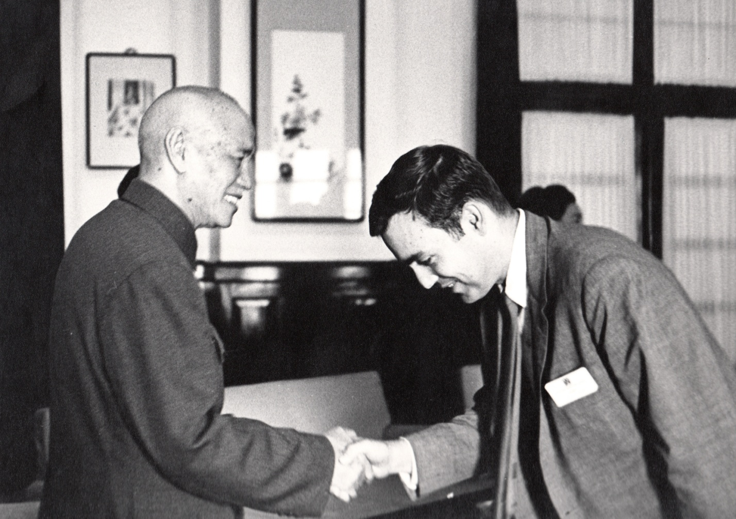

China Post, November, Nov. 5, 1966 p.4.
Seoul Kyungje Shinmun, Nov. 17, 1966, p. 4.
John Stickler, “Korea’s Sinless Tourist Lure,” San Francisco Chronicle, Sept. 1, 1963.
New York Times, special section, Nov. 4, 1973.
David Ogilvy, Confessions of an Advertising Man (Atheneum, 1963).

