Czechoslovakia

in the Neutral Nations Supervisory Commission

Personal memoirs and experiences of the first Czech and Slovak soldiers and diplomats on the Korean peninsula [1]*

Alex Švamberk

Czechoslovakia played an important role after the Korean War to help keep the truce on the Korean peninsula and to fulfill the Korean Armistice Agreement. Czechoslovakia was one of four countries in the Neutral Nations Supervisory Commission (NNSC), which ensured that both sides would respect the ceasefire terms. It continued to monitor the ceasefire until 1993, when it was forced to leave its post by the DPRK. This ended uninterrupted presence of Czech and Slovak members in NNSC, which – though with little publicity home and abroad – lasted almost 40 years.

This study will trace the experiences of the first Czechs who served with NNSC and shortly existing Neutral Nations Repatriation Commission (NNRC) in their early years, from the spring of 1953 into 1956, the period that covers the first two Czechoslovak deployments to the Korean peninsula.

In 1953, when the fighting in Korea ceased, both warring parties proposed two representatives to the newly established NNSC. The United Nations Command (UNC), under US leadership, chose Switzerland and Sweden; while the Korean People’s Army (KPA) (of the Democratic People’s Republic of Korea. DPRK) and the Chinese People’s Volunteers Army (PVA) selected Czechoslovakia and Poland. The same four countries, under the chairmanship of India, participated in the Neutral Nations Repatriation Commission (NNRC). Its duty was to guarantee the right of the prisoners of war to freely decide whether they would return in their homelands or stay in the countries in which they already had been interned.

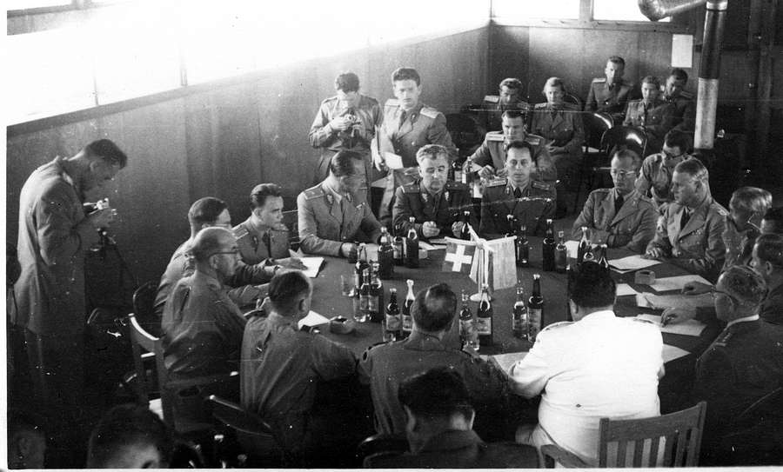

The Commission at work (FAB)

Both Commissions had a very important role: to supervise the withdrawal and exchange of soldiers as well as the removal and exchange of armaments and army materials in ten ports of entry created in accordance with the armistice agreement. Five – Manpo, Sinanju (now Anju), Chongjin, Sinuiju, and Hungnam – lay in North; and five – Daegu, Incheon, Busan, Gunsan, and Gangneung – were in the South. In each was a Neutral Nations’ Inspection Team with members from all four countries. Members counted departing United Nations soldiers and Chinese volunteers along with their weapons. They checked the exchange of arms to be sure that the warring sides had not replaced any with more modern weapons and inspected supplies so that neither side attempted to conceal arms in them. They not only carried out routine checks but also investigated claims about infringements of the armistice agreement. Mobile inspection teams a. o. visited North Korean airports, where they searched for secretly imported MiG fighters. They also investigated reports of a dogfight over North Korea and other breaches of airspace on one or the other side.

The NNSC originally was to carry out its work for a few months or at most a few years until North and South Korea had signed a peace agreement, but it still exists sixty years after the war. Several hundred Czechoslovaks were members of the NNSC over time, most of them in the early years, when amount of work was much greater. The largest deployment was the first, which had 300 participants. The tasks and size of the commission changed as majority of foreign soldiers left the Korean peninsula. When the commission started on 1 August 1953, it had ten Neutral Nations’ Inspection Teams (NNIT), one in every port of entry, and ten Mobile Inspection Teams. In each team were deputies of the four participating countries. In September 1955, reductions in the number of ports from ten to six meant that there were only three inspection teams on each side of the demilitarized zone. Then, each team had only one country that represented the North and the South instead of all four countries. On 9 June 1956, another reduction to the commission left only 14 members from each country. The inspection teams ceased to function, and the NNSC only studied materials it received from the Military Armistice Commission (MAC). The next reduction in 1960 left only nine members from each country, and the reduction in 1978 resulted in only six members and as of now, there are only two members from each from the remaining two countries (Sweden and Switzerland) permanently residing in the DMZ.

The NNSC gained a great deal of international respect. It was an honor for Czechoslovakia to participate in the work of the commission because it was a multinational body that the international community and the United Nations accepted. Czechoslovakia and Poland sometimes faced criticism that they were not genuinely neutral, like Sweden or Switzerland, and even that they served as the extended hand of Moscow. It is important to understand, however, that neutrality meant nothing more than the fact that the selected country had not fought in the Korean War. The United Nations itself was partial since the UN Security Council had agreed to send international forces to the Korean peninsula to help the South to repulse the North Korean invasion. In the NNSC, Czechoslovakia and Poland defended primarily the interests of the North Koreans and Chinese volunteers, and in many respects, in the similar way the Swiss and Swedish members stood up for Americans, that is, the United Nations Command.

**Establishing the Commissions**

In the first weeks of 1952, during the long negotiations to establish a truce in Korea, the diplomats finally accepted the four countries, including Czechoslovakia, which would participate in overseeing the ceasefire. During the negotiations both sides made big concessions. The Americans agreed that North Korea could have a contested military airport. North Korea and China abandoned the idea that the Soviet Union was to be one of the observers of the ceasefire and instead nominated Czechoslovakia and Poland. Simultaneously, the UNC chose Switzerland and Sweden to be on the NNSC.

In April 1952, the Czechoslovak authorities began to prepare a special group they were to deploy in Korea. The army inaugurated so-called “Action B” – under the leadership of Brigadier General František Bureš (1905-?) – and secret “Unit 9999”. At the peak of the Cold War, everything surrounding the mission was classified, even though the Czechoslovaks were to participate in an international body. The Czechoslovak organizers not only selected diplomats, officers, and translators for the mission but also drivers, radio operators, guards, and soldiers who were maintenance specialists, cooks, and even cobblers.

The training started on 1 May 1952, at the army base in Komorní Hrádek, and even the chosen participants did not know the full nature of their preparations. The translator Václav Pražák (1928-), who shortly before started his compulsory military service, remembered the hectic atmosphere: “Suddenly there was a phone call from the personnel officer in a department in Tachov ‘You’re going tomorrow to Smaragd. You don’t know what it is? It is the Ministry of National Defense.’” Pražák had to take a test in English and complete an interview. In the end, a captain told him, “This would be a task [an opportunity] for you to do something for the republic. I cannot tell you what, I cannot tell you when, I cannot tell you how and where, but the republic needs is calling you. When you nod [in agreement], gradually you will learn what and how.” Because Pražák agreed, in a short while he again was called.

Suddenly came the order to go to the Central Army Building in Prague. There was a horde gathered together of those who were to become interpreters, but I still did not know that. We got on a bus, it was already evening, and we departed. We did not know where we were going. We drove about 40 kilometers, and there was a castle. It was Komorní Hrádek, the military recreation center, where they brought together the future interpreters. The next day, we had parachute training, we climbed, we shot with pistols . . . . We said to ourselves that they will throw us somewhere as paratroopers, as saboteurs. Then they told us “pack, we’re leaving.” They took us to Ruzyně to the barracks. Around us were soldiers, who said, “hey, that is the group that is going to Korea.”

The army carefully prepared the soldiers for their mission. They received a great number of warnings about protecting themselves from dangerous diseases, and they learned English. In September, after the diplomatic talks had reached an impasse, they had to return their newly-tailored uniforms and their equipment to an army warehouse because the authorities had dissolved the military group. The draft of the armistice agreement was completed in September, but without articles regarding prisoners of war. North Korea and China demanded that all soldiers return to their native countries. South Korea, meanwhile, wanted to offer all Koreans the possibility of staying in their country and wanted to give all the Chinese volunteers who wished the opportunity of going to Taiwan. The UNC maintained that only 70,000 North Koreans and 5,100 Chinese volunteers wanted to return to their native countries. Beijing and Pyongyang strongly objected. The negotiations reopened in the spring of 1953, after India proposed to relocate all prisoners of war into the demilitarized zone under the protection of the newly established NNRC. There the POWs were to state their intention to return to the North or to stay in the South.

In April, the Czechoslovak defense minister, Alexej Čepička (1910-1990) issued an order to reactivate the special group for the NNSC. On 3 April, he noted the following:

Based on the recommendations that I received through the Ministry of Foreign Affairs and on the basis of the changed international situation, which gives legitimate hope for an early ceasefire in Korea, I ordered the activation of a special group for the control of the armistice in Korea. The formation of that special group began on 1 April 1953. This group will be the same size and built in the same manner as it was last year, that is, in conjunction and with the help of some members of the Ministry of Foreign Affairs. This group will have supplies for a period of four months (aside from fuels and lubricants).

Some of the members had to be called up anew because they had completed their two-year compulsory military service. Everything was done quickly. The defense minster added that “assuming that no other complications occur and that the reservists can be called [to active duty], I expect the assembling of personnel will be complete on 20 April 1953. After the final preparations are verified, it will be possible to count on the group being at full alert on 25 April.” The soldiers again were vaccinated, and they studied the draft of the armistice agreement.

The warring sides signed the armistice on 8 June 1953 in Panmunjom in what became the heart of the Demilitarized Zone. The NNRC, which included Czechoslovakia, Poland, Switzerland, and Sweden with India as the presiding country, was to solve the issue of repatriation. North Korea agreed in part because of the fear of renewed air raids on infrastructure. Nevertheless, problems with prisoners of war erupted again at the end of the month when 27,000 POWs “broke away” from camps in South Korea. Sweden and Switzerland pulled out of the NNRC and only returned to the commission when the United States guaranteed that South Korea will obey fully the armistice agreement. Negotiations resumed on 10 July, and on 20 July the demarcation lines were established.

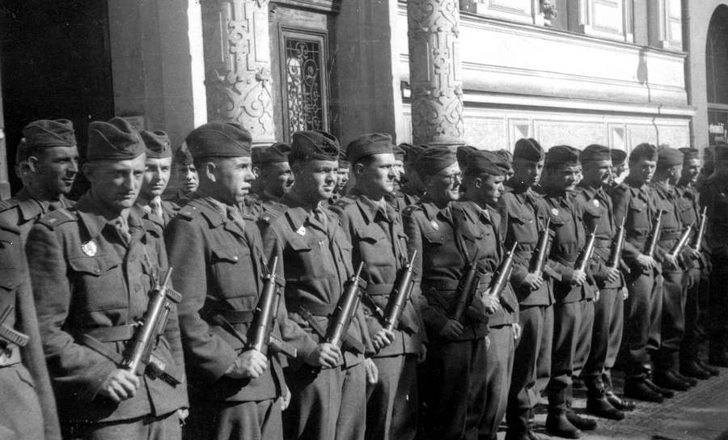

A few members of the first group of Czechoslovak NNSC and NNRC in full arms before their departure from Prague for Panmunjom (July 1953) (SAP)

The commander of the Czechoslovak team, General Bureš, issued the order on 17 July to activate the special troops for Korea. The chronicle of the first contingent of departing soldiers described events between 19 and 20 July: “The order was given to load the main transport. The comrades fulfilled it enthusiastically, perfectly, and in less time than the plan had intended. That work was not so simple. After all, we loaded 73 Tatra trucks full of cargo, 25 Willies [lend-lease Jeeps from the Second World War], two ambulances, three staff busses, four Tatraplán cars, and 25 motorcycles. We even took vehicles for the repatriation commission.” On Wednesday, 22 July, 270 soldiers left Prague.

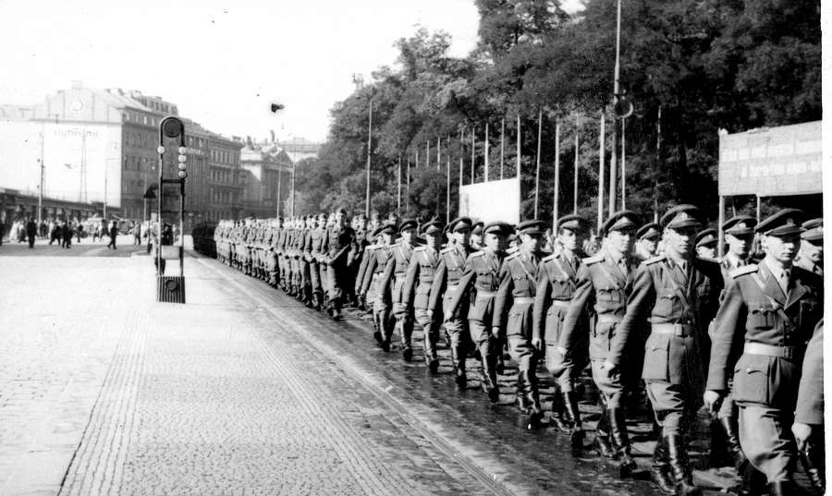

First group of Czechoslovak NNSC and NNRC members march through Prague before their final departure to Korea (July 1953) (SAP)

They had to travel for more than three weeks on the Trans-Siberian Railway and the Trans-Manchurian Line. The transport crossed the border with China at Zabaikalsk/Manzhouli, continued to Harbin, and finally reached the border with Korea on the Yalu River.

An advanced team of Czechoslovak representatives left Beijing for Korea on 26 July, just one day before the signing of the armistice agreement. The diplomat, turned Lieutenant Colonel, Mečislav Jablonský (1925-2010), who was a member of this delegation, remembered his selection and told about his first impression of the destroyed country:

I worked at the Ministry of Foreign Affairs, I was on business in Beijing, and one day I was called to Prague and told to report to the General Staff. There they trained me, dressed me in a military uniform, and gave me the rank of a Lieutenant Colonel because I was to go to as the secretary of the delegation in Panmunjom. We went at some point in June to Korea, where we had to sign the ceasefire agreement. For the signing we waited perhaps a month in Beijing. On the day of the signing, we boarded a train and from there went in the direction of Korea. We arrived to find rather difficult conditions. We rode slowly across the bridges because they were bombed and only had been temporarily rebuilt. Pyongyang was completely destroyed. We saw how the people crawled out of dugouts and looked curiously at those who were riding in the train because that was perhaps the first train to arrive after the ceasefire. Then we went to a point perhaps 40 kilometers from Kaesong, and from there we had to go by jeeps because the tracks went no further.

Jablonský participated in the establishment of the NNSC, which on 1 August 1953 began functioning. “I was the very first person who took part in the discussions,” Jablonský wrote more than 50 years later, “because the secretaries prepared the first session of the commission. Together with one each from Poland, Sweden, and Switzerland, we were in Peace Pagoda and discussed how we were to organize ourselves. It was fortunate that the Swedes had a career diplomat who had worked with the UN and who was familiar with administrative and secretarial matters. He put together the whole thing.” In Korea, the Swedes had the experienced diplomat General Sven Grafström (1902-1955), who had served as Sweden’s ambassador to Mexico and the United Nations, and Dr. Paul E. A. Mohn (1898-1957), who had helped Folke Bernadotte (1895-1948) with negotiations between the Arabs and Jews during the war in 1948.

The NNRC was established later, on 18 August, but in the first weeks, more attention was on the crucial work of the NNSC. The Czechoslovak interpreter in the NNRC, Zdeněk Nejedlý (1930-), described the role of the repatriation commission, which on 15 October started its work:

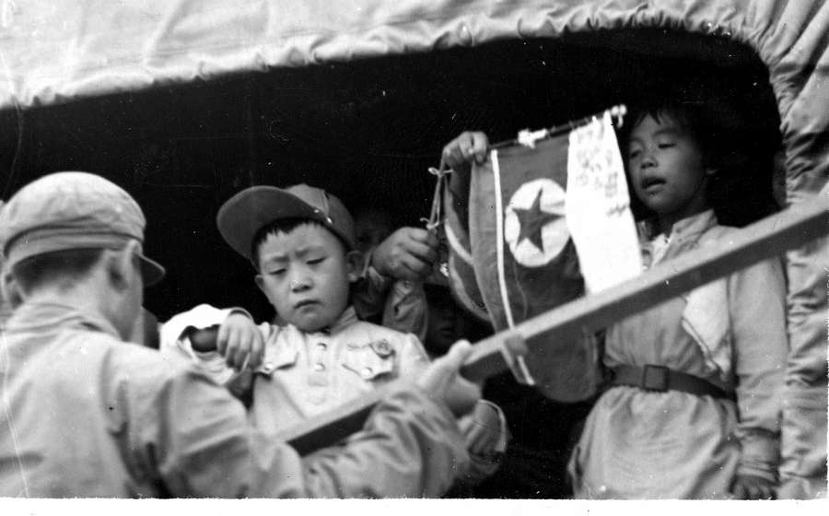

Only children, yet prisoners of war (SCH)

Our mission was to determine the opinion of the prisoners as to whether they want to return home or whether they want to stay in the country where they had been held as prisoners. All of it had to do with American policy, which proclaimed the principle that a prisoner has a right to say whether he wants to return to his home country or not. The Indian who presided [over the commission], said through a Chinese or Korean interpreter, “if you want to return to DPRK, you go out that door,” and pointed to one of the doors of the tent. “If you do not want to go back and stay where you are, go out that door,” he said, and again he pointed.

As Nejedlý noted, most of the prisoners did not visit the NNRC because it was not obligatory. “The condition was that the prisoner must be capable of going before the five-member commission” not that he had to do so. Many Chinese and North Korean prisoners did not want to be repatriated, but many others were under great pressure not to return them to their native communist countries. Their captors not only urged and sought to persuade but also tortured and sometimes murdered them. Unfortunately, this was not merely communist propaganda but brutal reality, and Nejedlý commented about the tormentors in the camps:

None of the prisoners dared to say in front of their fellow prisoners that he wants to return. If they realized [that someone wanted to return], they – it cannot be called anything else – murdered them. They killed them, cut them into pieces, and threw them with the excrement into the manure pile. I saw a case in which India tried prisoners who were imprisoned in South Korea and who had committed unbelievable atrocities against those they had found who had wanted to return. The Indians gave these people a stiff punishment, but they said that they will not take the sentenced with them to India. They did not want to turn over the murderers to the North Korean and Chinese, so they ended up released. They were in prison only a few weeks or months.

The interpreter and historian Pražák, who was an NNSC member, also mentioned the abuse. He saw that returning prisoners “were not that miserable,” but they were very happy to be back. “When they arrived by vehicle, they brought them on GMC trucks. They sang Korean military songs, and they appeared to be coming back with great joy. I saw once how, when they came home, they tore off the uniforms they had received and threw them from the vehicles. They arrived only in T-shirts and shorts. When the North Korean officers received them, they dressed in uniforms.” Pictures also show returning Chinese volunteers with tattoos of the Chinese Nationalist flag, an effort to force them to go to Taiwan instead of returning to the mainland China.

All the questioning finished on 23 December 1953, and the repatriation commission completed its task on 21 February 1954, as planned. At the end, there were two reports of its work. The Swiss and Swedish members wrote the minority report; the other was the result of the joint authorship of the Czechoslovak, Polish, and Indian members, who noted the killing of POWs, the agents provocateurs, and the hurdles the commission encountered.

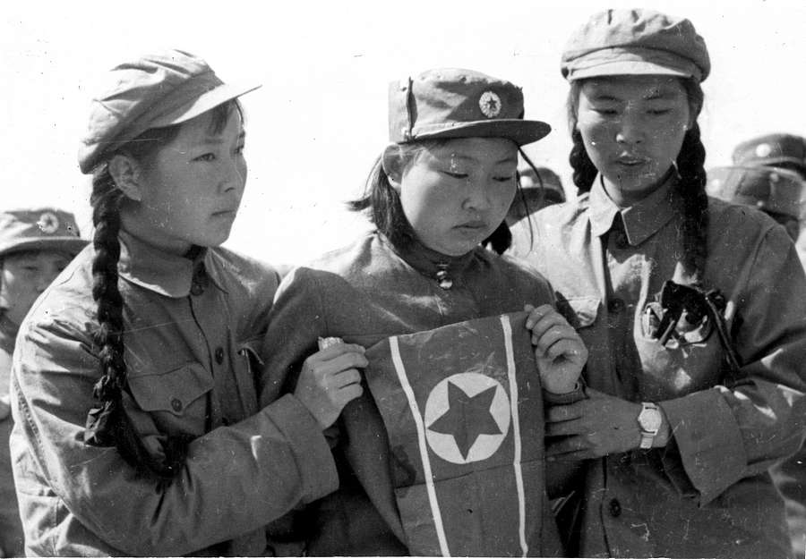

Chinese People’s Volunteers prepare to return home (MYN)

**The Work of the NNSC**

The two final reports that marked the conclusion of the repatriation commission’s work anticipated problems that were to occur with the NNSC. Jablonský described the evolution of the situation:

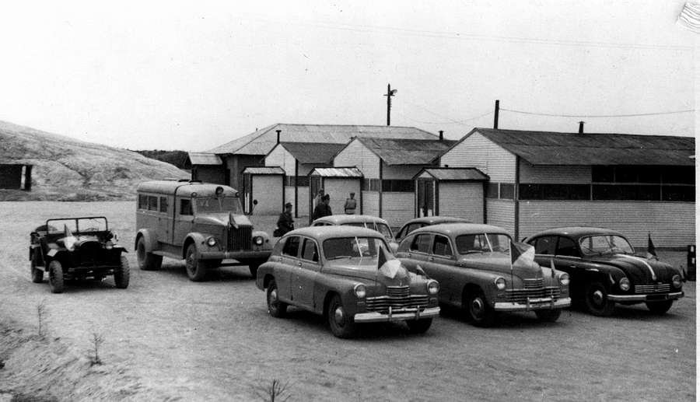

“Warszawa” cars of Polish NNSC and “Tatraplán” car of Czechoslovak NNSC during the meeting in Joint Security Area (1954/55) (FAB)

In the beginning, things went reasonably well. The first weeks, and it is possible to say the first several months, the work was rather normal. The groups prepared to leave, then the groups began to work… After, of course, contradictions between the North and South began to develop, with both sides doing things purposely. The Americans wanted us to help control the North in ways that would be very sensitive to the Koreans and the Chinese, who, in turn, wanted us to do things similar things regarding the South. That was a problem because, in the Commission, we blocked the demands against the North – we along with the Poles. Then, for the South, the Swedes and the Swiss blocked things at the request of the Americans. Thus, we came to a standstill.

The biggest problem was the even number of members in the commission–both sides had two representatives, and there was no fifth, independent member, as in the NNRC. All four countries served the sides that had sent them to the NNSC, and that paralyzed the commission’s work. Frequently, the NNSC did not reach a joint conclusion and sent the UNC Military Armistice Commission (UNCMAC or simply MAC) two different reports. At times, the NNSC was unable to sign protocols about arms exchanges because the Poles and Czechoslovaks claimed that the Americans had exchanged some planes for slightly modernized versions, even though the armistice agreement did not ban the practice. “There were routine meetings, during which it was stated that nothing occurs out of the ordinary and that things progress properly, but they killed the occasional request from one or another party that came to the commission. That was all,” said Jablonský in the spring of 1954 about the circumstances at the time. In the spring of 1954, General Josef Hečko (1907-1969), a hero from the Second World War who had fought against Nazis in fierce battles on Eastern Front, had the same feeling about the situation in the MAC. In his report to Prague of 22 July 1954, he wrote: “I concluded that the inspections of our group are totally formal and insufficient.”

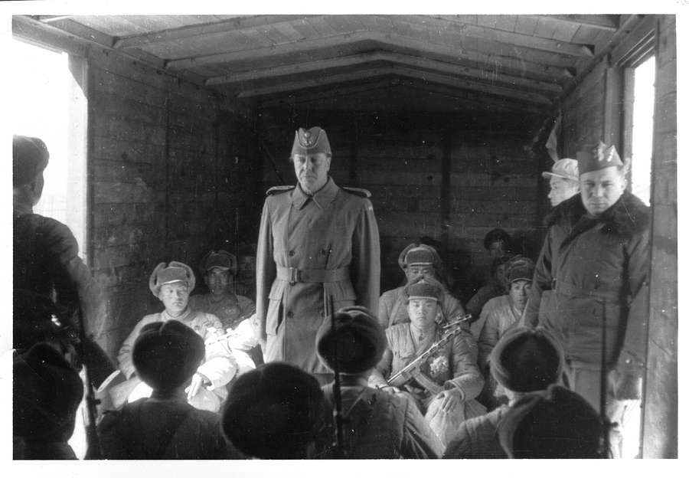

Swedish and Polish NNSC members controlling Chinese People’s Volunteers in Sinuiju (18 January 1956) (MYN)

Some of the members expressed similar concerns. One from the second group, Václav Kučera (1932-), who was inspecting the rotation of soldiers at a dock, remembered that:

They counted the soldiers who came to rotate the unit. [There were] perhaps 500 soldiers: 150 Turks, 200 Englishmen, and the rest Greeks. These left, and the same number of soldiers arrived. There always were bands that played, and a person could realize more than once that had they pressed [the hand tally counter] according to how the drummer beat the drum and not according to whether the soldier stepped on the blue or green or white [sorting] lines. So everything always depended on the partner, who immediately turned aside [and ignored the inaccuracies], and the numbers [in the end] were the same.

His colleague, Josef Souček (1928-) added: “In Incheon, we went to check Seoul airport, where it was reported how many military and combat aircraft had arrived, how many of them had remained, and how many had departed. Of course, it was impossible to check. On paper, it seemed formal [and correct], but that formality [and correctness] had its own meaning, and our presence had its consequence.” Jaroslav Komárek (1925-), the commander of the counter-intelligence group in Czechoslovak NNSC, expressed the same feeling: “Without fail, to ensure that the situation did not worsen–that was important. Beyond that there was some kind of control of what is happening there.” The translator Jaromír Švamberk (1926-2007) evaluated the role of the commission in his memoirs. “Outwitting us was simple, but it had to be modest,” he wrote. “Did it go, aside from some incident here and there, as far as some kind of new war in Korea? So a quiet and moribund mechanism of an agreement about a ceasefire always can prove [to have], so to speak, its own permanent life.”

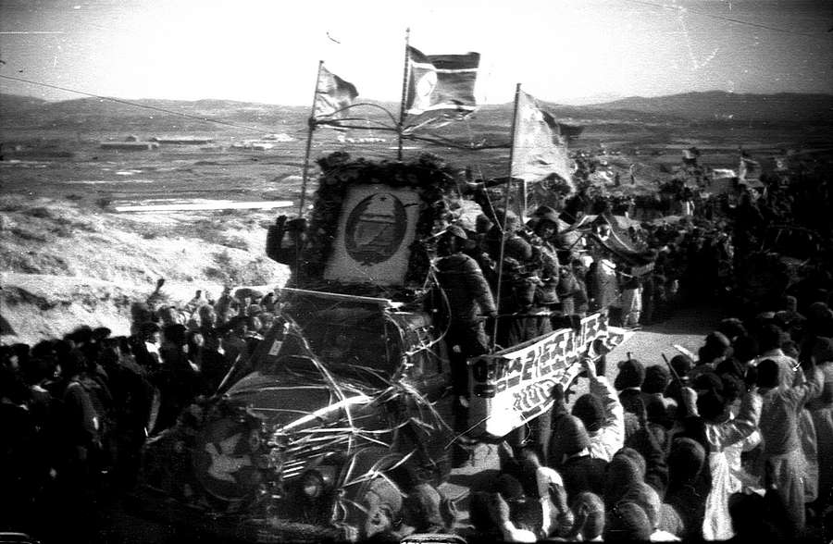

Returning prisoners of war (SCH)

Members of the NNSC did not count only departing UN soldiers and Chinese volunteers. They also investigated incidents and violations of the armistice agreement, especially the reports of illegally imported arms. “In Busan, an imported shipment of mortars came to the Americans,” quoted Jablonský. Komárek added: “In the boxes were imported, disassembled mortars–barrels separate, sights separate. [One only had] to assemble them. That was too much, even for the Swedes and Swiss.”

Jablonský mentioned another case which illustrates the problems the commission had:

In Incheon there was a problem with one boat on which munitions were loaded that we had discovered. It stirred up things because it went beyond the Americans. A mission of the secretariat from of all the delegations came from Panmunjom in order to solve the matter on the spot. Of course, we did not solve anything because we encountered the interests of both sides. We worked for nothing because there was no interest in resolving the thing in the end.

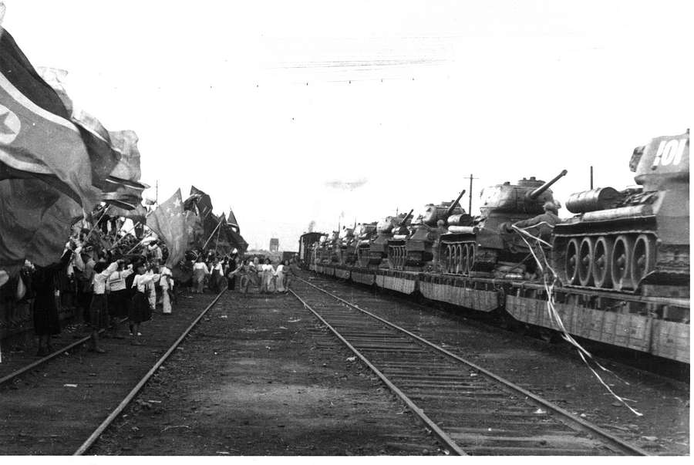

Farewell to Chinese People’s Volunteers at Sinuiju train station (January 1956) (MYN)

On the other side, the Americans had the impression that North Korea secretly had imported MiG fighters over the Yalu River, and an aerial reconnaissance mission and radar observation of air traffic over North Korea confirmed their suspicion. The US general in the Military Armistice Commission, L. D. Carter, wrote in 1955:

On the day of the signing of the KAA (Korean Armistice Agreement), UNC took aerial photos of each airport in the territory under the control of the KPA/PVA !Korean People’s Army / People’s Volunteers Army). These photographs show that, at the time, the KPA/PVA had no aircraft or useable airport in their territory. Air operations in North Korea were under constant radar surveillance from the signing of a truce until the present. The radar observation system found only seven sorties between 28 and 31 July 1953. This low level continued until October 1953, when air activity in North Korean increased. The rise accelerated greatly.

The American assumptions proved to be correct when, on 21 September, the North Korean pilot No Kum Sok (1932-), flew his MiG-15 to South Korea and landed at Gimpo Air Base. He testified that North Korea secretly had imported dismantled MiG fighters. In October, the UNC asked the NNSC to send Mobile Inspection Team 4 to the Uiju airport near Sinuiju. Swedish and Swiss members mentioned that some of the MiGs there appeared to be new, but the commander of the airstrip refused to show them any documents about the planes. They neither could confirm nor deny their suspicions.

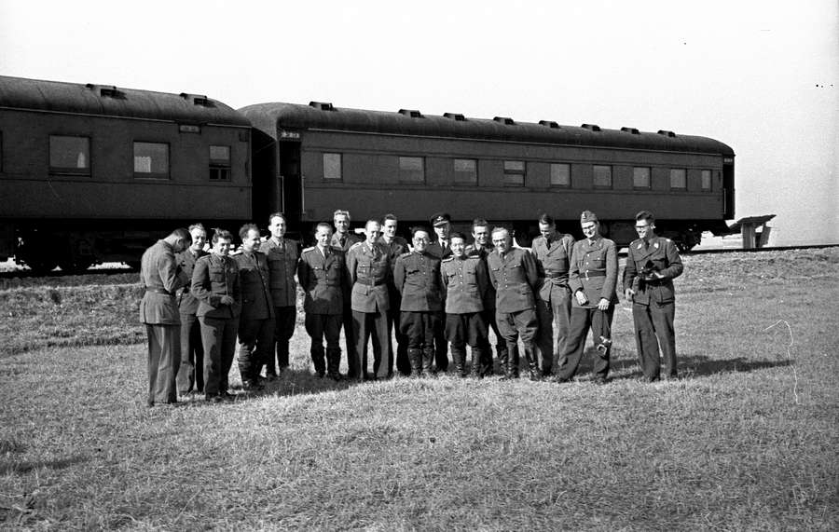

Arrival of the Inspection Team by train in Onjong-ni (SVM)

MiG fighters also were involved in a serious incident on 5 February 1955, when 12 American Saber F-86 fighters from the 335th Fighter Squadron that were escorting a reconnaissance RB-45C Tornado became engaged in a dogfight with eight MiG-15 fighters near the coast north of Pyongyang. When the Tornado turned back and flew along the west coast to the south, the MiGs attacked the formation of American planes. The North Korean pilots started shooting. The Sabre jockeys scuttled their auxiliary fuel tanks, faced the North Korean attackers, and shot down two of them.

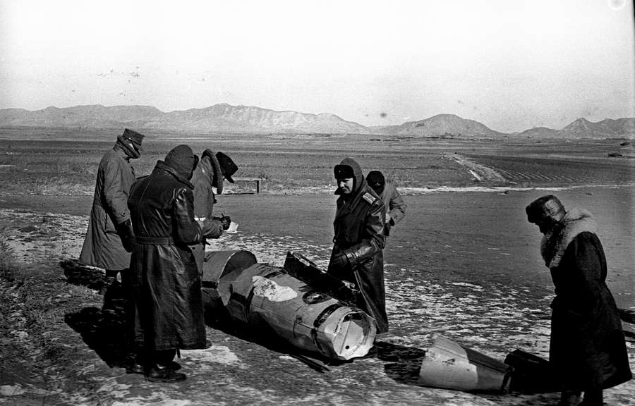

Examination of fuel tanks during NNSC investigation in Onjong-ni (KOM)

During the battle, they intruded into North Korean air space, which elicited a strong North Korean reaction. Of course, the North Koreans had hard physical evidence – the auxiliary tanks. Four days later, the North Korean general in MAC, Lee Sang Cho (1915-1996), delivered a letter of complaint to the MAC that charged the American pilots with aggression.

The NNSC sent the Mobile Inspection Team 5 by train to examine the Chinese and North Koreans’ claims in Onjong-ni, specifically to examine the fuel tanks that had fallen in North Korean territory. “In the most disgusting nasty winter, we went with an efficient fighter pilot from Korea and Lieutenant Colonel Franta Filouš [1924-] to investigate somewhere west of Pyongyang,” the translator Švamberk wrote in his memoirs. He added that the team members first tried to get physical evidence: “From pieces, we were able to put together partially some auxiliary fuel tanks, but others managed to be preserved as they fell, so we had physical proof that the American planes were over land.” In their draft report, the members of the Czechoslovak-Polish Mobile Inspection Team 5 concluded that “eight additional fuel tanks that the group inspected are more or less of the same type. There are of two measurements. On the basis of the inscriptions on the tanks, the group declared that they are additional tanks used in jet aircraft. According to the tables of producers, the group concluded that they are for the aircraft F-86.”

Collecting the fuel tanks was much easier than getting testimonies from villagers and farmers, wrote Švamberk:

When the local authorities found out that we wanted to stop people in the village square and ask them questions, they saw to it that nobody appeared outside. One man, who was standing nearby, recited word for word from an official news release: American airplanes illegally had flown over an area in the provinces of South Pyongan and North Pyongan and had attacked our country. When our pilots flew to defend the air space [of the country] and drove away the attackers, the enemy planes cast off their additional fuel tanks, which fell on the soil of our republic. He had it perfectly memorized, like a schoolboy, even though the actual description of the event consisted of true facts.

The Swedish and Swiss members were not satisfied and started to hunt for unbiased witnesses. The radio operator Jiří Černý (1931-) described one encounter with North Korean citizens:

So we went by car to somewhere on the coast. There were Koreans working in the field, so we ran there – mainly the Swedes and Swiss were running. Dressed in their military uniforms, they ran toward the peasants – furthermore, in unknown military uniforms. When the peasants saw that a band of unknown soldiers were running toward them, they began to flee. When they caught up with the peasants, the Swedes and Swiss asked them the same [questions].

Although they were able to find unbiased witnesses, it did not help them very much. The peasants spoke only Korean, so members of the inspection team had to use a North Korean translator. Černý added that “there was our Korean interpreter who interpreted everything. No one had a Korean interpreter, only us. They interpreted everything into Czech. Then, our interpreter interpreted it from Czech into English.” The Swiss and Swedish members felt that the interpreters did not interpret accurately the peasants’ testimonies, so they used a very unconventional way of communication. “It seemed to the Swedes and Swiss that it was staged, so they instead wanted the peasants to show them what had happened. So the peasants attempted to show them what actually had happened with gestures, but just the same, [the Swedes and Swiss] were not very satisfied,” Černý stated. The inspection team also visited a North Korean air base and interrogated two pilots who had participated in the battle. They repeated the same phrases. The NNSC spent many weeks in discussion to determine who started the incident because both sides had broken the armistice agreement. The Americans admitted that their fighters were over North Korean territory, but they said that they had been attacked over international waters. North Korea continuously repeated that the Americans had intruded into their air space, so they had to defend themselves and repel the intruders with gunfire. The NNSC never reached a definitive conclusion and sent two different reports to MAC. The Americans were disappointed, but that did not mean that the NNSC had failed. This kind of air battle never took place again, and the investigation opened the door to sending more inspectors to the North to prove the claims that Pyongyang secretly had imported jet fighters.

For more than a year, the NNSC had sent out no mobile teams, but shortly after the ferocious February 1955 dogfight, the North accepted three other teams in March 1955 to check their airports in exchange for two inspections of airports in the South. Mobile inspection teams visited six North Korean airports and discovered many suspicious circumstances. In Daejeon, inspectors spotted a number of tracks from fighters that had landed, but they did not see any MiGs there. Major Dušan Rozehnal (1921-?) wrote in his secret report to Prague what he had seen:

[There was evidence that flights had taken place] on the road and in the covered tracks of tires, even though the administrator claimed that no airplane was off of the runway since the armistice. He maintained that it was from aircraft tow vehicles and courier aircraft. [The administrators] promised to present evidence that the conspicuous track that had been covered was not the result of an airplane but a tow vehicle. Upon the return of the group after lunch, however, the track had been obliterated, even though the group had requested that [the administration] preserve it.

The North Koreans stopped one of their soldiers who wanted to testify before the inspection team members. In his dispatch to Prague about how the North Koreans dealt with this awkward situation, General Hečko wrote, “He was declared insane.” Hečko was very critical of the North Koreans and complained that they had not accepted his advice. In his March report, he wrote:

There are gross deficiencies in Daejeon. Workers in Daejeon displayed a reckless and irresponsible approach to things. According to my information, the Korean comrades still do not appreciate the full seriousness of the situation and they disregard the advice of their Czechoslovak and Polish comrades. The complications at that airport did not have to occur if they had informed us in a friendly manner about the situation and had left there a certain number of older MiGs and if the liaison offers had conducted themselves better. The failure was that [our] friends changed their line from day-to-day in important issues. [The Czechoslovak command referred to the Chinese and North Korean officers as friends (přátelé)].

In the end, the teams found no direct evidence of the importation and assembly of MiGs after the ceasefire had come into effect.

The two inspection teams went to the South also did not discover any infraction of the armistice agreement. They could not determine anything, as General Hečko’s dispatch indicated: “The mobile teams were unable to prove the accusations of [the North Korean] General Lee Sang Cho. It turned out that the allegations of our friends were unfounded and vague. Our friends apparently overestimated the accuracy of their information and the ability of the mobile inspection teams to have a propagandistic effect on the population in the South, which had no contact with the members of the team.”

Sending teams to the South had mainly propagandistic goals, which is apparent from the locations they chose to select for inspection. The translator Nejedlý noted that “they took us to Chinhae, a small town on the southwestern tip of Korea. We were to discover there a secret warehouse of weapons. Once there, I heard and then confirmed that it was the summer residence of President Syngman Rhee. Certainly, that was why the North Koreans selected [the location]. The group did not agree on all they wanted to check, and it found nothing,”

In their final report, the members of the NNSC were able to reach a joint agreement and concluded that all teams did not prove the suspicions of either the North or the South, although the Swedes and Swiss members included in the conclusion that suspicion remained regarding the North Korean and Chinese side. The Americans were very disappointed and again felt that the NNSC had no value, as they had said before.

**Protests against the Czechoslovak and Polish Members**

The South Koreans were suspicious about the Czechoslovak and Polish members of the NNSC. Seoul did not want them in the South to observe the withdrawal of soldiers and armaments from North Korea because the South Koreans feared that the Czechoslovak and Polish members were communist spies. Ironically, the second group of Czechoslovak NNSC members did not even have a local cell of the Communist Party of Czechoslovakia, quite a standard feature of every, regardless how small it be, state-run body. The commander of the second Czechoslovak group in the NNSC, General Hečko, even noted in his final report that “a serious shortcoming is that there is no [Communist] party organization in the delegation.”

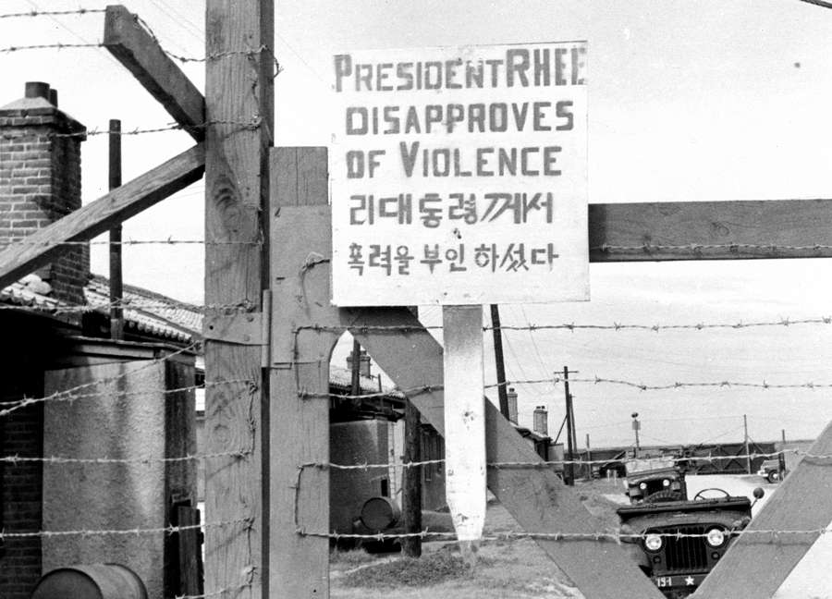

Sign at the gate of the US army camp at Gunsan during the demonstrations (KEL)

A number of Czechoslovak delegates even were not members of the Communist party, including some high-ranking officers. “That was perhaps my case,” wrote Jaroslav Keil (1931-), who was in the third group, “because I was not in the party. It certainly surprised me at the time. I thought that they will select only members of the Communist party. Evidently, they had a shortage [of qualified persons].” Diplomatic experience or knowledge of foreign languages played a bigger role in the second group than merely devotion to the Communist ideals.

The first public protests against the Czechoslovaks and Poles emerged at the end of 1953 and were against the activities of the repatriation commission. Because the NNRS worked in the DMZ, the targets were the Czechoslovak and Polish members of the inspection teams in the ports of entry in the South. The population had trepidations regarding the prisoners of war, the last of whom appeared before the commission just before Christmas Eve. Furthermore, the South Koreans were anxious to conclude the process. Pražák remembered his fears that the protests, which had erupted over the POWs, could escalate:

There were demonstrations against the Reparation Commission with claims that it did not fulfill its function efficiently. Nevertheless, the Indians who headed it were absolutely serious. [The demonstrations] were photographed, even with some of the banners. We met on Christmas 1953 – we were in the South in Daegu – and we were shaking because we thought that the war might begin again. We asked ourselves what then and where fate would take us. The fears subsided after Christmas, when things settled down again. It was very tense because there were thousands of prisoners.

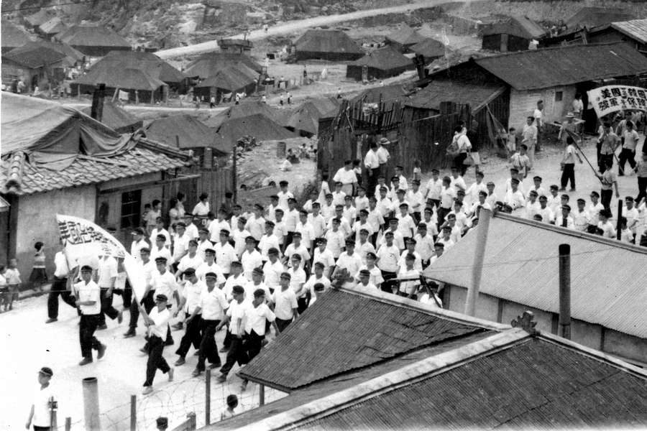

Anti-NNSC demonstration (unknown location) (KOM)

The situation became calm as the thorny issue of repatriation came to an end. Protests broke out again in the summer of 1954, when negotiations in Geneva about a peace agreement and the unification of Korea collapsed. Both sides were obstinate and made no concessions. The conference in Geneva ended on 20 July, and in the first days of August, people in the South demonstrated against the Czechoslovak and Polish members. The second group of Czechoslovak members of the NNCS, under the command of General Hečko, faced the strongest protests. There were mass meetings and demands that the “red spies” must immediately leave South Korea. Members in Busan and Gangneung were the targets of gunfire and grenade attacks. At the time, Nejedlý was interpreting in Busan, and he later described one incident:

Around six in the evening, we went to dinner. We met on the way to the dining room. My Swedish colleague stopped me to ask me something, so I was a bit delayed. When the Poles, Czechs, and Slovaks went through the dining room door, someone behind a wooden fence, which was a distance of about three meters away, shot at them from with a large-caliber American pistol. If I am not mistaken, they said at the time it was a 45 caliber. They stood in the doorway, there were several shots, but no one was injured. The bullets flew around the dining room. They showed them to us afterward. So we thought about it, and I think about it even today: was the shooter skillful because he did not hit any of those people or was he just a terrible shot? He was hiding right behind the fence. There was a narrow little street, and that person was lost in the nearby slums. The Americans sounded the alarm, but no one ever found anybody. However, they - demonstrating their power - parked an armored vehicle at the entrance.

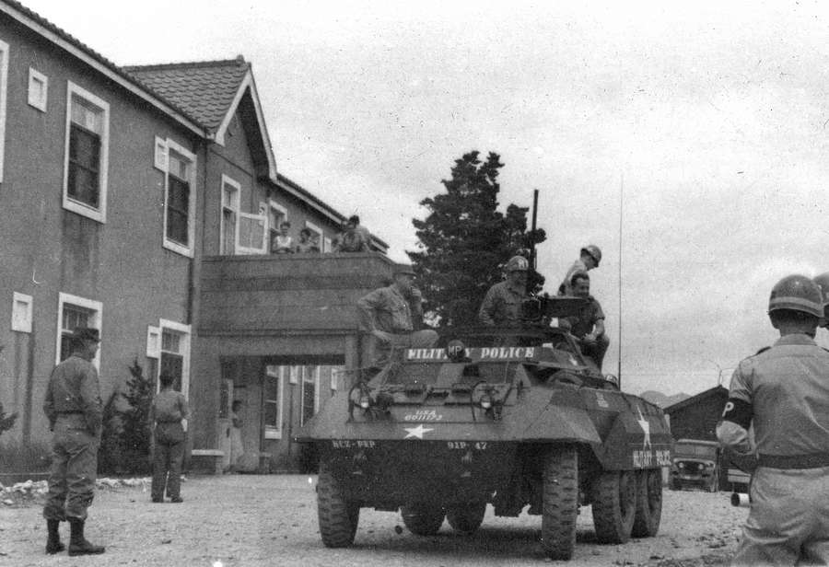

US army on alert during the anti-NNSC demonstrations in Incheon (KOM)

Demonstrations took place in all five ports of entry in the South. “I met with demonstrators in Gangneung and in Daegu,” recalled Kučera, a member of the second team. “They were very, very unpleasant – scream, scream, scream! The demonstrators got to the fence around our barracks. Of course, they did not get any further. Afterward, the MPs drove them off rather fiercely.” Another Czechoslovak member of the NNSC, the translator and interpreter Václav Rydyger (1928-), summarized in his diary:

From 2 August, the NNSC activity occurred in a new period, one in which there was a substantive reduction in the freedom of movement. That day, four members of the Czechoslovak delegation were shot at while going to a dining room in Busan (Hill Top). The perpetrator hid behind a fence a distance of about ten meters from the dining room. All three shots missed. One large-caliber bullet was found in the wall of the dining room. On 3-4 August, three homemade bombs were thrown into the Czechoslovak-Polish compound in Gunsan. In Incheon, port workers went on strike and attempted to go on the narrow road to Wolmi Island, where the inspection team was housed. The MPs, however, held them back. In Daegu a large crowd of protestors with banners came by bus and foot to the entrance of the compound. They shouted slogans and threatened a small group that was returning from an inspection at the airport. A gang then went to the second entrance of the barracks, from where one could see the compound. The MPs quickly had to use their batons to clear the road. They had to call in armed reinforcements with an armored vehicle.

Most of the Czechoslovak members stated that the demonstrations were not spontaneous but were organized, as Švamberk, who was at the time at Wolmi, wrote in his memoir:

During a very carelessly organized demonstration at the entrance to the road leading to the island, young men in dark blue suits directed the crowd, which was screaming. The crowd of demonstrators in the streets showed that Korea is a populous country. It was not pleasant for anyone, the office of the US Army liaison officers included. A tank came to the compound, with its machine gun pointed on the city. It indicated the current state of alert. We were unable to go in jeeps, and we had to resort to air transport. Helicopters arrived and took us to the local airport K-12 and the airport at Seoul K-14.

Like the other members, he described how the Americans, who made the arrangements for the inspection teams in the South, established new security measures. Members had to stay in their compounds and no longer could leave outside them, as they had done before in Busan. Komárek, who handled counter-intelligence in the second Czechoslovak group, observed that “in the camp, where we resided, stood tall watchtowers with machine gunners. Around it were strung high [walls of] barbed wires, and on the wires were tarpaulins, so that nobody could see out.” He continued:

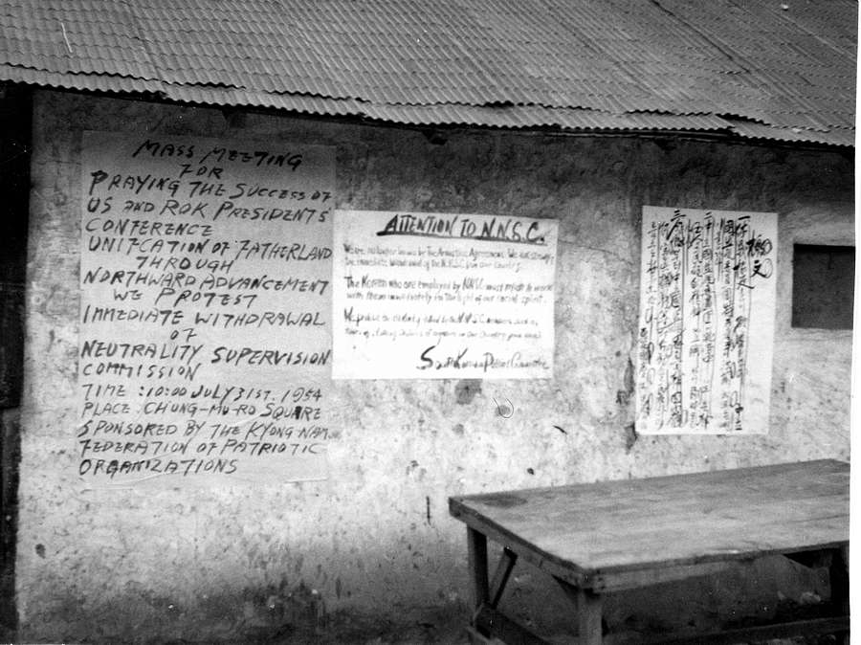

One of many anti-NNSC posters (KOM)

“We stopped going normally by jeep for inspections, and we started to fly with helicopters. Furthermore, the windows were clouded or blackened.” The NNSC symbols were removed from all means of transportation so that people were unable to recognize who was inside.

Some security measures were so strong that many Czechoslovak members viewed them as oppressive, which is what General Hečko intimated in his dispatch to Prague at the end of August:

“ ‘Precautions’ in some places, such as in Incheon, took on a ridiculous form. The liaison officer there unilaterally introduced a new procedure for requisitioning transportation and protection for inspections. A half hour before departure, the team had to fill out a special form in duplicate. In the end, even to go to the officers’ club, which was perhaps 50 meters from the living quarters of the team, it was necessary to have an escort. Meanwhile, the members of the inspection team had to sign in at the entrance of the living quarters with the MP in the guard booth.

Demonstrations were only one part of a wide range of pressures on the “communist members” of the NNSC to force them out of South Korea. Seoul tried to prove that the Polish and Czechoslovak NNSC members were spies and used photography, the favorite pastime of the Czechs and Slovaks, against them. The Korean press published pictures of the Czechoslovak soldiers took in the South and singled Captain Václav Verner (1928-), who allegedly tried to get information about the photographs he took. The South Koreans probably obtained the films from the Americans because a Czechoslovak soldier in the South processed film and negatives in the photographic laboratory in the American compound. That in itself proved that Verner was, in fact, nothing than an avid photo amateur, who wanted his films to be perfectly developed (which was not possible in the North), and not a secret agent since no spy would develop openly his covert photographs in his enemy’s laboratories.

In his report to Prague on 14 September, General Hečko wrote that the Czechoslovak members took pictures as did the Swedes and Swiss. He also noted that Verner was unable to obtain any information because he only spoke Czech. In fact, the ignorance of languages was one of the biggest problems of the Czechoslovak soldiers. Many Czechoslovak members took pictures because it was the first time they were abroad, and they wanted to preserve some memories of such a faraway and exotic land. Most of them never visited any foreign country, and they never saw the ocean or big ships because Czechoslovakia was a landlocked country. Pražák told how he took a picture in Busan:

I just arrived there, I was still in a daze because, for the first time, I was in proper port, and a large ship arrived. We said, “guys, let’s get to the port, we need to take a picture.” Well, there were about three of us along with our American escorts. When he walked around the port, everywhere there were signs that photography was forbidden. We agreed that we would do it anyway. So we stood to be photographed with a ship behind us. All at once, one of the MPs called, “Ale jo, jen si to tejkněte” [Yeah, just take it!]. In Czech! His parents had emigrated [from Czechoslovakia]. At home they spoke Czech, and he still could speak Czech, even though he had a strong American accent.

The radio operator Vladimir Vlček (1930-) remembered that there was no problem taking pictures of weapons, even of Sabre jets, and it was even possible to go into the cockpit. He was invited to visit a radar station where American operators monitored air traffic over North Korea.

The wave of protests in South Korea was so huge and some of the attacks were so serious against that the Czechoslovak armed forces addressed the difficult situation in letters to the families of the NNSC members to assure them that their relatives were well. General Hečko also received a warning from the Chinese that there was a serious threat of an attack. He wrote to the Czechoslovak Ministry of Foreign affairs:

My friends [the Chinese and North Koreans] warned me of the danger that the supporters of Syngman Rhee or Chiang Kai-shek could assassinate Czechs and Poles. The danger was especially high in some ports in the South. There are armed groups of terrorists who have been trained and are responsible for carrying out attacks at the appropriate moment. For everyone, I forbade contact of any type with the local population, photography, and departure from the residential area for any reason, other than inspections. I ordered everyone to remain close to the Swedes and Swiss.

Threats also appeared in the South Korean press. The South Korean government informed everyone officially on 26 August that “the Korean parliament wants to request the immediate dissolution of the NNSC because of spying.” The newspaper challenged the UN Command to eliminate the NNSC and threatened that if it did not do so, “the Republic of Korea will have to take steps in the interests of its own safety.” The press published similar articles in the next months, and the situation escalated again near the end of 1954 because the UN General Assembly did not solve the Korean problem. The United States repeated that the guarantees of security for the NNSC that were embodied in the armistice agreement. Finally, Seoul had to withdraw its demand to expel the Poles and Czechoslovaks. An official release on 20 December 1954 stated:

From the time that President Syngman Rhee postponed its decision to throw out the Reds, since they will not leave voluntarily, the windows of light aircraft, which transport the communists from Panmunjom to their posts in South Korea, have been covered. As soon as they arrive in South Korea, Poles and Czech[oslovak]s are restricted to their residential areas, provided that they are not conducting inspections of the arrival and departure of personnel and materials of the UN.

Various kind of pressures and demonstrations continued until the middle of 1956, when both sides decided to terminate the activities of the inspection teams because most of the foreign soldiers had departed from Korea with their weapons. The translator of the third team, Jaroslav Keil, described the last wave of mass protests in the summer of 1955:

The vast majority of demonstrators were children 14 to15 years of age, who, at the command of their instructors, probably their teachers, obediently lifted their hands in uniform rhythm, as though someone had shown them what to do. All the while, they were screaming at us, largely with incomprehensible slogans, of which we knew only one: “Chekko, Paran kara!” [Czechs, Poles go home]. Days later, when the number of demonstrators declined, modern technology filled their absence–a radio car, [that is] a truck fitted with a microphone and a speaker. At that time, the call for us to leave was broadcasted not only in Korean but also in wretched English and horrible Russian. At one point, when the demonstration exceeded its normal intensity, the base commander suddenly ordered the members of the team to move into an underground shelter near the airport.

**Duty in Difficult and Harsh Conditions**

Deployment on the Korean peninsula not only meant sensitive and complicated work for a commission that constantly encountered hurdles because both sides had their own intentions that were diametrically opposed to each other. It also was difficult because Korea was a destroyed country that lacked basic infrastructure. Czechs and Slovaks had to face many complications, from an extreme climate, with its very hot and humid summers and cold winters, to dangerous diseases. The low quality of water and food heightened the threat of intestinal infections, diarrhea, and dysentery.

Josef Barták, the doctor for the first group, mentioned the lack of drinking water in his final report: “The greatest need was for something to drink. In the first days, not even tea was available. We placed an emphasis on cultivating the habit of never drinking water that was not boiled.” The driver of the first group, Mojmír Sapák (1930-) confirmed what Barták stated: “Nobody was supposed to drink anything. They could drink only boiled water, or they made tea.” The motorcycle liaison and courier Jaroslav Schystal (1929-) explained how he quenched his thirst: “When we arrived in Kaesong – we arrived there in the day, after the rain finished – the sun was beating. It was like in a laundry at 95 percent humidity. We gathered our energy. In the meantime, our kitchen was lost, so we had nothing to eat and mainly nothing to drink. We found some cans of pickles. I was one of those who drank [the brine], and then I had problems.”

Further complications resulted in the first few days because the transports only brought the goods gradually. The first night, the soldiers had no tents, and they had to stay in a partially destroyed warehouse. Problems with accommodation remained throughout November 1953, and the commander of the first group, General Bureš, wrote:

We came to truly bad conditions regarding accommodations, which we gradually put in order. For example, in the building in which we lived, I already caught six rats directly in the room, and that was the best-maintained building in all of Kaesong. The windows and doors either are nonexistent or are leaking. When there is a wind, the pictures we brought fall from the wall. For example, we have been unable to obtain beds here because neither the Koreans nor Chinese use beds, nor do they know what they are. The houses here, if any exist at all, look the same as we used to see in Gypsy settlements in Slovakia. They are beams erected on stones [and have walls of] woven wicker covered with mud.

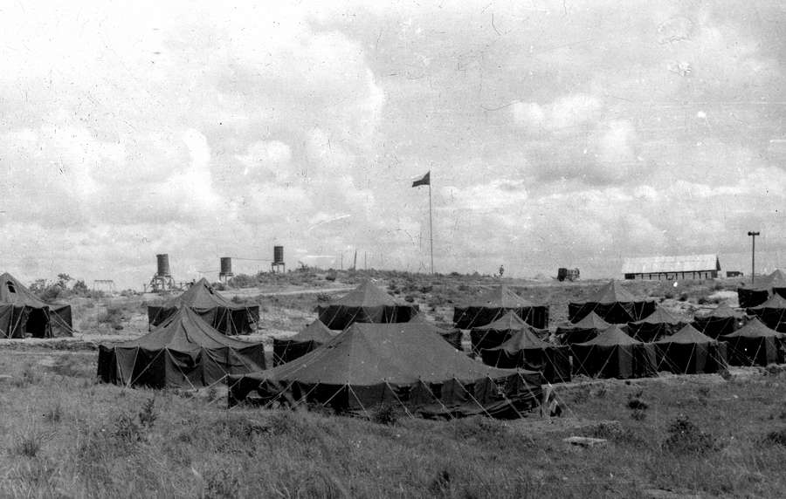

The very first tented camp of Czechoslovak NNSC in the DMZ (1953) (SCH)

The tented camp was not suitable for a long deployment during the course of a hard winter, which began in November. Bureš asked his superiors to send him wooden houses with beds, but Prague refused because of costs. The issue was not only comfort. The entry of 4 November 1953 in the official diary of the first group noted that “there are already very cold nights. This morning, we were rather surprised when we found that the water in the sink was covered with an icy crust. The heavy frost remained on the grass and trees until later in the afternoon.” Three days later, members were able to move into the new wooden houses that the Chinese soldiers built. And soon they also have their first joint Czechoslovak-Polish club building as well as an adequate place to eat. That solved one of the biggest problems of the first Czechoslovak group.

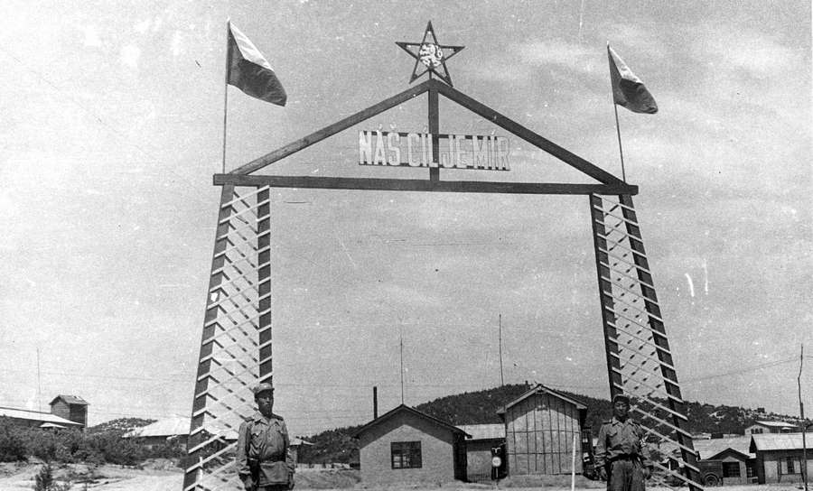

Entrance gate to Czechoslovak NNSC camp in the DMZ (1954/55) with a sign „Our Aim Is Peace“ (MYN)

The Czechoslovak Ministry of National Defense made every effort to provide its personnel with all they required. The soldiers brought the essentials they anticipated needing in trucks and jeeps, including flour as well as canned lunch meat and sausages to last for four months. Nobody thought the armistice would last for years, let alone decades. The expectation was that the commission would conclude its work in three months. The biggest fear came from the threat that the armistice would end and that the Czechs and Slovaks would be in a faraway land in the middle of a newly erupted conflict. The group was prepared for a different scenario than what they faced in the end: an armistice that seemed to be indefinite and work that was more diplomatic than military. They needed skills for delicate negotiations, something for which a knowledge of foreign languages was more important than military ability. General Bureš wrote to Prague at the end of 1953 that “the original assumption of our government and the Ministry of National Defense was that we will be here for a maximum of four months. That time limit has been exceeded, and there is no way to guess how long it will be until the task is complete.”

The Chinese side gradually took over supplying the food. The second doctor from the first group, Zdeněk Vacek, wrote that “from 1 December 1953, the Chinese side took over the care of the group and gave us food supplies, based on the variety of products to which our tastes had become accustomed. Chinese canned meat and chicken are sweet, and even the bacon and ham have a sweet taste.”

**The Invisible Enemy**

Vacek mentioned persistent and serious problems with hygiene. Various intestinal parasites and diarrhea were a constant threat for all members of the Czechoslovak delegation. Disinfection was essential, although it sometimes changed the taste of food, which displeased the soldiers. Doctor Vacek reported that:

We soaked fruits for twenty minutes in a pink permanganate solution, we did not use fresh vegetables, and we washed meat before cooking it in a solution of permanganate. We received fresh meat – both beef and pork – from the local slaughter house, which was in very bad condition. Thanks to the proper care of the meat after it came from the slaughter house and then during its preparation, no diseases were dragged into the compound.

Doctor Vacek also described the situation in Panmunjom, where there was a Czech cook. The recollections of the driver in the same group, Zdeněk Khol (1932-), corroborated what Vacek had to say: “I also transported from the warehouse sweetened water [that is, clear soda pop], as they call it, *saida*. The Koreans who loaded it at the warehouse had brooms and ran around swatting rats. They were so skillful that when a rat crawled up the wall, one of them would catch it by the fur and slam it [on the ground]. They were skilled at it, and they did not shrink from it. Then they picked them up by the tail to carry them away. In that moment, I was sick.”

It was much worse in the five North Korean points of entry, according to the interpreter Pražák, who was not only in Busan and Daegu but also there:

The worst eating in the last two months was in Sinuiju, where there was a Korean cook. Sometimes the smell of the food was not fresh. Perhaps twice there I was ill, but we were not surprised when we saw how poor the people were there. The majority of us got some kind of parasite. That was impossible to avoid, especially among those who were in the North, and at the end of my stay, I was in the North. I got some kind of parasite – roundworms or something – but they cured us.

The situation was much better in the South, where the US Army provided food. Members of the NNSC ate in the officers’ canteen, and they received the standard army meals. They sometimes did not like the taste of sweet bread or of maple syrup on a slice of ham, but the food was not tainted.

Some of the Czechoslovak members, because of their youth and desire for adventure and new experiences, tried Korean food, and some of them liked it. “Kimchi cabbage had an excellent taste. And the eggs – those so-called rotten eggs – we loved them to death. They were so good; they only looked disgusting,” remembered Komárek, who also tasted snake and dog. “During one reception, there was cut meat. One took it with a fork and fried it in oil. We did not know it was dog. When we found out, it did not bother me. It was very good. The same was true with worms. We thought that they were a crispy snack. It was good, so we ate it.” Komárek also noted that there was a serious problem with hygiene:

We saw that the kimchi was in large ceramic jars outside under the eves. Inside [the jars] was stomped-down cabbage that was full of flies. The same was true with the meat and fish. It all was excellent, but such preparation! We always clean fish properly. There they remove the inner organs, but they leave on the heads. We took a piece and ate it. How it was prepared, nobody knew. Because of this, the majority had roundworms or pinworms. I struggled with roundworms for half a year. It was horrible. Several had roundworms that were like snakes.

Intestinal parasites and different kinds of diarrhea were common, but nothing was serious. On the Korean peninsula, there were many more dangerous diseases, like tuberculosis, yellow fever, and spotted fever. The commanders introduced a number of precautions, and members were vaccinated against serious illness. In his final report, the doctor of the first group, Barták, wrote:

In 1952, we vaccinated all members [of the Czechoslovak group] against the following: typhoid fever, paratyphoid A and B, and tetanus with a total of two injections in six-week intervals; cholera with two injections during the course of nine days; typhus with three injections in five-day intervals; and bubonic plague with one injection. Against smallpox, there were one to three applications. In 1953, we inoculated again against typhoid fever, paratyphoid fever, tetanus, cholera, and typhus. The inoculation against cholera was ineffective, so we ordered vaccine directly from Beijing.

Regrettably, vaccination cannot prevent all diseases, and some soldiers contracted tuberculosis. The biggest peril was malaria, and averting it was difficult. “All contracted malaria, even though it might have been in a latent stage,” reported Vacek, the other doctor. He added that “the camp was in a terrain rife with malaria – rice paddies.”

Many soldiers learned how dangerous this disease was when they saw Koreans with it. “We saw how one worked the rice paddies. He was deep in the water and had an attack. He left the buffalo in the water and lay down on the dike. First he had a heavy fever and shook. In a while, he was sweating, and his whole body was covered with beads of sweat. After about 20 minutes, he got up and continued to till,” described Pražák, who had observed the entire drama with fright. They used mosquito nets at night, and Pražák noted that “if I hear a single mosquito buzzing around me, I cannot fall asleep. In the morning, we washed in pairs. That way one could see that the other had a mosquito on his back and could kill it.” They regularly received antimalarial medication. Doctor Vacek wrote that “we protected ourselves against malaria with the preventive atebrine in doses of two tablets two times each week. We ordered paludrine, which we received in Mukden, and we took it in the same dose as the atebrine. Paludrine does not cause same digestive difficulties as atebrine. We began these preparations nine days before we arrived in China, the anticipated habitat of the anopheles mosquito.”

Unfortunately, not all soldiers were as cautious as Pražák. Though mild malarial outbreaks in the southernmost part of Slovakia rarely occurred in the 1920s and 1930s, the doctors in Czechoslovakia had minimal experience with malaria, so it was easy to underestimate the danger. Soldiers could not imagine how serious the consequences could be for forgetting to take the unappetizing antimalarial medication. Some did not take the pills because the medication made them ill, according to the counterintelligence commander Komárek. “They did not take the paludrine, and many boys threw it away instead of swallowing it. When we realized that they did not take it, we had to find a way” to ensure that they did. The goal was to get the new treatment called chloroquine from the Americans that required only one pill each week. The Czechoslovak delegation requested that the Americans provide them with chloroquine, but the American command placed unrealistic conditions on its delivery. The Czechoslovak team would have to write an official letter asking for the drug, stating that the Chinese and North Koreans were unable to supply them with medication against malaria. For Czechoslovak authorities It was impossible to comply with the demand as the Americans could have used such a letter as propaganda against their *friends* in the North since the armistice agreement required both sides to provide for all the necessities of the NNCS members in the territories under their control. The Czechoslovaks had to find an unofficial way to obtain the better drug.

Unfortunately, some of the members contracted malaria. A few went to the Soviet Union for treatment, but there were cases in which the symptoms recurred after they had returned home. Zdeněk Khol, a driver in the first group, was one who suffered from malaria. Another was Kučera, who enjoyed sports, especially soccer. Years later, he remembered how he had entered the hospital in Prague with malaria:

When I returned in 1955 to the factory from Korea, it was the height of the preparations for *spartakiáda* [a regular mass gymnastics games organized in socialist Czechoslovakia every five years from 1955 to 1985], so I was actively involved and exercised. Somehow, I overdid it, and I passed out on Strahov. They took me to [the hospital in neighboring] Motol, where they told me that I had jaundice but that I also had a temperature. Then a doctor came, spoke with me, and said, “So you did not say that two months ago you had returned from Korea.” They tested me and immediately transported me to Bulovka [hospital specialized in exotic and rare diseases]. For almost two years, I had to take atebrine. It was difficult because, in the beginning, we were not even able to have children.

Finally, he had children, and for his entire life, was married to another member of the NNSC from Czechoslovakia, the typist Jiřina Oujezdská (1933-). The Czechoslovak command had asked them to marry in Korea, but he refused.

Colonel [Stanislav] Balda [1910-] tried to convince me: “Sergeant, you should marry here. It would support the activity and work of the inspection group a great deal. We would arrange it. There are Poles, we [Czechoslovaks], Swedes, Swiss, and from the northern side the Chinese and Korean representatives . . . . That would be a wedding!” Even though he tried and tried to convince us, and even though we cared for each other very much to this day, we did not go through with it. I loved my mother very much, and I could not imagine marrying in Korea and mom would not have been there.

**Under Pressure**

Kučera was a rare exception. Most soldiers had no close personal connections in Korea, and they were under strong psychological pressure because they were deployed thousands of kilometers from their homes in a totally different environment and without direct contact with their loved ones. They had no chance to phone their families. They only could depend upon the mail, and letters took weeks to arrive.

Over time, deployment became protracted, and the soldiers did not know when they would return home. Their psychological condition worsened, even though their superiors had selected them carefully for duty. Doctor Vacek observed some of the psychological problems, including:

Neurasthenia and psychoneurosis – a substantial workload with unusual mental work in an unusual environment with a great sense of responsibility, separation from one’s family, and sexual abstinence. Of considerable importance is the uncertainty of the length of stay here. Finally, the constant complaints reflected in the letters from Czechoslovakia of family members, who expected an earlier return of their nationals, according to the promises the authorities in Czechoslovakia gave about the length of stay in Korea.

The worst came on 26 November 1953, when Colonel Vajda attempted to commit suicide. General Bureš wrote to Prague on 30 November that “from an examination of his correspondence, it is possible to assume that one of the reasons was his personal situation, specifically the relationship of his fiancée, who had sent rejection letters to him from Czechoslovakia, claiming that he had not indicated how long he would be in Korea. She also threatened him with infidelity.” The situation was even more complicated because Vajda shot himself in the South, in Incheon, and he immediately was transported to an US hospital ship, where American doctors saved his life. The Czechoslovak command feared that the Americans might persuade him to change sides, as General Bureš wrote in his dispatch:

There was a serious danger of provocation on the side of the Americans, who assigned him a Czech-speaking doctor and nurse on a hospital ship in Incheon. Certainly, as soon as he gained consciousness, they wanted to get from him a statement in which he would request asylum.

Vajda’s defection would mean the work of the entire delegation would be impaired. He was informed of all the secret meetings and of the investigations of the NNIT [Mobile Inspection Team] that were sent at the request of the Americans to North Korea. In one case, he was the commander of the team. Recruiting him was a difficult political struggle. Today, on 28 November at 1:00 PM, the Americans transferred him, bringing him in a hospital helicopter from Incheon to Panmunjom, and from there, our ambulance took him to a Chinese hospital in Kaesong. We had to give the Americans a written statement that we take all responsibility for his transfer and for his health (it remains serious)!

The first group was not the only one that had to face a prolonged stay in Korea. The situation repeated itself with the second group, although its commander, General Hečko, unsuccessfully had requested that Ministry of National Defense not extend the deployment: “Dreams of going home for Christmas have quickly disappeared,” Švamberk, the translator from the second group, wrote in his memoir. The radio operator from the same group, Vlček, added: “They extended [our stay] for a half year. I have that letter, with the signature of the chief of the General Staff. It appeals to my wife so that we both understand that it is in the interest of the republic, socialism, and peace and that the costs are high.”

Some of the members stayed in Korea for more than a year, a list that did not only include experienced diplomats. The military command in Prague at times seemed to forget which professionals were necessary in Korea. “I am the longest-serving member of the supervisory committee in Panmunjom. I was not there for six months but for 16 months,” recalled the cook Václav Borovec (1931-). He continued:

During the celebration, which was a week before departure, everyone at the gala dinner rejoiced that the relief group already was in Moscow [and on its way to Korea]. In the morning, the general told me that no replacement is coming for me, so they have me down for another half year. I showed the general a letter stating that my mother is ill. He showed me his letter that his wife also is ill. So I was not the only one in such a situation.

Finally, he got to see his mother again, but his girlfriend was unable to wait so long. She married another man.

The financial commitment to send fresh soldiers to Korea together with the reality that the preparation for each group took time were two important factors in the decision to extend the soldiers’ time in Korea. Furthermore, it was difficult to find people who had enough experience for the mission and – from the point of view of socialist authorities - were reliable and trustworthy. A measure of the success of the Czechoslovaks in the matter of personnel selection is the fact that nobody defected to the West, which was not the case with the Poles.

**Personal Views about Korea**

Deployment in Korea was an incredible experience for all Czechs and Slovaks, regardless of whether they were members of the commissions, worked as doctors and medical staff in one of Czechoslovak hospitals, or helped as experts or technicians with the reconstruction of the war-torn North Korea.. Because of the World War II, most of them never left their native country, but on this occasion, they found themselves on the other side of the world.

They confronted a totally different culture with a unique history and distinct customs and food. Everything was different: landscape, plants, weather, and architecture. Astonished members gazed at the shrines with hundreds of Buddha statues and took pictures of ancient sculptures and tombs from the time when Kaesong was the capital of the Goryeo Kingdom. They wanted to know more about the people around them, so some of the members became interested in Korean history.

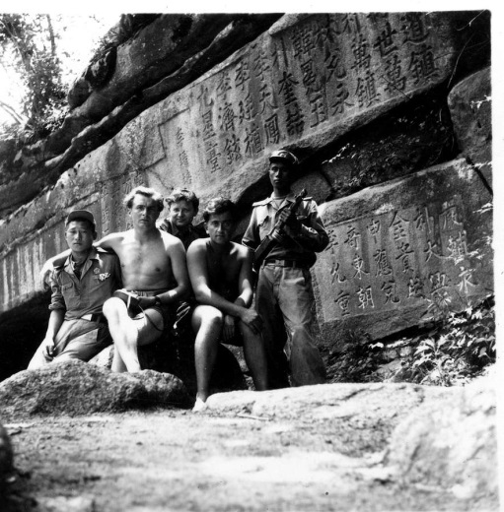

One of many weekend trips to historical sights near Kaesong (1953/54) (SCH)

The Czechoslovaks were bewitched with the amazing landscape that was full of rugged hills and outcroppings and where the colors rapidly changed with the season. The bright green rice paddies of the summer turned to a sea of golden rice straws in a reddish-brown soil in the autumn. White snow covered the landscape in the winter until the spring thaw, when the brown earth turned to a violet pink as the azaleas came into blossom. The Czechoslovak soldiers also watched astounding folk dances that the army art ensembles performed with their gorgeous costumes.

Also attractive were the traditions, especially the weddings, when the brides, sitting in closed litters, were carried to their grooms. The Czechs and Slovaks were surprised with the traditional clothing, for example, with the skirts that began under the breasts that resulted in a small bodice. They also were astonished that the Koreans buried their dead not only in cemeteries but in other places.

In an article for the weekly factory magazine *Sokolovák* under the title “Land behind the Barbed Wire” (Země za ostnatým drátem), Kučera wrote:

In the countryside, they commonly bury their dead in their field, in their garden, or on their land. The graves have the appearance of earthen mounds. Other times, on small earthen mounds, stones are erected that have tops with various shapes. Only the rich are able to build a wooden construction, usually with four columns that carry a curved roof in the shape of a pagoda. Otherwise, there are all kinds of burial grounds, that is, a larger number of graves together, on the slopes of hills, in forests, and in the knolls. These are freely accessible to anyone.

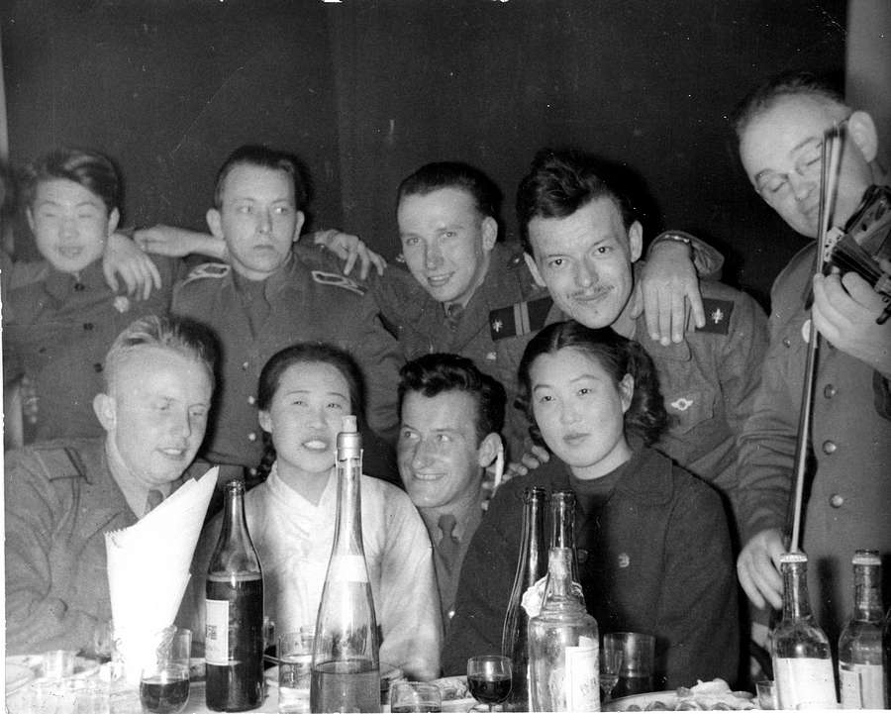

Friendly party after a music performance at the Czechoslovak NNSC club in the DMZ. Note that North Koreans were not yet shy of foreigners (1954/55) (MYN)

All of those who went to Korea from Czechoslovakia never forgot what they saw. Their discoveries were firmly imprinted in their minds. Their views were much more complex than those of the officials. Reality took them out of the black-and-white world of propaganda that was prevalent because of the divisiveness of the Cold War, when the socialist bloc countries depicted the heroic North Korean people as fighting for peace and socialism against the American imperialists and their so-called “South Korean puppet henchmen”. The personal experiences and independent observations created more of a detailed, complex, and altered picture. Members quickly discovered that the US soldiers were just guys like them with common problems and ordinary interests and concerns. In some ways, they were more naive. They sometimes had different tastes, but they did not like war, they did not want to die, and they did not want to kill or conquer. Those views were contrary to communist propaganda the Czechs and Slovaks were influenced by at home.

Occasionally, their observations corresponded to the official line. All members of the first two groups immediately recognized the horrible effects of the war. They saw the destruction as soon as they crossed the Chinese-North Korean border. The results of US bombing raids against the infrastructure, especially dams and bridges in the North was clearly visible. “By far the worst experience was when we crossed the Yalu from China to Korea. That bridge was bombed several times,” recalled Pražák from the first group. “The train had to go slowly, and there were all kind of squeaks. We said, ‘Comrades, this is going to end badly. These cars will fall with us, and we will be in the water.’ Still, we crossed it.”

Černý, who came to Korea a year later, in June 1954, with the second group, also described the bridge over the Yalu:

Across a major river, like the Yalu, the bridges were long, perhaps 300 meters. The Americans cut that bridge exactly in half because the border was there. The second half on the Chinese side remained. They did not risk destroying it. The bridges were repaired in a horribly provisional fashion. Where they could, they [repaired] them using logs. From where they got then, I have no idea. Perhaps the Chinese brought them. The branches were haphazardly thrown one on the other. It was not construction as we know it. It was something like a sparrow’s nest. On that they placed the tracks. There, one had to go very slowly.

Pražák continued his story:

The road to Kaesong was horrible. Around the tracks were continuous bomb craters, which were full of water during the rainy season. They were beautiful to see, but how those tracks were bombed! Coming toward us was a hospital train with wounded Korean soldiers and Chinese volunteers. Every car had on it ragged flags, torn from the war and riddled with bullet holes. That was incredible. The villages around the railroad tracks were nonexistent. The people lived in dugouts.

The sights of the destruction in Korea strongly affected Pražák, even though Czechs and Slovaks were familiar with the effects of the bombing raids and heavy artillery fire because of the final battles of the World War II. During his deployment, Pražák met a wounded soldier: “We had an old man in Hungnam who swept the floors. One fine day, we got into a discussion using our hands, and he said where he had fought on the front lines. He removed his shirt and showed us how his back was burned. When the Americans used napalm bombs, he was in the trenches, and the napalm burned him. He had scars all over his back, and it was not a pretty sight.” Other Czechs and Slovaks took pictures in the hospital of a child with napalm burns.

The commander of the first group, General Bureš, also wrote in his report to Prague about the effect of the battles: “If you look on the map, there are cities and villages. In reality, however, they do not exist. In several places, it is difficult to recognize that, in the area where we are driving, a village stood. What remains are only the rivers and roads, although [the roads] are destroyed. In the end, the explosions even reduced several hills by a few meters.”

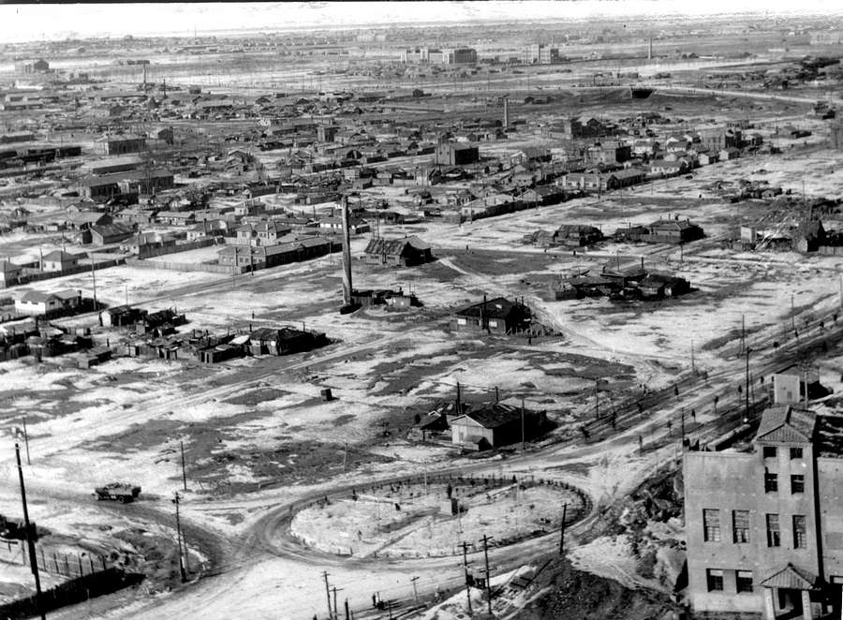

Destruction in Chongjin (PCK)

The destruction was so great that the members of the second group also recognized the results of the bombing, despite the enormous effort to reconstruct North Korea. In his memoirs, the translator of the second group, Švamberk, wrote:

It already was one year after the war in Korea, but it looked like the war had ceased yesterday. The entire route from north to south was bordered with beads of craters from bombs that had hit the fields, as if the aviators had dropped them on individual villagers in the fields. The only remains are flooded pits in the rice paddies. It is possible to recognize the villages because the chimneys protrude from the dugouts. The cities are gone. Only here and there, chimneys peek out of the leveled wreckage and ruins. Several are smoking. There has been peace for more than a year, but the ruins truly remain throughout [the country].

During a recent interview, Schystal concluded from the amount of destruction that the conflict was not only between the two Koreas:

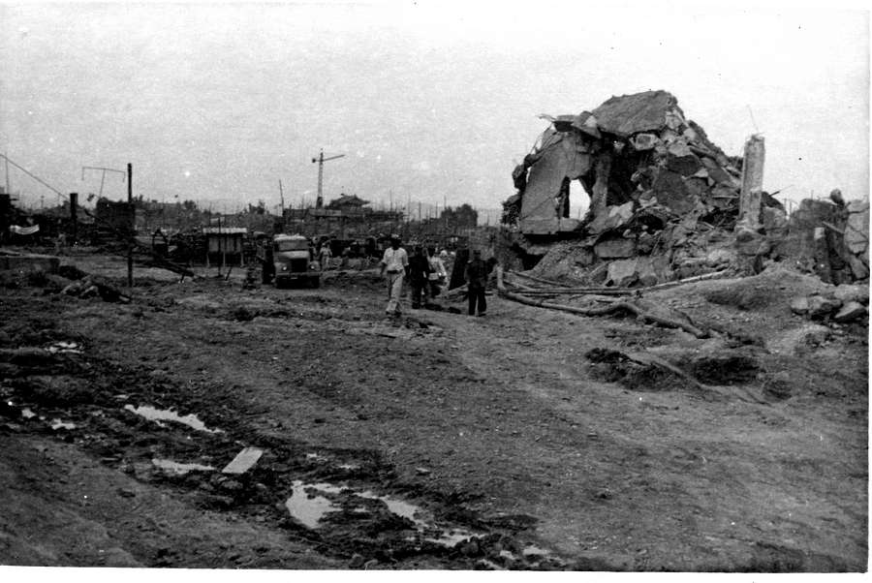

Destruction in unspecified location in North Korea (1953/54) (SCH)

Along the way, there was a large number of wrecked locomotives and cars. What the Americans destroyed during the day was immediately rebuilt as soon as it grew dark or they stopped flying. There were new rails, and along them ran supply trains. They either arrived, or they did not. Those [that did not] were the wrecks along the side of the tracks. The bomb craters were plus or minus five meters from the track. One could live there through the night until morning. At that time, they had to pack up [and leave]. Then the Americans came and destroyed what they could. It actually was a matter between China and America. The Koreans were the second-rate actors in the drama.

The war damage was so extensive that the North Koreans needed help on every level. Nurses and doctors from the Czechoslovak hospital in Chongjin often went to isolated areas, where they treated and vaccinated children. Engineers came to reconstruct dams. Everybody tried to assist in any way possible, even the NNSC members, to some extent. Švamberk wrote in his memoirs how they helped a newborn girl stay alive. “Our predecessors [that is, the first deployment of Czechoslovaks] saved the child with rations of condensed milk, which she did not get from her mother in its natural form. In such circumstances, children normally died, and this intervention still elicits admiration and gratitude.” Children played a big role in Korean society, wrote Kučera: “None of us who were in Korea will ever forget the Korean children. They were everywhere, and there are a great number of them born. Therefore, the Korean landscape without children is something unimaginable. The average number of children for each family is perhaps five or even more. A family with ten children is not rare.”

The drivers helped quite a bit. Czechoslovak-made Jawa motorcycles were able to survive the harsh roads on a daily basis without much problems. And the Tatra 128 trucks that the first group took were real workhorses, and the Koreans appreciated the use of them. Khol, a driver, remarked that “128s were good vehicles. They survived everything. They had an excellent engine.” He added that the Americans were surprised with their performance, as they have never heard about and saw that Czechoslovak-built truck, and admired them after one Czech driver in Panmunjom showed them how the truck was able to handle a steep slope. “When our soldiers arrived with a Tatra, the Americans crawled under the vehicle and photographed it because they saw no chassis, only a load-carrying tube.” All the Tatra trucks had swinging half-axles on the load-carrying tube, in which was housed the drive shaft. This concept accounted for Tatra’s success for half a century all over the world, including winning six Paris-Dakar Rallies in truck category. The drivers noted not only the lack of technology in Korea but also the absence of simple tools. The driver Sapák remembered:

We went to the inlet for river sand because they were building a new nursery or school. For one shovel to load the sand, there were three men. One worked the shovel and operated the handle. The shovel was tied to a rope, which the other two held. The shovel dug into the sand, the two pulled it out, and they dumped it into the truck. They did not even have wheelbarrows. Women with baskets on their heads carried material from the sand pit. Furthermore, they were singing while they did it.

The translator and later on leading Czech Koreanist Vladimír Pucek (1933-) added that women with baskets on their heads not only carried sand or soil but also heavy stones, which “easily could crush the head of the baby” that several were carrying on their backs.

General Bureš described the bad situation in his dispatch: “The technical outfitting of the civilian inhabitants and the army is very primitive. For example, there are not enough shovels because materials are loaded on the trucks with the help of farm shovels [that is, spades]. They do not know what a wheelbarrow is for carrying stones and sand. All the material is carried to and fro, specifically on the backs of the workers.” The war did not usher in all of the difficulties since poverty and underdevelopment was a historic problem, which the four decades of Japanese domination and exploitation since Japan’s annexation of Korea in 1910 did not changed. Khol said, “they had nothing there. There were bombed, empty, dusty streets. Malaria raged there. Everything seemed to be backward.” In January 1956, František Mynařík (1933-) noted in his diary that “after 15 days, we are leaving Sinuiju! I recognized at least partly how the people live here in the 20th century! The houses are made with mud and are without any kind of sanitation for the adults, children, and elderly. In the streets, women walk with heavy loads on their heads. In bags, they have flour, millet, and corn. Even small children carry heavy bags wrapped with rope that cut into their shoulders. They know no other life! Today we were with General [Václav] Tauš [1910-?] and Doctor Major [Vladimír] Borek [1921-] in the school we are sponsoring. Several pupils have the symptoms of tuberculosis.” He saw Korean teens dying of tuberculosis. In July 1956, he wrote in his diary about his visit to the Czechoslovak hospital in Chongjin:

Our surgeon invited me to be present during an operation. I received a white gown and everything else that was necessary. I stood in the corner, but the surgeon called me directly to the operating table, where he had prepared a girl about 16 years old for a procedure on her lungs. I have to admit that I was out of sorts not just when he opened her with a scalpel but when he stitched her. Those stitches simply cannot hold! When I went to visit the girl the next day, she was doing well. However, with that experience, my suffering did not end! Dr. Macek, from Brno, invited me to the morgue. They were doing an autopsy on a roughly 15-year-old Korean girl, who had died of tuberculosis.

Death was an imminent part of postwar existence, as the driver Khol recounted:

I saw a woman lying on the ground for a half day with children sitting around her. The flies were crawling on her because she already was dead. At the time, it would not have bothered me, even if I had been eating rations, because a person gets used to so many things. I calmly sat in the car, and I watched. A person becomes so numb that it does not matter. It simply does not matter. One can take it. Here, when someone sees someone, or rather when I go to the funeral of some acquaintance, I have that on my mind for a long time. There it somehow it did not bother me until later, when I had dreams in which the experiences gradually returned.

Many times, the Czechs and Slovaks felt as though they were in an ethnographic museum, as though they not only traveled to a faraway land on the opposite side of the Northern Hemisphere but also back in time. “There on the banks of the River Yalu, tens of women were doing laundry by pounding it with rocks from the river bank,” described Kučera with the help of Jan Dolina in an article for *Sokolovák*. He linked what he saw to the distant Czech past: “History breathes, even in the national dress of Korea: short coats and wide, white pants tucked into white socks, all normally without buttons or pockets. It is like Chinese clothing from the 14th century (…) Underdevelopment was visible everywhere, continued Kučera: “In the South, as in the North, simple villagers built their own dwellings from reeds and twigs bound together with rice straw and mud.” He also described how peasants cultivated their fields in the manner of their medieval ancestors:

To this day, South Koreans plow their fields with a pointed branch or agriculturalists dig up the entire field with hoes. Reaping also is done by hand and without a scythe. They use only small sickles, rather it is better to say slightly curved knives. Threshing is done either with a flail (even that is not known everywhere) or by driving cattle over the crops. Only with rice do they use very simple, small threshing machines powered by someone pedaling.

Khol also mentioned that the Koreans did not know flails, so the soldiers brought some from Czechoslovakia. At first, he was surprised to see that they had brought the flails: “I said, ‘why a flail?’ and there I saw how they beat the crops. Someone held a bundle of sheaves across a large rock, and another beat it with a stick.” As Khol stated, “I was interested how they live and farm. I noticed how they planted rice.” He also observed their system of canals and irrigation. Other members remarked how farmers used very simple tools to make their work easier. Rope with knots helped to keep the same distance between rows of rice. The small steps of those who held either end of the ropes kept the distance between the plants in each row. Khol noted the importance of human power at every stage–seeding, planting, cultivating, harvesting, threshing, and sometimes milling, but buffalo turned the bigger millstones. Manual work also was important for irrigation in hilly areas: “A stream of people carried water up the slopes. There was no foot pump. They just had a sling across the forehead, a hod on the back, and they carried [the water]. They had no pump–nothing. They simply had to carry the water 20 meters up that slope.” Once they reached the top, they poured out the water, which “trickled and then cascaded across the shelves [or steps]. They had it well thought out.”

Other than growing rice, ocean fishing attracted the Czechs and Slovaks because it was something they never had seen. In Chongjin, they watched fishermen hunting crabs, and in Busan and Incheon, they saw how people dried fish and squids. They sometimes visited the fish market, although for most of those from Czechoslovakia, the smell was unbearable. “Fish form about half of the nourishment in the South and the North. The seas that wash the shores of Korea are rich in all kinds of life. There are tens of types of fish here. They catch crab, lobster, as well as octopuses, which commonly reach a diameter of two meters,” wrote Kučera in one of his articles for *Sokolovák*.

The NNSC members had an interest in other aspects of the lives of ordinary people. Soldiers also were curious about how Koreans made their typical noodles, and they watched how people ate them from a bowl in the market. Another oddity was ginseng, and they were surprised how the Koreans cultivated it. “They grew ginseng roots in something like a hotbed. They covered it with rice straw, probably because it needs shade and not full sun,” Sapák stated. “It was valuable. Only the general received some, I think it was bottled in alcohol.”

On many occasions, they remarked about the great cultural differences between them and the Koreans. Švamberk mentioned that the Koreans did not eat cheese. “We also tried to offer them processed cheese in a can, but the dear Koreans indicated that they do not eat spoiled milk.” The soldiers tried to help malnourished Koreans with fish they occasionally electrocuted in a lake but also with army rations of luncheon meat or chocolates. Khol remembered some advice they had received for these situations: “They even warned us that when we want to give them chocolate, we can, but we have to tear the wrapping and not just give it to them unwrapped. Our chocolate once appeared in the market. When the boys got the chocolate, they went and sold it immediately.” Poverty was so great that sometimes the Koreans even tried to steal. Khol, who sometimes went to their cinema, recounted the problem of petty thievery:

I was curious about what they were showing. Their theater was provisional. There were posts in the ground and boards fastened to the posts. When I sat on those benches, I had to hold my pockets, otherwise they would steal everything. My friend, who was with me, was constantly without his [cigarette] lighter. They always took it from him because he was not careful with it. When I went to the market, I looked around countless times. When I was in their shops, I had to hold my pockets.

To prevent all these problems, North Korean soldiers usually escorted the Czechoslovak members of the NNSC if they went somewhere. The cook Borovec explained why it was necessary:

After the groups’ duties concluded, we could go to the market in Kaesong to buy something, but the selection was poor. It was like going to a shootout because before us were two body guards, behind us were another two, and between them was our group of six to ten people. It was as though they were leading us to jail. We were unarmed, and the North Koreans were responsible for our safety.

Most of the time, the Czechoslovak members were under the surveillance of different North Korean and Chinese units, as Vlček explained:

I was a telegrapher for some time at the (Czechoslovak) embassy in Pyongyang, but after 14 days, they wanted me back in Panmunjom. I returned by an overnight train. I got on the train in the evening, and across from me sat one or two Koreans. [One Korean and I] both spoke Russian poorly. A Chinese officer came by, I greeted him, and he answered. Soon I nodded off. In the morning, I awoke with a bite on my neck. That Korean [opposite me] showed me. He got up and pulled back the covering. Behind it was a swarm of bedbugs. He systematically squashed one after another. When I got off the train at the station, there was the Chinese officer. I did not know if he had escorted me, but perhaps that was the case. When we left, the conductor called for me to go to the last car because there was some sort of meeting. So they may have known about me.

Some Korean behavior was incomprehensible for the Czechs and Slovaks. They were especially surprised and disappointed with the position of women. It was not just the heavy work of the women that bothered them but their working conditions. Mynařík recounted a visit in May 1956 to a coal mine that Polish experts had reconstructed:

We arrived at one o’clock in the afternoon, and in a half hour, we went from Sinanju to their camp at the mine. With the agreement of the chief engineer, we had to go down into the mine. We received all of the miners’ clothing (they fitted us, but those poor Koreans!) and lamps, and we had to go down by foot! We walked in a stark and muddy terrain. We fell and laughed at our inability. In the horrible heat, we covered about 150 meters in ten minutes. Surprise! Working there were not only men but also female miners. From that point, we had to crawl on our knees, and one was indistinguishable from the other. They had there some sort of continuous miner, but it ran manually.

Communists emphasized the equality of men and women, but Korean society was different. Although North Korea was then described as a friendly people’s democracy in which the Workers’ Party of Korea had the leading role in society and people are equal, Czechs and Slovaks soon found that in fact the Korean men saw the women as servants. Mynařík wrote in his diary on 26 May 1956:

Opposite my window stands a small house thrown together with mud. A sweaty Korean woman mixes some sort of mortar with a shovel, and her husband further away is playing with the child. I noticed often, for example, even on the street, that the man goes first, and behind him is the woman with bundles and a kid hanging on her. Women here were (and to this day are) considered inferior (apparently, even today, the men defend their ancestral customs). The worst is perhaps in the village. There they work mainly in the fields–predominantly women. The men are talking with their friends. If a man is working somewhere, then the woman is giving birth or is sick, or the man does not have a wife.

Other members also were critical of the position of women in Korea. Kučera noted: “When I saw how the *papasans*, wearing high black horsehair hats and with a few straggly whiskers this long [he gestured], walk with their hands behind their back and their wives, who had children in front of them and behind them and who had a big bag of rice in one hand and rice straw in the other, walked behind them ... that shocked me.” Vlček expressed a similar opinion: “In Pyongyang we had a cook who was named Kim. When he went shopping, he acted as though he was God. He was three meters in front of his wife, who was loaded with bags. She carried something on her head and even had two children. I said, ‘Kim, man!’ He replied, ‘that’s normal here.’” Vlček noted that North Korean soldiers tended to express superiority. “One of our assistants received some ham. When he did not want any more, he flicked the ash from his cigarette on it. I said, ‘you jerk. Here people are dying [from hunger], and you have become so accustomed [to so much] in a half year.’”

**The Perception of the South**

There were many reasons for the intense interest the Czechoslovak members had in South Korea. They wanted to see “the enemy,” their army and armaments, and the highly-valued US equipment and technology. They were less impressed with the South’s popular culture, which they considered flooded with low-rated magazines and comic books at the expense of more serious literature. They appreciated the ability to purchase cameras and slide film in the PX at the American bases because they wanted to document their deployment and show others back home life in a faraway country. The Chinese side later supplied some Soviet cameras and films, but the soldiers favored the brands the PX sold, especially Kodak films.

The soldiers wanted to see South Korea and discover how people lived there, but it was not so simple. They rarely came into contact with South Koreans, aside from the personnel in the compounds, like the laundresses and the cleaning staff. The situation worsened after the protests in the summer of 1954, when the Czechoslovak NNSC members were unable to leave their compounds to explore freely. Furthermore, there was a significant language barrier. The NNSC members did not speak Korean, and the few translators available usually remained in and around Panmunjom

The Czechoslovak members of the inspection teams in the five ports in South Korea took a vast number of photographs. Many showed the bizarre narrow lanes with old houses in the typical Korean style with curved roofs and many woodcuts. They also photographed adults, children, and often poor families living in shanty towns. Kučera wrote:

In Gangneung, Incheon, Daegu, Busan, and anywhere one goes, one sees the same housing picture: part of the population, with respect to housing, is poor because they do not have even enough [money] for a small piece of land where they would build a shanty. Land rents for them are too high. They do not build their shanty in the village but search for a place with no owner, for example, on the banks of rivers. There, directly on the ground or on posts, they build their shanties. In the spring, of course, the regular flooding comes, which takes even the shanties built on the posts, and then a critical situation arises, which often ends catastrophically . . . . Others build their shanties under bridges, still others build dugouts, which they cover with wood or sheet metal. They use the metal from American cans for the roofs of their shanties or dugouts because even material for construction is not free. They have to buy it, and the majority do not have the money for it.

The situation in the North was no better, as he wrote when he described the poor houses. The people in North Korea used everything they found as well. When the members investigated the dog fight between F-86 Sabers and MiG-15s over Onjong-ni, they ran into difficulties when trying to collect the auxiliary fuel tanks the American pilots had scuttled. “The biggest problem was to put together the tanks,” wrote Komárek, who did the photographic documentation for Mobile Inspection Team 5. “The Koreans made sure of that. The people took them apart, cut them up, and put them on their roofs. After the war, every piece of sheet metal was good. Some of the tanks were whole, but several already were cut.” Czechoslovak and Polish members wrote in their report: “Several tanks were ruined when the local inhabitants cut them, and in several cases, the small parts were taken away [from the scene]. It is apparent from the explanation that the group on the ground provided that this results from the habit [that had developed] during the war, when the inhabitants made many useful things from the items they occasionally found.”

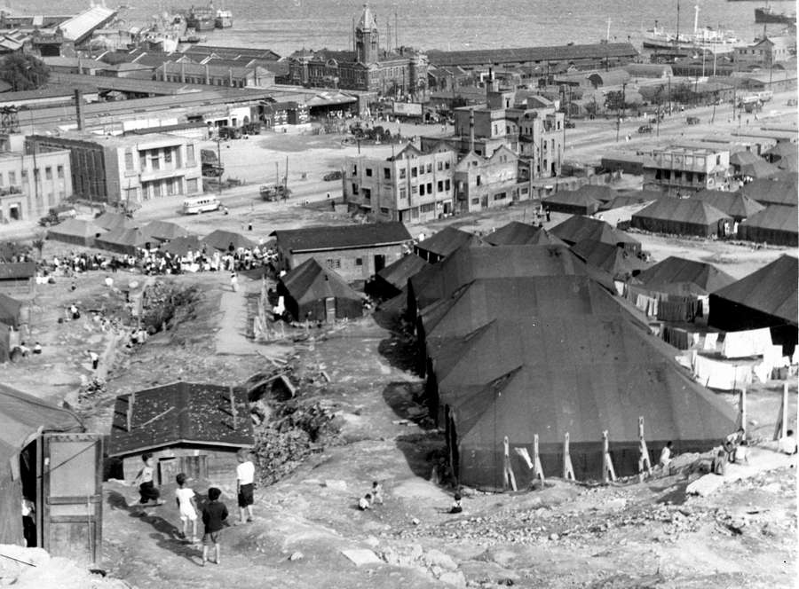

Refugee camp built by the US army after a devastating fire in Busan (NJD)

Kučera described a large fire in a slum in Busan, which Nejedlý had photographed:

Busan is a city of fires. It is natural. The construction materials are wood, wicker, rags, and paper. The sun parches all of that. Then just one carelessly tossed cigarette butt is enough for the houses, which are glued one to the other, to catch fire with tremendous speed and for the fire to spread to the neighbors. It was when we were present that one such large fire broke out only a few hundred meters from our camp. The wind fed the raging flames, which reached a height of five meters. The flames tore through the burning roofs, which came down on the other hovels, giving rise to more and more fires.

An unbelievable panic broke out because the flames soon engulfed the space that once had housed tens of thousands of people. Hopeless people fled in fright and trampled each other. Children perished. Hopelessly disadvantaged, they tried to extinguish the ocean of fire with buckets of water. Nothing could hold back the flames. The flames advanced to the side where the fire had originated and spread further down somewhere.

Kučera added that the Americans helped when hundreds of people lost the roofs over their heads. “The Americans eventually solved [the problem] by housing the homeless in the camps of the former POWs – where there previously had been North Koreans and Chinese.”

Kučera delivered a remarkably complex view of the South in his articles for *Sokolovák*. Although his series strictly copied the official ideological views, he often acknowledged that the situation in the North was no better. “The photographs of the cities in the South exemplified the difficult situation and poverty of the South Korean inhabitants, who one often sell their products directly on the ground [without tables or display counters], just as those in the North.”

Behind the ideological messages in Kučera’s articles, there sometimes were many interesting details. For instance, he described the South Korean fishermen in Gangneung, where there was a cooperative of the type that was typical in the socialist economies. He explained how people in the South got everything possible from the sea: “On the wild rocky cliffs of the shore, one can see women and girls, with turned-up skirts, climbing in the cruel cold to tear small shellfish from the rocks or scrape with a knife from the rocks a type of disgusting green slime, which they then cook and eat.” Kučera also observed the dangerous fishing in Incheon:

Interesting and at the same time horrible is the work of the fisherman. The ebb and flow of the tide at Incheon are dramatically different. The tide reaches a height of 8 to 12 meters. When that strong tide arrives, the fishermen set out to sea and travel in their boats to the location of undersea swamps. There they wait until the tide recedes, so that the boats will be grounded on the mud. The fishermen then go down into depressions and use their hands to catch a large number of sea creatures that they seldom catch in their nets in the open sea. They know the swamps well and are able to go from one depression to the next. It is a hunt during which the blood of the observers on the shore runs cold because one wrong step is enough for a fisherman to disappear forever in the sticky black mass of mud.

Kučera noted the deep influence of the American presence on South Korean society and tried to compare it with the North: “One difference is that the children on the street offer to clean the shoes of the American MPs. Ten-year-old and seven-year-old boys already have acquired the ‘means of production’ in the form of a box with cleaning supplies. They stopped us on the streets and called to us in their native language: ‘Sirs, clean your shoes!’ MPs riding in their jeeps have the habit of stopping at the curb and sticking out their feet.” He also described other impacts of American culture. “Color posters for American films add to the variety of color on the streets,” noted Kučera. “Korean signs mix with those in English, and Korean carts mix with American luxury cars. Megaphones blare Korean music and American jazz.”

**Conclusion**

As those who had been deployed on Korean peninsula returned home, they began to recount their experiences to friends and family and in the process painted a picture that was different from that of the official Czechoslovak media. The discrepancies were no secrets because thousands of people personally knew someone who was in Korea or they met Koreans in Czechoslovakia. A total of 792 Korean children lived in Czech orphanages, 420 Koreans studied in technical high schools, and 571 Korean students studied at Czechoslovak universities. The more accurate personal views gradually amended and corrected the official, ideologically driven interpretations in Czechoslovak newspapers, short movies, and books. At first, the short movies were pure propaganda – montages based on official news agency clips that linked the war in Korea with footage from *Neprojdou!* (They Shall Not Cross, 1952) that conveyed the duty to protect Czechoslovakia’s borders. *Budující Korea* (Building Korea, 1954) was about reconstruction. The next three movies maintained a similar general view, but they were shot in Korea, and the most important contributor to those projects was noted Czech film maker Jiří Ployhar (1927-2009), who was part of the Czechoslovak delegation. *Rozdělená země* (Divided Land, 1954) included the commentary of the NNSC member Jiří Kubka (1924-). Next, Ployhar made a film about the work of Czechoslovak doctors and nurses in Chongjin titled *Československá nemocnice v Koreji* (The Czechoslovak Hospital in Korea, 1954). Finally, *Daleko od Prahy* (Far away from Prague, 1956) showed the work of the NNSC.

In 1955, two books appeared. The first was Kubka’s fictional *Cestovní příkaz do Kesongu* (Travel Orders to Kaesong). The second was a collection of short stories and essays titled *Diamantové hory* (Diamond Mountains), a collaborative effort of medical doctor Bohumil Eiselt (1913-2013), who had served in the evacuation hospital in Korea, and the writer Pavel Bojar (1919-1999). It offered readers an engaging description of the efforts of the staff at the evacuation hospital to assist Koreans and included some excellent photographs.

Korea had a strong impact on all those who had been deployed there. Their experiences were eye opening. They took home pictures and souvenirs, but their most important acquisitions were the discoveries they had made. Unfortunately, many of them paid a high price for the time they spent in Korea. Some contracted serious physical illnesses that took months or years to cure, and many suffered psychological stress from the long deployment and from the difficulties they had encountered.

Others eventually paid a high price for the new perspectives they had acquired because of their contact with another culture. Most of them had believed in communist ideals, but after their experience in Korea, they lost much of their black-and-white view of the Korean conflict. Circumstances in Korea resulted in many challenging – often times ever so slightly – the orthodox interpretations of the Korean War that the Communist party of Czechoslovakia had advanced. Several of these individuals built respectable careers over the course of a decade and a half after their deployment to Korea, and they were supportive of the liberalization efforts of the 1968 Prague Spring in Czechoslovakia. After the 1968 Warsaw Pact invasion of Czechoslovakia, many of them lost their jobs because the new Czechoslovak hardline regime of Gustáv Husák (1913-1991) in the 1970s and early 1980s punished not only those who disagreed with the invasion and the end of the Prague Spring reforms but also those who had cultivated any sort of contacts with Westerners or who had spent time in the West. For instance, Vlček, whose experience in Korea as a radio operator enabled him to serve in the same capacity at Czechoslovak embassies in Jakarta and Athens, had to work in a factory. The translators and interpreters who later worked as journalists or for foreign trade companies faced the same fate. Švamberk, who was employed with the state-run ČTK press agency, was one translator who lost his job. Ployhar’s name no longer appeared in the credits of movies, although many segments of his film clips appeared in compilations about exotic lands. Those who had been workers or who had remained in the military, like Komárek, managed to keep their employment.

*English-language version edited by David E. Miller*

Note: This publication was produced as a part of project RM 04/01/09 of the Ministry of Foreign Affairs of the Czech Republic. Courtesy of Embassy of the Czech Republic, Seoul.

**Authors of photographs:**

FAB Karel Fabián (b. 1931)

KEL Jaroslav Keil (b. 1931), translator

KOM Jaroslav Komárek (b. 1925), head of counter-intelligence unit

MYN František Mynařík (b. 1933), radio operator

NJD Zdeněk Nejedlý (b. 1930), translator

PCK Vladimír Pucek (b. 1933), Koreanist

SAP Mojmír Sapák (b. 1930), truck driver

SCH Jaroslav Schystal (b. 1929), motorcycle liaison

**Contemporary publications on the Czechoslovak participation in NNSC**

**(In Western languages)**

Gnoinska, Margaret K.: “Czechoslovakia and Poland: Supervising Peace on the Korean Peninsula 1953-1955.” *Slovanský přehled*, 2012, No. 3-4.

Kim Se-jeong: “Post-war life captured in photos.” *The Korea Times*, 2013, 26 July.

Olša, jr., Jaroslav: “Die DMZ und Nordkorea in den 1950er Jahren aus der Sicht der tschechoslowakischen NNSC.” In: *Two Lines*. 한국 DMZ – 독일 Grünes Band. Suwon: Gyeonggi Tourism Organization 2013.

Olša, jr., Jaroslav: “Images shed light on work of Czechoslovakia.” *The Korea Times*, 2013, 27-28 July.

Olša, jr., Jaroslav: “Prelude of Communist Fraternity. Interaction of Czechoslovakia and Korea from the World War II to the End of the Korean War.” In: *The Korean Peninsula after the Armistice. South and North as Seen by Czechoslovak Delegates of Neutral Nations Supervisory Commission* (1953-1956). Seoul: Seoul Museum of History 2013.

Švamberk, Alex: “Czechoslovakia and the Neutral Nations Supervisory Commission in the 1950s. Work and Experiences of the first Czechs and Slovaks Helping to Keep Truce on the Korean Peninsula.” In: *The Korean Peninsula after the Armistice. South and North as Seen by Czechoslovak Delegates of Neutral Nations Supervisory Commission* (1953-1956). Seoul: Seoul Museum of History 2013.

**(In Czech and Slovak)**

„Aktivity československých institucí v jihovýchodní Asii v době korejské a vietnamské války.” (Activities of Czechoslovak Institutions in South East Asia during the Wars in Korea and Vietnam). *Securitas Imperii*, 2002, No. 9.

Korený, Jozef: „Slováci v Dozornej komísii neutrálnych štátov v Kórei v rokoch 1953–1993.” (Slovaks in NNSC in Korea, 1953-1993). http://www.mosr.sk/data/files/75.pdf

Olša, jr. Jaroslav: „Zapomenutá mise po zapomenuté válce. Čtyřicet let působení československých vojáků a diplomatů na Korejském poloostrově.” (Forgotten Mission after the Forgotten War. Forty Years of Czechoslovak Soldiers and Diplomats on Korean Peninsula). In: Švamberk, Alex – Švamberk, Jaromír: *Nasazen v Koreji. Zapomenutá válka a Čechoslováci*. Praha: Gutenberg 2013.

Pilát, Vladimír: „Příprava takzvané Zvláštní skupiny čs. armády k činnosti na linii příměří v Koreji.” (Preparations of so-called Special Group of Czechoslovak Army for a Work on Demarcation Line in Korea). *Historie a vojenství*, 1998, No. 5.

Smetánka, Tomáš: „Neutrální Československo. Čtyřicet let v komisi pro dohled nad příměřím v Koreji.” (Neutral Czechoslovakia. Forty Years in the Commission Supervising the Peace in Korea). *Mezinárodní politika*, 2010, No. 6.

Švamberk, Alex: „I Čechoslováci vyšetřovali letecký souboj nad Koreou po válce.” (Czechoslovaks Were Investigating the Dog Fight Above Korea after the War). *Hobby historie*, 2013, No. 21.

Švamberk, Alex – Švamberk, Jaromír: *Nasazen v Koreji. Zapomenutá válka a Čechoslováci*. (Stationed in Korea. Forgotten War and the Czechoslovaks). Praha: Gutenberg 2013.

Vavrincová, Zuzana: „Československo-severokorejské vztahy v kontexte činnosti Dozornej komísie neutrálných štátov v patdesiatych a šestdesiatych rokoch 20. storočia.” (Czechoslovak-North Korean Relations in the Context of Activities of NNSC in the 1950s and 1960s). In: Glomb, Vladimír – Lowensteinová, Miriam (ed).: *Podoby Koreje. Pocta Vladimíru Puckovi k 80. narozeninám*. Praha: Univerzita Karlova 2013.

Zídek, Petr: „Češi v korejské válce.” (Czechs in Korean War). *Pátek Lidové noviny*, 2010, č. 25.

Zídek, Petr: „Ty kluku kimirsenská, já tě mám rád. Během konfliktu mezi Severem a Jihem a bezprostředně po jeho skončení působily na korejském poloostrově stovky Čechů.” (‘I Do Love You, My Kim Il-sung’. Hundreds of Czechs Served on the Korean Peninsula during and after the Korean War). *Lidové noviny*, 2013, 27 July.

Zídek, Petr: „1950: Ty kluku kimirsenská, já tě mám tak rád.” (I Do Love You, My Kim Il-sung). In: Zídek, Petr: *Češi v srdci temnoty. Sedmadvacet reportáží o prvním čtvrtstoletí komunistů*. (The Czechs in the Heart of Darkness. 27 Reportages on the first 25 years of the Communist Rule). Praha: Knižní klub 2013.

**Alex Švamberk** (b. 1961) is a Czech journalist, performer, composer and musician. Although he graduated from the Czech Machinery Institute in 1985, since then he has worked as a journalist, both in the field of culture and nowadays as a political commentator.

As a composer and electronic musician, samplist and percussionist he has recorded three CDs with famous Czech jazz piano player Emil Viklický and one with American singer Laure Amat. He has composed music for two theatre plays, and wrote and recorded four suites for Czech radio, three of them with his own lyrics. He also created numerous dance performances, mostly with live music, partly based on *butoh* dance which he studied in Japan in Min Tanaka’s Mai juku.

He has written two book of interviews with leading British and American punk and hardcore musicians *Nenech se zas oblbnout* (Won’t Get Fooled Again, 2006) and *No Future*! (2012).

Because of his interest of oral history and microhistory he started collecting documents and memories of people who served in NNSC, where his father served, too. His major publication in this field is *Nasazen v Koreji* (Stationed in Korea, 2013).

This study has been prepared in co-operation with the Embassy of the Czech Republic and the Czech Center Seoul.

1. *An abbreviated version of this text was published as “Czechoslovakia and the Neutral Nations Supervisory Commission in the 1950s. Work and Experiences of the First Czechs and Slovak Helping to Keep the Truce on the Korean Peninsula” in: Hong, Seungju – Olša, jr., Jaroslav – Sa, Jongmin (eds.): *The Korean Peninsula after the Armistice as Seen by Czechoslovak Delegates to the Neutral Nations Supervisory Commission 1953-1956*. Seoul: Seoul Museum of History 2013. A list of the photographers will be found at the end of the text.