Transport Development in Korea

Andy Tebay and Nikola Medimorec

This paper describes the development of Korea’s transport system from the first tram in the 19th century to a tram renaissance through new light-rail technology in the 21st century. It draws the development of Korean cities and its prosperity can be shown through major milestones in Korea’s transport development.
We will follow how transport supported Korea’s rapid economic growth and which issues had to be overcome to establish a convenient and efficient public transport system that is now being exported to emerging countries.
The structure of the paper is not completely chronological, and after the introduction, the general concept of transport development is explored, along with different modes of public transport in Korea.

Concept of Transport Development
Barter’s 2004 model of transport development sets a clear and simple framework that can be used as a narrative for Korea’s transport system. The model explains the development of transport from a low mobility city to a large city with high levels of mobility, with several possible paths. The concept sees walking as the dominating method to move through a city with little mobility. With growing population and economic activity, cities encounter an increase in mobility. Depending on policy-makers’ decisions, a city can follow a public transport-dominant trajectory or a private mobility pathway. An absence of public transport measures leads to uncontrolled motorization.

The following figure summarizes the concept:

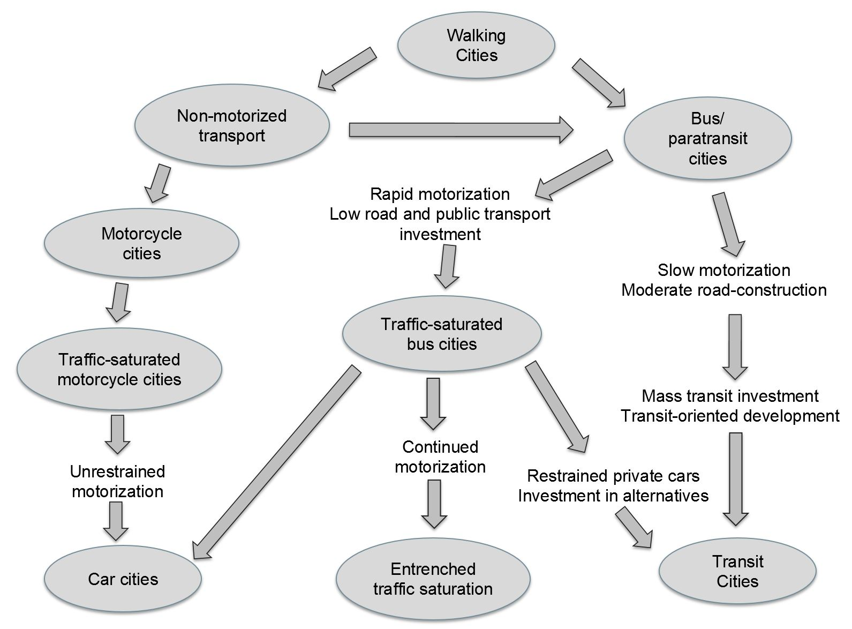
Source: Based on Barter, 2004

Seoul in the 1970s is seen as a bus/paratransit city, and the current Seoul is alongside Hong Kong and Singapore labelled as a transit city by Barter (2004). It emphasizes the success of Seoul, keeping motorization levels relatively low and being able to build a strong public transport network.

Korea’s History from the Transport Perspective

1. Trams
Prior to the first tram, walking and horse riding were the only methods of travel. Even bicycles had not been introduced before the late 19th century. The first bicycle is known to have been brought by the American Lieutenant Philip V. Lansdale and it caused a large stir of interest among the population, according to Neff (2007). King Gojong invited Lansdale for a demonstration of the two-wheeled vehicle.
However, the tram was the first mode of public transport, arriving a just couple of years after the first bicycle. Thus, after one hundred years as a walking city, Seoul suddenly became a paratransit city at an early stage.
The first trams opened for operations in Jongno on May 17, 1899. It was a significant milestone for the Korean Empire, not only because it was the first type of public transport, but because it was a major stepping stone on the road to modernization.
The idea for the tram system in Seoul did not come locally, but from two American businessmen Henry Collbran and Harry Bostwick. Collbran and Bostwick convinced Emperor Gojong of the benefits such a tram system could bring to the city, and ended up embarking on a joint venture which became the Hanseong Jeongi Hoesa (Seoul Electric Company), today known as Korea’s largest electric utility KEPCO. While electricity had already been introduced to Seoul, infrastructure was scarce, and the duo were tasked with putting in street lighting for Seoul along with the tram.
The original tram system had eight 40 passenger trams plus one private vehicle for the emperor. It was the second tram service to open in Asia, the first being located in Kyoto, Japan. There was much excitement from the general public over the launch of the trams, with people coming from all over Korea just to ride it, some spending the entire day on it.
However, the jubilant atmosphere was marred by what is known as Korea’s first traffic accident, when a five year old was struck and killed by a tram. The tragedy was a massive shock to the public, who had never witnessed an accident from such a big vehicle, and as a result the crowd went into a frenzy. The child’s axe-wielding father reportedly went after the conductor, who managed to escape. The tram was set on fire by the mob and completely burnt out. It was the beginning of many mishaps on the road as people became accustomed to trams and later, motor vehicles.
In 1909, the electricity company, which had then changed its title to “American Korean Electric”, went into negotiations with the Japanese. Colbran sold the company to Japan without telling Emperor Gojong about the deal and fled to London, leaving the Emperor furious, but able to do nothing.
The trams had no separate stops like buses or trains, and passengers were required to jump on and off as they travelled. As time went on, the services continued to be successful and the number of rolling stock grew with passengers. In 1937, the city had 150 trams with an average of 150,000 passengers per day.

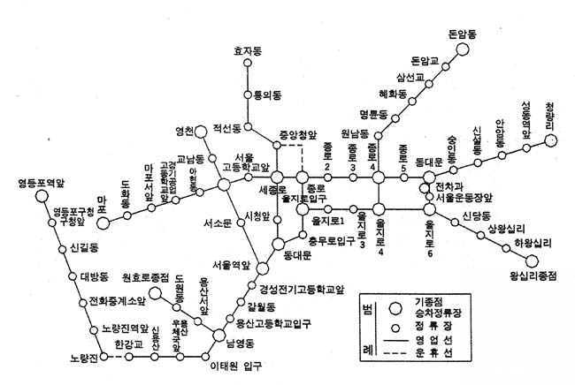

Tram routes were extensive and travelled to all major areas in Seoul at the time, including Seoul Station, Cheongnyangni, and across the Han River to Yeongdeungpo Station. Trams also spread to other cities around Korea, including Busan, which operated a system from 1915 to 1968, as well as Pyongyang from 1923 to 1950. Trams made a return to Pyongyang in 1991 and still run today alongside trolleybuses that have been in the city since 1962.
Following the war, trams continued to operate in Seoul despite infrastructure damage, and still had strong patronage in the 1960s, with 350,000 passengers and 197 services a day in 1966 (Joongang Ilbo, 1966). Despite this, there was little expansion of the tram network following the war. The rise of the motor vehicle had led to roads becoming extremely busy, and the infrastructure and vehicles had begun to age.
Trams officially went out of service in 1968, and from then until the first subway line opened in 1974, bus was the only public transport available in Seoul. A restored tram from the 1930s is permanently on display outside Seoul Museum of History.

2. Buses
Seoul continued to grow under Japanese occupation and buses were introduced. The city passed the 1 million population mark in 1942, but it wasn’t only Seoul’s population that was growing. Seoul’s city limits were also expanding, but the tram network did not follow the expansion and other forms of public transport were needed.
According to official statistics in 1965, the bus replaced the tram as the major public transport mode. Over half of all trips (54.4%) in 1965 were made by bus.
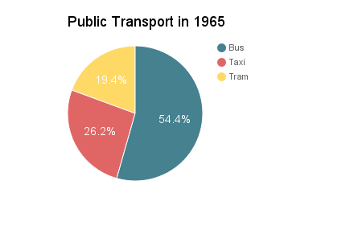
During the economic boom, the “miracle on the Han River,” the bus was the only public transport method able to keep up with the dynamic development, because subways required a long planning and construction phase.
The first buses were not designed for comfort or a pleasant experience. Their purpose was to transport a large amount of people, and the most efficient way was to have standing passengers. The first buses didn’t have any seats and were created with the pure intention of transporting a large amount of people without any regard for convenience.
One main characteristic of the bus era was the female conductors. Every bus had a female conductor to collect fares, tell the driver when to stop and when to depart. In post-war Seoul, the strategy to employ female conductors was introduced in 1961. The job was fairly popular as it only required basic education, and besides a salary, female conductors received free board and lodging which was beneficial for women who came from other parts of Korea to Seoul. In 1965, there were around 17,160 female bus conductors employed. The profession of female conductors disappeared abruptly in the late 1980s due to modern technology.
Bus services became a big financial burden for Seoul, while other issues such as corrupt hiring practices and inefficient management were also present. The city decided to privatize buses in 1972, but it was a bad decision with bad timing.
The privatization of bus services in the 1970s was a mistake, as bus operators had the freedom to choose their routes which meant that they focused only on the most profitable areas. A large number of buses served major routes, competing to transport as many passengers as possible, and in this way still following an outdated approach. Most importantly, the buses often neglected elderly, young children and people with disabilities, as waiting for them to get on the bus was a disadvantage in the race to the next bus stop.
Besides the bus privatization, the 1970s can be also seen as the start of slow private motorization and the subway era. These two factors accelerated the rapid decrease of bus trips. In 1971, 74.2% of trips were made by bus in Seoul, but by 1995, the modal share of buses fell to 36.7%. A vicious circle began — low bus service quality pushed people to buy their own cars, which caused traffic jams and lowering the bus service quality even further.
Seoul tried to break the vicious circle in 1997, but improvement plans failed. It wasn’t until 2004 that Seoul was able to revolutionize public transport. A major milestone in Korea’s bus history is the Cheonggyecheon Restoration project, with the so-called public transport reform under Lee Myung-bak as the mayor of Seoul. The project removed an elevated urban freeway and restored the former stream as a new public space. The public transport reform was implemented in parallel and officially launched on July 1, 2004. It was introduced city-wide, as a previous trial in a small district failed due to the scale. It consists of the following elements: (1) semi-public bus management system, (2) bus only lanes, (3) bus classification and (4) transportation cards with an integrated fare system.
First, the city took again the control over bus operations, but it didn’t completely remove private stakeholders. While the city government decides the fares, subsidies, routes and bus frequencies, private companies still own and maintain the vehicles, provide the bus service, collect fares and pay the drivers.
Secondly, bus-only median lanes were introduced in various parts of the city. They are high occupancy vehicle lanes that allow vehicles that exceed a certain number of passengers to use them — the main advantage being an increased driving speed. Seoul previously had a few hundred kilometers of curb-side bus-only lanes, but as such a system causes many conflicts between buses and right-turning cars, such lanes don’t offer any speed advantages.
Thirdly, the buses were newly categorized and the four colors (blue, green, yellow and red) were introduced. The blue buses are trunk buses which pass through large parts of the city, and green buses are feeder routes that usually connect to subway stations. Intercity buses are red, and yellow buses are loop routes which operate in a few neighborhoods. These are not the only bus types, but the main types that were introduced through the reform.
And lastly, probably the most important new feature for public transport users has been the integrated fare system. It allows the use of public transport with a single card, and transfers within a certain timeframe between different buses and subways. It is impossible to imagine Seoul’s public transport without this feature.
While it was officially called a public transportation reform, it can be rather described as a public bus reform. Best practices from other countries were investigated, and the median bus lanes and bus categorization structure was adapted from the Brazilian city Curitiba.
The results of the bus reform were an increase in bus service quality, proven through user surveys, and the downtrend of bus users was stopped. As mentioned earlier, buses escaped the gridlock of traffic jams and the operational speed of buses increased, too. Bus accidents decreased, even though there was initially an increase directly after the implementation. The transfer system also reduced transport costs for citizens.

3. Metro
While bus patronage was dropping before the reform, Seoul’s subway system was gradually being developed and becoming a preferred mode of transport for many. However, if we look at how Seoul’s subway originally came about, it took some time for construction plans to be acted upon.
Travelling around Seoul for commuters had became difficult after the tram system was abandoned in 1968. Plans to build four subway lines in Seoul had been considered even prior to trams being removed, but the government did not show much interest and was inevitably delayed. In the period from 1960 to 1970, census results show that Seoul’s population exploded from approximately 2.4 million to more than double that at 5.52 million, boosting the need for a transport solution even further. Progress had been notably slow until Mayor Yang Taek-sik became the 15th Mayor of Seoul in 1970. Yang was previously head of the Korea National Railroad, and knowing the importance of building a metro system, he got started on building it right away.
Construction on Seoul’s first underground subway — Line 1 between Seoul and Cheongnyangni — began in 1971 and was completed in August 1974. While the subway section had only five stations, it was also the start of metro services to northern Seoul via the existing railway, ending at Seongbuk Station, now known as Kwangwoon University Station. Southern services also stretched to the Incheon and Suwon areas. It was hoped that this would disperse some of growing population from Seoul to neighboring cities, as well as reduce traffic congestion and pollution. There were several events planned for the opening of the subway, which had been scheduled to take place on the National Liberation Day of Korea, August 15. However, most plans were cancelled when the first lady at the time, Yuk Young-soo, was assassinated on the same day.
Rough plans for other subway lines to follow Line 1 had been drawn up, but changed multiple times over the years. When Yang stood down the same month after opening Line 1, new mayor Ku Ja-chun took the lead on the next project, Line 2. Plans had already been through multiple revisions, including changing the line to a loop. It’s been documented by the Ministry of Land, Infrastructure and Transport (2013) that Mayor Gu drew the route himself in about 20 minutes with a coloured pencil on a map. Somewhat amazingly, the line was built from this rough plan into Line 2 as we know it today, with very few changes.
Although Line 2 was planned as a loop, it was built in stages and opened gradually over four years from 1980 to 1984. The first section of track was from Seongsu to Sinseol-dong, which operates today as a secondary service off the main line. Construction began from Sinseol-dong, not only because it was a transfer point, but also because rolling stock was able to be transported directly onto the new line via a connection to Line 1. A section from Seongsu to Sports Complex was also built at the same time, and both sections opened on October 31, 1980.
Remaining sections were completed and opened over the following years, with the final 19.8km section from Seoul National University to Euljiro-1-ga opening on May 22, 1984. For 28 years Line 2 was the world’s longest metro loop at 60km, until it was surpassed by Beijing’s Line 10 in 2012. Today it’s the most used subway line in the country, transporting over two million people a day, and making up over 30% of all subway use in Seoul (Seoul, 2014).
Seoul Metro was established in August 1981 when it became responsible for operating Lines 1 and 2, as well as picking up the construction and future operations for the remaining two lines. Lines 3 and 4 were built and both opened on the same date in October 1985. The next stage for the development of Seoul’s metro system was building lines 5 to 8, which was transferred to new public corporation Seoul Metropolitan Rapid Transit in 1994. The first construction began on Line 5 in 1990 and all four lines were open by August 2000.
Seoul’s metro system has continued to grow over the past two decades, with many new lines and extensions providing an efficient means of transport to cities and towns all across the Seoul Capital Area. It is also important to note that other major cities around Korea also built their own metro systems, starting with Busan in the 1980s and followed by Daegu, Incheon, Gwangju and Daejeon. For all these cities, metro systems play a huge role in how people commute and travel.
For Seoul, the metro system is a vital lifeline and the highest used mode of transport. It boasted a modal share of 37.1% in 2014, with buses and cars at 28% and 23.5% respectively (Seoul, 2014). Even delays of ten minutes make news headlines as crowds waiting for services often amass very quickly, even during normal operations. Seoul’s metro is a very large system by international standards and is sixth longest in the world, with 331.9km of track — soon to surpass Moscow at fifth place.
While metro systems are often referred to as subways, not all lines are underground or standard rail, and over recent years we’ve begun to see the addition of various light rail lines all over Korea.

4. Light rail
What made large agglomerations in Korea special was the equal mix of bus and subway lines. The public transport reform was basically a large bus improvement package and it emphasized the importance of bus services in the capital. However, the tide changed in 2011 as Mayor Park Won-soon introduced plans to build ten new subway lines in Seoul. This indicated that the current subway-bus system was not sufficient enough and that the city is moving towards a higher ratio of rail-based transport.
Seoul is not the only city increasing the modal share for rail, with new lines opening in different parts of the country almost every year. However, there has been a much stronger preference to build light rail over traditional standard gauge systems in the past decade. Since 2011, seven new light rail lines have opened across Korea, more than the number of standard gauge lines that have opened over that time. While many of these new lines have been successful, light rail originally got off to a shaky start with projects marred by accidents and delays.
The first form of light rail scheduled to open for use as public transport was the Incheon Wolmido Eunha (Galaxy) Monorail. The plan was to build a loop track around the Wolmido area and it was hoped that the new system would revitalize this tourism focused area which had become dated and dropped in popularity. Although the monorail was completed in 2009 and scheduled to go into service later that year, the opening of the line was repeatedly postponed, and operations came to a full stop after a wheel came off during trial operations and injured a woman who was passing below.
The incident resulted in a full investigation which revealed multiple flaws. Despite efforts to repair the line and get it up and running, the Eunha Rail was doomed to never open, and trains were finally removed from the track in 2016. However, the track itself was not dismantled, and a tourism venture plans to use the infrastructure to operate smaller vehicles on guided rails.
The next light rail line that was supposed to open after that was the Everline in Yongin, but this project also sat dormant over the city for three years after construction was finished. This was due to a number of issues between Yongin City and the line’s operator YongIn Everline, including a spat over the minimum revenue guarantee (MRG) for the project. The line finally opened in 2013, forfeiting the title of Korea’s first light rail line.
Busan, on the other hand, opened two light rail lines in 2011 — Busan’s Line 4 was opened in March 2011, while the Busan–Gimhae Light Rail Transit (BGL) was opened in September 2011. Since then, other light rail lines have opened in Uijeongbu (2012), Suncheon (2014), Daegu (2015), and Incheon (2016). Seoul is currently preparing to open its first light rail line in the north of the city September 2017.
However, not all of these systems are the same. The definition of light rail can be debatable, and for the purposes of this essay, several different modes of transport come under this term. Light rail can be at street level, raised or underground; Incheon’s line 2 is an example of both underground and aboveground. Certain types of light rail, like trams, share roads with other traffic, while others have their own dedicated track.
Automatic Guideway transit is the most common type of light rail system, and Korea has several rubber and steel-wheeled AGT systems such as the U Line (Uijeongbu) and the Everline (Yongin). Daegu’s third rail line is Korea’s first monorail used for public transport, and Suncheon has a PRT (personal rapid transit) system at its famous wetlands location. While not technically light rail, another new type of train system operating is Incheon International Airport’s urban maglev line, which is the world’s fourth commercially operating maglev system.
It is clear that Korea is not shying away from trying new technology and transport methods to help the public travel more efficiently. Moreover, all of Korea’s light rail lines are automated, with no driver operating the vehicles. This type of automated signal system isn’t limited to light rail, and standard gauge rail lines such as the Sinbundang Line are also automated. Korea currently has the second highest number of automated metro lines in the world, and its transport operators plan to continue implementing the technology on new and current lines.

Conclusion
Korea’s transport system has been through many changes over the past century, but has ultimately been successful in implementing efficient modes of transport throughout the country. While public transport improvements were previously often Seoul-focused, now many of Korea’s cities are active in trying to develop transport infrastructure through new rail lines, bus systems and technologies.
Most interestingly, many cities are now looking to implement trams again, almost 50 years after they were scrapped. Seongnam, Daejeon, Incheon and Suwon have all expressed interest in operating trams, with the first line expected to open in the tech-hub of Pangyo. Many citizens may find the return of the transport mode surprising, and the announcement of Daejeon’s Line 2 as a tram line has indeed received a mixed response.
While Korea's, and especially Seoul’s public transport is now emulated by many other cities around the world, there is still much room for improvement. Local governments are trying to encourage less use of private motor vehicles, not only to relieve congestion, but also to reduce carbon emissions — something desperately needed in a city like Seoul.
Nevertheless, as transportation infrastructure comes full circle with the reintroduction of the tram, we can look forward to a promising new future for Korea’s public transportation. New technologies and environmentally-friendly measures will be key in developing a better transport ecosystem for everyone.

References:

Barter, P., 2004, A Broad Perspective on Policy Integration for Low Emissions Urban Transport in Developing Asian Cities. Paper given at an international workshop, Institute for Global Environmental Strategies. Kanagawa, Japan

Neff, R. (2007). Bicycles Excite Jealousy in Joseon Korea, OhmyNews. Retrieved from http://english.ohmynews.com/articleview/article_view.asp?no=354957&rel_no=1

Joongang Ilbo (1966). 전차 없애고 「고속」으로 바꿔. Retrieved from http://news.joins.com/article/1023753

The Ministry of Land, Infrastructure and Transport Blog (2013). 대한민국 지하철의 역사_2편. Retrieved from http://korealand.tistory.com/2420
The Seoul Research Data Service. 1960 Census. Retrieved from http://data.si.re.kr/
The Seoul Research Data Service. 1970 Census. Retrieved from http://data.si.re.kr/
Seoul Metropolitan Government. 2014. Seoul Public Transportation

Andy Tebay is a New Zealander who has lived in South Korea for 7 years. He has a Bachelor of Arts in Korean and Linguistics from Auckland University and a Master of Business Administration from Sejong University. Andy is a writer for several publications including the International Rail Journal. With an avid interest in transport, he created the website Kojects.com in 2011 to report useful information about transport and urban projects in Korea.

Nikola Medimorec was born in Croatia and grew up in Germany. He has a B.Sc. in applied geography from the University of Trier in Germany and an M.A. in geography from the Seoul National University in Korea. In both degrees he focused strongly on transport and sustainable mobility. Professionally he works on research related to climate change and transport. On Kojects.com, he writes on urban policies as well as about walking and cycling measures in Korea.

