“Brilliant as the Morning Star”

Cultural notes on the yogang

Boudewijn Walraven

A Controversial Discovery
In the late 1970s I spent about three weeks roaming in the attic of what is probably the world’s oldest museum of ethnology, the Leiden Museum voor Volkenkunde in the Netherlands (going back to the 1830s), in order to trace the unexpectedly numerous Korean objects owned by the museum, so that after many years in utter darkness in drawers and storage cupboards they could be exhibited once more. Some of the things Korean the museum owned antedated its founding and had been acquired by the Dutch on Dejima, the artificial island in the bay of Nagasaki, which for centuries was the only place where Europeans, mainly Dutchmen but also some foreigners in the service of the Dutch East India Company, could enter Japan. In Nagasaki they sometimes could observe or even meet shipwrecked Koreans who were waiting for repatriation through the good offices of the feudal lord of Tsushima, who served as the diplomatic intermediary between Japan and Korea. Almost as soon as Korea opened its borders in 1876 the museum also commissioned persons who travelled to Korea to collect more items for its displays. Among them was, for instance, the German Friedrich Kraus, who in 1885 went to assist King Kojong with the creation of the Korean Mint.
What I found in these weeks included a variety of pieces of clothing as well as all kinds of furniture and knickknacks, so it was decided to recreate an interior with the mannequin of a seated gentleman, for which we arranged a good number of the objects we had found, mainly the paraphernalia of the scholar, with a low table for the book the man was reading, paper, brushes, a letter rack, and an inkstone, as well as a meter-long pipe, a tobacco pouch (which actually still contained 19th-century Korean tobacco) and an ash-tray. In a corner of the room there was a shiny round brass vessel with a lid. After a while, the museum was visited by an official from the Korean Ministry of Culture who, as soon as he saw the last object, indignantly demanded that it would be removed.
What had made the official so angry and was this object really so out of place that his anger was justified? An eloquent answer can be found in an account of the French writer Charles Varat, who travelled Korea in 1888 and 1889, and in 1892 reported about this in Le Tour du Monde, a kind of nineteenth-century French National Geographic Magazine.

A little later, we are joined by a stylish rider that we recognize as a courtier because of his robes and hat of hair from which two small wings project horizontally. He is followed by a servant on foot carrying on his shoulder, in a net bag, a round box of copper, 25 cm in diameter and 12 cm high, which sparkles in the rays of the sun with golden reflections. Struck by the ceremonial aspect of this new form of porterage, I ask my companion if this vase is not a tin of provisions. He laughs.
“Ah! I have it, I said: It’s a great box of sweets.
- You're nowhere near, he says, this vase, always made of metal, with a lid and no handle, plays a much more important role in Korean life. It is mandatory for all, as each has his own and never leaves it behind, even during visits and especially when traveling. The poor carry it themselves; the rich have a special servant attached thereto who has to keep it at all times in the most sparkling cleanliness, available for the master. Even the Mandarin himself, in all the pomp of his official visits, treating it as almost equal to his own seals, employs it as a counterweight on the horse carrying them.
- But what is its use?
- It is used day and night, in solitude, and in meetings, whenever the need arises. Here's how: on a sign, the clerk hands it to you and it is gently slipped under the long coat. Its function once performed, carefully putting the lid on, removing it from the asylum where it was briefly hidden, it is returned to the attentive servant: he knows what he has to do, while we continue peacefully the conversation as if nothing had happened. In addition, this object serves as a spittoon and replaces if necessary a candle-stick once its owner has disposed the cover to this end: finally, precious container! it is often used as a pillow by the poor of this world. Therefore, given its quintuple use in Korea, added my companion, I advise you, when you speak, to call it the “national vase.”
- No, I said, all civilized peoples use it, but I find that here it is no longer “chamber”, since it moves freely everywhere, or “night” because we meet it in sunlight, so it should be called, given its multiple functions, the “indispensable.”

In other words, Varat concludes that although it is a pot de chambre or a vase de nuit, these appellations do not do justice to the true identity of what in Korean is called the yogang; its position in Korean culture is infinitely more elevated than that of its western equivalents.

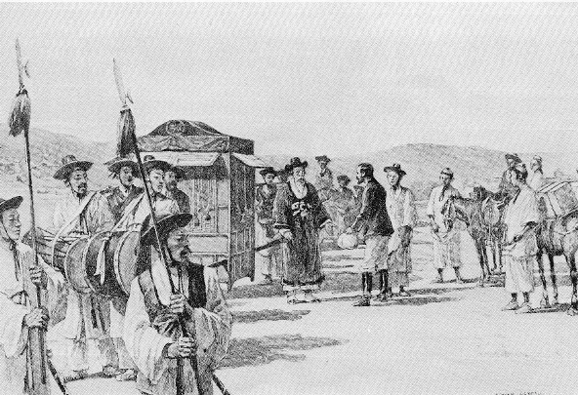
Varat meets a high official during his travels.

Varat was, incidentally, not the only person to mistake the yogang for something else. It is reported that an American lady at the end of the nineteenth century bought one of these handsome brass vessels and to the consternation of her Korean guests served soup in it. Equally in the dark was the intrepid German traveler Rudolf Zabel who visited Korea on his honeymoon during the Russo-Japanese War and published a book about it, with a photo of a yogang, together with some smaller brassware, spoons and chopsticks, accompanied by the caption: “Brassware, together forming a complete Korean dinner set.”

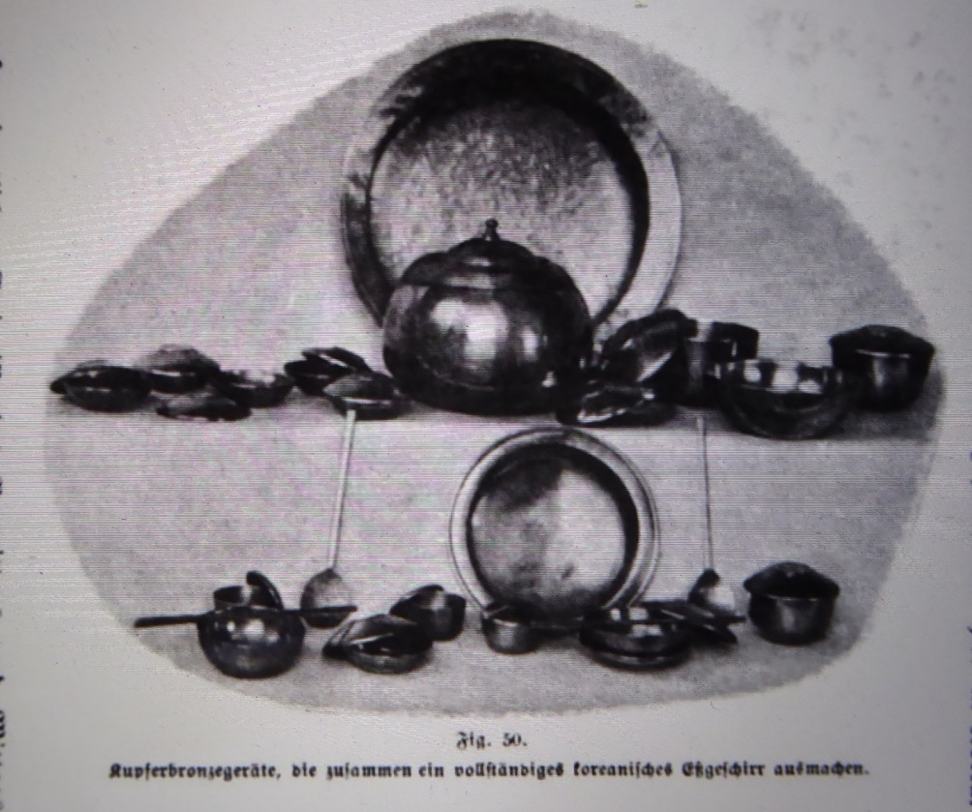
The illustration from Zabel’s Meine Hochzeitsreise durch Korea während des Russisch-japanischen Krieges (Altenburg: Stephan Geibel Verlag, 1906), p. 207.

It should be added that, in spite of Varat’s assertion to the contrary, not all yogang were made of metal. An early nineteenth-century encyclopedic work mentions various other options. These included oiled cow hide and lacquered paulownia wood. They might even be made of lacquered paper, with the advantage, particularly for those who travelled without the assistance of servants, that they were very light (like the yogang made of paulownia wood). Ceramic yogang were also an obvious alternative, but it should surprise no one that brass was a favorite material, first because Koreans already in the Shilla period had achieved a high degree of mastery in metalworking, and second for aesthetic reasons, which also are alluded to in Varat’s account, and are prominent in some of the texts cited below.

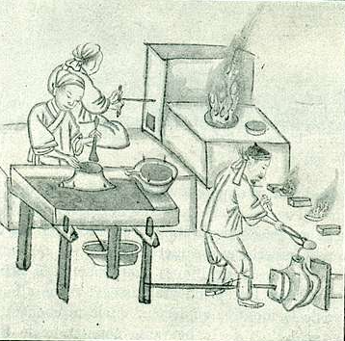

Metalworkers (“fondeurs”), one of the illustrations of Varat’s article, by Kisan Kim Chun’gŭn, an artist from Wŏnsan, who made innumerable sketches of Korean life for foreigners visiting Korea in the last two decades of the nineteenth century.

A Thing of Beauty
We do no not need to take the word of a foreigner like Varat who spent a relatively short time in the country as the last word about the place of the yogang in Korean society, even if he proves to be more trustworthy than Zabel. Nineteenth-century Korean literature, too, suggests that, humble as its function might be, a nice yogang could be an object of pride. The first piece of evidence is a shaman song about Sŏngju, the deity who protects both the house and the master of the house. In this particular song Sŏngju is referred to as Hwangje, the Yellow Emperor, but this is not reflected in his function. The deity appears here as a master builder and the song describes the entire process of the building and furnishing of a luxurious mansion, from the felling near Andong of the trees needed to construct the house to the minutest details of the decorations. The following passage is found near the end of the song.

If you want to have a look at the adornments of the room
[you see that] cushions and blankets have been spread out!
Tiered chests, square étagères
and back-rests from Chinju have been placed there!
Document chests of red sandalwood have been placed there!
Big screens and small screens,
a screen with filial children, a picture with the bliss of Guo Ziyi
and a screen with a hundred playing children have been placed there!
A rack to hold comb-cases, on which a pair of phoenixes is drawn,
is hanging prettily from a decorative knot
made of scarlet silk, in the form of a bee.
A chamber-pot brilliant as the Morning Star,
ash-trays and cuspidors are scattered here and over there.
Hwangje, who provides
wash-basins with a wide rim, wash-basins with a cover,
small basins and big basins, complete sets of then,
please enjoy yourself to your heart’s content!

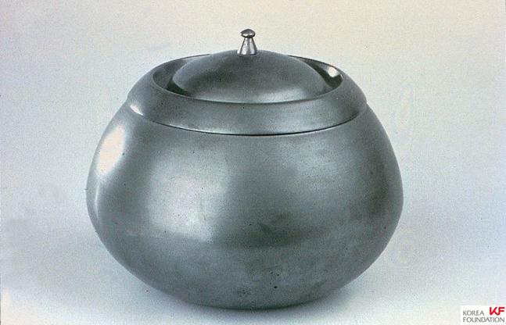
The yogang from the collection of the Leiden Museum of Ethnology.

It is no wonder that in “Hanyangga” a long nineteenth-century poetic description in the kasa form of the capital and its many marvels, the yogang, too, is mentioned as one of the many tempting items on sale at the city’s markets, which offer the best produce from the country and overseas:

[They sell]…
copper-nickel spittoons and jade spittoons,
copper-nickel yogang and silver ashtrays,
Japanese picnic boxes and Chinese picnic boxes,
and large inlaid dining tables…

Korea’s most celebrated traditional love story is undoubtedly that of Ch’unhyang, the daughter of a lowly kisaeng, and Yi Mongnyong, the son of the local magistrate, both just sixteen years old. There, too, the yogang has its place. When Ch’unhyang’s mother has consented to have her daughter joined to the young aristocrat, she has the bedroom prepared for their first night together.

The maid set out the quilt embroidered with mandarin ducks, a pillow stuffed with pine-nuts, a round brass chamber-pot which shone like the morning sun, and a large bowl of clean water. “Good night, sir. Sleep well.’

Modest as its role is in these lines, soon the yogang will play a more active part, in a passage that reminds me a little of a nouveau roman in which a dinner is described entirely through objects, the food items that are eaten and their progress through the human body.

Ch’unhyang slipped between the sheets. The boy quickly followed her, removed her bodice and threw it on a pile with his own clothes in the corner. They lay clasping each other. How could they sleep like that? As their bones melted in ecstasy, the heavy quilt danced, the brass chamber-pot kept time with ringing sounds, the iron loop of the doorhandle rattled, the flame of the candle flickered delightedly. It was the finest sort of sleep. Could any joy be greater than this?

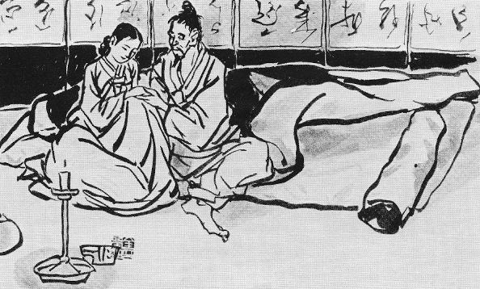
The yogang, discreetly but unmistakably present on the left, in a sketch by Kim Kich’ang that depicts a spring-autumn couple quite different from the two young lovers in the Ch’unhyang tale.

The story of Ch’unhyang has been told and retold in many forms and one of the retellings (Ilsŏl Ch’unhyang; serialized in the Donga Ilbo in 1925-1926) is by the man who is credited with writing the first truly modern Korean novel, Yi Kwangsu (1892-1950). Below he describes the preparations for the birthday banquet at the yamen of the evil local governor on the day he intends to kill Ch’unhyang if she does not consent to sleep with him. Again, the passage emphasizes the splendor of what was on view.

Cloud-like awnings white as snow had been raised, high and imposing. The hall of the yamen was full of embroidered screens, screens with peony blossoms, all kinds of screens. They sat on big mats with flower patterns, mats with decorations on the sides, cushions decorated with flowers in full bloom, decorated poufs, blankets of Mongolian felt wrapped around them. Paper lanterns, lanterns made from cow horn, and glass lanterns, were hung in great numbers from the rafters, on cords of fine pearls threaded with red cotton yarn: they intended to revel till deep in the night. Yogang bright as the Morning Star, cuspidors, and candlesticks adorned with sleeping dragons, were placed wherever you looked.

This provides confirmation of Varat’s observation that the yogang were in attendance at banquets, although in this case it seems they were provided by the host rather than brought by the guests.
The yogang also makes an appearance in the p’ansori version of the tale of the two brothers Hŭngbu and Nolbu. After the kind-hearted but poor Hŭngbu has taken care of a swallow’s broken leg, the next spring the swallow brings Hŭngbu some seeds when it returns from wintering in southern China. These grow into gigantic pumpkins. Hŭngbu saws them open and finds to his delight that they contain all kinds of riches and precious objects. From one of them even steps a concubine for him, no one less than Yang Guifei (the favourite of Tang Emperor Xuanzong) famous as one of the greatest beauties in Chinese history. It does not detract from her charms, rather adds to the splendor of her entry into the story, that in her retinue a shiny yogang is carried along (just as in Korea yangban brides when they were taken to their husbands’ homes would have a yogang with them in their sedan chairs). The gift of the concubine leads to a heated discussion between Hŭngbu and his wife, who thinks it cannot be accepted. But it is Hŭngbu who wins in the end, with the clinching argument that it would not be fair to Yang Guifei who has come from so far, all the way from China (and, we might add, from a thousand years back) to be sent home. The lazy and black-hearted Nolbu tries to imitate Hŭngbu, even if in the absence of a swallow with a broken leg he has to catch one and break its leg intentionally, and eventually grows pumpkins that turn out to contain everything imaginable that is revolting and undesirable, from excrement to tax collectors.

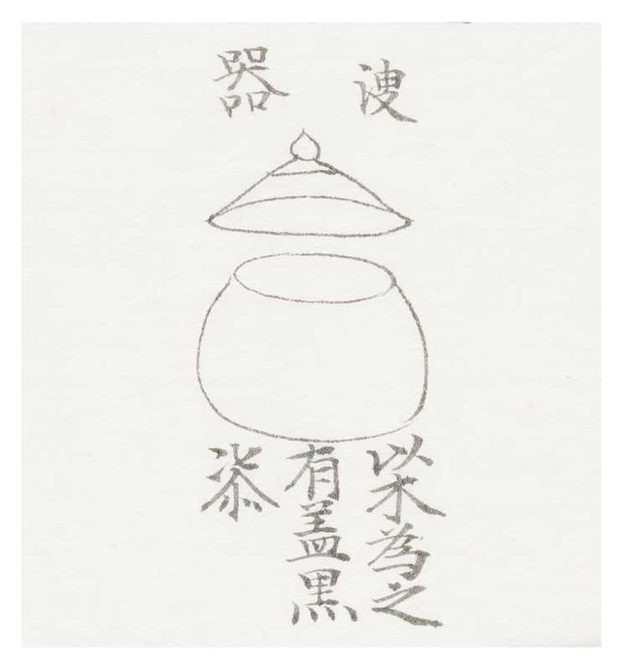
Illustration of the sugi in the Sejong shillok.

The yogang also played a role in royal funeral customs. From the Veritable Records (Chosŏn wangjo shillok) of the reign of King Sejong we learn that a yogang (in this case called sugi, literally “piss-pot”, although there was also a specific word for the yogang used only in the palace: chira) was included among the many objects (myŏnggi) that were buried with a deceased person, in this case someone belonging to the royal family, to serve him or her in the afterlife. These were usually miniaturized and included “wooden slaves.” The Shillok also present a picture of this sugi, noting that it should be made of wood, have a lid (as any yogang would) and should be covered with black lacquer. For many centuries the royal dead will have had this convenience at their disposal, until in the eighteenth century King Yŏngjo gave instructions to curtail the number of myŏnggi and judged that the sugi was “unnecessary.”

Fond Memories
From the above it will be clear that the yogang might be a prized possession, an object of pride. It could also be an object of affection, although that may be difficult to understand for those who have not experienced the revolution in life style that occurred in the 1970s and 1980s. As late as the early seventies many people even in Seoul lived in Korean-style houses that had a toilet outside, which meant that on a cold winter night a trip to the outhouse would require some steeliness. Even the “modern” free-standing two-story houses that were the latest thing at the time did not always have an indoor toilet (I lived in a house like that then). The high-rise apartments that have made Korea into an “apartment republic” started to be built in greater numbers only from the mid-seventies, once the problem of increasing water pressure to reach the highest floors had been solved. In those days the yogang was a great comfort, particularly to the elderly, but not just to them, as an author in Korea Journal mentioned in 1981 in a small piece entitled “Only Yesterday.” He himself had fond memories of it, but noted that it was about to be forgotten, and that children did not even know the word or thought that it was the name of a kind of toffee. The celebrated movie director Lee Changdong (born in 1954) may belong to a transitional generation. During a lunch where some reflections on the yogang were prompted by the serving of pokpunja (Korean bramble) liquor, of which the name is said to signify that the fruit of which it is made will make the drinker pee with such force that the yogang will be overturned, he described himself as belonging to the generation that had to empty the yogang of the elders. Even in such a case, the memories attached do not have to be negative. In his autobiographical One Spoon on This Earth, the Jeju writer Hyun Ki Young talks lovingly of his great-grandfather, of: “his ramie-like beard, the smell of tobacco, and the smell of urine from a chamber pot in the corner of the room. Despite the stench, even now it’s a heart-rending memory for me, as if I still could reach out and touch the warmth of his body.”

Boudewijn Walraven is a retired Professor of Korean Studies of Leiden University and presently attached to the Academy of East Asian Studies of Sungkyunkwan University, Seoul.

Frits Vos, “A Meeting Between Dutchmen and Koreans in 1828”, Korea Journal vol. 23, no. 1 (1983), pp. 4-12.
Charles Varat, “Voyage en Corée,” Le Tour du Monde LXIII, Mai 1892, pp. 289-368. The English translation is by Brother Anthony, who also has made it available online, together with the original: http://hompi.sogang.ac.kr/anthony/Varat/, Section Two.
The website of the Museum of Korean Straw and Plants Handicrafts (Myeongnyun 2 ga, Jongno-gu, Seoul) has a similar picture from another, unidentified German book, roughly from the same period, displaying a dining table with “table ware for two” (http://www.zipul.co.kr/coding/sub4/sub5.asp?bseq=9&mode=view&cat=-1&aseq=350&page=16&sk=&sv=; accessed May 15, 2017). The museum also shows a yogang, together with two spittoons, which are very similar in form, but much smaller.
Han’guk minjok munhwa tae paekkwasajŏn (Great Encyclopedia of the Culture of the Korean People), lemma: yogang; online: encykorea.aks.ac.kr (accessed May 13, 2017).
A Tang general who following a distinguished career lived with eighty grandchildren under one roof and after his death was worshipped as the god of wealth and happiness.
Boudewijn Walraven, Songs of the Shaman: the ritual chants of the Korean mudang (London: Kegan Paul International, 1994), pp. 187-188.
Pak Sŏngŭi (annotations and transl.), Nongga wŏllyŏngga.Hanyangga (Seoul: Minjung sŏgwan, 1974), pp. 126-129.
Translation (with a slight modification) by Richard Rutt, from Virtuous Women: Three masterpieces of traditional Korean fiction (Seoul: Korean National Commission for UNESCO, 1974), p. 273. With “shone like the morning sun” Rutt, who was a superb translator, took the liberty of not translating literally the standard epitheton ornans of the yogang: “brilliant like the Morning Star.”
Virtuous Women, p. 274.
In deference to female modesty, the yogang would be lined with cotton wool, so that its use would not produce any sound.
Sejong shillok 135:1B.
Sejong shillok 134:4B.
Yŏngjo shillok 89:31B-32A.
Valerie Gelézeau, Ap’at’ŭ konghwaguk (Seoul: Humanist, 2007).
Y.I. Song, “Only Yesterday,” Korea Journal vol. XXI, no. 6, p. 60.
Hyun, Ki Young, One Spoon on This Earth, translated by Jennifer M. Lee, Library of Korean Literature 2 (Champaign: Dalkey Archive Press, 2013), p. 15.

