North Korean Fragments of Post-Socialist Guyana

Moe Taylor

The Co-Operative Republic of Guyana has never conformed to simple geographical or cultural categories. It is the sole Anglophone country in South America, possessing a West Indian character akin to that of its fellow former British colonies among the Caribbean islands. And yet it contrasts drastically with these neighbours in several respects as well: for example, the survival of a vibrant indigenous culture, and the fact that people of South Asian descent make up the single largest constituency among six officially recognized ethnic groups. Guyana has faced much adversity since gaining independence from the British Empire in 1966, and long been designated the second-poorest country in the Western hemisphere after Haiti. For over two decades (1964-85) political life was dominated by Forbes Burnham (1923-85), leader of the People’s National Congress (PNC), an era many Guyanese associate with economic hardship and authoritarian rule in the context of a failed experiment in socialism. Since the post-PNC government embraced the neo-liberal consensus in the 1990s, economic growth and greater consumer affluence have been accompanied by drastically widening inequality, rampant corruption, the periodic revival of ethnic violence, reckless environmental destruction by multinational mining and logging companies, and the rise of narco-politics.
Another factor that makes Guyana so unique in Latin America and the Caribbean is the memories and vestiges of North Koreans that echo out from the past, alluding to another time in which dominant political paradigms were radically different from those of the neo-liberal present. Most Guyanese old enough to remember the 1980s remember Mass Games, a grand group gymnastic performances staged in the National Park to commemorate the 23 February 1970 founding of the Co-operative Republic of Guyana. Several friends and cousins of mine were among the young performers, and I would often hear that “Burnham learned that from the Koreans”; participants in the country’s first Mass Games in 1980 were in fact trained by North Koreans directly, before the annual operation was passed on to local organizers. A friend of my mother whose family owned a shop in Essequibo remembers North Korean customers in the 1970s, having never bothered to ask what business brought them to Guyana. I once met a woman who claimed the first cookbook she ever owned was from North Korea, laughing at the irony that she could acquire such a niche item in a time in Guyana’s history infamous for empty store shelves and long queues for basic items. Another vague anecdote circulates in my family, of a distant relative who had fallen seriously ill. After several doctors failed to diagnose her mysterious condition, she was referred to a North Korean doctor stationed at the Georgetown Public Hospital, who somehow cured her, as if by some miracle, never satisfactorily explained.

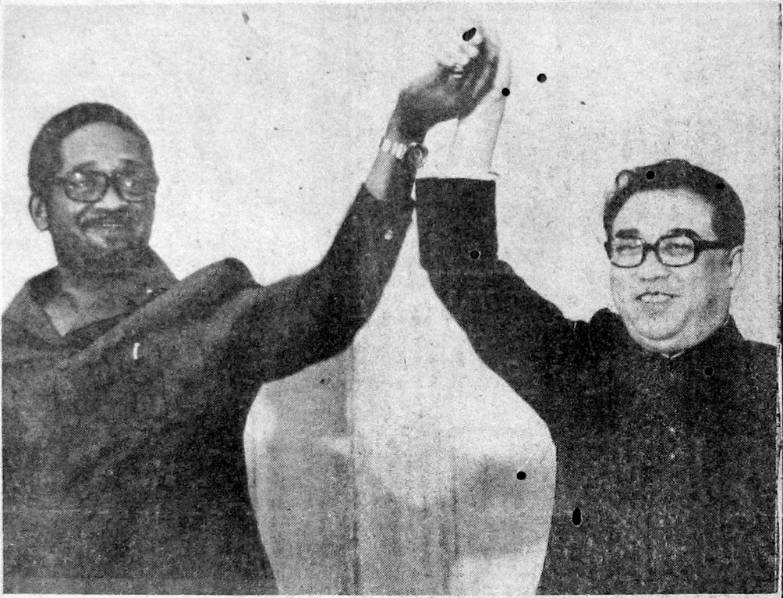
Figure 1. Guyana President Forbes Burnham is photographed with Kim Il-sng in Pyongyang in 1977. Source: New Nation newspaper
These North Korean phantoms that wander Guyana’s neo-liberal present manifest materially as well. For years an abandoned glass factory haunted the village of Yarrowkabra, some forty kilometers south of the capital along the Soesdyke-Linden Highway. A gift from North Korea, preliminary construction began in 1977 with the idea that with its quantity of high-grade silica sand, Guyana could become the leading manufacturer of glass products in the Caribbean. In recent years local businessmen purchased the derelict structure and converted it into a sawmill. Another such site is described by environmental scientist Logan Hennessy, who has studied the Burnham government’s efforts to incorporate indigenous people into agricultural cooperatives in the 1970s, which at times overlapped with the work of North Korean agronomists to assist in increasing and diversifying domestic food production. Excavating the remnants of one such project in the remote Pakaraima Mountains, he discovered “heaps of rusting machinery, oil drums, faded posters of Forbes Burnham, entire rooms full of metal junk, and punctured tractor tires. This unofficial museum for the socialist period contained all the dusty relics of a once-productive past, including twenty perfectly preserved copies of The Works of Kim Il-sung, 27 Classical Writings from 1964.” The physical-textual imprint of North Korea is one of its most enduring legacies – the works of Kim Il-sung lie dormant on library shelves and in personal book collections throughout the country. Policy-makers continue to wrangle over the unrealized potential of a hydropower station at Eclipse Falls in the Barima-Waini region, another development project spearheaded by North Korea in the early/mid-1980s. Kim Jong-il has a street named after him in the border town of Corriverton, while a local second-division cricket team still bears the name Kim Il-sung. More of North Korea’s material legacy is invisible: the cement, building supplies and steel parts that helped feed, in their own modest contribution, the construction of buildings, housing and infrastructure during the 1970s and 1980s. And there are other ways in which the history of DPRK-Guyana solidarity lingers, such as the North Korean flag that adorns a grim monument on the University of Guyana’s Turkeyen campus. It remembers the victims of the October 1976 terrorist bombing of Cubana Airlines flight 455, in which eleven Guyanese, five North Koreans and fifty-seven Cubans were killed.
Of course, there are also the memories that survive of the North Koreans themselves, particularly among former officials and PNC activists. These anecdotes tend to be remarkably uniform. North Koreans are remembered as disciplined and zealous above all else, punctual, industrious and tirelessly committed to their tasks. Their devotion to the party and to the Great Leader is described more like religious piety than political partisanship. In the words of one former Guyanese official, “they lived their politics twenty-four hours a day!” An uncle of mine, a recent engineering graduate in the late 1970s, worked alongside North Koreans at the Guyana Pharmaceutical Corporation (GPC), formed in 1976 after the government nationalized the British-owned Bookers Drug Store. “They were very nice, hard-working, helpful…and they got really irritated when people called them chiney” he recollects with a chuckle (in the not-terribly-sensitive Guyanese creole vernacular, chiney refers to all Asian people regardless of their nationality). But there is often something impersonal in the memories of these relations. In such narratives, when the work is over, the Koreans retreat to their embassy compound, physically and figuratively walled off from the society in which they are temporarily guests. They are mysterious and inaccessible. Although some Guyanese recall particular North Koreans and describe genuine friendships they shared with them, more often these individuals are spoken of as an undifferentiated collective. “There were so many of them by the name of ‘Kim,’” a university professor once joked to me, “I can’t remember who was who.”
North Korea’s relationship with the Global South during the Cold War has received growing attention in recent years, especially since Charles K. Armstrong’s ground-breaking work, Tyranny of the Weak: North Korea and the World, 1950–1992 (Cornell University Press, 2013). However it is a subject still commonly misunderstood. The Korean Worker’s Party’s (KWP) embrace of Third Worldist politics, unmistakable by the time of its participation in the Tricontinental Conference of January 1966 in Havana, was not an aberrant and temporary detour. Rather it is better understood as the long-standing and natural trajectory of its political orientation given Korea’s colonial history, the traumatic experience of the Korean War, the KWP’s complicated historical relationship with the Soviet and Chinese communist parties, and the country’s predicament within the post-war, bipolar international system. Even today visitors to North Korea, at least those from the Global South, can hear from their hosts a vocabulary that sounds quite vintage in the post-Cold War, neo-liberal present: “Third-World solidarity,” “south-south cooperation,” “the New International Economic Order.” Nor was North Korean Third Worldism a secondary and compartmentalized aspect of state policy. Rather, it was a central component of the KWP’s larger ideological matrix, inseparable from its other major developments in the same period: the further elevation of the Kim Il-sung personality cult, and the growing emphasis on the state ideology of Juche, rather than Marxism-Leninism, as the party’s intellectual foundation. Lastly, North Korean Third Worldism was not a singular and homogenous phenomenon, but has gone through several quite distinct phases since the 1950s.
This history of DPRK-Guyana relations took place in the context of the phase of North Korean Third Worldism arising in the early/mid-1970s. Since late 1966 the North Korean leadership had a blood-and-fire message of armed insurrection throughout the Global South, an “anti-imperialist, anti-US united front” that could “sever the limbs” of US imperialism. Its own contribution to this project was a campaign of bold military actions aimed at Seoul and US forces stationed in South Korea, and a program to train, arm and finance guerilla movements throughout the Global South. Yet by the early/mid-1970s Pyongyang was shifting towards a considerably more moderate strategy, demonstrating an apparent new faith in what could be achieved through peaceful dialogue with Seoul, participating in multilateral organizations and forums, and expanding diplomatic relations with countries it once dismissed as “fascist puppet states” of imperialism. While Cuba had been its sole state-to-state-relationship in Latin America and the Caribbean between 1959 and 1973, by 1982 it had formal diplomatic ties with thirteen countries in the region. Pyongyang gained seats on a number of international bodies, among them the World Health Organization, the World Meteorological Organization, the Inter-Parliamentary Union, and most importantly the Non-Aligned Movement. Behind this diplomatic effort was the goal of building a broad coalition of support within the Global South for its demand for the withdrawal of US troops from South Korea and the “peaceful and independent reunification” of the peninsula.
What inspired this course change? It was essentially an effort to recalibrate foreign policy in line with developments in South Korea – the announcement of a substantial withdrawal of US troops, the rising momentum of the democratic opposition led by Kim Dae-jung – as well as changing international conditions, chief among them the de-escalation of the Vietnam War, Sino-US rapprochement, and the growing power of the Third World in the United Nations General Assembly. In the Latin American/Caribbean context, while the Cuban-inspired guerilla movements North Korea once backed had been mostly defeated by the end of the 1960s, between 1968 and 1973 left-wing governments came to power in a number of countries, not through revolution but democratic elections and military coups. Moreover, with the influence of the Non-Aligned Movement reaching its peak, a fairly broad number of governments in the region were willing to consider diplomatic and commercial relations with North Korea.
This shift in foreign policy strategy was accompanied by a new ideological stance made clear in formal pronouncements by 1974. Kim Il-sung now proclaimed that the world was in the “era of independence,” in which the primary contradiction was not between the proletariat and the bourgeoisie, but rather the small countries of the Global South and imperialism led by the United States. Moreover, the progressive foreign policies of what Kim called “the second world” – Canada and some governments of Western Europe and Scandinavia – meant that these countries could be counted as allies. In short, Kim envisioned a grand coalition of the “Third World” supported by the socialist bloc and the more progressive capitalist countries that could forge a new international order based on the principles of self-determination and non-interference. Talk of socialism and class warfare were noticeably light in the new narrative – in the context of the “era of independence,” Third-World nationalism surpassed Marxism-Leninism in practical importance. What mattered was that governments rejected “servilism”: compromising independence by kowtowing to foreign powers. The most important trait of a true communist, Kim insisted, was not class consciousness, but patriotism. In an October 1974 interview with the Ecuadorian Jucheist Humberto Ortiz Flores, Kim argued that a military coup d’etat led by “progressive” factions within a country’s armed forces was an appropriate political strategy in the Global South. By the time of the KWP’s Sixth Party Congress in October 1980, the Hungarian ambassador to North Korea could remark that “The characteristic attribute of these views is a pragmatic and nationalistic approach that is moving more and more away from Marxism-Leninism.” An Albanian delegate was blunter: “What kind of congress it is where not a single word mentions Marxism-Leninism, and parties with no connection to communist ideologies participate as well?”
The People’s National Congress (PNC) of Guyana was surely one of the parties the Albanian delegate was referring to. In fact, what political forces in Latin America it now extolled and which it did not are a useful barometer of how North Korean foreign policy shifted in the 1970s. In the previous decade, Cuba had been one of North Korea’s closest allies on the international stage, with the KWP lionizing Fidel Castro and Ernesto ‘Che’ Guevara as the leaders of the Latin American revolution. But during the early 1970s such praise all but vanished, and now official North Korean pronouncements on Latin America often omitted any mention of Cuba at all. When Peruvian journalist Genaro Carnero Checa interviewed Kim Il-sung in June 1974, Kim claimed that it was Peru and Argentina that were leading the struggle against imperialism in the region. This was a reference to the leftist-military regime of Juan Velasco Alvarado, which had seized power in Peru in October 1968, and the second triumph of peronismo in Argentina the previous year. From North Korea’s new ideological standpoint, leaders like Velasco and Juan Perón were heeding Juche by championing a “national” political line and maintaining their independence from both Cold-War blocs, while Cuba was guilty of servilism towards Moscow.
The North Korean leadership’s new ideological stance and its desire to expand bilateral relations within the Global South made Guyana a natural ally. Forbes Burnham was a personalistic ruler whose professed commitment to the anti-imperialist struggle was coupled with a rejection of Marxist orthodoxy and the insistence that Guyana was “a pawn of neither East nor West.” The cornerstone of his self-styled doctrine of “cooperative socialism” was “self-reliance,” the most obvious point of ideological unity with the KWP. In the Guyanese context, self-reliance embodied the dream that by disentangling from the global capitalist system and developing domestic state industries, poor countries in the Global South could build strong, advanced economies less dependent on imports and less vulnerable to the fluctuations of the international market. It was a concept popularized during the post-war decolonization period and one that enhanced the appeal of North Korea as a model of development in the Global South. During the Burnham era, the Guyanese government took ambitious efforts to develop domestic production, with food, clothing and housing taking priority. Guyana even produced its own automobile, the Tapir, a boxy vehicle still commonplace on the roads of the East Berbice-Corentyne region. Cammie Ramsaroop, who as chairman of the PNC was responsible for party-to-party relations with the KWP, recalls, “self-reliance was the golden thread that held cooperative socialism and Juche together.”
This alliance was expressed in roughly a decade of exceptionally intimate political, economic, military and cultural cooperation, from the establishment of diplomatic relations in May 1974 to the death of Forbes Burnham in August 1985. North Korean assistance focused on supporting the government’s goal of self-reliance, helping it to develop new industries (glass, spare parts, agricultural machinery) or improve and expand existing ones (gold and manganese mining, pharmaceuticals), enhance domestic food production (rice, potatoes, fisheries, drainage and irrigation) and tap into the country’s hydropower potential. North Korea also provided Guyana with artillery, ammunition, patrol boats and military advisors in preparation for a potential conflict with Venezuela, with which it has a long-simmering border dispute. Additional material aid came in the form of tractors, disc harrows and plows, boat motors, cement, building materials and machines that converted rice straw into rope. North Korean doctors and surgeons staffed the Georgetown Public Hospital and created the country’s first acupuncture clinic. In 1986 US intelligence estimated there were close to two hundred North Koreans stationed in Guyana. A report issued the following year claimed North Korea had extended 2.5 million USD in economic credits and grants to Guyana between 1978 and 1985.
In return Guyana provided North Korea with bauxite and timber, and hosted an English-language program for North Korean students at the University of Guyana, making it the only country outside the communist bloc where North Koreans were sent in large numbers to study. A North Korean diplomat remarked recently to me that many of the best English speakers in the DPRK Ministry of Foreign Affairs are alumni of this program. Similarly, former members of the PNC government share anecdotes of visiting Pyongyang and meeting KWP officials who spoke English with an unmistakable Guyanese twang. Perhaps of greater value, Guyana aided North Korea’s diplomatic offensive in the Third World and its efforts to build support within the United Nations General Assembly. The Guyanese government become one of the most outspoken supporters of North Korea and its “five-point plan for reunification” in international fora and played a leading role in the international DPRK-solidarity movement. In January 1979 Georgetown was host to the ﬁrst “Latin-American Caribbean Conference for the Independent and Peaceful Reuniﬁcation of Korea,” which established a new regional body with PNC Vice Chairman Robert Corbin as honorary president. PNC officials also served on the preparatory committee of the April 1979 “International Seminar for the Juche Idea” held in New Delhi, and on the presidium of the July 1983 “World Conference of Journalists against Imperialism and for Friendship and Peace” in Pyongyang.
Forbes Burnham was most impressed with North Korea’s achievements in the areas of education and culture, and sought to emulate them in various ways. This included a national children’s choir for whom North Korea supplied the musical instruments, the creation of the President’s College modeled on the Man’gyŏngdae Revolutionary School in Pyongyang, an unrealized plan to build a “Students and Children’s Palace,” and the crafting of a state-propagated personality cult around Forbes Burnham. The element of cultural policy most successfully adopted in Guyana, however, was undoubtedly Mass Games, the grandiose gymnastic spectacle North Korea remains famous for. In September 1979 a seven-member team of North Korean Mass Games instructors arrived in Guyana, spending approximately six months working with Ministry of Education officials, schoolteachers, local artists, dancers and athletes. While never matching the grandeur of those held in Pyongyang, Guyanese Mass Games performances included up to 3,000 performers, although a total of 10,000 students were said to be involved in an entire production. Following the first Mass Games in February 1980, production was passed on to the newly trained team of Guyanese organizers and artists under the Ministry of Education’s Mass Games Secretariat. Creating a distinctly Guyanese variety of the North Korean medium, they remained a central facet of public life until the fall of the PNC government in 1992.

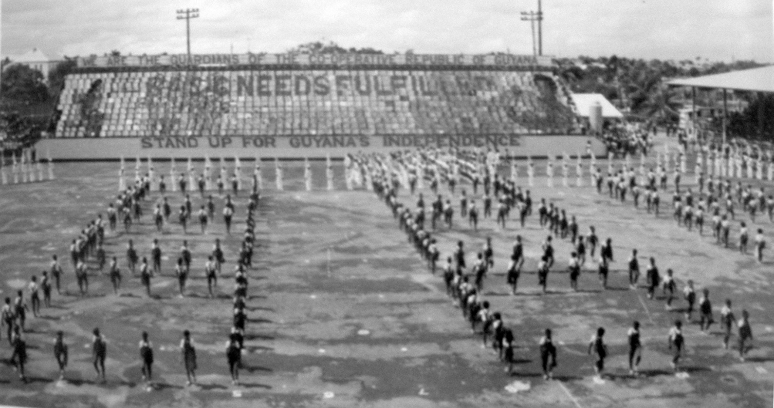
Figure 2. Mass Games in Guyana in 1987. Source: Archive of Mass Games Secretariat
The enthusiasm of the PNC leadership for Mass Games reveals precisely what it was about North Korean society they most admired. Central to Burnham’s political vision was the voluntarist concept that subjective factors were paramount to national economic development, and that Guyana could not escape backwardness until it broke with the psychological bondage of its colonial past. It was the role of the vanguard state to endow the citizenry with the values and attitudes necessary for the new society in the making: patriotism, collectivism, and more than anything else, “discipline.” The image North Korea presented to the world was that of a small country only emerging recently from colonialism and “feudalism,” having rebounded from the total devastation of the Korean War to achieve rapid industrialization, creating a modern, prosperous socialist society. Kim Il-sung claimed that North Korea’s experience had proven that “In a socialist society, the people’s high revolutionary zeal is the decisive factor which forcefully drives the development of the productive forces.” To PNC leaders, North Korea provided a tested solution to the plague of underdevelopment, and that the transformation of the people’s consciousness was the key to progress in the Global South. In the PNC-KWP relationship, the North Korean developmental model was integrated with a central component of the Caribbean leftist tradition: psychological and cultural decolonization as the foundation of social change.
Guyana’s experiment in “cooperative socialism” and the international linkages it facilitated were not ultimately sustainable. The economy entered serious difficulties following the 1973 oil crisis, which manifested in massive unemployment, a street crime epidemic, steady outward migration, and widespread cynicism towards the government. Corruption and bureaucratism plagued the rapidly expanded state sector. Unwilling to trust its fate to the ballot box, the PNC meddled with the national elections to ensure its majority in parliament. Police, soldiers, and party militants attacked anti-government demonstrations and broke picket lines. There were several murders of opposition activists, the most prominent being that of the renowned scholar, Walter Rodney (1942-80). When Burnham died on 6 August 1985, he was succeeded by Desmond Hoyte, who, representing the right wing of the PNC, believed Guyana’s long-term interests were better served repairing its relationship with Washington and the International Monetary Fund.
Hoyte’s presidency began the gradual decline of the DPRK-Guyana relations in the 1985-92 period, including the closure of the North Korean embassy in Prashad Nagar. It came alongside a series of defeats for the Caribbean Left during the Reagan era that put a halt to North Korea’s momentum in the region. Parties and coalitions Pyongyang had backed in Jamaica, Saint Lucia, Dominica, Antigua and the Dominican Republic suffered a series of devastating election losses, while the US invasion of Grenada in October 1983 brought down one of its key regional allies. Hernán Siles Zuazo’s return to power the same month bid well for a renewed relationship with Bolivia, but he was forced out of power in less than three years. The reassertion of US hegemony in the region and the fading power of non-alignment, coupled with the diplomatic blowback from the October 1983 Rangoon bombing, caused many Latin American governments to reconsider their ties to North Korea. With the fall of Nicaragua’s Sandinista government in February 1990, Pyongyang’s fortunes in the region appeared to have reversed back to where they were two decades earlier. Although a handful of countries retained diplomatic recognition, Cuba remained North Korea’s only significant bilateral relationship in Latin America and the Caribbean. The dramatic shift of the Latin American/Caribbean political landscape during the Reagan era does much to explain Fidel Castro’s decision to visit Pyongyang for the first time in March 1986.
Guyana’s ties to North Korea have not disappeared altogether, however. While today the Guyana-Korea Friendship Association has fallen into inactivity, its counterpart still exists in North Korea, where Guyana continues to be held in uniquely high esteem among veterans of the Ministry of Foreign Affairs. The Juche Tower serves as a lasting testament to the historic bonds between the two countries, with plaques donated by Guyanese delegations outnumbering those by any other single country. The two countries revived their diplomatic relations in 2012, with Pyongyang’s then resident ambassador in Cuba, Jon Yong-jin, being appointed non-resident ambassador to Guyana. In a ceremony in which Jon presented his Letters of Credence to Guyana’s then-President Donald Ramotar, he recalled the history of solidarity between the two countries, how they had fought together for the goals of the Non-Aligned Movement, and discussed ways the two countries could cooperate in “agriculture, information technology (IT), human resource and construction.” In fact, Jon’s meeting with Ramotar fit with a renewed attempt by Pyongyang to increase bilateral ties in Latin America and the Caribbean in recent years, assisted in large part by the so-called Pink Tide. The ascension of Hugo Chavez in Venezuela, Luiz Lula da Silva in Brazil, Evo Morales in Bolivia and Rafael Correa in Ecuador all created new diplomatic openings for North Korea. Efforts to strengthen ties with Cuba, its oldest partner in the region, have also been apparent. In September 2011, a new pre-university school named after Kim Il-sung opened in Havana’s Arroyo Naranjo borough. This past November, Cuban President Miguel Diaz-Canel visited Pyongyang for meetings with Kim Jong-un.
This is far from an irreversible trend, however. The Pink Tide is already widely spoken of in past tense, while Latin American intellectuals debate the reasons behind its apparent defeat. The Trump administration speaks openly of military intervention in Venezuela, with the acquiescence of most Latin American and a number of Western governments. Most of the Caribbean seems firmly mired in a kind of post-post-colonial malaise, where the high aspirations that drove the Left of the 1960s and 1970s are dismissed as the naïve sentiments of a bygone era, and privatization, austerity and dependency widely accepted as inescapable realities. This demonstrates the difficult terrain and uncertain future North Korea will continue to face in Latin America and the Caribbean for the foreseeable future, and the broader challenges of its commitment to “Third World solidarity” in an age of neo-liberal hegemony.

Moe Taylor is a historian, documentary filmmaker and a PhD candidate at the University of British Columbia. His research explores the relationship between North Korea and Latin America and the Caribbean during the Cold War era. His publications include ’One Hand Can’t Clap: Guyana and North Korea, 1974-1985’ (Journal of Cold War Studies, 2015) and ’Only a disciplined people can build a nation’: North Korean Mass Games and Third Worldism in Guyana, 1980-1992 (Asia-Pacific Journal, 2015). His documentary film projects include Guyana and North Korea: Two Vehicles on the Road to Socialism (2014) and Remembering Canadian Volunteers of the Spanish Civil War (2013).

