The Architectural Roots of Myeongdong Cathedral

Nate Kornegay

When French Catholic buildings were being constructed in Seoul in the 1890s, Gothic architecture had already been introduced to China. Ecclesiastical structures in particular, like St. John’s Cathedral in Hong Kong, had been standing for forty years while Korea’s built environment was just starting to see such examples of architecture transplanted into its early modern cities. Throughout East Asia, some of these buildings were designed by formally trained engineers and architects, while others were planned by local builders, entrepreneurs, and compradores. In Korea, it was in many cases the missionaries themselves who designed and oversaw the construction of their churches. Such buildings were typically not the result of professional technical drawings. Rather, these missionaries learned and adapted throughout their projects.
One the first examples of a missionary-architect can be found in the case of Fr. Eugéne Jean Georges Coste (1842-1896), the Catholic priest responsible for designing what is now referred to as Myeongdong Cathedral. Though he is thought to have been involved in the Catholic mission’s seminary at Yongsan (1891) and Yakhyeon Church (1892), it was the cathedral that became his crowning achievement. Coste, a native of southern France, spent years working throughout Asia as part of the Paris Foreign Missions Society. He arrived in Korea at the end of 1885 “[d]isguised as a layman … on a Japanese steamer” from Yokohama as the treaty between France in Korea had yet to be signed. By 1887, he was able to legally purchase and subsequently level the hill the cathedral would be built on. It then fell to the priest to oversee the building’s construction, which is how he is generally credited as its designer.

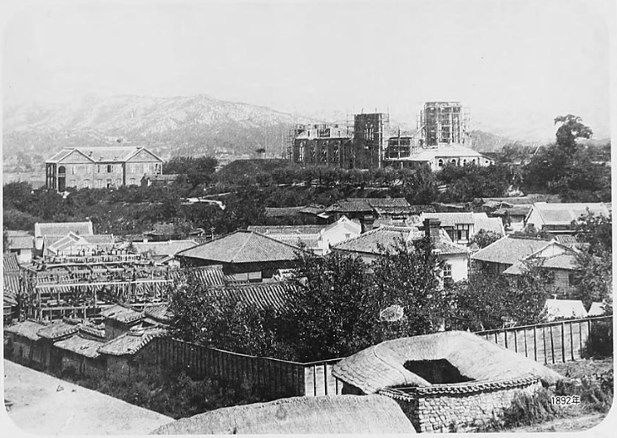
Figure 1. A photo taken from the Japanese settlement at Namsan shows Myeongdong Cathedral under construction, Seoul.
The cathedral was referred to as Coste’s “greatest achievement”, a massive, over-engineered neo-Gothic structure built of red and blue brick over the span of six long years. It is unclear how he, without an engineering background, was able to manage its creation. However, the architectural inspiration for the building and Coste’s design abilities seem to have come from his time in Hong Kong between 1872 and 1874. There, beginning in late 1873 in the Pokfulam valley on Hong Kong Island, the Paris Foreign Missions Society backed the construction of a sanatorium complex known as Béthanie that was to become part of the society’s administrative base in China. The sanatorium was completed in 1875, its design credited to a society administrator named Fr. Pierre-Marie Osouf, with construction supervision in the hands of the priest who would become the first director of Béthanie, Fr. Charles Edmond Patriat.

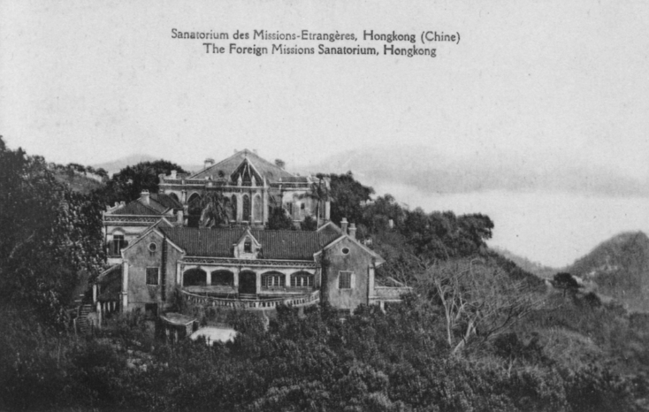
Figure 2. A postcard depicts the sanatorium at Béthanie, Hong Kong. Note that the chapel building in the background is significantly smaller than Myeongdong Cathedral, though clearly Gothic in style. The buildings remain in Hong Kong today.

Current scholarship does not recognize Coste’s involvement in the project, but a lengthy memorial published in The Korean Repository indicates it was at Béthanie where he first “tried his talents as an architect”. He built a lasting friendship with Osouf, and looked back on his time there with great fondness. “I constantly see myself in Hong Kong” he wrote in a letter, “with Papa Osouf and the good Narcisse, discussing the buildings of Béthanie”. His experience, so profound as to make him want to regret going to Korea, is what then probably led him to “[borrow] from the clever builders of Béthanie that taste for Gothic art - a little exclusive perhaps - which he always retained.” Such architectural borrowing is most evident in the apse of Myeongdong Cathedral, which mirrors the same Gothic style of the chapel at Béthanie.

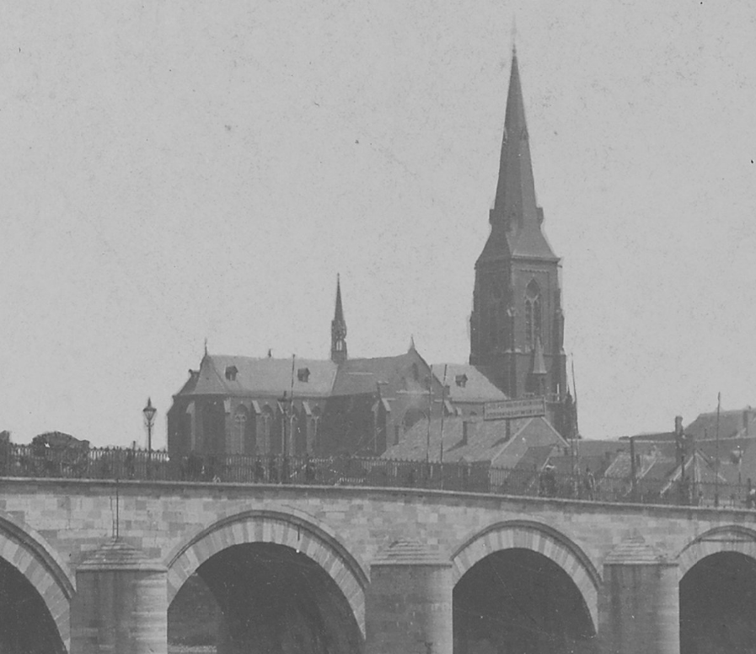
Figure 3. A cropped section of a photograph depicting St. Martin Cathedral, or Sint-Martinuskerk, Netherlands, built around 1857-1858. Note that while its steeple is taller than Myeongdong Cathedral’s, their forms are similar.

Though Coste’s memorial in The Korean Repository clearly references his time in Hong Kong as the inspiration for Myeongdong Cathedral, another account published in 1906 suggests the design came from elsewhere. Writing of his 1902 visit to Korea, Hungarian aristocrat Count Péter Vay claimed Coste’s church was “built on the model of one of the old cathedrals in the Netherlands”. The count was probably referring to examples of brick neo-Gothic churches like St. Martin in Maastricht, which is not at all dissimilar in form and style to Coste’s cathedral. Vay wrote that he was hosted by one of the clergy while visiting Seoul, from whom he could have obtained such information, yet it remains unclear as to whether Vay meant Myeongdong Cathedral was a copy of a Dutch church or merely resembled architecture from the Netherlands.
Unfortunately, without blueprints or technical drawings, the matter is likely to remain murky. Evidence from Korea’s colonial period suggests no formal building plans were ever made. Instead, the construction of the cathedral seems to have been managed much in the same way as the Chinese-built compradoric architecture of Shanghai and Hong Kong, where compradors, contractors, and other middlemen handled the execution of the building ideas sketched by Westerners. To be clear, years after the cathedral was completed, an American priest visiting Seoul reportedly asked “Bishop [Mutel] for blue prints, or a copy of the plans, and the Bishop was forced to answer that they never had any such things - only small memoranda and drawings made on the spot as needed”.
Coste spent almost ten years preparing for and overseeing “his building” before succumbing to a fever in early 1896. Fighting the illness for about ten days, he finally passed away at dusk on February 28. His comrade who was handling administrative work of the mission, Fr. Victor Louis Poisnel, then took charge of the project, seeing it to its completion in 1898.
The cathedral was massive relative to the other structures in Seoul. Despite its monumentality, occupying a prominent space overlooking the entire city, the cathedral was decidedly spartan. “No fresco ‘artists’ had stenciled these walls, and with the exception of a few benches for Europeans, the pulpit (a model of wood-carving), and a baptismal font, there were no church furnishings.” Nevertheless, Myeongdong Cathedral became a model for future Catholic church projects in Korea, arguably influencing Gothic and ecclesiastical brick architecture for decades to come.

Figure List
Figure 1. “1890-1932- ‘Myong-Dong’, from the Moffett Korea Collection, Princeton Theological Seminary Library.
Figure 2. “The Béthanie at Pok Fu Lam”, Hong Kong Historical Postcards, courtesy of Hong Kong Memory (HKM).
Figure 3. Photo. “Maas, bridge, gate, church,” 1895. Item Number OF-00850. National Service for Cultural Heritage (Rijksdienst voor het Cultureel Erfgoed)

Nate Kornegay photographs and writes about early modern architecture in Korea. He is currently working on a number of projects, including the study of a particular ceramic tile trend found throughout the former Japanese Empire. Research articles and architectural photo essays can be found at his website, Colonial Korea. Visit www.colonialkorea.com.

Mrs. Alexander Kenmure, “Father Coste,” The Korean Repository, Vol. 3 (Seoul: The Trilingual Press, 1896), 151; Note that the treaty with France was signed the following year.
Mrs. Alexander Kenmure, “Father Coste,” 151.
Heritage Appraisal of Béthanie provided by the Antiquities Advisory Board of Hong Kong. This documented can be directly accessed: http://www.aab.gov.hk/form/160meeting/AAB%2045%202011-12%20(Annex%20A).pdf
Mrs. Alexander Kenmure, “Father Coste,” 146.
Mrs. Alexander Kenmure, “Father Coste,” 147.
Personifying the place and experience as “Mgr. de Béthanie” in French, Coste reportedly wrote that “He [the sanatorium at Béthanie] wants to make me regret going to Korea”. Mrs. Alexander Kenmure, “Father Coste,” 147.
Mrs. Alexander Kenmure, “Father Coste,” 146.
Count Vay de Vaya and Luskod, Empires and Emperors of Russia, China, Korea, and Japan (New York: E. P. Dutton and Company, 1906), 254.
Bishop Mutel’s name is not given in this account. However, he was the bishop of Myeongdong Cathedral at the time. James A. Walsh, Observations in the Orient, 88.
Mrs. Alexander Kenmure, “Father Coste,” 155-157.
Poisnel would go on to become an important priest-architect in Korea, using the skills learned in the making of Myeongdong Cathedral to assist, design, and oversee a number of church projects. “Victor Poisnel,” Notices Biographiques, Archives de Missions Étrangeres de Paris. https://archives.mepasie.org/fr/notices/notices-biographiques/poisnel (Accessed May 6, 2019).
James A. Walsh, Observations in the Orient, 87-88.

