Coveting the Dragon’s Pearl

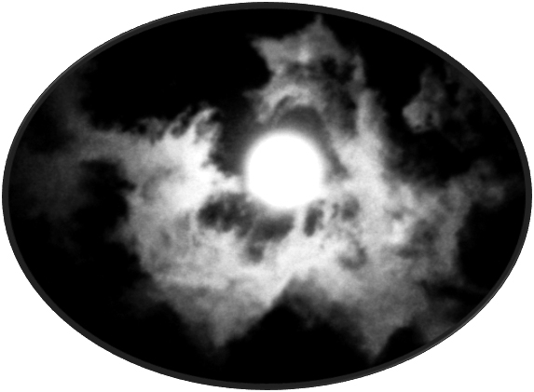

Fred Jeremy Seligson

We suffer emotionally and physically from birth until death. Our daily lives are fraught with worries for survival. This is why we have conjured up a dragon savior and its wish-fulfilling jewel. The latter brightens a super-sensibility and brings good fortune.
Coincidentally, above both the Joseon king’s and the Buddha’s thrones, twin yellow and blue dragons fly in circles, chasing a flaming yeouiju. Eagerly, they lunge for it with open jaws. So doing, they harmonize the interplay of yin and yang gi throughout the cosmos. Coiling and uncoiling, alternating to the extremes of yin and yang, they mingle the “Five Phases” of Wood (木), Fire (火), Soil (土), Metal (金), and Water (水), creating “the 10,000 things” of existence.
The wish-fulfilling gem is a black and white, blue and red, gold, green, white or clear sphere with an antler-shaped flame on its surface. Born of continence, it coalesces in a dragon’s spine.
A dragon usually gives one, but on special occasions seven, to a deserving human. Clasped against a heart, it drives away evil spirits, cures any ailment or grants a boon according to the holder’s will. No wonder, while suffering oppression, so many people yearn for one. That’s why they show up in dreams. Swallowing one, supposedly, can transform a human into a dragon.
March 3, 2019 in Dream Country:

A gray spider is crawling over the ground in front of me. It finds a pebble a little bigger than its body and encircles it with its eight long legs, rolling it forward under its body. I point this out to someone behind me. It is riding on the pebble, propelling it with its legs pushing on the ground around. Now it comes to a dark hole, wider than its body. I am afraid it will drop the pebble, which is like a pale pearl. As it makes it way down a small depression, it holds on to its pebble, one stage at a time, lying on and rolling it as a vehicle.

☼Years ago I purchased a crystal ball at a shop in the Tibetan town of Ladhak up in the Himalayas. During meditation, I clasp it between my fingers which can translate into the dream spider’s legs. The ball becomes the spider’s body and the pearl it rides on. I enter into the crystal ball with its ice-like caverns.
ξ Fancy cupping a yeouiju in your hands. Gaze deeply into it and feel its soothing sensations. Watch it shape an aura about you.
Miss Kang tells a folktale about how someone will go to any costs to obtain a yeouiju:

“Even though old man Kim employs many servants, his wealth has been stolen several times. On a full moon night, a four-foot-long carp rises out of a pond and drops a pearl into his palm. She says, ‘This pearl will guard your wealth.’
Another night the gem floats outside and captures a thief. Awakened by a cry, old Kim sees it return to its original place.
One day, Gu-ryong (Nine Dragons) shows up. Coveting the pearl, the scoundrel feigns love for Kim’s daughter and proposes marriage. Then he urges her to steal the pearl from her father. When she does, the lovers meet and sit on the pond’s bank.
The pearl wakes old Kim up. He discovers and kills them. Despairing, he commits suicide.
The girl dies with the pearl tucked in her bosom. A new flower blooms around her grave. People name it ‘Pearl Flower.’”

☼It doesn’t pay to steal a yeouiju. It is a conscious object that only rewards good intentions.

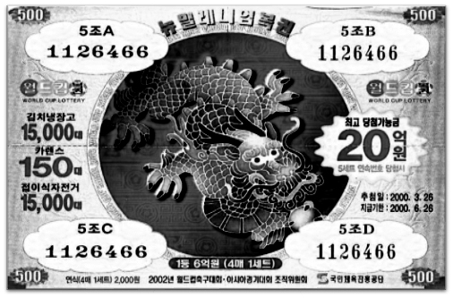
2002 World Cup Lottery Ticket

2000, the Year of the White Metal Dragon: I buy a lottery ticket at a kiosk which bears a curvy jade dragon, clutching a jade green yeouiju in its claw against a rose background. Green represents wealth. Opportunities are offered to the possessor of a yeouiju. Who wouldn’t want one?
Mr. Jong said, “Earlier this year, I heard that a poor friend of mine made a fortune in just one night. He bought a lottery ticket and won 100,000,000 won (equivalent to $100,000.00).”
As usual, someone asked him, “Did you dream a lucky dream?”
He answered, “Yes, in my dream”:

It is raining with thunder and lightning. When I step outdoors, I see an enormous blue dragon flying about the flashing sky. It flies down in front of me and says, ‘I dropped a golden globe somewhere around here. Could you please help me find it?’
I look around for a while and find it. Secretly, I keep it for myself.

“When I woke up, I ran out and bought the lottery ticket.”
☼An air-refreshing storm is generated by a dragon clutching a yeouiju in its claws. The yeouiju enables the dreamer to realize their desires.
Considering a dragon’s integrity, if the man hands over the golden globe, it would give back extra blessings!

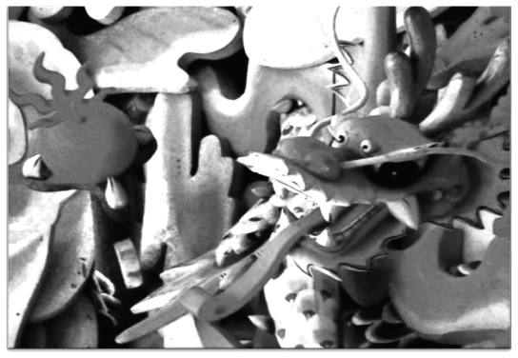
Red Dragon & Pearl, Bongwon Temple

The following dreams illustrate the preciosity of a yeouiju and the kindness of dragons. Mr. Joh says, “My mother told me, “In your taemong (conception dream):

I walk by the riverside in the middle of the night. Someone is following me. So I run back to the house, enter my room and lock the door from inside. Undaunted, he opens it and walks in. I look at his face. He is not a man but rather a dragon. He gives me a gem and disappears like smoke. The gem is very bright as if there is a sun in it. The light from the gem illuminates all of the room.

After this, my mother was in the family way.”
☼Composed of 100% gi, the dragon glides around the door’s atoms. Generously, he conveys a yeouiju containing the sun which illuminates the room. Now it clarifies the young man’s soul.
A dragon shows a sense of humor. Mr. Koo says, “When my mother was pregnant, she had a curious dream at the peep of dawn:

While I climb a mountain path, a dragon bursts from between clouds. I am frightened out of my wits.
It drops a white baduk (Japanese go) chip, flies up in the sky and disappears. The chip flashes on the ground as if a glittering jewel. I try to pick it up, but it’s too hot.

☼We can hear the woman cry out, “Ouch! Too hot to handle!” when touching the dragon’s gift. Her forthcoming child is the yeouiju. Perhaps he’ll become a baduk champion!
A yeouiju comes as a surprise. Miss Noh says, “This taemong was dreamed by Aunt Sun-nae. She said:

I am sitting on the terrace in front of our house facing our beautiful garden. Birds are singing and the brook is murmuring. Suddenly, I remember that I have forgotten to wash the dishes, so I walk into the kitchen.
Looking out the window, I see a serpentine creature crawling out of the brook. It grows larger and larger until it’s as big as our house! I can see its face clearly, staring at me fiercely with red eyes through the small windows. I am struck dumb with fright. Yes, it is a huge lizard, rather a dragon!
I reach under the sink to take out the garbage, tie up the bag and pick up the garbage can. Holding it in front of me, I take mincing, backward steps, stuttering in fear. With a terrible crash, the dragon bursts into the house. I cry out, ‘Don’t eat me! Please don’t eat me!’ Instead of attacking me, it smiles and leaves me a gleaming dewdrop pearl.

“A few weeks later, my aunt’s daughter-in-law bore a baby boy. It was during The Year of the Dragon. Isn’t it marvelous?”
☼Confused, Aunt Sun-nae tries to take the garbage out! Alarmed, she grasps the lid for a shield. But the dragon means no harm. Instead, he shows an amiable, giving heart.
Her grandson will grow up into a big man, brightened by the blessings of the Dragon Year and the yeouiju.
A yeouiju burns with life. Mr. Choi says, “When my mother conceived me, she dreamed a taemong:

A dragon flies in the cloudy sky. It carries a dragon ball in its mouth and puffs white smoke out of its nostrils. I freeze in fear. I want the dragon ball but there is no way. So I pray to heaven, ‘Almighty, please let me have it!’
Answering my prayer, the dragon twists about and throws the ball into my house. It burns down from the ball’s heat. After this, only the dragon ball is left where the house had been. I walk over and embrace it.’
“A few days later, she found out that she was pregnant.”
☼Steam issues from the dragon’s boiler-pot body. The woman overcomes her fear and prays to the dragon as “Almighty,” as if a god.
So what if your house burns down if you have a yeouiju child who can grant any wish, including one for a new and finer abode?
One afternoon, during a shaman (a mediator between Heaven and Earth) ritual for my friend’s deceased mother, I ask the shaman, “What is the yeouiju?”
She replies, “The yeouiju is the universe. There is a drop in everyone’s heart.” Imagine -- a drop of the universe -- our shared nature.
Another shaman tells me, “In my dream”:

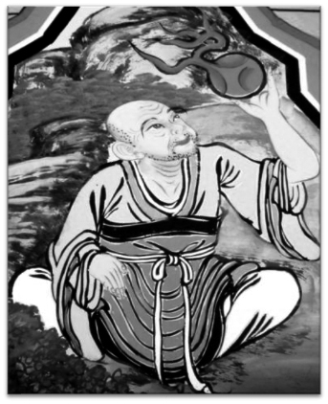
Ascetic & Mani-stone, Hoeryong Temple

A red-and-white dragon flies down from the ceiling into my room and lands in front of me. Then it flies up, out into the sky. Soon it flies back in again and sets a jade yeouiju, the size of a baseball (she places a hand over a fist to show me the size) on my desk and, also, a red sheet of paper with the words, ‘You got blessed,’ on it. They enter my heart. The dragon smiles and laughs, ‘Hah hah, hoh hoh!’ I feel a great rush of power. So I smile and laugh, too, ‘Hah hah, hoh hoh!’ A strong wind blows all around. It is very powerful!

“When I woke up, I felt a great headache that wouldn’t go away. Two months later, I told my story to a shaman. She exclaimed, ‘You’re a shaman!’”
I ask the shaman, “Can you see the dragon, and feel the yeouiju in your body now?”
“Yes, I feel the power. Sometimes, it is invisible. Other times, I can see the dragon for only a second.”
“What color is it?”
“It is shiny black, gray or of mixed colors.”

☼The dragon is full of spiritual power. The wind, aroused by its rushing around, empowers the woman. A personal deity, the dragon can shift colors and endow her with esoteric understanding. The yeouiju and the paper charm’s protection from demons are housed in her heart. The jade ball combines a yeouiju and a dragon. They grant powers and enable the shaman to cooperate with other shamanic deities.
ξ Close your eyes and hear heavy breathing in front of you. Feel a dragon place a yeouiju inside your heart. Make a wish!
Occasionally the Dragon King in his human form gives away a yeouiju. Miss Cho says:

My grandmother strolls along the seashore. The water is wavy and foggy. A small island rises from the middle of the sea. On it is an old man with a long white beard. My grandmother is surprised and confused. The old man tells her, ‘I want to give you this present, come here.’
She says, ‘I can’t because I don’t have a boat.’
He says, “Open your long skirt.”
She does and he throws her a bead which she catches in her skirt. It is purple-blue. Other women gather around her. They want to see the bead. She grips it and doesn’t show it to anyone. She returns home and opens her blue-stained palm.
My mother is born. She grows up to be bright and beautiful.

☼The Dragon King dwells on a submersible island in his Water Palace (Su Gong). The bead is a yeouiju. Purple is a blending of red and blue, yin and yang qualities and potentials. The skirt symbolizes the womb.
Composing a poem is like riding on a dragon’s back. Not knowing what will pop up next, the poet explores in shadows, open to everything. Sunlight dapples the path. Words pop up and a poem comes together. The following fragments celebrate the yeouiju, also known as the “Demon-Expelling Pearl” and the “Pearl of Truth.”

The Yellow Emperor went wandering.
On the way home,
He lost his night-colored pearl
The Yellow Emperor said,
“Strange, indeed; Nothingness
Had the night-colored pearl”

- Chuang-Tzu (4th c. B.C. China), Thomas Merton tr.

With an aura like the Mani-pearl,
Its brilliance knows no day or night

- Monk Shide (8th c, China) James Hargett tr.

Though face and form alter over the years,
I hold fast the pearl of the mind

- Monk Toson’s taemong (827-879, Korea)

In one thousand postures, ten thousand appearances,
A dragon toys with a pearl

- Monk Ryokan (12th c Japan) K. Tanahashi tr.

The black dragon jewel
You search for Is everywhere

- Monk Dogen (13th c Japan)

☼When we let go of the self and act for a purpose grander than the ego -- for example, in the search for enlightenment -- we stand on the holy ground of nothingness and can align with everything. Once in that state we can grasp the pearl and receive its blessings.
July 18, 2018, in Dream Country:

A handsome Russian prince invites me to a dance. There, I transform into a woman and dance lightly through the air to the orchestra’s beautiful music. It is gentle and transcending.
Next I approach an arching door. Through its window-pane, on the far wall, I see the painted head of Jesus, and then Mary. When I am about to enter, an Orthodox Russian priest and some officers push by. He shouts, “Where is the Wish-Fulfilling Jewel?”
I turn around and depart, for it is my jewel -- it is shining black and held against my breast. I will escape with it.

☼The yeouiju fits comfortably in my hand. It has a mysterious potentiality. As human beings, we are capable in our dreams and fantasies to become male/female, Russian/Chinese, Jesus/Mary, anything of our whimsies. At root, we are formless, nobody at all. Paradoxically, just like empty space, we are not nothing but something. We contain everything and so can assume any form, at least for the timespan of a dream.
October 22, 2010: Attending an exhibition of 14th century Goryeo Buddhist paintings at the National Museum of Korea, I stand before a haloed Buddha who is balancing a clear sphere yeouiju between the tip of his middle finger and thumb. It contains nothing and so mirrors everything. The Buddha can see from a 360 degree perspective, free from “me” and “you.” At one with the orb, he can manifest anything. For example, by raising one thought, “Lotus,” a beauteous flower of white light appears in his open palm. He smiles, hoping we will understand that our mind is the yeouiju. From the roots of holiness grows love and beauty. Our thoughts can spread justice and freedom to our planet.
Two Tibetan lamas in red-purple wine-colored robes walk over to the painting. I gather courage and ask, “Is the Buddha’s halo three-dimensional?” Smiling, they say, “Yes!”

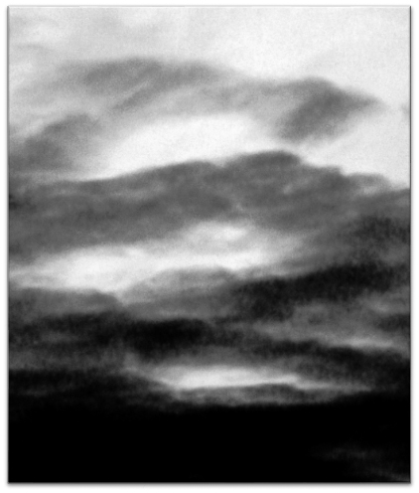
Green Cloud Dragon

What is the “night-colored pearl? When free of thought we become clear and still like a mountain pond, so can contain the sun and moon, the spheres of light. Closing eyes we see an orb of darkness, but also containing light and color around us, too. After a span of silence we forget our self and become oneness. This is our original nature, exemplified by the Cloth Sack Buddha, the round “Laughing Buddha” of Nothingness and Abundance.
When Jijang (Earth Womb) Bodhisattva vows to save all sentient beings and, so, descends into the darkness of Hell, he lifts up a yeouiju, which is actually the spotlight of his mind. It illuminates the caverns and clears the ignorant thoughts of the inmates who have created their own circumstances. Witnessing the secret of happiness, they get freed by their own awareness.
Daehaeng (Great Practice) nun’s No River to Cross, No Raft to Find (2005) shares a vision as a young wanderer in the forest:

One day, a huge dragon transforms into a thousand shapes. It is spectacular. Many Mani-jewels come out from its mouth and are connected by a string. Suddenly I feel that it is not a dragon. Instead it is the manifestation of a single thought from the foundation. After this, the dragon soars into the sky and makes a huge column of fire. The symbol 卍 lays flat on top of the column of fire. The column rotates. It feels as if everything around is connected to and rotating with this column.

☼The nun says the dragon is “the manifestation of a single thought from the foundation.” A holy ground of no thought and form underlies all things. The dragon is an instrument of Change. “A thousand shapes” emerge from it.
Universal consciousness appears as a string of wish-fulfilling gems. Together, they produce a pillar of fire, like Moses’ ever-burning bush, and the waterwheel symbol (backwards swastika) of continuously turning life. Rotating, the fire column burns off impurities and unites everything.

Fred Jeremy Seligson, a counselor of the RAS, is currently writing about dragon dreams.

