Grit and Enterprise:
Western Correspondents in Korea during the Russo-Japanese War

Matt VanVolkenburg

Japan’s victory in the 1904-05 Russo-Japanese War was an important stepping stone in its rise to great power status and its imperialist expansion into Korea and Manchuria. This titanic clash of arms, which resulted in the unprecedented defeat of a Western great power by an Asian nation, also generated another clash between East and West – that between the Japanese War Office and the Western journalists who tried to cover the war. On the one hand, the Japanese military initially tended to perceive the foreign correspondents who came to cover the war as potential security threats and sought to strictly control them. On the other hand, the reporters were left at the mercy of the Japanese War Office because, believing war would not break out, their newspapers neglected to dispatch them until it was nearly too late.
A dozen or more reporters who sailed from San Francisco on the Siberia arrived in Yokohama on January 25, just two weeks before the war broke out, only to discover that civilian passenger ships to Korea were no longer available. Forced to rely on the good offices of the Japanese Army, Western journalists were attached to specific Armies, and it was not until early April, two months after hostilities began, that the correspondents with the First Army were permitted to leave Japan for Korea. Those with the Second Army only arrived at the front in August, while it was not until early winter that those with the Port Arthur Army arrived in Manchuria.
Not every correspondent was forced to spend months in Tokyo filing stories about geisha and sumo wrestlers, however. Three Western journalists managed to make their way to Korea before war broke out and civilian travel was curtailed. The first to arrive, on January 31, 1904, was Frederick Arthur McKenzie, a Canadian who had lived as an expatriate in London for a decade and who was writing for the London Daily Mail. The next day, Robert Lee Dunn, a Tennessee native who had worked as a photojournalist for years, arrived at Chemulpo to cover the war for Collier’s magazine. The last to arrive two weeks later was a correspondent for the San Francisco Examiner, an up-and-coming author from California named Jack London.

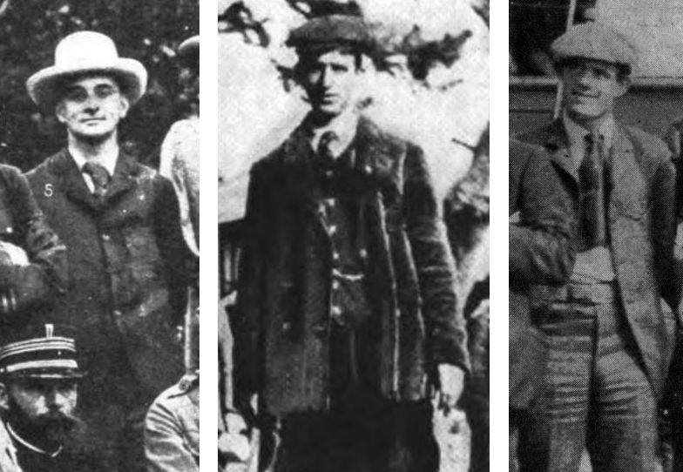
From left: Frederick McKenzie, Robert Dunn, and Jack London.

Though the month they spent traveling through Korea with the vanguard of the Japanese Army may not be well-remembered today, it was well-documented. McKenzie wrote a book about his wartime experiences, while London and Dunn wrote numerous articles and took hundreds of photos. What follows makes use of these sources to shed light on how these three reporters covered the war. Central to their efforts was the journey they made from Chemulpo (modern-day Incheon) to Pyongyang, a winter-time undertaking made arduous by the fact that the railways linking Pusan and Uiju were not yet finished.
Korea was not entirely devoid of railways, of course. Upon McKenzie’s arrival in Chemulpo, he took the train to Seoul “in greater comfort than one travels as a rule from London to Dover.” He stayed in Seoul a few days, impressed by the city’s “strange combination of barbarism and modernity,” and interviewed figures such as Minister Yi Yong-ik, who argued there would be no war.
In contrast to this, Dunn stated there was “evidence on every hand that [war] would start shortly. The harbor of Chemulpo was studded with war ships, nearly every nation being represented. The port closed. The mails stopped. The wires became silent. Tidings from the outside world were not to be had.” With dispatches cut off, the Russian gunboat Korietz tried to leave for Port Arthur on February 8, but was quickly forced by a group of Japanese battleships to return to harbor. The Russians aboard the Korietz and the cruiser Variag could do little but watch as “the Japanese transports landed their ﬁrst 3,000 soldiers on the bund of Chemulpo.”
McKenzie, then in Seoul, hurried to Chemulpo to witness the landings. As Dunn related, “The landing of troops continued far into the night, and as long as the opportunity lasted I busied myself taking ﬂashlight pictures. Those were really the only happy and satisﬁed hours I spent on Korean soil. The scenes I witnessed were weird and picturesque and full of promise of still better things to come.”
The first harbinger of things to come occurred when he was “stopped, searched and cross-examined for at least an hour, and with the [soon-to-be] familiar phrase, ‘I am very sorry for you,’ was permitted to depart.” The next came when, “as a matter of formality,” he visited General Yasutsuma, who “discouraged the idea of starting for Seoul that night” and offered him a seat on the train with the troops the next morning. “I was so pleased that I spent all night developing the ﬁlms that represented the result of my ﬁrst day’s work at the front,” but upon arrival at the station the next morning “the place was dead. Not a soul, civil or military, was to be seen.” Arriving in Seoul on the next train, he “found all the soldiers again. They had undoubtedly been boarding the trains at the very hour I was talking with their commander the night before.”
Despite his annoyance at having been misled, “Seoul presented many scenes picturesque – the arriving soldiers, the school children massed into line to meet them, and the heavily laden bulls carrying towering loads of supplies for the army corps.” He was to soon regret this move to Seoul, however.
“It was just at the stroke of twelve that a dull boom sounded, miles away; another and another, and yet another. The war had begun. The ﬁrst battle was on at Chemulpo, twenty odd miles back. The war I had come to see had started, and I was not at the starting.” As Dunn made his way back to Chemulpo, McKenzie watched as the Korietz and Variag made a suicidal run towards the open sea. During the forty-minute battle, the Variag suffered direct hits and was riddled with shrapnel to devastating effect for the men aboard. Arriving at Chemulpo, Dunn hired a sampan to take him out to the U.S.S. Vicksburg so he could photograph the aftermath of the battle. “The Variag, powerful as she was when I photographed her the day before, now rolled with every wave of the incoming tide. Her funnels were perforated, her decks strewn with wreckage, her guns twisted and almost completely dismantled.” After the Russians abandoned ship, the Variag burned and sank and the Korietz was scuttled with a thunderous explosion.

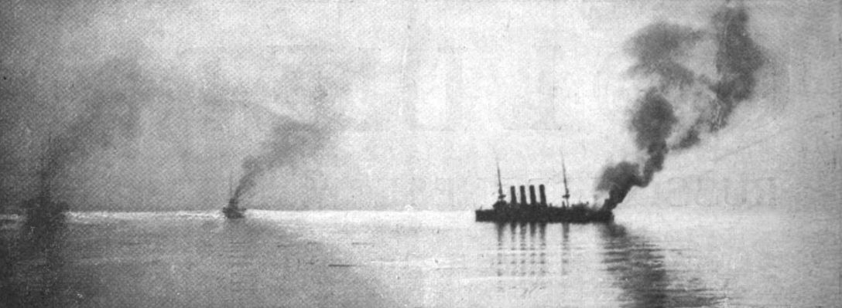
The Variag on fire in Chemulpo Harbor.

On February 16, a week after the battle, Jack London sailed past these wrecks. Though Dunn had befriended London on the Siberia, he wrote, “When London arrived in Chemulpo I did not recognize him. He was a physical wreck. His ears were frozen; his fingers were frozen; his feet were frozen.” Delayed by a sprained ankle – and by being arrested as a spy for taking photos around the Japanese base at Moji – London was eventually able to board a steamer for Chemulpo, only for it to be forced off course by the Japanese navy at Pusan. The next steamer he took was forced to land at Mokpo, so he spent eight days in a sampan sailing up Korea’s west coast in freezing weather with Korean and Japanese sailors. Despite being “absolutely down and out,” as Dunn put it, “He said that he didn’t mind his condition so long as he got to the front.”
Reaching the front provided numerous challenges. One of the most pressing was the fact that the correspondents did not have official permission to travel with the Japanese Army. Once in Seoul, as London described it, “we were advised by the Japanese Minister and generals to remain there until the Headquarters Staff should arrive.” They were not officially forbidden to leave, however, and they “had in mind always the Chino-Japanese War, wherein, by similar tactics, all but two or three men were inveigled into missing about everything that happened. The few that succeeded in seeing anything, had succeeded by virtue of the fact that they had shoved on.” They decided to set off for the front without explicit permission and left directions for their permits to follow them.
With the Seoul-Uiju rail line still under construction, they would have to share a narrow, snow-covered road with Japanese soldiers for 250 kilometers. There was another complication for London: “The trip had to be performed on horseback. I did not know how to ride.” Dunn and McKenzie set out to teach him, but finding the right horse proved to be a challenge. Korean ponies were known for their viciousness. McKenzie’s, for example, had a habit “of kicking fore and aft, and biting any stranger who approached him,” though they quickly learned to get along. A crowd of curious Koreans in front of Seoul’s Grand Hotel watched as the first horse London was placed on, a stallion, attacked the other horses and threw him into a snowbank. Korean Customs chief McLeavy Brown then sold London a gentle horse he grew fond of until it walked into a wall, revealing that it was blind. Finally, by chance he was sold a large horse that had belonged to the Russian Minister that he named Belle.
They next had to gather supplies. As London put it, “Everything was to be bought – saddles, bridles, blankets, hitching straps, nose bags, rope lashings, spare sets of horseshoes all around, horseshoer’s tools, pack-saddles, extra girths, canned goods, rubber boots, mittens, caps, gloves, clothes, ﬂour, cooking utensils, shoes, candles, and all the thousand and one articles necessary for a campaign which might extend into Manchuria. And it was New Year’s!”
As the supplies and pack horses to carry them were gathered, so too were the Korean and Japanese men needed to facilitate their travel: the interpreters, “boys,” and mapus, or grooms. “Boys,” or general helpers, could refer to actual boys, but often did not. McKenzie described his “number one boy,” Kim Mingun, the “overlord of my coolies, master of my horses, bodyguard and friend,” as a man of forty, while the two boys hired by Dunn appear in photographs to be teenagers. Photos of London’s “gem of a boy,” Manyoungi, who served as London’s “cook, interpreter, treasurer, [and] manager,” show him to be in his twenties. London had less luck in hiring a Japanese interpreter, who it turned out had simply memorized English phrases, so “ﬁve minutes later I had to borrow Dunn’s interpreter in order to understand what my interpreter was talking about.” Dunn alienated the interpreter he hired by addressing him as “boy,” so London hired him instead. As London put it, “I engaged always to call him ‘Mr. Yamada,’ whereupon he looked very pleased and asked me for an advance of two months’ salary.”
The advent of war quickly drove up prices and caused the value of Korean currency to skyrocket. Creating more difficulty was the fact that Korean “cash,” or the strings of coins used in daily transactions, were not made to be transported easily, as Dunn discovered to his dismay. When he sent out his new interpreter, Kurita, to convert $150, he was shocked by the result when Kurita returned hours later. “It took me only an instant to realize that I was the proud owner of what looked like a whole city block of real money – money enough to sink a ship.” “I could not carry it, and nothing short of an army could move it.” Kurita “insisted that twenty men were needed to guard my wealth, night and day, until I should be ready to move it.” He hired the necessary guards, but due to their wages, by the time Dunn returned “the heap of money had eaten itself up.”

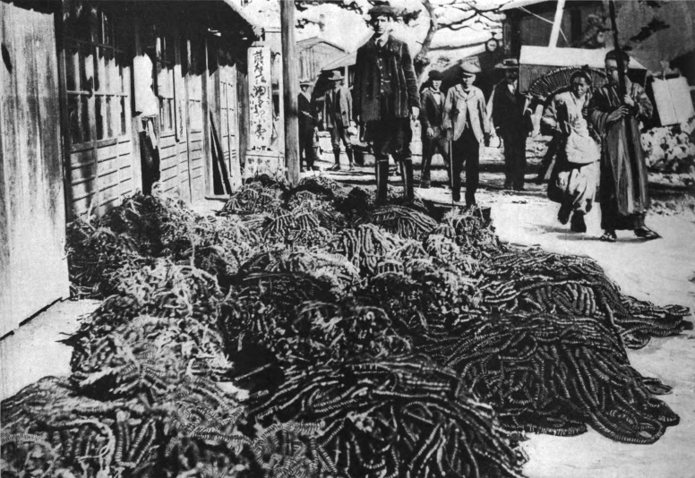
Robert Dunn with his pile of money.

Dunn and McKenzie had planned to head north on February 22 before London was fully ready, but they met with delays, so it was London who left first two days later, taking McKenzie’s pack horses ahead with him. Before he could leave, however, he was confronted by the mapus who demanded higher wages; already getting double the normal rate, they demanded twice as much again. As McKenzie described it, “I might have compromised, but the spirit of my comrades fired me to fight. ‘These men are money mad,’ cried Jack London. ‘We’re not going to give way.’ The men threw the packs on the road.” In the end, however, “Our servants stood by us. The packs were replaced, and the strikers found the procession of ponies starting north without them.”
Dunn was the first to catch up. According to London, “that night, at the end of ﬁfty li, found Dunn sans boy, sans mapus, sans everything and dining with me.” McKenzie headed out the next day carrying only a blanket, a toothbrush, and a revolver, followed by his interpreter and boy. He described the “Peking Road” they were to take north as “surprisingly well made, although often in a bad state of repair.” He rode all day and into the night until finally “I could hear the voices of my friends, who…were now shouting for us.”
McKenzie wrote memorable descriptions of his friends. “If ever a man deserved success, Jack London is he. Whatever came during the days of our trip north (and we had our share of the very rough) his open, frank face never lost its laugh. He had to learn riding, and before many days his flesh was raw with saddle soreness. Then he laughed the more, even though his teeth were clenched, only insisting that we should ride harder, and himself hardest of all.” He described Dunn as “American every inch. A Tennessee man, trained in New York, he will do anything, bear anything, go anywhere, to get a beat. He is capable of asking a General to delay a bombardment until the light grows better for picture taking.”
Once gathered, “We three had among us eighteen ponies and thirteen men, boys and interpreters.” This was, as London put it, “a puzzling parcel to deposit in chance livery stables along the way. And stables were a necessity, ﬁrst because of the impossibility of carrying horse food or of grazing horses at night in the snow, and second because Korean ponies are only fed on cooked beans and soup, piping hot.” Also complicating the journey was the fact that “supplies of food had been cleared out for the troops and many villages were wholly taken up by the advance guards. One night Dunn had to keep out by sheer physical force a party of Japanese soldiers who wanted to take over our hut.” These food supplies were also important because “After the first day or two we had left our carts and boys behind and had pushed on with one native attendant, relying mainly on native supplies for food. The weather had been exceedingly trying. Several of our boys had broken down from the quick exertion [and] Dunn was struggling against an attack of pneumonia.”
London also described the demanding conditions: “I shall not soon forget such an ice-slope we climbed at the rear of a column of infantry. The men were sprawling right and left. Slipping became contagious. McKenzie, in front of me, after mad gyrations, went down. A soldier picked him up and promptly went down himself. My feet were inclined to move in divers simultaneous directions, and the resultant was precarious equilibrium maintained at hazard and by miracle. But poor Belle, my horse, had four feet sliding in many simultaneous directions.” By the time they made it to the top almost all of her shoes had come off. The necessity of carrying one’s own horseshoe supplies soon became apparent. As London wrote of Korean villagers, “Love, money, or force could not procure from them a horseshoe or a horseshoe nail. ‘Upso,’ was their invariable reply. ‘Upso,’ cursed word, which means ‘Have not.’”
At a time of war and possible invasion by Russians, Korean villagers were, unsurprisingly, not always willing to put Dunn, London, McKenzie, and their entourage up for the night, despite the income they could earn. A memorable instance of this took place in Hwangju, which London described as “an ancient walled city of an estimated population of 30,000.” That day they had “started at dawn and traveled hard until evening, climbing over two stiff mountain passes in the afternoon, and keeping on for long after dark.” London had fallen behind, but when the McKenzie and Dunn arrived, exhausted, “the head man there absolutely refused to give us shelter,” nor would anyone sell them food for the horses. As London put it, “there were frequent invitations to go on to the next village, ‘ten li more.’ This phrase, ‘ten li more,’ has a peculiarly irritating effect on Dunn. He avers that he has heard nothing else since he entered the country, and that he has heard it so often and under such exasperating circumstances that he is going to write a book on Korea and entitle it, ‘Ten Li More.’” When they were led to the gates, McKenzie tried another tactic: “I shifted my revolver from my hip pocket to the front of my coat, ostentatiously letting the head man see my every movement.” He then made it clear they would not be leaving, and, “As if by magic, the head man’s expression changed.” In retaliation, their horses’ blankets were stolen off their backs during the night, and only a tense confrontation the next morning, during which they all drew their guns, got the blankets back.
Such dramatic interactions were uncommon, however. As McKenzie put it, “We early learned to submit ourselves to the friendly curiosity of the people. They crowded around us, timid and good-natured, making holes in the paper windows to spy our doings, and noticing our every movement.” He described how London would amuse himself by sitting in the doorway and, “gazing vacantly at the crowd in front of him,” would let his false teeth begin to drop from his mouth. “Then he would start up with a shout and the whole mob would fly helter-skelter in terror.”
Despite being beset with hardships during their journey north, they “could not fail to be struck by the majestic beauty of the land.” As McKenzie put it, “I shall never forget the evening when one descended from the hills, and crossed the ice on the broad Imjin River – as grand a stretch of mountain and river scenery as I have ever beheld.” In addition to the natural landscape, the march of Japanese infantry, horses, artillery, and pontoons with which to make bridges presented many opportunities for a war photographer – especially when he was one of only two foreign correspondents with a camera in Korea. As Dunn put it, “There never was a time when good photographic scenes failed to present themselves.” But while finding subjects to photograph was easy, developing the film and sending the photos back to New York was not.
One problem was interference by the Japanese military. “Being stopped and detained for hours at a time got so common that shortly I quit protesting,” Dunn wrote. Whenever he wanted to develop film, “A hut if possible was located at the extreme side of a village, where the soldiers could not interfere without going far out of their way.”
Though Dunn had brought with him a developing machine, chemicals, and a great deal of film, he was forced to develop the film in sub-zero weather. “The next problem,” according to Dunn, “was water. One well to a village is the rule and water in plenty one must have when there are dozens of ﬁlms to be developed. The moment I entered a village…the entire population was sent scurrying to the town’s only well for water. The primitive method by which I obtained my water supply is well illustrated by the picture of the Korean girl with the big jar of water on her head. It would tax a man to lift such a weight to his shoulder, yet this mere child, inured to hardship, carried it without difficulty. Indeed, the opportunity to earn a little money was so attractive to her that she followed our little party from place to place for the sake of what she could get in this way. Sometimes she could not keep pace with us, and for a few days we would not see her; then she would again appear on the scene, ready to help in the carrying of water for my developing machine. By the time my helpers with the packs arrived, water in every conceivable pot and pan in town was in readiness for the developing.”
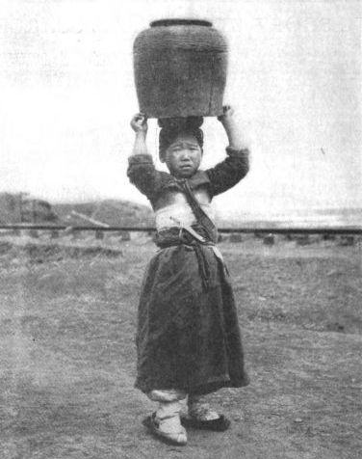
One of Dunn’s water carriers.

Among his helpers were two Korean boys, and with their aid he spent hours developing photos. “The water had to be warmed, so had the machine, and by working rapidly we were able to develop the roll before the developer would get too cold.” The two Korean boys he hired “proved exceptionally smart and bright. It took only two or three days before they were able to run the developing machine, and in fact mix all the chemicals for developing. They learned to dry the ﬁlms, clean the developing machine, and very often would take a Kodak and make a fairly good photograph.”

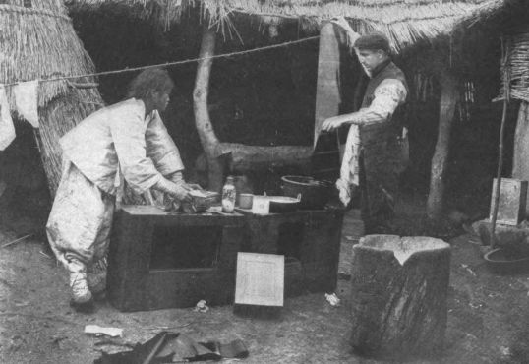
Dunn working with a Korean boy to develop photos.

“With my Kodak under my saddle and the saddle for a pillow I turned in usually about midnight,” surrounded by drying films. He would rise early, caption his photos, and then arrange to send them abroad. As Dunn put it, “I sent a messenger almost daily for over a month. These messengers were Korean coolies, generally the ones who had worked for the missionaries and could be fairly well trusted. It took a coolie, traveling very hard, on foot, about six days and half the nights, to arrive at Seoul. At Seoul arrangements were made with foreigners to see that the ﬁlms and correspondence got the ﬁrst available craft for China.” Many of the messengers were involuntarily drafted by passing Japanese soldiers and forced to turn around and carry their packs north. As a result, some took weeks to make the trip to Seoul, and some never made it there at all.
Upon their arrival in Pyongyang on March 2, after eight days of riding, Dunn and London photographed the exhausted Japanese troops waiting for a pontoon bridge to be built across the Taedong River. The city offered many opportunities to those with cameras, and they both took photos of Japanese troops marching into the city, a re-enactment of a skirmish with Russian scouts at the city walls, and the interior of a Korean palace then being built in the city.

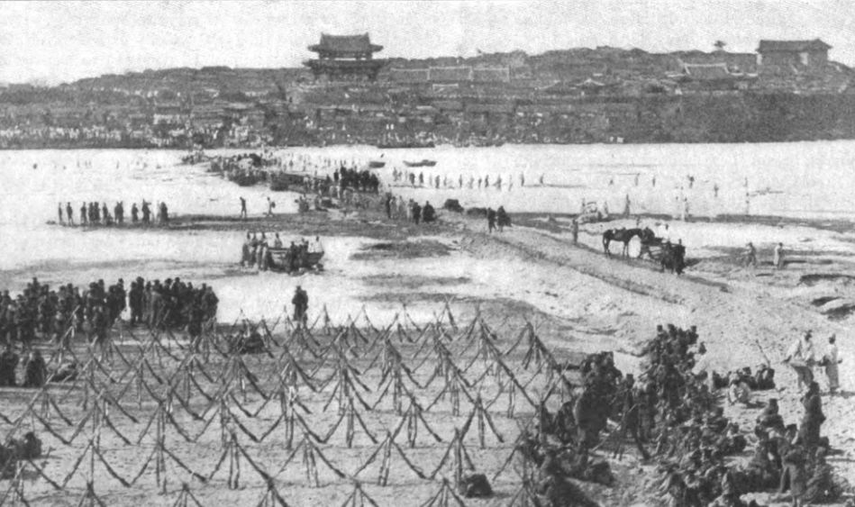
The pontoon bridge being built at Pyongyang.

Pyongyang also offered the correspondents other opportunities. According to McKenzie, after days of eating only rice and hard-boiled eggs, they were “dominated by one great longing – the desire to find bread, white bread, without which all the rest of the good things of this earth are almost worthless.” Upon arriving at a Japanese inn on the river bank, McKenzie was sent out to find bread but slipped and fell on the ice-covered steps, fracturing his wrist, so it was ultimately Dunn who went out to gather all the bread he could. Though they were staying at “a Japanese Hotel crammed with soldiers,” it offered at least one comfort, described by London in a letter in which he stated he was “ordering whiskey just now” for Dunn and McKenzie.
In Pyongyang, they also came across the American missionaries active there: Samuel Moffett, Graham Lee, and Edwin Koons. McKenzie praised their self-sacrifice and patient endurance, saying they “deserve admiration and regard in the highest degree.” Koons tried to help McKenzie convert a bank draft from Seoul, and also convinced London to buy Japanese silver dollars with paper yen that would be useless further north. London later found Moffett’s Korean name, Mah-mok-sah, “a word to conjure with” when dealing with Korean villagers further north.
After several days in Pyongyang, Dunn, London, and McKenzie were anxious to move further north to Anju where Japanese scouts were encamped. The Japanese Army was reluctant to let them go, however, and the fact the correspondents’ permits had not yet caught up with them was “the string by which the War Department had hold of us.” At first only gentle pressure was applied. At numerous meetings with the Japanese Consul in Pyongyang, they were “neither permitted to go on, nor commanded to stay back.” As well, General Sasaki urged them to wait and travel with him, which, as London told it, convinced one of them to remain: “Mackenzie fell by the wayside. Most anxious of the three of us to push on at once north to Anju, he allowed himself to be persuaded by General Sasaki and deported on a side-trip to the seaport” of Chinnampo.
On March 8, Dunn and London headed north but faced so many delays they made it only 13 kilometers before having to stop for the night at a village called Poval Colli. Amid villagers coming to stare at them, London set the scene as he tried to write: “My interpreter comes in with his daily report. Manyoungi, my Korean cook and interpreter, comes in with tea and toast. Dunn sends down half a can of hot pork and beans – and there are a thousand interruptions.”
Soon after setting out the next day, they were met by a Korean messenger who delivered news from missionaries that Russians had been sighted north of Anju, 50 kilometers away, and that they should press on as fast as possible if they wanted to witness the imminent clash. When they arrived in the nearby village of Sunan, however, they were surrounded by a detachment of soldiers there who had been tipped off by the group’s Japanese interpreters. Orders soon came from General Sasaki that Dunn and London were not to proceed farther.

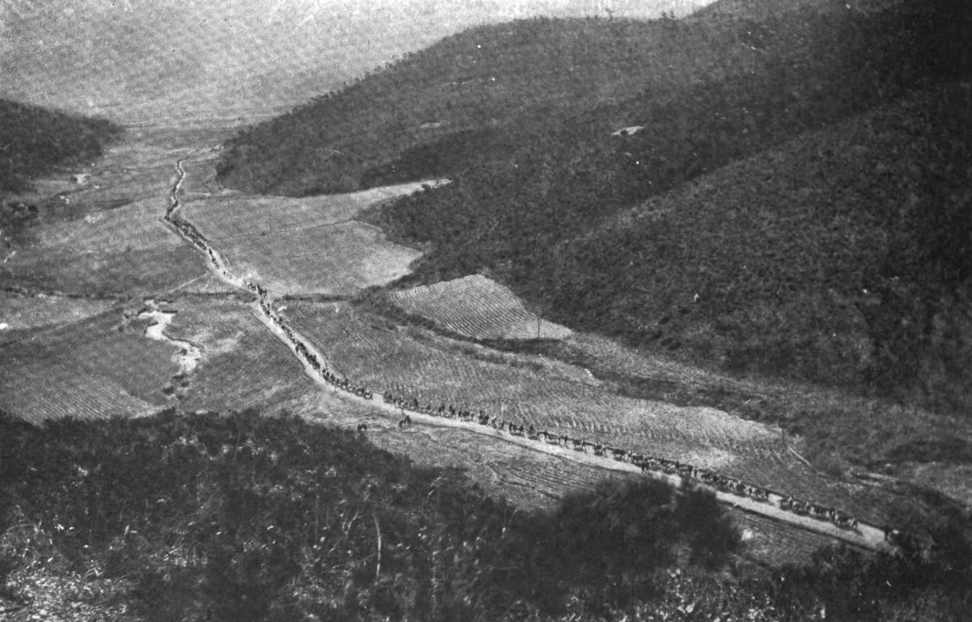
Japanese troops on the move through northern Korea.

Though the infantry captain there provided them with food and they were free to ride their horses, any attempt to go north was challenged by Japanese sentries. As most of the villagers had fled at the outbreak of war, London set up camp in a deserted house on the main street and watched as soldiers and supplies streamed by, heading north. During their stay in Sunan, many villagers began to return, and London himself proved to be a star attraction. “All of my functions, from eating to sleeping are performed in public” and “all day long there is a rapt and admiring audience before my door.” “There is a constant discussion going on as to why I do this or that; but my star performance is shaving. When Manyoungi brings the hot water and I lather my face the street blocks up.” London returned the favor by setting up an outdoor photo studio, and he and Dunn took turns photographing the villagers.
After two or three days in Sunan, Dunn went back to Pyongyang “to wake the dead in an effort to get permission to proceed,” leaving London to pass the time sending Korean poems to his future wife and trying to “grind something out of nothing for the Examiner.” In Chinnampo McKenzie also found himself sequestered. Intending to watch the landing of Japanese troops there until a despatch boat arrived from China, his wait stretched into more than a week because, unbeknownst to him, the Japanese had turned the boat back. As all of the hotels were filled with Japanese officers, he was “isolated in a lonely Korean hut,” where he typed out two or three chapters of his book.
Dunn, London, and McKenzie eventually came to learn what had led to their detainment. As London put it, “The Japanese are disciplining us for our rush ahead and the scoop we made – and they are doing it for the sake of the correspondents who remained in Japan by advice of the Japanese and who have made life miserable for the Japanese by pointing out that we have been ahead gathering all the plums.” After correspondents in Tokyo threatened to go to Korea on their own, the War Office ordered those in Korea to obtain official permits.
In Pyongyang, the Japanese Consul told Dunn “that complaints were coming to him daily,” and ordered him back to Seoul. As Dunn saw it, these complaints came from men “who did not have the grit or the enterprise to get anywhere near the field of action.” Dunn packed up his gear and headed back to Seoul the way he had come, and after a six-day trip he arrived in Seoul on March 20.
After more than a week of waiting in Chinnampo, McKenzie was given a written order of expulsion by a police official. His plan to take an army transport the next day changed when The Times’ despatch boat docked for a short visit, and he was invited to join the crew as they sailed to Chemulpo. While aboard, McKenzie revelled in the “strange luxury” of Western food, a bed, and a hot bath.
London was ordered to return to Pyongyang, and upon arriving there on March 16, he was ordered back to Seoul. He rode down to Chinnampo but was given no time to view the troops landing. “The Japanese Consul, turning a deaf ear to the complaints of the captain, held a coasting steamer all afternoon and long after dark until he saw us safely on board and steaming out of the harbor.”
By March 18, London and McKenzie were back in Seoul, but were forced to wait three weeks for the other correspondents attached to the First Army to arrive from Tokyo. As London passed the time learning billiards and giving a reading of Call of the Wild at the Seoul YMCA, he complained about the “irritating inactivity,” writing, “Have never been so disgusted with anything I have done. Perfect rot I am turning out. It’s not war correspondence at all.” Unable to see any war, they were faced with “gorgeous uncertainty and a hotel proprietor who raises the rates every little while and calls it a war price.”
In mid-April London and McKenzie joined the group of correspondents who had arrived from Tokyo. They sailed to Chinnampo, rode to Pyongyang and collected the gear they had left behind, and then headed north with the First Army so they could witness the Battle of the Yalu River, the first major land battle of the war. From there they followed the Japanese Army into Manchuria.
Dunn was not so lucky. Though he had been explicitly assured in Pyongyang that the Japanese Minister in Seoul could authorize him to rejoin the army, “there was a hitch somewhere,” so he was ordered to return to Tokyo. “I fumed and flared,” he wrote, “but had to go.” Upon arriving in Tokyo in early April, he found he would not be assigned to the First Army along with London and Dunn, nor to the Second Army, but rather to the Third Army. After a wait of almost two months, he left Tokyo in disgust on June 10 and headed home.
‘To tell a man plainly that he can not do a certain thing, and to stick to it, has evidently never been dreamed of in Japan,” he wrote. “It is so much easier to promise with a smile and break with a shoulder-shrug. At Tokio the game is played hourly – at the War Office, at the telegraph office, at the hotels, everywhere.” He proposed that if the war correspondents were to collect every case of misrepresentation together, “no book of size hitherto seen would be large enough to hold their tale of woe.”
McKenzie disagreed. Though he was critical of the way the Japanese antagonized the foreign correspondents in the field and treated them with suspicion – something an Imperial rescript put an end to in the fall of 1904 – he found that many of the charges of bad faith resulted from misunderstanding. “Much trouble was caused by the fact that the Japanese mode of expression is different from our Western way. When a Japanese has to refuse your request, courtesy forbids that he should reply with a direct negative.” As for so many correspondents being held back in Tokyo, he wrote that the War Office was “undoubtedly overwhelmed by the total of applications from so-called correspondents,” many of whom, he asserted, “were not proper war correspondents but mere posers,” a “crowd of irresponsible outsiders.”
London was soon sailing home as well. In late May, after he got into an altercation with a Japanese groom who was stealing his horse’s feed, he barely escaped being court martialed and, after stopping in Seoul and Tokyo, headed home. After the Battle of Liaoyang in late August, McKenzie began a journey that took him to Poland and the Caucasus to report on the war’s effects on Russian society.
Anyone learning about the opening of the Russo-Japanese War today has almost certainly come across Robert Dunn’s photos, but this trip marked his only involvement with Korea. Frederick McKenzie returned to Korea in 1906 and wrote a critical account of Japan’s protectorate titled The Tragedy of Korea. He followed this up with an account of the March First Independence Movement of 1919 titled Korea’s Fight for Freedom. Though he is not well remembered today, practically every South Korean has seen the photo of Righteous Army soldiers he took in 1906.
Jack London never returned to Korea, but it continued to exert an influence on him. He brought his Korean “boy,” Manyoungi, to the U.S. to work as his valet for several years, and his experience in Korea influenced his short story “Nose for a King” and a chapter of his 1915 novel The Star Rover, in which he wove his own experiences in Korea into a fictional reworking of Hendrik Hamel’s Journal. But perhaps the most noteworthy result of his time in Korea may have been “Jack London,” a World War II-era film about his life which climaxed with the realization, while in Korea in 1904, that Japan posed a dire threat to the West. While today it is not uncommon for globally popular American films to have scenes set in Korea, it may be worth remembering that the first Hollywood film to feature Korea as a setting was based on the journey London undertook with McKenzie and Dunn in 1904.

Matthew VanVolkenburg has lived in Korea for 14 years, received an M.A. in Korean Studies from the University of Washington and is the author of the blog Gusts of Popular Feeling. He has been published in the Journal of Korean Law and Transactions.

Frederick Arthur McKenzie, From Tokyo to Tiflis: Uncensored Letters from the War (London: Hurst and Blackett, Ltd., 1905), 270.
Photo sources: James Hare, ed., A photographic record of the Russo-Japanese war (New York: P. F. Collier & Son, 1905), 200; Richard Harding Davis et al., The Russo-Japanese war; a photographic and descriptive review of the great conflict in the Far East (New York: P. F. Collier & Son, 1905), 88, 89.
McKenzie, 21-38.
Robert L. Dunn, “In Korea with the Kodak,” Collier’s, August 13, 1904, 21.
Ibid; McKenzie, 41.
McKenzie, 39-40.
Robert L. Dunn, “Ways That Are Dark, And Tricks That Are Vain,” Colliers, July 23, 1904, 9.
Dunn, “In Korea with the Kodak,” 21.
Dunn, “Ways That Are Dark,” 9.
Dunn, “In Korea with the Kodak,” 20. Dunn describes an arduous Jinriksha ride to Chemulpo that is, to say the least, rather improbable.
McKenzie, 42-54.
Dunn, “In Korea with the Kodak,” 20. Dunn’s photos of the burning ships appeared in Collier’s six weeks later.
Photo Source: Collier’s, March 26, 1904.
R.L. Dunn, “Jack London Knows Not Fear,” San Francisco Examiner, June 26, 1904.
Ibid.
King Hendricks and Irving Shepard, eds., Jack London Reports: War Correspondence, Sports Articles, and Miscellaneous Writings (New York: Doubleday Company, Inc., 1970), 64.
Jack London Reports, 33.
McKenzie, 98.
Jack London Reports, 33-37.
Ibid, 37. McKenzie overcame a Chinese tailor’s reluctance to work on the holiday by promising to write about him in his book. McKenzie, 66-67.
McKenzie, 72.
Dunn, “In Korea with the Kodak,” 21.
Jack London Reports, 35, 43.
Ibid, 35.
“A ‘Cash’ Transaction in Korea,” Collier’s, June 4, 1904, 8.
Photo Source: “A ‘Cash’ Transaction in Korea,” Collier’s, June 4, 1904, 8.
McKenzie, 74.
Jack London Reports, 37. In his earliest articles London referred to Dunn and McKenzie as “Jones” and “McLeod,” respectively. I have corrected this.
McKenzie, 81-84.
Ibid, 64-65.
Ibid, 74; Jack London Reports, 43.
McKenzie, 88.
Ibid, 92.
Jack London Reports, 54-55.
Jack London, “The Yellow Peril,” in Revolution and Other Essays. http://london.sonoma.edu/Writings/Revolution/yellow.html
Jack London Reports, 57-58.
McKenzie, 88.
Jack London Reports, 58. “Jones” has been changed to Dunn.
McKenzie, 88.
Ibid, 89-91; Jack London Reports, 59-60.
McKenzie, 87. He does not mention London by name, but London himself described how he removed his teeth while in a Korean fishing village, after which “one old fellow…crept in to me at three in the morning and woke me in order to have another look.” Jack London Reports, 11.
McKenzie, 81-82, 91.
Dunn, “In Korea with the Kodak,” 20. London also had a camera.
Ibid, 21-22.
Dunn, “In Korea with the Kodak,” 20.
Photo Source: Dunn, “In Korea with the Kodak,” 20.
Ibid, 21.
Ibid.
Photo Source: Dunn, “In Korea with the Kodak,” 21.
Ibid, 23.
Ibid, 21. Dunn later tried to mail a number of photos from Pyongyang, but never saw them again and assumed the Japanese had confiscated them. Collier’s, May 21, 1904, 12-13.
London’s photos of Pyongyang can be seen at the Huntington Library’s website: https://hdl.huntington.org/digital/collection/p16003coll7/id/632/rec/302
Photo source: Collier’s, April 23, 1904, 5.
McKenzie, 92.
Ibid, 93.
Dunn, “In Korea with the Kodak,” 23.
Jack London Reports, 13.
McKenzie, 104-107; Jack London Reports, 68-72.
Jack London Reports, 82-84.
Ibid, 92.
Ibid, 65-66.
Ibid, 15.
Jack London Reports, 66.
Dunn, “Ways That Are Dark,” 9.
Photo source: Collier’s, May 14, 1904, 10.
Jack London Reports, 16-17, 75.
Ibid, 73-77; The Russo-Japanese War, 59, 66.
Jack London Reports, 17, 23, 75.
McKenzie, 109-111, vi. Or so one assumes; this was only time he was alone in Korea.
Jack London Reports, 17, 92.
Collier’s, May 21, 1904, 12-13.
Dunn, “Jack London Knows Not Fear.”
McKenzie, 111-112.
Jack London Reports, 17, 93.
Ibid, 18; McKenzie, 112.
Jack London Reports, 18-20, 93.
Dunn, “Ways That Are Dark,” 10.
Ibid.
McKenzie, 279-80, 275.
Ibid, 273-74.
Jack London Reports, 24-25.
McKenzie, 281-316.

