Building the Daegu Hospital (1903-1907): A Study on the Construction and Design of Early Western-Korean Hybrid Architecture

Nate Kornegay

The building endeavors of Christian missionaries in turn-of-the-twentieth-
century Korea are well-regarded by some scholars and members of the public today, their medical institutions in particular informing the peninsula’s modernization. Some of these projects were relatively large feats of engineering, impressively standing for years despite some of who we could call missionary-architects having only a very basic understanding of building matters. Hospitals, schools, churches, and missionary residence projects from the 1900s often appeared successful. However, they were successful in the sense that these missionary-architects, who were largely unprofessional builders taking up construction tasks in addition to their mission work, were able to overcome the obstacles that stood in their way of implementing Western design ideas. A closer look at a variety of missionary accounts shows some of these building projects were difficult to complete and were riddled with imperfections. This is perhaps in no way more apparent than in the case of the Presbyterian mission’s first hospital at Daegu.
The enormity of the hospital problem there from 1903 to 1907 led to a wealth of written accounts describing the building’s design and construction, and while some scholars are quite familiar with this case and the various research materials related to it, the following study helps better our understanding of the nature of hybrid Western-Korean building projects in 1900s Korea.
In 1899, missionaries Woodbridge O. Johnson and James Edward Adams opened a “little room” for medical work in a small Korean chogajip (straw-thatched hut) adjoining the Presbyterian mission’s first property in Daegu. Henry Munro Bruen, a Princeton graduate and New Jersey native, also joined the Daegu mission station in October 1899, the three of these men becoming the “founders” of what is now referred to as Daegu’s Jejungwon — its first hospital. In missionary publications, reports, and correspondence, it had no official name and was merely referred to as the Daegu Hospital. It is to this hospital that present-day Dongsan Medical Center traces its roots.
The Presbyterian mission appears to have had three of their missionary residences at Daegu built by 1903, the hospital then becoming the fourth mission building under construction between spring and summer of that year. The hospital was designed by Henry Bauld Gordon, the professional Canadian architect known for Severance Hospital in Seoul. It was a large, 2,640-square-foot building originally budgeted at 6,000 yen minus equipment and furnishings. The building was largely overseen by Johnson, who personally supervised the making of the foundations, masonry walls, placement of the trusses, and flooring. A local Korean individual, referred to only as Mr. Chung, was dubbed the “native Christian overseer” who supervised the work alongside Johnson, including the construction of the three residences. With wood too expensive to use for the entire structure, bricks were used instead — burned by local Koreans and laid with Japanese plaster. Timber was, however, used to frame the roof.
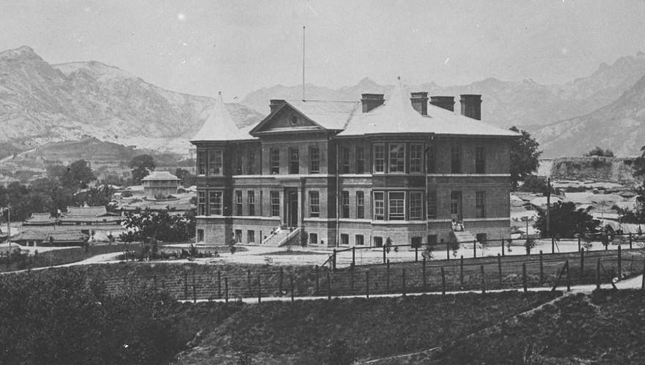
Image 1. A photograph from the 1900s-1910s depicting the main building of Severance Hospital in Seoul, completed in 1904 and designed by Gordon. (Glass plate negative. “Severance Hospital, Seoul.” Probably photographed in the 1900s-1910s. Presbyterian Historical Society.)

Managing the project then became an enormous challenge for the Daegu station founders. Not only was Adams on leave in the United States during that time, but Bruen, who was on the Building Committee with Johnson and shared some level of responsibility, did not become as directly involved in the hospital’s construction, as he was preoccupied with taking on all of Adams’ normal work in addition to his own. Gordon, the architect, was asked to come to Daegu to superintend the hospital he designed. However, with the Severance Hospital project underway in Seoul and the railway line between the capital and Busan incomplete, he wouldn’t come. The hospital then, by his own account and others, became the responsibility of Johnson.
With Johnson organizing much of the project, Chinese builders came down from Seoul to handle the foundation and masonry while an agreement with an unnamed Japanese contractor in Busan was struck for the roof and timber sections. According to one of Bruen’s accounts, complications arose quickly when the contractor became too busy to come to Daegu, instead sending a “head carpenter” to frame the timber for the hospital. The situation was made worse when the timber arrived in Daegu via the Nakdong River without the aforementioned carpenter. The “head carpenter” was, according to what Bruen said of the Japanese contractor, sick and would not be leaving Busan. With the Chinese builders already in Daegu waiting for the framing to be completed, Johnson took to making “the best out of a poor job and set to work with Korean carpenters to put together foreign trusses marked in Japanese hieroglyphics.” To be clear, waiting meant the spoilage of materials during the coming wet season, as well as the eventual loss of the masons who were waiting to do their job. It took days of “matching and experimenting” in the assembly of the trusses before the roof frame was up and the Chinese workers could begin their part. The roof timbers were assembled into five Western-type trusses, according to Gordon’s building plans, which supported a Korean giwa (clay-tile) roof.
A letter written by Johnson, dated April 6, 1903, gives us some idea of the construction timeline. He wrote that the Chinese workers had arrived on March 25, and were at the time of writing laying the stone foundation. Bricks and roof tiles were also then being burned close to the site, however the timber had yet to arrive from Busan. The Chinese workers built a cistern using the personal funds of Johnson, Bruen, and a recent arrival to the mission named William Marshall Barrett.
Johnson, who had written of his increasingly poor health, took a leave of absence that autumn, sometime before the end of September. He left the unfinished hospital in the hands of Barrett, who reportedly oversaw its completion, and was “made ready” to receive patients by Marion Michael Null — another recent arrival to the Daegu station. The reality was that the dispensary portion of the building was, reportedly, the only room to ever be used.

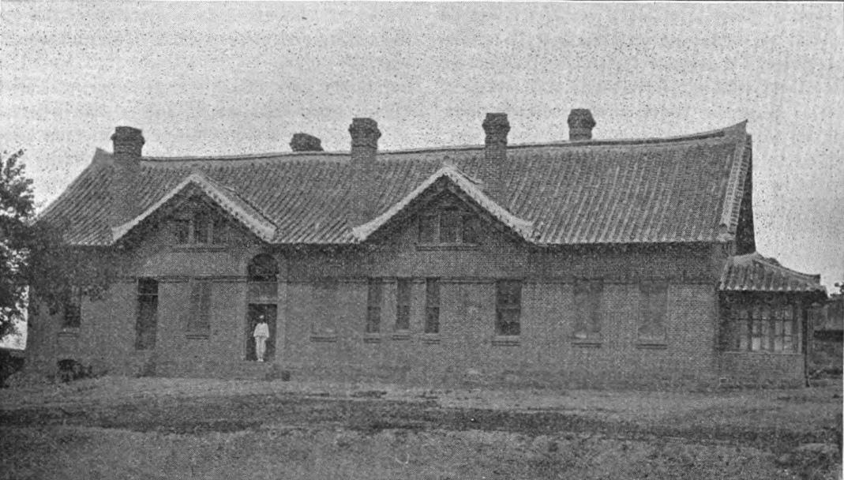
Image 2. A photograph, published in November 1904, depicting the first dedicated hospital building at Daegu, which was completed between the end of 1903 and beginning of 1904. (“The New Hospital at Taiku, Korea”. Marion M. Null, “The Korean Ch’im, or Needle”, The Assembly Herald, v.10 no.11 [November 1904]. Hathi Trust Digital Library.)

A few years later, the hospital was deemed structurally unsound by members of the mission’s building committee and subsequently demolished in 1906. What transpired in the years between its construction and demolition is not perfectly clear. However, many reports offer information on its issues and why it was torn down.
Null wrote that the mission at Daegu had been taking local patients into the dispensary since January 1904, placing the hospital building’s completion sometime between September 1903 and the very beginning of 1904. The main rooms of the hospital went unused as, according to Null, the Presbyterian mission had failed to provide the hospital with the equipment it needed that winter, specifically heating stoves. No known accounts shed light on what specifically happened after the building’s first winter season, however it was probably shortly after this that problems with the structure were found.
One of Null’s accounts does much to better our understanding of what was happening:
The building has been a constant state of annoyance to me ever since I came to Korea. I could never tell what was going to happen. I have moved in and out of the dispensary rooms five times. [Null appears to have been sleeping in the dispensary for a while]. Once the weight of a truss broke down the brick wall that was between it and a window below. I got jackscrews and workmen and built in the wall with cement. Again during a heavy storm the roof leaked so much that most of the plastering on one side of the house dropped off and I had to get workmen in and replaster and fix up the damage that was done. Again the foundation was not sufficient and I had to get workmen to put in new pillars and sills under the sleepers [a support for the flooring]. Again the walls were springing out and cracking down and a truss was falling gradually, so I had to get workmen to put in wooden posts under the points of weight.

These issues took place over a few years until the first part of 1906. Publications from the period, and even some contemporary texts from today, cite typhoons as the reason for the hospital’s destruction. And while storms may have done something to reveal the issues with the building, the fact was that the hospital, despite being designed by the same person who created the widely praised Severance Hospital in Seoul, was poorly built.
According to Null, his fellow missionaries in Daegu did not take much issue with the hospital structure and its constant repairs until what he called “the final break” occurred. Upon his return from Cheongju after spending the month of March (1906) there, he found the hospital in such a sorry state that he “at once closed up the doors of the dispensary and called a station meeting, which was held on April 9.
The station members decided to call missionaries from other stations to come assess the situation, specifically Graham Lee (Pyongyang), Charles Allen Clark (Seoul), and Charles H. Irvin (Busan). All three of these individuals had varying degrees of construction experience. In the meantime, Null began moving the equipment out of the dispensary and having carpenters temporarily shore up the building with wooden posts.
With Irvin unable to leave his work in Busan, Lee and Clark went to look over the hospital building themselves about a week later. Lee had been in Daegu two months prior in February and, after seeing the hospital then, had already urged the station to take off the roof as the building was “liable to collapse at any moment.” Upon his return with Clark in April, he was surprised to find the building had worsened in those two months.
In a letter regarding his findings, Lee stated that “the building ought to be pulled down to the foundation. The walls are laid with only mud and so badly cracked in places that it would be nothing but a botched job to try and repair the building without relaying [the bricks].” Lee gave three straightforward reasons for his recommendation at the end of his letter. These were:
1. Brick work laid in mud and very imperfectly done
2. Ends of trusses not laid on proper plates so as to distribute weight
3. Roof timber too small and imperfectly planed [leveled].
Clark, in his memoirs, similarly called into question the Japanese plaster used to lay the bricks, claiming that “when the mud dried, it was no better than a flat piece of board.” He continued in his description of the hospital, offering further insight into how it was built. “Cross walls were not woven into the long walls. Roof timbers were run thro active chimney flues etc. [sic]”
Lee and Clark brought their assessment to the station members at Daegu and immediately decided to tear down the building without waiting for a response from the mission or board. Null was elected to carry out the task, convincing Clark to stay a while longer in Daegu to help with the demolition. The hospital was torn down sometime in April-May 1906, with some of its materials dismantled for reuse in the new missionary residence for the McFarlands being erected at the time. For the demolition Null seems to have initially tried to hire a Japanese contractor, who first quoted the job at 680 yen before being haggled down to 220 yen. The missionaries, according to Null, were able to do it themselves for less than 50 yen.
Null’s own description of the demolition process paints a vivid picture of its condition:

It was so dangerous that we had to use every precaution in tearing it down to keep the workmen from getting hurt; therefore it was almost indispensable for two [missionaries] to be present all the time. We did the dangerous work ourselves and by using every caution no accidents occurred. Two gables were so dangerous we sent the workmen away and Mr. Clark and I shoved the walls over ourselves with very little effort.

The process only took them six days. In a letter to Arthur Judson Brown describing the hospital after it had just been torn down, Null wrote a scathing review of the building and all the things that, in his estimate, were wrong:
1. A building too large for the appropriation was attempted. This of course [meant] inferior material, and less material being used than in other houses, for example joists were put two feet apart when they [should] be four-teen inches.
2. Those who had the building in charge did not know how to build. Mistakes were made in placing the trusses, in the plates, in the spacing of timbers, in the locking of the walls together by partitions, in the bonding of the walls, in the window arches, in building the chimneys, in the size of the beams necessary to support the weight, in the securing [of] the joists to the walls, in the notching of the sleepers, in the points of bearing for the foundation. No building is put up that is perfect and especially on the mission field where an experienced workman cannot be found, but where a building has too many mistakes it cannot stand.
3. The building was too large to be built of mud instead of mortar.
4. When building the work was not properly superintended, for all the work on the building was very poorly done and things which should never be in any building were common.

Some of these issues were echoed by Lee and Clark. Even the claim that inferior materials were being used was similarly used by Bruen, who claimed Johnson was skimping on materials under pressure from the mission to reduce building costs. Null, clearly irritated by the building and having to deal with its issues for years, was sure to point out that “it is a pity that a new building must be torn down before it is ever occupied.” He continued his lamentation by saying “we have had inpatients almost ever since we came,” yet the building “has been lying idle for three years.”
Johnson, who had been on furlough in the United States all this time, was saddened to hear of what happened to the hospital building that he spent so much time and effort on. “The prospect of now returning to my station” he wrote, “to find the building in which I hoped to at last begin medical work in proper and suitable surroundings instead of in the native mud and straw house, to find this building, erected with such cost and labor and care torn down is indeed bitter. [sic]”
He had also become aware of some of the blame that was being passed around and was sure to gracefully defend himself. Johnson recognized his shortcomings and that he could have committed “errors of ignorance” during the construction process, but he argued in multiple letters that Gordon’s plans for the hospital were accurately followed and that he supervised the project closely. One part of his argument included the visit of Bruen’s father-in-law, who was staying at the Bruen home for a few months in 1903 while Johnson was working on the hospital. His name was Jeremy Scott and, described as a fisherman who had worked construction on dams, coal breakers, and railways, he offered construction advice to Johnson during his visit to Daegu. Scott’s experience and witness became part of Johnson’s defense for making good choices during the project.

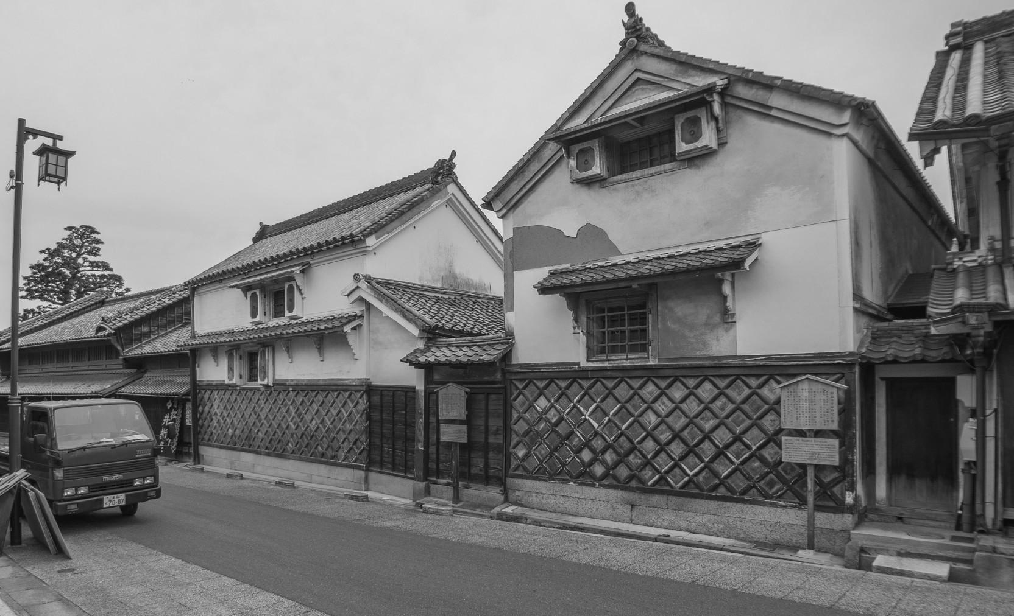
Image 3. A photo, taken in 2017, depicting late-Edo to early-Meiji period storehouses in Arimatsu, Japan. These wood-frame buildings are finished with shikkui — the material used instead of a Western-type mortar in the masonry of the Daegu Hospital. (Photo by Nate Kornegay.)

Johnson then went into great detail regarding various aspects of the project, particularly the building materials. The brick burned by Koreans was described as “slightly reddish or yellowish in color, more or less porous and decidedly inferior to the hard, dull-red brick ordinarily used in [the United States].”
The material used for mortar was what he described as “air-slaked Japanese lime,” which was essentially the same weak mud plaster (shikkui) material that had been used to fire-proof higher-quality vernacular (homes, storehouses) and institutional (temples, castles) buildings in Japan. Though inappropriate for laying structural brick walls on a large building like the hospital, this plaster, as well as the Korean bricks, were the only materials of their kind available to Johnson.
In comparing the hospital to the missionary residences that had just been constructed at the Daegu mission station between 1900 and 1903, Johnson indicated that the roofs of the Adams and Bruen homes were supported by the brick walls themselves — his own home being the only one framed in the traditional Korean method. Despite the Adams and Bruen homes being built in a way similar to the hospital, they did not collapse while the hospital roof did. He suspected the weight of the hospital’s roof crushed the north truss down into the brick wall because there were no center supports, meaning the roof load was not being distributed throughout the structure on the northern side.

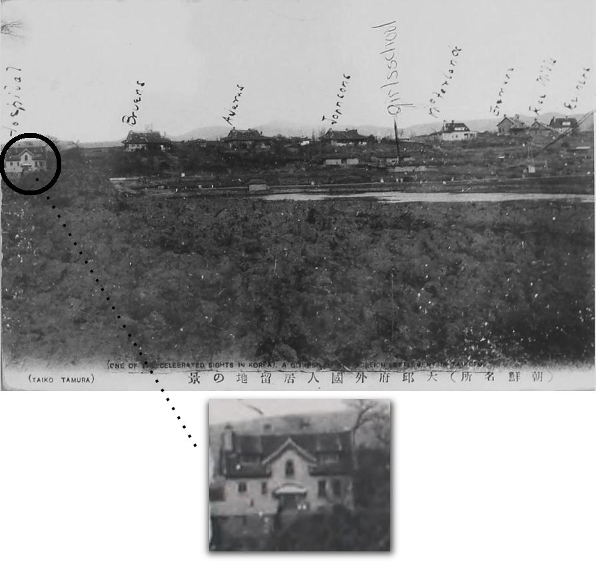
Image 4. A postcard depicting the Presbyterian mission station at Daegu, circa 1907-1911. The second hospital building, built by Clark, has been circled and magnified. (“Mission Compound, Taiju, Korea - Taegu Station”. Handwritten date of June 9, 1911. Moffett Korea Collection, Princeton Theological Seminary Library.)

“In planning the Taiku Hospital” Johnson wrote, “Mr. Gordon arranged for five foreign [Western] trusses one of which was . . . entirely unsupported except at its ends for a distance of 33 feet, the width of the Hospital.” He continued: “Whether the architect did not take into consideration this weight or did not know the character of the brick and lime obtainable and in use at Taiku I cannot say but after carefully going over the copy of the Taiku Hospital plans in my possession I have come to the conclusion that if the hospital has been torn down because of the crushing down of the north truss and fear that the others might follow it, then one or the other of the above mentioned facts may be responsible.”

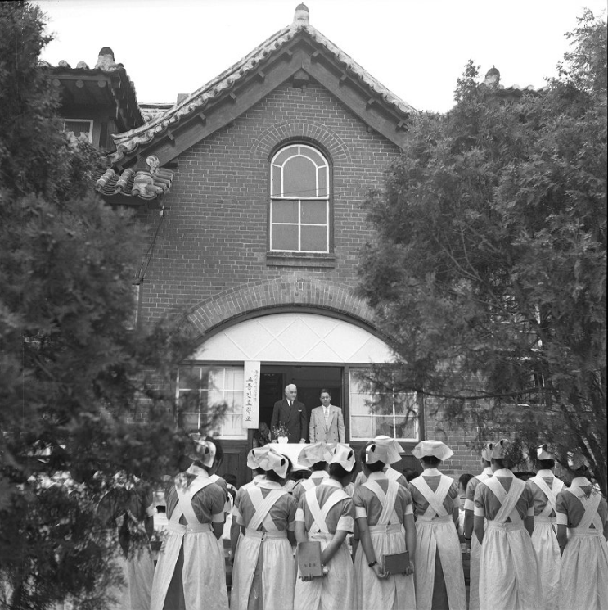
Image 5. The second hospital building at Daegu, which was built by Clark in 1907. (Acetate negative. “Taegu Nurses’ School dedication, June 1952.” Recorded creation date June 18, 1952. Presbyterian Historical Society.)

With Clark already on the ground in Daegu after the demolition of the first hospital building, he became the builder for the second hospital building. The second hospital was to be about a thousand square feet smaller than the first one, built at 33x50 instead of 33x80. It was a one-and-a-half story structure budgeted for $3000, excluding whatever materials could be reused from the first building. According to Clark, “we built kilns, dug up mud in our yard and burnt the necessary brick; dug up more mud, built a different kiln and burnt our heavy tile for the roof . . . We [went] ten miles out in the hills bought a mountain, dug out limestone and burnt our own lime, and brought it in on men’s back, as no roads. We bought a wooded mountain, cut the trees and brought those in on men’s backs for rafters.” The timber was largely sawed by hand from the logs gotten on the nearby mountain.
Clark couldn’t get any contracts on the project, instead using day labor made up of Korean workers, Chinese masons, and Japanese carpenters. A well was made by a combination of blasting and drilling twenty-eight feet below ground until water was struck, after which Clark had the water piped into a Montgomery Ward water tank in the attic of the hospital, installing the plumbing himself. “For the two buildings,” he wrote of the hospital and the McFarland residence that he was overseeing at the same time, “we brought flooring, doors, sash, nails, and hardware from America” — presumably also from Montgomery Ward. Construction began in 1906, and by July 1907 the new hospital was “under roof and floored before the heavy summer rains.”
Johnson, who was back in Korea by this time, called the second hospital “the handsomest building yet constructed in Taiku.” He continued by praising Clark’s work on the nearby McFarland house and his ability to successfully balance the economical and artistic aspects of a building. In a letter dated July 19, 1907, Clark wrote that the hospital building was almost finished and that he was putting in the pipes for a furnace that they hoped would be funded and sent out from the United States to Daegu. It was also in this letter that Clark seems to have implied the new hospital was modified from Gordon’s plans for the first hospital. “I made about 10 different plans,” Clark wrote, “each smaller and smaller after the original one which embodied Dr. Johnson’s minimum desire. The one on which we finally built contains on a more or less miniature scale all that Dr. Johnson declared to be absolutely essential.”
Clark was able to have a much better building constructed — one that would stand for decades and last into, at least, the 1950s. However, even he found the project challenging. He described the experience as being “almost creation” — a Biblical reference comparing the hospital’s construction to God’s making of the world. To be sure, the entire ordeal, from the first building in 1903 to the completion of the second building in 1907, arguably set the development of Daegu station back by a few years. It surely had an impact on medical work in Daegu as having a fully working hospital ready earlier could have done something to alleviate the pressure of the missionary-doctors’ work.
In summary, due to the magnitude of the hospital problem, the discussions and writings made by missionaries in its aftermath generated a wealth of information on building matters at the time. The reports by Lee, Clark, and Null provide us with invaluable knowledge on the structural aspects of hybrid Western-Korean designs being made under the missionary community. Furthermore, Johnson’s subsequent responses to the hospital problem specified points of interest on building materials and the construction process.
These accounts strikingly illustrate the challenges of building in 1900s rural Korea, where modern, Western, and every kind of architecture in between were simply all-around difficult to implement when funds and resources were limited. Becoming even more true within the context of hybrid buildings, there was sometimes a disconnect between worlds and an unfamiliarity with that of Korea. While projects such as Severance Hospital had the luxury of a large budget and, in that particular case, the personal supervision of its architect, hybrid buildings were problematic answers to the question of how Christian missions could afford their first (semi) modern institutional structures in rural, unmodern communities. Reports on these early hybrid and “modified Joseon” buildings somewhat frequently showed their issues, but none perhaps as dramatic and pronounced as those regarding the Daegu Hospital.

Nate Kornegay photographs, researches, and writes about early modern architecture in Korea. He is currently working on a number of projects, including the study of a particular ceramic tile trend found throughout the former Japanese Empire. Research articles and architectural photo essays can be found at his website, Colonial Korea. Visit www.colonialkorea.com.

For more on early hybrid and “modified Joseon” architecture in Korea, see Nate Kornegay, “Modifying Joseon Design (1884-1905),” Colonial Korea, 18 June 2019. https://colonialkorea.com/2019/06/18/modifying-joseon-architecture-1884-1905
This property was purchased in 1896 by Dr. William Baird. Clara Hedberg Bruen, “Historical Sketch,” 40 Years In Korea, 385. Unpublished, undated manuscript. Samuel H. Moffett Manuscript Collection, Princeton Theological Seminary Library. All of the following sources were found in the Samuel H. Moffett Manuscript Collection, Princeton Theological Seminary Library.
Clara Hedberg Bruen, “Historical Sketch,” 40 Years In Korea, 2.
There was a mention of an American who was said to have wanted to have it named as a memorial hospital in memory of a family member, but this might not have come to fruition.
W. O. Johnson to A. J. Brown, 16 June 1906. Microfilm copy.
Gordon’s name is mentioned numerous times in letters written by Johnson and Bruen. For example: W. O. Johnson to A. J. Brown, 6 June 1906. Microfilm copy.
Charles Allen Clark, Memories of Sixty Years (1954). Unpublished manuscript. Samuel H. Moffett Manuscript Collection, Princeton Theological Seminary Library; and W. O. Johnson to F. F. Ellinwood, 15 June 1903. Transcript.
W. O. Johnson to A. J. Brown, 6 June 1906.
W. O. Johnson to A. J. Brown, 16 June 1906.
Ibid.
To be clear, the Presbyterian mission referred to each of its established areas or compounds as “stations” in Korea.
H. M. Bruen to A. J. Brown, 3 May 1906. Transcript. Located in: Clara Hedberg Bruen, “Historical Sketch,” 40 Years In Korea, 257. Unpublished, undated manuscript.
Ibid, 258-259.
Ibid.
Ibid.
Ibid.
Johnson explicitly wrote of these trusses and were probably some kind of king or queen post truss system. The Korean giwa roof, though not clearly stated, was implied to have been used when he wrote about the weight of it. It is also visible in the 1904 published photo. W. O. Johnson to A. J. Brown, 16 June 1906.
W. O. Johnson to F. F. Ellinwood, 6 April 1903. Microfilm copy.
H. M. Bruen to A. J. Brown, 21 September 1903. Transcript. Located in: Clara Hedberg Bruen, “Historical Sketch,” 40 Years In Korea, 185.
Ibid, 183.
H. M. Bruen to A. J. Brown, 3 May 1906.
M. M. Null to A. J. Brown, 23 March 1904. Microfilm copy.
M. M. Null to A. J. Brown, 3 May 1906. Microfilm copy.
Ibid.
Ibid.
Ibid.
Graham Lee was responsible for many of the first missionary buildings in Pyongyang. Clark learned, to some degree, of construction when he was younger in the U.S., and was involved in building matters for years in Korea. Irvin’s experience is unclear, but he was responsible for having the first Presbyterian hospital in Busan built.
M. M. Null to A. J. Brown, 3 May 1906.
Null indicated it took Lee and Clark about a week to arrive in Daegu, probably implying this was after the April 9 station meeting. Regardless, it was likely April when Lee and Clark arrived. M. M. Null to A. J. Brown, 3 May 1906.
G. Lee to A. J. Brown, 3, June 1907. Microfilm copy.
Ibid.
Ibid.
Charles Allen Clark, Memories of Sixty Years (1954). Unpublished manuscript.
M. M. Null to A. J. Brown, 3 May 1906.
Null argued the materials needed to be reused quickly before the wet season came and ruined them. M. M. Null to A. J. Brown, 3 May 1906.
Ibid.
Ibid.
Ibid.
H. M. Bruen to A. J. Brown, 3 May 1906.
M. M. Null to A. J. Brown, 3 May 1906.
W. O. Johnson to A. J. Brown, 16 June 1906. Microfilm copy.
Ibid.
W. O. Johnson to A. J. Brown, 6 June 1906. Microfilm copy.
W. O. Johnson to F. F. Ellinwood, 8 May 1903. Microfilm copy. Samuel H. Moffett Manuscript Collection, Princeton Theological Seminary Library; This letter indicates the person referred to in Johnson’s later letter was Mrs. Bruen’s father.
W. O. Johnson to A. J. Brown, 6 June 1906.
W. O. Johnson to A. J. Brown, 16 June 1906.
W. O. Johnson to A. J. Brown, 16 June 1906. Microfilm copy. Samuel H. Moffett Manuscript Collection, Princeton Theological Seminary Library; In one account from July 11, 1907 regarding the updating of the Johnson house, much about its origins was revealed. Johnson’s house was the first of the missionary residences to be constructed at the Daegu station. It was built in the Korean style by Korean carpenters and walled in with brick, like many other “modified Joseon style” buildings occupied by Westerners at the time. Johnson’s house was considered something of an “experiment” at the time and lacked the American conveniences that other missionary homes had. The Johnson house had a kitchen, a living room, and dining room, a study, and two bedrooms. As their family grew, Johnson wanted to put in a request to the mission board for funds to expand his home. He and Clark had worked out a way to enclose the home’s porch and turn it into another bedroom. Whether or not his addition happened is unclear. W. O. Johnson, Requested appropriation for alteration and addition to Dr. Woodbridge O. Johnson House, 11 July 1907. Microfilm copy.
W. O. Johnson to A. J. Brown, 16 June 1906.
Ibid.
Charles Allen Clark, Memories of Sixty Years (1954).
Ibid.
Charles Allen Clark and Mabel Craft Clark, “Home Letter”, August 1937. Loose published letter in “Korea Missionary Files”,
W. O. Johnson to A. J. Brown, 11 July 1907. Microfilm copy.
Ibid.
C. A. Clark to A. J. Brown, 19 July 1907. Microfilm copy. Samuel H. Moffett Manuscript Collection, Princeton Theological Seminary Library; This furnace may have been the Montgomery Ward water tank that Clark wrote of in another account. However, it is unclear whether or not the tank and furnace were separate pieces of equipment in this case.
Ibid.
Charles Allen Clark and Mabel Craft Clark, “Home Letter”, August 1937.

