*The Life and Work of Pierre Louis Jouy (1856-94),* ‘The Smithsonian’s First Man in Korea’

Peter Juhl

*“Jouy [is] about the best informed person on Corean affairs and customs in Washington.”* – Washington D.C. *Star* newspaper, 1888

**Pierre Louis Jouy** (1856-94) was the first Western scholar of any kind active in Korea.

An American naturalist and ornithologist, he was attached to the first U.S. legation in Korea, arriving with U.S. diplomat Lucius H. Foote in May 1883. He did considerable anthropological-ethnological work in addition to his main focus, zoological specimen collection. He took dozens of photographs, among the earliest taken in Korea. He was the first American to travel overland from Seoul to Pusan where he resided for most of his three-and-and-a-half-year stay in Korea.

Jouy became all but unknown after his time. 1 But he was a leading influence on American attitudes towards Korea in the late 1880s, and here Jouy occupies a quiet place in diplomatic history. Though not a diplomat, and so uninterested in politics that he left Seoul for Pusan, Jouy shaped views back home and contributed to America’s early views of Korea. After his 1887 return to Washington, D.C., following six years in Northeast Asia, Jouy was one of America’s unsung experts on Korea.

All Jouy’s work and influence, Korea-related and otherwise, was disrupted by illness beginning by late 1890, and ended with his death in 1894, when he was still in his thirties.

1 Not once, for example, has Jouy been discussed in *Transactions of the Korea Branch of the Royal Asiatic Society* over this journal’s ninety-four volumes.

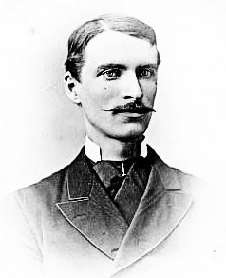

**Figure 1. Pierre L. Jouy, March 1881 (Smithsonian Institution Archives)**

What follows is a life-portrait of Pierre L. Jouy, a biographical investigation focusing on his 1880s Korea sojourn, and reflection on his legacy and role in Korea’s history and relations with the U.S.

If any propose competition for the title “first Western scholar in Korea,” one thing at least we can say without ambiguity: Jouy was “the Smithsonian’s first man in Korea.”

# Early life

Despite his name, Jouy was only one-quarter French, and in his youth he was known by his middle name, Louis.2 His father was Joseph Jouy, who married Mary Macklin in April 1855.3 They were Episcopalians of New

2 “Louis Jouy” may have been a rhyming name. Phonetic spellings show the family pronounced “Jouy” in French style, “*Zhoo-ee*” or similar (e.g., the 1870 census taker wrote the name “Jewey”). He was called Louis in childhood; “Louis Jouy” may have rhymed (1860/1870 U.S. censuses: “P. Louis” and “Louis,” respectively, at ages 4 /14). By age 20 he dropped preference for Louis and began to favor his first name.

3 Joseph Jouy (1831-1900) was born in New York to a France-born father and a U.S.-born mother of New York or New Jersey origin. Mary Jane Macklin (1834– 1920s) was born in New York to Irish-born parents. Pierre Jouy was one-quarter

York City.4 Probably soon after Pierre’s birth, they left for Iowa; by 1860 they were in Illinois where Joseph was a clothing dealer.5

The U.S. Civil War pushed the Jouy family back east. The future naturalist’s father was assigned to the Army Hospital in Washington. 6 Joseph Jouy found his life’s calling in Washington and stayed with the Army Hospital eleven years (1863-74), later running a private medical practice and then working with the Census Bureau in the early 1880s.

The Jouys lived along Washington Circle and here the children were raised.7 By 1867, the family was involved with St. Paul’s, a new Episcopal congregation planning to erect a church at Washington Circle; Joseph Jouy was elected vestryman.8 Pierre, age ten when the church was

French, one-quarter American, and half-Irish. (1870 U.S. Census, D.C. Ward 1, 269; 1880 U.S. Census, D.C. Enumeration District 36, 28; 1900 U.S. Census, D.C. Enumeration District 29, Sheet-17.)

4 This Jouy family’s Episcopalian origins ca.1830s is suggested by Joseph Jouy’s adult church affiliation and the marriage of Joseph Jouy’s (presumed) sister, Clara, recorded at (Episcopal) Trinity Church, Manhattan, 1849.

5 The 1860 census finds the Jouys in Scott County, Illinois. “P. Louis Jouy” is listed as born in Iowa. All other records have him born in New York, including the 1870 census and his obituaries. Two younger sisters on the 1860 census—one born in Iowa, one in Illinois—both apparently died in childhood.

6 Joseph Jouy enlisted (Aug. 12, 1862) in the 129th Illinois Regiment, Co. K, and transferred (Sept. 15, 1863) to the U.S. Army Hospital, Washington, appointed Hospital Steward. (1890 Census: “Special Schedule—Surviving Soldiers, Sailors, Marines, and Widows, etc.”: Washington, D.C.: Lincoln Post #3.) Joseph Jouy’s gravestone in Arlington Cemetery lists him as “Hospital Steward, U.S.A. [United States Army].”

7 Jouy had two surviving younger sisters, one dying in 1876. The 1880 and 1900

U.S. censuses have the Jouys living at the south end of Washington Circle (2210 and 2218 Pennsylvania Ave., respectively). In 1880, the Jouys shared the house with another family. According to a period map (“Sanborn fire map”), the home was a “frame house”; most nearby homes were brick rowhouses. “Map of Washington Circle in 1888,” *Ghosts of DC*, Jan. 8, 2013, https://ghostsofdc.org/2013/01/08/map-of-washington-circle-in-1888. Jouy wrote his address as “2218 Pa. Ave. NW, City” in an 1886 Smithsonian memorandum. (Smithsonian Archives, Record Unit 305, SIA000305_R112_ Y1887_A0018348.) The site of Jouy’s boyhood home is now a ten-story office building.

8 St. Paul’s Episcopal was among many new churches organized following the Civil War-related Washington population boom. Founding members bought a site south of Washington Circle. An 1880s-era map shows the church, (diagonal- across from present-day Foggy Bottom Metro Station entrance); the Jouy home

organized, would have been among the first children “raised” in St. Paul’s Episcopal Church.

Taking advantage of the talent, energy, and resources available in Washington, by the early 1870s Jouy was under the mentorship of Spencer

F. Baird, a leading Smithsonian naturalist at the United States National Museum, as the Smithsonian Institution’s museum was then named. The Baird connection became an important springboard for Jouy, for Baird is how Jouy ended up in Asia.9

Joseph Jouy was a Horticultural Society member. 10 His son’s crucial connection to Smithsonian circles and Baird may have been made at Washington Horticultural Society meetings around 1870.

The Smithsonian was an exciting place for those with ambition and academic interests, and Pierre would spend his entire adult life associated with it. He was often away from Washington starting in 1881. Why did he leave? There were the ‘pull’ factors: adventure and the prospect of making new discoveries, like those ongoing in Japan.11 There was also a decisive ‘push’ factor: a personal loss.

was around the corner. Joseph Jouy was elected vestryman several times, first in June 1867. (Two Union generals were among other inaugural vestrymen; existing Episcopal churches in Washington were often ‘Southern.’). “St. Paul’s Church, First Ward,” *Evening Star* (Washington), June 18, 1867, 3; “Election of Vestrymen,” *Evening Star*, March 30, 1869, 4; “Incarnation,” *National Republican* (Washington), Dec. 25, 1876, 4; “History,” *St. Paul’s Parish*, [http://www.saintpaulskstreet.org/about/history;](http://www.saintpaulskstreet.org/about/history%3B) “Map of Washington Circle in 1888,” *Ghosts of DC*, https://ghostsofdc.org/2013/01/08/map-of-washington- circle-in-1888.

9 The Smithsonian’s Spencer Baird is unrelated to later Pyŏngyang missionary William M. Baird, subject of a separate paper in this volume by Nate Kornegay.

10 Among social ties besides the Horticultural Society, Joseph Jouy was an active Freemason and sang with the Georgetown Masonic Choir and church choirs. His Arlington Cemetery gravestone is inscribed with a Masonic symbol. “The Horticultural Society,” *Evening Star*, Oct. 10, 1878, 4; “Masonic Relief,” *National Republican*, Dec. 28, 1874, 4; “The Georgetown Masonic Choir,” *National Republican*, Dec. 12, 1878, 4; “Masonic Election,” *National Republican*, Jan. 28, 1886, 4.

11 Jouy wrote of being inspired by reports of the late-1870s discoveries made by an American archaeologist at the Omori Shell Mounds, Japan. Robert Oppenheim, *An Asian Frontier: American Anthropology and Korea, 1882-1945* (Lincoln: University of Nebraska Press, 2016), 71. Pierre L. Jouy, “The Collection of Korean Mortuary Pottery in the U.S. National Museum,” in *Annual Report of the Board of Regents of the Smithsonian Institution for the year ending June 30, 1888* (Washington: Government Printing Office 1890).

# Career in Washington, marriage, and tragedy

A fragmentary record in the Smithsonian’s Department of Zoology archives suggests that Jouy’s earliest fieldwork was in Washington-area ornithology in the early 1870s.12 His mentor, Spencer Baird, co-published *A History of North American Birds* in 1874 and Jouy, then still a teenager, may have helped compile material for this ambitious project.13 From this early age, Jouy considered ornithology his “favorite pursuit” and had an “artistic temperament” and “varied interests in…many branches of science and art,” but birds were always his favorite.14

Jouy’s Smithsonian ties date to 1874; that his credited fieldwork predates his employment indicates a passion for zoology from youth.15 In 1877, Jouy, then twenty-one, published a booklet, “Catalogue of the Birds of the District of Columbia.” It sold at bookstores for ten cents.

Much was happening in Washington, and there were few better places to be for someone interested in science. Jouy was among those dazzled when, in April 1878, Thomas Edison demonstrated his phonograph prototype. President Hayes and members of Congress saw demonstrations, but Edison did others, including at the Academy of Sciences. The latter’s circles overlapped with Smithsonian circles, which so Jouy may have been among the first in the world to witness a “sound- reproducing machine” at work.

12 “Jouy, Pierre Louis – Biographical History,” *Smithsonian Institution Archives*, accessed Dec. 27, 2020, https://siarchives.si.edu.

13 Baird’s book involved considerable collective effort, probably including from teenage enthusiast volunteers like Jouy. “A History of North American Birds,” *Boston Globe*, Feb. 25, 1874, 2; “The Naturalist’s Career,” *Reading Times* (Pennsylvania), Aug. 20, 1887, 1; Pamela Henson, Smithsonian historian, notes that “Baird wrote to young people and encouraged them often.” Personal correspondence with author.

14 “Obituary for Pierre Louis Jouy,” *The Auk: A Quarterly Journal of Ornithology* XI, no iii, 1894: 262–63.

15 Chang-Su Cho Houchins, *An Ethnography of the Hermit Kingdom: The J. B. Bernadou Korean Collection 1884-1885* (Washington, D.C.: Asian Cultural History Program, Smithsonian Institution, 2004), 18. According to Houchins, Jouy’s regular employment as a “copyist” began in 1877. But Jouy was collecting specimens in the preceding few years: In 1874, “P. Louis Jouy” captured for the museum a bird, “usually confined to the western plains,” in Maryland. *Annual Report of the Board of Regents of the Smithsonian Institution, Showing the Operations, Expenditures, and Condition of the Institution for the Year 1874* (Washington: Government Printing Office, 1875), 32.

Of course, it would be decades before “sound reproduction” would become practical, standard, or mainstream, but the future had been glimpsed and it seemed unstoppable. The same was true regarding the advance of zoological knowledge, to which Jouy felt he could contribute. So it was, too, with the world’s then-receding frontiers. Cultures and peoples hitherto in sporadic-at-most contact with the West were destined to ‘open.’

In June 1879, Jouy, then twenty-three with rising success and prospects at the Smithsonian, married Alice Elizabeth Craig, a popular twenty-six-year-old local schoolteacher.16 They made their new home at 1020 26th Street NW, between the Georgetown of Alice’s youth and the Washington Circle of Jouy’s.17

Everything looked set for a happy life. A baby was on the way. In mid-1880, Alice gave birth to a daughter named Louise Elizabeth, a combination of the parents’ middle names. But the hand of fate had a cruel card to play. There were birth complications. The prognosis looked grim. Alice died of birth complications a week after the baby was born, and the infant, in poor health, soon joined her.18

This disorienting reversal of fortune—the loss of a wife and daughter—weighed on Jouy in his suddenly empty home. Supervisors and friends at the Smithsonian took pity. Could anything be done? A radical change of scenery might help.

# Jouy in Japan and China

It so happened that plans for a scientific mission to map longitudes in East Asia were coming together in 1880, a collaborative effort between Washington scientific and naval circles. It seemed that the longitude problem, a surprisingly difficult one for science, might finally have been solved by a new method using telegraph technology.

With the death of Jouy’s wife and daughter, a door had closed on one potential life-trajectory. But almost immediately, a window was

16 Alice’s father was from a multi-generational Georgetown family; her mother was of Maryland. The wedding was on June 26, 1879, at Foundry Methodist Episcopal Church, then at 14th & G Streets NW, one of Washington’s leading churches. “Marriage,” *Evening Star*, July 3, 1879, 4.

17 U.S. Census 1880, District of Columbia Enumeration District 35, 31. The house site is today grassy parkland.

18 “Death,” *Evening Star*, July 8, 1880, 4. Infant and mother were interred together. Oak Hill Cemetery records have the infant’s age as 24 days.

opened.19 He was on hand and available just as Washington’s naval and scientific partnership was launching.20

Symbolic of the link between America’s naval and scientific communities is the fact that the Navy agreed to repurpose one of its main force-projection ships in East Asian waters for the scientific mission. The

U.S.S. *Palos*, one of six ships in the Navy’s Asiatic Squadron, was to take on this scientific work for a year or more.

The plan centered around Francis Matthews Green, a lieutenant- commander in the U.S. Navy and expert in telegraphy-based longitude measurements. Green’s substantial ties to Washington scientific circles made the addition of a Smithsonian man to the mission a natural move.21

The “telegraphic longitude” mission was made public knowledge by early September 1880 and scheduled to begin the next spring. American newspapers were particularly enthusiastic, reporting on the major imminent strides in precision mapping, especially of the coasts of China and Japan. Conspicuously absent was any mention of Korea.22

The U.S.S. *Palos* under Commander Green would visit all points at which underwater telegraph lines came on land and use the new technique to determine longitudes. As for Jouy, the *Palos* would be a moving base from which he could conduct fieldwork and collect birds and other specimens.

In March 1881, Jouy sat for a portrait. 23 Not long after, he

19 It is fair to presume Jouy would not have gone abroad in 1881 had his wife and daughter survived; here Jouy shares a story-thread with fellow member of the first American legation in Seoul, Sacramento man Charles Scudder (secretary to Minister Foote), 1883-85. Scudder, recently divorced and losing his three children to his wife, was in low spirits and jumped at the Korea opportunity in 1883.

20 Oppenheim discusses the Smithsonian’s “new cooperative arrangement with the navy” in the early 1880s, a relationship that affected U.S. Navy ensigns Foulk and Bernadou, later attachés to the legation in Seoul. Oppenheim, *An Asian Frontier,* 28-30, 66.

21 Green had close ties to the U.S. Academy of Sciences and the Smithsonian. “National Academy of Sciences,” *Evening Star*, April 21, 1880, 1.

22 All governments concerned were reported to be cooperating, with one exception: the Russians had refused access to the port of Vladivostok. Korea, given the lack of diplomatic ties, had not been consulted. *New York Herald*, Sept. 3, 1880. A U.S. Navy report dated Nov. 1, 1880, named the principal proposed sites to be visited as “Yokohama, Nagasaki, Shanghai, Amoy, Hong-Kong, Manila, Saigon, and Singapore.” *Annual Report of the Secretary of the Navy* (Washington: Government Printing Office, Navy Department, 1880), 110.

23 This photograph appears at the start of this paper. Smithsonian Archives,

boarded a train bound for San Francisco. Commander Green was close behind. In all, five officers of the new, science-focused *Palos* officer corps assembled in San Francisco. Jouy, Green, and the others crossed the Pacific aboard the passenger steamer *City of Peking*, departing San Francisco April 2 and arriving at Yokohama two weeks later, where they boarded the U.S.S. *Palos*.24

The steamer *City of Peking* hosted many regular East Asia-bound passengers. One was Manhattan art dealer Edward Greey, who struck up a friendship with Jouy on board. Greey, originally from Kent, England, was in his mid-forties, twenty years Jouy’s senior. He was a connoisseur and dealer of Asian art who made regular trips to Japan for his work.

According to Greey, he and Jouy passed the days aboard ship in meandering conversation, and their discussions sometimes turned to the mysterious peninsula-kingdom, Korea, about which virtually nothing seemed to be known.25 By Greey’s account, despite, or because of, its still-off-limits status, Jouy expressed his intention to go to Korea. 26 Whether Greey’s claim (from 1888) is the unbent truth or not, events would soon align to put Jouy in Korea.

The *Palos* often visited the open ports of Northeast Asia to defend U.S. commercial interests, meaning its new scientific mission would take place in familiar waters.

The *Palos* had been one of the ships on the 1871 U.S. expedition attempting diplomatic contact with Seoul, which devolved into fighting at

Record Unit 95, Box 27C. (Photograph signed “Pierre L. Jouy, March 1881.”)

24 The *Palos* was at Shanghai in early March 1881, transited to Nagasaki in mid- March, and there received new orders to proceed to Yokohama for the scientific mission and personnel rotation. Jouy arrived in California March 23, Green, two days later. The Navy billed the Smithsonian for Jouy’s travel expenses. “Coming and Going,” *Record-Union* (Sacramento), March 23, 1881, 2; “Passengers Coming,” *San Francisco Examiner*, March 21, 1881, 3; “Coming and Going,” *Record-Union*, March 23, 1881, 2; “Freights, Charters, Etc.,” *San Francisco Examiner*, March 31, 1881, 4; “Naval Matters,” *Boston Post*, May 20, 1881, 4; “Longitude of the Asiatic Coast.” *New York Times*, April 7, 1881, 2; Oppenheim, *An Asian Frontier,* 66, 286, note 10; National Archives Administration, “United States Naval Enlistment Rendezvous at Washington for week ending March 5th, 1881”; Edward Greey, *Hand-Book of a Unique Collection of Ancient and Modern Korean and Chinese Works of Art, Procured in Korea During 1883-1886, by Pierre L. Jouy of Washington, D.C.* (New York: Brower Brothers Press, 1888), 5.

25 Greey, *Hand-Book*, 5. These April 1881 conversations predate the first popular book on Korea in English, Griffis’ *Corea: The Hermit Nation* (October 1882).

26 Ibid.

Kanghwa Island. By the Americans’ telling, the fighting originated when Chosŏn coastal batteries fired on U.S. vessels taking depth measurements to chart the area as they awaited diplomatic contact. Later authors have pointed out that taking such measurements without express permission from a hostile government was asking for trouble. Commander Green, ten years later, would not risk it, thinking it better to stay away from Korea.

Jouy got a wide-ranging tour of East Asia. The *Palos*’ movements during his time with the ship took him to parts of Japan and coastal China. He was also able to do substantial specimen collection near Shanghai and Hong Kong.27

Despite the favorable circumstances, Jouy felt he was being held back, writing that it was “utterly impossible to do any systematic work…under the restraints of Navy discipline.”28 Still, he accomplished a lot, and his fieldwork had begun drawing interest back in Washington, and the American Ornithologists Union elected Jouy a member in 1883.29 He had not done it alone. The *Palos’* surgeon, Frank C. Dale, had an interest in ornithology and volunteered to double as Jouy’s assistant.30 While in Japan, Jouy also made many friends and was in contact with the Asiatic Society of Japan, which took interest in his work.31

Jouy also took interest in archaeology and collected items like archery equipment from Canton, China, a Japanese “Buddhist rosary,” and

27 A landmark noted on late-nineteenth-century-era maps of Hong Kong named “Palos Pier” dates to this mission. “Palos Pier. Observation spot of Commander Green U.S. Navy,” *Gwulo: Old Hong Kong*, https://gwulo.com/node/40903. An 1884 volume used Jouy’s Hong Kong Bay specimens to show how species differ across regions of the world. Spencer F. Baird, M. T. Brewer, and R. Ridgeway, *The Water Birds of North America*, vol. I (Boston: Little, Brown, & Co., 1884).

28 Jouy to Baird, June 21, 1882, cited in Oppenheim, *An Asian Frontier,* 67.

29 *Annual Report of the Board of Regents of the Smithsonian Institution for the Year 1883* (Washington: Government Printing Office, 1885), 26. Hereafter *Annual Report, 1883*; Pierre L. Jouy, *Record of birds collected on the cruise of the U.S.S. Palos, April 25, 1881–Aug. 22, 1882, China and Japan*, unpublished material in Smithsonian archives, National Museum of Natural History, Division of Birds.; “Obituary for Pierre Louis Jouy,” xix.

30 Oppenheim, *An Asian Frontier*, 66; 21. *Annual Report of the Board of Regents of the Smithsonian Institution for the Year 1882* (Washington: Government Printing Office, 1884), 21. Hereafter *Annual Report 1882*.

31 Jouy was consulted for a paper on birds of Japan, read for the Asiatic Society of Japan by Blakiston and Pryer in February 1882. *Transactions of the Asiatic Society of Japan* X (Yokohama: R. Meiklejohn and Company, 1882), 100.

a Taiwanese aboriginal pipe.32

Jouy remained with the *Palos* from April 1881 to June 1882. He wrote back to Washington and requested to stay, on land, in Japan.33 With Dale’s assistance he had been reasonably successful in his specimen- collection work from the *Palos*, but so much more was possible.

# The Korea opportunity

Near the end of Jouy’s time with the *Palos* came an unexpected diplomatic breakthrough: The U.S.-Korea treaty, signed in May 1882 at Inchŏn by U.S. Commodore Shufeldt, Qing-Chinese officials, and Chosŏn-Korean officials. When Jouy left Washington, there had been no sign that Korea’s opening was imminent, nor that America would be a “first mover,” a rare position for its diplomacy at the time.

The outcome of the Shufeldt treaty would determine much of the rest of Jouy’s life. For one thing, he played a supporting role in the establishment of the first U.S. legation under Lucius Foote.34

In the meantime, now off the *Palos* for good, Jouy had shifted his planned specimen-collection operation to Honshu, Japan, and returned to Yokohama. A few Western residents in Yokohama gladly assisted with Jouy’s somewhat unusual operation. One was Alan Owston of England, who like Jouy was a great enthusiast for the natural world, as well as long- and well-established in Yokohama despite his relatively young age of twenty-eight. Owston extended to Jouy his hand in friendship and magnanimous assistance.

32 These are among the many items Jouy later donated to the Smithsonian’s Department of Ethnology from his pre-Korea years. *Annual Report of the Board of Regents of the Smithsonian Institution, showing the Operations, Expenditures, and Condition of the Institution for the Year Ending June 30, 1889* (Washington: Government Printing Office, 1891), 124, 288. Hereafter *Annual Report 1889.*

33 Houchins and Oppenheim have Jouy leaving the *Palos* in June 1882. Houchins errs in saying Jouy left the *Palos* “after five months”; he was with the ship fourteen months, April 1881 to June 1882. The Smithsonian’s *Annual Report* covering 1882 mentions specimens jointly credited to Jouy and Dale, collected March 30, 1882, in Chinese waters while with the *Palos*, indicating Jouy was still with the *Palos* at that time. Houchins, *An Ethnography of the Hermit Kingdom*, 18; Oppenheim, *An Asian Frontier*, 66-67; *Annual Report 1882*, 211.

34 Lucius Foote’s life, career, and role in Korea are the subject of a forthcoming work by this author. Seldom is Jouy’s name mentioned in academic treatments of the early U.S. legation, despite Jouy’s presence in Seoul for most of 1883 and despite Foote’s official correspondence with Washington mentioning Jouy.

Jouy also met A.J.M. Smith, a popular, thirty-year-old, second- generation ‘foreigner’ in Yokohama, who sought adventure and jumped at the opportunity to assist Jouy.35 Jouy knew his work, but didn’t know Japan; Smith didn’t know the work, but knew Japan and the language. Together they made an effective team.

In late June 1882, Jouy and Smith began to explore the Mount Fuji area, where they had adventures hiking, camping, and negotiating with mountain people for bird specimens and probably much else. Jouy’s report on their summer 1882 “Fuji-yama” work reads in part like a travelogue, describing how they “had a bath heated by a natural spring.”36

Jouy made repeated expeditions into the Honshu interior, where he carried out his boldest fieldwork to date. He visited Lake Chūzenji, Tateyama, and the mountains around Nagano, focusing on birds but exploring a variety of interests. A contemporary Smithsonian report characterized Jouy’s Japan work as covering “all branches of zoology as well as…archaeology.”37

In December 1882, Jouy filed an annotated forty-five-page report on species he had documented. Continuing his contacts with the academic-minded in Yokohama, Jouy prepared an article for publication in the Yokohama magazine *Chrysanthemum* on findings from the Honshu interior.38

35 Jouy dedicated a later article to Owston; Owston was a British citizen, as apparently was A. J. M. Smith. T. W. Blakiston, “Ornithological Notes,” *Chrysanthemum* 3, no. 2, Feb. 1883, 76; Pierre L. Jouy, “Ornithological Notes on Collections Made in Japan from June to December, 1882,” in *Proceedings of the United States National Museum* vol. VI (Washington: Government Printing Office, 1884), 273. Pierre L. Jouy, “The Paradise Flycatchers of Japan and Korea,” in *Proceedings of the United States National Museum* vol. 37 (Washington: Smithsonian Institution, Government Printing Office, 1910), 655.

36 Jouy’s field notes list places he was active in Honshu**.** On his first trip into the interior, he wrote: “Accompanied by Mr. A.J.M. Smith, I left Yokohama on the morning of 23d of June, 1882, for an ornithological trip to Fuji-yama. This, the highest mountain in Japan, is a favorite breeding ground for many species of birds, both migratory and resident […].” See Jouy, “Ornithological Notes, 273 and Pierre L. Jouy, *Chinsenji Lake, Tateyama Shinshiu* [sic], *1882–1883,* unpublished field catalog in Smithsonian archives, National Museum of Natural History, Division of Birds.

37 *Annual Report 1883*, 26.

38 *Nature* attributes the *Chrysanthemum* article to Jouy. The credited author is Blakiston but he clearly worked closely with Jouy on it. Blakiston, “Ornithological Notes,” 76; “Zoology in Japan,” *Nature*, April 26, 1883, 614;

By early March 1883, the drive to put a U.S. resident- ambassador in Seoul was moving forward. Lucius H. Foote, carrying the title Minister Plenipotentiary and Envoy Extraordinary, was set to arrive at Yokohama from San Francisco in mid-April. Jouy would be waiting.39

Jouy probably read the English-language Yokohama press that the long-‘closed’ kingdom of Corea/Korea would be ‘opening.’ At first, none of the foreigners in Japan knew what to make of Shufeldt’s (and Li Hongzhang’s) gambit or what would come of it. Korea was a new frontier that existed essentially entirely in the imagination when Jouy first arrived in Asia—as it had in Jouy’s and Edward Greey’s conversations while cruising on the Pacific in 1881.

Jouy’s role in the opening of Korea dates to the day he greeted Minister Foote in mid-April 1883 at Yokohama. Jouy wrapped up his Japan work and bade farewell to his Yokohama friends, while Foote mixed in diplomatic circles and prepared for onward movement to Korea. Foote had to, cumbersomely, hire two separate interpreters, one Korean– Japanese and one Japanese–English, for nobody knew anyone reasonably conversant in both English and Korean. Two days before sailing with Foote to Nagasaki, Jouy sent the Smithsonian his final report from Japan. Foote was an experienced diplomat but new to Asia.

Jouy had spent two years in Northeast Asia, but he had never been to Korea, nor approached its coast nor likely met any of its people.

How did Jouy end up attached to the brand-new U.S. legation in Korea? Either the Smithsonian ordered it or Jouy himself requested it. In either case, it was subject to Smithsonian approval. 40 Why Jouy was

*Annual Report 1883*, 317.

39 A subject for future research, impossible at this time of writing given archive closure, would be to determine how and when Jouy, the Smithsonian, and the State Department arranged for Jouy to attach to Minister Foote. (As for communication, letter was likeliest, but a telegraph link between Washington and Japan [though not Korea] existed by ca.1872, via undersea cable between New York and Europe, cross-Siberia telegraph, and another undersea cable to Japan.)

40 Greey claims Jouy “determined, upon his own responsibility, to venture into the wilds of Chosön.” Greey, *Hand-Book*, 5. Oppenheim does not comment on the question of by whose initiative Jouy ends up in Korea but states it was “at Jouy’s own expense.” Oppenheim, *An Asian Frontier*, 67. Austin writes: “The Museum evidently did not have funds to finance Jouy’s Korean trip. To make it possible, he managed to attach himself temporarily to the U.S. Legation in some vague and obscure capacity.” Oliver L. Austin, “The Birds of Korea.” *Bulletin of the Museum of Comparative Zoölogy* 101-102, 1948: 8. A journalist with whom Jouy had later contact believed Jouy was “sent by the government.” Frank G.

selected is not entirely clear, but in early 1883 Jouy was nearby, available, reliable, and apparently eager. His work had already contributed most of the information on birds of Japan which the Smithsonian possessed up to that time. In a personal sense, Jouy’s work in Japan gave him the confidence to operate largely independently in Korea.

As Jouy was about to enter Korea, the U.S. had unexpectedly taken the lead among Western powers in diplomatic engagement with Chosŏn- Korea. U.S. academics, such as those with the Smithsonian, aspired to jump ahead in all fields of the soon-to-emerge scholarship on Korea. At that time, all they had was Jouy.

# Jouy in Korea

Jouy wrapped up his work in Japan in April 1883.41 In May he was back aboard a U.S. naval vessel, the *Monocacy*, in conditions which he did not welcome.42 Another ship that had taken part in the 1871 unpleasantness at Kanghwa, the *Monocacy* would be attached to the new Korea diplomatic mission for several months, usually at anchor off Wŏlmido. Boarding the *Monocacy* at Nagasaki were Minister Lucius Foote and wife Rose, Foote’s secretary Charles Scudder, the interpreters, servants hired recently in Japan, and Jouy. All were unsure whether the ‘hermits’ would welcome them. Minister Foote expected a tough assignment. The lavishly warm welcome the received in Korea took them all by surprise.

Reports suggest that Jouy was among the Americans presented to

Carpenter, “Actors and Writers,” *Lancaster Daily Intelligencer*, July 7, 1888, 4. That Jouy went to Korea despite a lack of funding implies he embraced the opportunity.

41 A running list of specimens Jouy had collected in Japan ends abruptly on April 28, 1883; his report to the Smithsonian (later published) is dated April 30, two days before departing with Foote and others for Nagasaki, en route to Inchŏn. Jouy, “Ornithological Notes.”

42 Jouy’s ambivalent-to-negative feelings about the navy are seen in his letter to Baird dated June 21, 1882, in certain negative comments in press interviews, and friends’ descriptions of his personality. Jouy later told a reporter: “Americans are highly respected in Corea, and carry more weight than any other nationality. The only drawback to our national glorification there is the horrible way in which we are represented—in the line of naval forces, I mean.” Jouy quickly explained this as reference to the relative quality of U.S. Navy ships (as against officers/men), in contrast to the “fine vessels from England, France, Russia,” and others. “The Hermit Nation - The Interesting Coreans and Their Customs and Habits,” *Evening Star* (Washington, D.C.), Jan. 28, 1888, 2.

the king at noon, May 20, 1883, and was present at that evening’s late- into-the-night banquet. 43 Minister Foote’s entourage during this first Seoul visit was top-heavy with navy officers from the *Monocacy*, not generally Jouy’s preferred type, but soon he would be free of them.

Minister Foote searched for a legation site and found one, which is still occupied by the U.S. ambassador’s residence today. The *Monocacy* officers left, but Jouy lived at the legation for six months.

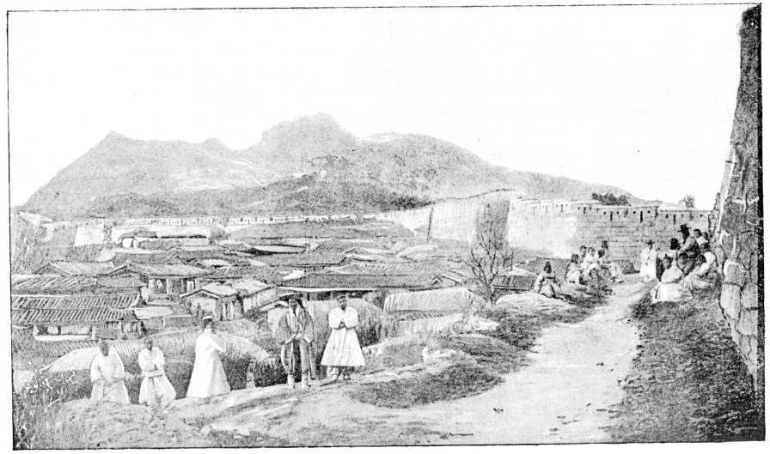

**Figure 2. Jouy’s photograph of Seoul shows the city wall and Mount Inwang to the north, taken in 1883 outside the city wall west of the United States legation where he lived. (Smithsonian Institution)**

Retracing Jouy’s steps via dates and places in the Smithsonian archives, we see his first bird collection was on May 28, 1883, at Chemulpo (Inchŏn), probably near Wŏlmido, as Foote and his staff had returned to the *Monocacy* for a time. After settling in at Seoul, to which the Americans returned on June 1, Jouy began his fieldwork primarily in search of birds. His first Seoul-area collection is dated June 10. Jouy took some of the earliest photographs of Korea starting about this time, and he also made some “mineralogical and ethnological collections.”44

All this travel in the interior was, officially, not allowed under

43 Jouy later implied he met the king of Chosŏn (but never the queen), probably on several occasions. “The Hermit Nation,” Evening Star, Jan. 28, 1888.

44 *Annual Report 1883*, 189; Austin, “The Birds of Korea,” 8; Smithsonian Division of Birds Collection record.

local law. A foreigner without royal permission was at the mercy of provincial authorities. The internal-travel “passport” issue was an early diplomatic controversy confronting Foote and others, for eager Americans in Japan were pushing the matter. 45 How was Jouy able to travel so freely? The warm relationship between the king and Minister Foote was to thank for this; the king arranged special permission for Jouy’s movements and activities, a dispensation given out sparingly.46 The king liked Foote, desired good relations with the U.S., and for years tried one maneuver or other to win America as an ally. The granting of travel permission to an American, who claimed to want to study birds, is a hitherto-unnoticed example of the king’s pro-American attitude, in clear view already in the spring of 1883.

In the warm months of 1883, Jouy visited Inchŏn and many other parts of Kyŏnggi Province, becoming the first American to travel extensively outside the ports and Seoul. 47 Jouy soon developed the confidence to propose relocating his operation to Pusan, the southernmost of the new open ports. He and a friend headed south in November, leaving Minister Foote and others behind and avoiding the Seoul winter.48

To make the overland trip to Pusan, Jouy received an even-more- powerful internal-travel passport under royal authority.49 Jouy was proud of this passport and, after returning to America, proudly displayed it to

45 Some later-arriving Protestant missionaries, e.g. Underwood, would later violate, even flout, the interior-travel ban. Formally, the law remained in effect for years. The State Department disapproved of interior travel by missionaries. In 1883, Minister Foote also did not think it wise to push it yet and discouraged early attempts. Lucius Foote to Bingham [U.S. Minister to Japan], July 25, 1883; Fred Harvey Harrington, *God, Mammon, and the Japanese: Dr. Horace N. Allen and Korean-American Relations, 1884-1905* (Madison, WI: University of Wisconsin Press, 1944), 79, 112-13.

46 U.S. naval attachés Bernadou and Foulk got similar permissions, or “passports” in 1884, as did German scientist Carl Gottsche, who was working for the Chosŏn government.

47 Jouy’s 1883 trips “often extended twenty to thirty miles from the Capital, and to Chemulpo.” Greey, *Hand-Book*, 6. Jouy’s movements in the interior predate by a year those of the better-known and more-studied George Foulk.

48 Austin, “The Birds of Korea,” 8.

49 Jouy “was granted the first passport issued to a foreigner for an overland journey to the south-eastern port, Fusan.” A Yun Chi-ho diary entry suggests the passport was issued Oct. 24, 1883; Jouy’s last Seoul-area collection may be Nov. 5, 1883. Greey, *Hand-Book*, 6; Oppenheim, *An Asian Frontier*, 67.

visitors:50

“Traveling in Corea is a difficult matter unless one is provided with a passport, such as this,” [Jouy said,] unrolling a long piece of coarse paper printed with the peculiar characters of the Corean language. “With this I journeyed from Seoul to Fusan, an unheard-of trip on the part of a stranger. […] This passport called for the courtesy of all natives, and also for entertainment by all officials. This was a saving clause, for inns and houses of public comfort are unheard of […] Whenever I arrived at one of the yamens and exhibited my passport all work was laid aside to provide for me. The room was cleared, extra mats were laid on the floor, attendants brought food and robes, and, in fact, I, with my passport, was treated in a splendid style.”

The royal passport made the Seoul-to-Pusan journey possible and somewhat comfortable, if still not easy. The journey took about fifteen days.51 In any case, Jouy was in no hurry and was on the lookout for souvenirs and birds in this new frontier. He made collections noted as “Central Korea” on most days between Nov. 16 and 22, then one at the Naktong River, Nov. 22, and finally a bird specimen at Pusan, Nov. 30.

As Jouy rode on horseback with Korean guides through the heart of the southern provinces, he took note of Korean burial customs: “[T]here are many sections where the cemeteries occupy at least a quarter as much space as that used for agricultural purposes.” The cemeteries, wrote Jouy, “are scarcely ever out of sight of the traveler, their prominent position on the hillsides making them very conspicuous.”52

50 “The Hermit Nation,” *Evening Star,* Jan. 28, 1888.

51 In a Dec. 1, 1884 letter, George Foulk gave Seoul-to-Pusan travel time at the time as fifteen days. George C. Foulk, *America's Man in Korea: The Private Letters of George C. Foulk, 1884–1887*, ed. Samuel Hawley (Lanham, MD: Lexington Books, 2008), 72. Foulk also recounted how a Pusan official demanded to see his travel passport. George C. Foulk, *Inside the Hermit Kingdom: The 1884 Travel Diary of George Clayton Foulk*, ed. Samuel Hawley (Lanham, MD: Lexington Books, 2008), 121.

52 Pierre L. Jouy, “The Collection of Korean Mortuary Pottery in the U.S. National Museum,” in *Annual Report of the Board of Regents of the Smithsonian Institution for the year ending June 30, 1888* (Washington: Government Printing Office 1890), 589.

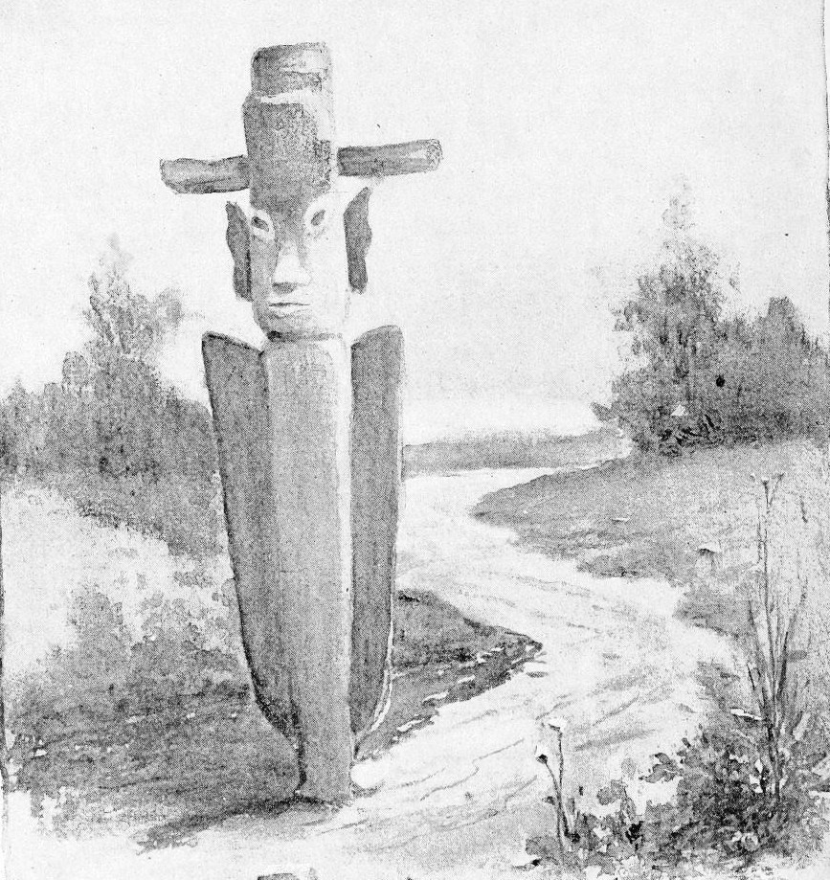

**Figure 3. Jouy's sketch of a “*chang sung*,” or Korean guidepost. Jouy said these posts “occur at frequent intervals throughout the country, and have often been mistaken by travelers for gods. They are said to be the effigy of a general who was noted at one time in past ages as a celebrated road-master**

**—a sort of engineer commissioner, as it were.”53 (Smithsonian)**

Jouy’s November 1883 journey may be the first ever Seoul-to- Pusan overland trip by an American, or any Westerner—the title of ‘first,’ though, if applicable, is shared by a second man whom Jouy had invited.54

53 “The Hermit Nation*,*” *Evening Star,* Jan. 28, 1888.

54 Jouy’s co-traveler was “Mr. M. Willet, a resident of Kobe, Japan,” apparently *Marinus Willett* (b.1858, New York). Greey, *Hand-Book*, 6.) The Willetts had trade ties to East Asia. Jouy and Willett likely met in 1882 in Yokohama; Jouy

Jouy found travel in Korea difficult but was cheerful enough about it and eyed solutions:55

[A] traveler is forced to sit in silent submission on the back of one of their stubborn little beasts, which is led by a coolie. I objected to such a process, and, greatly to the disgust of the natives, procured a saddle and bridle of modern make. A friend who made the trip from Seoul to Fusan with me did the same, and we enjoyed an unwonted privilege. We had great trouble at first in getting our animals to understand the new arrangement, but finally succeeded in training them so that we could walk or gallop, or leave the line of the road at will. This last operation astonished the coolies, who predicted all sorts of disaster as a consequence.

And so Jouy left Seoul behind. If he ever returned to Seoul, it was only briefly, another reason his name is conspicuous by its absence in Seoul- centric English-language historiography on 1880s Korea.

In Pusan, Jouy settled into a salaried position at the new customs service, suggesting an arrangement with Paul-Georg von Möllendorff, a somewhat mysterious figure who had founded Chosŏn customs a year earlier.56 The Smithsonian was at first unclear what Jouy was doing.57

likely invited Willett to Seoul by letter, proposing the overland journey to Pusan. Willett apparently returned to Japan, where a daughter, Soma, was born in late 1884; Willett later moved back to America; it is unknown if her ever returned to Korea. His daughter Soma briefly got press attention in 1907 for a sensationalistic Manhattan scandal. “Claims Eight Husbands,” *New York Times*, May 9, 1907, 4.

55 “The Hermit Nation,” *Evening Star,* Jan. 28, 1888; Frank G. Carpenter, “Corea’s Awakening: The Corean Exhibit at the National Museum,” *Harrisburg Telegraph*, April 14, 1888, 3.

56 Scholars have multiple views on Möllendorff’s goals. What is sure is Möllendorff hired Europeans, and a few Americans, with Asia experience to staff his new customs service. See Karl Leuteritz, “Pioneers of German-Korean Partnership,” *RASKB-Transactions* 54, 1979; Walter Leifer, “Paul-Georg von Möllendorff-Scholar and Statesman,” *RASKB-Transactions* 57, 1982; T.M. Simbirtseva, “P.G. von Möllendorff’s Pro-Russian Activities in Korea (1882- 1885): Opinions of Russian Historiographers” *RASKB-Transactions* 76, 2001.

57 Houchins has Jouy as “advisor to the Korean civil service,” citing an 1884 Smithsonian document, indicating possible confusion in Washington on Jouy’s activities; being with Chosŏn customs made Jouy a “Möllendorff man,” hardly an adviser to the government. Other confusions on Jouy’s activities in Korea have appeared in print such as Paul Michael Taylor, in the introduction to Houchins,

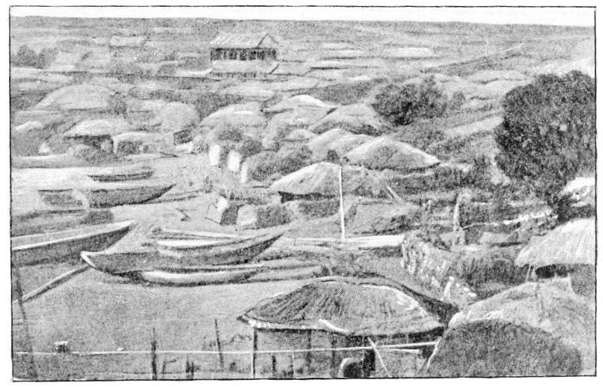

**Figure 4. Jouy's image of a fishing village near Pusan (Smithsonian Institution)**

Jouy’s successor as the “Smithsonian man in Seoul” would arrive in March 1884, by coincidence another American with a French name: John Baptiste Bernadou. A young U.S. naval officer, Bernadou had a direct role in the December 1884 unrest in Seoul, which Jouy, in Pusan, missed. Jouy largely avoided “politics” throughout his time in Korea, unlike some of his American contemporaries. Content operating beyond Seoul’s influence, Jouy continued collecting specimens when off duty or on leave from his customs job, and in time gathered hundreds in all.58

saying Jouy “assisted with the mission that led to the 1882 treaty.” This confuses the May 1882 Shufeldt treaty with the May 1883 arrival of Minister Foote; Jouy was with the latter only. Houchins, *An Ethnography of the Hermit Kingdom*, 8, 18.

58 Jouy collected hundreds of bird specimens in Korea; some remain of value to historical biogeography; e.g., Jouy’s short-tailed albatross specimen, a now-rare seabird, is the only specimen of this bird ever collected in Korea (June 1885, Korea Strait off Pusan). Later also a Chinese egret (*Egretta eulophotes*) (April 1886, North Kyŏngsang). Austin, “The Birds of Korea,” 8; 32; 41; Jouy, “The Collection of Korean Mortuary Pottery”; *Annual Report 1889* (Washington: Government Printing Office, 1891), 358. Even Jouy’s first Korea collection (May 28, 1883, Chemulpo) was a *Phylloscopus borealis* (arctic warbler), also now rare in Korea.

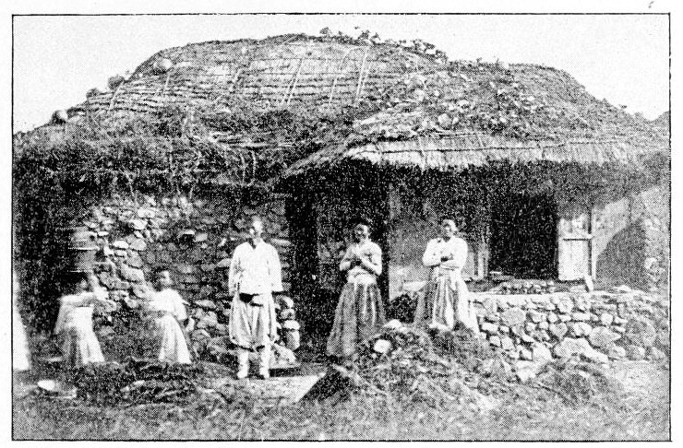

**Figure 5. A Korean farmhouse photographed by Jouy (Smithsonian Institution)**

Pusan was, in Jouy’s time, two distinct settlements—a “Japanese” town, coterminous with the port, and a “Korean” town inland. Jouy lived in the Japanese port town, which was a mixed blessing for his work. Though his bird specimen collection was going well, archaeology had been a dream since hearing of the Omori shell mound discoveries. Interacting with Japanese connoisseurs of Korean art in Pusan renewed this dream.

He worried the spectacle of a white foreigner digging around would lead to trouble. For one thing, there were rumors that the death penalty was in force for such digs. 59 Jouy worried Koreans would be alarmed by any kind of archaeological fieldwork. His instinct told him to avoid potential problems with provincial governments. Collecting bird specimens was safer than activities related to people or archaeological work. Even photography was difficult, as Jouy recounted later:

The natives exhibit a great deal of curiosity [...] For instance, while there I thought it a good plan to take a few views of some of the landscapes, and one afternoon I went out to the suburbs of Fusan to get a picture of the city and harbor. As I went along the

59 Jouy, “The Collection of Korean Mortuary Pottery.”

road with my camera the natives began to follow me, and by the time I had reached a good position for taking the view I was accompanied by several hundred Coreans, eager to see what I was going to do. I descended from my horse and set up my camera, but when I tried to get a focus on the scene found nothing in my lens but a mass of stolid countenances reaching as far as I could see. They squatted in the fore-ground, but stood up in the rear ranks and waited patiently, without a sound or a movement of their faces, for my next move. I gave up in disgust and went home.60

Deception could defeat curiosity: “A few days afterward,” Jouy continued, “I had my camera, disguised, sent on ahead of me, and stole a march” on the local crowds. He got the picture.

Jouy had mixed feelings on late-Chosŏn society and people. He marveled at their ways: “Two of them on meeting will, if they chance to be sufficiently acquainted, immediately ‘squat’ and gossip for an hour at a time.” Like many of the era, he saw Koreans as economically less than dynamic, writing that “as a rule, they have no business capacities” and that “they are lazy, and have a luxurious, leisurely idea of life.” Few would deny the relative economic backwardness of late-Chosŏn Korea, a comparative disadvantage acutely felt by the royal government. Jouy later recounted how on one particular “long journey from the capital,” perhaps the Seoul-to-Pusan journey, “he was unable to buy anything as curios except an old candlestick. There were no shops and nothing for sale.”61

But Jouy found much to admire in the people. As he described it, “smiling” was a Korean “national habit,” “the people are even-tempered,” and “crimes are almost unknown.” As for the Chosŏn army, he thought it not worth much, but in his eyes that was not so much a bad thing..62

What had Korean civilization been like in centuries past? As a would-be archaeologist, Jouy was interested. Little information of an archeological nature was known about Korea. “Knowing that [archaeological] objects would soon become exceedingly rare,” Jouy secured “the services of a young native who from time to time brought [him] specimens of pottery and other objects” which were “buried in the

60 “The Hermit Nation,” *Evening Star,* Jan. 28, 1888. His photographs also include several ordinary Koreans in portrait.

61 “The Hermit Nation—Mr. Jouy Tells the Biological Society Something about Corea,” *Evening Star*, March 8, 1887, 3.

62 “The Hermit Nation,” *Evening Star,* Jan. 28, 1888.

ancient graves near the cities of Taiku, Urusan, and Torai.”63

Jouy’s experience of Korea was thus quite different from that of the Seoul-based missionaries and diplomats, to say nothing of the naval officers. Demonstrating his weak ties to Seoul and lack of interest in politics, Jouy later told a reporter that he was “not sure” of the king’s name “The king’s name is Lee, I think, but I’m not sure. I have found that it is not safe to be sure about Corean names.”64

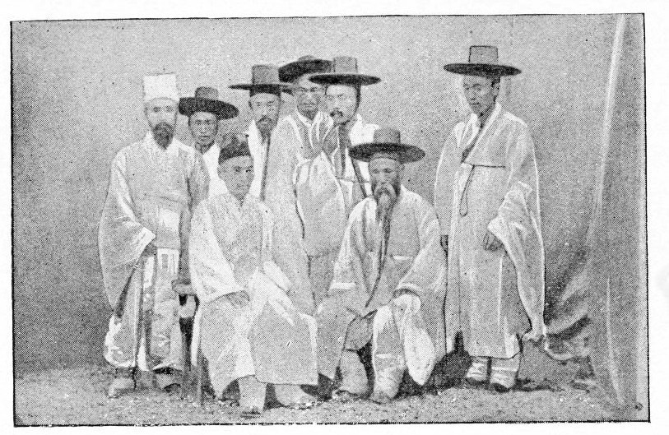

**Figure 6. Jouy’s image of Korean students and aristocrats. The figure on the left was in mourning costume. (Smithsonian Institution)**

# Jouy, Foulk, and Lowell

Two young Americans are worth contrasting with Jouy: the brilliant but irascible naval attaché (later *charge d'affaires*) George Foulk and the philosophical Harvard graduate Percival Lowell. Both learned a remarkable amount about Korea, probably much more than Jouy; neither would likely have joked that they were “not sure” of the king’s name. Both provide glimpses of Jouy in Pusan. Foulk’s travel diary and Lowell’s

63 Greey, Hand-Book, 6. Jouy, “The Collection of Korean Mortuary Pottery.” The sites Jouy refers to are Taegu, Ulsan, Tongnae, respectively.

64 “The Hermit Nation,” *Evening Star,* Jan. 28, 1888. The name Kojong, as the king is known to history, was bestowed after the king’s death.

monumental book about Korea, which combined philosophy, history, cultural observations, and travelogue, both contain passages about Jouy.

Foulk’s story intersects with Jouy’s when Foulk arrived at Pusan during his 1884 cross-country trip. Jouy, hearing that an American had arrived, tracked down Foulk and greeted him. Foulk, in a bad mood and fatigued from long overland travel, was evasive. The two briefly argued about a trivial matter, the details of which Foulk did not record. Jouy persisted and invited Foulk to view some recent pottery acquisitions. Foulk was noncommittal. Jouy tried again the next day, for seldom was an American in Pusan and the few who passed by might easily be missed.65 Foulk again declined, deciding he did not like the Smithsonian man.

Foulk was suspicious of all of “Möllendorff’s men,” who were generally European freewheeler types like Möllendorff himself. That Jouy was part of this “customs gang” did not help. Foulk’s diary records several insults against Jouy and accuses Jouy of badmouthing him around town. He had not singled out Jouy in particular, though. Foulk disliked every white foreigner in Pusan: “One-horse people throughout.”66

At risk of pausing too long on the triviality of Foulk’s and Jouy’s petty dispute, there may be insights into both of their personalities. A friend called Jouy “often severe in his condemnation of what he considered a wrong, sometimes to his own detriment,” though also “a delightful companion and a faithful friend to those…fortunate enough to possess his confidence.”67 Jouy and Foulk were not so different after all.

Lowell got along better with Jouy. A young man of great intellectual curiosity, Lowell had experience in Japan. He sojourned in Korea for several months between December 1883 and spring 1884. Like Foulk, he had found himself involved with escorting Korean diplomats

65 Missionary-doctor Horace Allen, during his stopover at the port of Pusan on his first trip to Korea, recorded encountering only five Europeans and no Americans in town. Jouy may have been away on a collecting expedition. Horace Allen diary Sept. 14, 1884, cited in Andrea Yun Kwon, *Providence and Politics: Horace N. Allen and the Early US-Korea Encounter, 1884-1894*, PhD diss. (University of California at Berkeley, 2012), 30.

66 Foulk was exhausted from his travels on the days he met Jouy and “drank so much coffee [he] was awake most all night” the night before Jouy came to greet him. Foulk wrote to his parents on the second day he interacted with Jouy (Dec. 1, 1884), expressing that it had been a “very hard journey.” His “body ached from constant jerky chair motion as carried by the two coolies.” He complained of “lice and vermin of all sorts” and bad sleep. Foulk, *America's Man in Korea*, 71-72; Foulk, *Inside the Hermit Kingdom*, 121-22.

67 “Obituary for Pierre Louis Jouy,” 262.

around America and returned with them at their invitation. Lowell’s book, *Chosön, the Land of the Morning Calm: A Sketch of Korea,* published early 1886, was the best book on Korea to date.

Lowell met Jouy during his two port calls at Pusan, en route to and from Seoul, in December 1883 and spring 1884. Lowell’s account of his second visit to Pusan offers a glimpse of Jouy as a customs employee:

We were to lie there at anchor all day; so after breakfast I went ashore. The town had changed but little. There was the same crowd to see me land, the same idlers in the square, and the same Korean vendors of knick-knacks, squatting beside their goods spread out before them on the ground. Only the eyes with which I saw it all had changed. What then had seemed to me so odd no longer struck me as in any way peculiar. I had ceased to notice. The dawn of acquaintance had broadened into the noonday light of familiarity, and the contrasts had disappeared in the glare.

J——, I learned, was still in the Customs; and there I found him at his desk, grown now an old *habitué* of the place. He promised to tiffin with me, and at the hour agreed upon we met in the same restaurant we had dined in when I went away. Nothing had changed. The same tea-house girl waited on us, and remembered that she had done so in the past. Only the manner of her hair showed that she had since been married. Through the opened *shoji* we saw the sunlight of the street below, the trees just answering the warmth, the Japanese wending their ways hither and thither, and stopping, with their ceremonious bows, as they met a friend, to chat awhile. Inconsequently we fell to talking of the past—of the winter that had gone, of the new of a few months before so soon become the old, and, paradoxically, of what had been in a place whose career was only just opening to the world. Then the present itself was the past. He returned to his post, and I wandered up to the top of the little hill in front and sat down on the grass.68

Lowell compares his own growth in the previous few months, mainly in Seoul, with Jouy’s growth in Pusan. Jouy may have been an “old *habitué”* of the customs house by spring 1884 (he had been a neophyte in December 1883), but he also remained active in his Smithsonian work. He

68 Percival Lowell, *Chosön, the Land of the Morning Calm: A Sketch of Korea*

(Boston: Ticknor & Company, 1886), 394-95.

was in a comfortable position, as the customs job paid well and offered flexibility, and continued to do so even after Möllendorff fell from grace, another casualty of Seoul’s scheming politics.

Lowell returned to America and wrote his book. Did he ever meet Jouy again? As for Foulk, his several-year involvement with Korea ended when he was maneuvered into *persona-non-grata* status, a state of affairs instigated by Qing-China. He left Korea in June 1887 to teach mathematics at a missionary college in Japan.

People came and went but Jouy’s specimen-collection work continued. His area of activity stretched across southeastern Korea to Tsushima Island in the Korea Strait.69 Pulling up stakes in the summer of 1886, Jouy traveled north to Wŏnsan, another Korean treaty-port. He found himself lodging at a Buddhist temple, a normal practice for travelers at the time. Jouy later quipped that lodging at a Korean Buddhist temple was “more pleasant to think of than to experience.”70

# Return to America

Jouy’s activities from July to December 1886 are unclear, but he probably spent this time mostly in Japan. By November 1886 he was in Yokohama, from where he shipped to the Smithsonian “five cases of specimens of minerals, rocks, and other productions” collected in Korea.71 His large collection of bird specimens from Korea remains his most unique contribution. He returned to Pusan for one last attempt at winter specimen collection in December 1886.72 He was soon back on U.S. soil.

Back in Washington by early 1887, Jouy celebrated his thirty- first birthday while finding himself in immediate demand for his knowledge of Korea. Souvenirs brought back from Chosŏn-Korea

69 Austin, “The Birds of Korea,” has notes on Jouy’s collections; many are in Kyŏngsang Province, a few in Tsushima, and elsewhere.

70 Jouy picked up several items in “Yuensan” (Wŏnsan) in July 1886, which he brought back to the U.S. He had had previous interaction with temples and other items of his collections were acquired “from a Buddhist monastery near Torai, southern Korea, 1885.” Greey, *Hand-Book*, 9-10, 31; Austin, “The Birds of Korea,” 8. Percival Lowell may be the first documented Western “temple-stayer” on his early 1884 trip into the mountains, described in chapter 33 of his book.

71 “Specimens from Corea,” *Daily Alta California*, Nov. 24, 1886, 1.

72 One of Jouy’s specimens from South Kyŏngsang was collected Dec. 14, 1886, which puts Jouy in Korea at that date. This specimen was a harlequin duck (*Histrionicus histrionicus pacificus*). Austin, “The Birds of Korea,” 69.

“surrounded” Jouy in his new, “comfortable bachelor quarters.”73

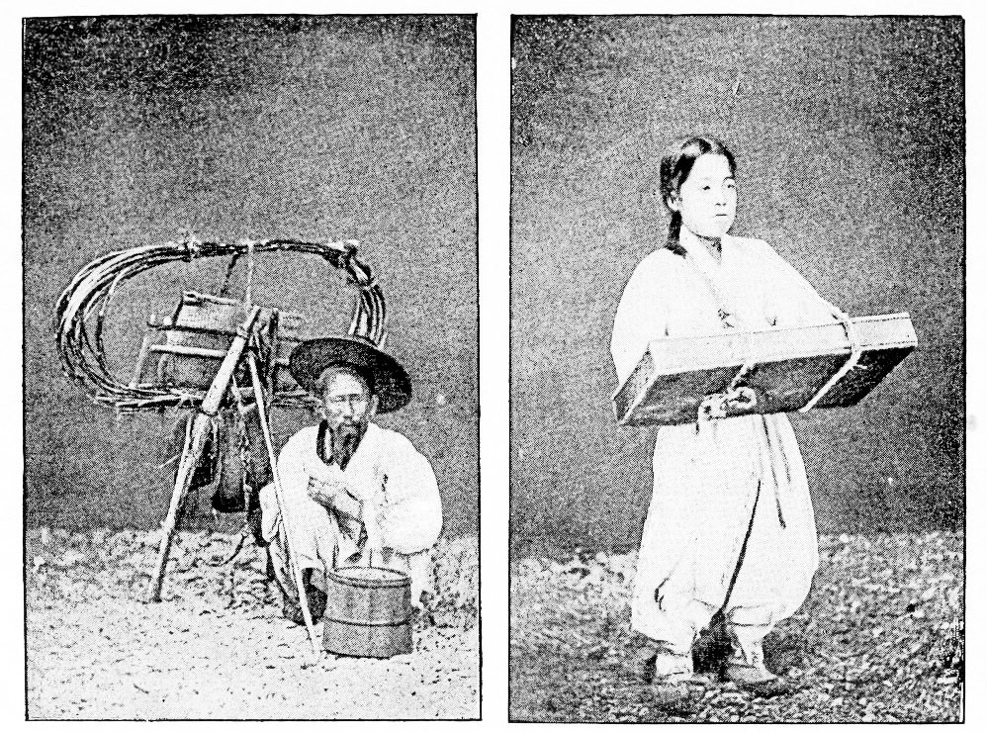

**Figure 7. Jouy's photographs of a tub mender, left, and a young candy seller (Smithsonian Institution)**

Interest in Korea had risen exponentially since Jouy left Washington in 1881, though the “hermit kingdom” label persisted. Interest in Korea got a big boost with the arrival of the first Chosŏn-Korean ambassador and his staff to set up their reciprocal legation in January 1888.74 At some point Jouy appears to have met Horace Allen; Jouy spoke

73 “Mr. Jouy was surrounded by souvenirs of his Corea experience,” wrote a newspaper reporter. The souvenirs included “weapons, mats, masks, photographs and documents.” “The Hermit Nation,” *Evening Star,* Jan. 28, 1888.”

74 After the Korean diplomats’ January 1888 arrival, a newspaper wrote “Corea seems to have become the latest craze” in Washington, with curiosity including on customs, clothing, and hats. “The Hermit Nation,” *Evening Star,* Jan. 28, 1888. Greey reported two reasons for the surge of interest in Korean art as of spring 1888: Percival Lowell’s book and the exotic-clothed Chosŏn-Korean diplomats’ Washington activities. Greey, *Hand-Book*, 5. Washington Journalist Frank G. Carpenter wrote in April 1888: “These Coreans are rare birds. I see the tall hats and the gorgeous silks of the members of the Corean legation in every

highly of the missionary-doctor and aspiring diplomat.75

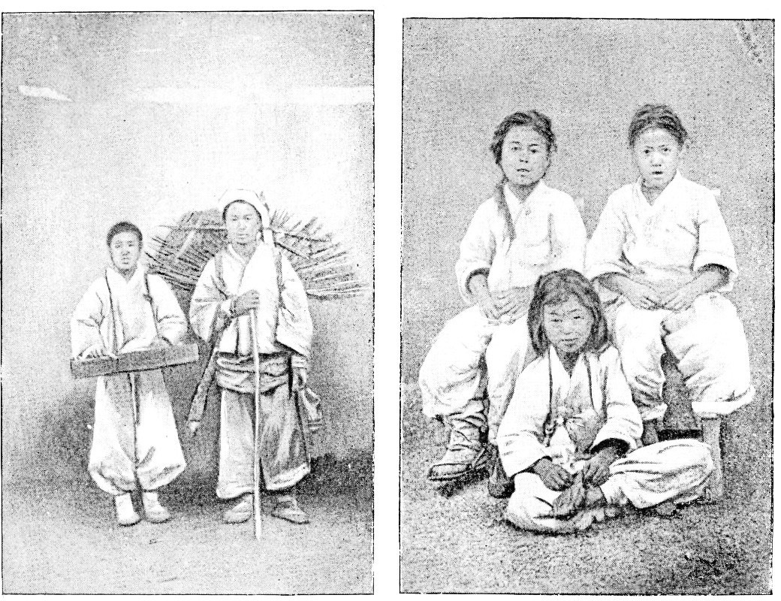

**Figure 8. Korean boy peddlers, left, and a group of boys, photographed by Jouy (U.S. National Library)**

Jouy returned to the Smithsonian’s zoological department, settling back into the life he had left six years earlier. The Spencer Baird network had familiar faces and new ones, the latter including Norwegian naturalist Leonhard Stejneger, who had walked into a Smithsonian job following fame in Europe. Stejneger admired Jouy’s work and they became fast friends after meeting in person in 1887 at the Smithsonian. As some figures drifted in, others drifted out; Jouy’s old mentor, Spencer Baird, fell ill and died in summer 1887.

Jouy’s six years in East Asia, and his three-and-a-half years involved with Korea, led to a partial, implicit career change. Jouy was

conceivable place. [...] [T]he pretty girls of Washington seem to court them. They wear their hats at all times, and even at the White House they do not take them off.” Carpenter, “Corea’s Awakening.”

75 Allen had evolved from missionary to diplomat and was in Washington as of 1888 as the Korean legation’s foreign secretary and adviser. Jouy said Allen’s “success is well deserved.” “The Hermit Nation,” *Evening Star*, Jan. 28, 1888.

now a de facto Korea specialist. His work, along with Bernadou’s, had effectively founded the study of Korean archaeology in the U.S. His collections included “stone daggers, arrow and spear heads, knives, chipped and polished hatchets, polished jade, Megatama or curved jewels, amber heads, and a polished stone ornament.” As of 1889, Jouy had given the museum its “only specimens of prehistoric stone implements [ever] received from Corea.”76 Among other items of interest Jouy brought back to Washington was a small *changsŭng*, which he understood to function as a guidepost for travelers.77

Jouy gave a series of talks to Washington audiences on Korea beginning in early 1887. One characteristic talk was titled “Corea, the Country and the People.” 78 He covered social, economic, and cultural conditions. Attracting curious and educated guests and written about in the local press, Jouy quietly became influential as Washington’s first academic Korea specialist with on-the-ground experience. A leading newspaper called Jouy “the best informed person on Corean affairs and customs in Washington.”79 Jouy played a leading role in organizing the Smithsonian’s first major Korea exhibition in 1888.80

Jouy reconnected with his Manhattan art-dealer friend Edward Greey, and together they prepared “a descriptive handbook of the Jouy collection” in early 1888. The Jouy-Greey partnership secured for Greey’s

76 The Smithsonian’s report covering 1888-89 reproduces in photographic form some of these artifacts. *Annual Report 1889,* 329, 330-31. The Smithsonian came to group the three major contributors’ objects into one collection. See Walter Hough, “The Bernadou, Allen, and Jouy Korean Collections in the U.S. National Museum,” in *Annual Report of the Board of Regents of the Smithsonian Institution, showing the Operations, Expenditures, and Condition of the Institution for the Year Ending June 30, 1891* (Washington: Government Printing Office, 1892), 429-488.

77 Ibid., 479 and Plate XVII; see also Figure 3 of this paper.

78 “The Hermit Nation,” *Evening Star,* March 8, 1887.

79 “The Hermit Nation,” *Evening Star,* Jan. 28, 1888.

80 Washington journalist Frank G. Carpenter described the emerging Smithsonian Korea exhibit in an April 1888 article and interviewed Jouy. Carpenter, “Corea’s Awakening.” Hough names Jouy as one of seven behind the first Korea exhibit. The others: Americans J.B. Bernadou, W.W. Rockhill, and W.E. Griffis; Korean political exiles Sŏ Kwang-bŏm, Philip Jaisohn [a.k.a. Sŏ Chae-pil], and Pyŏn Su. Houchins, *An Ethnography of the Hermit Kingdom*, 17. In mid-1888, Horace Allen was critical of the Smithsonian’s weak Korea display before the main exhibit opened; Allen blamed Bernadou. Oppenheim, *An Asian Frontier*, 38.

lucrative Asian art and antique gallery its first Korean items. 81 Soon thereafter Jouy was published in *Science* writing about Korean pottery.82 Much more such work was planned.

In July 1888, Jouy married 24-year-old Smithsonian employee Marion Antisell. Like Jouy, Marion had lived in Japan.83

# Jouy’s Korea legacies and (ephemeral) influence

What is Jouy’s place in history? His influence upon zoology is strong, his early role in Korean archaeology and anthropology is notable, and his influence on diplomacy and American public opinion related to Korea is less immediately obvious but worth further reflection and study.

Jouy’s impact on zoology, especially in Korea, although not well- known today, is clearly documentable.84 The Smithsonian praised Jouy’s Korea fieldwork as “one of the most valuable and interesting collections ever acquired by the Museum,” especially because Korea had been “hitherto ornithologically [an] entirely unexplored country.”85 One Korea- related silent tribute to Jouy was provided by naturalist Austin H. Clark, who later undertook a comprehensive review of Jouy’s Korea specimens that remained unclassified. Clark named one of the new subspecies in Jouy’s honor: A heron subspecies was henceforth known under the Latin taxonomic name *Ardea cinerea jouyi*,with the proposed English name

81 “Edward Greey, the Orientalist,” *Brooklyn Daily Eagle*, May 20, 1888, 10. An early February 1888 visitor to Greey’s gallery, writing to his hometown paper (the New Orleans *Times-Picayune*), does not mention Korean items, indicating Jouy’s items arrived in Greey’s hands between February and May 1888.

82 Pierre L. Jouy, “The Korean Potter’s Wheel,” *Science* 12, Sept. 21, 1888, 144.

83 Marion Stuart Forsyth Antisell (1864-1908) was a native of Washington, D.C. Her mother was of multi-generational U.S. ancestry. Her father was *Thomas Antisell*, a scientist who left Ireland in 1848. The Antisell family was in Japan 1871-76, while Thomas Antisell worked as an adviser to the government. Marion, at the Smithsonian most of her adult life, probably met Jouy in early 1887.

84 From Korea, Jouy transported back to Washington and donated or sold plant, bird, fish, reptile, crustacean, insect, chipmunk, mouse, fish, and rock specimens. *Annual Report of the Board of Regents of the Smithsonian Institution, showing the Operations, Expenditures, and Condition of the Institution for the Year Ending June 30, 1892* (Washington: Government Printing Office, 1893), 156; *Annual Report of the Board of Regents of the Smithsonian Institution, showing the Operations, Expenditures, and Condition of the Institution for the Year Ending June 30, 1894* (Washington: Government Printing Office, 1896), 127.

85 *Annual Report 1889*, 358.

“Jouy’s Green Heron”. 86 Jouy’s friend Stejneger had named a newly identified bird subspecies after Jouy in 1886, prior to meeting him.87

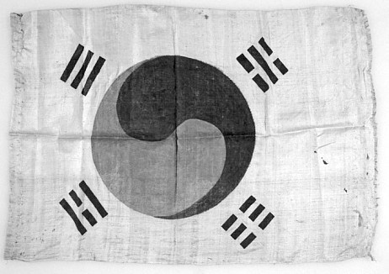

**Figure 9. Korean flag collected by Jouy, probably in 1883, and donated to the**

**U.S. National Museum in 1890. The flag remains in possession of the Smithsonian Anthropology Department today. (Smithsonian Institution)**

Another part of Jouy’s legacy is the set of the cultural artifacts he collected at the inception of Western scholarship on Korean anthropology and archaeology. A full account of his items would be too long, but one may be of especially symbolic value: Jouy brought a cloth flag back to the Smithsonian, where it remains today, which, given that the flag had only been created in 1882, must be among the oldest *Taegŭkki* flags extant.88

86 A subspecies of the bird known as *waegari* in Korean. Austin, “The Birds of Korea,” 8. A comparable case is William Richard Carles, a British diplomat and contemporary of Jouy’s, after whom was named the Korean flower *Viburnum carlesii*. Brother Anthony of Taizé, “William Richard Carles and Korea,” *Brother Anthony of Taize,* [http://anthony.sogang.ac.kr/Carles/WilliamRichardCarles.html.](http://anthony.sogang.ac.kr/Carles/WilliamRichardCarles.html)

87 A type of slaty-breasted rail. Originally proposed as *Rallus jouyi*, recently reclassified *Lewinia striata jouyi*.

88 Smithsonian Acc. No. 23,753. Jouy’s flag is noted as from Seoul, likely indicating 1883; Jouy donated it in 1890.

Beyond these academic legacies is the impact Jouy may have had upon U.S. impressions of Korea. In 1887-90, few Americans had direct Korea experience. The occasional young Korean political refugee notwithstanding, Jouy was the only permanent American staff member at the Smithsonian who could speak about Korea from experience.89

It is here that Jouy deserves attention even from those with no interest in ornithology or archaeology or the like, for Jouy’s views, often via informal contacts with academic circles and journalists who sought him for comment whenever Korean matters came up, may have had a considerable impact on American attitudes towards Korea around 1890. For example, Jouy had extensive contact with Frank G. Carpenter, who emerged as one of America’s leading journalists on Korea. Jouy was often used as a “primary source,” sometimes quoted directly, and probably many other times exerted informal influence on what was printed. Jouy was not necessarily the most knowledgeable American about Korea, but he was in the right place, at the right time, with the right people.

We can conceptualize a process by which Jouy’s impressions had an outward-ripple effect on the consciousness of what Korea and Koreans meant to educated American circles, influencing their opinions and attitudes on Korea, and in turn leaving some impression on foreign policy. For when we consider the 1880s-90s era in U.S.-Korea relations,

a puzzle remains: Why did the U.S. ignore Chosŏn when it was making clear appeals for closer ties? Some even spoke of a U.S. moral obligation to safeguard Korean independence, but it was never to be. Most administrations cited the U.S.’ traditionally neutrality policy. But foreign policy decisions are never monocausal or reducible to slogans. Nor can foreign policy be understood solely by careful readings of the diplomatic correspondence. Inquiring more deeply into figures like Jouy, who exist outside the diplomatic correspondence on which scholarship is

89 Horace Allen was in Washington for most of January 1888 to September 1889, as legation secretary for the new Chosŏn-Korean legation (by early 1889 located at a house on Logan Circle; the ROK government bought the house in 2012 and it is now a museum). Allen is a leading contender for ‘Korea expertise’ in Washington, and sold/donated items to the Smithsonian but was never a “Smithsonian man” like Jouy or even Bernadou. Allen and Jouy had seen different “Koreas.” Allen exceeded Jouy in knowledge of things “Seoul” and in political connections. Kwon, *Providence and Politics*, 83; Harrington, *God, Mammon, and the Japanese*, 86. Oppenheim writes on the exiles’ roles at the Smithsonian, e.g., briefly employing Philip Jaisohn in mid-1888. Sŏ Kwang-bŏm had Smithsonian ties longer but his exact role is elusive. Oppenheim, *An Asian Frontier*, 54-61.

traditionally based, may generate new insights into these decisions.

Finally, when considering his role as a scholar who arrived as part of the entourage of America’s first ambassador to Korea, it is worth reflecting on Jouy’s symbolic presence. The U.S. State Department refused a salary for Minister Foote’s secretary, repeatedly delayed payment for the U.S. legation building, and responded to Foote’s letters sluggishly. This was clearly neglect. And yet present at the U.S. legation was a scholar from the leading museum in America. What does this say about U.S. priorities in the 1880s and early U.S.-Korea relations?

Jouy’s active influence on U.S. perceptions of Korea lasted only a few years. For one thing, Smithsonian demands diverted him from his focus on Korea. 90 Believing he had many years to write, he worked slowly. 91 Although lingering influence continued, a firm bookend on Jouy’s active influence on Korean matters can be fixed to late 1890, when he fell ill with tuberculosis.

# Early death

Jouy suffered from tuberculosis for several years. He and Marion relocated to Arizona, hoping the favorable climate would help. From 1890 to 1893 he often showed signs of recovery. His struggle with tuberculosis and the move to Arizona meant that Korea-related work and Korea-related conversations with journalists, academics, and other influential Washington types were no longer possible for the time being.

Jouy continued fieldwork in Arizona and Mexico during periods of good health. The Smithsonian again praised “the excellent quality of his collections and of his field observations.” A colleague wrote of his early-1890s work: “Though sadly handicapped by failing health, Mr. Jouy’s love of his favorite pursuit [ornithology] showed no diminution.” During these years in Arizona and Mexico, Jouy was “helped by his faithful wife who shared the hardships and privations” of fieldwork.92 In early 1891, he undertook an expedition to Guayamas on Mexico’s Pacific coast and elsewhere in Mexico later that year. In 1892, at Lake Chapala,

90 Jouy was assigned in 1889 to the Department of Mollusks. *Annual Report 1889*, 371.

91 In mid-1888, Jouy told Washington journalist Frank G. Carpenter he was “preparing a book” on Korea. Carpenter, “Actors and Writers.”

92 *Annual Report 1892*, 156; “Jouy on Central Mexican Birds,” *The Auk: A Quarterly Journal of Ornithology* XI, no iii, 1894: 246; “Obituary for Pierre Louis Jouy,” 263.

Mexico, he collected “an especially excellent series of vampire bats,” again supplementing his naturalist work with pottery.93

Jouy’s condition turned for the worse in mid-1893, and he died in Arizona in March 1894, age 38.94 Stejneger wrote an obituary and tribute to his deceased friend in the leading ornithology journal.95 Jouy’s remains were returned to Washington for interment in his hometown cemetery. His journey ended near where it began, back in Washington in obscurity. Soon to fade entirely from ‘Korea’ awareness and never much making it into Korea-related historiography, Jouy was buried alone, with no gravestone.96

# What might have been?

Jouy’s 1894 death largely ended the story of one of the first American residents in Korea, though not entirely. Classification work on specimens he collected continued, and his widow sold or donated many of his Korea items, such as small statues and pottery, to museums.

The sad thing from an academic standpoint is that we know Jouy wanted to write a full work on his Korea experiences but never found the time, and eventually his time ran out. Seeing the end near, Jouy entrusted

93 *Annual Report 1892*, 160, 176, 178; *Annual Report 1894*,46; *Annual Report of the Board of Regents of the Smithsonian Institution, showing the Operations, Expenditures, and Condition of the Institution for the Year Ending June 30, 1898* (Washington: Government Printing Office, 1900), 273.

94 Jouy’s active life was over by mid-1893; thereafter he was weakened and bed- ridden though alert, his wife Marion caring for him. *Arizona Weekly Citizen* [Tucson], March 31, 1894, 4; “Obituary for Pierre Louis Jouy,” 262.)

95 “Obituary for Pierre Louis Jouy,” 263–64 (signed “L.S.,” Leonhard Stejneger).

96 This author located Jouy’s burial plot in a quiet corner of Oak Hill Cemetery. No monument stone stands as of 2021. Jouy’s plot is marked by a metal peg. No relatives by blood or marriage are buried nearby. His first wife and daughter are buried in a distant part of the cemetery. Jouy’s Smithsonian mentor, Spencer F. Baird, was also buried here, and has a prominent monument. Jouy’s widow, Marion, died in her mid-forties in 1908, reportedly due to suicide. She was in chronic pain from “several severe operations” and had spoken of ending her life. “Mrs. Jouy Killed Herself,” *Evening Star*, June 18, 1908, 11. She was buried at Congressional Cemetery, Washington, a private cemetery, in an Antisell family plot. A newspaper article published after her death offers a touching portrait of Marion Jouy in life. “Gives Last Penny for Benefactor,” *Washington Times* of June 22, 1908, 3. The fate of Marion’s one child, listed on the 1900 census, is unclear; possibly given for adoption after Jouy’s 1894 death.

his papers, largely in note and early outline form, to Stejneger, hoping he could do something with them. Stejneger later published one as a short article, “The Paradise Flycatchers of Japan and Korea.” This was a small fraction of Jouy’s intended output on Korea.97 Had Jouy lived to old age it is likely his name would be found much more in the historical record and in Korea scholarship.98

Jouy’s initial presence in Korea predates the arrival of the Protestant missionary-scholars, that talented group from whose work, writing, and commitment derives so much of English-language historiography on late Chosŏn. Many of these people were core figures in RAS Korea, but by 1900, when RAS Korea was founded, Jouy had long passed from Korea and from this earthly life. The missionaries appear never to have known him.

*Peter L. Juhl holds an MA from Johns Hopkins School of Advanced International Studies (SAIS) in Washington, D.C., with a Korea Studies co- concentration. He has worked professionally in Korea and the United States, recently at a think tank. He is preparing a book on Lucius Foote, the first U.S. ambassador to Chos*ŏ*n-Korea. During preparation of this article, Peter lived in Virginia. He can be reached at* [*pjuhl026@gmail.com.*](mailto:pjuhl026@gmail.com)

*The author thanks Pamela Henson, historian at the Smithsonian, and Deborah Shapiro, Smithsonian archivist, for their research guidance and helpful comments and insights.*

97 Stejneger implies Jouy’s deathbed regret was failing to publish more on Korea.

98 Oppenheim and Austin have several pages on Jouy, focusing on anthropology/archaeology and ornithology, respectively. A few Smithsonian publications mention Jouy, notably Houchins. Jouy seldom gets a single line in works on political or diplomatic history. Jouy’s name makes one unelaborated appearance in Horace Allen’s 1901 compilation of “chief events in the foreign intercourse of Korea.” Hawley’s annotated version of George Foulk’s 1884 travel diary includes considerable and insightful notes (on people, places, etc., which Foulk encountered) and has a one-line endnote on Jouy (“…of the Smithsonian Institute, who accompanied U.S. Minister Lucius Foote to Korea in May 1883.”) Foulk, *Inside the Hermit Kingdom*, 163, n110.