*The Bulldozed Future:*

*Exploring Korea’s Urban Redevelopment Zones*

Ryan Berkebile

No matter where you reside, what your station in life is, urban exploration offers a unique opportunity to see your surroundings in a new light. Whether living in Korea as a foreigner or native, you can see things you might otherwise miss if you stick to the usual tourist destinations or cultural hot spots. With a keen eye, walking through areas undergoing redevelopment reveals secrets of Korea that alter one’s perspectives.

Over time I have refined a systematic process for finding, documenting, and exploring these areas before they are razed. Entire neighborhoods have provided a bountiful opportunity to gather information not only about the residents who once lived and worked there, but about Korean culture as a whole.

Since 2014, I’ve been actively documenting abandonments and redevelopment zones around Korea. As I wander around cities throughout Korea, I always keep an eye out for clues that show a neighborhood in the early stages of demolition and redevelopment. The most telling sign is brown tarp or pastel-colored cloth scaffolding used to demarcate the condemned area and shield neighbors and passersby from the unpleasant scene of the eviction and removal of a community. Before the scaffolding is assembled, there are other indicators, such as buildings without any windows and spray-painted doors and windows.

Urban exploration (also known as “urbex” or “UE”) is a synthesis of adventure, tourism, anthropology, and modern archeology. The ethics that apply in these areas are also valid in the world of urbex. Sustainable tourism requires visitors to be considerate about their impact on the immediate surroundings. They make efforts to leave the area how they came upon it. Similarly, an ethical explorer considers how negative behavior will affect the neighborhoods explored, as well as the hobby as a whole. A thoughtful urbexer, like any knowledgeable anthropologist or archeologist, will also be an objective observer in the field. An enthusiast

of the hobby attempts to answer the unanswerable questions of who occupied the abandoned space and what they did as a career or for fun, by studying any artifacts left behind. Even if an abandonment is empty, the thrill of the hunt itself motivates one to keep searching.

Many of the sites documented in the following photos have already disappeared, but in cases where they remain some details are withheld to protect the sites and the people connected with them.

# Residential spaces

Abandoned residential spaces vary in size, shape, and style. A redevelopment zone is generally a mix of Western style and Korean traditional style homes. Not as often, an explorer will come across abandonment houses from the Japanese colonial era.

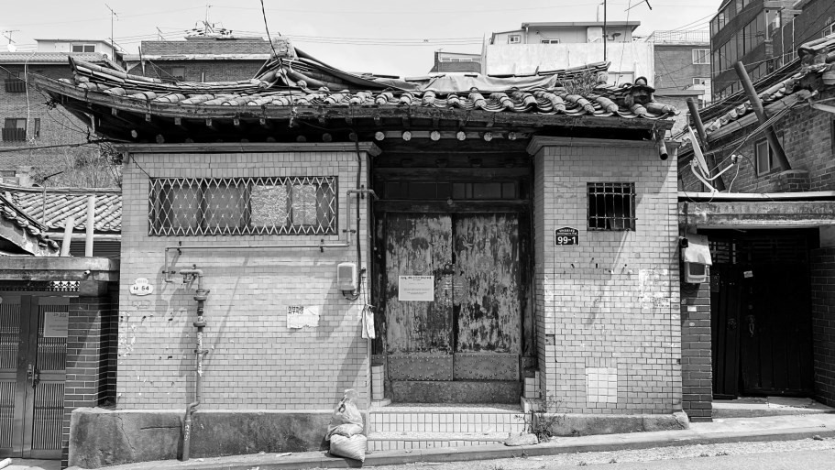

**Figure 1. The “Tatami Hanok” was registered in the government ledgers on June 30, 1938.**

I encountered two colonial-era *hanoks* on a chance visit to a condemned section in Seoul’s Samseon-dong, now all destroyed. While any exploration of an abandoned area is a trip into the unknown, these specific *hanoks* especially caught me by surprise. As mentioned earlier, it is rare to find vacant *hanoks* from the Japanese colonial era. One was hiding in plain sight due to numerous modernization efforts through the decades. The other was tucked away behind 1970s- and 1980s-style brick apartments.

I christened the first *hanok* the “Tatami Hanok” due to the Japanese-style flooring found in a small storage space above the kitchen. Not much was left behind except the *tatami* mats themselves, hence my name for the house, but discovering these pieces of history was thrilling. It is rare to see *tatami* mats in Korean homes these days, so they must have been in there for ages. A friend did some digging and discovered the government first registered this house on June 30, 1938. This was not the first time I had encountered *tatami* while exploring in Korea, nor traces of Korea’s Japanese colonial past.

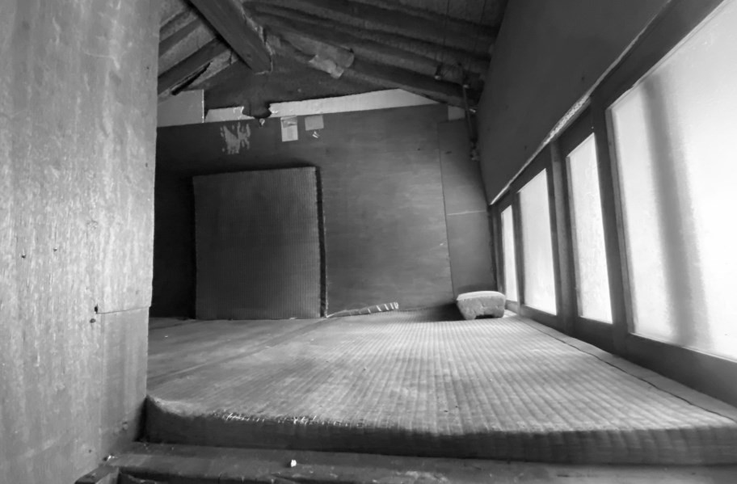

**Figure 2. In a storage space above the kitchen lay three *tatami* mats on the floor and one and a half more affixed to the wall.**

The second *hanok* I nicknamed the “Great Japan Hanok.” It looked older than the other 60s/70s city *hanoks* I usually come across in redevelopment zones. Although the Great Japan Hanok was empty of any personal effects, the exciting discovery was found on the roof tiled ends, also known as *mangwa* and it was here that I saw two etched *hinomaru* Japanese flags crisscrossing each other. Underneath the flags, written in Chinese characters, read “大日本” (Great Japan). In total there were five “Great Japan” *mangwa*.

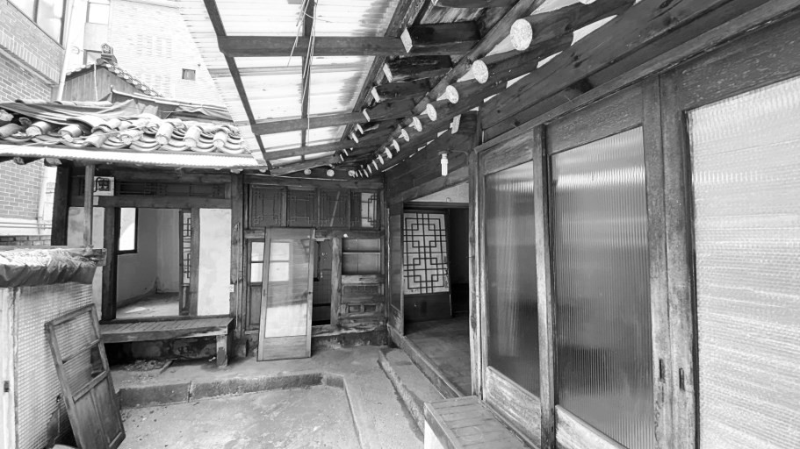

**Figure 3. The “Great Japan Hanok” was registered on Aug. 22, 1936.**

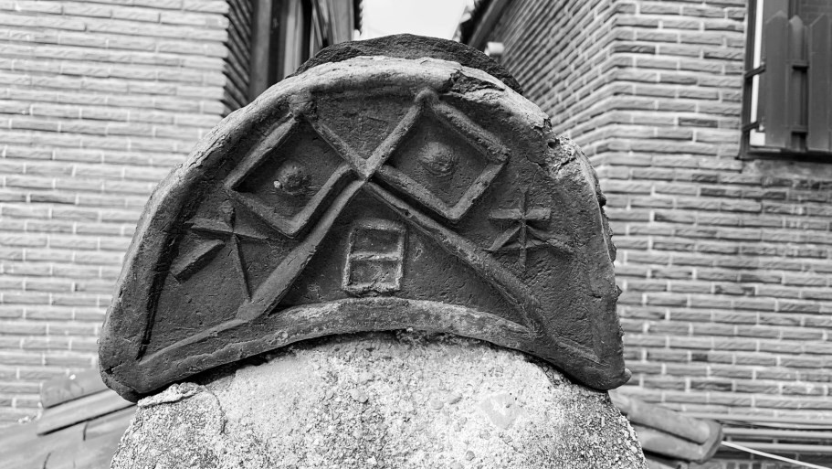

**Figure 4. Two *hinomaru* Japanese flags crisscross each other, while underneath, the Chinese characters read “大日本” (Great Japan).**

As mentioned, the Tatami Hanok was not the first time I came across *tatami* mats while exploring an abandoned colonial-era house. In June 2019, after an RAS Korea member alerted us to the impending demolition of a house next door to his apartment in Huam-dong, a friend and I explored a Japanese-style house from the 1930s, on the eve of its destruction.

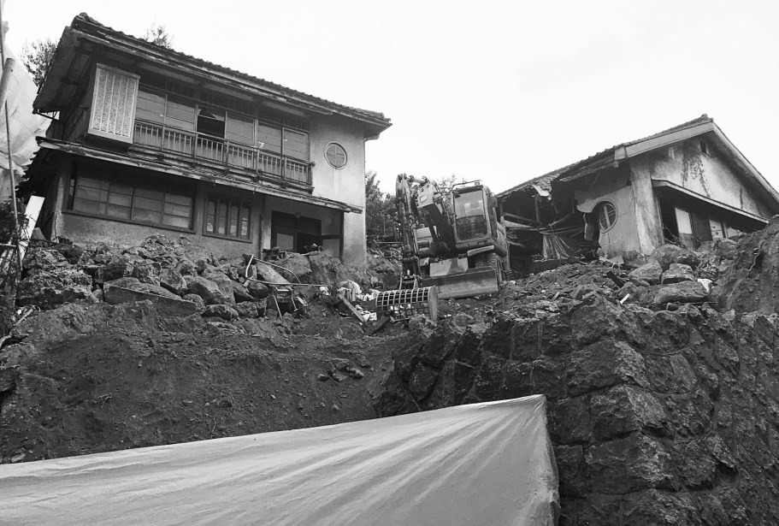

**Figure 5. “Roy’s House” in Huam-dong before its June 2019 demolition.**

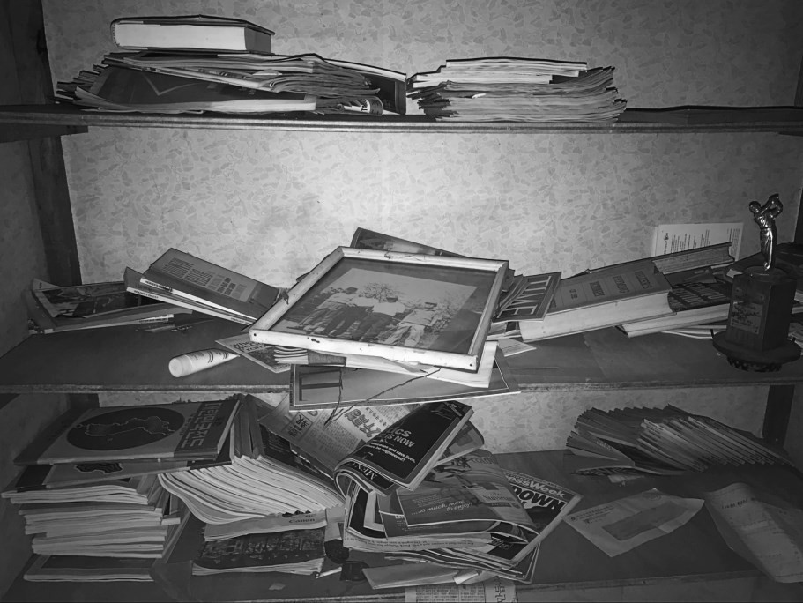

**Figure 6. Pictures, magazines, books, and other personal possessions were strewn all over.**

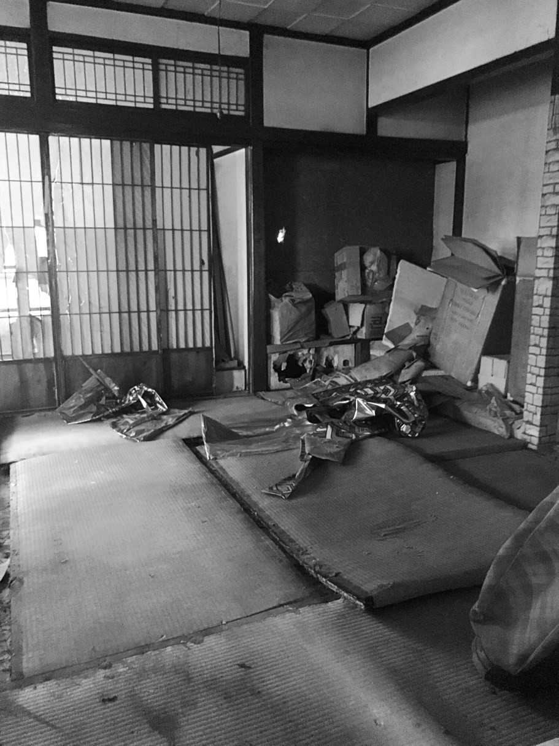

**Figure 7. A second-floor room of “Roy’s House” had space for ten *tatami***

**mats.**

Letters, magazines, books, and other personal effects dating back to the Korean War lay scattered about as workers prepped the house for demolition. We spent hours learning about the former residents of the

place, which I nicknamed “Roy’s House” in honor of the name associated with most of the correspondence found inside.

Roy was a well-rounded man, as was evident in his piles of books, magazines, and saved newspaper articles. He was fond of reading English-language magazines like Newsweek, National Geographic, and Time, faithfully maintaining subscriptions to each one. Roy also read a wide variety of books in Korean and Japanese. A garbage bag of saved letters showed that Roy was a dedicated writer as well. We were able to construct a partial biography of Roy and his family based on the materials left behind. Roy’s House was an urban anthropologist’s dream to explore.

# Spiritual spaces

Even spaces for worship and sanctuaries are not spared from urban renewal. These spaces that strengthen communal bonds are abundant in redevelopment zones. I’ve come across a wide variety of abandoned spiritual spaces in my explorations of redevelopment zones. Exploring everything from Christian churches of various sects, to shaman houses, and even a few abandoned Buddhist temples. More often than not, these places are empty; maybe some photographs, artwork, or scripture are left behind. Any piece of evidence is an opportunity to speculate about the people who once spent their lives at these places.

Shaman or fortune teller houses are common sites found in redevelopment zones. Some are decorated with swastikas and/or Buddhist imagery, but other times they are unmarked residences that I only notice once I see the multicolored, *dancheong*-patterned wallpaper. Traditional motifs and numerous *bujeok* hanging on the walls are strong clues that a shaman/fortune teller once practiced in the house.

I was first made aware of Korean shamanism, *bujeok*, and other folk religious practices after visiting an abandoned house in Gwangju which we called the “Shaman Hoarder’s House.” It was the untidiest, dustiest abandonment I have encountered to this day; exploring this place meant walking over newspapers, wrappers, dishes, clothing, books, and a countless amount of Buddhist and Taoist tsotchkes. The walls are equally cluttered with *bujeok*, lists of people’s names, and other spiritual knick- knacks. Surprisingly enough, the Shaman Hoarder’s House still stands as the lone abandonment in an active neighborhood.

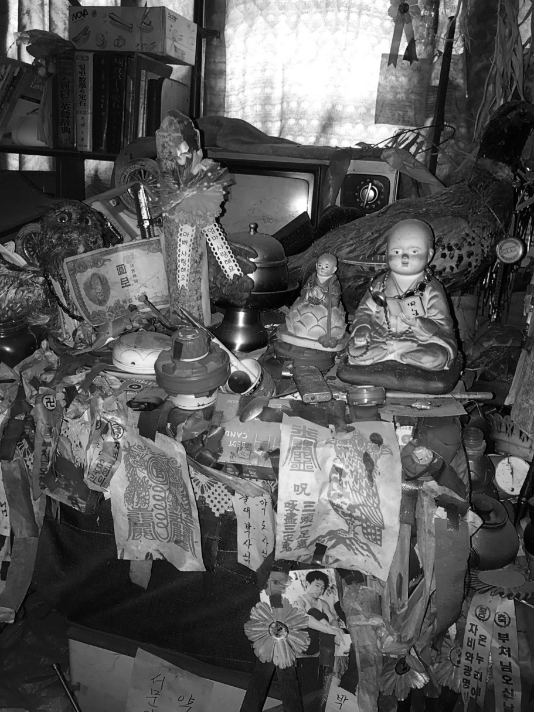

**Figure 8. *Bujeok*, statues, and other personal items clutter a desktop in the Shaman Hoarder’s House in Gwangju.**

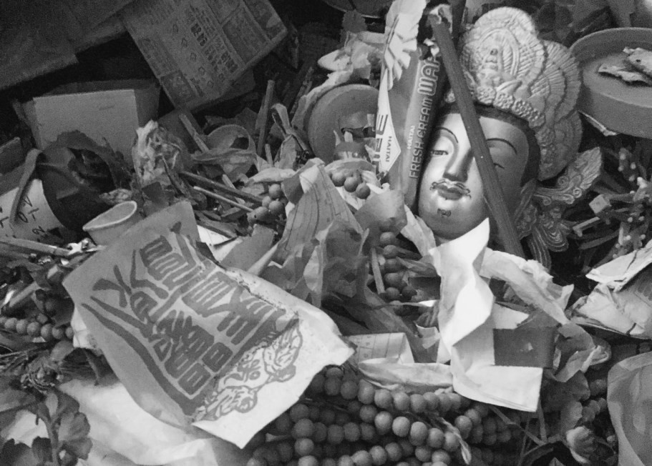

**Figure 9. A bodhisattva statue is buried in the Shaman Hoarder’s House.**

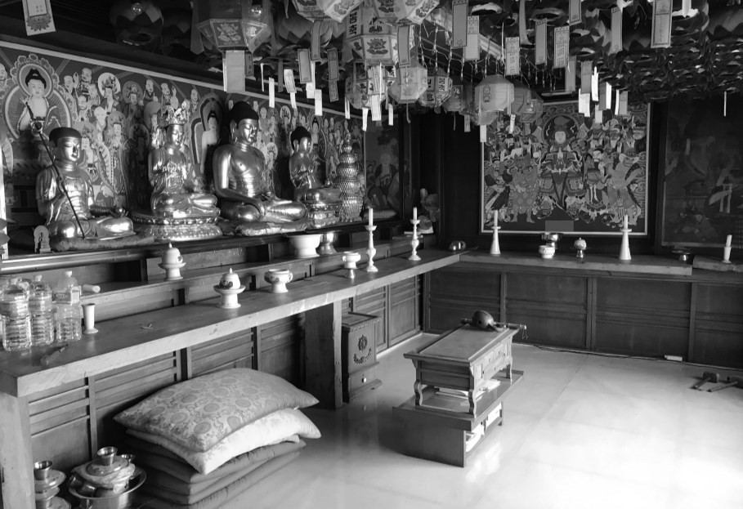

**Figure 10. The Great Buddha Hall of Samhong Temple**

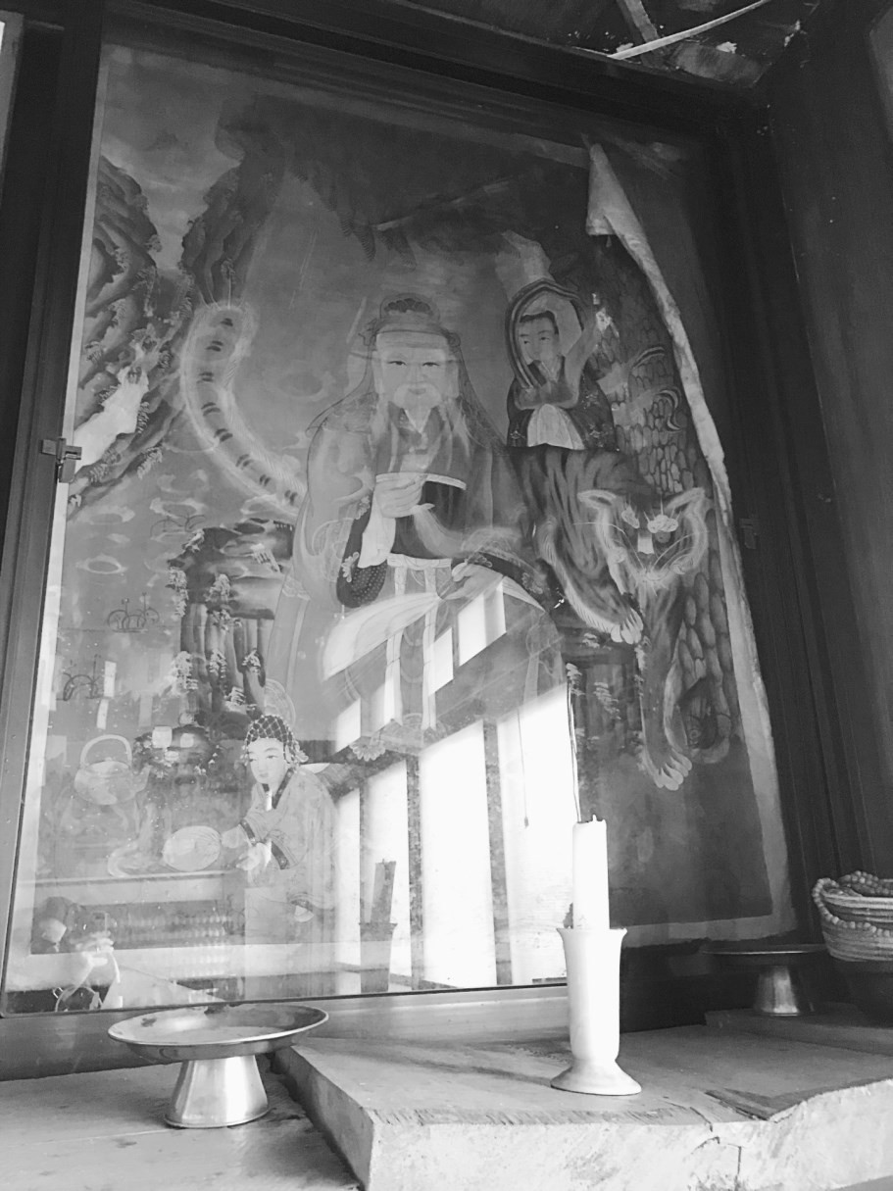

**Figure 11. Water damage pervades the right side of the *Samshin taenghwa* at Samhong Temple, making the artwork begin to curl up.**

Finding a fully furnished Buddhist temple was another extraordinary discovery. Samhong Temple, in Imun-dong of northeastern Seoul, provided refuge for spiritual seekers until one day the monks in charge left and never came back. It had been abandoned for years, the roof in the adjacent living quarters building caved in long ago. The Great Buddha Hall, however, fared better; statues and paintings of bodhisattvas lining the altar were dusty, but salvageable. When I returned a month later, the temple had been looted, maybe by workers or scavengers. Months later the entire neighborhood was bulldozed.

# Educational spaces

I’ve explored a wide variety of abandoned educational spaces. Academies and cram schools are the most common and easiest to find. Closed public schools and universities are also widespread across Korea, but accessibility inside varies at each location.

I have enclosed a few pictures from a variety of spaces including a former calligraphy academy, an airplane on an abandoned university campus, and an institute for senior citizens’ education.

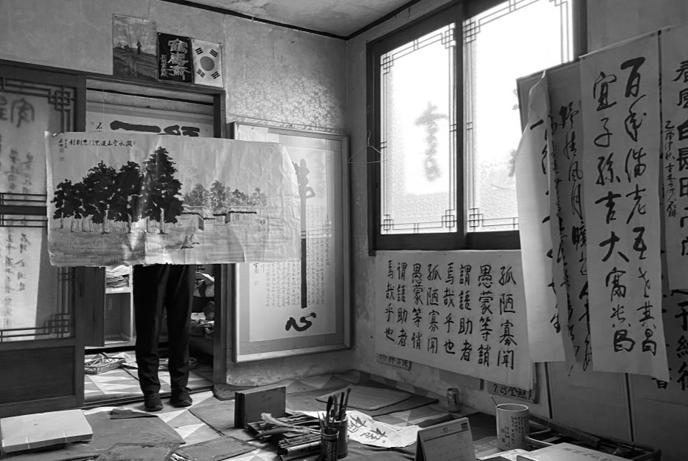

**Figure 12. Some examples of Kim Yun-hwan’s calligraphy.**

In a now-demolished section of Gwangju’s Hak-dong, I had the opportunity to explore a calligraphy academy once owned by a prolific calligrapher named Kim Yun-hwan. While the building’s facade was nondescript, the three-room studio provided a peek into the life of the man who owned and operated the school. In the lounge area, acclamations and awards were on full display. The main classroom was still set up, ready to be used to teach students the fundamentals of calligraphy.

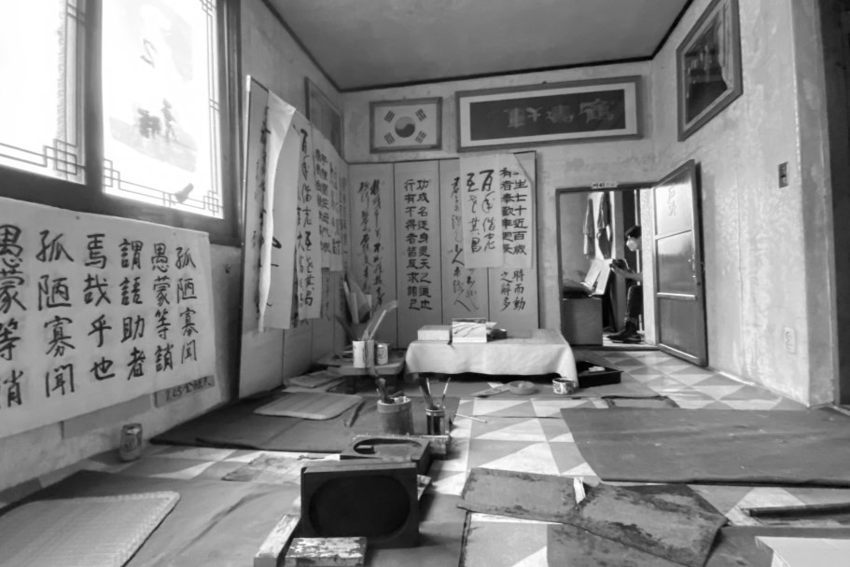

**Figure 13. Another view of the main room of Kim Yun-hwan’s calligraphy academy in Gwangju’s Hak-dong.**

Sitting on the disused property of an undisclosed university in the Honam region lies an equally neglected airplane. The airplane was once part of the school’s program to train students for flight attendant careers. However the university was shut down in 2011 due to financial and academic corruption and the property was rented out to businesses hosting aviation-themed summer camps for young learners. It seems these programs never caught on, as the university and the plane remain grounded.

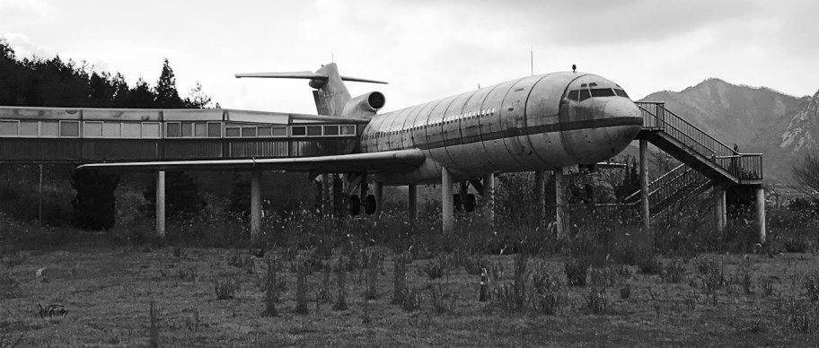

**Figure 14. An abandoned airplane used to train flight attendants sits on an abandoned university campus.**

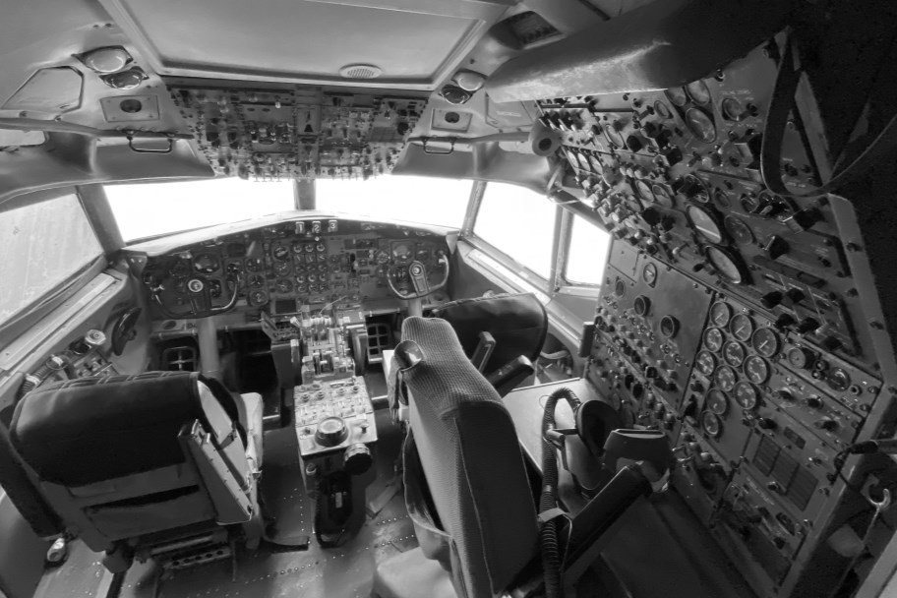

**Figure 15. Inside an abandoned airplane used to train flight attendants.**

In a yellow multipurpose building in Seoul’s Yeomni-dong, Seoul Senior Citizen’s University helped the elderly further their education while also strengthening community bonds. The place had lots of interesting artifacts including a *gayageum*, countless photos, and a stuffed weasel. However, it’s the left-behind seat cushions in the desks that left me with the biggest impression, as I imagine the *halmoni* and *haraboji* that once occupied those seats.

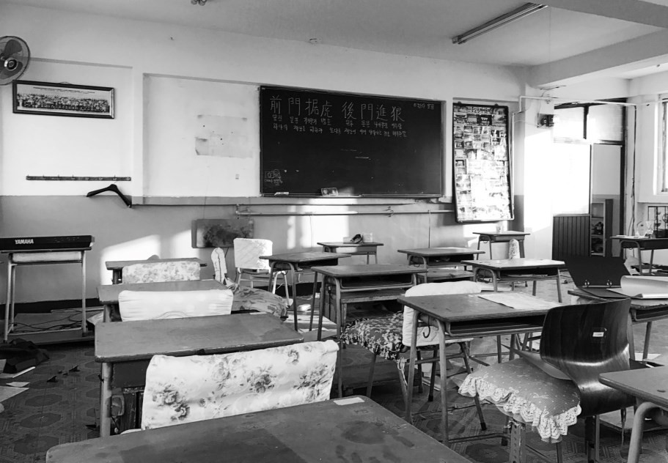

**Figure 16. An empty classroom at Seoul Senior Citizen’s University.**

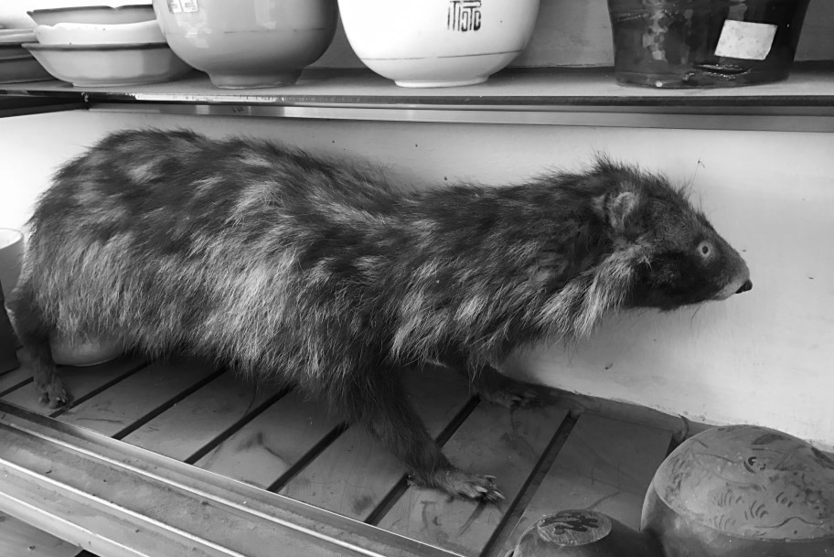

**Figure 17. A stuffed weasel found in a classroom cupboard in Seoul Senior Citizen’s University.**

Seemingly unanswerable questions and the scant clues left behind motivate me as I explore Korea's neighborhoods undergoing redevelopment. Who are the people who lived and worked here? Where did they go? My fellow explorers and I might not get as complete of a picture as what we found at Roy's House, or even the Shaman Hoarder's House, but over time the accumulated photos we have taken in abandoned houses, shrines, and educational facilities have broadened our understanding and appreciation of Korea.

*When Ryan Berkebile is not taking photos of abandoned neighborhoods, he likes to write up his explorations for his website, Long Distance Runner. He is also a frequent contributor to Gwangju News, an international magazine covering Gwangju and the South Jeolla Province region. Ryan also self-publishes a photography zine titled The Bulldozed Future; digital and print issues are available for purchase from him directly. You can find out more about this and other projects at longdistancerunner.org and on Instagram: @l0ngdistancerunner and @naturaryan1600*

*The writer would like to thank Suk JiHoon for his assistance in researching some of these places, as well as Isaiah Winters who wrote about the calligraphy teacher in the July 2020 issue of Gwangju News, plus various other individuals whose names will not be mentioned to protect their privacy.*