*The Emperor and the Miner: The Story of John Kavanaugh*

Robert Neff

At the beginning of the twentieth century, Korea was known as a land ripe with opportunity for a person willing to work. Telegraph and telephone lines were being stretched across the peninsula, various railroads, such as those connecting the capital with the two main ports, Chemulpo and Fusan, were under construction, while in the northern part of the country gold and other valuable minerals were being mined in great quantities making Korea the Klondike of Asia.

John Kavanaugh, an American gold miner, arrived in Korea in late May or early June 1902. He was 35 and had a fairly regular build―a little over 5 foot 8 and about 152 pounds―with black hair. If there was anything about him that could be considered an anomaly it would be his dark grey eyes, as those of many of the early American gold miners in Korea were blue. Born in Kansas City, Missouri, in 1866, his family moved to the Tacoma region in Washington Territory in the late 1880s. Much of his past―including that of his family’s―has been obscured by the passage of time and we know so little about him prior to the mid- 1890s, when he worked as a miner in California for a couple of years before drifting north to the gold fields in British Columbia and then on to Nome, Alaska―always seeking a fortune but never really finding one.

After a short stint in the far north, he went to Hawaii where he was involved in tunneling and then returned to the San Francisco region, and its nearby gold fields, in 1901. When the Oriental Consolidated Mining Company (OCMC)―the largest gold mining concession in Korea―offered him a job he readily accepted it. I would like to claim it was the thrill of the adventure that enticed him to accept the position but it wasn’t―it was simply a matter of money. In California, he received a monthly wage of $120 and was responsible for his own room and board (nearly $50 a month) but the OCMC was offering him $150 a month, free room and board, medical care, and roundtrip tickets.

Along with a few other recruited miners, he left San Francisco on May 1, 1902, and arrived in Korea sometime in late May or early June. Kavanaugh was placed at Taracol in North Pyongan Province, one of the largest mines the OCMC had, and he seemed to enjoy his job. It was hard work, with little time off and very few venues for entertainment―just drinking, hunting and cards.

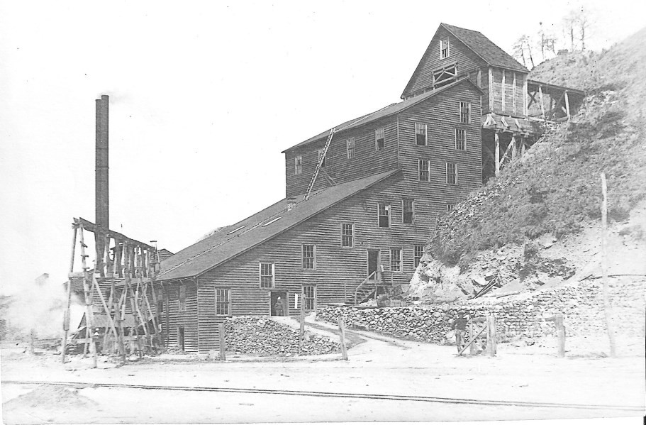

**Figure 1. OCMC stamp mill in early 1900s (Robert Neff Collection)**

He was a dutiful son who wrote letters home frequently. Judging by his letters and their atrocious spelling and grammar errors,1 he was not very well-educated but he was very considerate and sent a substantial amount of money home, unlike some of the other miners. He urged his mother Mary and his younger sister Mollie to use it for whatever they needed, and even suggested they use it to build a new house.2

Miners employed by the OCMC usually signed three-year

1 I have taken the liberty to correct his spelling errors in an effort to make his writing more understandable. I have chosen to retain the old spellings of Chemulpo (Incheon), Fusan (part of modern Busan) and Chinnampo (modern Namp’o); Ping Yang (Pyongyang) will only be used in quoted text.

2 John Kavanaugh to his mother and sister, Jan. 5, 1903, *Kavanaugh Collection at Washington State Historical Society*. From this point on these letters will be referred to as “JK” and date.

contracts, but Kavanaugh seems to have been a rare exception to this rule. He spent only about a year at the company, but even after he left he maintained good working relations with his former employer. While the few letters he wrote describing his life in Korea mostly focused on the OCMC, in January 1903, perhaps while accompanying the bullion wagon, he traveled to Seoul and described in some detail the uncertainty gripping the country due to the increasing animosity between Russia and Japan:

Well, I am still here at the place waiting to find out what Russia and Japan will do. I hope they will settle it one way or another soon as the suspense is hard [and] business is at a standstill. My friend, General Min Yong-chul, is ordered to Pekin, China, to try and get a treaty to protect Korea in case of war, and, in case of war, Korea will be the loser. [It] is the prize they are fighting for. [The] Koreans are like children no minds of their [illegible] and will not do anything they can put off till tomorrow. I find them all right, of course the government is rotten, [the officials] all steal from the top down. The country is rich in all kinds of minerals, in fact the biggest mineral deposits I ever have seen are in the country waiting for development which will be done in time. The Japanese will develop the country but the Russians will not. If Japan takes the place there will be some fear full time here as they are so barbarous; there is no honor in a [Japanese] so the poor Korean will suffer the most of all.

All of the different legations here [have] from 50 to 100 soldiers as guards. In Chemulpo there are a lot of warships but they do not let the men on shore for fear of starting a row.3

In this letter he also implied that he would have said more were the Japanese not examining the mail. Much of his letter seems exaggerated and it exhibits a certain bitterness that may have been influenced more by the loss of a 700-yen money order (the ship carrying it sank off the coast) than his personal concern with the Korean political situation.4

3 JK, Feb. 3, 1903.

4 Ibid.

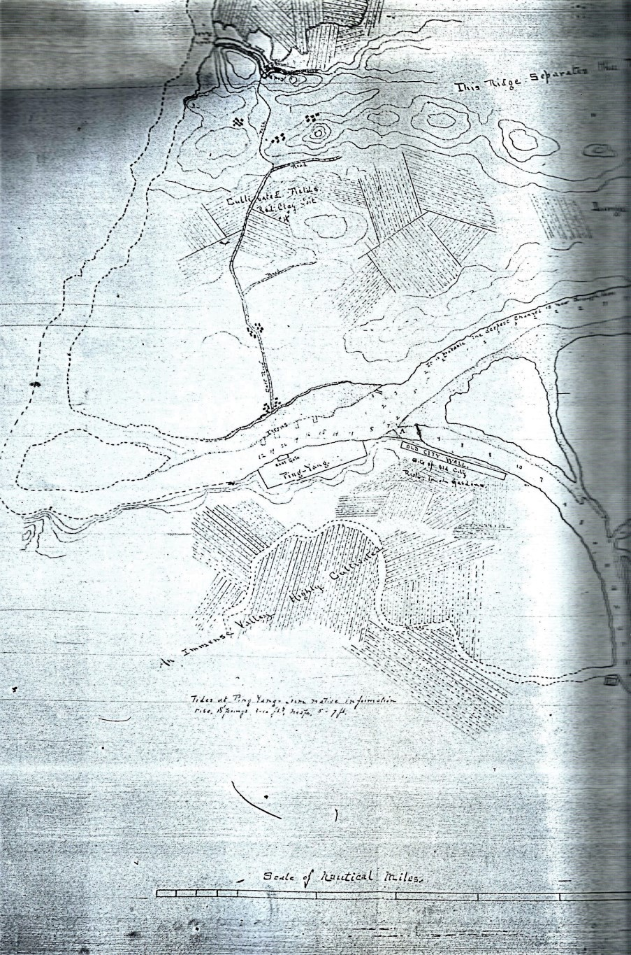

**Figure 2. Map of Pyongyang in November 1891 (Robert Neff Collection)**

Just over a month later, he was still in the Seoul region and informed his family that he “had a chance to go over to China for another go at a better wage but do not like the district so will not go.” He claimed to be satisfied with the OCMC which has the “largest [mine] in Asia that is working. It turns out $140,000 [per month]. My wages are $125 gold per month, board, lodgings and doctor are provided … [and he is a first class doctor] and we do not have [to] pay anything for the medicine.”5

By April he was back at Taracol, and in a letter to his family he complained “there is no news here that would be of interest to you.”6 He wasn’t quite telling the truth, however. There was news, but he just wasn’t writing about it. His decision not to go to China might have been because he had secured a far more lucrative opportunity through his good friend General Min, a Korean official he had somehow befriended.7

# The other black gold: coal

Gold wasn’t the only thing being mined in Korea. The northern part of the country, especially near Pyongyang, had large coal deposits. There were several plans in the past to develop these mines but none of them really got off the ground. In November 1891, U.S. Minister to Korea Augustine Heard and crewmembers of the U.S.S. *Alliance* had traveled to the mine to examine the quality and quantity of the coal. Their initial impressions were very favorable. Five years later, in 1896, Alfred Burt Stripling, an Englishman who worked for the Korean government on a number of occasions and in various roles, was granted a coal mining concession in northern Korea provided that he begin operations within two years and use Korean labor as much as possible. He apparently did not fulfill his end of the agreement. Where the foreigners had failed, the Korean government―particularly Emperor Gojong―was determined to succeed.

It seems that, sometime after May, General Min, perhaps with the assistance of the OCMC, established a Korean government-owned coal mining company known as “The Poong Poo Company” to work a concession about twenty miles north of Pyongyang. General Min would serve as the company’s president while Kavanaugh would serve as foreign superintendent and be responsible for getting the mine operating.

5 JK, March 22, 1903.

6 JK, April 30, 1903.

7 He is listed as Min Bung-Hun, president of Poong Poo Co*. Directory & Chronicle for China, Japan, Corea, Indo-China for 1907* (Hong Kong: The Hong Kong Daily Press, 1907), 582.

Throughout the summer Kavanaugh’s correspondence ceased. Perhaps he was too busy getting the coal mine into operation or maybe his letters were lost with the passing of time or in one of the frequent shipwrecks.

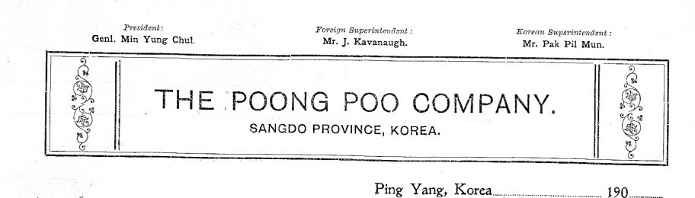

**Figure 3. Poong Poo Company Letterhead (Courtesy of Washington State History Research Center)**

In late January 1904, however, he wrote a letter from Seoul describing not only his mining camp but also the political situation on the peninsula:

I am well and working still for the emperor of Korea [who] sent for me to come down from Ping Yang and report to him what work has been done so far so I am here waiting his pleasure to see him which will be in a few days.

There is a great deal of war talk between the Japanese and Russians. What they will do I cannot say but it will not affect me. At any rate, I will not be in danger as there are 100 American soldiers at the legation. In fact, all of the different legations have a guard here.

I came down overland in a chair, six coolies to [carry] it and it took seven days to cover overland. I will start back in about ten days. The weather is not very cold, two degrees below [zero Fahrenheit] with six inches of snow. It is a good road, plenty of towns all along. The cities all have stone walls around them 30 ft. high and 5 feet wide on top. I have 30 Koreans at work near Ping Yang sinking a shaft and 25 Japanese fixing up a mineral spring well. 8

8 JK, Jan. 25, 1904.

He ended his letter, writing, “I have [seen] things in the last few days [which] are hard to believe. I cannot put it on paper as they will not let news leave here that tells of the [moves].”9 The possibility of war between Japan and Russia was growing higher and higher as the days passed.

# Seoul during the war

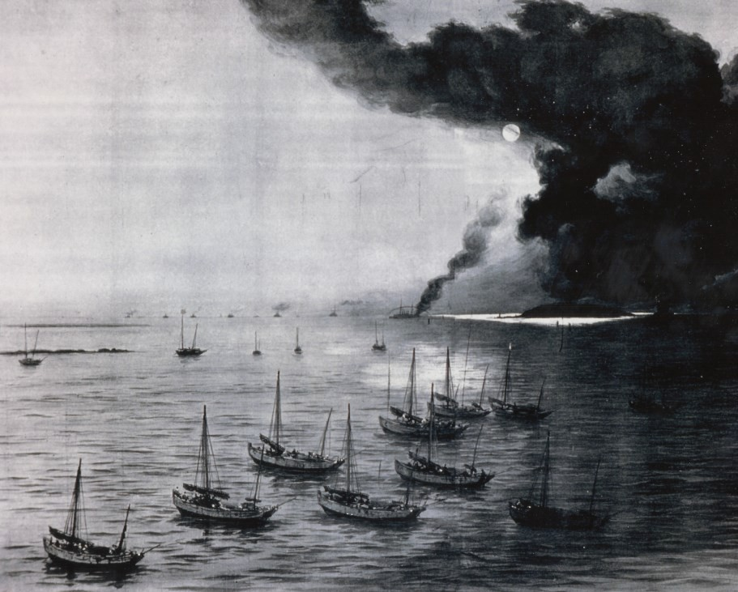

**Figure 4. Engraving of the naval battle at Chemulpo (Robert Neff Collection)**

On Feb. 9, 1904, two Russian warships in Chemulpo sailed out to meet the Japanese fleet in combat, knowing that they had little chance of winning the heavily lopsided battle. After months and months of anticipation, the Russo-Japanese War had begun. Kavanaugh, who was stuck in Seoul, began to write earnestly about the quickly unfolding events. Not all of his accounts were accurate or impartial, but they provide a non- missionary view of the war. In the third week of February he explained to

9 Ibid.

his family that the “war is on here in good shape” and that “we could hear the firing at Chemulpo 30 miles from here when the Japanese attacked two Russian men-of-war. They outran the Japanese and got back in Chemulpo where the Russians blew up their ships after sending the men to the French warship.”10 The 60 Russian sailors killed during the brief battle were left aboard the ships when they were scuttled and the Russian sailors aboard the French ship were sent to Chefoo [Yantai], China.11

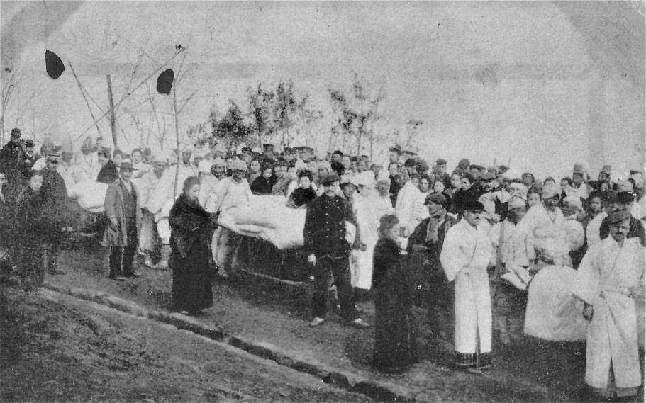

**Figure 5. Wounded Russian sailors taken to the Red Cross hospital in Chemulpo (Robert Neff Collection)**

The wounded Russian sailors, who were not placed on the French warship, were taken to a Japanese Red Cross hospital where they were treated very well―“much better than the Russians will treat the Japanese when they get them in the same fix.”12 On Feb. 27, he visited the hospital and declared it “a sad sight” to see nearly 40 wounded sailors―he later adjusted this to 75―from the Russian cruiser *Varyag*. He did, however, praise the cleanliness of the hospital and the kind treatment of Russians whose “mothers could not do more” for their sons than the Japanese nurses in their white uniforms.13 Once again, Kavanaugh speculated that

10 JK, Feb. 22, 1904.

11 JK, March 11, 1904.

12 JK, Feb. 22, 1904.

13 JK. Feb. 28, 1904.

if the tables were turned, the treatment of the wounded Japanese sailors would be far worse, writing, “in fact, where the Russians win there will be but few wounded if one can believe reports of them in Pekin and China.”14 At Chemulpo, Japanese soldiers of “all kinds, big, little, old and

young” disembarked from numerous Japanese transports along with their horses and goods.15 “The soldiers are all very quiet and still no drinking among them so far,” as they waited patiently to be sent on to Pyongyang at a rate of 15,000 men per week, or to Seoul, where barracks were being built at Yongsan capable of housing 10,000 soldiers. Until the barracks were completed, the Japanese soldiers stayed in the homes of Japanese residents in Seoul, with as many as possible placed in each household.16

Despite the large number of soldiers and the early victory at sea, he was convinced the Japanese would not be able to stand up to the Russian soldiers in a land battle as the Japanese horses were “small and poor” and their horsemen equally poor, if not worse, requiring “three [men] to saddle one horse.”17

When Kavanaugh finally met the emperor, he was told to remain in Seoul―an order the American was more than happy to comply with:

Well, I am staying in General Min Yung-chul’s river house three miles from Seoul at the end of the electric car line. It is the finest house in Korea [and it] cost him 95,000 yen [about $45,000].

His mother, wife and four of his favorite concubines are here. I am taking care of the place. He leased it to me for 12 months. I have the American flag floating over it so that the Japanese will not take it for officer quarters; they take away things they want if Koreans have it.18

He assured his family that there would be no fighting in the vicinity of Seoul and that all of the combat would take place north of Pyongyang―which kind of worried him because he had a trunk filled with fine silk and jade worth about $800 at a Japanese hotel in that city and he was afraid the Japanese soldiers would steal it. He was also somewhat concerned about money because the price of goods was

14 Ibid.

15 JK, Feb. 22, 1904.

16 JK, Feb. 28, 1904.

17 JK, Feb. 22 and 28, 1904.

18 JK, Feb. 22, 1904.

climbing steadily due to the war. His monthly salary was 800 yen (about

$400) but his wages were in arrears of 2,000 yen and would not be paid until the situation in Korea settled down. His connection with General Min comforted him because the general was “the president of the company and so my wages go on.”19

He was also offered a job as a dispatch rider with a monthly salary of 1,000 yen, but he turned it down, writing, “what is the use, I have fine quarters and the best food here and no danger. So here I will sit.”20

Although he was fairly certain he would remain in Seoul until the end of the war, he was by no means inactive, as evidenced by his letter in mid-March when he described the funeral of the Empress Dowager Myeongheon, which took place at dawn on March 14.21 She had died on Jan. 2 at the age of 72 and, in the days that followed, the people of Seoul began wearing mourning clothes and a “proclamation was sent throughout the country ordering all classes to do the same and to turn their faces toward Seoul and wail.22 Her body was watched over not only by palace officials but also “guarded day and night by thirteen members of the peddlers’ guild.”23

According to him, the empress dowager’s coffin was carried by 500 men and there were about 30,000 men in the parade. “It cost the emperor 600,000 yen, about $300,000, beside what the people spent.”24 He explained further that by tradition, Koreans generally kept the body for six months, but on account of the war they only kept her three months.25 He was captivated by the pageantry, with “all kinds of devils to scare off the evil spirits, big paper horses for her to ride, money to spend and food for her to eat was taken along,” and declared “it beat anything I ever saw.”26

19 JK, Feb. 28, 1904.

20 JK, Feb. 22, 1904.

21 The dowager queen’s obituary and subsequent funeral are described in detail in “The Late Queen Dowager,” *The Korea Review* Vol. 4, 1904 (January), 6-9 and “The Royal Funeral,” *The Korea Review* Vol. 4, 1904 (March), 103-109.

22 “Odds and Ends,” *The Korea Review* Vol. 4, 1904 (January), 25.

23 Ibid., 26.

24 His figures are mistaken. According to *The Korea Review*, the funeral was expected to cost between $600,000 and $650,000. JK, March 11 and 27, 1904; “The Late Queen Dowager,” *The Korea Review* Vol. 4, 1904 (January), 6-9; “Odds and Ends,” *The Korea Review* Vol. 4, 1904 (January), 26.

25 The funeral had been scheduled for May. “The Late Queen Dowager,” *The Korea Review* Vol. 4, 1904 (January), 6-9.

26 JK, March 11, 1904.

Over the next couple of weeks, his letters reported various developments. The Japanese had started building a railroad from Seoul to the battlefront; Marquis Ito had arrived in the city; there were rumors the Korean emperor might go to Japan (whether on his own volition or not was unclear); and Japanese soldiers, once quiet, were now “insulting Korean women.”27 His letters were rather sparse in detail about the current events but, as he explained, “the news is all under Japanese censorship, so they tell what they want to and no more.”28 And, if he knew any news, there was no use to tell his family anything as “the Japanese open all mail” and censor it.

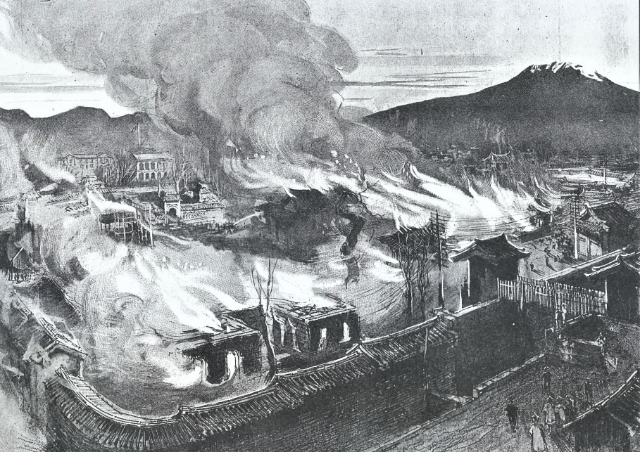

**Figure 6. Engraving of the fire at the palace (Robert Neff Collection)**

A month after the funeral, the imperial family was again struck by tragedy. On April 15, Kavanaugh wrote, “His Majesty’s Imperial Palace caught fire last night and was burned to the ground. How the fire started no one can tell or, if they can, will not. No lives were lost but all of the old seals and books and a lot of paper money was burnt. How much is hard to say.” There were in fact several theories as to how the fire started; some

27 JK. March 27, 1904.

28 Ibid.

were mystical and supernatural while others were rational.29 The city was somewhat fortunate as it had been very rainy the previous ten days and the fire did not spread as quickly as it would have otherwise.

The imperial family continued to suffer losses. Still mourning the death of the dowager queen, on November 6 most of the Korean population was dismayed to learn that the 31-year-old crown princess had died.30 Yun Chi-ho, a Korean official, noted in his diary that she had “died―or rather was compelled to die by the absurd custom of Korea which keeps doctors from a female patient.”31 The male doctors were not able to even look at their female patient’s flesh, and he had “no doubts that a foreign doctor would have saved her.” 32 There was a court physician, Richard Wunsch, and according to him, “Four [of the Korean physicians] are in jail, because the Crown Princess has died, they will be banished later.”33 Kavanaugh had just returned to Seoul from the coal mine near Pyongyang and apparently was not aware of the controversy surrounding her death, merely noting in his letter to his family that due to her passing “everything here is at a standstill till after the funeral which will be in about three months.”34

As time passed, Kavanaugh became increasingly negative towards the Japanese. Some of the reasons were personal, such as the missing trunk of silk and jade he had shipped from Pyongyang aboard a Japanese steamer. He was convinced the company had failed to offload it in Chemulpo and had taken it to Japan where he would never see it again. He believed it was useless to complain because the Japanese steamship agents did what they wanted to do and there was no one to hold them accountable. Much to his relief, however, his trunk showed up about a month later. It had been mistakenly shipped to Japan but apparently was forwarded to Chemulpo on the next trip.35

Sometimes his letters were filled with long angry tirades:

29 “The Burning of the Palace,” *The Korea Review* Vol. 4, 1904 (April), 155-163; April 15, 1904, Yun Chi Ho Diary; April 15, 1904, Martha House Noble, compiler, *The Journals of Mattie Wilcox Noble* (San Luis Obispo, CA: unpublished, 1986).

30 Born in 1872, she was married to Crown Prince Sunjong in 1882 and witnessed the assassination of Queen Min (Empress Myeongseong) in 1895. The Crown Princess was posthumously elevated to Empress Sunmyeong. “News Calendar,” *The Korea Review*, Vol. 4, 1904 (November), 512.

31 Nov. 6, 1904, Yun Chi Ho Diary.

32 Ibid.

33 Martin Uden, *Times Past in Korea* (Abingdon, England: Routledge, 2003), 314.

34 JK. Nov. 7 and 19, 1904.

35 JK. April 11 and May 15, 1904.

The [Japanese] are getting the big head bad. Someone will have to lick them soon if the Russians do not; there will not be enough room on the face of the earth for them. I have got my first [Japanese] to see that is not a liar and thief if you give them half a chance … Even the Post Office Department will not pay back money that is sent by money order but will say “excuse me please,” “wait a while longer,” “I am very sorry.” I sent a money order from Pyongyang last Dec. to Seoul. The order never arrived [and] all I can find out is wait a while longer. It is this way with them all, they will promise but never fulfill. I am sick of them.36

He was careful to note that it was the Japanese men he found fault with. “There is more honor in the lowest Japanese woman than there is in the highest Japanese officer.” He was convinced the Russians couldn’t be as bad as the Japanese and once he returned to the United States, “God help the Japanese man that gets in my road.”37

The Russians, however, were not doing well in the war. A little over a week later, two badly wounded Russians, dressed in Korean clothing, were brought to Seoul “to make a show to the Koreans.”38 Although he claimed he did not care which side won the war, he was beginning to believe the Japanese would win and then Korea would be controlled by Japan. “Well, I do not blame them for that, still I think less of them every day.”39 The Japanese authorities were not waiting for the end of the war before they started making demands upon Korea, however. In mid-July he described the increasing tensions as Japanese officials demanded the “vacant lands in Korea which includes the mineral lands” be turned over to the Japanese government. This greatly angered the Korean population and “several public meetings” were held in Seoul.40 One of these meetings had over 20,000 participants, and several were killed by Japanese soldiers amid the growing unrest.

The country is under Japanese martial law, [the Japanese] do just

36 JK. May 15, 1904.

37 Ibid.

38 One Russian soldier was shot in both arms and a leg while the other had wounds to an arm and his head. Kavanaugh speculated the soldiers had been ordered by the Japanese to don Korean clothing. JK. May 25, 1904.

39 JK. June 19 and July 5, 1904.

40 JK. July 16 and 26, 1904.

about as they wish. They arrest and execute Koreans for most anything. They shot one the other day for trying to stop the Japanese from taking his land from him. He was a leader so they shot him to scare the rest. If the people in the United States could come in contact with them for a short time they would pray for the Russians to win the war.41

While the Japanese officials were terrorizing the Korean population, they generally left the foreign population unmolested. Kavanaugh was sure this would change once the war was over and predicted all of the foreign employees of the Korean government would be dismissed. He wasn’t very troubled by this as he was owed 5,500 yen in back wages and had 4,000 yen loaned on land in Seoul at 2% monthly interest.42 This claim of being unconcerned with what would happen after the war ended almost became a mantra for him and was often repeated in letters home.

# Return to Poong Poo Coal Mine

Throughout the spring and summer, Kavanaugh’s orders from General Min and the Korean emperor were to remain in Seoul, as no work could be done at the coal mine until mining machinery could be obtained from the United States. During the early stages of the war, it was nearly impossible for foreign businesses to import machinery and goods into Korea because most of the shipping was done by Japanese steamers, and they were focused on the Japanese war effort.43 He often expressed no great desire to get back to work, as he was living in a luxurious mansion with great food, and was surrounded by 40 women, including General Min’s wife and concubines, his son’s wife, and about 30 slaves who were all in his care while the general was away. Kavanuagh rarely mentioned any romantic interest in women, but apparently his mother asked him about getting married, so he teased her by claiming he might soon marry one of the women in the mansion but offhandedly noted they were all Koreans.44

Finally, on Aug. 1, Poong Poo Company ordered 30,000 yen of machinery from San Francisco and Kavanaugh began preparing a trip to

41 JK. Sept. 3, 1904.

42 JK. Aug. 16 and Sept. 3, 1904.

43 JK. May 15, 1904.

44 JK. May 25 and June 12, 1904.

Pyongyang to start work on the coal mine and to also inspect a possible site for a gold mine. He had a letter of identification from the Japanese consul in Seoul so he did not expect to have any problems with Japanese soldiers.45

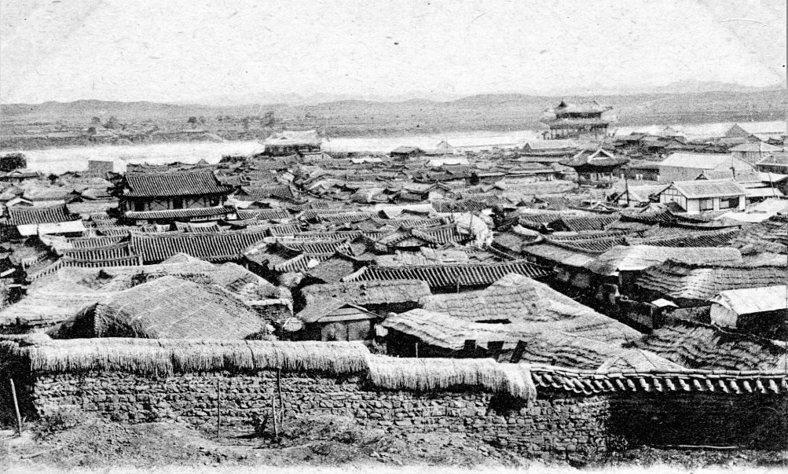

**Figure 7. Pyongyang in the early 1900s (Courtesy of Diane Nars Collection)**

On Sept. 7, proudly boasting in a letter to his mother that he had been sent by His Imperial Majesty, the Emperor of Korea, he departed for Pyongyang to report on the gold field near the OCMC. He and three Korean officials went by four-man chairs and “had the best the country could put up and plenty of it.”46 They saw many Japanese soldiers but none of the Russians said to still be haunting the area. As protection, his party had a guard of Korean soldiers but he had little faith they would stand their ground if attacked.

At the gold field they found some 25,000 Korean miners working the placer mines. The miners had been there for three months, but most of them slept out in the open because there were no facilities and they received very little pay, in contrast to the Korean landlords who were making thousands of dollars per day.47

Prior to beginning work at the coal mine, he visited the different

45 JK. Aug. 16 and Sept. 3, 1904.

46 JK. Oct. 11, 1904.

47 Ibid.

magistrates and officials in the region to ensure they recognized him as the foreign superintendent whose authority had been granted by the Korean emperor. With a crew of 65 Korean coolies and carpenters, he started construction of the coal mine buildings. Security was provided by 20 Korean guards, but Kavanaugh had little faith in them and complained “it would not take much of a man to make all of them run.”48

The death of the crown princess brought him back to Seoul in early November. The subsequent mourning period would “delay all work for about three months so our mine will have to stop for a time again.”49 Despite this, he still needed to visit Chinnampo because the 128 tons of machinery he had ordered from San Francisco was expected to arrive during the first week of December. Apparently the shipment was somewhat delayed, though this didn’t really matter because it could not be installed until May on account of the winter.50 The war had not yet ended, but already he was having doubts as to how long his employment by the Korean government would be allowed: “So far the Japanese have not objected to our work but I expect it any time.”51

The winter passed, but because of a lack of letters, we do not know how he spent it. Most likely he stayed at General Min’s house and continued to draw a salary from the Korean government. It’s clear he had the means to send $500 home, in addition to a leopard skin via Japanese parcel post and a tiger skin by English parcel; the former arrived nearly 15 days before the tiger skin. They were half-tanned and had been killed near Pyongyang and, according to him, the value of the tiger skin was 95 yen ($45 gold) and the leopard was valued at 45 yen ($27.50). He thought they might not require duty taxes as they had not been completely tanned, but if they did it would be no more than $15. He did not say how much he paid for them but noted they were obtained cheaply and advised his family to either keep them or sell them at Edwards Brothers in Tacoma.52

On March 14, 1905, just before he departed Seoul for Chinnampo and then the mine, he sent his family a letter in which he wrote:

The war is going on but I think it will stop soon as the Russians seem to be defeated at Mukden. There is a large immigration of

48 JK. (Part of the date is ripped but the year given is 1903 which is incorrect and should be 1904).

49 JK. Nov. 7, 1904.

50 JK. Nov. 19 and Dec. 7, 1904.

51 JK. Nov. 19, 1904.

52 JK. March 14, 1905.

Japanese to this country most of them are [of the] coolie class and are bad as they can be but the upper [class] that are educated are all right, of course, I think they will take Korea at the end of the war but you cannot blame them for that if they do it will be Korea for the Japanese and the others can get out. For my part I do not care.”53

Whether he was deceiving himself or just trying to make his family feel better, his claim that he didn’t care if he was forced out was not true. He had invested a lot of time and money in Korea and was not about to go quietly. At Chinnampo he was met by Captain Ebenezer Barstow, the superintendent of transportation for the OCMC, as well as a couple of other OCMC employees. The bridge at Pyongyang was under construction and apparently no Korean boats were allowed to go under it. It isn’t clear, but the Americans were likely aboard the OCMC’s small steamer *Dorothy* when an incident took place that compelled Kavanaugh to publish an article in *The Korea Review*, an English-language magazine published in Seoul:

Capt. Barstow, myself and some other men who were going to the American Mines, left Chinnampo on a small river boat. We knew that our boat could not go above the bridge, so I decided to telegraph to the Poong-poo Co. to send a sampan to meet me at the bridge. Capt. Barstow asked me to get two sampans for his party. So I wired for three boats. The Company agent sent the boats and they arrived at the bridge just at dusk. It was neither dark nor light when the boats went under the bridge between the piers. Six or seven Japanese caught the first boat, struck the head policeman of the company and knocked him out of the boat. He was unconscious and floated down stream until picked up by others. The second policeman was struck on the head at the same time and badly injured but he was not knocked out of the boat. The Japanese tried to throw him out but he begged off. The boatman, a young Korean about eighteen years old, was struck on the head and knocked out of the boat but caught hold of one of the bridge timbers. Then one of the Japanese began pounding on his hands with a drift-bolt about twenty inches long till he had to let go of the timber. He sank in the water and drowned and his body was not found until April 11th, when his father and brother

53 Ibid.

succeeded in recovering it. The Japanese Consul and police were notified but they made no effort to find the Japanese murderers. The bridge police took the sampan and kept it a long time. The Japanese did not want to take up the case as they could easily have found the murderer. They knew who the Japanese were that were employed on the bridge at the time, but Japanese sampans were landing people and they did not want Koreans to have the Work. We had to walk up to the city from the bridge and did not arrive till 11.30 p.m.

The head policeman of the Company was picked up by another boat below the bridge and was taken by Japanese and Koreans to a big fire built by the bridge watchman. There he was rolled over a log until the water was gotten out of him. The deep cut in his head was bandaged up. He was then taken to the Company’s house and put to bed. The second policeman’s head was bleeding freely when I arrived and the clothing of both policemen was ruined, so I had to put up twenty yen, the Japanese refusing to do anything.

After the boatman’s body was found, his father took it to the policeman’s house and made a demand upon the Japanese for Y 300 because of the boy’s death. But no attention was paid to it. He refused to let the body be buried, neither would he remove it from the policeman’s house and drove away everyone who came near. I went to the Korean magistrate to have the thing settled but found that he had no power to compel the burial of the body. I went to the Japanese Consul and he said he could not interfere in the case. Well, by this time you could smell the body a hundred yards away. It had been in the water twenty days and in the house three days. We raised thirty dollars between us to help the father but he and his son chased away eighteen of the yamen-runners and also the Company’s policeman and defied anyone to come near. At last the magistrate got the father into court and I was there to see the thing settled. The old man was quiet enough and agreed to the funeral arrangements but the son refused. He was brought before the magistrate but refused to kneel, so court servants seized him and forced him to kneel. He then began insulting the magistrate. They began to beat him with iron clubs about a font long with two or three chain links on the end and a diamond-shaped piece of iron

fastened to the end of each. The young man wrenched himself free, drew a knife five or six inches long, leaped clear of the crowd and, shouting defiance to the law made off at the top of his speed. I heard later that he was retaken and I think he is still in jail. The poor fellow was badly punished. He needed some of it, but not the beating. I do not know why he would not kneel down but, say, you should have seen those fellows scatter that were beating him. Two of them jumped through a window, one ran into the magistrate’s private office, one into the street, and another crawled under the house as far as he could go. As for myself I had a good place, perched on top of a wall where I could jump down either side. I stayed there an hour after everything was over but none of the servants appeared during that time. The magistrate himself came back soon after the man ran away but by the way he was breathing he must have run a long way or else he was wind- broken, sure! So that is how it stands. If you want more details I can give them. When the body was found, some Japanese police went down to have a look at it but that is all the interest they took in the matter.54

The article was obviously edited and was well-received by the general foreign community but not by the Japanese authorities. Kavanaugh was making enemies, but fortunately for him he spent most of his time at the coal mine and away from the disapproving glares of Japanese officials.

At the mine he had 75 men constructing buildings and setting up machinery. Life was comfortable at the site, as he had houseboys (he was responsible for their pay along with his provisions) and was provided with a house and a monthly salary of $400. “I am doing well,” he wrote, “no hard work and good pay with plenty of servants to wait on me, so I am in no hurry to leave.”55 But there was a degree of loneliness. “There is no one here that can talk English but I have a large Victor Phonograph. I start this when I want to hear English.”56 He also asked his mother to send a magic lantern (one that burned coal oil) with 100 views of various kinds that he thought she could purchase for around $20. He promised to pay her back and, judging from his correspondence, he probably kept his

54 John Kavanaugh, “An Unvarnished Tale,” *The Korea Review*, Vol. 5, 1905 (September), 330-332.

55 JK. April 27, 1903 (Misdated – should be 1905).

56 Ibid.

promise.

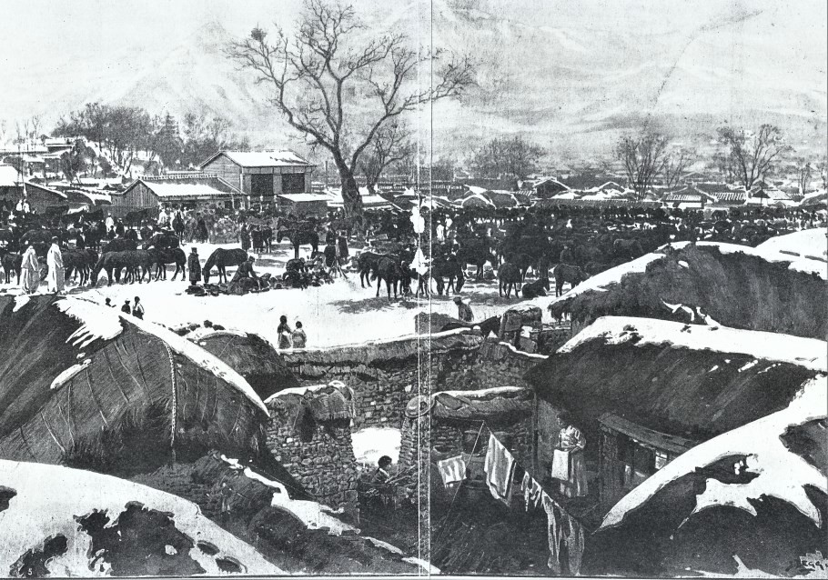

**Figure 8. Japanese encampment in vicinity of Seoul (Robert Neff Collection)**

Only a few letters survive from 1905. In September he wrote about typhoid fever, the end of the war, and discontent among the Japanese over the peace terms. The mine was in fair shape but he was convinced it would soon be in first-class operation. Perhaps his only complaint was the magic lantern had still not arrived.57 In October, the lantern still had not arrived and he declared he had given it up for lost. His mother asked when he would be returning to the U.S. and he told her he was unsure, but as long as “the Japanese do not interfere I will hold my position as I cannot find a job in the States where I get $400 gold per month, so while I am well off I had better remain.”58 This would not be easy because the Japanese were forcing the Korean government to discharge all of its foreign employees and had already taken over the customs department.

In December he wrote a short note to his family complaining he had not heard from them in some time and mentioning he had just recently returned to the mine from Seoul. His letter seemed upbeat and peppered

57 JK. Sept. 18, 1905.

58 JK. Oct. 27, 1905.

with indifferences, but it echoed some of his earlier concerns: “The weather here is very cold 18 below this morning but I have a coal mine for fuel so I do not care.” “I am working but for how long I do not know as the Japanese have taken Korea and their nature is Korea for the Japanese, but I do not care.” He then closed his letter with a request for vegetable seeds to be sent as he expected he would “turn farmer” if he stayed another year.59

With the New Year came a new mood. The mine was running at full operation and he had returned to Seoul to ask the U.S. representative for permission to receive an award from the Korean emperor. He and the Belgian Consul received the declaration of the 5th class of the Tai Kuk given under the emperor’s real name and stamp. The medal was solid gold and silver, one and a half inches square. Kavanaugh was quite proud of it, as its rank was “the same as Sir Knight if I were an Englishman and amounts to quite a lot but in America it is nothing.”60 He also received two paintings given to him by the governor of the province, which he then sent to his family as gifts.61 But by the end of February, his mood began to sour. He received the magic lantern but it was not very good and he ended up giving it away. “I have the mine in good shape and am working 100 men but will work 250 when the ice leaves the river then we can send coal to the city of Ping Yang and outside.”62 He was positive that there would soon be some big mining deals, but was dissatisfied with his situation. “I am still at work for the Co. but wish they would discharge me then they would have to pay me 16,000 yen Japanese money or $8,000 gold in back pay. I have an offer from an English Co. to go to work for them at $400 gold per month with a 2 year contract. I cannot quit the Poong Poo Co. without losing the back pay.”63 The coal company had to be making a profit before he could collect and he was worried the Japanese would soon take over the mine.

By May his mood had improved somewhat, but he was preparing for the worst. “I have bought a piece of land in the city of Ping Yang and will build a house on it to rent soon. The Japanese do not want to let foreigners hold land here but the American government say different, so it is o.k. so far.”64

59 JK Dec. 22, 1905.

60 JK. Jan. 16, and undated letter, probably last week of January 1906.

61 JK. Feb. 1, 1906.

62 JK. Feb. 21, 1906.

63 Ibid.

64 JK. May 23, 1906.

By June he was nearly finished building a small railroad from the mine to the river―a distance of 2.5 miles. He now had 250 Koreans working at the site, each was paid 500 cash daily (about 25 American cents, gold) and he had a fine little garden with potatoes almost ready to harvest. The Japanese had not bothered him in some time but he was convinced they would take the mine once the Japanese-owned railroad wanted it. Again, he professed he was not concerned, as he still had an opportunity available with the English company.65

Throughout the summer and fall he continued to work and bide his time, waiting for the Japanese to take the company, but it wasn’t the Japanese that ended his service with the Korean government―it was a cold. In late November he visited the OCMC and on his way back caught a bad cold that settled in his neck. He was treated by a physician but his condition worsened and he went to Seoul where he was hospitalized for 18 days and lost a good deal of weight. He submitted his resignation to the emperor and, prior to being hospitalized, had planned on returning to the United States for a short visit but now he felt there wasn’t enough time, as he had to be back in Seoul by the end of April. He made it perfectly clear that he did not envision himself leaving Korea for good:

I have bought some ground in Seoul and paid $1,800 gold for it. I want to put up some houses in the spring and rent them. I can get 30% on the money here, there is no use for me to think of trying to live in the States again. Here I do not have to work and have servants to wait on me. It is different at home than here, I can make money and have a little that is more than I ever could do in the States.66

Unfortunately, Kavanaugh did not write about how he settled with the Korean government―perhaps he decided he would just tell his family in person when he visited them a few months later or perhaps he was waiting to let the newspapers do it for him.

Shortly after he arrived in California in March, his account was published in newspapers throughout the U.S. Kavanaugh claimed the coal mines “were operated as a private enterprise by the Emperor of Korea, to whom the profits of the mine went as a part of his personal income.” Once the Japanese assumed control of Korea, a syndicate fostered by the Japanese imperial government consolidated all of the coal mines and

65 Ibid.

66 JK. Dec. 22, 1906.

“politely notified Kavanaugh that his services were not needed and incidentally, with equal politeness, disclaimed all knowledge of a matter of 21,000 yen due Kavanaugh for services rendered the Emperor up to the time of the Japanese control.”67 According to Kavanaugh, he tried to get his full amount through diplomatic channels but was eventually forced to settle for half the sum.

Kavanaugh closed his interview by stating: “It is to be Korea for the Japanese, and they don’t want anyone else there. All foreigners are kept under a close surveillance that is extremely irksome.”68

George Trumbull Ladd, a Japanese apologist and writer, had more than enough to say about Kavanaugh in his own book. He disputed the American’s claim to be a mining engineer and denounced him as being merely a “three-yen-a-day” miner who along with the Korean superintendent, Pak Pil-mun (“popularly known as ‘Pak the liar’”) managed to obtain assistance from powerful court officials and formed a franchise company giving them “exclusive rights to find coal-oil where no coal-oil was, to bottle mineral water from springs which have no valuable qualities to their water, and to export coal which was totally unfit for export.”69 Ladd claimed it was the Korean emperor who grew weary of the company and shut it down by paying Kavanaugh 12,000 yen in supposed back pay. The company had been a complete failure with “only a few thousand tons of coal taken from one small mine―sold, but the proceeds never accounted for…” As for Kavanaugh, “he departed to his native land to complain that the Japanese were inimical to the investment of foreign capital in Korea.”70

There may be some truth to what Ladd wrote: Kavanaugh began taking mining courses with the Scranton Correspondence School in March 1903; he did spend a lot of time in Seoul doing nothing while he stayed at General Min’s home; and, following his resignation from Korean service, he did return to the U.S., but not to badmouth Japanese policies in Korea. Instead, he sought other business opportunities, such as bringing religious figures made in the U.S. back to Korea.71 That, however, is a story for another time.

67 “No place for Americans,” *The Washington Post*, March 7, 1907, 6.

68 Ibid.

69 George Trumbull Ladd, *In Korea with Marquis Ito* (New York, NY: Charles Scribner’s Sons, 1908), 361-362.

70 Ibid.

71 JK. March 22, 1903.

*Robert Neff is a writer and researcher of Western-Korean relations in the late nineteenth century. He has written or co-written several books including* Westerner’s Life in Korea, Korea Through Western Eyes, Letters from Joseon, *and* Brief Encounters: Early Reports of Korea by Westerners*.*

*The writer wishes to express his appreciation to Edward Nolan, head of Specialty Collections at the Washington State History Research Center, for alerting him to the collection and assisting in obtaining copies of the correspondences. He also wishes to thank Diane Nars, who tirelessly searched through the many archives at her disposal for the elusive names and facts that he begged her to find.*